What is docker?
Is basically a server that holds a group of containers (containerisation).
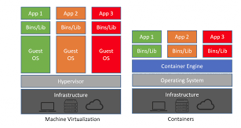
The container manager only has the app that you want to run. For example, it won’t let you log into it to update the server, it only lets you run on it. Only the application is running. You cannot log in.
For the hypervisor, you can log in to it and update cause each app has its own operating system.
The machine virtualization is ‘heavy weight’ and the containerization is ‘lightweight’.
Command prompt:
- docker run -d -- name sql1 -p 1433:1433 kcornwall/sqlnorthwind
- port 0 to 1024 – do not use it!!! They are reserved

SQL server is a client server system
Therefore, we need a client that understands SQL and that’s where SSMS comes into place.
SQL and Agile
Introduction to Databases
What is a Database?
- A collection of information and retrieving.
- Folders are the databases
- A structured set of data held in a computer, especially in one that is accessible in various ways.
Column – Database tables are composed of individual columns corresponding to the attributes of the object
Row – A row consist of one set of attributes corresponding to one instance that a table describes. Also known as records.
Table – A table is a predefined format of rows and columns that define an entity., Also known as the file.
DBMS – A Database Management System allows a computer to perform database functions of storing, retrieving, adding, deleting and modifying data.
Application – inputs data, processes data and then outputs the data.
Relational Databases contain connected data!
The tables should be related.
Types of Databases:
- Flat-file Database
  - Stores everything in one table. Good for small numbers of records related to a single topic.
- Relational Database
  - Gives you the ability to separate masses of data into numerous tables.
  - They are linked to each other using keys.
- Big Data
  - MongoDB, Vertica, etc.
  - Used for Data Analytics and Business Intelligence
  - Digital Age and Internet of Things.
Relational Databases
Relationship types:
- One to one
  - Each row in Table A is linked to no more than one row in Table B. This is an attribute of the relationship not the tables. A student may have one row in the contact_info table.
- One to many
  - Each row in the table can be related to many rows in the relating table.
  - This allows frequently used information to be saved only once in a table and referenced many times in all other tables.
- Many to many
  - One or more rows in a table can be related to 0,1 or many rows in another table.
Primary Key:
- The primary key uniquely identifies each record in the table.
- Most tables should have a primary key.
- The DBMS will enforce the uniqueness of the primary key, not allowing repeated records to exist in the table.
Primary Key Constraints:
- A primary key must be unique
- Must always have an entry
  - Cannot be blank or null
  - The value must never change
  - Each table may have a maximum of one primary key.

Foreign Key:
- Natural relationships exist between tables in most database structures, foreign keys are used to create solid relationships.
- Foreign keys ensure that the row of information in Table A corresponds to the correct row of information in Table B.
- The constraint is used to prevent actions that would destroy links between tables.
- It prevents invalid data from being inserted into the foreign key column, because it must be one of the values contained in the table it points to.
- There is no uniqueness contract for Foreign keys.
- A table can have any number of Foreign keys.
- A row cannot be deleted from a reference table if it is in use via a foreign key.
If a table has a foreign key, then we know that it is not the primary table and it is the secondary table.
Database Tools:
- Access
- Excel
- SQL server
- PostgreSQL
- Oracle
DML DDL DCL and TCL
- Data Manipulation Langauge
  - Select
  - Insert
  - Update
  - Delete
- Data Definition Language
  - Create
  - Alter
  - Drop
  - Truncate
- Data Control Language
  - Grant
  - Revoke
- Transaction Control Language
  - Commit
  - Rollback
  - Savepoint
Data Types:
- VARCHAR
  - Adaptable to different lengths of characters. Records MAX size
- CHARACTER or CHAR
  - Data must be at a fixed length. Fixed amount of space used.
- INT
  - Holds a whole number/integer value.
- DATE or TIME or DATETIME
  - Stores Date, Time or both date and time
- DECIMAL or NUMERIC
  - Fixed precision and scale
- BINARY
  - Use to store binary data such as an image or file.
- FLOAT
  - Working with scientific numbers
Database Considerations:
- Data Security
- Data Recovery
- Data Integrity
- Normal Form
Normal Form:
1st Normal Form:
A database is in First Normal Form when the following conditions are satisified:
- Make everything Atomic
  - Data must be presented as small as it can be.
- There should be no repeating groups
  - For example, a table that records data on a book and its authors with the following columns: [BookID], [Author1], [Author2] etc.
2nd Normal Form:
A database is in Second Normal Form when the following conditions are satisfied:
- It is in 1NF
- All non-key attributes are fully functional dependent on the Primary Key.

3rd Normal Form:
A database is in Third Normal Form when the following conditions are satisfied:
- It is in 2NF
- There is no transitive functional dependency.
Using SQL as a tester:
- Getting data for testing
- Solving Data, generated during testing activity
- Data verifications in databases
  - Find data
  - To ensure data integrity
Querying Databases
SQL Statements:
- SELECT
- DISTINCT – used for duplicates, gives you the first of the duplicates
- FROM – From which table
- WHERE – where (then put the condition)
- GROUP BY
- HAVING
- ORDER BY
SELECT * FROM Customers
- An Asterisk * means to select all columns
- i.e Select all columns from the customers table
JOINS AND SUBQUERIES
JOINS – JOIN is an SQL keyword used to combine matched rows from two or more tables.
It allows you to create a list of combined rows of matching data from different tables.
JOIN Types:
- INNER JOIN (Simple Join)
  - The most frequently used, its returns any rows where there is a matched key in both tables.
- LEFT JOIN or LEFT OUTER JOIN
  - Return all rows from the left table, and the matched rows from the right table regardless of any matching entry in the right table.
- RIGHT JOIN or RIGHT OUTER JOIN
  - Return all rows from the right table, and the matched rows from the left table regardless of any matching entry in the left table.
- FULL JOIN or FULL OUTER JOIN
  - Return all rows in both tables regardless of any match. Where no match exists, the missing side will contain NULL.
Subquery
- A subquery is a nested query inside another SELECT statement
- This allows you to take the results of one query and apply them to another query.
A subquery may occur in any of the following clauses:
- SELECT (nested subquery- returns single value only)
- FROM (inline view)
- WHERE (nested subquery)
- Example:
  - SELECT CompanyName AS “Customer”
FROM Customers
WHERE CustomerID NOTIN
(SELECT CustomerID FROM Orders)

AGILE
Agile Manifesto:
- Individuals and Interactions
  - Over processes and tools
- Responding to Change
  - Over following the plan
- Working Software
  - Over comprehensive documentation
- Customer Collaboration
  - Over contract negotiation

The 12 principles of Agile Software Development
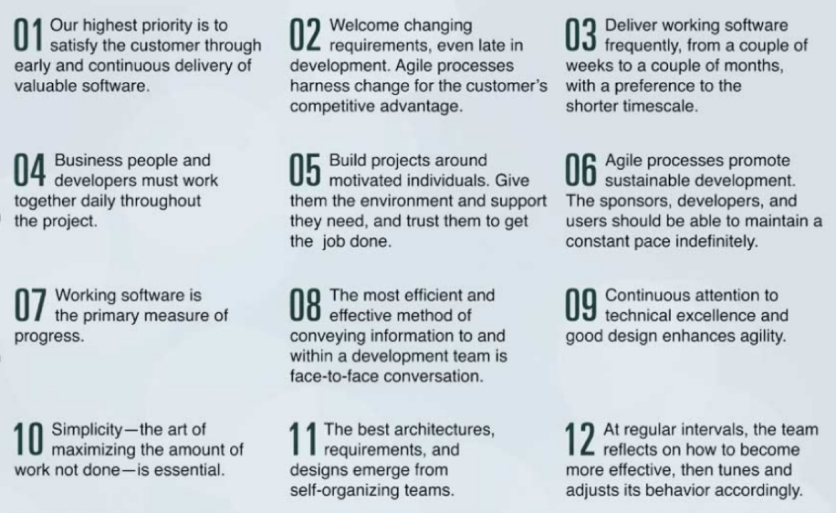

Difference between agile and scrum:
- SCRUM is a way of implementing AGILE principles.

SCRUM FRAMEWORK
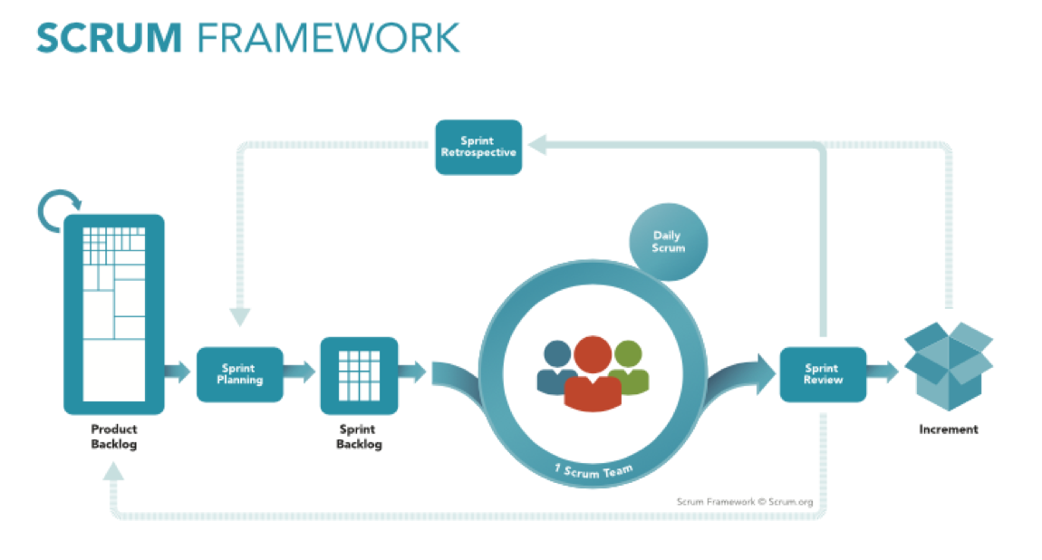
The Three Pillars of Empiricism
- Transparency
  - Everyone presents the facts as is and collectively collaborates for the common organizational objective. No one has a hidden agenda
- Inspection
  - Inspection is not done by an inspector but by everyone on the scrum team
- Adaptation

Key Points
- Co-located
- Engaged
- Self-Organising
- Accountable & Empowered
- Cross Functional
Roles:
- Product Owner
  - Key stakeholder who should have deep understanding of the product and communicates with both the team and other stakeholders.
- Scrum Master
  - Ensures that the team keeps to the values of Scrum, facilitates meetings and removes impediments.
- Scrum Team
  - Effectively 3-9 people
  - All doing whatever it takes to complete the agreed tasks
  - Everyone is not just committed, they are involved

SCRUM EVENTS:
- The Sprint
  - Planning and development work
  - Limited to 1 month
  - No changes should be made that endanger the sprint goal
- Sprint Planning
  - What can be delivered in the upcoming sprint?
  - How will the work be done?
  - Limited to 8 hours for a month long sprint or less if shorter sprint
- Daily Scrum
  - Optimising team collaboration
    - What did I do yesterday?
    - What will I do today?
    - Do I see any impediment?
- Sprint Review
  - Informal discussion about what was done during the sprint and to adapt the product backlog
  - Explains what has been done what hasn’t
  - Demonstrate the working packages
  - Review timeline, budget and capabilities
  - Timeboxed to 4 hours for a moth long sprint or less if shorter sprint.
- Sprint Retrospective
  - Inspect how the last sprint went
  - Identify what went well and what needs improvements
  - Create plan for improvements#
  - Timeboxed to 3 hours for a month long Sprint or less if shorter sprint
Scrum Artefacts and Information Radiators:
Scrum Artefacts:
- Product Backlog
  - Contains all of the stories to be done to complete the entire product
- Sprint Backlog
  - Contains only the stories to be worked on in the current sprint
- Increment
  - A piece of working software created in a sprint. The sum of all increments that forms the whole product.

Information Radiators:
- Task board
  - Used to track the work visually, showing the state if the sprint for both the team and other stakeholders.
- Burn Up Chart
  - Used to track team velocity, showing work completed vs time
- Burn Down Chart
  - Used to track team velocity, showing work remaining vs time
- Definition of Done
  - Shared agreement of what constitutes as ‘done’ for any story.

User Stories and Estimation:
Terminology:
- User Stories
- Epics
- Features
User Stories:
As a <type of user>, I want <goal> so that <reason>
If we have a large user story, and can break it down we call it an EPIC.
Devil in The Detail
There are two primary ways to add more detail:
- Splitting
- Conditions Satisfaction

Writing Good User Stories:
- User Comes First
- Use Personas
- Create Collaboratively
- Keep your stories simple
- Start with epics
- Refine Stories until they are ready
- Add acceptance criteria
- Use paper cards
- Keep them visible
- They are not everything
- Understandable
- Follow As a … I want… So that…
- Independent
- Negotiable
- Valuable
- Estimable
- Small
- Testable
The 3 C’s
- Card
- Conversation
- Confirmation
KANBAN
Used to:
- Remove Waste
- Improve flow of production process
- Utilize people’s efforts efficiently
- Adopted for production of software to promote Just in Time (JIT) delivery.
“Kanban is not a software development lifecycle methodology… It requires that some process is already in place so that Kanban can be applied to incrementally change the underling process.”
Principles of Kanban:
- Start with the existing software development processes.
- Agreement to pursue incremental and evolutionary change.
- A respect and evolution of the current process, roles and responsibilities.
- Encouragement of leadership at all levels in development process.
Kanban Process:
- Visualises data flow to identify bottlenecks.
- Sets Work-In Progress (WIP) limits to focus on the current task.
- Concentrate effort on a single task at any given time to enhance efficiency.
- Product owner keeps prioritised backlog up to date and protects team from distraction.
Continuous Flow:

