Exercise 1
Q1.1
SELECT CustomerID AS 'Customer ID', CompanyName AS 'Company Name', ISNULL(Address + ',', '') +
ISNULL(City + ',', '') +
ISNULL(Region + ',', '') +
ISNULL(PostalCode, '') +
ISNULL(Country + ',', '')AS 'Address'
FROM Customers WHERE City = 'Paris' or City = 'London'

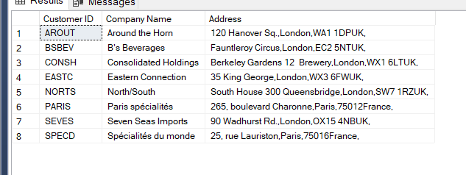

Q1.2
SELECT * FROM Products WHERE QuantityPerUnit LIKE '%bottles%'
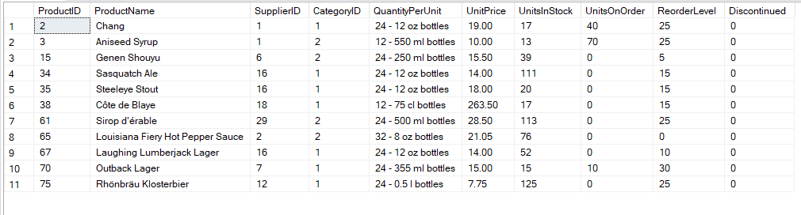
Q1.3
SELECT Products.ProductName AS 'Product Name', Suppliers.CompanyName AS 'Company Name', Suppliers.Country FROM Products
JOIN Suppliers ON Products.SupplierID = Suppliers.SupplierID
WHERE QuantityPerUnit LIKE '%bottles%'

Q1.4

SELECT Categories.CategoryName, Products.UnitsInStock FROM Categories JOIN Products ON Products.CategoryID = Categories.CategoryID

Q1.5
SELECT ISNULL (TitleOfCourtesy + ',', '') +
ISNULL(FirstName + ',', '') +
ISNULL(LastName +',','') AS 'Full Name', City
FROM Employees

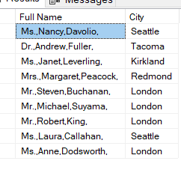

Q1.7
SELECT COUNT (*) FROM Orders WHERE Freight > 100 AND ShipCountry = 'USA' or ShipCountry ='UK'

AMOUNT = 96

Q1.8
SELECT (UnitPrice - Discount)*Quantity AS 'Total Sales', [Order Details].OrderID FROm [Order Details]
ORDER BY 'Total Sales' DESC

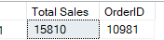

Q2.1
CREATE TABLE Spartans
(
Title VARCHAR (10),
FirstName VARCHAR (25),
LastName VARCHAR (25),
University VARCHAR (100),
Course_Name VARCHAR (50),
Grade VARCHAR (15));

Q2.2
INSERT INTO Spartans (Title, FirstName, LastName, University, Course_Name, Grade)
Values ('Mr', 'Zaid', 'Khider', 'Queen Mary University', 'Aerospace Engineering', 'First Class'),
('Mr', 'Hamza', 'Hamza', 'Greenwich University', 'Computer Science', 'First Class'),
('Mr', 'Shav', 'Shav', 'Greenwich University', 'Computer Science', 'First Class'),
('Mr', 'Julien', 'Acosta', 'Queen Mary University', 'Software Engineering', 'First Class'),
('Mr', 'Omid', 'Ayoobe', 'Brighton University', 'Computer Science', 'First Class'),
('Mr', 'Daniel', 'Flynn', 'Bedfordshire University', 'Computer Engineering', 'First Class'),
('Mr', 'Michael', 'Michael', 'Queens University', 'Computer Science', 'First Class'),
('Mr', 'Matt', 'Matt', 'Queen Mary University', 'Computer Science', 'First Class'),
('Mr', 'Pradeep', 'Pradeep', 'Greenwich University', 'Aerospace Engineering', 'First Class'),
('Mr', 'Ally', 'Ally', 'Portsmouth University', 'Maths', 'First Class');

Q3.1
SELECT Employees.EmployeeID, Employees.LastName, Employees.FirstName, Employees.ReportsTo FROM Employees
Q3.2
SELECT [Order Details].OrderID,(UnitPrice-Discount)*Quantity AS 'Total Sales' FROM [Order Details]
WHERE (UnitPrice-Discount)*Quantity>10000

