Computational, Communication and Scheduling Limits of Modular Multilevel Converter Control Architectures

A quantitative three-case study: centralized MCU with bubble sorting, centralized FPGA with Bitonic sorting networks, and decentralized consensus control
This report studies the scalability limits of three implementation strategies for the control of a single-phase Modular Multilevel Converter (MMC). In strategy A, a classical centralized controller runs the capacitor voltage balancing with bubble sort on a microcontroller (STM32G474). In strategy B, the controller is still centralized, but the sorting is done by a Bitonic sorting network on an FPGA, according to the method of Ricco, Math and Teodorescu. In strategy C, the control is fully decentralized. Each submodule computes locally and exchanges data with its ring neighbors only.
For each case, the maximum number of submodules per arm, N_max, is derived from the computing cost of each task, from a frame model of six industrial communication protocols, and from a Rate-Monotonic stimulability analysis. The computing costs were calibrated on the extracted model code. On the microcontroller, the centralized architecture is limited by the acquisition and computing path. This gives N = 12 on a shared SPI bus and N = 19 with one bus per arm. With parallel on-board acquisition the limit moves up to N = 37. On the FPGA, the limit is about N = 128.Here the logic resources are the constraint. Here the logic resources, and not the timing, are the constraint. In the decentralized case the picture changes. The amount of work on each node stays the same as N grows. Its CPU utilization was found to be U = 5.88 %, with 13.3 µs of each period spent on the exchange with the neighbors. What limits this case is the convergence of the consensus around the ring, which gives about N = 64 to 90.

The three cases are also reduced to their scaling laws in N, for both computing and communication. Wherever the control is centralized, it is the communication law that dominates

Contents
Contents 2
1. Introduction and problem statement 3
2. Methodology, task set and cost models 3
2.1 Task set and rates used 3
2.2 Processor cost model 3
2.3 Communication frame models 4
2.4 Symbols and quantities used throughout 4
2.5 How each task budget is computed 4
3. Case A Centralized MCU with bubble sorting 5
3.1 Practical configuration 5
3.2 Results three regimes, three walls 5
3.3 Practical implementation notes 5
4. Case B Centralized FPGA with Bitonic sorting network 6
4.1 Practical configuration 6
4.2 Results time never binds, resources do 6
4.3 Practical implementation notes 8
5. Case C Fully decentralized consensus control 8
5.1 Practical configuration 8
5.2 Results constant load, and where N really enters 8
6. Computational scaling laws for N 9
7. Scheduling analysis of the three-layer stack 9
8. Comparative results 10
9. Discussion, assumptions and limitations 11
10. Conclusions 11
References 12

1. Introduction and problem statement

1.1 Context
The modular multilevel converter (MMC) has become the reference topology for medium- and high-voltage conversion [9]. The structure is modular and it scales. The harmonic distortion of the output voltage is low as well [9]. But the same modular structure brings the complexity of control. In every control period, the controller has two fixed tasks, the regulation of the circulating current and the control of the grid-side quantities, and one task whose size depends on the arm, the balancing of its N capacitor voltages [9]. Only the capacitor voltage balancing grows with the number of submodules N. The other two grow weakly or not at all.The implementation question is therefore not whether N costs something, but where N enters the design and which resource it exhausts first: processor time, bus time, silicon area or closed-loop bandwidth. The literature has pushed N back along each of these axes separately. Section 1.2 reads that literature as a single argument and Section 1.3 states the gap this report fills.

1.2 State of the art: three ways N has been pushed back
Sorting-based balancing on sequential processors
The classical capacitor-voltage balancing (CVB) ranks all N voltages each period and inserts the nearest level according to the arm-current sign [9]. On a sequential processor its cost is the sort itself, O(N²) for the exchange sorts of early implementations. Siemaszko [17] and Ilves et al. [18] attack this cost from the same observation: capacitor voltages move slowly relative to the control period, so consecutive orderings are nearly identical. They differ in what they do with that observation. Siemaszko [17] exploits the near-sortedness directly and approaches linear cost in steady state. Ilves et al. [18] first predict the voltage trajectory and then sort, which also minimizes the voltage spread and restrains reselection switching. The split follows from the objective: [17] optimizes computing time alone, whereas [18] spends some computation to buy a better harmonic and switching outcome. Both remain centralized, and both leave the acquisition of 2N measurements per period untouched. This is their shared blind spot. They measure improvement in comparisons, not in the end-to-end deadline, so neither asks whether the sort or the bus binds first. Section 3.2 answers that question quantitatively and finds that, on a bus-fed microcontroller, the bus binds.
Moving the sort into hardware
The sorting time can be removed from the control period completely if the sorting is moved into the FPGA fabric, and a Bitonic sorting network was built for this purpose in [1]. The comparator-network model in [1] is taken from the general work on sorting networks in [2]. For N inputs, this model needs O(N·log²N) comparators and the sorting is finished in O(log²N) stages. The sorting network in [2] was developed for database applications, where a high throughput is required, so it was fully pipelined. The MMC needs one sorting per control period. The network in [1] was factorized as much as possible to reduce the FPGA area, since the high throughput of [2] is not necessary in this case. The same choice is made in Section 4.
The results reported in [1] are the latency and the number of LUTs. The 2N isolated measurement channels at the input of the network are assumed to be available, and their cost, which includes the wiring and the transceivers, does not appear in the paper. The same situation exists for [17] and [18], where the time of the measurement is ignored. Therefore, the acquisition, whose cost grows linearly with N in all the centralized methods.
Removing the central node: consensus
Olfati-Saber and Murray gave the general theory of consensus in [10]. It was extended in [11]. In this theory, the agents reach a common value with the information of their neighbors only. The convergence rate depends on the algebraic connectivity λ2 of the communication graph. For a ring graph, λ2 decreases with N as (2π/N)². This theory can be applied to the capacitor voltage balancing of the MMC. The central controller does not need N measurements any more. Each submodule only exchanges a fixed number of messages with its neighbours. So the communication load of one node is not related with N. However, the effect of N is not eliminated. It appears in λ2 now. The convergence of the closed loop becomes slower with a larger N. This kind of method is not included in the MMC survey [9]. In that survey, the balancing is still treated as a centralized selection problem.
. The consensus works in [10] and [11] are general. They are not related to any topology or application. The control period is not discussed in them. The frame time and the nearest-level modulator are not discussed either. So their convergence bound cannot be compared directly with [1], [17] and [18]. It has to be calculated again with the task set of the MMC. This calculation is made in Case C of this report for one consensus candidate. This candidate is one of several decentralized methods studied in the project. It is not the selected method.
Timing instruments that make a comparison possible
The quantitative tools of this report come from three mature fields. The stimulability bounds of periodic task sets were given by Liu and Layland in [12]. They are summarized in [13]. In [12], the rate-monotonic bound for three tasks is 78 %. If the periods are harmonic, this bound becomes 100 %. This result is used to select the rates in Section 2.1. In [16], nested multirate interrupts are described as the usual practice in digital power electronics. So the rate-monotonic scheduling is more suitable here than the earliest-deadline-first scheduling.
On the communication side, the worst-case frame times are taken from the CAN standard [3] and the Ethernet standard [5]. The frame time of the Aurora link is taken from its specification [7]. The bus-load ceiling of CAN was analyzed by Davis et al. in [4]. The achievable synchronization accuracy is limited by IEEE 1588 [6]. The harmonic limits of IEEE 519 [15] give a minimum number of levels. This minimum is converted into a lower bound on N. None of these results is in doubt. But they have never been put together for the MMC balancing task. In the scheduling literature, the cost C_i of each task is assumed to be known.
.

1.3 Gap and contribution
The limit of N has been pushed back by the works above, but each of them works in a different direction. The computing time of the sorting algorithm is reduced in [17] and [18]. A sorting network with a small silicon area is given in [1] and [2], and a different network topology is used in [10] and [11]. The result of each direction is expressed in a different quantity, that is, the number of comparisons, the number of LUTs or the eigenvalue λ2. Therefore it is difficult to compare the three results on one scale. The acquisition time is the first part of the measurement-to-actuation path. It is not counted in any of them.
In this report, the same three-layer periodic task set is used for all the three architectures. The same Cortex-M4F cost model is used as well. This cost model is calibrated on the code extracted from the project models. One frame-time model is built for each protocol. The same schedulability test is applied in all cases. The result of each case is N_max and the resource which reaches its limit first. The scaling laws are then derived in Section 6. They show where N enters each design.

1.4 Problem statement
For a given processor, a given communication medium and a given control technique, what is the largest N for which all the control deadlines can be met? Three concrete cases are analysed from measurement to actuation. The same methodology and the same task set are used for the three cases. The cost models are calibrated on the Simulink implementations developed in the project. Case A is centralized on an MCU with bubble sorting. Case B is centralized on an FPGA with a Bitonic sorting network [1]. Case C is fully decentralized consensus control. In Case C, each submodule exchanges information with its immediate neighbours only. This is one of the candidates studied in the CARROTS project.

2. Methodology, task set and cost models

2.1 Task set and rates used
All three cases are analysed against the same three-layer periodic task set, in the hierarchy fixed during the project meetings. The periods are harmonic, which is essential: for harmonic period sets the Rate-Monotonic schedulability bound rises from 69.3% to 100% [12], [13].
Task | Function | Period | Rate | Cycle budget @170 MHz
τ1 :CVB, low level | sorting / consensus + acquisition + gate decision | T1 = 100 µs | 10 kHz | 17,000 cycles
τ2 :Energy, inner | circulating current / total & differential energy | T2 = 1 ms | 1 kHz | 170,000 cycles
τ3 :Grid, outer | SOGI ×2, PLL, dq current control, power loop | T3 = 10 ms | 100 Hz | 1,700,000 cycles

The other parameters are fixed as follows. The grid frequency is f0 = 50 Hz. The measurement payload is 32 bits per frame, which contains the Vc value (12–16 bits), the identifier and the status. The reference operating point is N = 15. This value was retained on the project whiteboard for the STM32G474. The utilization bound is U ≤ 1 according to the harmonic RMS bound.
.

2.2 Processor cost model
The computing costs are counted operation by operation. The source code is the MATLAB Function code extracted from the project models. Then the operations are converted to cycles with the Cortex-M4F model given below. The values of this model come from the ARM TRM. They are adjusted for the load/store and pipeline effects [14]. All the counts are design estimates.
Operation | Effective cycles
FADD / FSUB / FMUL / FMA | 3
FDIV / FSQRT | 14
sin / cos (CMSIS table) | 50
tanh (polynomial) | 60
floating mod | 20
persistent state access | 4 / variable
function overhead | 40

Table X gives the calibrated cost of each control layer in cycles per period. The costs of the decentralized case do not change with N. The mean and the energy sums of the centralized energy layer are O(N), which was verified in the extracted code.
Layer | Task | Centralized (cycles) | Decentralized per node (cycles)
SM (τ1) | CVB, bubble sort, both arms | 12N2+10N+50 | ≈970 (constant)
SM (τ1) | Merge-class sort | 40⋅N⋅log2​N+10N+50 | —
SM (τ1) | Min/max scan, ±1-module rule | 200+6N | —
Energy (τ2) | Mean and energy sums | 200+19N | 220 (replica)
Grid outer (τ3) | Outer loops, O(1) | 800 | 800 (replica)

Note: τ1 in the decentralized case = 260 + 150 + 560 ≈ 970 cycles (consensus law; neighbour-frame packing, unpacking and DMA service; rotating-threshold gate decision with stale-neighbour and health checks).

2.3 Communication frame models
Protocol | Frame-time model (payload b bits) | t_frame for b = 32
CAN 2.0, 1 Mbps | (47 + b)·1.19 / 1 Mbps (worst-case stuffing) [3] | ~94 µs
CAN FD, 5 Mbps data | 29/1M + (b+28)/5M [3] | ~41 µs
UART 8N1, 3 Mbps | 10·⌈b/8⌉ / 3M | ~13 µs
SPI, 20 MHz | b/20M + 2 µs (CS + service) | 3.6 µs
Ethernet 100M | max(672, b+336)/100M (min on wire frame) [5] | 6.7 µs
Aurora 8B/10B, 3.125 G | b/2.5G + 40 ns [7] | < 0.1 µs

Centralized acquisition of one phase leg requires 2N frames per T1; on a shared bus the acquisition time is 2N·t_frame and the bus load ρ = 2N·t_frame/T1 must remain below ~0.5 for schedulable [4]. In the decentralized case each node exchanges exactly two neighbor frames regardless of N.

2.4 Symbols and quantities used throughout
Symbol | Meaning | Value / model used
N | submodules per arm (2 arms acquired) | swept 4–256; reference 15
T1, T2, T3 | layer periods (harmonic) | 100 µs, 1 ms, 10 ms
f0 | grid frequency | 50 Hz
C1(N) | CVB-layer cycles | 12N²+10N+50 (bubble); 40N·log2N (merge); 200+6N (±1 rule); 970 const (per-node consensus τ1)
C2(N), C3 | energy / outer cycles | 200+19N (cent.) or 220 (dec.); 800
t_frame | on-wire frame time | protocol models of Table 3, payload 32 bit
U(N) | RMS utilization | ΣCi/Ti, bound 1 (harmonic)
λ2 | ring algebraic connectivity | 2(1−cos 2π/N)
THDq | staircase quantization THD | ≈ 0.816/N

2.5 How each task budget is computed
All the figures in Sections 3–5 come from one five-step procedure. The reader can recompute any entry with it.
- Budget. B_i = f_CPU · T_i is the cycle budget of a task. With f_CPU = 170 MHz, the budgets of τ1, τ2 and τ3 are 17,000, 170,000 and 1,700,000 cycles respectively.
- Cost. C_i is counted operation by operation from the extracted MATLAB-Function code. Each operation is priced with Table 2. The time is then t_i = C_i / f_CPU, where 1 µs = 170 cycles.
- Utilization. U = Σ C_i / T_i. It is compared with the harmonic RMS bound of 100 %, or 70 % with the design margin. This step tells if the CPU is too busy to meet a deadline.
- Deadline path. A DMA transfer occupies the link and not the CPU. So it is not included in U. But it is included in the path which must be finished inside T1 at the critical instant, when the three tasks are released together. This path is T_path = T_acq + t_1 + t_2 + t_3 ≤ T1. On a shared bus, T_acq = 2N·t_frame. With one bus per arm, T_acq = N·t_frame. This step tells if the fresh data arrive and are processed in time.
- Actuation latency. T_act = T_acq + t_1 + T_dist. On the MCU, the distribution is one 32-bit gate frame per arm, with 1 bit per module and N ≤ 32. On the FPGA, T_dist = 0, because the gates are outputs of the fabric. In the decentralized case, T_dist = 0 per node as well, because each node gates itself.
N_max is the largest N for which steps 3 and 4 both pass. On the FPGA, step 3 is replaced by the resource count. In the decentralized case, steps 3 to 5 do not depend on N by construction.
Step | A : MCU + bubble (N = 15) | B : FPGA + Bitonic (M = 16) | C : Decentralized (any N)
(1) Budgets B1 / B2 / B3 | 17,000 / 170,000 / 1,700,000 cyc | not applicable: always-on pipelines, tick 100 µs / 1 ms / 10 ms | 17,000 / 170,000 / 1,700,000 cyc per node
(2) Costs C1 / C2 / C3 | 2,900 / 485 / 800 cyc = 17.06 / 2.85 / 4.71 µs | sort ≈ 0.50 µs (44 clk analytical = 0.44 µs) / sub-µs / sub-µs | 970 / 220 / 800 cyc = 5.71 / 1.29 / 4.71 µs
(3) Utilization U | 17.06/100 + 2.85/1000 + 4.71/10,000 = 17.39 % (125 % if blocking) | time ≈ 2 % of T1; binding quantity = LUTs (3 % at M = 16) | 970/17,000 + 220/170,000 + 800/1,700,000 = 5.88 %
(4) Deadline path | 54 + 17.06 ≤ 100 (dual SPI) → slack 28.94 µs at the critical instant (71.06 µs); single bus 108 + 17.06 FAIL | L_Aurora + 1.20 + 0.50 + select ≈ 1.70 µs + L_Aurora ≪ 100 µs | 13.33 (2 links in parallel) + 5.71 = 19.0 µs ≪ 100 µs
(5) Actuation latency | 54 + 17.06 + 3.6 = 74.7 µs | ≈ 1.70 µs + L_Aurora (distribution = 0) | ≈ 19.0 µs (distribution = 0), invariant in N
N_max rule | path: 2N·3.6 + C1/170 ≤ 100 → 12 (shared bus); N·3.6 + C1/170 ≤ 100 → 19 (dual bus); U = 1 compute only → 37 | LUT(M) ≤ device → ≈ 128 (Spartan-6 class) | consensus time τ ≈ Ts/(k·λ2) and ring-broadcast traversal → 64–90 on a pure ring
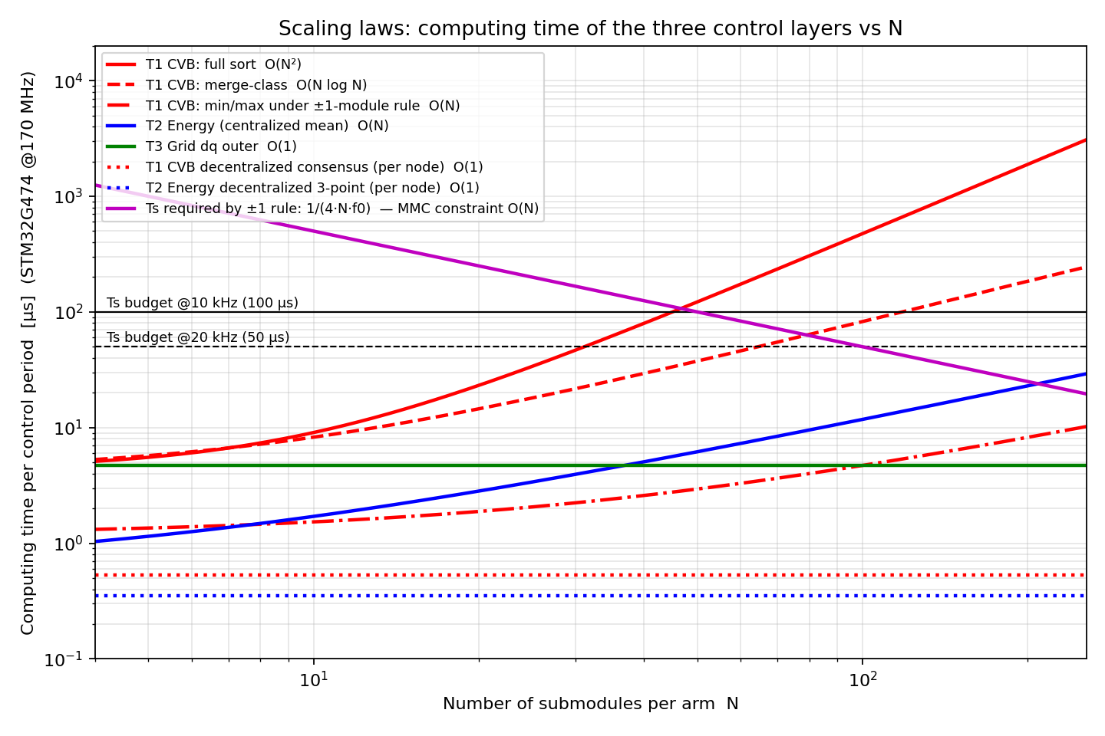
Figure 1 Layer computing times versus N on STM32G474 (log–log): centralized variants (solid/dashed) against decentralized per: node constants (dotted), with the T1 budgets and the ±1-rule minimum: rate curve.

3. Case A Centralized MCU with bubble sorting

3.1 Practical configuration
The platform is the STM32G474 [8]. It has a Cortex-M4F core at 170 MHz, an FPU, 5 ADCs and a hardware CORDIC. The control technique is a full re-sort of both arms in every T1. The sorting is a bubble sort on packed words of the form (Vc<<8)|ID. Then the nearest level is selected according to the sign of the arm current. This is exactly the implementation of the project model NLMsortclose7. The outer controller extracted from this model also gives the calibrated cost of τ3, which is 800 cycles. This controller contains two SOGIs, a PLL, the dq current PIs and the energy loops. The gains of the current PIs are Kp = Lωc and Ki = Rωc, with ωc = 2π·600 rad/sIn every period, 2N voltage frames go through the uplink. The transfer is made by DMA over SPI at 20 MHz. One frame of 32 bits takes 3.6 µs. The downlink is much lighter. For each arm, the gate bits of all the modules are packed into one frame of 32 bits, which is enough for N ≤ 32. The downlink time is therefore 3.6 µs and does not change with N. The communication limit of Case A is on the uplink.
Other data are exchanged between the tasks without the bus. One example is the arm sums ΣVc, which are produced by the sort itself. This costs about 45 extra cycles. τ2 takes these sums in the following period. The local ADC channels of τ2 and τ3 are read in less than 0.5 µs. Two references are passed downwards. v_circ is renewed in every period. v_ac is renewed every 10 ms only. The CVB works with the held value in between, as a zero-order hold.

3.2 Results three regimes, three walls
Regime | Binding condition | N_max
A1 : blocking communication (busy wait SPI) | U(N) = 1 with comm inside C1 | 12
A2 : DMA communication, single shared SPI bus | path 2N·3.6 + C1(N)/170 ≤ 100 µs → N = 12: 97.56 PASS; N = 13: 106.59 FAIL | 12
A2′ : DMA communication, one SPI bus per arm | path N·3.6 + C1(N)/170 ≤ 100 µs → N = 19: 95.29 PASS; N = 20: 101.71 FAIL | 19
A3 : DMA + parallel on board ADC acquisition | U(N) = 1 with compute only (12N² term) | ≈ 37

The whiteboard reference N = 15 cannot be run on a single bus. The acquisition of 30 frames takes 108 µs, which is more than the 100 µs period, while the sort itself needs only 2,900 cycles (17.1 µs). With one SPI bus per arm, the acquisition time falls to 54 µs and the deadline is met. The blocking variant is not feasible in any layout, since its utilization reaches 125 %. With dual SPI and DMA, the system is schedulable, and the CPU is not the problem:
U = 17.06/100 + 2.85/1000 + 4.71/10,000 = 17.39 %
The problem is the bus, which is occupied by the communication block during 54 % of T1. At the critical instant, the chain acquisition → CVB → τ2 → τ3 ends at 71.06 µs and only 28.94 µs remain. One retransmission is enough to miss the deadline.
From measurement to actuation, the latency is 54 + 17.06 + 3.6 = 74.7 µs, where the three terms are the acquisition, the sort and one gate frame per arm. On a shared bus this path stays inside the period up to N = 12 (97.56 µs), and it fails at N = 13 with 106.59 µs. One bus per arm pushes the limit to N = 19. So the architecture can be scheduled, but the communication is its weak point.
.
Replacing the bubble sort by the merge sort does not change N_max at all. Both sorts give the same limit:
- shared bus: N_max = 12
- one bus per arm: N_max = 19
The acquisition hits the deadline long before the sorting does. A better algorithm is of no use here as long as the acquisition stays the same. The numbers confirm the whiteboard annotation "influence of the communication scaling law"
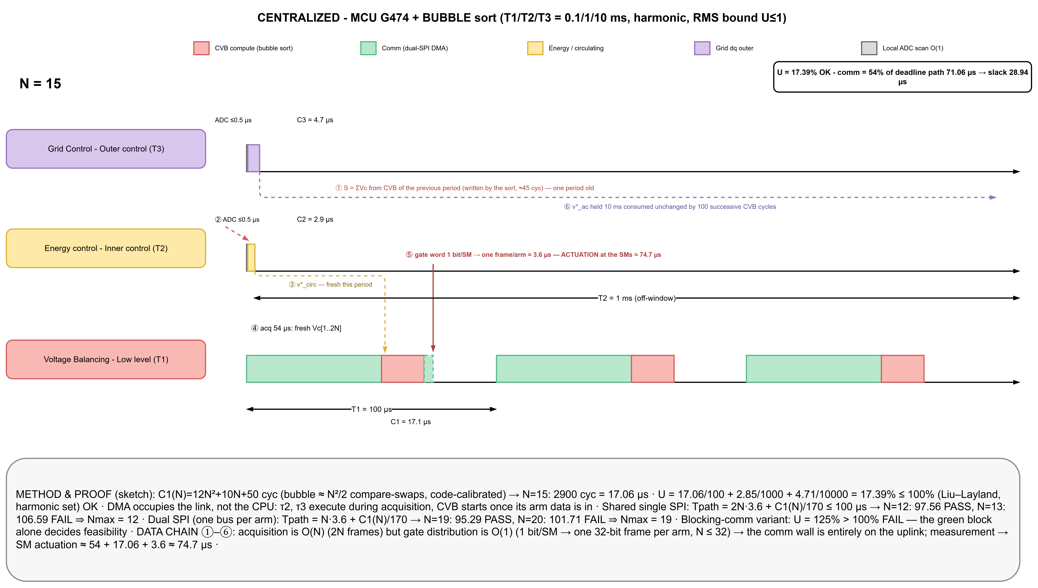
Figure 2 Case A Gantt at N = 15, true time scale: CVB compute (red), DMA communication (green, 54 µs), energy (yellow) and grid (purple) tasks, with the method and proof panel.

3.3 Practical implementation notes
Whether the figures of Table 4 are reached in practice depends on three implementation details. The first is the data layout. Each voltage and its module identifier are packed into one 32-bit word, (Vc<<8)|ID. A comparison or a swap is then a single instruction. The identifier stays attached to its voltage for free. Two separate arrays would double the cost of the swap. They would also be a common source of alignment bugs.
The second detail is the deadtime and the complementary gates. The gate pairs should be completed locally at the module. The hardware inserts the deadtime there. Only one bit per module is transmitted. If the complements were generated centrally, the distribution payload would be doubled, and a shoot-through could occur.
The third detail is the use of the hardware. The outer layer makes four trigonometric calls per period. The hardware CORDIC accelerator which is integrated in the STM32G474 is used for the four trigonometric calls of the outer layer, which can reduce the computing cost of these calls from about 200 cycles to about 80 cycles. This is a software version of the predictive sorting of [17] and [18]. It moves the compute limit of regime A3 towards N ≈ 50. The communication limit is not changed by it.
.

4. Case B Centralized FPGA with Bitonic sorting network

4.1 Practical configuration
Case B is implemented on an FPGA running at 100 MHz. The implementation follows the work of Ricco, Mathe and Teodorescu [1]. A Bitonic sorting network [2], fully pipelined and maximally factorized, processes the pairs [Vc; position] with b_v = 12 bits and b_p = 6 bits. The network size M is a power of two, and when N is smaller than M, the remaining inputs are filled with the dummy element [0; −1].
The acquisition uses an Aurora-class multi-gigabit link. The samples are streamed at 40 ns per sample, so the 2N = 30 samples of N = 15 arrive in 1.20 µs. The arm sums ΣVc are produced by an adder tree placed inside the acquisition path, which takes a few nanoseconds and needs neither a hand-off nor a shared memory. τ2 and τ3 are fed by dedicated ADCs within 1 µs. The references v_circ and v_ac stay in registers. v*_ac is refreshed at every 10 ms tick and held in between as a zero-order hold. The gates are direct outputs of the fabric, and the distribution time is zero.
The analytical equations (1)–(7) of [1] are calibrated with the three anchor points validated in that paper:
- 18 clock cycles for an arm of 8 inputs;
- 6,200 LUTs and 260 cycles (2.6 µs) for six arms of 64 inputs;
- 21 % of a Spartan-6 XC6SLX45.

4.2 Results time never binds, resources do
N (=M) | Acquisition | Sort (2 arms) | Total / T1 | LUT % of XC6SLX45
8 | 0.6 µs | 0.36 µs | ~2 % | 1.5
16 | 1.2 µs | 0.44 µs | ~2 % | 3
32 | 2.6 µs | 0.64 µs | ~4 % | 8
64 | 5.1 µs | 0.88 µs | ~7 % | 21 (validated)
128 | 10.2 µs | 1.16 µs | ~12 % | 55 (extrapolated)
256 | 20.5 µs | 1.48 µs | ~23 % | 135 — exceeds device

Three parts make up the measurement-to-actuation path of Case B, namely the link latency, the sample streaming and the sorting is:
T_act = L_Aurora + T_stream + T_sort + T_sel ≈ L_Aurora + 1.70 µs
with T_stream = 1.20 µs, T_sort = 0.50 µs (44 clk = 0.44 µs analytical, plus pipeline fill) and T_sel ≈ 0.
The time utilization is far below the bound. The whole activity of T1, which is computed here for N = 15 on a network of M = 16, takes about 2 % of the period only. The scheduling question is therefore void on the FPGA. The three layers are spatially parallel pipelines which are sequenced by a state machine, as shown in Fig. 8 of [1], and RMS, EDF or round robin have no meaning here.
The real limit is the logic resource. It grows as O(N·log²N), which gives N_max ≈ 128 on a Spartan-6 class device and more on larger and costlier families. Two practical limitations are inherited from the architecture. The network size M is a power of two, so the hardware cost increases by steps of a factor of two. The acquisition of 2N isolated measurements into one device is still an O(N) wiring and I/O problem, which is left out of the scope of the sorting paper.
The project target is the Artix-7 XC7A35T with 20,800 LUTs. The network which is extrapolated for N = 128 needs about 15 k LUTs, and this amount already corresponds to 70 % of the device before the aggregation and the transceiver logic are considered. The value N ≈ 128 should therefore be read against Spartan-6-class resources.
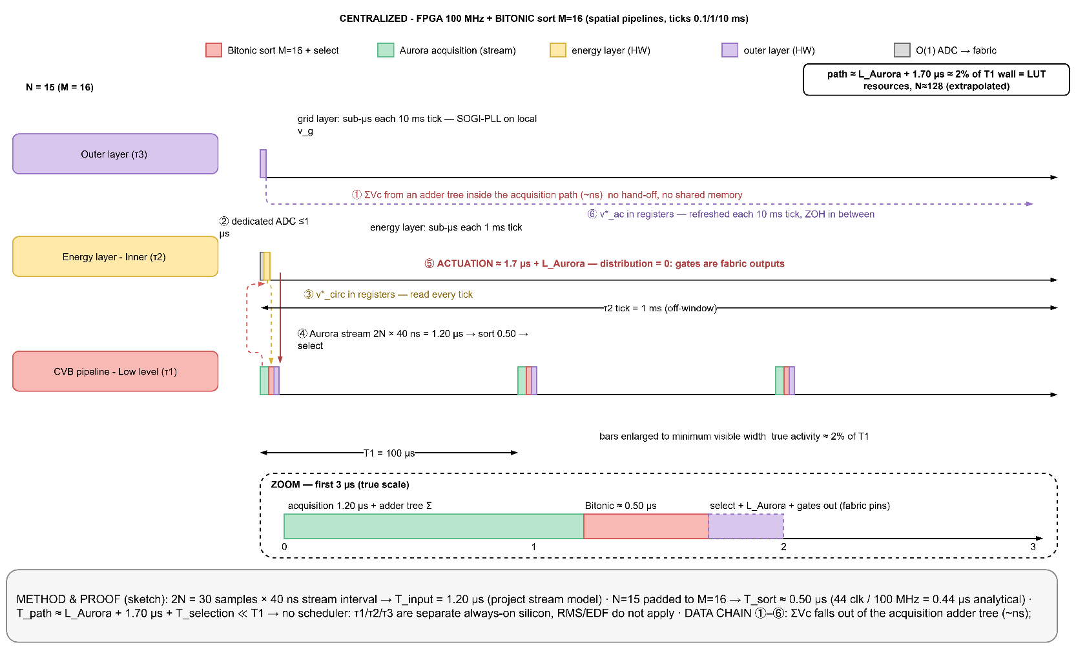
Figure 3 Case B Gantt at N = 15 with zoom inset of the first 3 µs: acquisition 1.2 µs (green) and sort 0.44 µs (red); bars drawn at minimum visible width.

4.3 Practical implementation notes
The factorization level L of the network is the main design dial: at L = 2 (fully pipelined) the M = 64 network costs ~28 k LUTs and could accept a new list every clock a throughput 10^4 times beyond the need of six sorts per sampling period while at maximum factorization the same function costs 6.2 k LUTs at 260 cycles of latency [1]. Since MMC utilization of the pipeline is ~0.01 %, maximum factorization is always the right choice, and the retained figures assume it. The dummy padding mechanism ([0; −1] entries) doubles as fault tolerance: a bypassed module is simply reentered as a dummy, and the modular structure of the Bitonic network even allows early extraction of the result when N is far below M (Fig. 5 of [1]). The unsolved item remains acquisition: 2N isolated measurement channels must reach one device, which in industrial practice means per module fiber links aggregated by serial transceivers precisely the cost and vendor binding that motivates Case C.

5. Case C Fully decentralized consensus control

5.1 Practical configuration
In Case C, each submodule has its own controller of the STM32G474 class, which runs every T1 = 100 µs the full replicated stack extracted from the project model decentnlm5_v4. This stack is made of three local replicas:
- the consensus balancing law, where the error with respect to the neighbor average goes through a deadband, the direction term tanh(i_arm) replaces the hard sign, and the correction is bounded;
- the arm-level replica, with a three-point energy estimator (self + prev + next)/3, an energy PI and an arm-current PI;
- the outer replica, with two SOGIs, a PLL and the power loop, or the reception of its broadcast.
The three replicas run at different rates in each node: τ1 at 10 kHz, τ2 at 1 kHz and τ3 at 100 Hz.
The arm current is a local measurement. It is taken by a series shunt and the on-chip ADC in about 0.3 µs, without any communication. The grid voltage is not local. The leader therefore broadcasts θ and ω, together with the P/Q references, on the ring at the τ3 rate, and between two broadcasts each node extrapolates θ by itself. The communication of one node is limited to two neighbor frames per period on point-to-point links.In the reference design, the link is a UART in 8N1 format at 3 Mbps with DMA. With the start and stop bits, the 32-bit payload becomes 40 bits on the wire. One frame therefore takes 13.33 µs.

5.2 Results constant load, and where N really enters
Per-node item | Cost | Fraction / utilization
τ1 : consensus law + neighbor-frame handling + gate decision (10 kHz) | ≈ 970 cycles = 5.71 µs | 5.71 %
τ2 : arm-level replica (2 PIs, filters) (1 kHz) | ≈ 220 cycles = 1.29 µs | 0.13 %
τ3 : outer replica (SOGI ×2, PLL, power) or broadcast reception (100 Hz) | ≈ 800 cycles = 4.71 µs | 0.05 %
Neighbors communication (2 frames, DMA) | 2 × 13.33 µs = 26.67 µs serialized; 13.33 µs wall with both links in parallel; ≈ 150 cycles of CPU service (inside τ1) | 13.3 % of deadline, link occupancy ≠ CPU load
Measurement → actuation | 13.33 + 5.71 µs (distribution = 0: each node gates itself) | ≈ 19.0 µs, invariant in N
Total processor utilization | 970/17,000 + 220/170,000 + 800/1,700,000 | 5.88 % independent of N
The independence from N comes from the structure itself. Each node uses data only from itself and its two neighbors, {self, prev, next}. For this reason, neither the computing cost nor the communication rate per link increases with N.
The effect of N appears instead in the consensus dynamics. For a ring, the slowest balancing mode depends on the algebraic connectivity
λ2 = 2(1 − cos(2π/N)) ≈ (2π/N)²
so the convergence time grows roughly with N²·T1. Using
τ ≈ Ts / (k_v · λ2)
with k_v = 0.2 [10], [11], the convergence time becomes 3.28 ms at N = 16, 51.9 ms at N = 64, 102.6 ms at N = 90, and 207.5 ms at N = 128.
Since the capacitor-voltage imbalance evolves over tens of milliseconds, a pure ring remains practical up to about N = 64–90. Chordal links or hierarchical clustering can extend this limit beyond 256 submodules. The restriction therefore comes from the control bandwidth, not from the scheduling. Figure 4 keeps the same Gantt pattern for any N.
N enters Case C in a second and different place. The grid quantities θ and ω cannot be measured locally, so the leader broadcasts them on the ring. The broadcast reaches the farthest node after
L ≈ (N/2)·(t_frame + t_fw) ≈ 7.5·N µs
which is about 0.48 ms at N = 64. This latency is marginal against the 1 ms tick of τ2 but comfortable against the 10 ms tick of τ3. The broadcast is therefore issued at the τ3 rate, and θ is extrapolated locally between two broadcasts. The reception stays O(1) per node, one frame only. It is the traversal latency alone that grows with N.

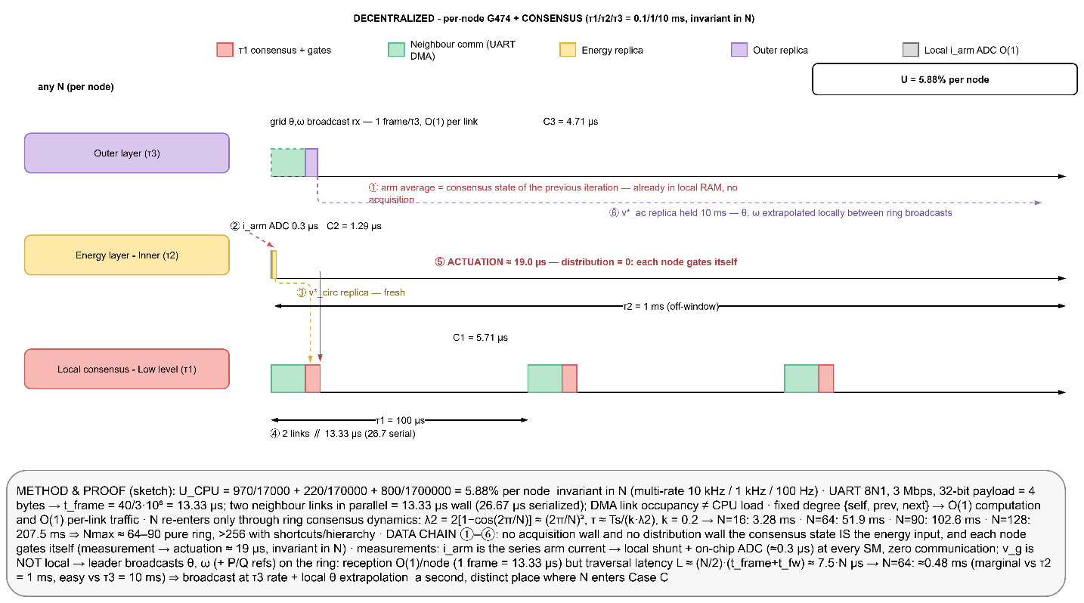
Figure 4 Case C per-node Gantt (multi-rate 10 kHz / 1 kHz / 100 Hz): the picture is invariant in N; the green communication block is O(1) per link.

6. Computational scaling laws for N
The three cases are now reduced to their dependence on N. Each layer of the task set, together with the acquisition / communication mechanism and the closed-loop dynamics, is assigned its asymptotic class and the calibrated cost law used in Sections 3–5. The first table gives the classes; the second gives the calibrated expressions and their value at the reference point N = 15. Cycle figures are design estimates FPGA entries are expressed in clock cycles of latency and in LUTs, the currencies of that platform.
Layer / mechanism | A : MCU + bubble | B : FPGA + Bitonic | C : Decentralized consensus
τ1 CVB sorting / balancing | O(N²) time | O(N·log²N) resources; O(log²N) latency | O(1) per node
τ1 level selection / gate decision | O(N) time | O(N) gate vector, O(1) latency | O(1) local threshold
τ2 energy / circulating current | O(N) time (mean, ΣE) | O(N) adder tree, O(log N) depth | O(1) per node (3-point estimate)
τ3 grid / outer loop | O(1) | O(1) pipelined | O(1) replica per node
Acquisition / communication per T1 | O(N): 2N frames on a bus | O(N) channels / I-O, O(N) serial time | O(1): 2 neighbor frames per node
Closed-loop dependence on N | none | none | STILL not define
Binding wall | communication, then O(N²) compute | logic resources O(N·log²N) | STILL not define

Table 6.1 Asymptotic scaling class of every layer and mechanism, per case.
Layer / quantity | A : MCU + bubble | B : FPGA + Bitonic | C : Decentralized consensus
C1(N) CVB, both arms | 12N² + 10N + 50 cyc; 2,900 cyc = 17.1 µs ;N = 15 | M·p(p+1)/4 CS, depth p(p+1)/2 clk (M = 2^p ≥ N); 18 clk per 8-input arm; 0.44 µs @M = 16 | ≈ 970 cyc = 5.71 µs, constant
C2(N) energy layer | 200 + 19N cyc; 485 cyc ;N = 15 | adder tree, sub-µs, resources O(N) | ≈ 220 cyc = 1.29 µs at 1 kHz, constant
C3 outer layer | 800 cyc (CORDIC: ≈ 680) | pipelined, O(1) | ≈ 800 cyc = 4.71 µs replica at 100 Hz
Acquisition / comm time per T1 | 2N·t_frame; 108 µs single SPI, 54 µs dual SPI @N = 15 | 2N·40 ns; 1.2 µs ;N = 15 (Aurora) | 2 × 13.33 µs UART (13.33 µs with two links), any N
Utilization U(N) | (12N²+10N+50)/17,000 + (200+19N)/170,000 + 800/1.7·10⁶; 17 % DMA, 125 % blocking ;N = 15 | time ≈ 2 % @N = 15; LUT ≈ 3 % (M = 16), 21 % (M = 64), 55 % (M = 128) of XC6SLX45 | 5.88 % per node, independent of N
Dynamic / resource law | — | LUT ≈ O(N·log²N), device full at N ≈ 256 | τ ∝ N²·T1 via λ2 = 2(1 − cos 2π/N); 3.28 ms ;16, 51.9 ms ;64; ring broadcast 7.5·N µs
N_max | 12 (shared bus), 19 (dual bus); 37 (parallel acquisition) | ≈ 128 (Spartan-6 class resources) | 64–90 (pure ring)

Table 6.2 Calibrated cost laws and reference values per layer and case (cycles at 170 MHz unless stated; FPGA at 100 MHz).
Read across the rows, the tables show that N enters the three architectures through three distinct mechanisms. In Case A it enters through algorithmic time complexity on a sequential processor, quadratically in the sort and linearly in acquisition, and because acquisition is the larger coefficient at the relevant N the communication law binds first. In Case B it enters through silicon area: time complexity collapses to a logarithmic latency, and the binding quantity becomes the O(N·log²N) comparator count. In Case C it enters through neither time nor area every per-node quantity is O(1) by construction — but through the closed-loop dynamics of the consensus, whose slowest mode slows as N². In every case τ2 and τ3 contribute at most O(N) and O(1) terms whose coefficients are small against the sort and acquisition terms, so the ordering of the three cases is fixed by τ1 and by the communication mechanism alone.

7. Scheduling analysis of the three-layer stack
The whiteboard question is there literature on scheduling these three layers admits a precise answer. The stack is a set of three independent periodic tasks with implicit deadlines, the textbook setting of fixed priority real time theory. Under Rate Monotonic priority assignment (shorter period, higher priority), Liu and Leyland proved stimulability whenever total utilization U = ΣCi/Ti stays below n(2^{1/n} − 1), i.e. 78.0 % for n = 3 [12]. For harmonic period sets each period an integer multiple of the faster one, exactly our {0.1, 1, 10} ms choice the bound rises to 100 %: at every release of a slower task, an integer number of faster task periods fits before its deadline, so no bandwidth is lost to phasing. This is why the rates of Table 1 were chosen harmonic.
Earliest Deadline First is optimal on a uniprocessor (schedulable if U ≤ 1 for any period set [13]) but buys nothing here: with fixed harmonic periods RMS already reaches the same bound at lower overhead, implemented naturally as nested interrupts the ADC/timer ISR runs τ1, a subrated branch runs τ2, and τ3 executes in the remaining slack, where it is preempted exactly as sketched by the split purple blocks of the whiteboard. Round Robin offers no deadline guarantee and is rejected for the hard layer. Response times follow the standard recurrence Ri = Ci + Σ_{j∈hp(i)} ⌈Ri/Tj⌉·Cj; at N = 15 in Case A the worst-case response of τ3 is 17.1 + 2.9 + 4.7 ≈ 24.7 µs of compute spread over its 10 ms period preemption cost is negligible, confirming that the only scheduling risk in the whole stack is the τ1 communication block. On the FPGA (Case B) the question dissolves: layers are concurrent hardware pipelines, and in Case C the per node utilization of 5.88 % makes any of the three policies trivially feasible.
Practice in digital power electronics confirms this arrangement: multirate interrupt nested control is the standard implementation pattern [16], and the recommendation retained for the project is RMS with harmonic rates, ISR nested, with a 70 % utilization ceiling to reserve bandwidth for communication DMA service.

8. Comparative results
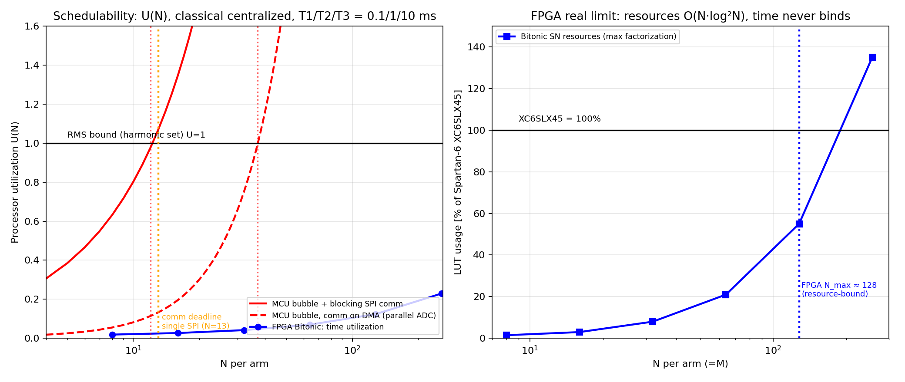
Figure 5 Left: processor utilization U(N) for Case A (blocking and DMA variants) and time utilization for Case B, against the harmonic RMS bound; right: FPGA resource usage versus N with the device limit.

Figure 6 Simulated Gantt over a 1 ms window at N = 20: MCU case (top) against FPGA case (bottom).
Criterion | A :MCU + bubble | B :FPGA + Bitonic | C : Decentralized
Scheduling model | RMS, harmonic, bound 100 % | none spatial pipeline | trivial (U = 5.88 % ∀N)
Binding wall | comm path (12 shared bus, 19 dual bus) or O(N²) compute (37) | LUT resources O(N log²N) → ~128 | consensus convergence O(N²) → 64–90 (ring)
N = 15 verdict | feasible only with dual-SPI DMA; comm = 54 % of deadline | ~2 % of T1; trivially met | 5.88 % per node; unaffected
Sensitivity to comm law | decisive: ×3 swing of N_max | negligible (SerDes) | none per link; N² in loop dynamics
Single point of failure | yes (controller + bus) | yes (FPGA + link) | no (bypass + renumbering)
Cost / openness | lowest, open | highest, vendor-bound | moderate, open, per-module

Two observations apply to all three cases.
The first one concerns the harmonics. The two centralized cases and the decentralized case do not differ in the amount of distortion only, but in its nature. Both centralized cases have the quantization floor of the NLM, THD ≈ 0.816/N. This gives 10.2 % at N = 8, and the 5 % class of IEEE 519 is reached only above N ≈ 16 [15]. On top of this floor, the free re-sorting in every period adds a reselection spectrum which is not bounded. In the decentralized case, the rotating-threshold modulator changes the reselection into one deterministic tone.
The second one concerns the project rule. According to this rule, at most one module is connected or disconnected in each step. Under this rule, the control rate has to satisfy f_ctrl ≥ 4·N·f0, and the sorting is replaced by a simple min/max scan. The computing limit of the centralized case on the G474 then moves beyond N ≈ 300. Only the communication limit remains.
.

9. Discussion, assumptions and limitations
The The analysis is based on five explicit assumptions.
(i) The cycle counts come from an operation-level cost model which was calibrated on the extracted code. They have not been measured on the target yet. The DWT–CYCCNT campaign of the project benchmark protocol, which covers the GPIO-to-GPIO latency with a sweep of the clock frequency, the FPU usage, the bus occupation and the sampling time, will replace the estimates by measured values.
(ii) In the centralized communication model, the acquisition is either fully blocking or fully overlapped by DMA. Real drivers are between these two cases.
(iii) The FPGA resource figures above M = 64 are extrapolated from the validated equations of [1].
(iv) The convergence bound of the decentralized case is a linearized one. It is computed for a ring with the project gain k_v = 0.2. Large signals, measurement noise and the dead band floor are left to the project harmonic report.
(v) All the results are given for one phase leg. In a three-phase system, the centralized acquisition is multiplied by 3, while the figures per node of the decentralized case do not change.
None of these limitations changes the order of the conclusions. They shift individual values of N_max by tens of percent, whereas the differences between the architectures are of one order of magnitude.
These results can now be put against the literature of Section 1.2, where several questions were left open. The sorting improvements of [17] and [18] do not help on a bus-fed microcontroller. The reason is that the acquisition, once it is counted, reaches the deadline before the sorting does. The area bound of [1] holds only if the O(N) wiring problem, which is excluded in that paper, is solved separately. The consensus rate of [10] and [11] becomes a concrete value, N ≈ 64–90, when the task set, the gain and the period of the MMC are substituted. It should be noted that these figures are tied to the task set and the cost model of the project. With another task set or another cost model, the values would move but their order would stay. The choice among the decentralized candidates which are still under comparison is also not decided by these results alone.
.

10. Conclusions
- In Case A, the MCU still meets the deadline, but communication leaves little spare time. One shared bus supports 12 modules per arm, two separate buses support 19, and parallel acquisition raises this to 37. At (N=15), the controller needs dual-bus DMA, and communication already takes 54% of the deadline.
- In Case B, the FPGA handles the timing easily. The available logic sets the limit instead, at about 128 modules per arm on a Spartan-6-class device. The hardware cost also jumps with powers of two, while the measurement wiring still grows with (N).
- In Case C, each node works only with its own data and the data of its two neighbors. Adding more modules does not increase its local workload. CPU use stays at 5.88%, actuation ends within 19 µs, and each link carries two frames per period. The larger ring mainly slows the consensus, giving about 64–90 modules on a simple ring and more than 256 when shortcuts or hierarchy are added.
- A centralized controller must collect (2N) measurements before it can make its decision. This data transfer grows with (N) and reaches the limit before the sorting calculation does. With the ±1-module rule, the controller only searches for the minimum and maximum values.
- The same calculations can be repeated for another (N), processor, protocol, or method. The Gantt charts and the equations in Section 6 give the results by hand. The MATLAB script mmc_scaling_analysis.m performs the same calculation automatically.

References
[1] M. Ricco, L. Mathe, and R. Teodorescu, "FPGA-based implementation of sorting networks in MMC applications," in Proc. 16th Eur. Conf. Power Electron. Appl. (EPE'14 ECCE Europe), Lappeenranta, Finland, 2014, pp. 1–10.
[2] R. Mueller, J. Teubner, and G. Alonso, "Sorting networks on FPGAs," VLDB J., vol. 21, no. 1, pp. 1–23, Feb. 2012.
[3] Road Vehicles — Controller Area Network (CAN) — Part 1: Data Link Layer and Physical Signalling, ISO Standard 11898-1:2015, 2015.
[4] R. I. Davis, A. Burns, R. J. Bril, and J. J. Lukkien, "Controller Area Network (CAN) schedulability analysis: Refuted, revisited and revised," Real-Time Syst., vol. 35, no. 3, pp. 239–272, May 2007.
[5] IEEE Standard for Ethernet, IEEE Std 802.3-2022, 2022.
[6] IEEE Standard for a Precision Clock Synchronization Protocol for Networked Measurement and Control Systems, IEEE Std 1588-2019, 2019.
[7] Aurora 8B/10B Protocol Specification, Product Guide PG046 / SP002, Xilinx, Inc., San Jose, CA, USA, 2019.
[8] STM32G4 Series Reference Manual and Datasheet, Reference Manual RM0440 / Datasheet DS12288, STMicroelectronics, Geneva, Switzerland, 2020.
[9] S. Debnath, J. Qin, B. Bahrani, M. Saeedifard, and P. Barbosa, "Operation, control, and applications of the modular multilevel converter: A review," IEEE Trans. Power Electron., vol. 30, no. 1, pp. 37–53, Jan. 2015.
[10] R. Olfati-Saber and R. M. Murray, "Consensus problems in networks of agents with switching topology and time-delays," IEEE Trans. Autom. Control, vol. 49, no. 9, pp. 1520–1533, Sep. 2004.
[11] R. Olfati-Saber, J. A. Fax, and R. M. Murray, "Consensus and cooperation in networked multi-agent systems," Proc. IEEE, vol. 95, no. 1, pp. 215–233, Jan. 2007.
[12] C. L. Liu and J. W. Layland, "Scheduling algorithms for multiprogramming in a hard-real-time environment," J. ACM, vol. 20, no. 1, pp. 46–61, Jan. 1973.
[13] G. C. Buttazzo, Hard Real-Time Computing Systems: Predictable Scheduling Algorithms and Applications, 3rd ed. New York, NY, USA: Springer, 2011.
[14] ARM Cortex-M4 Technical Reference Manual, DDI 0439B, ARM Ltd., Cambridge, UK, 2011.
[15] IEEE Standard for Harmonic Control in Electric Power Systems, IEEE Std 519-2022, 2022.
[16] S. Buso and P. Mattavelli, Digital Control in Power Electronics, 2nd ed. San Rafael, CA, USA: Morgan & Claypool, 2015.
[17] D. Siemaszko, "Fast sorting method for balancing capacitor voltages in modular multilevel converters," IEEE Trans. Power Electron., vol. 30, no. 1, pp. 63–70, Jan. 2015.
[18] K. Ilves, L. Harnefors, S. Norrga, and H.-P. Nee, "Predictive sorting algorithm for modular multilevel converters minimizing the spread in the submodule capacitor voltages," IEEE Trans. Power Electron., vol. 30, no. 1, pp. 137–149, Jan. 2015.

