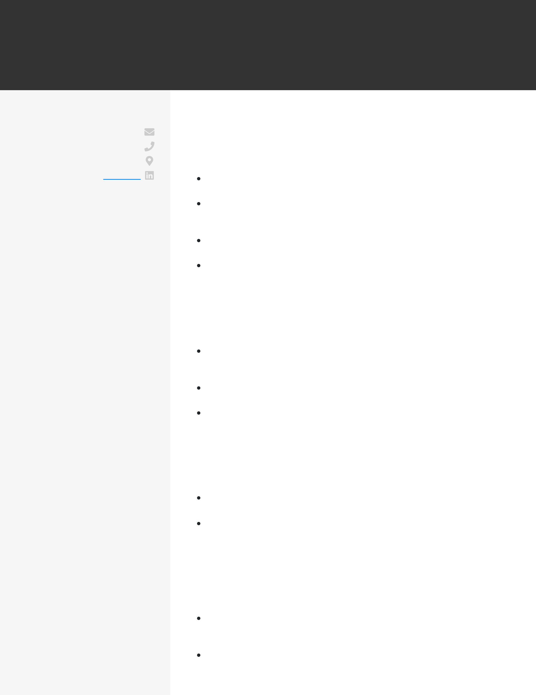
CHARLES MCTURLAND
SOFTWARE ENGINEER
CONTACT cmcturland@email.com  (123) 456-7890  New York, NY | WORK EXPERIENCE  Software Engineer  Embark  January 2015 - current / New York, NY  Worked with product managers to re-architect a multi-page web
app into a single page web-app, boosting yearly revenue by $1.4M
EDUCATION  B.S.  Computer Science  University of Pittsburgh  September 2008 - April 2012 Pittsburgh, PA  SKILLS  Python (Django)  Javascript (NodeJS ReactJS, jQuery)  SQL (MySQL, PostgreSQL, NoSQL)  HTML5/CSS  AWS  Unix, Git | Constructed the logic for a streamlined ad-serving platform that scaled to our 35M users, which improved the page speed by 15% after implementation  Tested software for bugs and operating speed, fixing bugs and documenting processes to increase efficiency by 18%  Iterated platform for college admissions, collaborating with a group of 4 engineers to create features across the software  Software Engineer  MarketSmart  April 2012 - January 2015 / Washington, DC  Built RESTful APIs that served data to the JavaScript front-end based on dynamically chosen user inputs that handled over 500,000 concurrent users  Built internal tool using NodeJS and Pupeteer.js to automate QA and monitoring of donor-facing web app, which improved CTR by 3%  Reviewed code and conducted testing for 3 additional features on donor-facing web app that increased contributions by 12%
Software Engineer Intern
Marketing Science Company
April 2011 - March 2012 / Pittsburgh, PA
Partnered with a developer to implement RESTful APIs in Django, enabling analytics team to increase reporting speed by 24%
Using Selenium I built out a unit testing infrastructure for a client application that reduced the number of bugs reported by the client by 11% month over month
PROJECTS
Poker Simulation
Built a full-stack web app to allow users to simulate and visualize outcomes of poker hands against opponents of different play styles using open source cards.js on the front-end
Utilized sci-kit learn in Python to simulate possible outcomes under different scenarios that the user chose

