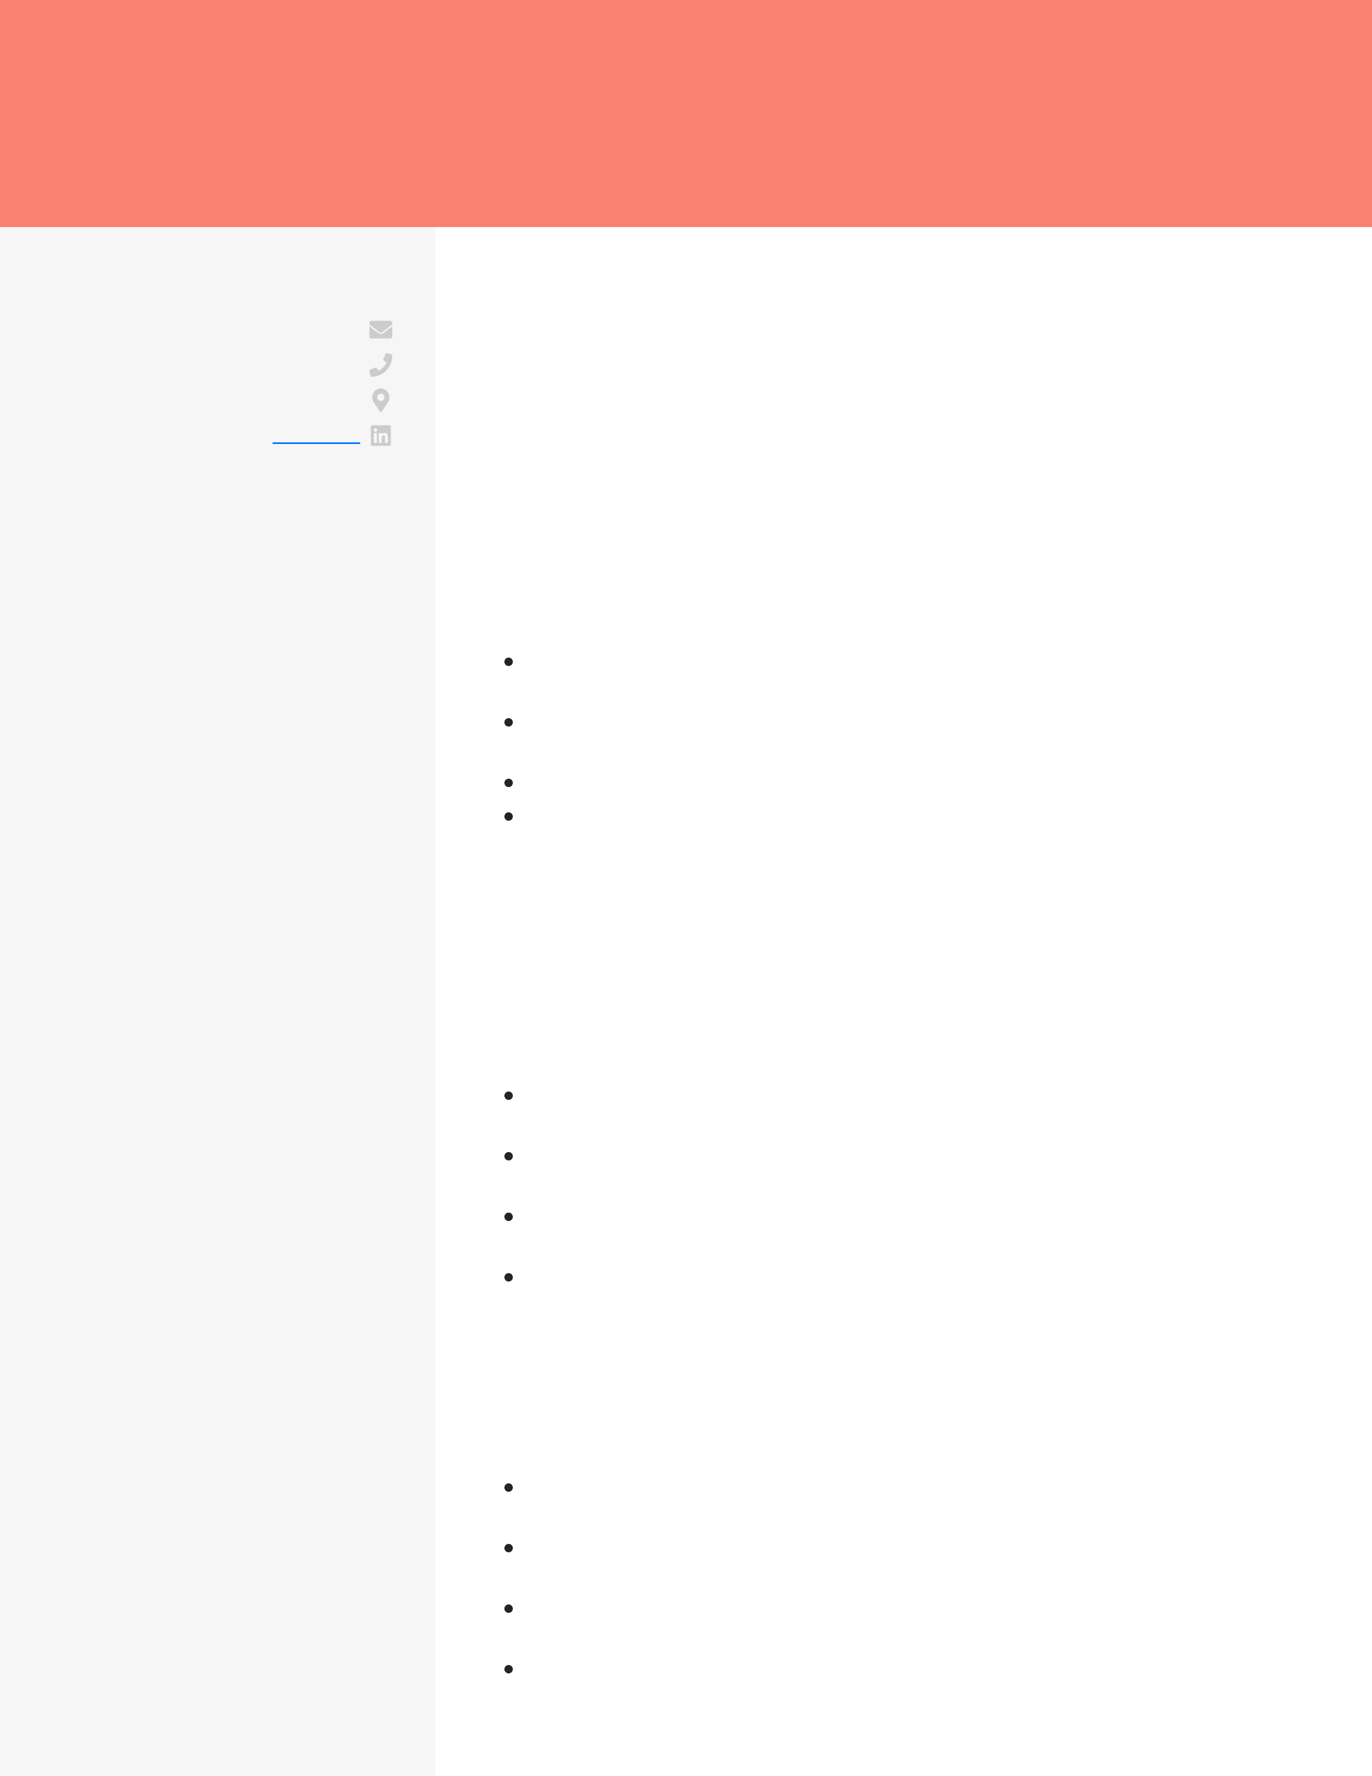
TINA COOK
SOFTWARE ENGINEER INTERN
CONTACT t.cook@email.com  (123) 456-7890  Seattle, WA  EDUCATION  Bachelor of Science  Computer Science  University of Washington 2021 - current  Seattle, WA | CAREER OBJECTIVE  Passionate software engineer intern with project experience designing a mobile application design and POS-based smart contract development, aspiring to bring my expertise to Tableau Software. Excited to apply my skills in your firm to drive innovative data visualization solutions.  WORK EXPERIENCE  Customer Service Representative  T-Mobile  2023 - current / Seattle, WA  Provided on-call support to a minimum of 71 customers daily, resolving 92% of issues on the first call.  Implemented a C++ script to automate CRM data entry tasks, reducing the
time needed to create reports by 39 minutes.
SKILLS  C++ | Prevented escalations for 8 billing issues each month via quick resolutions. Managed high-volume inbound calls during peak hours, maintaining an average response time of under 44 seconds.
Mercurial
Eclipse  MongoDB  OpenShift | PROJECTS  PixelPilot
UI/UX Designer
2022 - 2023
Designed and prototyped a mobile app interface for a drone control application, gaining a 87% user engagement rate during the testing phase. Held multiple user testing sessions, gathering feedback to refine the app’s user interface and decrease post-launch bug reports by 41%.
Used Eclipse IDE to debug the mobile app, fixing critical issues and releasing the application 3 weeks ahead of schedule.
Leveraged MongoDB for storing user data and drone records, lowering data retrieval speed by 6 minutes.
Blockchain
Seminar Attendee
November 2021
Attended a comprehensive blockchain technology seminar with 175+ attendees, understanding its applications in finance and healthcare.
Participated in hands-on workshops on blockchain, achieving a 9.5/10 report score by industry experts for Google Cloud Platform integration.
Optimized blockchain deployments on OpenShift, using seminar knowledge to expedite deployment time by 4 days.
Created a proof-of-stake smart contract for a healthcare setting, reducing data processing time by 17 minutes compared to industry standards.

