GAMING-Spot Arena.

By Zaid Shaikh,

Ashutosh Dwivedi,

Anand Choudhari.

# **I**NTRODUCTION

Gaming-Spot Arena is an online website for Walkthroughs on a wide range of PC games. It is a full-featured Game-legend website with capabilities like Feedback Forum. Here, Users can get Help, Guidance, Tips and Walkthroughs for various games. For each and every strategy as well as an action game, there are times when most of the beginners get stuck on a particular stage, Gaming-Spot aims to provide help at such hard times and help those beginners become experts of the prime levels.

# **P**ROBLEM **S**TATEMENT

With rising adoption of the Internet, PC Gaming is now taking over traditional sports and hobbies. Gaming-Spot aims to work primarily with the Internet so as to eliminate efforts incurred by brick-and-mortar establishments.To give the gamers all over the world a platform on which, they can discuss their progress and provide with their valuable feedback.

Thus an attempt is being made to design a complete website using client and server web technologies which will assist with reliability, scalability and agility,and also provdes the necessary Walkthroughs, Tips, And guidance to the users all over the internet.So as to help them through the tough times in the games, and help them evolve from Noobs to Legends.

# **L**ANGUAGES USED

1. HTML5
2. CSS3 along with CSS.
3. JavaScript
4. Server side scripting Using PHP.
5. SQL using Xampp localhost.

# **R**EQUIREMENTS

## Hardware requirements

1. Any General Configuration computer/laptop/phone to serve as a client to the portal.
2. A Server Configured Machine to host the entire application.

## **S**OFTWARE **R**EQUIREMENTS

1. A modern web browser like Edge, Chrome, Firefox or Safari
2. Server side localhost software such as an Apache distribution containing MariaDB, PHP, and Perl, Such As XAMPP.

# **W**ORKING

The user lands onto the homepage first.



***The User Can Check If He Has The Specifications Required Through The Compatibility Tool.***

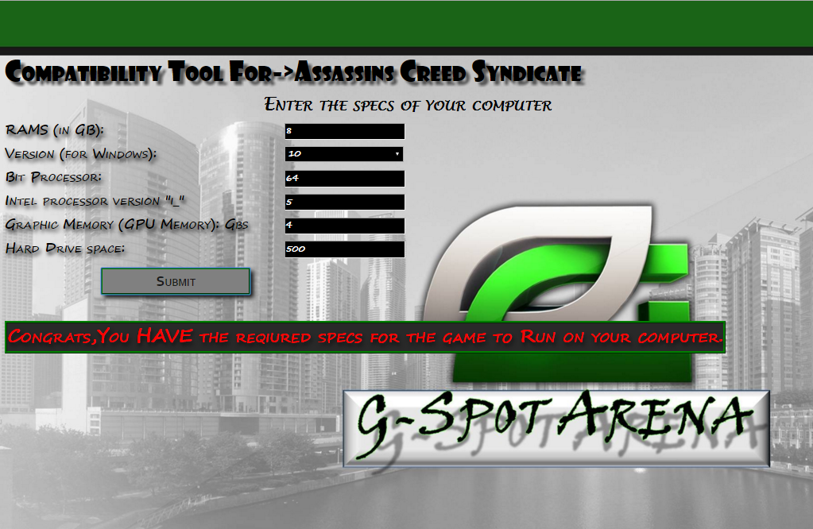

***The User Can Provide Feedback If Required.***

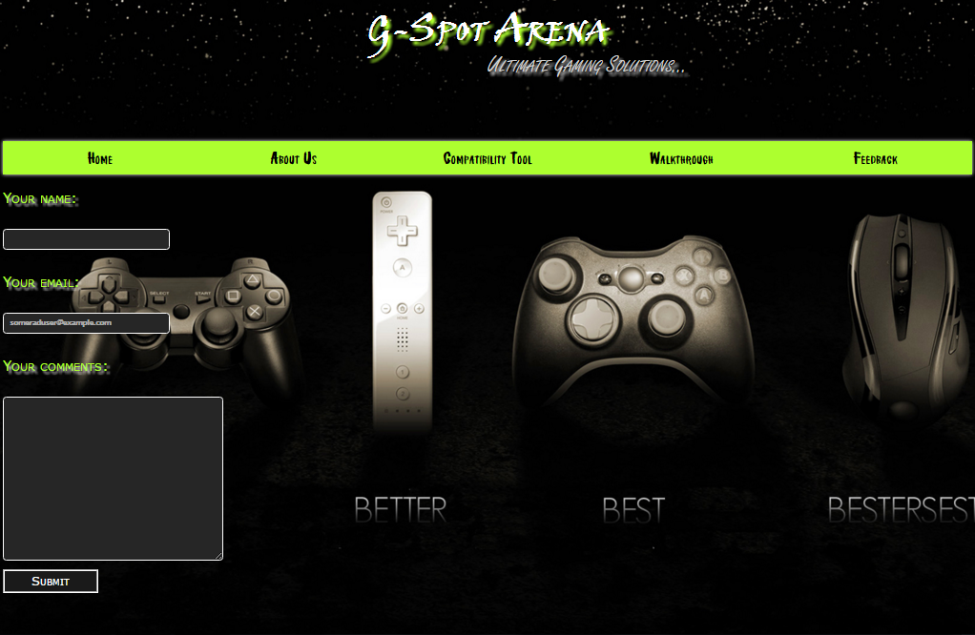

***The User Can Contact The Developers Of The Site If Required.***



# **R**EFERENCES

1. http://www.w3schools.com/
2. https://hexadecimalchromes.com/
3. http://www.youtube.com/
4. https://1001fonts.com/