📘 PHASE 2
🚀 PROJECT TITLE
Fulfilment Operations Intelligence & Optimisation System (FOIOS)

🏢 Business Context (Simulated: Nivoda-style)
You are hired as a Business Analyst supporting a multi-hub global fulfilment operation.
The company:
- Receives orders from customers
- Routes them to fulfilment hubs
- Performs QC
- Ships internationally
- Tracks delivery & returns
There are issues:
- Increasing turnaround time
- Missed SLAs
- Rising shipping costs
- Backlogs at certain hubs
- QC bottlenecks
- Delivery delays in certain regions
Leadership wants:
“Full visibility. Early warnings. Bottleneck detection. Cost clarity.”

Business Requirement Document (Stakeholder Version)

Project Name
Global Fulfilment Performance & Optimisation Program (GFPOP)

🧑‍💼 Stakeholder
Head of Global Fulfilment
VP Operations
Regional Hub Managers

📌 Background
Over the past 6 months, fulfilment operations across hubs in:
- Dubai
- Mumbai
- Hong Kong
- New York
have experienced:
- Increasing SLA breaches
- Growing QC rework rates
- Rising shipping costs
- Backlog formation in specific hubs
- Variability in delivery reliability
- Increasing customer returns linked to delays
Operations leadership currently lacks:
- End-to-end visibility
- Stage-level bottleneck clarity
- Early warning signals
- Standardised SLA tracking
- Cost-performance correlation insights

🎯 Primary Objectives
1️⃣ End-to-End Visibility
Build structured reporting across:
- Intake
- QC
- Packing
- Shipping
- Delivery
- Returns

2️⃣ Operational Optimisation
Identify:
- Bottlenecks
- Capacity pressure
- Stage drop-offs
- Rework drivers
- Throughput constraints

3️⃣ SLA Governance
Track:
- Stage-level SLA adherence
- Total order TAT
- Express vs Standard performance
- Hub-level compliance

4️⃣ Cost & Margin Monitoring
Understand:
- Shipping cost drivers
- Partner performance
- Return impact on margin
- Cost per on-time delivery

5️⃣ Data Foundations
Ensure:
- Clean metric definitions
- Consistent SLA logic
- Reliable hub utilisation calculations
- Scalable reporting structure

📊 Required Dashboard Layers
You must design reporting for:
- Executive View (High-Level KPIs)
- Hub Performance View
- Stage-Level Bottleneck View
- Shipping & Cost View
- Returns & CX Impact View
- Capacity & Forecasting View

🧠 Analytical Questions (Minimum 40)
These will test:
- SQL logic
- Business reasoning
- Operational intuition
- Pattern recognition
- Tradeoff thinking
🔹 A. Turnaround Time & SLA (1–10)
- What is overall average Turnaround Time (Order → Delivery)?
- What is stage-wise average processing time?
- Which stage contributes most to SLA breaches?
- What % of orders breach Delivery SLA?
- What % breach any stage SLA?
- SLA breach rate by hub?
- SLA breach trend month-over-month?
- Express vs Standard SLA comparison?
- Which hub has highest TAT variance?
- What % of SLA breaches originate in QC?

🔹 B. Bottlenecks & Flow Efficiency (11–20)
- Average queue time between stages?
- Which stage has highest processing time variability?
- QC rework rate by hub?
- Does QC rework increase overall TAT?
- Backlog volume per hub (orders open > SLA)?
- Daily throughput per hub?
- Hub capacity utilisation %?
- Are there days exceeding 110% capacity?
- What happens to SLA breach rate on high-utilisation days?
- Which hub is most operationally unstable?

🔹 C. Shipping & Cost Efficiency (21–30)
- Average shipping cost per order?
- Shipping cost by zone?
- Shipping cost by weight bucket?
- Which shipping partner has best on-time rate?
- Which partner has lowest cost?
- Cost per on-time delivery?
- Does higher shipping cost reduce SLA breach?
- Shipping cost as % of order value?
- Express shipping cost vs incremental revenue?
- Which hub has worst cost-to-performance ratio?

🔹 D. Returns & Customer Impact (31–38)
- Overall return rate?
- Return rate by hub?
- Return rate by destination country?
- Return rate by delay bucket (On-time, 1–2 days late, 3+ late)?
- Are late deliveries increasing returns probability?
- Refund value trend over time?
- What % of refunds linked to SLA breach?
- Margin impact of returns by hub?

🔹 E. Early Warning & Strategic Insights (39–45)
- Leading indicator of SLA breach (which stage delay predicts it)?
- Does QC duration spike precede backlog formation?
- If demand increases 20%, which hub breaks first?
- What is required capacity increase to maintain SLA?
- Which hub should receive operational investment?
- If we reduce QC time by 15%, what happens to SLA?
- What is biggest cost driver in fulfilment pipeline?

Assumption
📈 KPI Definitions (You Must Standardise)
This is interview-critical.

Total TAT
Delivery_stage_end - Order_date

Stage TAT
stage_end_time - stage_start_time

SLA Breach Flag
stage_TAT > SLA_definitions.sla_hours

Hub Utilisation %
Orders processed per day / capacity_per_day

Backlog
Orders with incomplete stage OR stage_TAT > SLA

On-Time Delivery %
Delivered before promised_delivery_date

Return Rate
Returned orders / total delivered orders

Cost Per Order
shipping_cost + hub.cost_per_order

Cost Per On-Time Delivery
Total cost / On-time deliveries

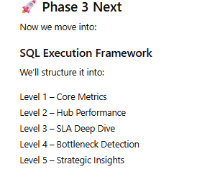

Solutions:

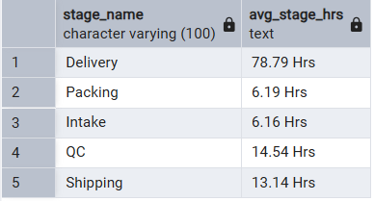

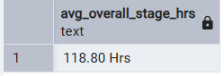

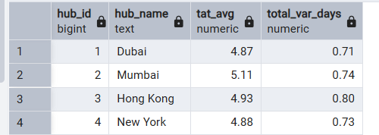

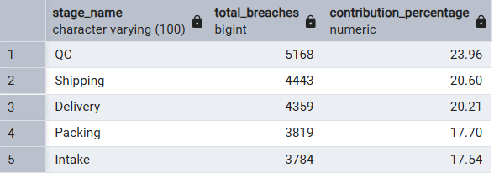

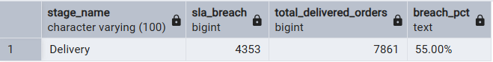

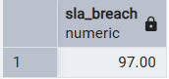

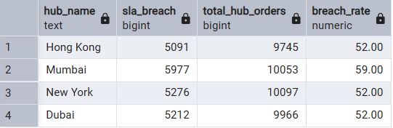

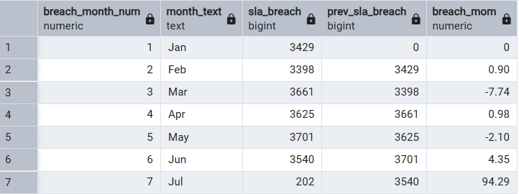

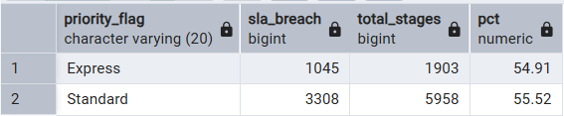

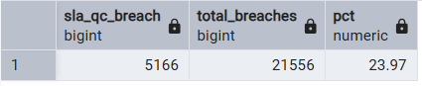

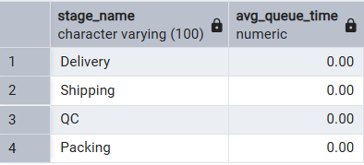

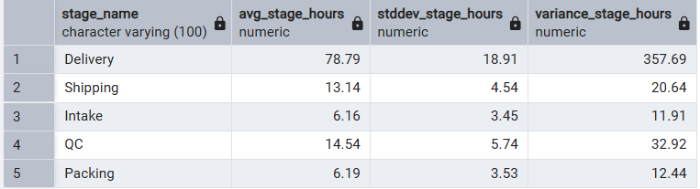

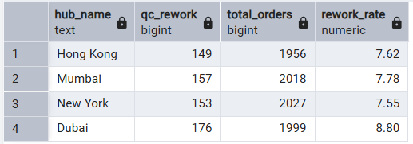

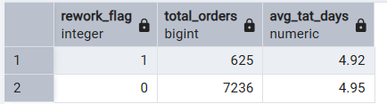

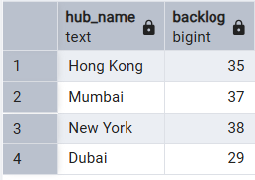

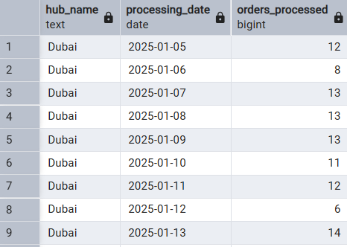

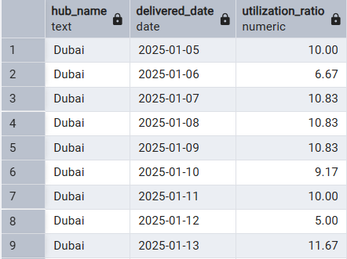

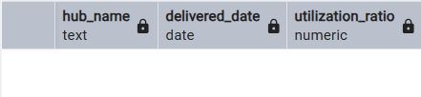

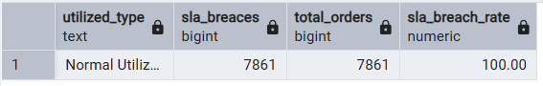

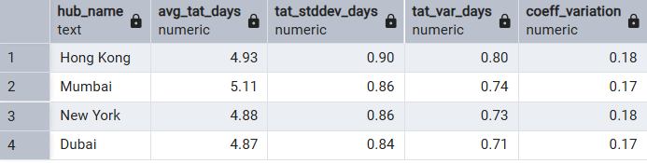

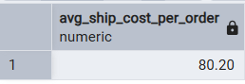

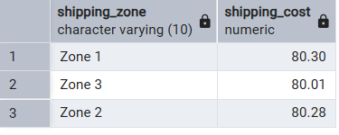

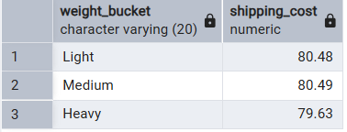

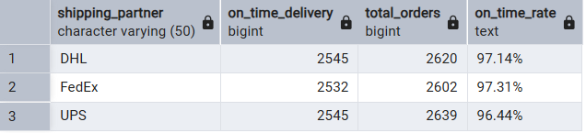

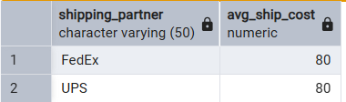

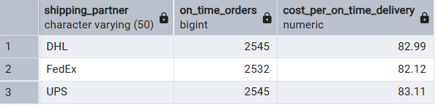

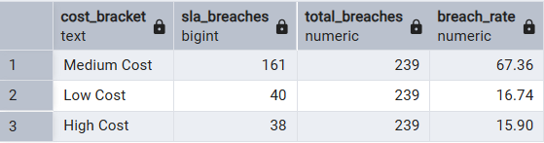

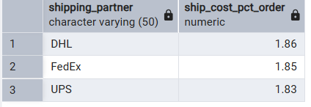

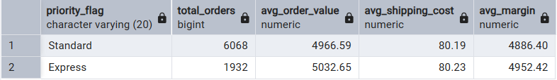

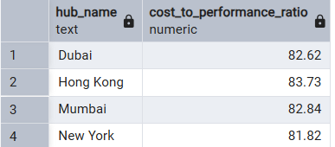
-- the bigger the cost_to_performance_ratio is the worst performing hub it is

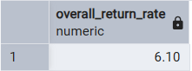

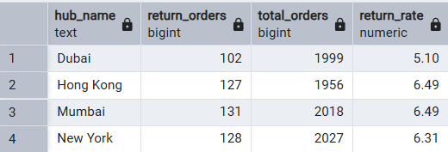

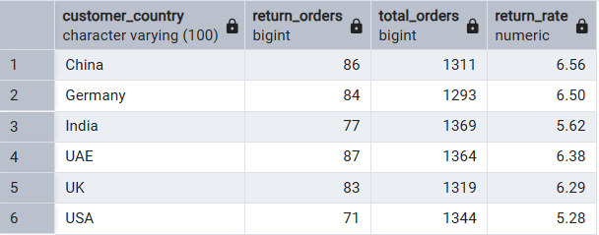

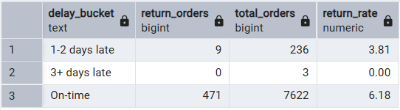

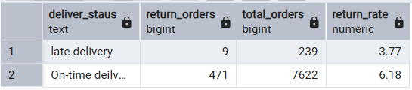

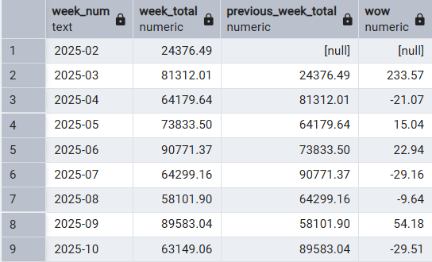

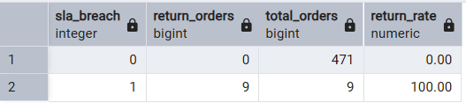

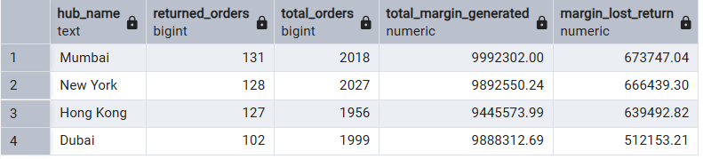

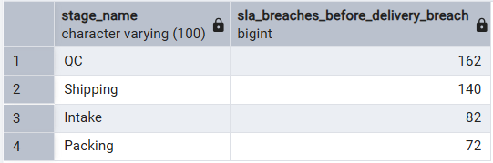

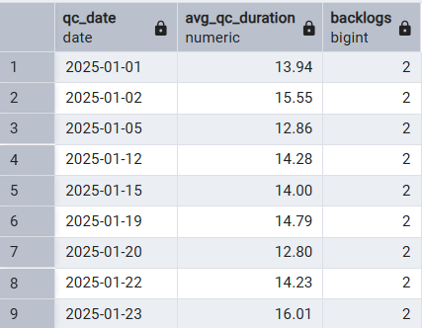

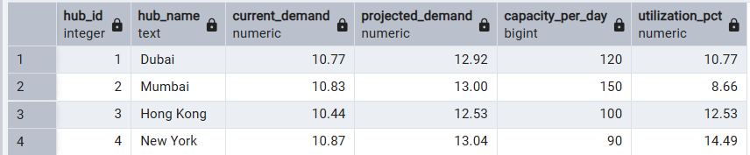

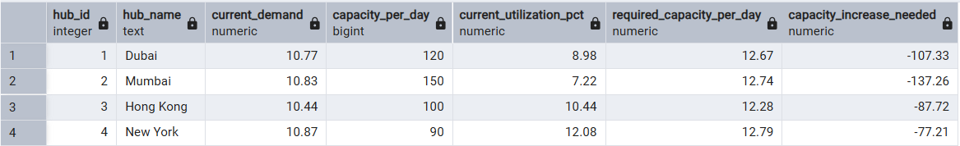
-- in our case we can reduce the capacity_per_day in each hub because they are under utilized

