Disaster Response Logistics: Multi-Depot Routing and Resource Allocation
[Author 1], [Author 2], [Author 3], [Author 4]
Department of Computer Science and Engineering, [Institution], [City], [Country]
Course: Design and Analysis of Algorithms (DAA), Internal Project 4 | [e-mail addresses] | [Repository URL]

Abstract—After a disaster, a few depots hold limited supplies and many locations need them before a deadline, while roads are slow or closed. We model this as a decision problem on a weighted road graph and solve it with a pipeline of classical algorithms: a Kou-Markowsky-Berman Steiner tree for the backbone that connects depots and critical nodes, a deadline filter and a 0-1 knapsack dynamic programme for prioritization, and Clarke-Wright savings with 2-opt and relocate local search for routing, validated against an exact Held-Karp set-partition DP. Robustness is studied with a Monte Carlo simulator that applies random delays and link closures and compares five execution strategies on identical disruptions. On a 60-node scenario whose supply covers 55% of demand, the nominal plan delivers 52.7% of demand on time. With 20% of roads closed and delays up to +50%, a static plan delivers 13.5%, while a buffered plan with live re-routing and re-allocation delivers 47.7%. The heuristic routes are within 0.2% to 2.0% of the optimum on small instances, and the whole planning pipeline, including shortest paths, takes about half a second on a 1,280-node network.
Index Terms—Steiner tree, knapsack dynamic programming, Clarke-Wright savings, vehicle routing with deadlines, Monte Carlo robustness, emergency logistics.
I. INTRODUCTION
Relief supplies such as water, food and medicine must reach affected people quickly, but the supply is finite, the vehicle fleet is limited and the road network is damaged. Planners must decide which demands to serve, from which depot, and along which route, and the plan must keep working when travel times turn out worse than forecast. Even the individual sub-problems are hard: choosing what to serve is a knapsack problem, sequencing deliveries under capacity and deadlines is a vehicle routing problem, and linking depots to critical sites with the least road effort is a Steiner tree problem. All three are NP-hard, so we combine exact algorithms where they scale and heuristics with measured quality where they do not.
Problem statement. Given multiple supply depots and priority demand nodes after a disaster, design routing and allocation policies that maximise the demand served within deadlines, and present policies that are robust under uncertain travel times.
Contributions. (i) A reproducible simulator and scenario generator; (ii) implementations of Kruskal, Prim, Kou-Markowsky-Berman, knapsack DP, Clarke-Wright with deadline-aware merging, local search and an exact deadline-aware routing DP; (iii) an event-driven robustness simulator with five strategies evaluated on common random numbers; (iv) correctness and complexity arguments and an experimental study of runtime, solution quality and sensitivity; (v) data-driven policy recommendations. Section II reviews related work, Section III formulates the problem, Section IV presents the algorithms, Section V solves a worked example, Section VI reports results, Section VII describes testing, and Sections VIII and IX discuss limitations and conclude. Appendix A maps every required deliverable to its file.
II. LITERATURE SURVEY
Emergency logistics. Surveys by Altay and Green [1] and Caunhye et al. [2] classify disaster operations research into facility location, relief distribution, casualty transport and network repair, and note that most models are NP-hard and solved heuristically. Özdamar et al. [3] formulate multi-commodity relief distribution as a network flow problem, and Sheu [4] proposes a quick-response distribution scheme driven by the urgency of demand. These works motivate our priority-weighted selection under limited stock and tight deadlines.
Network backbone. Minimum spanning trees are computed by Kruskal [5] and Prim [6]. When only a subset of terminals must be connected, the task is the Steiner tree problem, which is NP-hard; Kou, Markowsky and Berman [7] give a polynomial algorithm with cost at most 2(1 − 1/|T|) times the optimum, which we use for the backbone.
Selection under limited resources. The 0-1 knapsack problem is solved exactly in pseudo-polynomial time by dynamic programming [8], [9], and the fractional relaxation gives an upper bound. Kellerer et al. [9] discuss when greedy ratio rules are near-optimal.
Routing. The savings algorithm of Clarke and Wright [10] is the classical constructive heuristic for capacitated routing [11]; local search with 2-opt moves goes back to Croes [12]. Small instances can be solved exactly by the subset dynamic programme of Held and Karp [13], which we extend with deadlines and a set-partition phase. Shortest paths use Dijkstra [14].
Uncertainty. Stochastic vehicle routing [15] and robust optimisation [16] handle uncertain travel times by chance constraints or worst-case sets. We use a simpler, transparent approach, Monte Carlo evaluation of buffered plans and adaptive re-routing, which fits the classical algorithms of this course. Table I maps each technique to its role.
TABLE I
How the classical techniques map to the project
Component | Technique and source | Role
Travel times | Dijkstra [14] | Shortest paths, live re-routing
Backbone | Kruskal [5], Prim [6], KMB [7] | Roads linking depots and critical nodes
Prioritization | Deadline filter + knapsack DP [8], [9] | Choose what to serve within supply
Routing | Clarke-Wright [10], 2-opt [12], relocate | Vehicle routes with deadlines
Validation | Held-Karp + set partition [13] | Exact optimum on small instances
Robustness | Monte Carlo, buffers [15], [16] | Compare execution policies

III. PROBLEM FORMULATION
The road network is an undirected graph G = (V, E) with positive travel times t(e) in minutes. A set D of depots holds stock S(d) units and operates K(d) vehicles of capacity Q. A set N of demand nodes is given; node i needs q(i) units, has priority p(i) in {1,…,5}, serves a population π(i) and must be reached before its deadline τ(i). The value of serving i is v(i) = p(i)·π(i). Nodes with p(i) = 5 are critical (hospitals, shelters). A solution selects a set of demands, assigns each to a depot, and builds routes that start at a depot. The goal is to maximise the value delivered on time:
maximise Σ v(i)·x(i), x(i) ∈ {0, 1} (1)
subject to: (a) the units assigned to depot d do not exceed S(d); (b) every route load is at most Q; (c) the arrival time a(i) at every served node satisfies a(i) ≤ τ(i); (d) every demand is served by at most one vehicle; (e) depot d uses at most K(d) routes. Unloading takes 5 minutes per stop. The problem contains the 0-1 knapsack and the capacitated vehicle routing problem as special cases and is therefore NP-hard, which justifies the staged design of Section IV.
Metrics. (M1) % demand satisfied = 100·Σ q(i) over demands delivered on time / Σ q(i) over all demands. (M2) Average delivery latency = mean arrival time of delivered demands. (M3) Resilience under X% link closure = M1 with X% of roads closed divided by M1 with none closed, at the same delay level. We also report the percentage of priority-weighted value and of critical demand delivered.
Uncertainty model. In every Monte Carlo run each road e gets a delay multiplier
t′(e) = t(e)·(1 + δ(e)), δ(e) ~ U[0, δmax] (2)
with δmax in {25%, 50%, 100%}, and a random fraction x in {0, 5, 10, 20, 30, 40}% of the roads is closed. Table II lists the default scenario.
TABLE II
Parameters of the default scenario (seed 7)
Parameter | Value
Nodes / roads | 60 / 118
Depots (stock, units) | 32 (53), 5 (43), 41 (58)
Demand nodes (critical) | 34 (5)
Total demand / supply | 281 / 154 units (55%)
Fleet | 3 vehicles per depot, capacity 30
Service time | 5 min per stop
Deadlines | critical 45–150 min; others 60–360 min
Delay levels / closure levels | +25, +50, +100% / 0, 5, 10, 20, 30, 40%
Monte Carlo runs per setting | 60

IV. ALGORITHM DESIGN
The pipeline (Fig. 1) is: scenario → backbone → deadline filter → knapsack DP → depot allocation → Clarke-Wright → local search → robustness simulation. Each stage is a separate module that is analysed and tested on its own.
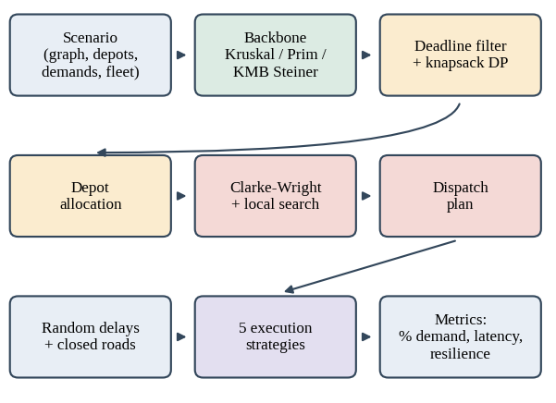
Fig. 1. Pipeline of the project: planning stages (top two rows) and robustness evaluation (bottom row).
Table III summarises the algorithm chosen for each sub-problem and the alternatives we considered, which addresses the requirement to select and justify algorithms.
TABLE III
Algorithm choices and alternatives
Sub-problem | Chosen | Alternative and why not
Shortest paths | Dijkstra, heap | Floyd-Warshall is O(n³) and computes pairs we never use; Bellman-Ford is needed only for negative weights
Spanning tree | Kruskal and Prim | Both implemented and equal in cost; Prim suits dense graphs, Kruskal sparse ones
Backbone | KMB Steiner tree | The MST connects all nodes and costs 1.9 times more here; exact Steiner is NP-hard
Selection | Knapsack DP | Greedy has no guarantee (worst loss 7.9%); DP is exact in O(kW)
Routing | Clarke-Wright + local search | Exact DP is exponential, so it is used only to validate (up to 13 customers)
Uncertainty | Monte Carlo, buffer, re-routing | Worst-case robust optimisation needs uncertainty sets and a solver, beyond this course

A. Network model and shortest paths
The graph is stored as adjacency lists. Travel times are shortest-path times computed by Dijkstra’s algorithm [14] with a binary heap, O((n + m) log n) per source. The same routine accepts closed roads and per-road delay multipliers, so vehicles can re-plan on the live network. Floyd-Warshall (O(n³)) and Bellman-Ford (O(nm)) are implemented as references and cross-checked against Dijkstra in the tests. Dijkstra is preferred because the network is sparse, only about |T| + |N| sources are needed, and distances must be recomputed after disruptions.
DIJKSTRA(G, s, blocked, scale):
dist[v] <- INF; dist[s] <- 0; PQ <- {(0,s)}
while PQ not empty:
(d, u) <- EXTRACT-MIN(PQ)
if d > dist[u]: continue
for road (u, v, w) not in blocked:
d2 <- d + w * scale(u, v)
if d2 < dist[v]:
dist[v] <- d2; INSERT(PQ, (d2, v))
return dist
B. Backbone: MST and Steiner tree
Kruskal [5] sorts the roads by travel time and adds a road when it joins two different components, tracked with union-find (path compression, union by rank): O(m log m). Prim [6] grows one tree from a start node using a heap: O(m log n). Correctness follows from the cut property: for any cut, the cheapest road crossing it belongs to some minimum spanning tree. Every road added by Kruskal is the cheapest one leaving the component it joins, and every road added by Prim is the cheapest one leaving the current tree, so both return trees of equal cost.
A spanning tree connects every node, but only depots and critical nodes (the terminal set T) must stay connected. Since the Steiner tree problem is NP-hard, we use the Kou-Markowsky-Berman (KMB) algorithm [7]:
KMB(G, T):
C <- complete graph on T,
weight = shortest-path time in G
M <- MST(C)
H <- union of shortest paths of M's edges
S <- MST(H) # removes cycles
repeat: delete a leaf of S not in T
return S
Approximation sketch. A depth-first walk around an optimal Steiner tree visits all terminals and costs at most twice the optimum; shortcutting it yields a spanning tree of C of cost at most 2(1 − 1/|T|)·OPT. The MST M of C is no more expensive, and steps 3 to 5 never increase the cost. Complexity: |T| Dijkstra runs plus O(|T|²) for the closure, i.e. O(|T|(n + m) log n + |T|²). The backbone is the set of roads to repair and protect first; Section VI-D measures its value.
C. Prioritization: deadline filter and knapsack DP
Stage 1: deadline filter. A demand is kept only if some depot reaches it before its deadline, min over d of dist(d, i) ≤ τ(i). Others have no value and would waste supply. Cost: O(|D|(n + m) log n).
Stage 2: 0-1 knapsack DP. The feasible demands are items with weight q(i) and value v(i); W is the total stock. Let dp[c] be the best value with capacity c:
dp[c] = max(dp[c], dp[c − q(i)] + v(i)) (3)
KNAPSACK-DP(q[1..k], v[1..k], W):
dp[0..W] <- 0
for i = 1..k:
for c = W downto q[i]:
if dp[c-q[i]] + v[i] > dp[c]:
dp[c] <- dp[c-q[i]] + v[i]
keep[i][c] <- 1
c <- W
for i = k downto 1:
if keep[i][c]: add i; c <- c - q[i]
return dp[W], chosen
Correctness. By induction on i, dp[c] after item i equals the optimum over the first i items: the optimal set either omits item i (value from the previous row) or contains it (v(i) plus the optimum for capacity c − q(i) over the first i − 1 items). Scanning c downward guarantees dp[c − q(i)] still belongs to the previous row, so each item is used at most once. Complexity: O(kW) time and kW bits for the traceback; this is pseudo-polynomial, acceptable because W is a few hundred to a few thousand units. Baselines are greedy selection by value-to-weight ratio (O(k log k), not optimal) and the fractional knapsack, whose value is an upper bound.
Stage 3: depot allocation. Selected demands, highest priority and tightest deadline first, go to the nearest depot that has enough stock and can arrive in time. Leftover stock is then used for unselected feasible demands in order of value per unit. The DP is optimal for the pooled stock; this allocation is a heuristic because stock is split across depots.
D. Routing: Clarke-Wright, local search and exact DP
For each depot, its assigned demands are split into routes that respect the capacity Q and the deadlines. Route cost is the time from leaving the depot until returning, including service. The Clarke-Wright algorithm [10] starts with one route per customer and merges routes by decreasing saving
s(i, j) = d(0, i) + d(0, j) − d(i, j). (4)
A merge is accepted only if capacity and every deadline still hold; both orientations of each route are tried because direction changes arrival times.
CLARKE-WRIGHT(depot 0, customers N):
routes <- {[i] : i feasible alone}
for (i,j) by decreasing saving
s(i,j) = d(0,i)+d(0,j)-d(i,j) > 0:
if i, j are ends of routes A != B
and load(A)+load(B) <= Q:
for orientations A', B' with
i = last(A'), j = first(B'):
if A'+B' meets all deadlines:
replace A, B by A'+B'; break
return routes
Correctness (feasibility). Every initial route is feasible and only feasible merges are accepted, so the output is feasible; optimality is not guaranteed. Complexity: O(c² log c) for c customers. Local search applies 2-opt [12] (reverse a segment inside a route) and relocate (move a stop to another route); a move is accepted only if both routes stay feasible and the total time strictly decreases, so the search terminates. If a depot needs more routes than it has vehicles, the routes with the lowest value per minute are dropped and reported.
Exact DP for small instances. To measure the heuristic gap we solve instances of up to 13 customers exactly in two phases. Phase 1 (Held-Karp [13] with deadlines): f[S][j] is the earliest time at which a vehicle has served set S and finished at j,
f[S∪{j}][j] = minᵢ f[S][i] + d(i,j) + service (5)
where i runs over S and the transition is allowed only if the arrival time is at most τ(j) and the load fits. Phase 2 (set partition): g[k][S] = min( g[k−1][S], min over T ⊆ S containing the lowest customer of S of cost[T] + g[k−1][S \ T] ), where cost[T] is the cheapest closed route through T; g[K][N] is the optimum with at most K vehicles. Why earliest time is a valid state: arriving earlier never violates a deadline and never lengthens the route, because a vehicle never has to wait, so among partial routes with the same visited set and last node the earliest one dominates. Complexity: O(2ᶜ c²) for phase 1 and O(K·3ᶜ) for phase 2.
E. Proof details
Cut property. Let T be an MST and e the cheapest edge crossing a cut. If e is not in T, adding e to T creates a cycle that crosses the cut again at some edge f of T with t(f) ≥ t(e); replacing f by e gives a spanning tree that is no heavier, so some MST contains e.
KMB bound. Doubling an optimal Steiner tree gives a closed walk of cost 2·OPT through all |T| terminals. Cutting it into |T| segments between consecutive terminals and dropping the longest leaves a walk of cost at most 2(1 − 1/|T|)·OPT whose segments are at least the closure distances, so the closure MST is no more expensive. Expanding closure edges into paths, taking the MST of H and pruning leaves never increases the cost.
Earliest-arrival dominance. Fix the visited set S and the last node j. If one partial route finishes at time f1 and another at f2 ≥ f1, every continuation feasible after f2 is feasible after f1, because all later arrival times shift by a constant and deadlines are upper bounds; and the cost after f1 is no larger. Keeping only the minimum is therefore exact.
Counting. Phase 1 has 2ᶜ·c states with c transitions each, i.e. O(2ᶜ c²). Phase 2 enumerates pairs T ⊆ S, and the number of such pairs is Σₛ 2^|S| = 3ᶜ, repeated for K layers. Termination of local search. Every accepted move strictly decreases the total duration and the number of feasible solutions is finite, so no solution repeats and the search stops (we also cap it at 30 passes).
F. Robustness: execution strategies
Each strategy runs in an event-driven simulator on the disrupted network; a delivery counts only if the vehicle arrives before the deadline. All strategies see the same random disruptions (common random numbers), so differences are not sampling noise.
- Static: vehicles follow the planned shortest paths; a closed road strands the vehicle and its remaining stops are lost.
- Static + buffer: the plan is built with all travel times inflated by 25%, leaving slack in every route.
- Adaptive: before every leg the vehicle re-runs Dijkstra on the live network (closures and current delays are known) and skips stops that are unreachable or would be late.
- Adaptive + re-allocation: skipped stops go to a shared pool; a vehicle that finished its route and still has cargo and time picks the pool stop with the highest value per minute.
- Buffered + adaptive + re-allocation (robust policy): the combination of the above.
ADAPTIVE(plan, blocked, scale, realloc):
vehicle: t=0, queue=stops, cargo=load
while some vehicle can act (earliest first):
if queue not empty:
s <- pop front; Dijkstra on live network
if reachable, arrival <= tau[s],
q[s] <= cargo:
deliver; cargo -= q[s]
else: skip s;
if realloc: pool += s; wake idle
else if realloc and pool has feasible stop:
take best value/(travel+service)
else: vehicle idle
Each leg costs one Dijkstra run, so a run costs O(L(n + m) log n) for L legs. Adaptive strategies assume real-time information on closures and delays, so their benefit is an upper bound.
G. Complexity summary
TABLE IV
Asymptotic and observed cost (n = 1280 nodes, 2388 roads)
Component | Time | Observed
Dijkstra (one source) | O((n+m) log n) | ~1 ms
Kruskal / Prim | O(m log m) / O(m log n) | 1.5 / 1.4 ms
Steiner tree (KMB) | O(|T|(n+m) log n + |T|²) | 7.2 ms
Knapsack DP | O(kW) | 198 ms
Knapsack greedy | O(k log k) | 0.2 ms
Clarke-Wright | O(c² log c) per depot | 4.2 ms
CW + local search | CW + O(c²) per pass | 29 ms
Full planning | sum of stages | 249 ms (468 with shortest paths)
Exact routing DP | O(2ᶜ c² + K·3ᶜ) | 20 ms at c = 10

V. WORKED EXAMPLE
The example follows the default scenario of Table II.
Backbone. The terminals are the three depots and the five critical nodes (3, 12, 49, 54, 57). In the metric closure the depot-to-depot times are 106.0 min (32–5), 128.9 min (32–41) and 235.0 min (5–41). KMB returns a tree of 22 roads costing 431.9 min, against 59 roads and 835.4 min for the full MST (Kruskal and Prim agree).
Deadline filter. Critical node 49 (deadline 77.3 min, earliest arrival 86.6 min) and node 36 (priority 4, deadline 99.1 min, earliest arrival 117.7 min) are rejected. The remaining 32 demands need 260 units and are worth 56,770, but only 154 units are available.
Knapsack. The DP selects 14 demands of value 45110 (greedy 45088; LP upper bound 45306). Allocation adds three demands from leftover stock (nodes 37, 38, 40); one selected demand (node 43) finds no depot with enough stock in time.
Routing at depot 5. Stock 43 units: nodes 12 (18 units, deadline 54.3), 2 (8 units, 120.3), 42 (12 units, 196.9) and 40 (5 units, 343.3), at depot times 15.0, 90.2, 33.4 and 18.1 min. Capacity is 30 and service time 5 min. Table V shows the Clarke-Wright run.
TABLE V
Clarke-Wright trace at depot 5 (minutes)
Pair | d(i,j) | Saving | Decision
(2, 42) | 84.7 | 38.9 | Merge [2, 42]; arrivals 90.2, 179.9 on time
(2, 40) | 73.7 | 34.6 | Reject: [42, 2, 40] reaches 2 at 123.1 > 120.3
(12, 2) | 75.2 | 30.0 | Reject: load 18 + 20 > 30
(42, 40) | 21.8 | 29.7 | Merge [2, 42, 40]; load 25; arrivals 90.2, 179.9, 206.7
(12, 40) | 4.2 | 28.9 | Reject: load 18 + 25 > 30
(12, 42) | 22.6 | 25.9 | Reject: 42 is no longer an end point

The result is the routes [12] and [2, 42, 40] with durations 35.0 and 229.7 min (total 264.7 min). The exact DP finds [12] and [40, 2, 42] with total 259.8 min, so Clarke-Wright with local search is 1.9% above the optimum here: visiting node 40 first requires moving a stop inside a route, which neither 2-opt (reversal would delay node 2 past its deadline) nor inter-route relocate can do. The nominal plan of the whole scenario uses 8 routes and delivers 52.7% of the demand with an average latency of 87 min.
VI. EXPERIMENTS AND RESULTS
All experiments run in Python 3 on a single core. Scenarios are synthetic and seeded: nodes are uniform in a 100×100 km square, each node is linked to its 3 nearest neighbours (components are stitched together), travel time is 1.5 min/km times a detour factor in [1.0, 1.3], depots are chosen by farthest-point sampling, and critical demands (15% of nodes) have larger quantities and deadlines of 45 to 150 min. Supply covers 55% of demand, and each depot has 3 vehicles of capacity 30. Robustness results use 60 Monte Carlo runs per setting on the scenario of Section V; algorithm-quality results average over many random scenarios.
A. Backbone and prioritization
Kruskal and Prim return the same cost (835.4 min). The Steiner backbone costs 431.9 min, 52% of the MST and 20% of all road time, yet it connects all 8 terminals (Fig. 2). Table VI shows how much the exact DP gains over greedy selection across random scenarios (25 per row).
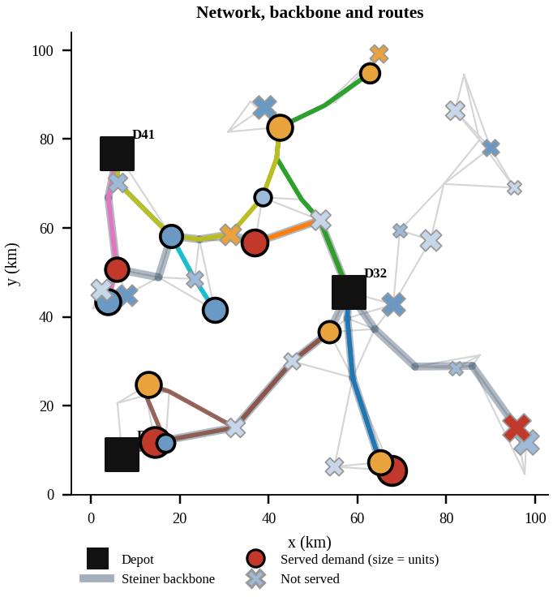
Fig. 2. Network, Steiner backbone (grey band) and delivery routes; circles are served demands, crosses unserved.
TABLE VI
Knapsack quality over random scenarios
Nodes | Supply | Greedy loss % | Worst loss % | DP better | DP to LP %
30 | 30% | 0.67 | 7.9 | 28% | 2.36
30 | 50% | 0.63 | 2.6 | 52% | 1.23
30 | 70% | 0.25 | 2.2 | 24% | 0.56
60 | 30% | 0.40 | 2.2 | 52% | 0.68
60 | 50% | 0.25 | 1.4 | 64% | 0.25
60 | 70% | 0.20 | 1.0 | 52% | 0.18
120 | 30% | 0.21 | 0.6 | 68% | 0.14
120 | 50% | 0.09 | 0.5 | 52% | 0.04
120 | 70% | 0.07 | 0.3 | 56% | 0.07

Greedy loses 0.07% to 0.67% of value on average but up to 7.9% in the worst case (few large items, tight stock). The DP is always optimal and is within 2.4% of the LP upper bound in every setting, so the selection is close to the best possible.
B. Routing quality against the exact DP
TABLE VII
Heuristic routing vs exact optimum (same number of vehicles)
Customers | CW gap % | CW+LS gap % | CW optimal | CW+LS optimal | Exact DP ms
5 | 6.0 | 0.4 | 76% | 92% | 0.1
6 | 2.2 | 1.1 | 72% | 84% | 0.3
7 | 2.1 | 0.2 | 64% | 88% | 0.7
8 | 4.9 | 1.6 | 48% | 76% | 1.9
9 | 4.6 | 1.9 | 48% | 68% | 5.8
10 | 3.6 | 2.0 | 44% | 52% | 19.6

Clarke-Wright is on average 2.1% to 6.0% above the optimum (20 to 25 instances per row) and local search reduces this to 0.2% to 2.0%, finding the optimum in 52% to 92% of the instances (Table VII). The exact DP time grows roughly threefold per added customer (0.1 ms at 5 customers, 20 ms at 10), which is why it is limited to small instances.
C. Robustness and sensitivity
TABLE VIII
% of demand delivered on time, delay up to +50% (mean of 60 runs)
Closed | Static | Static+buf. | Adaptive | Adapt.+realloc | Robust
0% | 26.4 | 52.3 | 29.7 | 29.9 | 52.3
5% | 21.9 | 45.1 | 29.5 | 30.4 | 51.4
10% | 18.0 | 37.0 | 27.6 | 28.5 | 49.6
20% | 13.5 | 26.9 | 26.1 | 28.5 | 47.7
30% | 9.1 | 16.8 | 22.6 | 25.3 | 42.1
40% | 7.3 | 12.6 | 19.5 | 22.7 | 36.4

Robust = buffered plan + adaptive execution + re-allocation.
At zero closures the delay alone cuts the static plan to 26.4%, because Clarke-Wright packs stops close to their deadlines and late arrivals do not count; the 25% buffer restores 52.3%. Closures hurt the static plans most (a closed road strands the vehicle), while adaptive execution degrades slowly (Table VIII, Figs. 3–5). The robust policy keeps 70% of its undisturbed service at 40% closures (resilience 0.70), against 28% for the static plan. The 95% confidence half-widths are at most 2.4 percentage points, far below the gaps between strategies. Re-allocation adds only 1 to 3 points over re-routing, because few vehicles have both cargo and slack left after a disruption.
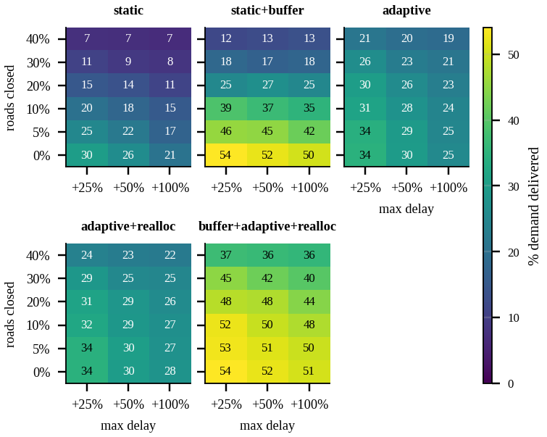
Fig. 3. Sensitivity study: % of demand delivered for each strategy over road closures (rows) and delay range (columns).
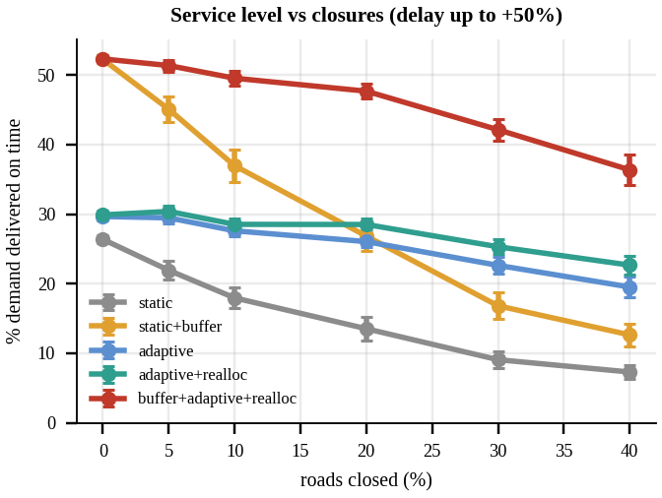
Fig. 4. Service level versus closures (delay up to +50%; bars show 95% confidence intervals).
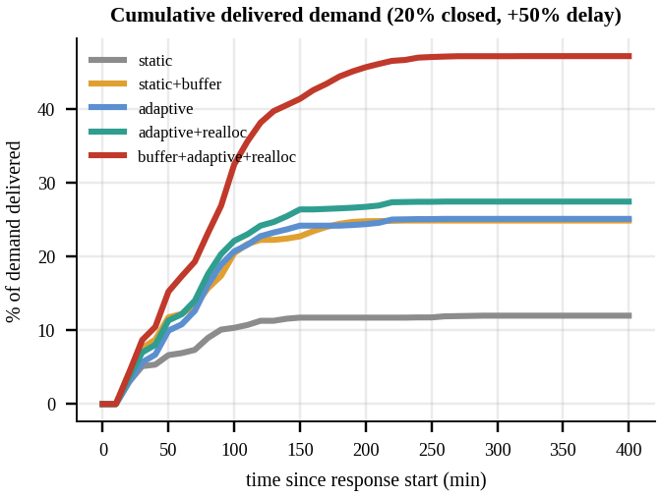
Fig. 5. Cumulative delivered demand over time (20% of roads closed, delay up to +50%).
Critical demand is the weak spot: with deadlines of 45 to 150 min, only 19% to 24% of it arrives on time at 20% closures and +50% delay, whatever the strategy. A tiered buffer (none for critical demands) did not improve results, so the cause is the physical delay rather than the planning rule.
D. Policy studies: safety buffer and backbone protection
TABLE IX
Planning buffer (robust policy; stress = 20% closed, +50% delay)
Buffer | No disruption % | Stress % | 95% CI
0% | 52.7 | 27.9 | ± 0.8
10% | 54.1 | 43.4 | ± 1.0
20% | 52.7 | 45.2 | ± 0.9
30% | 54.4 | 49.1 | ± 1.3
40% | 54.4 | 49.4 | ± 1.3
50% | 54.4 | 49.1 | ± 1.3

A buffer of 30% or more roughly doubles the stressed service level (27.9% without buffer to 49.1% at 30%) and, in this scenario, costs nothing in calm conditions because the buffered plan chooses a different set of demands (Table IX, Fig. 6, left). In the hardening study, closures never hit the backbone roads (delay up to +25%): at 30% closures the robust policy delivers 50.1% instead of 42.3% (Fig. 6, right). The same number of roads still closes, so failures concentrate on the remaining roads.
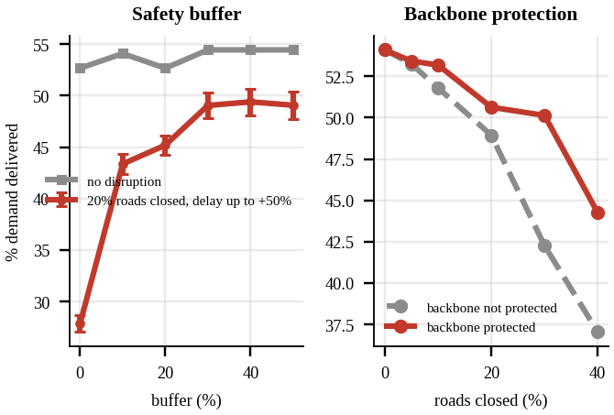
Fig. 6. Left: safety-buffer trade-off. Right: demand delivered with and without a protected backbone.
E. Scalability and network parameters
TABLE X
Runtime (ms) against network size
Nodes | Kruskal | Steiner | Knap. DP | Routing CW+LS | Full planning
80 | 0.1 | 0.1 | 0.8 | 0.9 | 1.6
320 | 0.3 | 0.5 | 12.3 | 11.1 | 23.8
1280 | 1.5 | 7.2 | 197.9 | 29.0 | 249.2

The spanning trees and the Steiner tree cost milliseconds. On these networks the knapsack DP is the largest single planning cost, growing linearly in kW, and routing is small because each depot serves only about ten customers. Routing cost depends on the customers per depot and grows roughly quadratically, as predicted: 6.7 ms for 100 customers and 561 ms for 800, an 8-fold increase in customers for a 83-fold increase in time (Table X, Figs. 7 and 8). Varying road density, the MST cost stays near 1,170 min while the Steiner cost falls from 672 min (k = 2) to 461 min (k = 8). Varying vehicle capacity, the fleet becomes the bottleneck below capacity 30: with capacity 15, 11 planned demands cannot be routed and only 33% of demand is served, while from capacity 30 upward the service stays at 55%, the supply limit (Fig. 9).
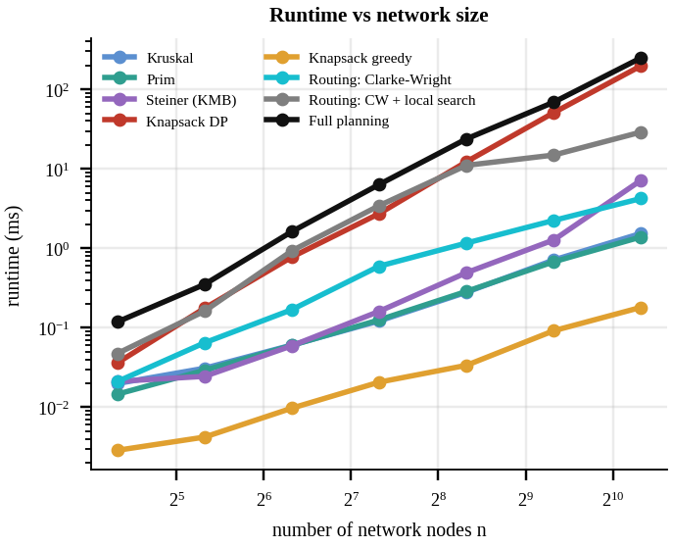
Fig. 7. Runtime of each stage against network size (log-log).
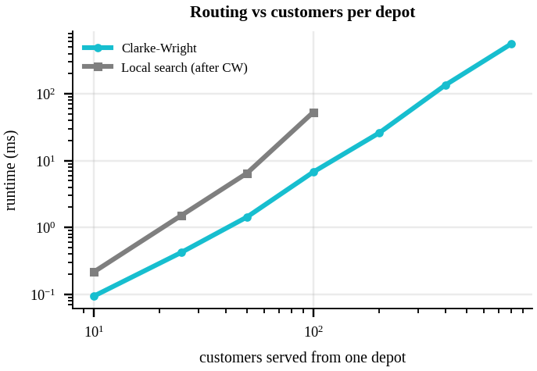
Fig. 8. Routing heuristics against the number of customers served by one depot.
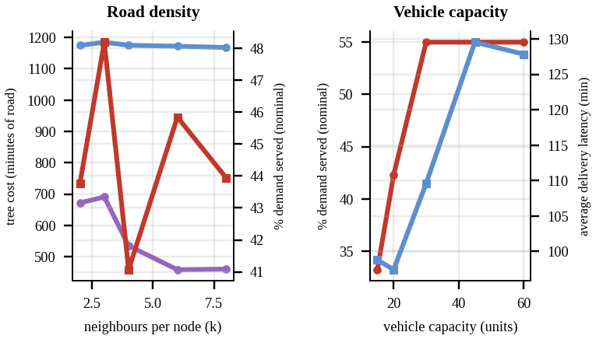
Fig. 9. Left: tree costs and nominal service against road density. Right: service and latency against vehicle capacity.
F. Policy recommendations
The simulator also produces an interactive dashboard (a single offline HTML page) that shows the network with the backbone and routes, lets the user close roads with a slider, switch strategy and delay level and protect the backbone, and lists heat maps, time series, scalability charts, the route table and, for every demand, whether it is served and why not. CSV tables give the routes and decisions (Fig. 10 shows demand density and coverage). From the experiments we recommend:
- Plan with a safety buffer. A 25% buffer raises the static plan from 13.5% to 26.9% under 20% closures and +50% delay; the gain levels off from about 30% and costs nothing in calm conditions here.
- Re-route and re-allocate during execution. Together with the buffer this gives 47.7% under the same stress; at 40% closures the robust policy delivers 36.4% against 7.3% for the static plan.
- Protect the Steiner backbone. It uses 20% of the road time and lifts service at 30% closures from 42.3% to 50.1%.
- Use the exact DP for selection. It costs milliseconds and avoids the worst-case greedy loss of up to 7.9%.
- Treat supply and critical deadlines as the binding constraints. Of the 20 demands left unserved on the nominal schedule, 15 lost out because supply ran out; critical demand with deadlines shorter than the delays cannot be secured by planning alone.
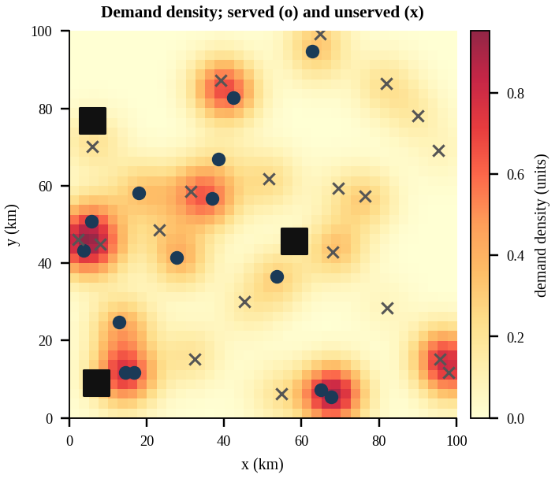
Fig. 10. Demand density heat map; circles are demands served on the nominal schedule, crosses are not served; squares are depots.
VII. TESTING AND VALIDATION
Sixteen unit tests check every algorithm against an independent reference rather than against itself:
- Dijkstra agrees with Bellman-Ford and Floyd-Warshall on random graphs; closed roads are never used.
- Kruskal and Prim return equal costs and spanning trees; KMB connects all terminals and stays within 2(1 − 1/|T|) of a brute-force Steiner optimum.
- The knapsack DP equals brute force on random instances and satisfies greedy ≤ DP ≤ LP bound.
- The exact routing DP equals brute-force permutations on tiny instances, is never worse than Clarke-Wright, and returns feasible routes.
- Every plan respects depot stock, capacity, deadlines and fleet size and serves each demand once; with no disruption the executors reproduce the planned arrival times exactly; no strategy delivers after a deadline or twice; Monte Carlo runs are reproducible from the seed.
VIII. DISCUSSION AND LIMITATIONS
Findings. (1) Delays are as damaging as closures for tightly packed plans, and a modest planning buffer is the cheapest remedy. (2) Closures are best handled by live re-routing; combining both gives the best and most stable service. (3) Protecting a small backbone (20% of road time) recovers a large part of the loss under heavy closures. (4) The exact knapsack DP is cheap and never worse than greedy, though greedy is usually close. (5) Clarke-Wright with local search is within a few percent of optimal where this can be checked.
Limitations. The knapsack is optimal only for the pooled stock of all depots; allocation and routing are heuristics, so the whole plan is not provably optimal. Exact routing is verified on at most 10 customers. The robustness study uses one scenario instance with 60 disruption draws; the algorithm-quality studies average over many scenarios. Data are synthetic, so the results show how policies compare, not absolute predictions for a real city. Adaptive strategies assume real-time information on closures and delays. A single commodity is modelled; the multi-commodity extension mentioned in the project synopsis would turn the knapsack into a multi-dimensional one.
Threats to validity. Internal: implementation errors are mitigated by 16 tests against independent references. External: the network is a random geometric graph; grid-like or hierarchical real road networks may behave differently. Construct: a delivery counts only if it is on time and units, not lives, are counted; partial credit for late delivery is not modelled. Conclusion: 60 draws per cell give narrow confidence intervals (at most 2.4 points), but all robustness results come from one scenario.
IX. CONCLUSION AND FUTURE WORK
We built a complete, tested pipeline for multi-depot disaster logistics: a Steiner backbone, an exact knapsack selection under deadlines, deadline-aware Clarke-Wright routing validated against an exact DP, and a Monte Carlo robustness study of five execution strategies. A buffered plan combined with adaptive re-routing and re-allocation delivered 47.7% of demand under 20% closures and +50% delays, against 13.5% for the static plan, and the planning pipeline handles over a thousand nodes in about half a second. Future work includes a per-depot (multiple) knapsack, multiple commodities, time-dependent travel times, stronger routing metaheuristics, periodic re-optimisation during execution and calibration on a real road network.
APPENDIX A: DELIVERABLES AND REPRODUCTION
Table XI maps each required deliverable to its location in the repository. Everything is reproduced by the commands below; all random choices are seeded.
TABLE XI
Required deliverables and where to find them
Deliverable | Location
Simulator (scenarios, constraints) | src/network.py, src/robustness.py
Backbone, selection DP, routing | src/backbone.py, prioritization.py, routing.py
Robustness experiments, sensitivity | experiments.py, outputs/results.json
Maps, heat maps, time series | outputs/*.png, outputs/dashboard.html
Policy outputs (routes, decisions) | outputs/routes.csv, demand_decisions.csv, policy_recommendations.md
Code and sample data | README.md, data/sample_scenario.json, tests/
Report | this paper
Presentation and demo (15–20 min) | docs/DEMO_SCRIPT.md; python main.py --demo

pip install -r requirements.txt
python main.py # everything, ~20 s
python main.py --quick # reduced run, ~6 s
python main.py --demo # pauses between stages
python -m unittest discover -s tests -v
REFERENCES
[1] N. Altay and W. G. Green, “OR/MS research in disaster operations management,” Eur. J. Oper. Res., vol. 175, no. 1, pp. 475–493, 2006.
[2] A. M. Caunhye, X. Nie, and S. Pokharel, “Optimization models in emergency logistics: A literature review,” Socio-Econ. Plan. Sci., vol. 46, no. 1, pp. 4–13, 2012.
[3] L. Özdamar, E. Ekinci, and B. Küçükyazici, “Emergency logistics planning in natural disasters,” Ann. Oper. Res., vol. 129, pp. 217–245, 2004.
[4] J.-B. Sheu, “An emergency logistics distribution approach for quick response to urgent relief demand in disasters,” Transp. Res. E, Logist. Transp. Rev., vol. 43, no. 6, pp. 687–709, 2007.
[5] J. B. Kruskal, “On the shortest spanning subtree of a graph and the traveling salesman problem,” Proc. Amer. Math. Soc., vol. 7, no. 1, pp. 48–50, 1956.
[6] R. C. Prim, “Shortest connection networks and some generalizations,” Bell Syst. Tech. J., vol. 36, no. 6, pp. 1389–1401, 1957.
[7] L. Kou, G. Markowsky, and L. Berman, “A fast algorithm for Steiner trees,” Acta Inform., vol. 15, pp. 141–145, 1981.
[8] G. B. Dantzig, “Discrete-variable extremum problems,” Oper. Res., vol. 5, no. 2, pp. 266–288, 1957.
[9] H. Kellerer, U. Pferschy, and D. Pisinger, Knapsack Problems. Berlin, Germany: Springer, 2004.
[10] G. Clarke and J. W. Wright, “Scheduling of vehicles from a central depot to a number of delivery points,” Oper. Res., vol. 12, no. 4, pp. 568–581, 1964.
[11] P. Toth and D. Vigo, Eds., Vehicle Routing: Problems, Methods, and Applications, 2nd ed. Philadelphia, PA, USA: SIAM, 2014.
[12] G. A. Croes, “A method for solving traveling-salesman problems,” Oper. Res., vol. 6, no. 6, pp. 791–812, 1958.
[13] M. Held and R. M. Karp, “A dynamic programming approach to sequencing problems,” J. Soc. Ind. Appl. Math., vol. 10, no. 1, pp. 196–210, 1962.
[14] E. W. Dijkstra, “A note on two problems in connexion with graphs,” Numer. Math., vol. 1, pp. 269–271, 1959.
[15] M. Gendreau, G. Laporte, and R. Séguin, “Stochastic vehicle routing,” Eur. J. Oper. Res., vol. 88, no. 1, pp. 3–12, 1996.
[16] A. Ben-Tal, L. El Ghaoui, and A. Nemirovski, Robust Optimization. Princeton, NJ, USA: Princeton Univ. Press, 2009.

