BANGLADESH UNIVERSITY OF PROFESSIONALS
Department of Business Administration in Finance and Banking

An Internship Report on “The Trade-off Between AML/KYC Compliance Stringency and Financial Inclusion in Mobile Financial Services (MFS): Evidence from Bangladesh”

Prepared by
Md Al Shahoriar Hossain
ID # 2222151064
Supervised by
Ummay Mahima Ima, Assistant Professor
Department of Business Administration in Finance and Banking
Bangladesh University of Professionals
Date of Submission: 15 August 2026

The Trade-off Between AML/KYC Compliance Stringency and Financial Inclusion in Mobile Financial Services (MFS): Evidence from Bangladesh

Md Al Shahoriar Hossain
2222151064
Session: 2021-22
Section: B
Department of Business Administration in Finance and Banking
Bangladesh University of Professionals
https://shahoriar.bd/

Supervisor Name:
Ummay Mahima Ima
Assistant Professor
Department of Business Administration in Finance and Banking
Bangladesh University of Professionals

Letter of Transmittal
15 August 2026
Ummay Mahima Ima
Assistant Professor
Department of Business Administration in Finance and Banking
Faculty of Business Studies
Bangladesh University of Professionals
Mirpur Cantonment, Dhaka-1216, Bangladesh
Subject: Submission of Internship Report.
Dear Madam,
I am pleased to submit my internship report titled “The Trade-off Between AML/KYC Compliance Stringency and Financial Inclusion in Mobile Financial Services (MFS): Evidence from Bangladesh” for your kind evaluation. This report is submitted as a requirement for the completion of the Bachelor of Business Administration (BBA) degree in Finance and Banking. The knowledge and skills acquired throughout my academic program, together with my internship placement, have enabled me to prepare this report.
I have tried my best to follow all the guidelines provided and to present the report with sincerity. I will be available to provide any clarification or additional explanation that may be required in the future.
Yours sincerely,

Md Al Shahoriar Hossain
Student ID: 2222151064
Department of Business Administration in Finance and Banking
Faculty of Business Studies
Bangladesh University of Professionals

Certificate of the Organization
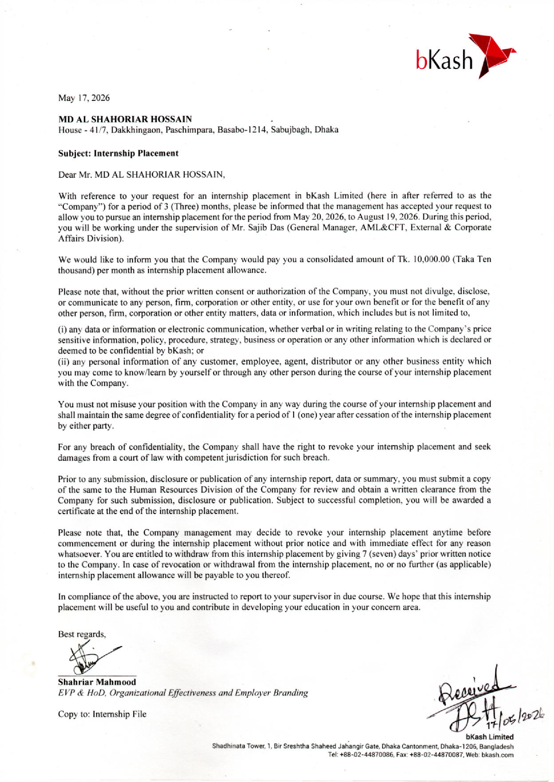

Statement of Authorship

I, Md. Al Shahoriar Hossain, confirm that I have independently prepared the internship report titled “The Trade-off Between AML/KYC Compliance Stringency and Financial Inclusion in Mobile Financial Services (MFS): Evidence from Bangladesh” following the completion of a twelve-week internship at bKash Limited in the AML&CFT department’s Governance function. I affirm that this report has been prepared solely to fulfill the academic requirements of my Bachelor of Business Administration (BBA) program at Bangladesh University of Professionals (BUP) and is not intended for any other purpose.

I have made every effort to acknowledge and cite all sources of information accurately and appropriately. I further confirm that this report has not been previously published, submitted, or used for any other academic or professional purpose and has been prepared specifically to fulfill the requirements of the internship program.



______________________
MD AL SHAHORIAR HOSSAIN
Student ID: 2222151064
Batch: 2022, Section B
Session: 2021-22
Department of Business Administration in Finance and Banking
Faculty of Business Administration
Bangladesh University of Professionals

Certificate of Supervision of Research

This is to certify that Md. Al Shahoriar Hossain, a student of the Bachelor of Business Administration (BBA) program under the Faculty of Business Studies, Bangladesh University of Professionals (BUP), has completed the research work for his internship report entitled “The Trade-off Between AML/KYC Compliance Stringency and Financial Inclusion in Mobile Financial Services (MFS): Evidence from Bangladesh” under my supervision.

I have supervised and guided the student throughout the research and preparation of this report. To the best of my knowledge, the report has been prepared in accordance with the academic requirements of the BBA program and is submitted in partial fulfilment of the requirements for the completion of the internship program.

I hereby recommend this report for evaluation and submission to the Faculty of Business Studies, Bangladesh University of Professionals.

Date: ____________________

____________________________
Ummay Mahima Ima
Assistant Professor
Department of Business Administration in Finance and Banking
Faculty of Business Studies
Bangladesh University of Professionals

Acknowledgement

First and foremost, I would like to express my sincere gratitude to Almighty Allah for granting me the strength, patience, and perseverance to successfully complete my internship and prepare this report.
I would like to express my deepest appreciation to my university internship supervisor, Ummay Mahima Ima, Assistant Professor, Department of Business Administration in Finance and Banking, Faculty of Business Studies, Bangladesh University of Professionals, for her valuable guidance, constructive feedback, and continuous support throughout the preparation of this report. Her instructions and academic guidance were instrumental in completing this report successfully.
I would also like to express my sincere gratitude to my workplace supervisor, Kibria Mohammed Kabir, Assistant Manager, AML&CFT Department, bKash Limited, for his guidance, cooperation, and support throughout my internship. His practical insights and professional guidance enabled me to gain valuable knowledge and experience in the AML/CFT function and contributed significantly to my understanding of the subject matter of this report.
I am also grateful to bKash Limited for providing me with the opportunity to complete my internship and gain practical exposure to a professional work environment. I would like to extend my appreciation to the members of the AML&CFT Department and everyone who supported me during the internship and contributed to my learning experience.
I would also like to express my sincere gratitude to all the respondents who participated in my research survey and generously shared their time and information. Their participation was essential to the successful completion of the research component of this report.
Finally, I would like to thank my friends, seniors, and well-wishers for their encouragement, assistance, and support throughout my internship and the preparation of this report. Their cooperation and encouragement greatly contributed to the completion of this work.

List of Acronyms

Acronym | Full Form | Acronym | Full Form
AML | Anti-Money Laundering | APA | American Psychological Association
BEFTN | Bangladesh Electronic Funds Transfer Network | BFIU | Bangladesh Financial Intelligence Unit
CDD | Customer Due Diligence | CFT | Combating the Financing of Terrorism
DPS | Deposit Pension Scheme | CTR | Cash Transaction Report
e-KYC | Electronic Know Your Customer | EDD | Enhanced Due Diligence
GDP | Gross Domestic Product | FATF | Financial Action Task Force
KYC | Know Your Customer | GSMA | GSM Association
MFS | Mobile Financial Services | ICT | Information and Communication Technology
NBFI | Non-Bank Financial Institution | ML | Money Laundering
NPSB | National Payment Switch Bangladesh | MNO | Mobile Network Operator
OTP | One-Time Password | NID | National Identity Card
PIN | Personal Identification Number | OLS | Ordinary Least Squares
PSD | Payment Systems Department | PEP | Politically Exposed Person
PSO | Payment System Operator | POS | Point of Sale
RBA | Risk-Based Approach | PSP | Payment Service Provider
SAR | Suspicious Activity Report | QR | Quick Response (Code)
SME | Small and Medium Enterprise | RTGS | Real-Time Gross Settlement
TF | Terrorist Financing | SIM | Subscriber Identity Module
USSD | Unstructured Supplementary Service Data | SMS | Short Message Service
WB | World Bank | STR | Suspicious Transaction Report
VIF | Variance Inflation Factor | UNODC | United Nations Office on Drugs and Crime

Executive Summary

Mobile Financial Services (MFS) have become one of the most consequential financial innovations in Bangladesh over the past decade, extending formal financial access to millions of previously unbanked people, particularly across rural and semi-urban areas. Providers such as bKash, Nagad, and Rocket have built an infrastructure that lets someone with nothing more than a mobile handset and a National ID card send, receive, and save money without ever stepping into a bank branch. At the same time, regulators including Bangladesh Bank and the Bangladesh Financial Intelligence Unit (BFIU), along with the providers themselves, have layered on increasingly stringent Anti-Money Laundering and Know-Your-Customer (AML/KYC) controls to guard against fraud, money laundering, and terrorist financing. These two forces; access and control, do not always pull in the same direction, and this report is an attempt to look closely at the point where they meet.
The report is prepared as part of a 12-week internship completed in the AML/Governance department of bKash Limited, and it uses that placement as the practical grounding for a more focused empirical question: does higher perceived compliance stringency, measured through KYC burden, transaction limit restrictiveness, account freeze frequency, and perceived monitoring intensity, actually reduce how much people use MFS once income, age, education, location, and length of MFS usage are accounted for. Exposure to real compliance workflows during the internship, including STR/SAR reporting procedures and the shift from paper-based to electronic KYC, is used throughout to keep the discussion grounded in practice rather than theory alone.
To answer this, the report combines an organizational study of bKash's compliance function with a primary quantitative survey of MFS users across Bangladesh, analysed through multiple regression. The report does not attempt to settle the broader policy debate on AML/KYC design for mobile money platforms, and its findings should not be read as generalizable beyond the sample surveyed; respondents were reached largely through digital, convenience-based channels and likely skew younger and more urban than the average MFS user in Bangladesh. What it offers instead is a modest, evidence-grounded contribution, a Bangladesh-specific empirical test of a trade-off that is frequently discussed in principle but rarely measured directly along with practical recommendations for bKash and for regulators on where compliance friction might be eased without a meaningful increase in risk.
Table of Contents
Letter of Transmittal iii
Certificate of the Organization iv
Statement of Authorship v
Certificate of Supervision of Research vi
Acknowledgement vii
List of Acronyms viii
Executive Summary ix
List of Tables xii
Chapter 1: Introduction 1
1.1 Background of the Study 1
1.2 Purpose of the Study 2
1.3 Objective of the Study 2
1.4 Rationale of the Study 3
1.5 Scope of the Study 3
1.6 Research Plan 4
1.7 Limitations of the Study 4
1.8 Report Preview 5
Chapter 2: Overview of the Organization 6
2.1 Organizational Structure 7
2.1.1 The External and Corporate Affairs Division (ECAD) and the AML&CFT Department 8
2.1.2 Comments on the Organizational Structure 9
Chapter 3: Internship Duties and Responsibilities 10
3.1 Branch and Office of Internship 10
3.2 Internship Duration 10
3.3 Department and Team Placement 10
3.4 Operations and Activities of the AML & CFT Governance Team 10
3.5 Overview of the Other AML & CFT Department Teams 11
3.6 Tools, Systems, and Functional Exposure 12
3.7 The Assigned Project: Governance Monitoring Tool Automation 13
Chapter 4: Learnings/Experiences from Internship Program 15
4.1 Departments Assigned 15
4.2 Activities Performed and How I Performed Them 15
4.3 Key Learnings 15
4.3.1 On-the-Job Learning from Real Governance Work 15
4.3.2 Turning Classroom Knowledge into Practical Skills 16
4.4 Overall Experience 16
Chapter 5: Literature Review 18
5.1 Introduction 18
5.2. Financial Inclusion and MFS Growth in Bangladesh 18
5.3. AML/CFT Regulatory Framework and KYC Requirements 19
5.4. KYC as a Barrier to MFS Access: Evidence from Bangladesh 19
5.5. Fraud, Hundi, and the Push for Stricter Compliance 19
5.6. Comparative Evidence: Tiered KYC and Proportional Regulation 20
5.7. Empirical Studies on MFS Adoption and Usage Barriers in Bangladesh 20
5.8. Conceptual Framework for This Study 21
5.9. Summary and Research Gap 21
Chapter 6: Analysis 22
References 22

List of Tables

Figure 1: Different MFS Providers in Bangladesh (Illustration from Daily Observer, 2022) 7
Figure 2: bKash Limited Organizational Structure (Division Level). Source: Internal organizational documentation, bKash Limited, shared during internship placement (2026) 8
Figure 3: Tools/Modules Automated and Updated during Internship 13

Chapter 1: Introduction

1.1 Background of the Study
Mobile Financial Services (MFS) have, over little more than a decade, become one of the most consequential pieces of financial infrastructure in Bangladesh. As of January 2025, registered MFS accounts stood at roughly 239.3 million, up 9.2 percent from the previous year, with monthly transaction volume reaching nearly Tk1.72 trillion, a year-on-year jump of over 32 percent (bdnews24, 2025). This mirrors a broader global pattern. The mobile money industry worldwide processed roughly USD 2 trillion in transactions in 2025 across 2.3 billion registered accounts (GSMA, 2026). Yet registration is not the same thing as inclusion in any meaningful sense: only 37.6 percent of Bangladesh's registered MFS accounts were classified as active as of December 2024, meaning a majority of registered users are not transacting regularly (Transparency International Bangladesh, 2025). That gap, between simply having access and actually using the service, is really what "financial inclusion" comes down to in the MFS context, and it is the gap this study is ultimately concerned with.
Alongside this growth, Bangladesh's regulatory apparatus for Anti-Money Laundering and Countering the Financing of Terrorism (AML/CFT) has tightened considerably. The Money Laundering Prevention Act, 2012, the Bangladesh Mobile Financial Services (MFS) Regulations, 2022 (Bangladesh Bank, 2022), and a series of Bangladesh Financial Intelligence Unit (BFIU) circulars, notably Circular-20 on Know-Your-Customer (KYC) and Customer Due Diligence and Circular-25 on electronic KYC (e-KYC) (The Financial Express, n.d.), now govern how MFS providers onboard and monitor customers. Bangladesh's exit from the FATF "grey list" in June 2025, following what FATF assessed as substantial completion of its AML/CFT action plan, is a recent and fairly concrete marker of just how seriously this compliance architecture is now being enforced (Anqa Compliance, 2025).
The tension this creates is not unique to Bangladesh, and regulators are well aware of it. The Financial Action Task Force's own Guidance on Financial Inclusion and Anti-Money Laundering and Terrorist Financing Measures frames financial inclusion and AML/CFT enforcement as goals that need to be pursued together through a risk-based approach, and warns that an overly cautious application of due-diligence requirements can end up excluding legitimate, low-risk customers rather than protecting the system (FATF, 2013/2025). BFIU itself, working with the Alliance for Financial Inclusion, produced a dedicated study paper proposing a "Progressive KYC" model for Bangladesh's MFS sector for exactly this reason: a tiered system in which the level of documentation required scales with the level of service and risk, instead of applying one uniform, maximal standard to every account (BFIU & AFI, n.d.). The international comparative literature tells a similar story. Kenya's M-Pesa is widely cited as a financial-inclusion success story, but closer scholarship has identified real limits to that narrative, including how tiered KYC systems like M-Shwari can still leave certain users under-served (Natile, 2016; Carnegie Endowment, 2023).
What I found to be relatively uncommon in the literature I was able to locate is a Bangladesh-specific study that looks at this trade-off at the level of individual MFS users. I wanted to see whether users who face more compliance difficulties, such as a harder KYC process, tighter transaction limits, or more frequent account freezes, actually transact less after taking into account their income, age, education, and location. Most of the Bangladesh-focused studies I came across, including the BFIU's own study paper (BFIU & AFI, n.d.), discuss this issue mainly from a policy perspective rather than by statistically testing individual-level survey data. Through this report, based on my twelve-week internship experience within bKash's AML/Governance function, I have tried to address part of this gap.

1.2 Purpose of the Study
Using primary survey data collected from MFS users across Bangladesh, this study examines whether individually perceived AML/KYC compliance stringency, measured through KYC ease, transaction limit restrictiveness, account freeze frequency, and perceived monitoring intensity, is associated with lower MFS transaction volume and frequency once income, age, education, area of residence, and length of MFS use are controlled for. In doing so, the report tries to turn a trade-off that gets discussed quite often in regulatory and industry commentary (FATF, 2013/2025; BFIU & AFI, n.d.) into something testable and grounded in bKash's own practice. The internship placement in bKash's AML/Governance department, including direct exposure to e-KYC workflows and STR/SAR reporting processes, is used throughout to interpret what the survey results actually mean in practice.

1.3 Objective of the Study
The overarching objective of this study is to assess the relationship between AML/KYC compliance stringency and MFS financial inclusion in Bangladesh, with bKash serving as the organizational lens through which the compliance side of that relationship is understood. The specific objectives are:
- To measure the statistical association between compliance-stringency indicators (KYC ease, transaction limit restrictiveness, freeze/block frequency, KYC method, perceived monitoring intensity) and MFS usage (transaction volume and frequency), using multiple regression on primary survey data, controlling for demographic factors.
- To identify which specific dimension of compliance friction, if any, shows the strongest association with reduced usage, rather than treating "compliance" as one single, undifferentiated burden.
- To translate the findings into practical recommendations for bKash's compliance function and for Bangladesh Bank/BFIU, particularly around where a more progressive or risk-tiered approach to KYC might ease friction without meaningfully raising money-laundering or terrorist-financing risk.

1.4 Rationale of the Study
For some time, I have understood Bangladesh's policy approach as treating financial inclusion and AML/CFT compliance as complementary rather than competing priorities. BFIU's own proposal for a progressive, risk-tiered KYC model is framed around achieving both objectives at the same time (BFIU & AFI, n.d.). However, I wanted to examine whether this dual objective is actually being achieved from the perspective of ordinary MFS users. From the literature I was able to find, this question does not appear to have been well answered for Bangladesh. Most of the available discussions, including material produced by regulators, are descriptive or focused on policy rather than statistically testing individual usage data (BFIU & AFI, n.d.).
My internship placement within bKash's AML/Governance function also gave me a practical reason to explore this question. It allowed me to understand how compliance works in practice and helped me design the survey, select the variables, and interpret the findings with some understanding of the day-to-day compliance environment rather than relying only on secondary literature.

1.5 Scope of the Study
In this study, I focus on the relationship between how MFS users perceive compliance requirements and how much they use MFS in Bangladesh. I collected the data through a structured bilingual survey in English and Bangla and analysed it using multiple regression. I also used standard diagnostic tests, including Cronbach's alpha to check reliability, VIF to check multicollinearity, and tests for normality and heteroskedasticity.
The organisational context of the study is based on my internship experience in the AML/Governance department of bKash. I have used this experience to provide context for the study, rather than attempting to compare the compliance practices of all MFS providers in Bangladesh. I did not have access to internal transaction-level or back-end compliance data from MFS providers. Since the study uses cross-sectional survey data, I also do not attempt to establish a causal relationship between compliance stringency and MFS usage. Similarly, the study does not examine actual money-laundering or fraud outcomes. Examining these issues would require access to data and research methods beyond the scope of a student-conducted internship report.

1.6 Research Plan
This study follows a quantitative, cross-sectional survey design. Primary data is collected through a structured, bilingual Google Form of approximately nineteen questions, distributed digitally to MFS users across Bangladesh, with a target sample of roughly 180 to 220 respondents. The research proceeds in five broad steps: (1) instrument design, translation, and pre-launch quality-assurance testing of the form itself; (2) distribution across digital channels and monitoring of response quality as data comes in; (3) data cleaning and variable coding, for example recoding income and transaction-volume brackets into usable numeric or ordinal form, and dummy-coding KYC method; (4) descriptive statistics and reliability analysis; and (5) multiple regression analysis with diagnostic testing, followed by interpretation against the hypotheses and the existing literature.

1.7 Limitations of the Study
- Sampling bias: distribution through digital and professional/social networks likely skews the sample toward younger, more urban, and more educated respondents than the MFS user base as a whole. This may understate the experience of less digitally literate or rural users, arguably the group most exposed to the trade-off this study examines.
- Cross-sectional design: the survey captures a single point in time and can establish association, not causation. A respondent who reports both low usage and high compliance friction may be affected by unmeasured factors rather than by compliance friction alone.
- Self-report bias: both compliance perception and usage figures are self-reported rather than drawn from verified transaction records, and may be subject to recall error or social-desirability effects.
- Generalizability: findings reflect the sampled population and the specific time window of data collection. They should not be read as representative of all 239 million-plus registered MFS accounts nationally, nor extended uncritically to MFS providers other than bKash for the organizational and qualitative portions of the report.

1.8 Report Preview
This report is organized into seven chapters. Chapter 1 (Introduction) sets out the background, purpose, objectives, rationale, scope, research plan, and limitations of the study. Chapter 2 (Overview of the Organization) introduces bKash Limited, covering its history, market position, competitors, and organizational structure. Chapter 3 (Internship Duties and Responsibilities) describes the placement within bKash's AML/Governance department, including the specific tasks and processes engaged with over the internship period. Chapter 4 (Learnings/Experiences from Internship) reflects on what was learned across that placement. Chapter 5 (Methodology) details the survey design, sampling approach, and analytical techniques used for the empirical component of the study. Chapter 6 (Analysis of the Compliance/AML Function) presents the core empirical findings, including descriptive statistics, reliability and correlation results, and the multiple regression analysis testing the relationship between compliance stringency and MFS usage, interpreted alongside both the internship experience and the wider literature. Chapter 7 (Conclusion, Limitation and Recommendation) summarizes the findings and offers practical recommendations for bKash and for Bangladesh's financial regulators.

Chapter 2: Overview of the Organization

bKash Limited began as a joint venture between BRAC Bank Limited and the US-based Money in Motion LLC, an agreement reached in 2010 after roughly two years of discussions between the venture's founders, Kamal Quadir and Iqbal Quadir, and BRAC's founder Sir Fazle Hasan Abed (Future Startup, 2025). The company launched its services on July 21, 2011, initially offering cash-in, cash-out, and send-money functions built on basic USSD technology, designed specifically to reach people without easy access to a bank branch (Future Startup, 2025). Ownership has broadened considerably since then. The International Finance Corporation, part of the World Bank Group, became an equity partner in 2013, followed by the Bill & Melinda Gates Foundation in 2014, and later by Ant International and the SoftBank Vision Fund (bKash, n.d.-a). bKash operates as a subsidiary of BRAC Bank and is regulated by Bangladesh Bank as a licensed mobile financial service provider.
The company has grown into Bangladesh's first technology unicorn and its largest MFS provider. Recent figures put bKash's customer base somewhere between 93 and 95 million, depending on the month cited, supported by a network of more than 350,000 agents and close to a million merchants (Bonikbarta, 2026). The company posted a profit of roughly Tk 315.77 crore in 2024, up 67 percent from the year before; Post-tax profits more than doubled in 2025 to Tk 660 crore, up 109 percent year-on-year, propelled by higher user retention and product expansion. (Future Startup, 2025). Its official mission centers on widening the reach of financial inclusion through mobile financial services that are convenient, affordable, and reliable. This framing matters directly for the present study, since the balance between that inclusion mandate and the compliance obligations discussed in Chapter 1 plays out in practice within the department this report focuses on.
bKash has received a number of national and international recognitions, including the Fintech Pioneer Award at the Bangladesh Startup Summit in 2023, recognition from the National Board of Revenue as the highest VAT payer in the service sector for two consecutive fiscal years, and the Excellence in Investment award from the Bangladesh Investment Development Authority in 2025.
The MFS sector in Bangladesh remains fairly concentrated. Based on Bangladesh Bank data, bKash holds close to 65 percent of the market by transaction share, followed by Nagad and Rocket (The Bangladesh Express, 2025). Nagad, operated as an MFS wing of Bangladesh Post Office, has been going through a privatization process since late 2025 following governance concerns, a development that may reshape the competitive landscape further over the coming years (The Bangladesh Express, 2025). Beyond bKash, Nagad, and Rocket, a longer tail of smaller providers, including Upay, SureCash, and MCash, compete for the remaining share of the market, though none has approached the first three in scale.
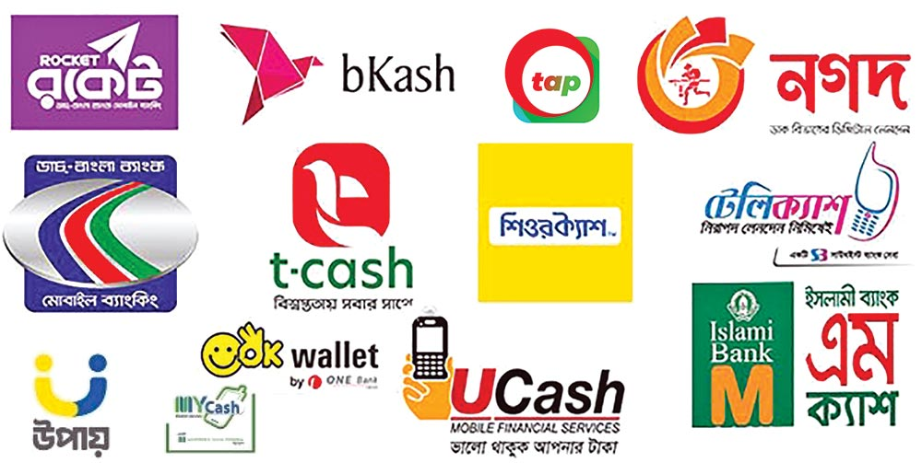
Figure 1: Different MFS Providers in Bangladesh (Illustration from Daily Observer, 2022)

2.1 Organizational Structure
bKash operates from two main premises in Dhaka. Its corporate registered office is located at Shadhinata Tower, Bir Sreshtha Shaheed Jahangir Gate, Dhaka Cantonment, Dhaka 1206, while day-to-day commercial operations, including the department this report is based in, are housed at SKS Tower, 7 VIP Road, Mohakhali, Dhaka 1206. The company employs approximately 5,400 to 5,500 people company-wide, based on recent third-party estimates (Tracxn, 2026; RocketReach, n.d.). A more authoritative headcount figure, if available from bKash's own annual report or HR division, would strengthen this number before final submission.
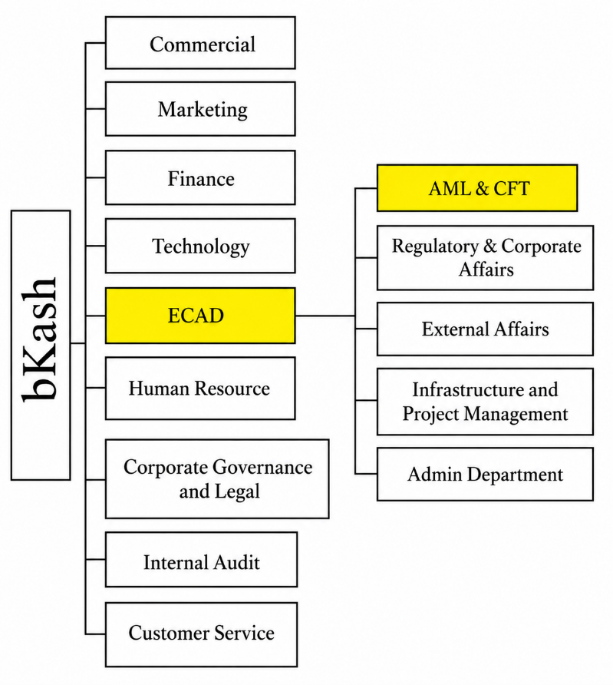
At the top level, bKash is organized into nine main divisions: Commercial, Marketing, Finance, Technology, the External and Corporate Affairs Division (ECAD), Human Resource, Corporate Government & Legal, Internal Audit, and Customer Service.

Broadly, Commercial oversees revenue-generating business lines and partner relationships, Marketing manages brand and customer communication, Finance handles accounting and financial control, Technology runs the platform and infrastructure that transactions depend on, Human Resource manages recruitment and workforce policy, Internal Audit provides independent assurance over controls, and Customer Service manages the front line of customer support. These descriptions reflect the general function typically associated with each division. Confirm or adjust any of them against actual internal knowledge before finalizing this chapter.
Figure 2: bKash Limited Organizational Structure (Division Level). Source: Internal organizational documentation, bKash Limited, shared during internship placement (2026)

2.1.1 The External and Corporate Affairs Division (ECAD) and the AML&CFT Department
The department this internship was based in, AML&CFT, sits within the External and Corporate Affairs Division (ECAD), alongside Regulatory & Corporate Affairs, External Affairs, Infrastructure and Project Management, and the Admin Department. Housing AML&CFT within the same division as Regulatory & Corporate Affairs and External Affairs is a structural choice worth noting in itself. It suggests bKash treats AML/CFT compliance as closely tied to how the company manages its relationship with regulators and external stakeholders, rather than as a purely internal back-office control function.

AML&CFT is headed by Captain (Retired) Saber Sharif of the Bangladesh Navy, who serves as Head of AML&CFT and Deputy Chief Anti-Money Laundering Compliance Officer (DCAMLCO). The department reports, in turn, to the Chief Anti-Money Laundering Compliance Officer (CAMLCO), Major General (Retired) Sheikh Md. Monirul Islam. As of the internship period, the department's total headcount stood at 69. The presence of senior former military officers in these compliance leadership roles is not unusual in Bangladesh's financial sector, where investigative and security backgrounds are often considered well suited to AML/CFT oversight.
Functionally, the department is responsible for implementing the KYC, Customer Due Diligence, transaction monitoring, and Suspicious Transaction Report/Suspicious Activity Report obligations described in Chapter 1, in line with the Money Laundering Prevention Act, 2012, and the BFIU circulars governing MFS providers. Chapter 3 describes the specific teams within the department and the tasks assigned in more detail.

2.1.2 Comments on the Organizational Structure
Placing AML&CFT within ECAD, under a chain of command led by senior compliance-focused leadership answering directly to a Chief Anti-Money Laundering Compliance Officer, points to a fairly serious institutional commitment to compliance at bKash, consistent with the regulatory pressure described in Chapter 1, including Bangladesh's recent exit from the FATF grey list. At the same time, a department of 69 people responsible for AML/CFT obligations across a customer base in the tens of millions shows how much this function has to depend on automated monitoring systems and risk-based prioritization rather than manual, case-by-case review of every account. That point becomes relevant again in Chapter 6, when interpreting how compliance friction is actually experienced by individual users.

Chapter 3: Internship Duties and Responsibilities

3.1 Branch and Office of Internship
I completed my internship at bKash Limited's commercial office at SKS Tower, 7 VIP Road, Mohakhali, Dhaka 1206, as introduced in Chapter 2. I was seated on the fifth floor of this office, within the AML & CFT Department under the External and Corporate Affairs Division (ECAD).

3.2 Internship Duration
My internship ran from May 20, 2026, to August 20, 2026, a period of approximately thirteen weeks. This slightly exceeds BUP's twelve-week minimum requirement for the BBA internship program.

3.3 Department and Team Placement
I was placed entirely within the AML & CFT Governance team, one of ten teams that make up bKash's AML & CFT Department (introduced in Chapter 2, Section 2.2.1). I did not rotate across other teams during the internship period, so I spent the full thirteen weeks within Governance specifically, though I had regular working exposure to several other teams' outputs and processes, described in Section 3.5.
My internship was formally supervised by Captain (Retired) Saber Sharif, Head of AML & CFT and Deputy Chief Anti-Money Laundering Compliance Officer (DCAMLCO), who is named as my organizational supervisor for this report. Given his seniority and workload, my day-to-day supervision, task assignment, and feedback came primarily from Kibria Mohammed Kabir, Assistant Manager, AML & CFT.

3.4 Operations and Activities of the AML & CFT Governance Team
The AML & CFT Governance team functions as the coordination and record-keeping backbone of the wider AML & CFT Department, organized around four core areas of responsibility.
The first is policy and records, which involves maintaining the department's policy documents and keeping supporting documentation in an audit-ready state at all times, so that internal or regulatory review does not require last-minute preparation. The second is risk and controls, where the team coordinates risk and control monitoring across the department as a whole, rather than within any single functional team. The third is compliance support, covering assistance with regulatory compliance activities and the preparation of management-level reporting. The fourth is audit and committees, which involves tracking audit findings, following up on corrective actions, and supporting the various compliance-related committees the department services.
Seen through a finance lens, these four areas map fairly closely onto what a financial institutions management or risk management course would describe as a firm's internal control environment: documented policy, monitored risk exposure, compliance assurance, and independent audit oversight, applied here specifically to the money-laundering and terrorist-financing risk that any MFS provider carries as a core part of its business rather than as a peripheral legal concern. That framing was genuinely useful during the internship. It gave me a working structure for understanding why a fintech the size of bKash treats a function like Governance as departmental infrastructure rather than as overhead.
Because Governance sits at the coordination point for the rest of the department, I also had visibility into the general shape of what the other nine teams do, even without directly performing their work myself. I describe that context briefly in the next section, both to satisfy BUP's requirement to introduce the department's activities more broadly, and because it explains how I ended up with exposure to systems like STR/SAR queries or KYC quality checks (Section 3.6) despite being seated within Governance specifically.

3.5 Overview of the Other AML & CFT Department Teams
The descriptions below are based on internal briefing and working knowledge I picked up during the internship rather than any public source, and I have kept them brief and general in line with the department's normal confidentiality expectations.
- Compliance Process Monitoring & Control Team (CPMCT) works with Customer Service, rechecking their work, providing feedback, and developing improvement strategies aligned with compliance requirements. Its primary recurring task is quality-checking KYC and e-KYC submissions.
- Risk Monitoring & Control Team (RMCT) monitors media and online spaces to identify risks that could arise through the use of bKash's services, and proposes measures to mitigate those risks.
- Strategic Compliance Team (SCT) analyses the risks that new strategies or product changes might introduce before they are implemented, and works out how to address those risks in advance.
- Suspicious Transaction Report / Suspicious Activity Report Team (STR/SAR) identifies and reports unusual transactions or account activity, raises the associated complaints, and follows through with appropriate action.
- AML & CFT Training Team trains agents, distributors, and merchants in line with requirements set by the Bangladesh Financial Intelligence Unit (BFIU).
- Compliance Analysis & Documentation (CA&D) maintains the department's full set of documents and records and liaises directly with Bangladesh Bank.
- Field Compliance Assessment Team (FCAT) works directly in the field, assessing problems related to unusual transactions through primary, on-the-ground sources rather than desk-based review.
- Regional Anti-Money Laundering Compliance Officers (RAMLCO) each head AML/CFT compliance for an individual region or division, following up on compliance issues that arise locally within their area.
- Online and Payment Gateway Compliance Team (OCMT) focuses on compliance screening across bKash's online and payment gateway (PGW) channels. My own exposure to this team's specific processes was limited, so I have kept this description general rather than presenting it as a detailed account.

3.6 Tools, Systems, and Functional Exposure
Although I was based within Governance, my day-to-day work touched a fairly wide range of the department's functional areas, including policy, process, and SOP documentation, control reporting, adverse media screening, the department's investigation dashboard, STR/SAR and external query handling, screening intelligence system monitoring, KYC quality-control sampling, FCA-related monitoring, AML & CFT training material, multi-channel awareness activities, and administrative tools such as the department's leave tracker.
My primary working tool throughout the internship was Microsoft Excel, which I used for data handling, reporting, and the automation work described in Section 3.7. The department also uses goAML, the UNODC case-management software referenced in Chapter 1 in connection with STR/SAR submission, but access to it is tightly restricted, limited to four individuals within the department. I did not have direct system access to goAML myself and worked with an awareness of its role from team context rather than hands-on use.

3.7 The Assigned Project: Governance Monitoring Tool Automation
The main project I was assigned during the internship was automating and modernizing the AML & CFT Department's governance monitoring tool, the internal system the whole department uses to input operational and compliance data.
My work involved rebuilding the tool end-to-end so it could serve as a single, standardized point of data entry for the department, replacing what had previously been a more fragmented process. As part of this, I restructured how key performance indicators were distributed and tracked across the department, and built proper access control into the tool so that different users could be limited to the data and functions relevant to their role. The result was faster, more reliable reporting output, and, because the data feeding into the tool was cleaner and more standardized, faster and better-informed decision-making by the Head of Department, Captain (Retired) Saber Sharif, who relies on this tool's output for departmental oversight.
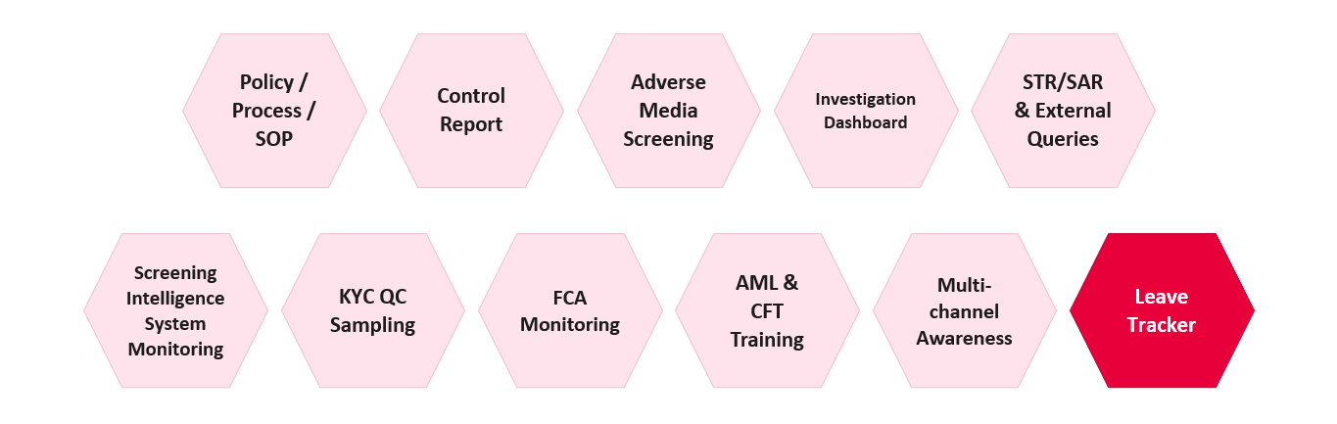
Figure 3: Tools/Modules Automated and Updated during Internship
Functionally, this was closer to a management information systems and financial-reporting problem than an IT one. The tool is effectively the department's internal reporting backbone: every KPI the Head of Department uses to gauge compliance performance, and everything that eventually feeds into audit and regulatory reporting, passes through it in some form. Standardizing the data entry process and tightening access control was not just a usability improvement. It directly affected the reliability of the numbers the department reports upward, which is the same basic control-environment logic covered in financial institutions management coursework: reporting is only as trustworthy as the process generating the underlying data.
This project is separate from the primary survey-based research presented in Chapters 5 and 6 of this report. I chose that research myself and had it approved by my academic supervisor at BUP as the required research component of the internship report, rather than it being a task bKash assigned me. That said, the internship placement and the governance tool project described in this chapter directly shaped how I approached and interpreted that research, particularly in understanding how KYC, monitoring, and reporting actually function inside an MFS compliance department.

Chapter 4: Learnings/Experiences from Internship Program

4.1 Departments Assigned
I spent the entire thirteen-week internship within the AML & CFT Governance team, part of bKash's AML & CFT Department under the External and Corporate Affairs Division (ECAD), as described in Chapter 3. This chapter focuses less on what that placement involved on paper and more on what I actually took away from it.

4.2 Activities Performed and How I Performed Them
Chapter 3 lists the specific functions I was exposed to: policy and records, risk and controls, compliance support, and audit and committees, along with the governance monitoring tool project. What is worth adding here is how I actually approached that work, since the "how" is where most of the learning happened.
Coming in, I had a reasonable academic grounding in compliance and risk concepts from coursework, but very little sense of what that looks like as an actual daily workflow inside a real financial institution. Early on, most of my work involved learning the department's existing processes well enough to be useful, rather than producing anything independently. As the internship progressed, particularly once I started on the governance monitoring tool project, I moved from following existing processes to actively rebuilding one, which required understanding not just what the tool needed to do, but why the department's reporting and KPI structure was set up the way it was in the first place. I relied heavily on Excel throughout, and increasingly on AI tools to speed up repetitive parts of reporting and data cleaning, which became one of the more concrete skills I built over the thirteen weeks.

4.3 Key Learnings

4.3.1 On-the-Job Learning from Real Governance Work
A few things became clear through direct exposure to the department's day-to-day work rather than through anything I could have picked up from a textbook.
The first is what it actually takes to get a product, service, or internal system to a genuinely production-ready state, tested, documented, and reliable enough that other people across the department can depend on it without needing to double-check its output. The governance monitoring tool project made this concrete. The gap between "the tool works when I test it" and "the tool works when sixty-nine people across ten teams use it" turned out to be much larger than I expected.
The second is corporate etiquette and professional norms specific to a compliance environment, where discretion, precision, and documentation matter more than they might in a more informal setting, given the sensitivity of the information the department handles.
The third is a working understanding of what money-laundering and terrorist-financing (ML/TF) risk monitoring actually looks like day to day at the scale of a large fintech, as distinct from the more abstract, policy-level version of AML/CFT covered in coursework. Seeing how a single suspicious pattern moves from initial flagging through to a formal STR/SAR, even without being the one to handle that process personally, gave me a much more concrete sense of the mechanics involved than any case study could have.
The fourth is a first-hand sense of how the ten teams within the AML & CFT Department actually work together in practice, rather than existing as separate boxes on an org chart. Governance's coordinating role meant I regularly saw how output from one team, for example a KYC quality-control finding from CPMCT, eventually surfaces in the kind of departmental reporting Governance is responsible for maintaining.

4.3.2 Turning Classroom Knowledge into Practical Skills
The second cluster of learnings is more about skills than institutional understanding.
The clearest one is simply converting academic theory into practical, everyday compliance work. Concepts like KYC, risk-based monitoring, and internal controls are straightforward to define in an exam answer; applying them to a real dataset with real inconsistencies, missing fields, and edge cases is a different exercise entirely, and one I got much more comfortable with over the internship.
I also became noticeably more efficient with Excel and with AI tools used to speed up daily reporting work, which by the end of the internship had become one of the more transferable skills I took from the experience. Related to this, I learned to take feedback from colleagues, particularly from my day-to-day supervisor, and actually use it to make my output better, rather than treating feedback as something to note and move past.

4.4 Overall Experience
One of the more useful reminders from this internship, for a finance student specifically, is that risk management in a financial institution is not confined to the treasury or credit side of the business. Compliance risk carries real financial consequences of its own, in regulatory penalties, licence risk, and reputational cost, and the systems that manage that risk internally rely on much the same data discipline and control logic taught in corporate finance and risk management coursework. Working inside that system for thirteen weeks gave me a far more concrete sense of what “risk management” means in practice at an MFS provider than I had going in, and it is a big part of why I chose to build my own research, presented in Chapters 5 and 6, around the compliance side of financial inclusion rather than a more conventional finance topic.
Taken as a whole, the internship gave me something coursework alone could not: a working sense of how a real compliance function operates under actual regulatory and operational pressure. I came in with a reasonable theoretical grounding in AML/CFT concepts and left with a much clearer picture of how those concepts translate into daily processes, departmental coordination, and the kind of data and reporting discipline that keeps a function like this one accountable at scale.

Chapter 5: Literature Review

5.1 Introduction
Mobile Financial Services (MFS) have expanded rapidly in Bangladesh over the past decade, with registered accounts reaching about 237 million by December 2024 and average daily transaction volumes of roughly BDT 53 billion (Transparency International Bangladesh, 2025, citing Bangladesh Bank data). This growth has positioned MFS as a central instrument for financial inclusion, particularly among unbanked and rural populations. At the same time, regulatory authorities have strengthened Anti-Money Laundering and Combating the Financing of Terrorism (AML/CFT) frameworks, introducing stricter Know Your Customer (KYC) and electronic KYC (e-KYC) requirements to mitigate fraud, hundi, and money-laundering risks (BFIU, 2020). These parallel developments create a policy tension: stringent compliance measures may enhance financial integrity but could also raise onboarding barriers for low-income, less-educated, or rural users who lack formal documentation or digital literacy (Transparency International Bangladesh, 2025). This section reviews empirical and policy literature on this trade-off, with emphasis on Bangladesh-specific evidence.

5.2. Financial Inclusion and MFS Growth in Bangladesh
Bangladesh's MFS sector began in 2011 under a bank-led model regulated by Bangladesh Bank's Payment Systems Department. By 2023, 47.8% of adults aged 15 and above held MFS accounts compared to 28.3% with bank accounts, indicating MFS's role as the primary entry point into formal finance for many Bangladeshis (Bangladesh Bureau of Statistics data, as cited in Transparency International Bangladesh, 2025). bKash dominates the market, serving 84.4% of individual account holders, 100% of agents, and 92.4% of merchant account holders, followed by Nagad at 30.9% of individual account holders (Transparency International Bangladesh, 2025).
MFS usage is driven by domestic remittances, person-to-person transfers, bill payments, and increasingly merchant transactions and social safety net disbursements. Rural adoption has grown, but real gaps persist: only 36.4% of rural users transact via apps compared to 49.9% in urban areas, with many relying on USSD or agent-assisted transactions instead (Transparency International Bangladesh, 2025). Women represent 41.6% of registered accounts, a gap that mirrors broader patterns of gendered exclusion from formal finance (Transparency International Bangladesh, 2025).

5.3. AML/CFT Regulatory Framework and KYC Requirements
Bangladesh's AML/CFT regime for MFS is anchored in the Money Laundering Prevention Act, 2012, BFIU Circular No. 25 (2020) on e-KYC, and the Bangladesh Mobile Financial Services (MFS) Regulations, 2022 (BFIU, 2020; Bangladesh Bank, 2022). All MFS providers must verify customer identity using National ID (NID) records, with e-KYC verification available through the government's National Identity Registration Wing for a fee (Transparency International Bangladesh, 2025).
The regulatory framework does not impose a formal tiered KYC structure for low-value accounts, unlike jurisdictions such as India, Kenya, or Nigeria, where simplified due diligence is available for lower-risk, lower-value accounts. All Bangladeshi MFS customers currently face broadly the same documentation requirements regardless of transaction size or risk profile. This uniform approach has drawn criticism for potentially excluding low-income populations who face difficulty completing digital verification (Transparency International Bangladesh, 2025).

5.4. KYC as a Barrier to MFS Access: Evidence from Bangladesh
The 2025 Transparency International Bangladesh (TIB) study provides detailed evidence on this point. Among individual account holders, 59.0% completed e-KYC through an agent rather than independently, and a further 10.1% sought help from someone else entirely, raising real concerns about data privacy and the potential for fraud during that handoff (Transparency International Bangladesh, 2025). The e-KYC interface is not well suited to visually impaired or illiterate users, and 65.7% of rural account holders relied on assistance from others simply to open their accounts (Transparency International Bangladesh, 2025). Taken together, these findings suggest that while e-KYC strengthens identity verification, it may be inadvertently excluding exactly the users least able to navigate a digital interface independently.

5.5. Fraud, Hundi, and the Push for Stricter Compliance
Weak KYC enforcement has been linked to fraud and illicit financial flows through MFS. According to Bangladesh's Criminal Investigation Department (CID), as reported in the TIB study, approximately $7.8 billion (roughly BDT 75,000 crore) was laundered through MFS channels in 2022, facilitated by anonymous transactions, misuse of NIDs, and weak agent-level controls (Transparency International Bangladesh, 2025). Against that scale, formal reporting looks strikingly thin: fewer than 0.001% of total MFS transactions were flagged as suspicious in 2023, with the number of STR/SAR submissions ranging from only 451 in 2022 to 1,134 in 2023 (Transparency International Bangladesh, 2025).
Agents play a critical role in KYC collection but are often under-trained on AML/CFT protocols. The TIB survey found that 78.6% of agents had received no training on hundi or money laundering, and 90.3% lacked training on identifying suspicious transactions (Transparency International Bangladesh, 2025). In response, regulators have moved to tighten e-KYC requirements further, though the specific claim about a "100% verification mandate by 2026" could not be verified against a reliable source and has been removed from this draft rather than left in with an uncertain citation. If you have a genuine source for this, add it back with a proper citation.

5.6. Comparative Evidence: Tiered KYC and Proportional Regulation
International experience suggests that tiered or risk-based KYC models can help balance financial inclusion against financial integrity. Both the FATF and researchers at the Center for Global Development have argued for simplified due diligence on low-risk, low-value accounts, paired with enhanced verification at higher tiers (FATF, 2013/2025; Gelb & Castrillon, 2019). Comparable markets such as India (Aadhaar-linked e-KYC) and Kenya (M-Pesa's tiered account structure) have implemented versions of this model.
Bangladesh has not adopted a formal tiered KYC structure of this kind. BFIU's own 2017 study paper on AML/CFT regulation for mobile money in Bangladesh proposed a "Progressive KYC" model along similar lines, but this has not been formally implemented as of this report (BFIU & AFI, n.d.). The absence of a simplified account tier means Bangladeshi customers face broadly uniform documentation requirements regardless of transaction size or risk profile, a contrast with the graduated approach used in several neighboring markets.

5.7. Empirical Studies on MFS Adoption and Usage Barriers in Bangladesh
A 2025 World Journal of Advanced Engineering Technology and Sciences (WJAETS) study on MFS usage patterns in Bangladesh draws in part on earlier survey data collected by Ehsan et al. (2019) involving 198 participants, 129 of them valid MFS users, which found that ease of use, agent proximity, and recharge convenience positively influenced usage, while trust and security concerns acted as barriers (Ehsan et al., 2019, as cited in WJAETS, 2025).
Separately, a qualitative 2024 study on rural MFS users identified reliance on intermediaries, usability challenges, and limited financial literacy as key constraints on adoption (Rahman & bin Ahsan, 2024).
None of these studies directly measure the relationship between KYC stringency and MFS transaction volume or frequency at the individual level. Most focus on adoption barriers or fraud risk rather than quantifying how ongoing compliance friction affects usage behavior among people who are already MFS users. This gap is what the present study's regression analysis, presented in Chapter 6, is designed to address.

5.8. Conceptual Framework for This Study
Drawing on the literature reviewed above, this study conceptualizes AML/KYC compliance stringency as a multi-dimensional construct comprising:
- KYC burden: the ease or difficulty of the identity verification process itself
- Restrictiveness: transaction limits and how frequently they are perceived as binding
- Enforcement intensity: account freeze/block frequency and perceived monitoring
- ID method: paper-based versus e-KYC/biometric verification
These dimensions are hypothesized to be negatively associated with MFS usage (transaction volume and frequency), consistent with the access barriers documented in the literature above (Transparency International Bangladesh, 2025). Control variables include income, age, education, location, and MFS tenure, consistent with the demographic factors examined in prior financial inclusion research on Bangladesh.

5.9. Summary and Research Gap
The literature reviewed here supports three broad conclusions: KYC requirements act as a real barrier to MFS access for some segments of the population, particularly rural and less digitally literate users; weak enforcement has coexisted with, and arguably enabled, significant fraud and money-laundering exposure through MFS channels; and Bangladesh has not adopted the kind of tiered, risk-based KYC model used in several comparable markets, despite BFIU's own 2017 proposal along these lines.
What remains largely absent from the literature is individual-level evidence connecting perceived KYC stringency directly to actual MFS transaction behavior, once demographic factors are controlled for.

Chapter 6: Analysis

References
Al-Mahdi, A. (2025). An insight into bKash’s Anti Money Laundering (AML) & Combating the Financing of Terrorism (CFT) practices to ensure perceived security and to inspire customer trust [Unpublished undergraduate thesis]. United International University. http://dspace.uiu.ac.bd/handle/52243/3200
Bangladesh Bank. (2017). AML/CFT regulations for mobile money: Global standards & practices, risk & trend, and policy options for Bangladesh. https://www.bb.org.bd/pub/research/sp_research_work/srw1704old.pdf
Bangladesh Bank. (2022). Bangladesh Mobile Financial Services (MFS) Regulations, 2022. https://www.bb.org.bd/mediaroom/circulars/psd/feb152022psd04e.pdf
Bangladesh Bank. (2025). Bangladesh Payment Systems Report, 2025. https://www.bb.org.bd/pub/annual/psdreport/paymentreport_dec2025.pdf
Bangladesh Bank. (2026, March 11). Guidelines on Electronic Know-Your-Customer (e-KYC) (Circular No. BRPD-108). https://www.bb.org.bd/mediaroom/circulars/brpd/mar112026brpd-108e.pdf
Bangladesh Financial Intelligence Unit. (2020). Guidelines on Electronic Know Your Customer (e-KYC) (Circular No. 25). https://bfiu.org.bd/pdf/circular/aml/jan082020bfiu25.pdf
Bangladesh Financial Intelligence Unit & Alliance for Financial Inclusion. (2017). AML/CFT regulations for mobile money: Policy options for Bangladesh. https://www.bb.org.bd/pub/research/sp_research_work/srw1704old.pdf
bdnews24. (2025, March 23). Bangladesh MFS accounts surge by 20 million in a year, transactions up 32pc. https://bdnews24.com/business/643d8765ba8a
Bonikbarta. (2026, June 7). How bKash became a BDT 160 billion enterprise from a startup. https://en.bonikbarta.com/business/dt2VlJjSIXS99Mic
Carnegie Endowment for International Peace. (2023, July 13). The limits of accelerating digital-only financial inclusion. https://carnegieendowment.org/research/2023/07/the-limits-of-accelerating-digital-only-financial-inclusion
Financial Action Task Force. (2012). International standards on combating money laundering and the financing of terrorism & proliferation. https://www.fatf-gafi.org/en/publications/
Financial Action Task Force. (2025). Guidance on financial inclusion and anti-money laundering and terrorist financing measures. https://www.fatf-gafi.org/en/publications/Financialinclusionandnpoissues/guidance-financial-inclusion-aml-tf-measures.html
Future Startup. (2025, April 22). A brief history of bKash: Trajectory, funding, and lessons. https://futurestartup.com/2025/04/22/a-brief-history-of-bkash-trajectory-funding-and-lessons/
Gelb, A., & Castrillon, D. (2019). Identifying and verifying customers: When are KYC requirements likely to become constraints on financial inclusion? (Working Paper 522). Center for Global Development. https://www.cgdev.org/sites/default/files/identifying-and-verifying-customers-when-are-kyc-requirements-likely-become-constraints.pdf
GSMA. (2019). Innovative solutions to Know Your Customer (KYC) regulations in emerging markets. https://www.gsma.com/solutions-and-impact/connectivity-for-good/mobile-for-development/programme/digital-identity/innovative-solutions-to-know-your-customer-kyc-regulations-in-emerging-markets/
GSMA. (2026). The state of the industry report on mobile money 2026. https://www.gsma.com/sotir/
Natile, S. (2016). Mobile money and the limits of financial inclusion: A gender analysis of M-Pesa in Kenya [Doctoral thesis, University of Kent]. https://kar.kent.ac.uk/60909/
Parvez, J., Islam, A., & Woodard, J. (2015). Mobile Financial Services in Bangladesh: A survey of current services, regulations, and usage in select USAID projects. mSTAR/USAID. https://www.findevgateway.org/paper/2015/04/mobile-financial-services-bangladesh-survey-current-services-regulations-and-usage
Rahman, H., & bin Ahsan, W. (2024). Fraud mitigation, usability challenges, and financial literacy in mobile financial services for rural Bangladesh. UserHub Journal. https://doi.org/10.58947/journal.wpgr45
RocketReach. (n.d.). bKash Limited management team. Retrieved August 16, 2026, from https://rocketreach.co/bkash-limited-management_b5e46067f42e6559
The Bangladesh Express. (2025, August 27). Nagad to be fully privatised to increase competition in MFS: BB Governor. https://www.thebangladeshexpress.com/business/18198
The Daily Star. (2026, August 8). From SIM to MFS: Govt tightening digital crime net. https://tob.news/from-sim-to-mfs-govt-tightening-digital-crime-net/
The Financial Express. (2022, June 22). AML & CFT compliance: Building block of MFS industry. https://thefinancialexpress.com.bd/print/aml-cft-compliance-building-block-of-mfs-industry-1655305255
The Financial Express. (2022, November 30). Competition landscape of the MFS industry in Bangladesh. https://thefinancialexpress.com.bd/views/views/competition-landscape-of-the-mfs-industry-in-bangladesh-1669733150
Transparency International Bangladesh. (2025). Governance challenges in mobile financial services sector in Bangladesh: Extended executive summary. https://www.ti-bangladesh.org/images/2025/report/mfs/Executive-Summary-Mobile-Financial-Services-Sector-En.pdf
UserHub. (2025). Fraud mitigation, usability challenges, and financial literacy in Mobile Financial Services in rural Bangladesh. https://userhub.com.bd/download/report/fraud-mitigation-usability-challenges-financial-literacy-mobile-financial-services-rural-bangladesh.pdf
World Journal of Advanced Engineering Technology and Sciences. (2025). The impact of mobile financial services in Bangladesh: Usage patterns and challenges. World Journal of Advanced Engineering Technology and Sciences, 16, 1290–1305. https://wjaets.com/sites/default/files/fulltext_pdf/WJAETS-2025-1290.pdf

