# CONTENT

1. Insights
2. Relevant visualizations
3. Answers to the company's questions.

# Insights

* Majority of the customers stay in City Hotel
* Majority of the Customers do NOT cancel their reservations
* Majority of the reservations are done from City Hotel.
* April to Oct are considered high seasons for City Hotel. For Resort Hotel mostly July and August are considered high seasons.
* Mostly the clients stays 0 nights or 2 nights or 1 night during the weekend.
* During the week days the customers stays 2, 1 or 3 nights.
* Majority of the reservations will not have any childrens.
* Majority of the meals reserved are BB – Bed & Breakfast.
* Majority of the customers are from Portugal, United Kingdom or France.
* Majority of the reservations are for: TA: means Travel Agents.
* Majority of the reservations room type is A.
* Majority no changes on the boking.
* Majority did the checkout for each type of hotel

# Relevant visualizations

# Answers to the hotel booking questions.

**Can we predict when a customer is going to cancel a reservation?**

Yes is possible we have an RFC model that will predict if a customer will cancel or not his/her reservation with a 82% of accuracy.   
For this model there’s a precision of 82% for the customer that doesn’t cancel the reservation and 81% of the precision for the customer that really cancel the reservation.

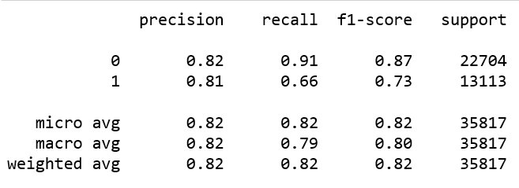

A second model was also created using SVM (Support vector machine) but the accuracy is lower with just a 79%.   
For this model there’s a precision of 77% for the customer that doesn’t cancel the reservation and 86% of the precision for the customer that really cancel the reservation.

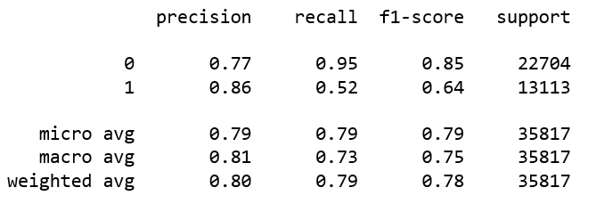

A third model was created using Neural Network and the accuracy was higher with 84% of precision.

For this model there’s a precision of 88% for the customer that doesn’t cancel the reservation and 78% of the precision for the customer that really cancel the reservation.

Also another model was created using the Gradient Boosting algorithms having a precision of 83%.

For this model there’s a precision of 84% for the customer that doesn’t cancel the reservation and 82% of the precision for the customer that really cancel the reservation.

Overall using the Neural Network we will have a precision of the prediction of 84% been that model the best one (if we interested to predict both cancel and Not cancel). If we are interested to predict the reservations that will be cancel that is not the best model to choose, a good option could be the one using Gradient Boosting with an overall 83% of precision and 82% precision on the cancelation from customers.