FINAL PROJECT DOCUMENTATION
All the customized text is written in BLUE. You are required to replace it with details according to your own project and then change font color to BLACK.
Kindly pay attention to properties of font carefully and follow the same formatting accordingly as mentioned in given document.
E.g. Project Titlehas following font properties:
Size: 24
Color: Black
Alignment: Center
Style: Bold
Font: Times New Roman

Project Title
Replace with your project title and change font color to BLACK& BOLD
Project title must be self-defining what actually you project can do and should not be confusing.


Submitted By

Student name | Reg #
Student name | Reg #
Student name | Reg #
Supervisor
Name
Designation

Year

Barani Institute of Sciences, Sahiwal
PMAS-Arid Agriculture University, Rawalpindi
Project Title
Write your department and remove the rest

Project submitted to
Department of Computer Science
Barani Institute of Sciences, Sahiwal

By
Student name | Reg #
Student name | Reg #
Student name | Reg #

In partial fulfillment of the requirements for the degree of
(BSCS/SE (Hons.))

Write only the title of degree you registered in, and remove the rest
Footer is started from this page. The footer content shouldn’t be changed.

Barani Institute of Sciences, Sahiwal
PMAS-Arid Agriculture University, Rawalpindi
Members’ Detail
To be given by Department

Project ID | BIS-SWL-BSCS-2021-01

Project Title
Group Leader: Member Name
Group Members:3
Name | Registration # | Email Address | Class
Member 1 | Reg # | membermailid@gmail.com | BSCS
Member 2 | Reg # | membermailid@gmail.com | BSCS
Member 3 | Reg # | membermailid@gmail.com | BSCS

_____________________
Muhammad Waleed
Project Coordinator, BIS-SWL

Date Format:
October 23, 2017
(Hand Written)
Dated: _____________________

Dedication
Dedicated to our beloved parents, our teachers, most importantly to our supervisor ‘Ms. Maryam Saba’ and to all those, whose prayers are always pave to the success for us۔

Project Summary
Do not add new rows in this table.

Project Title | Project Name
Project ID | BIS-SWl-BSCS-F2021-01
Organization | Gujrat Institute of Management Sciences
Objective | Write the objectives of project here  - Obj 1  - Obj 2  - .  - .
Undertaken By | Member 1 (Roll #), Member 2 (Roll #), and Member 3 (Roll #)
Supervised By | Supervisor name
Date started | March20, 2017
Date Completed | July 20, 2017
Technologies Used | Sublime text 2 , Code igniter etc.
System Used | Window 10 pro

Proofreading Certificate

This is to acknowledge that the project entitled

Project Title [BIS-SWL-2021-01]

has been proofread
By
Write name, designation and attached organization name.
Same patter will be followed for rest of relevant fields
E.g.
Mr. Ali
Lecturer, BIS-SWL

_____________________
Mr. / Ms. XYZ
Designation, Department/institution

Date Format:
October 23, 2017
(Hand Written)

Dated: _____________________

Declaration
We hereby declare that we developed this project and this report entirely on the basis of our personal efforts made under the sincere guidance of our project supervisor. We further declare that, thetitled project and all associated documents, reports are submitted as partial requirements for the degree of “BS (Hons.) in Computer Sciences/ SE ”.
The title of degree you registered in

Members’ Name | Registration # | Signature
Student name | 1234 | _______________
Student name | 1234 | _______________
Student name | 1234 | _______________

Date Format:
October 23, 2017
(Hand Written)

Dated: __________________

Acknowledgement
First and foremost, we would like to express gratitude towards Almighty Allah, the most Merciful, whose countless blessings help us to complete this project. WE gained a lot of knowledge by performing this task and it will surely advantage us in the future life. My many friends assisted me throughout the project but WE appreciate the assistance and support of PMAS Arid Agriculture University Rawalpindi, who help out me in all the stages of this project. His direction helped us a lot during difficulties. In the end, WE would also like to appreciate all our friends for their valuable suggestions support, inspiration and guidance.
Certificate
This is to certify that Name of Student, Roll #, Name of Student, Roll #, and Name of Student, Roll # have successfully completed the final project titled:“your project’s title will come here”, accepted by the Department of Computer Science/IT and find satisfactory for the requirement of:
Barani Institute of Sciences, Sahiwal
PMAS-Arid Agriculture University Rawalpindi

For Award of the Degree

Degree Title

________________
Supervisor
Mr. / MS. XYZ
Designation, BIS-SWL
________________
Examiner 1
Mr. / MS. XYZ
Designation, BIS-SWL
 | ________________  Examiner 2  Mr. / MS. XYZ  Designation, BIS-SWL | Date Format:  October 23, 2017  (Hand Written)
________________
Examiner 3
Mr. / MS. XYZ
Designation, BIS-SWL
________________  HOD/CS-IT  BIS-SWL |  | ________________  Director General  BIS-SWL
Dated:___________________

Abstract
The BLUEtext enclosed in [ ] is description of the corresponding section followed by an example i.e. to assist that what and how you should write in each heading/section.
Note: Same pattern will be followed in rest of the sections. You are required to write your own description in each section.
Line Spacing: 1-1.5 (Adjust able in case of large abstract)

[Thedocumentation should be introduced by an abstract of around 300 to 500 words, which enables the reader to get an overview of the contents of the project without reading it. It must include a clear statement of the expected novel contribution to the subject.
Provide a concise summary of the proposed effort describing the objectives, theoretical background, and experimental approach. The abstract should convey the essential nature of the work to other scientific/technical personnel. ]
FOR EXAMPLE: This project is aimed at developing a desktop based application named Inventory Management System for managing the inventory system of any organization. The Inventory Management System (IMS) refers to the system and processes to manage the stock of organization with the involvement of Technology system. This system can be used to store the details of the inventory, stock maintenance, update the inventory based on the sales details, generate sales and inventory report daily or weekly based. This project is categorize individual aspects for the sales and inventory management system. In this system we are solving different problem affecting to direct sales management and purchase management. Inventory Management System is important to ensure quality control in businesses that handle transactions resolving around consumer goods. Without proper inventory control, a large retail store may run out of stock on an important item. A good inventory management system will alert the wholesaler when it is time to record. Inventory Management System is also on important means of automatically tracking large shipment. An automated Inventory Management System helps to minimize the errors while recording the stock.

Table of Contents
Font Size: 12
Font: Times New Roman
Line Spacing: 1.5
Same formatting for “List of Figures”, “List of Tables” etc.
It should be auto generated. Manually written TOC is strictly prohibited.
Throughout the TOC, remove “Space before and after Paragraph”.
Row with each Chapter name should be bold. The rest should be normal

Dedication iii
Project Summary iv
Acknowledgement vii
Abstract ix
Table of Contents x
List of Tables xii
List of Figures xiii
List of Abbreviations xiv
Chapter 1 Introduction 2
1.1 Problem Statement 3
1.2 Significance 5
1.3 Objectives 5
1.4 Limitations and Restrictions: 6
1.5 Overview 6
1.6 System Architecture 7
1.7 Software/Hardware Requirements 8
1.8 Implementation Tools and Technology 8
1.9 Implementation Plan 9
1.9.1 Deliverable Items 9
1.9.2 Milestone Chart 9
Chapter 2 Requirement Analysis 12
2.1 Functional Requirements: 12
2.2 Non Functional Requirement: 13
2.3 Use Cases 14
Chapter 3 DESIGN 16
3.1 UML Diagrams 16
3.2 Use-Case Diagram 17
3.2.1 Use-Case Diagram for HMP 17
3.2.2 Admin 18
3.3 Class Diagram 19
3.4 Sequence Diagram 20
3.4.1 User Authentication 20
3.5 ERD 21
Chapter 4 Testing 23
4.1 Sign Up Admin User & Worker 23
Chapter 5 User Manual 25
5.1 Home Page 25
References: 26

List of Tables
Font Size: 12
Font: Times New Roman
Line Spacing: 1.5
Throughout the table, remove “Space before and after Paragraph”.

It should be auto generated. Manually written LOT is strictly prohibited.
Table 2.1: Use-Case 1 14
Table 4.1: Sign up Test case 23

List of Figures
Font Size: 12
Font: Times New Roman
Line Spacing: 1.5
Throughout the table, remove “Space before and after Paragraph”.

It should be auto generated. Manually written LOF is strictly prohibited.
Figure 1.1: Model-View-Controller 8
Figure 1.2: Gantt chart for milestones 10
Figure 3.1: Use-Case Diagram for SMP 17
Figure 3.2: Use-Case Diagram for Admin 18
Figure 3.3 Class Diagram 19
Figure 3.4: Sequence Diagram for User Authentication 20
Figure 3.5: ERD of HMP 21
Figure 5.1: Home Page 25

List of Abbreviations
HCI |  | Human Computer Interaction
UI |  | User Interface
UX |  | User Experience
SNK |  | Student-Newman-Keuls
TFT |  | Thin Film Transistor LCD
BOSS |  | Bank of Standardized Stimuli
AOI |  | Area of Interest
EEG |  | Electroencephalography
This section defines all terms, concepts, symbols, and acronyms used in the document.
This is a table with hidden border, so you can add more rows according to your own requirements.

- Page number should be written in footer and centralized.
- Up to this page, the page number should be ROMAN (i, ii, iii) styled.
- The actual page number should start from next page i.e. from 1st Chapter.
- From next page;
  - The page number will be numbered as 1, 2, and 3. . .
  - Footer will be removed

Chapter 1
This page should be added before each chapter starts and change Chapter #/ title accordingly. The text should be horizontally and vertically centralized.

Introduction

Introduction
[A good introduction should tell the reader what the project is about without assuming special knowledge and without introducing any specific material that might obscure the overview. It should anticipate and combine main points described in more detail in the rest of the project report. Also, importantly, it should enthuse the reader about the project, to encourage them to read the whole report. Normally it should include such things as:
The BLUEtext enclosed in [ ] is description of the corresponding section followed by an example i.e. to assist that what and how you should write in each heading/section.
Note: Same pattern will be followed in rest of the sections. You are required to write your own description in each section.
- The aim(s) or goal(s) of the project;
- The intended audience or “beneficiaries” of the work done;
- The scope of the project;
- The approach used in carrying out the project;
- Assumptions on which the work is based; and
- A broad summary of important outcomes.
]
FOR EXAMPLE: In this information technology revolution era, everybody is talking about the latest technology and trying to use it as an opportunity. People have seen an opportunity in usage of hashtag. Hashtag technology is being widely used by enterprises as a marketing technique. Hashtag were initially proposed as tags to manage and group related messages in social media. As time goes on, hashtag are being use by enterprises to organize hashtag campaign or event for marketing purpose. Hashtag management and analysis tool are one of the important tools for these enterprises in order for them to keep track of the particular hashtag that they are using.
The proposed system will provide functions that are need for ones to keep track on hashtag. Data analysis, graph and report generation can be done after data is collected. Public reaction and their satisfaction towards the event can be seen after analysis is being done.

[The rest of the introduction chapter will include the below mentioned elements:
  - Problem Statement
  - Project Goals
  - Significance
  - Objectives
  - Overview
  - Limitations and Restrictions
  - System Architecture
    - Component no.1
    - Component no.2
    - Component no.3
    - Component no.4
  - Software/Hardware Requirements
  - Implementation tools and Technologies
  - Implementation Plan
    - Deliverable Items
    - Milestone chart (Gant chart)
]

Problem Statement
[This section describes the problem that is to be addressed during the project work.
This is the rationale for what you will be doing and why it is important, why it demands your attention. You might present this statement in terms of quantitative metrics or qualitative criteria, or you may simply state the problem in the form of one or more questions: "what if"? Since the problems can be theoretical or applied in nature, the statement of the problem can vary according to these forms. So, it becomes a matter of what is most appropriate, given the type of project work that is to be conducted, the domain(s) in which the work is being done, and on the nature and scope of the problem to be solved.
It is no use coming up with a problem such as "I want to solve the problems of software maintenance". The Assessors here are looking for clear focus and a clearly identified problem. Also, be sure to identify both the particular problem you are solving and also the foundational issues you are addressing. The latter will consist of the generic problem you are solving, and its solution will enable you to clarify the contribution to your field. ]
FOR EXAMPLE:Social media provides a great platform and chances to organization for public engagement and spreading event information in a fast pace widely. Social media can be a good marketing platform to spread whether an idea, thought or even commercial products by using hashtag. Advertisers see this as a big opportunity to promote and market about their products, service and brands by using the power of social networking. Social media and hashtag became a good place for real time identification of what is trending now. Besides being a great marketing channel, with the amount of user that is continuously increasing; social media became a place for enterprises to collect information and to listen to the public. In order to achieve this, enterprises are making use of social media platforms and hashtag as promotional and marketing tools. As events go on, the public will often try to get, share and spread the information to others. In a real time event, a certain hashtag will probably be used in the tweets, picture’s captions, statuses and etc. Collecting all these data is extremely important to organizers and enterprises in order to know what the public think, collecting feedback on events and use these data as insight for further planning of upcoming events. Due to large amount of user generated content about the event such as tweets, pictures and etc.; collection of data by using traditional methods are difficult and it requires large amount of time to review all the content. Since data are so important to the enterprises, definitely the enterprises would like to capture all the data but in the other hand collecting all these data requires a lot of time. This is the time where social media monitoring tool comes in place. By using these tools, enterprises will be able to collect all the user-generated content easily resulting in higher demand of social media monitor and analytical tool.
Re-state the problem clearly and precisely and say what your project intends to do or what you plan to do with the problem. In other words, what is the purpose of your study?

Significance
[Why is your project important? How is it different from other projects on related topic? What new will it contribute to already existing solutions? What are its policy implications?]

Objectives
[In this section, the current state of the art specific to this project and the motivation and need for this work. Try and differentiate between your goals and your objectives - and include both. Objectives are operational, describe specific things you will be accomplishing in your project, and are very measurable. Your objectives will form the basis for the activities of your project and will also serve as the basis for the evaluation of your project. Measurable objectives for your project should be presented. If you are dealing with "things" it is easier for them to be measured than if you are dealing with abstract ideas. Your proposal is easier for prospective stakeholders if you describe your objectives in measurable ways.]
FOR EXAMPLE:The aim of the project is to create the propose system that to allow event organizers to keep track and analyze on hashtag campaigns; allow user to capture and monitor public responses and to further make use of captured data.
The objectives are:
- To develop a desktop application that would allow user to search for a particular hashtag from social media.
- To enable real time update which allow user to keep track on the ongoing or past event or campaign with hashtag.
- To collect responses on social media with the hashtag use
- To use an appropriate analysis method (sentiment analysis) to generate graph and reports based on public satisfaction.
- To make use of data gather to enhance the event attraction, i.e. random picking for lucky draw, printing of pictures collected.

Limitations and Restrictions:
[List and describe each of the internal (self) and external (environment) limitations and/or restrictions on the range of system functions: What will the system not do. DO NOT INSULT THE READER BY INCLUDING ITEMS THAT WOULD NOT BE A SURPRISE.]
Same table formatting should be followed i.e. no Left and Right Border, Top table border style: , Bottom Table border style:, in-between border

Overview
This letter should be issued by the concerned organization with the subject; that student will deploy the project in their organization.

Project Goal:
[Goals are the large statements of what you hope to accomplish but usually aren't very measurable. They create the setting for what you are proposing.]
Type of project: R&D Development
Project Success criteria:
[Project success criteria are the standards by which the project will be judged at the end to decide whether or not it has been successful in the eyes of the stakeholders, in your case, evaluators.]
Risks of the Project:
[Please describe the factors that may cause delays in, or prevent implementation of, the project as proposed above; estimate the degree of risk.]
(Please mark where applicable) | Low | Medium | High
Technical risk | ❑ | ❑ | ❑
Timing risk | ❑ | ❑ | ❑
Budget risk | ❑ | ❑ | ❑

Organization Details (if any):
[Students may choose to develop and deploy the project in external organizations, such as industrial or commercial companies (large or small), hospitals, schools, charities and so on. In that case, students are required to submit the “Letter” issued by the concerned organization stating the deployment collateral. Also provide the details (i.e. name, address etc.) of the relevant organization here.]
Target End users:
[The list of the end users that will get benefit or use the designed project.]
Development Technology/ Languages:
FOR EXAMPLE:
- PHP
- BOOTSTRAP(CSS, JavaScript, J Query )
Bottom Table border style:
Border weight: 1 ½ pt

- MYSQL
- XAMP Server
- Code Igniter
- SUBLIME TEXT 2
Platform:

Web based Distributed Setup Configurations
Desktop based Android iOS
Other_____________________
Project Supervisor:Supervisor Name

System Architecture
[Defines the overall application architecture e.g. a two-tier architecture or a three-tier architecture. It must contain a diagram depicting the system architecture properly Architecture is the highest-level concept of a system in its environment. The architecture of a software system (at a given point in time) is its organization or structure of significant components interacting through interfaces, those components being composed of successively smaller components and interfaces.
Architecture can also be defined as the organizational structure of a system. Architecture can be recursively decomposed into parts that interact through interfaces, relationships that connect parts, and constraints for assembling parts. Parts that interact through interfaces include classes, components and subsystems.]
FOR EXAMPLE:

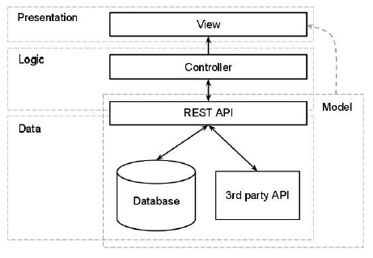
Figures should not be inserted directly in documents, rather create a 1x1 table, insert figure in that table and set centralized indent.
This should be done for all figures throughout the document.
Relevant Table should have Preferred Width: 6 and hide Border.
Apply “CaptionFig” style on each caption of figure.
Remove “space above/below paragraph “ for each caption, if any.

Figure 1.1: Model-View-Controller

Software/Hardware Requirements
[Any hardware or software specifications e.g. machine type required, operating system and other utilities should be clearly specified for the system to be developed.]

Implementation Tools and Technology
[The application tools, which are to be used on front and back end of the system to be developed, should be listed. The reasons for these tools should also be enlisted.
Identify what the needs for tool support are, and what the constraints are, by looking at the following:
- The development process. What tool support is required to effectively work? For example, if the organization decide to employ an iterative development process, it is necessary to automate the tests, since you will be testing several times during the project.
- Host (or development) platform(s).
- Target platform(s).
- The programming language(s) to be used.
- Existing tools. Evaluate any existing and proven tools and decide whether they can continue to be used.
- The distribution of the development organization. Is the organization physically distributed? Development tools generally support a physically distributed organization differently.
- The size of the development effort. Tools support large organizations more or less well.
- Budget and time constraints]

Implementation Plan

Deliverable Items
[List and describe each of the items you will submit in fulfillment of the project requirements. Deliverable items include, but are not limited to, program executable file(s), program data file(s), program listings, program documentation, user manual and CD.]
FOR EXAMPLE:
  - Project Proposal
  - Software Requirement Specification (SRS)
  - Project Presentation and Final Documentation
  - Executable Files
  - CD
  - User manual

Milestone Chart
[Identify each of the milestones or check points that mark the completion of some phase of project implementation. Milestones include, but are not limited to, detailed system analysis, system design, file design, module design, system test design, module coding, and documentation.
The Gantt chart enumerates the activities to be performed on the vertical axis and their corresponding duration on the horizontal axis. It is possible to schedule activities by either early start or late start logic. In the early start approach; each activity is initiated as early as possible without violating the precedence relations. In the late start approach; each activity is delayed as much as possible as long as the earliest finish time of the project is not compromised.
Based on the Work Breakdown Structure (WBS), a timeline or Gantt chart showing the allocation of time to the project phases or iterations should be developed. This Gantt chart would identify major milestones with their achievement criteria. It must contain duration estimation of all the necessary activities to be carried out during the project development along with the human resources responsible for the respective tasks. Activity dependencies are also required to be mentioned in it.]
FOR EXAMPLE(Gantt chart):
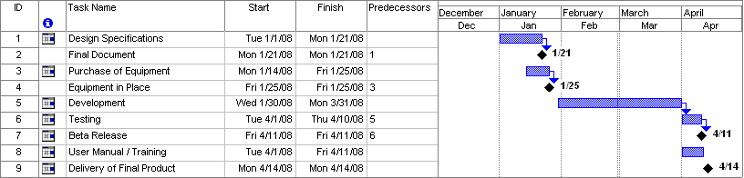
Figure 1.2: Gantt chart for milestones

Chapter 2
Requirement Analysis

Requirement Analysis
[The purpose of this chapter is to give the reader a clear picture of the system you plan to create, in terms of the capability required. A specification should tell the reader what the software system is required to do. The design then gives the top-level details of how the software system meets the requirement. It will also identify constraints on the software solution that are important in guiding decision making throughout the development process.
Requirement analysis is divided in two categories which are functional requirements and non-functional requirements which will be as followed.]

Functional Requirements
[This is a detailed specification of functions performed by the proposed system, from an external or user perspective, not from an internal or programmer viewpoint. Thus, the system is regarded as a black box with various inputs and outputs related by the functions performed by the system. The description should be sufficient for another programmer to implement the system.]
FOR EXAMPLE:
For Customers
- Facility of Login:
- Customers have to be logged in by their username and password.
- Facility of search:
- We provided the search facility whether manual or auto to the customers.
For Employees
- Facility of search:
- Employees can search the portal to be the part of that portal.
- Posting facility:
- Provides the facility of post about the services given by the employee himself.
For Admin
- Facility of Login:
- Admin has to be logged in by their username and password.
- Manages the portal:
- Admin is the authorized person that manages the whole portal i.e. registration of workers, confirmation of the registration, addition of workers, deletion of workers, any updating in information, and can check the rating of performanceof the workers.

Non Functional Requirement
[This nonfunctional requirements includes the following
- Usability
- Reliability
- Performance
- Design Constraints
- Portability
- Maintainability
- License Agreement]
FOR EXAMPLE:
All non-functional requirements of proposed system are as followed:
- Application availability will be 24/7 in a year. It means user can use this platform at any time anywhere.
- Application security is good. User data is secure and can be seen by only that user.
- Interactive Design/Usability is good. It is easy to use this application.
- Performance/Efficiency of this application is good. It do not take long time to open and do not hang on any browser.
- This application secures data of each user and do not involve third party to use his all user data. It means privacy of this application is good.
Same table formatting should be followed i.e. no Left and Right Border, Top table border style: , Bottom Table border style:, in-between border .
Apply “CaptionTab” style on caption of each table throughout the document

Use Cases
Table 2.1: Use-Case 1
- Use case Number : | 1
- Use case Name : | Sign up/ User
- Level: | System/ User
- Primary Actor : | User
- Goal : | Account Creation
- Pre-condition : | Sends request
- Post-condition : | Account successfully created
- Trigger : | User

User Activity | System Response
1.Fills all required fields.
2.Clicks on sign up button
 | 3. System verifies info
4.Request sends to admin
5.Confirmation of account creation by admin. | Bottom Table border style:  Border weight: 1 ½ pt

- Main Success Scenario:
- Alternative Path :
User Activity | System Response
1.Fills all required fields.
 | 2.Clicks on sign up button

Chapter 3
Design

DESIGN
[Third chapter is all aboutobject oriented modeling and software design. In the previous chapter, analysis of the system is completed. So we understand the current situation of the problem domain. Now we are ready to strive for a solution for the problem domain by using object-oriented approach. Following artifacts must be included in this deliverable.
- Use cases Diagram
- Class diagram
- Sequence Diagram
- Data Model i.e. ERD
More detail on UML Modeling and designing can be found in “APPENDIX A”

UML Diagrams
FOR EXAMPLE: There are different UML diagrams are added in this project and are as followed:

Use-Case Diagram
Figures should not be inserted directly in documents, rather create a 1x1 table, insert figure in that table and set centralized indent.
This should be done for all figures throughout document.
Relevant Table should have Preferred Width: 6 and hide Border.
Apply “CaptionFig” style on each caption of figure.
Remove “space above/below paragraph “ for each caption, if any.

Use-Case Diagram for HMP
Figure 3.1:Use-Case Diagram for SMP

Admin

Figure 3.2: Use-Case Diagram for Admin

Class Diagram

Figure 3.3 Class Diagram

Sequence Diagram

User Authentication

Figure 3.4: Sequence Diagram for User Authentication

ERD

Figure 3.5: ERD of HMP

Chapter 4
Testing

Testing
[This Testing phase includes all the Test Cases of the functional requirements of your project]
FOR EXAMPLE: A software test engineer is involved in the testing of an application and is generally a member of software quality assurance team. Test engineers of this web application were Member 1&Member 2.

Sign Up Admin User & Worker
Table 4.1: Sign up Test case
Sign Up Test Case
Test Engineer | Member Name
Test Case ID | TC-1
Date | March 15th, 2017
Purpose | Sign up to system.
Pre-Req | To check module programming.
Test Data | - Username & Password.
Steps | Following steps will take place in test.  - User enter his user name and password in require field.  - User click on sign up button.
Status | Pass

Chapter 5
User Manual

User Manual
[Detailed manual of your project along with pictures and description]

Home Page
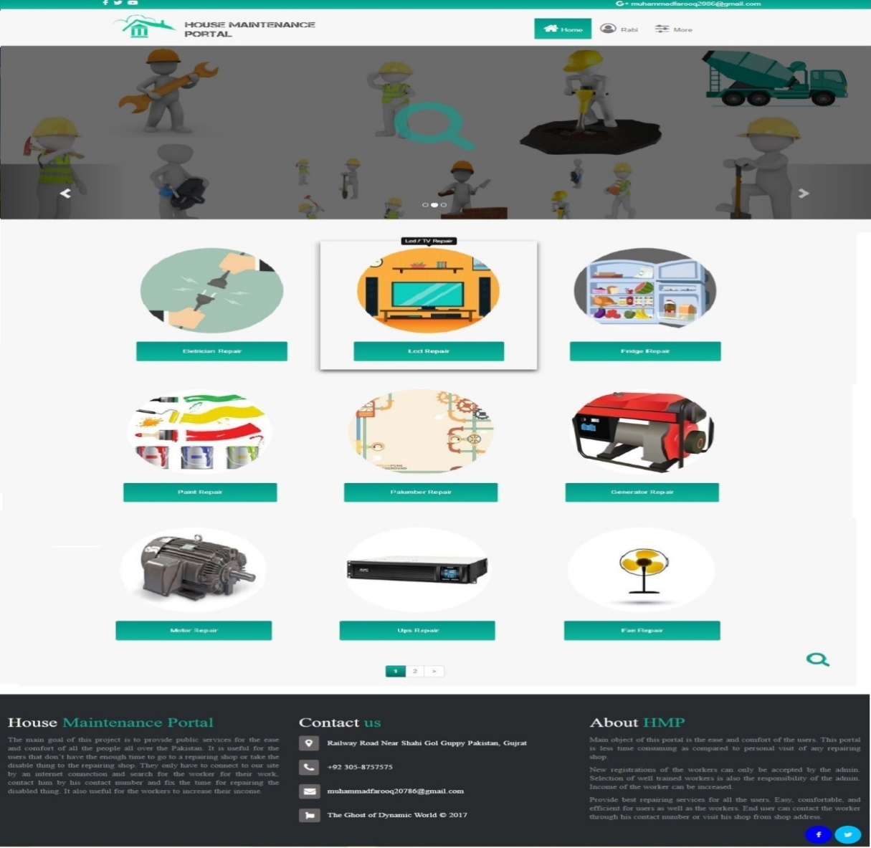
Figure 5.1: Home Page

References:
[If you take another person's work as your own and do not cite your sources of information you are being dishonest; in other words you are cheating. When referring to other pieces of work, cite the sources where they are referred to or used, rather than just listing them at the end.
In this section you list in standard bibliographic format the books, papers, course notes, websites and project or thesis reports which you have used in preparing your project report.
References must be numbered. In the text they should be referred to by squared bracketed numerals, e.g. [1]. The list of references must be typed on a separate sheet(s), in the same format as the main text, and ordered consecutively, according to the following models:]
FOR EXAMPLE:
For URL:
[1] “AT Commands API for SMS sending” (Last Retrieved: January 2015). Retrieved from http://www.nbcmiami.com/news/local/Teen-Posed-as-Doctor-at-West-Palm-Beach-Hospital-Police-288810831.html
For a paper in a journal/ conference:
[2] D.W. Jones, "Concurrent operations on Priority Queues," Communications of the ACM, 32, l (January 1989), pp- 132-137.
For a book:
[3] H.F. Korth and A. Silberschatz, Database System Concepts, McGraw Hill, New York, 1986.

