Name: - khan naseer Sem: - III
Roll no: - 25BIT34 Sub: - Computer Network
Class: - SY-BSCIT Batch:-2

🖥️ DHCP
(Dynamic Host Configuration Protocol)
Configuring DHCP Server In Packet Tracer
DHCP (Dynamic Host Configuration Protocol) is a network management protocol that automatically assigns an IP address and other network settings to devices when they connect to a network

STEP 1:- OPEN PACKET TRACER 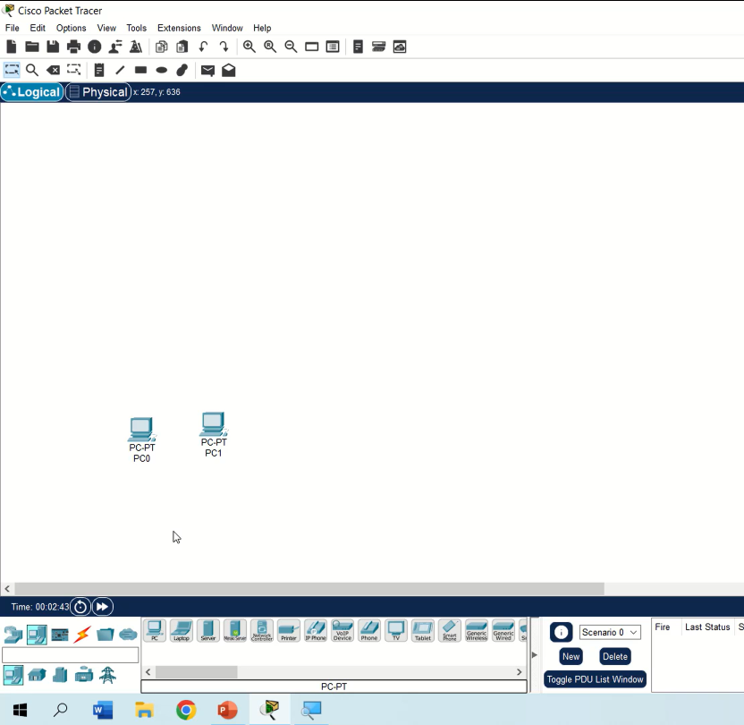

STEP 2:- AND FOR DHCP TO WORK, WE NEED PC’S A SERVER, A SWITCH AND A ROUTER

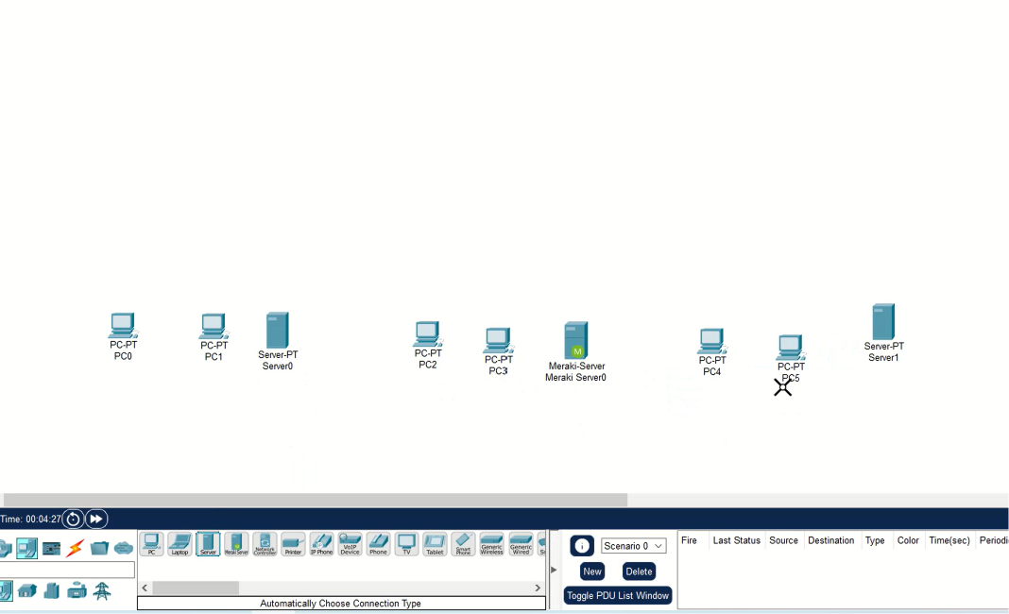

STEP 3:- AS SHOWN IN THE DEMONSTRATION, IT CONTAINS 3 SETS OF 2 PC’S AND THREE SERVERS AND THREE SWITCHES WITH ONE ROUTER
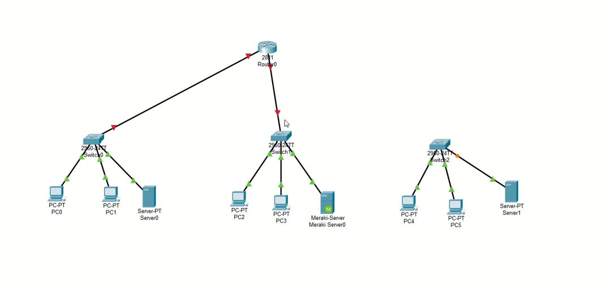
STEP 4:- CONNECT THE DEVICES BY USING CONNECTION CABLE THEN FIRST CONNECT THE PC’S AND SERVER TO THE SWITCH, THEN CONNECT THE SWITCH TO ROUTER, DO THE SAME FOR THE TWO OTHERS CONNECTIONS

STEP 5:- THERE IS NO CONNECTION GIVEN IN THE ROUTER WHILE TRYING TO CONNECT THE THIRD SWITCH TO THE ROUTER > CLICK > ROUTER > SWITCH OFF THE ROUTER (GREEN INDICATION SWITCH) > SELECT > NM-2FE2W > DRAG THE TWO EXTRA PORT AND ATTACH IT TO THE EMPTY SLOT OF THE ROUTER > SWITCH IT ON (AFTER THAT WAIT FOR A MINUTE BEFORE CONNECTING THIRD SWITCH TO THE ROUTER)
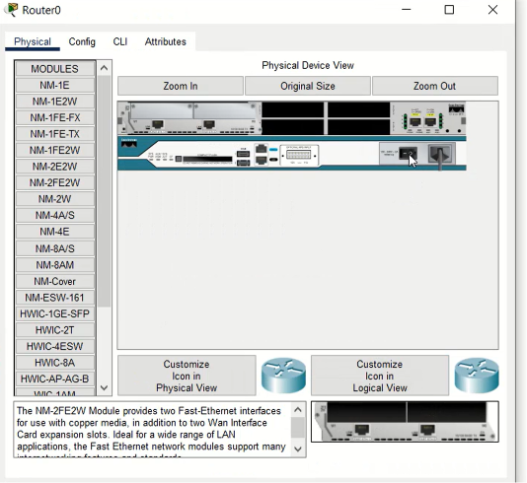
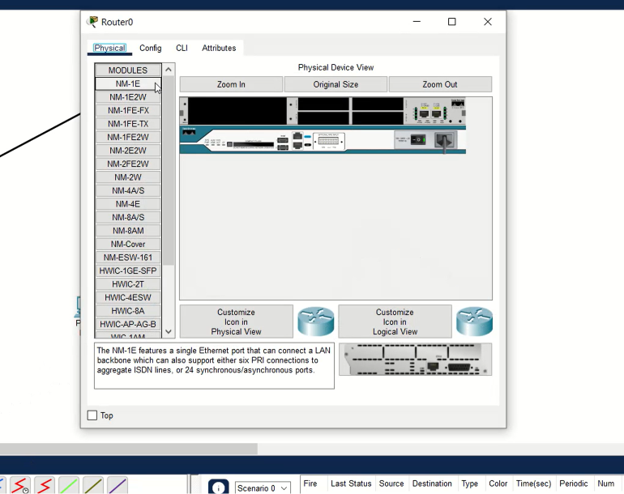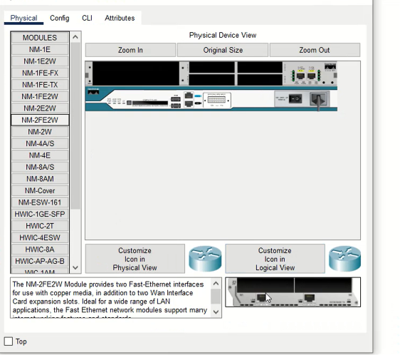

STEP 6:- SELECT THE CABLE FROM THE THIRD SWITCH AND ATTACH IT TO THE ROUTER

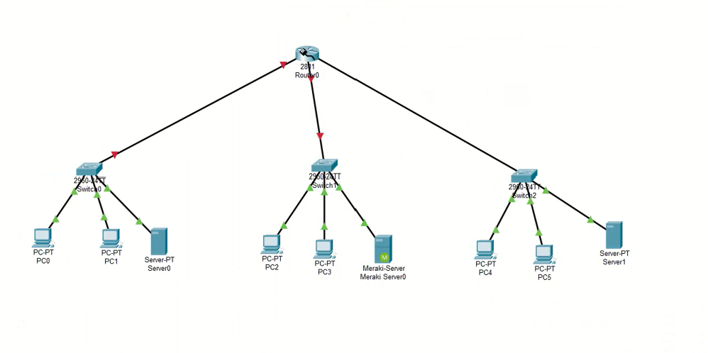

STEP 7:- FIRST SERVER CONFIGURE > DESKTOP > IP CONFIGURE > IPV4-192.168.0.2 > SUBNET MASK > DEFAULT GATEWAY-192.168.0.1 > DNS SERVER-192.168.0.2
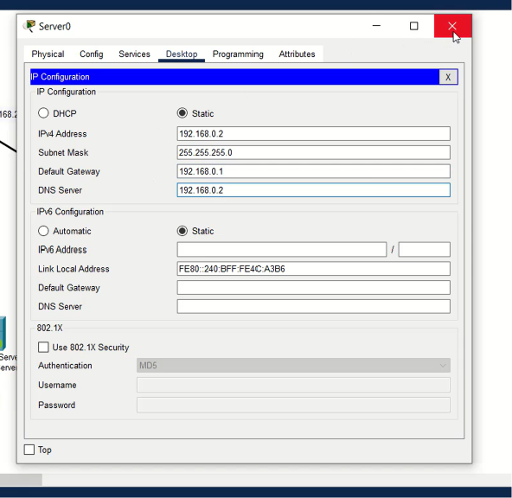

STEP 8:- SECOND SERVER CONFIGURE > DESKTOP > IP CONFIGURE > IPV4-192.168.1.2 > SUBNET MASK > DEFAULT GATEWAY-192.168.1.1 > DNS SERVER-192.168.1.2
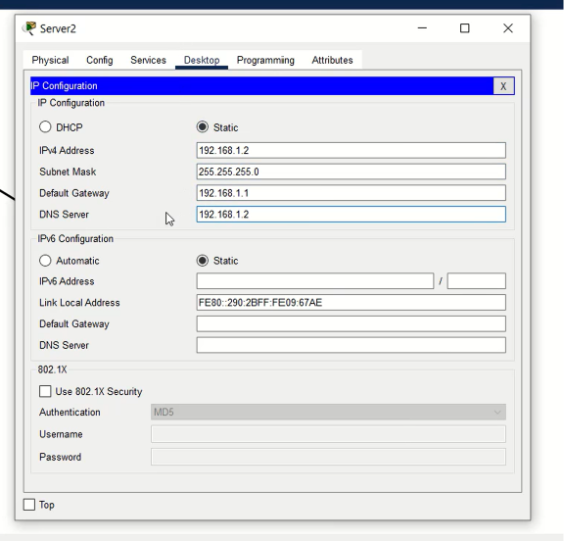

STEP 9:- THIRD SERVER CONFIGURE > DESKTOP > IP CONFIGURE > IPV4-192.168.2.2 > SUBNET MASK > DEFAULT GATEWAY-192.168.2.1 > DNS SERVER-192.168.2.2
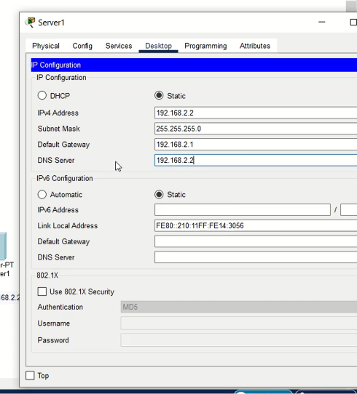

STEP 10:- ROUTER > CONFIG > INTERFACE > FASTETHERNET0/0 > IPV4-192.168.0.1 > SUBNET MASK > FASTETHERNET0/1 > IPV4-192.168.1.1 SUBNET MASK FASTETHERNET1/0 > IPV4-192.168.2.1 > SUBNET MASK
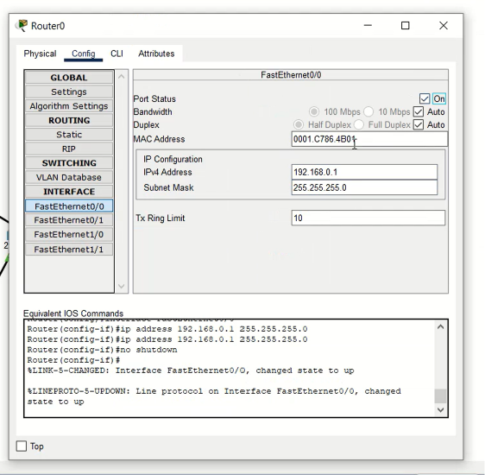

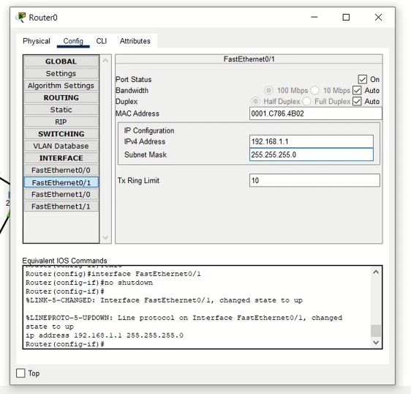

STEP 11:- ROUTER > CLI > (WRITE) INTERFACE FASTETHERNET0/0 (ENTER)IP HELPER-ADDRESS 192.168.0.2 (YOU HAVE CONFIGURED THE IP ADDRESS TO THE ROUTER) DO THE SAME FOR THE OTHER TWO CABLE (FASTETHERNET0/1 TO FASTETHERNET1/0) THEN CLICK ENTER & WRITE :exit >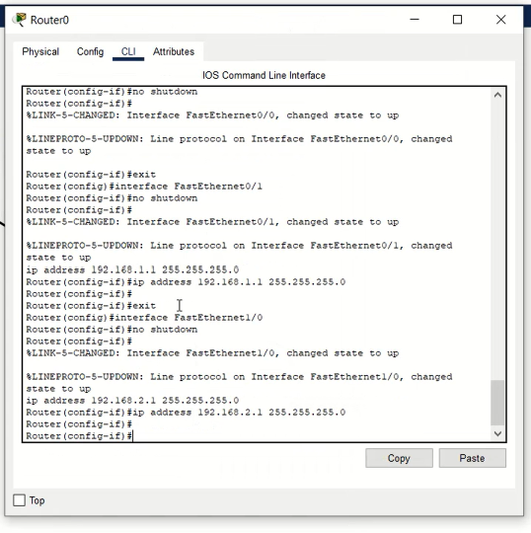

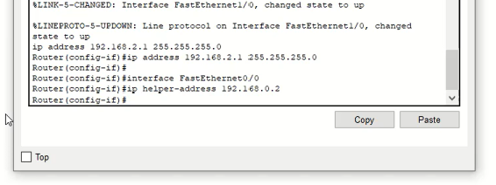

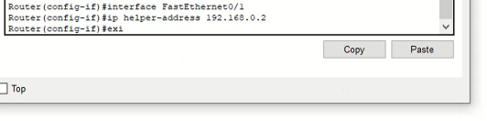

STEP 12:- GO TO SERVER0 > SERVICES > DHCP > SERVICE-ON > DEFAULT GATEWAY-192.168.0.1 > DNS SERVER-192.168.0.2 > SAVE > POOL NAME-SERVERPOOL (AFTER THAT CREATE TWO MORE SERVERPOOL CREATE IN THE SAME SERVER)

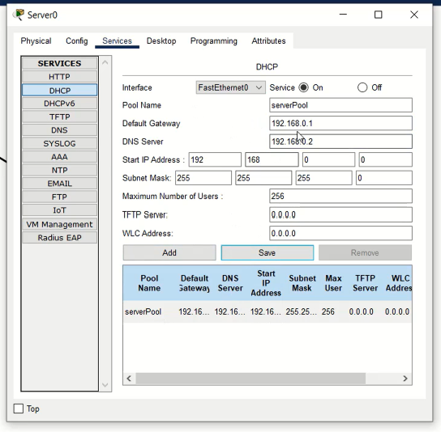

NAME-SERVERPOOL1 > SERVICE-ON > DEFAULT GATEWAY-192.168.1.1 > DNS SERVER-192.168.0.2 > START IP ADDRESS- 192.168.1.0 > ADD > SAVE

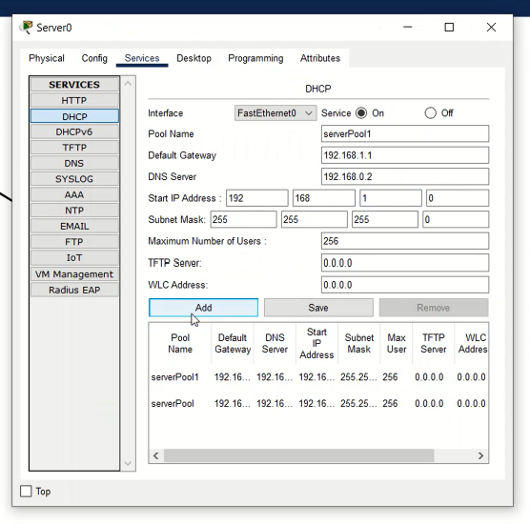

NAME-SERVERPOOL2 > SERVICE-ON > DEFAULT GATEWAY-192.168.2.1 > DNS SERVER-192.168.0.2 > START IP ADDRESS- 192.168.2.0 > ADD > SAVE
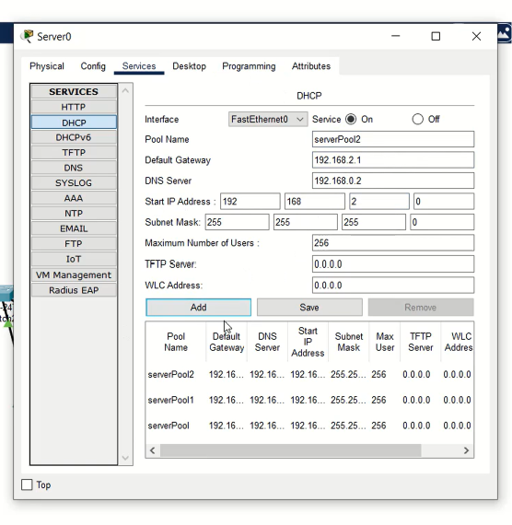

STEP 13:- GO ON ANY PC > IP CONFIGURATION > CLICK ON DHCP
