Name: - khan naseer Sem: - III
Roll no: - 25BIT34 Sub: - Computer Network
Class: - SY-BSCIT Batch:-2

🖥️ D N S
(Domain Name Server)
Configuring DNS Server In Packet Tracer

DNS (Domain Name System) translates human-readable domain names (like ://example.com) into numerical IP addresses (like 192.168.1.10) that computers use to identify each other on a network.

STEP 1:- OPEN PACKET TRACER
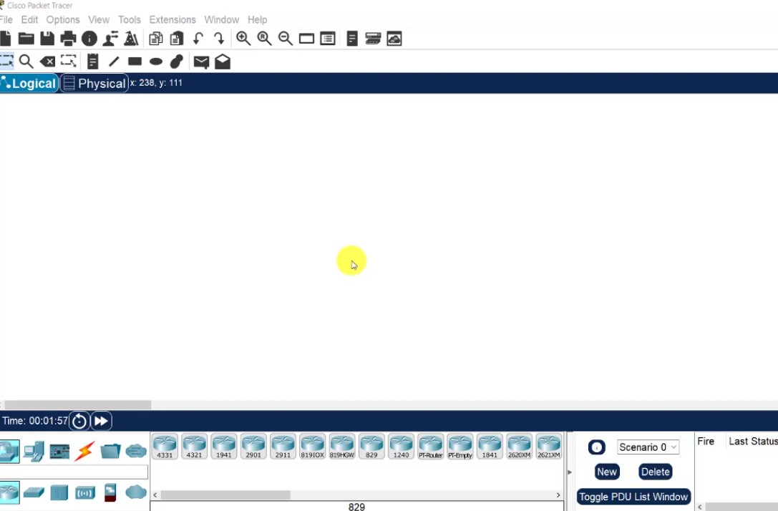

STEP 2:- SELECT NETWORK DEVICES IN (BOTTOM LEFT) PACKET TRACER
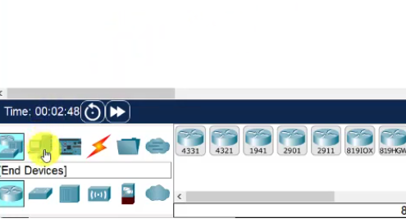

STEP 3:- SELECT A SWITCH & ROUTER
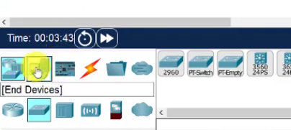

STEP 4:- SELECT END DEVICES IN (BOTTOM LEFT) PACKET TRACER
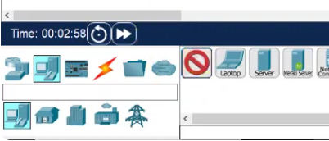

STEP 5:- SELECT TWO PC’S
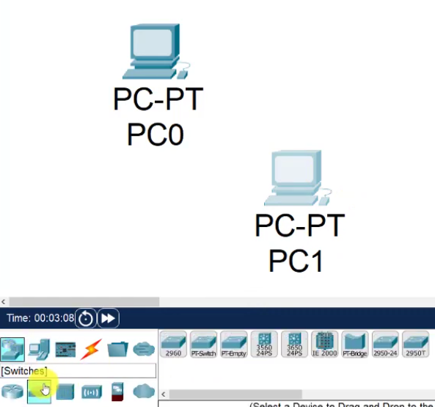

STEP 6:- FOR CONNECTING THIS DEVICES, USE CONNECTION AND CHOSE AUTOMATIC CONNECTION CABLE TO CONNECT THE DEVICES
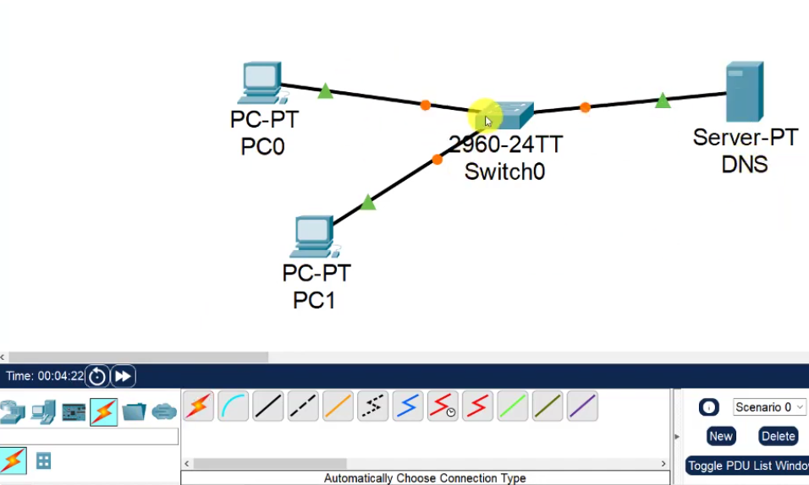

STEP 7:- AND CONNECT BOTH PC TO SWITCH AND CONNECT SWITCH TO SERVER (OPTIONAL:-DOUBLE TAP THE SERVER 0 ON SERVER AND NAME IT DNS)
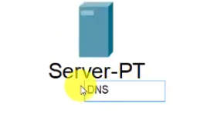

STEP 8:- CLICK SERVER > DESKTOP > IP CONFIGURATION > IPV4 - 192.168.10.1 > TAP OF SUBNETMASK > DNS SERVER - 192.168.10.1 .>> SERVICES > HTTP > INDEX.HTML > EDIT > HTML TAG WILL APPEAR REMOVE THE TAG WITHOUT DELETING <HTML> TAGS TOP AND BOTTOM YOU CAN INSERT TEXT WHATEVER YOU LIKE EX:- DNS TESTING > SAVE > YES >> DNS > NAME-ctracer > ADDRESS-192.168.10.1 > ADD > SAVE (DNS SERVICE SHOULD REMAIN ON)
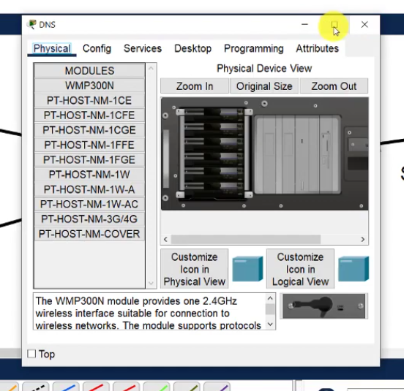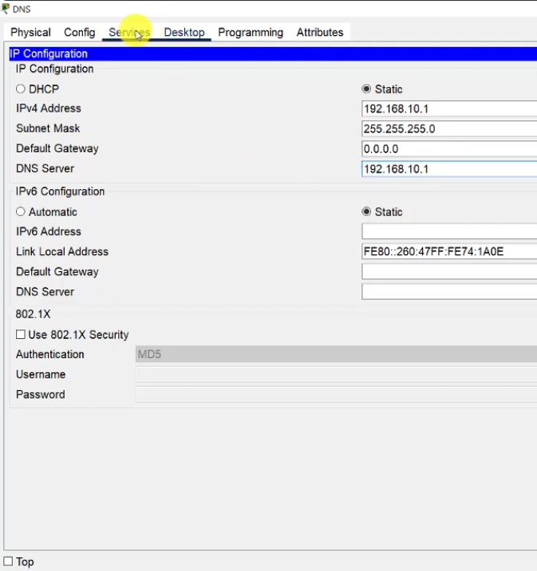

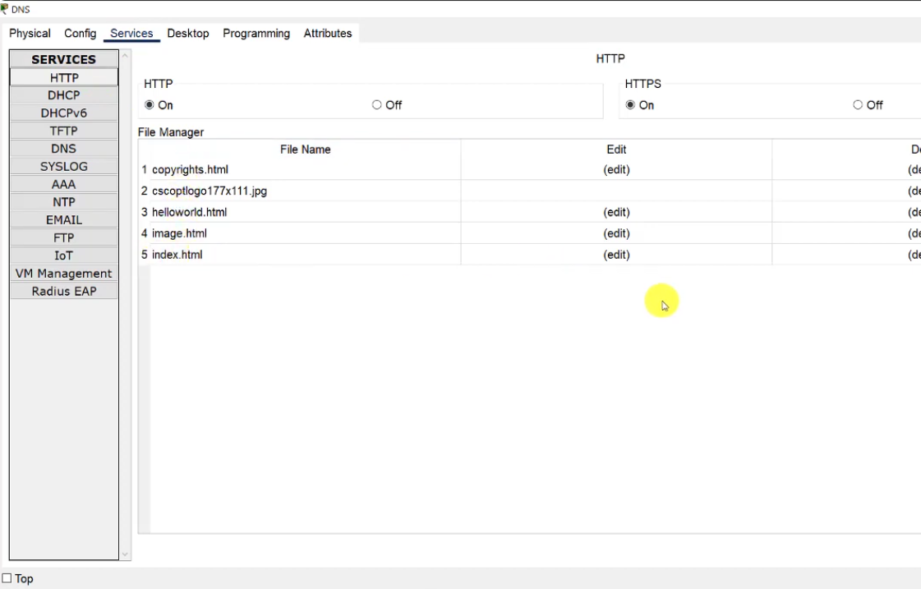

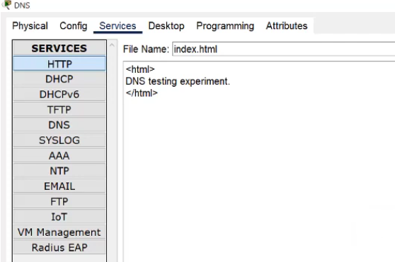

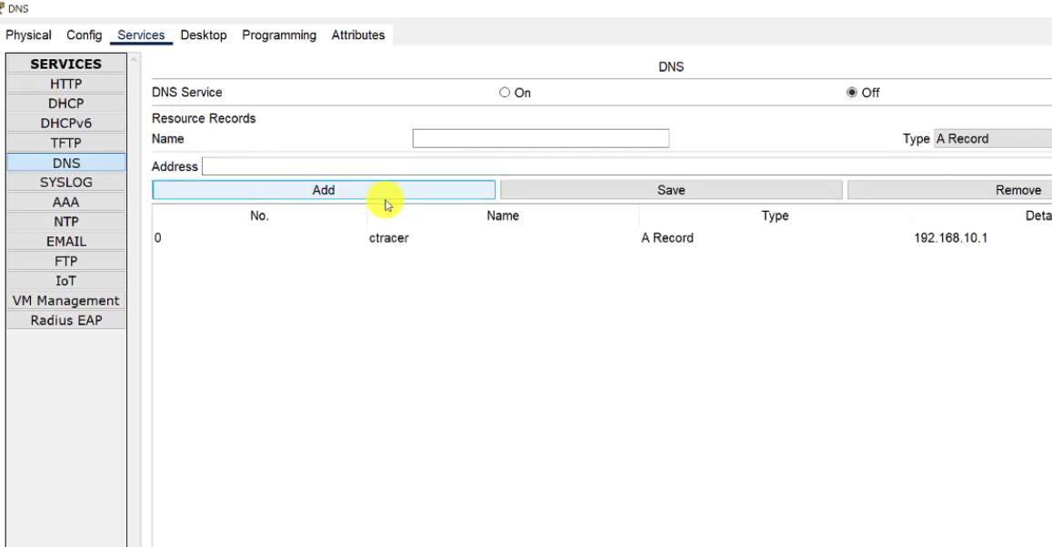
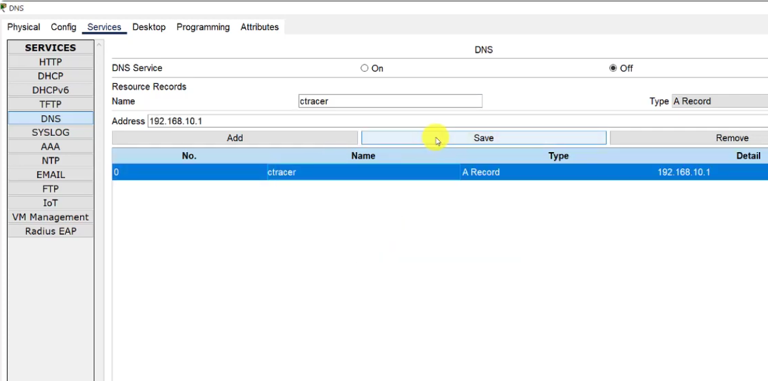

STEP 9:- CLICK > PC0 > DESKTOP > IP CONFIGURATION > IPV4-192.168.10.5 > TAB ON SUBNET MASK > DNS SERVER-192.168.10.1 >> WEB BROWSER > URL-REHAN > PRESS > GO > “DNS TESTING EXPERIMENT”
