Name: - khan naseer Sem: - III
Roll no: - 25BIT34 Sub: - Computer Network
Class: - SY-BSCIT Batch:-2

🖥️ HTTP
(Hypertext Transfer Protocol)
Configuring HTTP Server In Packet Tracer
HTTP WHICH IS USE TO TRANSFER A DATA FROM A WEB SERVER TO PC AND VISE VERSA

STEP 1:- OPEN PACKET TRACER
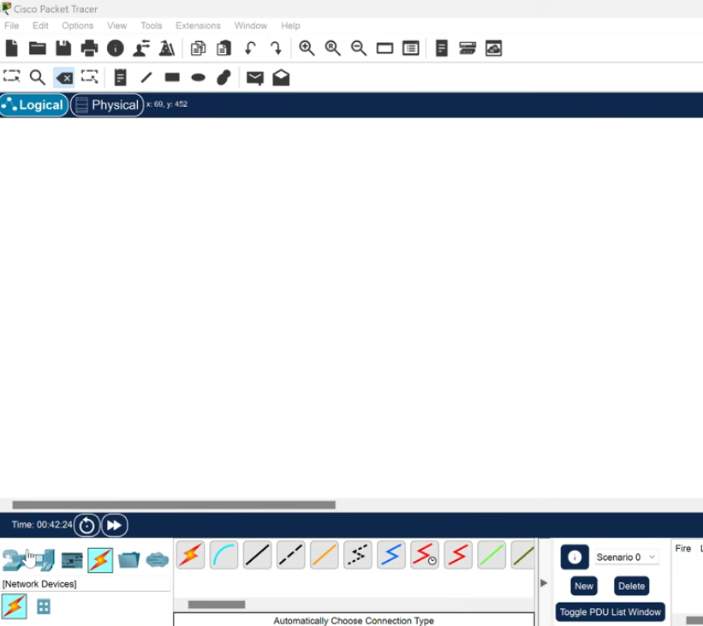

STEP 2:- SELECT NETWORK DEVICES IN (BOTTOM LEFT) PACKET TRACER
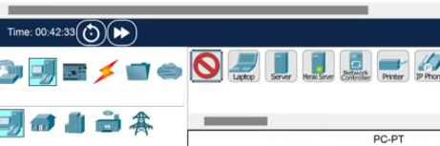

STEP 3:- SELECT SWITCH
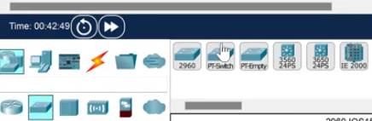

STEP 4:- SELECT END DEVICE > SELECT SERVER > SELECT PC(ACCORDINGLY)
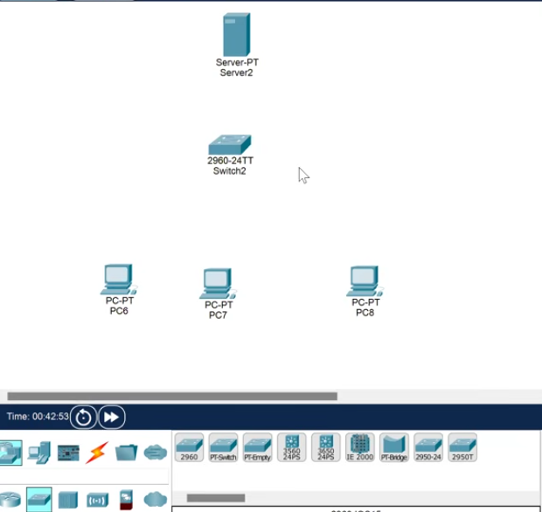

STEP 5:- SELECT CONNECTION > AUTOMATICALLY CONNECTION TYPE
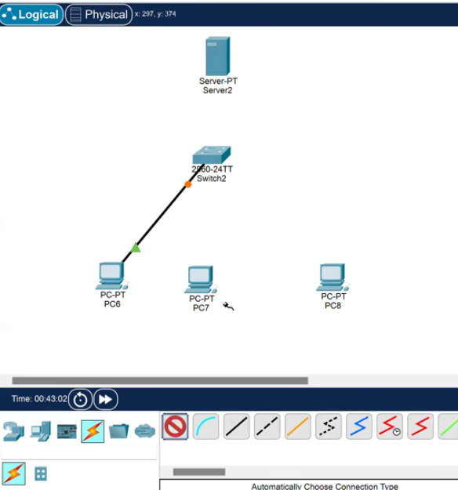

STEP 6:- USE CONNECTION TYPE CABLE AND CONNECT PC OR PC’S TO SWITCH > CONNECT SWITCH TO SERVER (YOU CAN NAME SERVER AS - WEB SERVER)
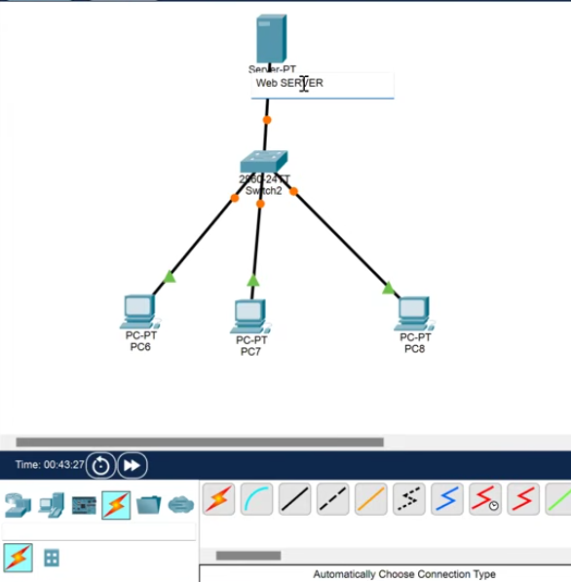

STEP 7:- TAP ON PC > DESKTOP > IP CONFIGURATION > IPV4- 10.10.10.2 > TAB ON SUBNET MASK
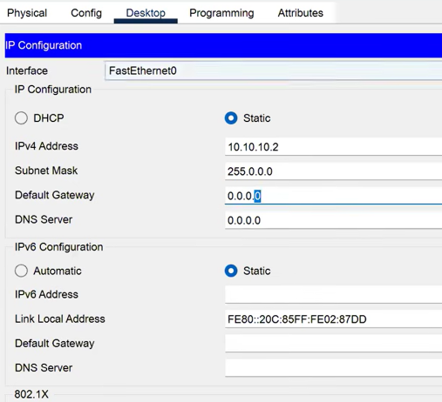
STEP 8:- DO THE SAME FOR EACH PC JUST USE DIFFERENT IP EX:-10.10.10.3, 10.10.10.4 AND SUBNET MASK
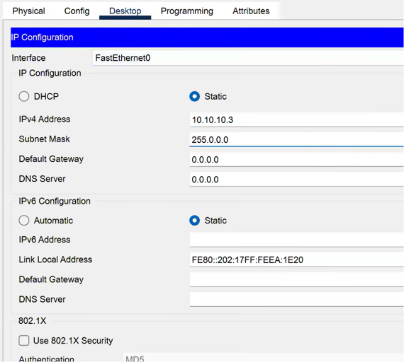

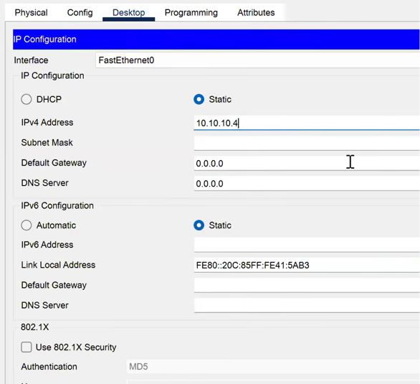

STEP 9:- ASSIGN THE IP ADDRESSES TO SERVER(WEB SERVER) > DESKTOP > IP CONFIGURATION > IPV4-10.10.10.1 > SUBNET MASK >> SERVICES > HTTP > ON > INDEX.HTML > EDIT > WANT TO MAKE CHANGES YOU CAN (JUST DO NOT DELETE </html> CAN YOU CAN MAKE CHANGES IN BETWEEN THOSE, IF ANY CHANGES ARE MADE > CLICK > SAVE > YES
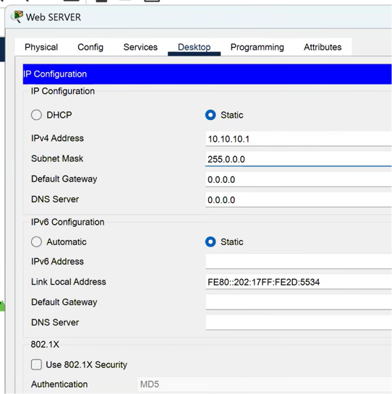
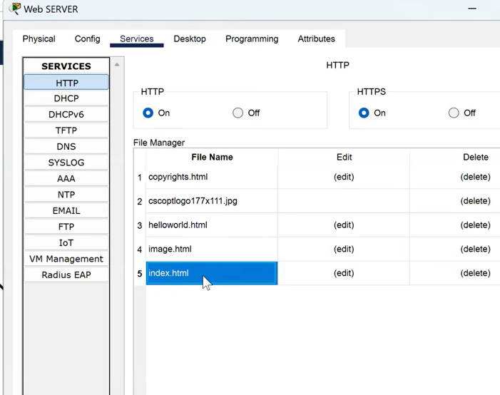
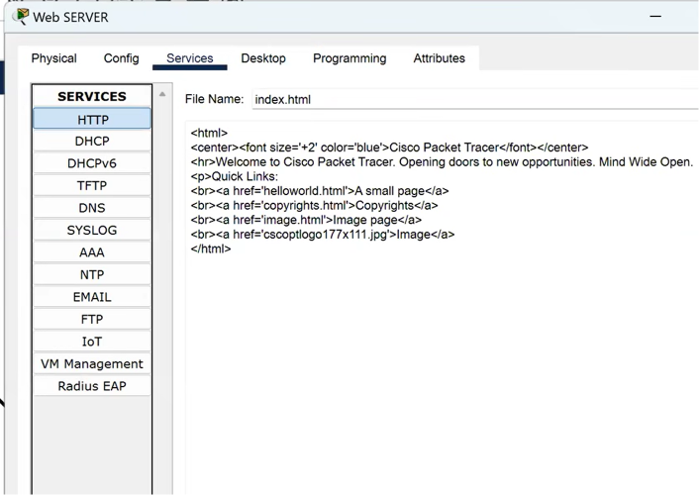

STEP 10:- CLICK ON PC > DESKTOP > WEB BROWSER > URL-10.10.10.1 > CONTENT WILL SHOW IN FILE
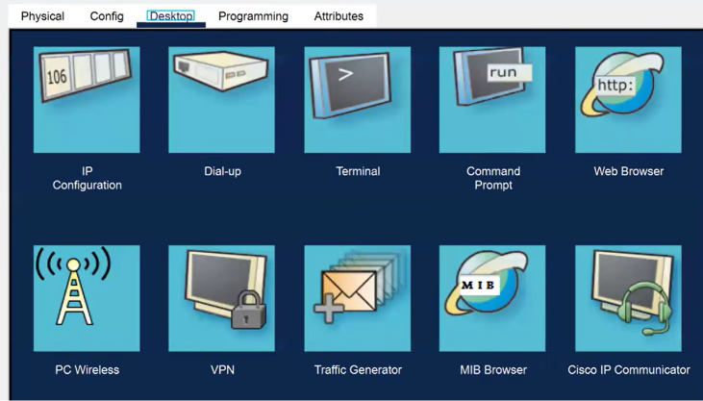
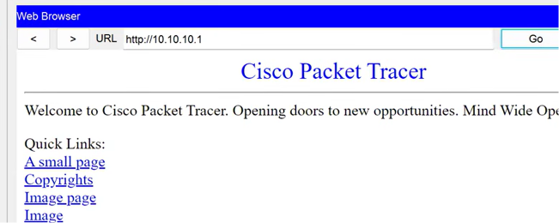
STEP 11:- YOU CAN DO IT WITH MULTIPLE PC IF YOU ARE USING MORE THAN ONE PC
