Name:- Ansari Mohd Ayan Nasiruddin Branch:SYBscIT
RollNo:-25BIT41 Sem:-III
Subject:- Computer Network Batch:- 2

Practical 1
Basic Network Commands and Configuration

Aim: Study of basic network command and Network configuration commands. ifconfig, ipconfig, ping, ARP, trace route netstat, etc.

1.ifconfig: This command enables us to initialize an interface, assign IP address, enable or disable an interface. It displays route and network interface.
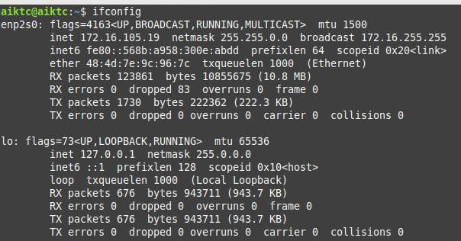

2.ipconfig
3.ping
ping: - Linux ping command stands for (Packet Internet Groper). It checks connectivity between two nodes to see if a server is available.
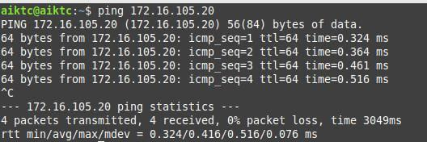

4.APR: The ARP commands to view, display, or modify the details/information in an ARP table/cache.The ARP cache or table has the dynamic list of IP and MAC addresses of those devices to which your computer has communicated recently in a local network.
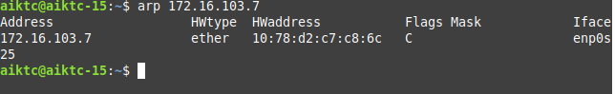

5.trace route: - Linux traceroute command is a network troubleshooting utility that helps us determine the number of hops and packets traveling path required to reach a destination.
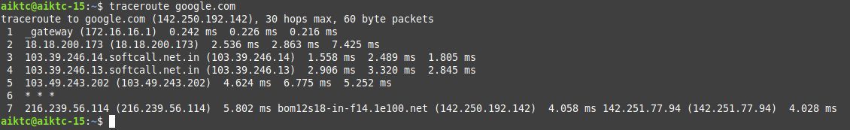

6.netstat: Linux netstat command stands for Network statistics. It displays information about different interface statistics, including open sockets, routing tables, and connection information.

