Name:- Ansari Mohd Ayan Nasiruddin Branch:SYBscIT
RollNo:-25BIT41 Sem:-III
Subject:- Computer Network Batch:- 2

Practical 2
Colour code for crimping LAN(Cat5/6/7)cable
Aim:
a) Study of Different colour codes
b) Study of different connecting devices and their differences
c) Crimping LAN Cable
Theory:
CAT 5, CAT 6, and CAT 7
CAT 5, CAT 6, and CAT 7 are different generations of Ethernet cables, each with varying characteristics. Following are the key differences between them:

1)

2)

3)

Speed and Bandwidth:
CAT 5: It supports data transfer speeds up to 100 Mbps (Megabits per second) with a maximum bandwidth of 100 MHz. CAT 5 cables are considered outdated and are rarely used for new installations.
CAT 6: It supports data transfer speeds up to 10 Gbps (Gigabits per second) with a maximum bandwidth of 250 MHz. CAT 6 cables are commonly used for home and small office networks.
CAT 7: It offers higher performance with data transfer speeds up to 10 Gbps and beyond, reaching up to 40 Gbps. It has a higher bandwidth capacity of 600 MHz.
CAT 7 is designed for more demanding applications and larger network infrastructures.

Shielding:
CAT 5: It is typically an unshielded twisted pair (UTP) cable, meaning it does not have any shielding to protect against electromagnetic interference (EMI) or crosstalk. CAT 6: It can be either unshielded twisted pair (UTP) or shielded twisted pair (STP) cable. Shielded variants have additional shielding to reduce EMI and crosstalk.
CAT 7: It features additional shielding known as individually shielded pairs (S/FTP or S/STP). This shielding provides better protection against EMI and crosstalk, leading
to improved signal quality and reduced interference.

Connectors and Backward Compatibility:
CAT 5: It commonly uses RJ-45 connectors, which are the standard connectors for Ethernet cables. CAT 5 cables are backward compatible with newer Ethernet standards like CAT 5e, CAT 6, and CAT 7.
CAT 6: It also uses RJ-45 connectors, and CAT 6 cables are backward compatible with CAT 5 and CAT 5e.

Page 1

4)

CAT 7: It uses specialized RJ-45 connectors with stricter specifications to ensure better signal integrity at higher frequencies. CAT 7 cables are backward compatible with older Ethernet standards as well.

Distance:
CAT 5: It is suitable for shorter distances within a network, typically up to 100 meters (328 feet).
CAT 6: It can also reach up to 100 meters for 10 Gbps speeds but may have reduced performance at longer distances.
CAT 7: It can achieve 10 Gbps speeds at longer distances, typically up to 100 meters (328 feet).

RJ45 Pin-out Ethernet Cables and Colour codes
Ethernet LAN cables can come in two types – Crossover or Straight through. The following are the pin-outs for the RJ45 connectors

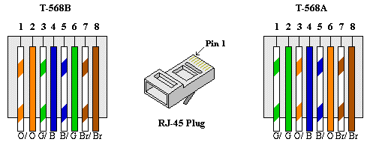

There are two different pin-out standards used worldwide, and depending on location, we determine which one to use.
T568A is used in America and Asia and
T568B is used in Britain and Europe
Different connecting devices and their differences:
There are several different connecting devices used in computer networks. Here are the most common ones and their key differences:
1)

Hubs:
a)
b)
c)
d)

Hubs operate at the physical layer of the network.
They have a single collision domain, meaning all connected devices share the same bandwidth.
They broadcast incoming data to all connected devices, regardless of the intended recipient.
Hubs are considered outdated and are rarely used in modern networks.
2)

Switches:
a)
b)
c)
d)

Switches operate at the data link layer of the network.
They create individual collision domains for each connected device, allowing for
simultaneous communication.
Switches use MAC addresses to direct incoming data to the appropriate device.
They offer better performance, security, and scalability compared to hubs.
Page 2

3)

Routers:
a)
b)
c)
d)

Routers operate at the network layer of the network.
They connect multiple networks or subnets and forward data packets between them. Routers use IP addresses to route traffic based on network protocols.
They provide network segmentation, enable interconnectivity, and enforce security policies.
4)

Bridges:
a)
b)
c)
d)

Bridges operate at the data link layer of the network.
They connect two network segments and filter network traffic based on MAC addresses.
Bridges help to reduce network congestion and improve overall network performance. They are commonly used to extend network coverage and create smaller broadcast domains.
5)

Repeaters and Extenders:
a)
b)
c)
d)

Repeaters and extenders amplify or regenerate network signals to extend their reach. Repeaters operate at the physical layer, while extenders work at higher layers. Repeaters boost analog signals, while extenders can amplify both analog and digital signals.
Repeaters and extenders are primarily used in long-distance or large-scale network deployments.

Page 3

Crimping LAN Cable
Crimping LAN wires, also known as Ethernet cables, involves attaching RJ-45 connectors to the ends of the cable. Here are the steps to crimp LAN wires:
1)

To Gather the following tools and materials:
a)

b)

c)

d)

Ethernet cable (UTP or STP)

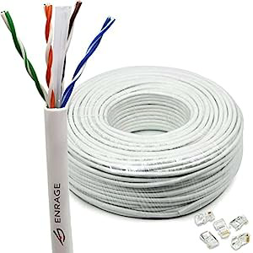

RJ-45 connectors (usually 8P8C)

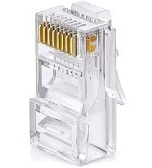

Crimping tool

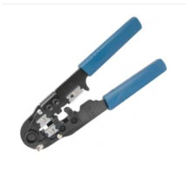

Cable cutter/stripper

Page 4



e) Cable tester (Optional)

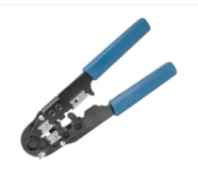

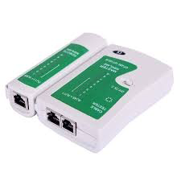
OR

2)

3)

Measure and cut the cable:
Determine the desired length of the LAN wire and cut the cable accordingly. Use a cable cutter to make a clean, straight cut.

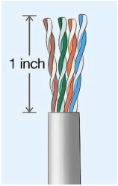

Strip the cable jacket:
Use a cable stripper or a sharp blade to carefully remove approximately 1-1.5 inches (2.5-3.8 cm) of the outer jacket from the cut end of the cable. Be cautious not to damage the internal wires.

Page 5

4)

5)

6)

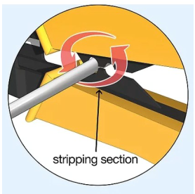

Untwist and arrange the wires:
After removing the jacket, you'll find four twisted pairs of coloured wires inside. Untwist the pairs and arrange them according to the desired wiring standard (T568A). Make sure to maintain the same order on both ends of the cable.

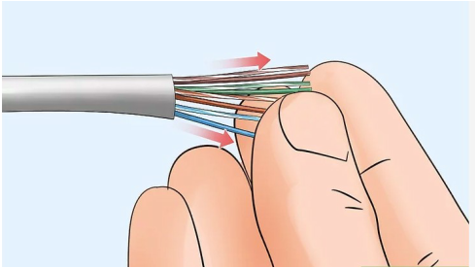

Trim and straighten the wires:
Cut the excess wire length to ensure they are even and of equal length, typically around 0.5 inches (1.3 cm).
Use your fingers or a wire straightened tool to align the wires neatly and make them easier to insert into the connector.

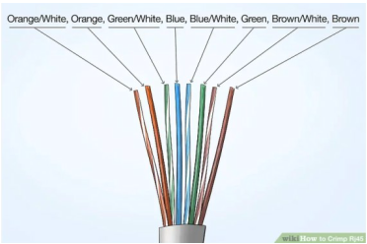
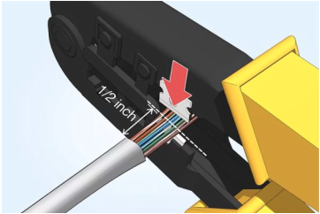

Insert the wires into the connector:
Carefully insert the arranged wires into the RJ-45 connector, ensuring they reach the end and make contact with the metal contacts inside. Check that the wire colours are in the correct order.

Page 6

7)

8)

9)

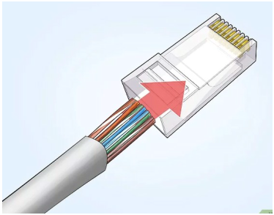

Crimp the connector:
Place the connector and cable into the appropriate slot of the crimping tool, ensuring it is properly aligned.
Squeeze the handles of the crimping tool firmly to crimp the connector. This action will secure the wires in place and create a strong connection.

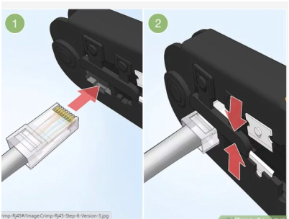

Repeat for the other end:
Repeat steps 3 to 7 for the other end of the LAN wire, ensuring that both ends follow the same wiring standard.

Test the cable (optional):
If available, use a cable tester to verify the connectivity and integrity of the crimped LAN wire. The tester will check for proper wire order and continuity.
By following these steps, we can crimp LAN wires and create custom Ethernet cables as per network requirements.

Page 7

