Name:- Ansari Mohd Ayan Nasiruddin Branch:SYBscIT
RollNo:-25BIT41 Sem:-III
Subject:- Computer Network Batch:- 2

Practical3
3.Configuring LAN setup
a | Planning and Setting IP networks.
b | Basic network troubleshooting.
Aim: a) Planning and Setting IP networks.
b) Basic network troubleshooting.

- Planning and Setting IP networks.
1. Understand the Requirements
- Identify the purpose of the network (home, office, data center, etc.).
- Estimate the number of devices (PCs, phones, printers, servers, etc.).
- Plan for future expansion (scalability).

2. Choose the Network Type
- LAN (Local Area Network): For small, local setups like offices or homes.
- WAN (Wide Area Network): For connecting across cities or countries.
- MAN (Metropolitan Area Network): For large campuses or towns.

Select IP Addressing Scheme

🔹 a) IP Version
- IPv4: Most common (e.g., 192.168.1.1)
- IPv6: Newer, for larger addressing space (e.g., 2001:0db8::1)

🔹 b) Public vs Private IP
- Private IPs (for internal use):
  - 10.0.0.0 – 10.255.255.255
  - 172.16.0.0 – 172.31.255.255
  - 192.168.0.0 – 192.168.255.255
- Public IPs (for internet-facing devices): Assigned by ISP

c) Static vs Dynamic IP
- Static IP: Manually assigned, doesn’t change (used for servers).
- Dynamic IP: Assigned automatically by DHCP, changes over time.

4. Subnetting
- Divide IP addresses into smaller networks (subnets) for better management and security.
- Helps in efficient IP address usage.
- Example: From 192.168.1.0/24 to multiple subnets like /25, /26.

5. Plan Network Devices
- Router: Connects LAN to the internet.
- Switch: Connects devices within the same LAN.
- Access Points: For wireless devices (Wi-Fi).
- Firewall: Provides security by controlling traffic.

6. Assign IP Addresses
- Reserve IPs for:
  - Router/Gateway (e.g., 192.168.1.1)
  - Servers/Printers
  - DHCP Pool (for client devices)
- Ensure no IP conflicts (no two devices have the same IP).

7. Configure DHCP (if needed)
- Automatically assigns IP addresses to client devices.
- Set range (e.g., 192.168.1.100 to 192.168.1.200).

8. Test the Network
- Use ping command to test connectivity.
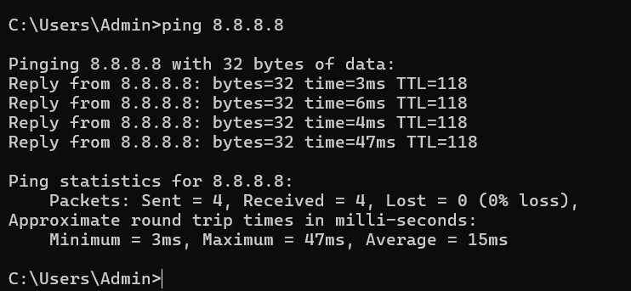
- Use ipconfig/ifconfig to check IP configurations.
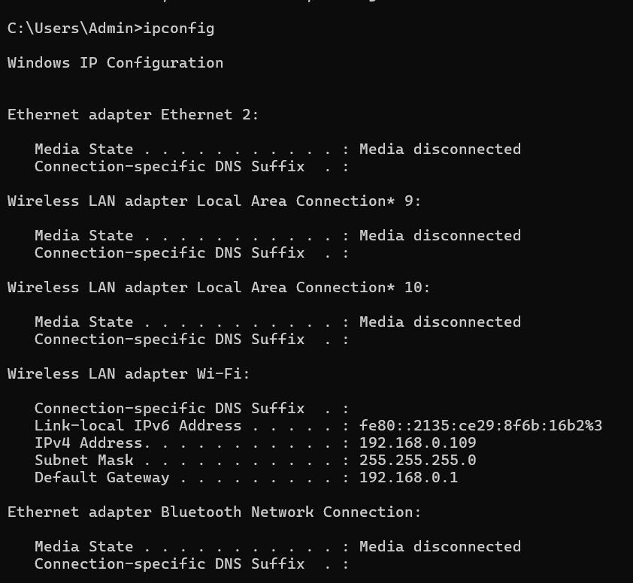
- Check internet access and internal communication.

9. Document the Network Plan
- Record IP ranges, device roles, MAC addresses, static IPs.
- Helps in troubleshooting and future upgrades.

10. Monitor and Maintain
- Use tools like Wireshark, PRTG, or Nagios for monitoring.
- Regularly update firmware and security settings.
- Review and expand IP plan as the network grows.

- Basic network troubleshooting.

Network troubleshooting is the systematic process of searching for, diagnosing, and correcting network issues.

1. Check Physical Connections
- Ensure all cables (Ethernet, power) are properly connected.
- Look for loose or damaged cables.
- Check indicator lights on modem/router/switch.

2. Restart Devices
- Restart the computer, router, and modem.
- Power cycling often fixes temporary issues.

3. Check IP Configuration
- On Windows:
Open Command Prompt → type ipconfig
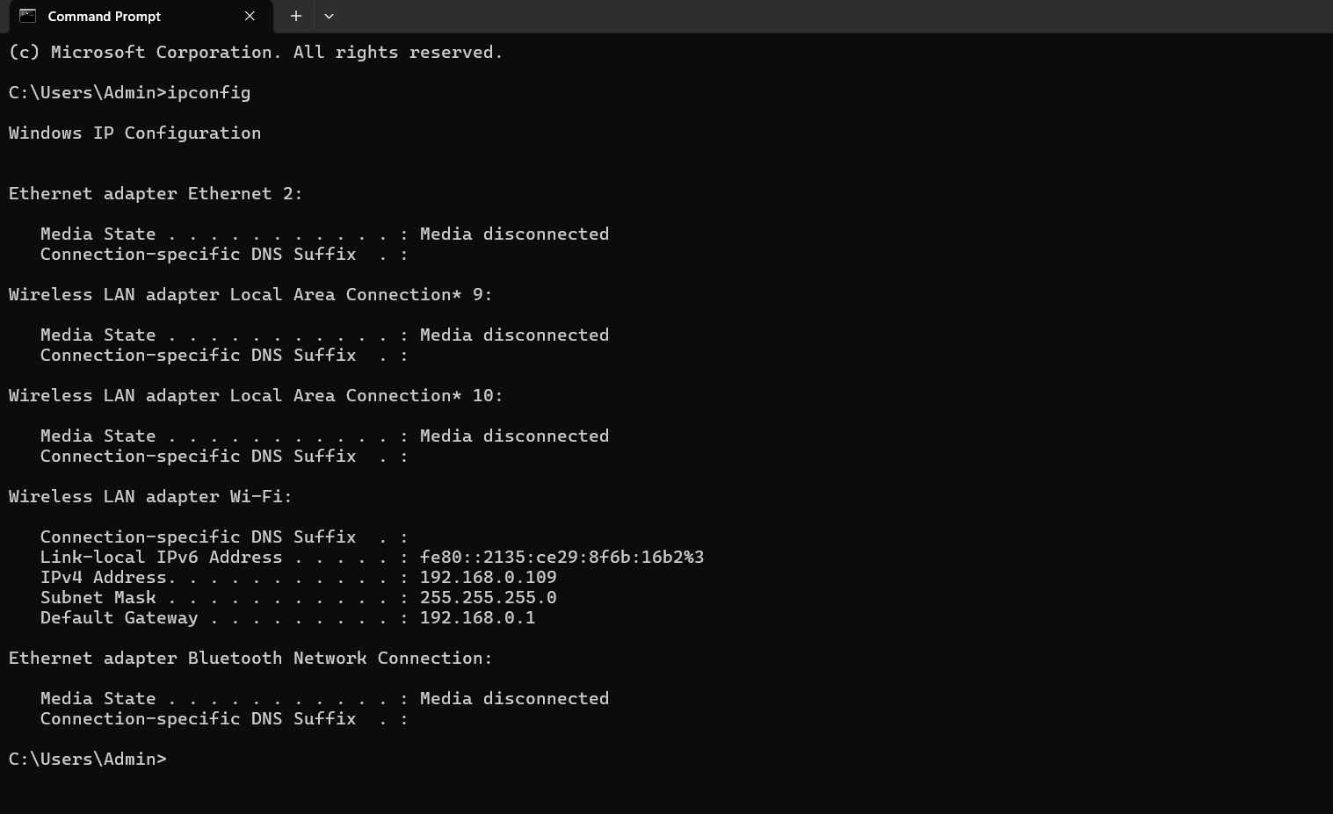
- On Linux/macOS:
Use ifconfig or ip a
- Check if the device has a valid IP (not 169.x.x.x).

4. Use Ping Command
- Test connection to:
  - Local router: ping 192.168.1.1
  - Internet: ping 8.8.8.8 (Google DNS)
  - Website: ping google.com
- No reply = connection issue.

5. Check DNS Settings
- If pinging IP works but website doesn’t, it's a DNS issue.
- Try using public DNS:
  - Google DNS: 8.8.8.8, 8.8.4.4
  - Cloudflare DNS: 1.1.1.1

6.Check Firewall or Antivirus
- Sometimes, they block network access.
- Temporarily disable to test (then re-enable).

7.Contact ISP
- If everything seems fine but internet still doesn’t work,
contact your Internet Service Provider.

