Name:- Ansari Mohd Ayan Nasiruddin Branch:SYBscIT
RollNo:-25BIT41 Sem:-III
Subject:- Computer Network Batch:- 2

Practical4
4.TCP/IP Configuration and Network Resource Sharing in Windows/Linux.
a | Configuration of TCP/IP Protocols in Windows / Linux.
b | Implementation of Drive/file sharing and printer sharing.

Aim: a) Configuration of TCP/IP Protocols in Windows / Linux.
b) Implementation of Drive/file sharing and printer sharing.

a) Configuration of TCP/IP Protocols in Windows / Linux.

Configuration of TCP/IP in Windows

1. Open Network Settings
- Press Windows + R, type ncpa.cpl, and press Enter.
(This opens the Network Connections window.)
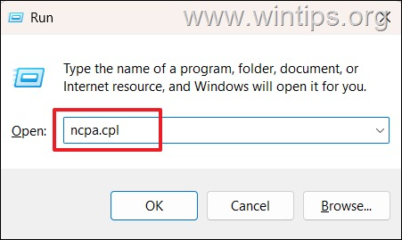

2. Select the Network Adapter
- Right-click on the active network adapter (e.g., Ethernet or Wi-Fi).
- Click Properties.
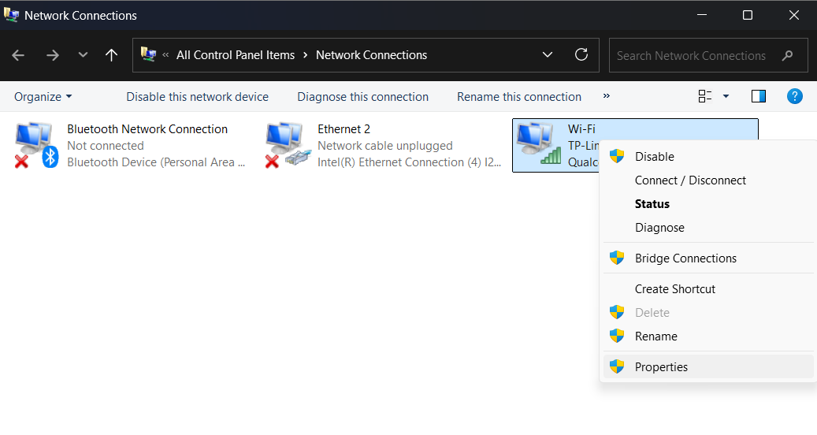

3. Choose TCP/IPv4
- In the Networking tab, select Internet Protocol Version 4 (TCP/IPv4).
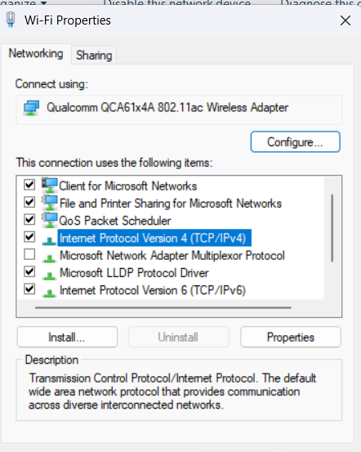
- Click Properties.

4. Configure IP Settings
- For Static IP:
  - Select Use the following IP address
  - Enter:
    - IP address: e.g., 192.168.1.10
    - Subnet mask: e.g., 255.255.255.0
    - Default gateway: e.g., 192.168.1.1
  - (Optional) Configure Preferred DNS and Alternate DNS.

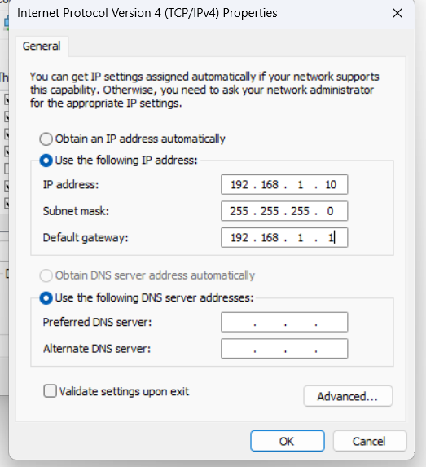
- For Dynamic IP (DHCP):
  - Select Obtain an IP address automatically
  - Select Obtain DNS server address automatically
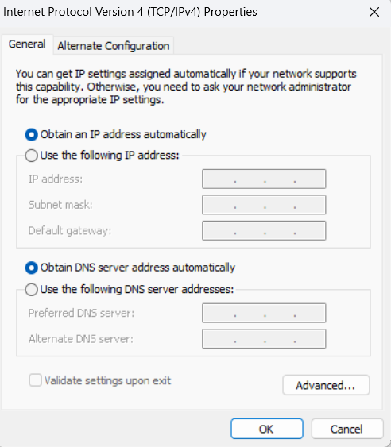

5. Save and Verify
- Click OK, then close the windows.
- Open Command Prompt and type:

Linux .Permanent IP Configuration (GUI)
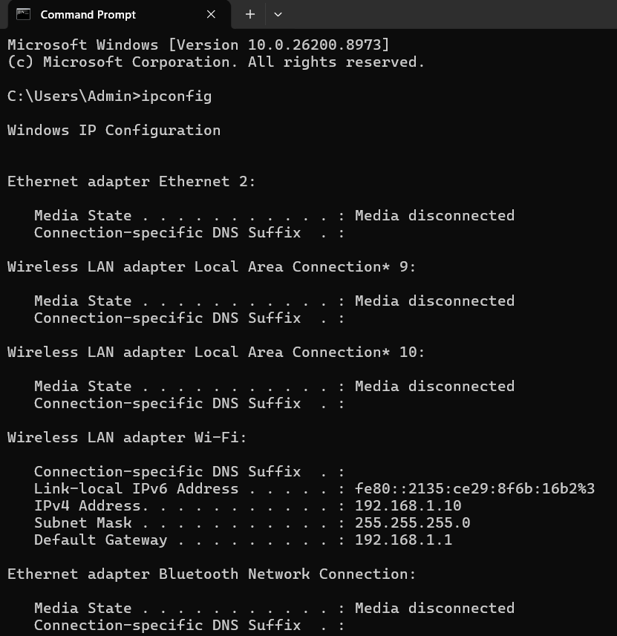
- Go to Settings → Network.
- Select the active adapter (e.g., Wired).
- Click the gear icon .
- Under IPv4, choose Manual.
- Enter:
  - IP address: 192.168.1.20
  - Netmask: 255.255.255.0
  - Gateway: 192.168.1.1
Click Apply and reconnect.
b) Implementation of Drive/file sharing and printer sharing.

1. Drive / File Sharing in Windows

Step 1: Select the Folder to Share
- Right-click the folder you want to share.
- Select Properties → Sharing tab.

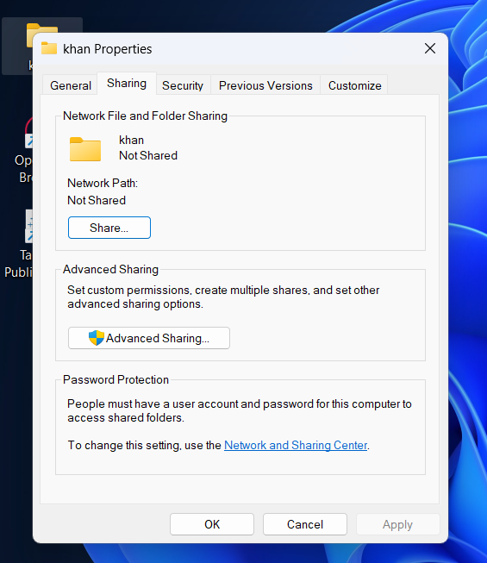
- Click Advanced Sharing… → check Share this folder.
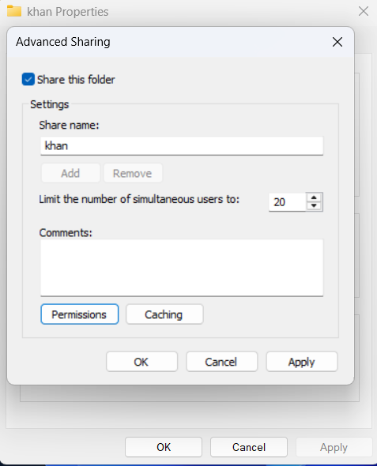
- Optionally, click Permissions to set:
  - Read → users can only view files.
  - Change → users can modify files.
  - Full Control → users can modify and manage permissions.
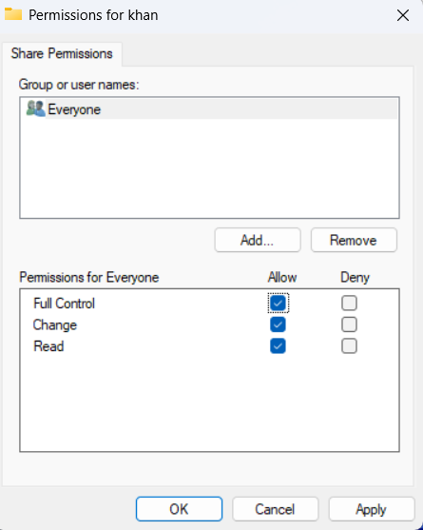
- Click OK to save.

Step 2: Access the Shared Folder
- From another computer on the same network:
  - Press Windows + R, type \\ComputerName\SharedFolderName → Enter.
  - Or open File Explorer → Network and select the shared computer.

2. Printer Sharing in Windows

Step 1: Share the Printer
- Go to Control Panel → Devices and Printers.

- Right-click the printer → Printer properties → Sharing tab.
- Check Share this printer and give it a share name.
- Click Apply → OK.

Step 2: Connect to Shared Printer on Another Computer
- Option 1: Using Network Path
  - Press Windows + R, type \\ComputerName\PrinterShareName → Enter.
  - Follow prompts to install drivers if needed.
- Option 2: Using “Add a Printer”
  - Go to Control Panel → Devices and Printers → Add a Printer.
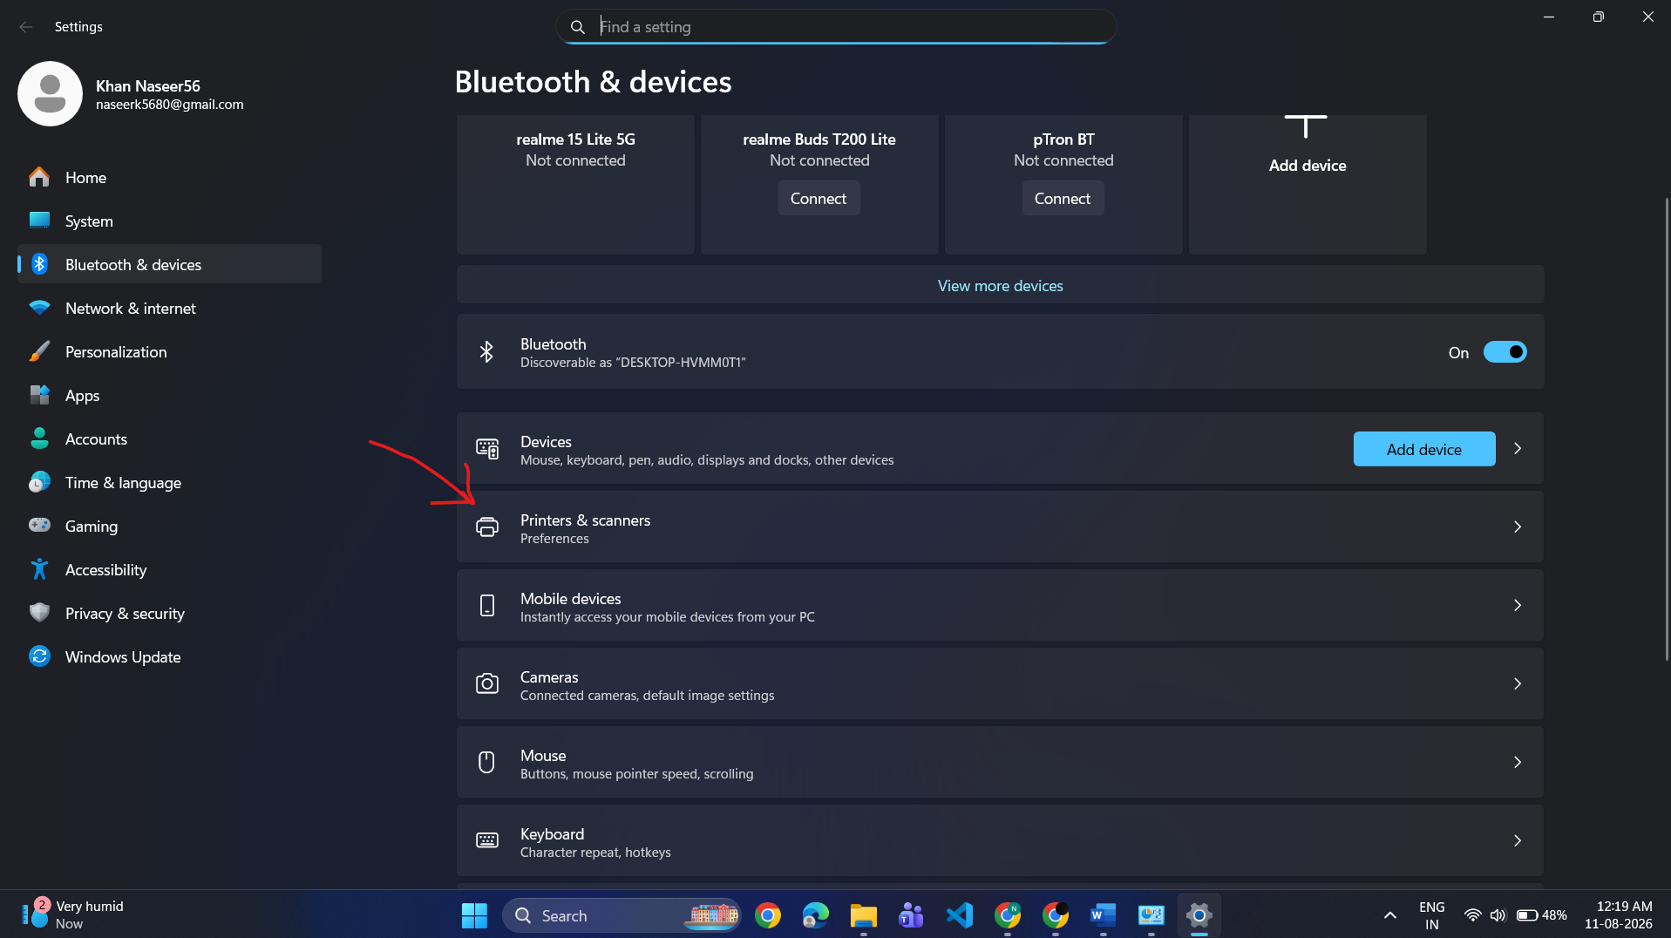
  - Select The printer that I want isn’t listed → Select a shared printer by name.
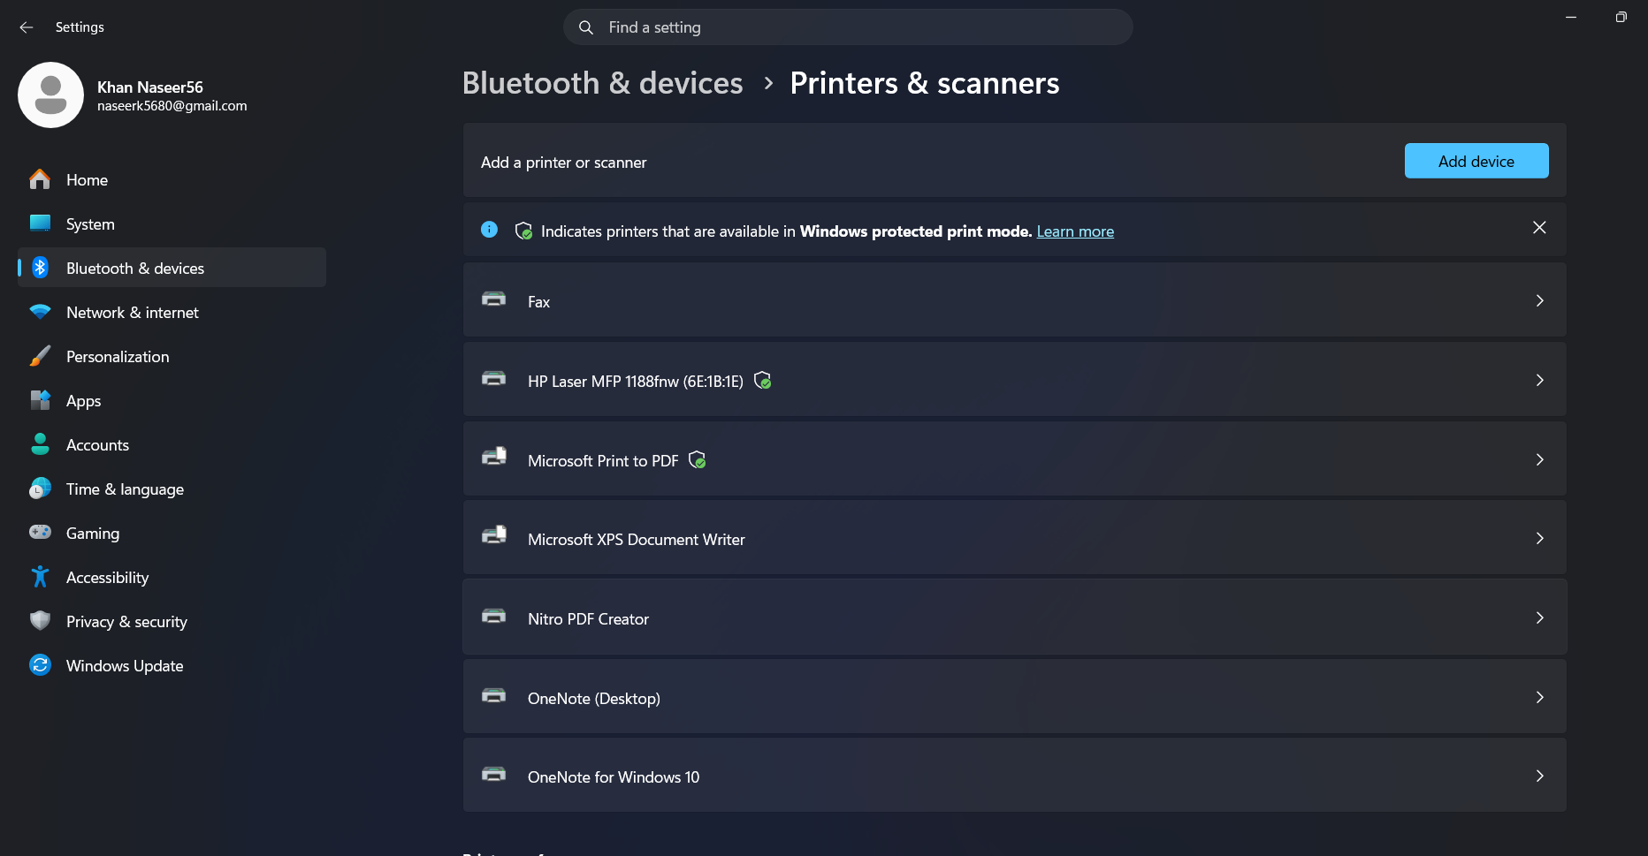
  - Enter \\ComputerName\PrinterShareName → Next → Finish.

Important Notes
- All computers must be on the same network/workgroup.
- Ensure File and Printer Sharing is enabled in Control Panel → Network and Sharing Center → Advanced Sharing Settings.
- Proper permissions are essential to control access to files and printers.
- Firewalls may block sharing; ensure exceptions are enabled for file and printer sharing.

