Name: - khan naseer Sem: - III
Roll no: - 25BIT34 Sub: - Computer Network (CN)
Class: - SY-BSCIT Batch:-2
===========================================================================
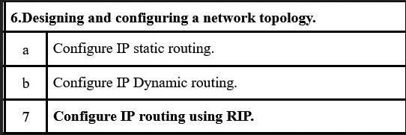

A. Configure IP static routing
- Step 1: open cisco packet tracer
- Step 2: place two router (1841)
- Step 3: place two pc
Step 4: connection copper cross over wire ( PC 0 to Router 0 ) Fast-ethernet 0 to fast-ethernet 0/0
- Step 5: connection copper cross over wire ( Router 0 to Router 1 ) Fast-ethernet 0/1 to fast-ethernet 0/1
- Step 6: connection copper cross over wire ( PC 1 to Router 1) Fast-ethernet 0/0 to fast-ethernet 0
- Step 7: assign ip (internet protocol ) to both pc PC 1: 10.0.0.10
PC 2: 12.0.0.10
- Step 8: assign gateway and IP address to both router Router 0 = 10.0.0.1 (gateway)
Router 0 =11.0.0.1 (ip)

Router 1 = 12.0.0.1 ( gateway)
Router 1 = 11.0.0.2 (ip)
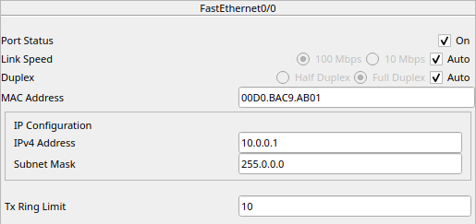
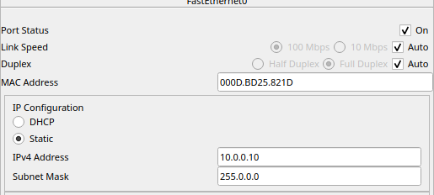
- Configure the ip of pc 0
- Configure the ip of pc 1
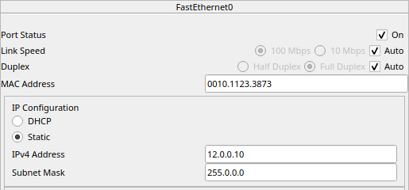
- Configure the router 0 both side Fast-ethernet 0/0
Fast-ethernet 0/1
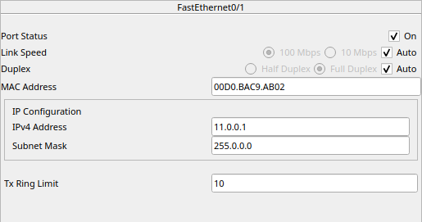
- Configure router 1 both side Fast-ethernet 0/0
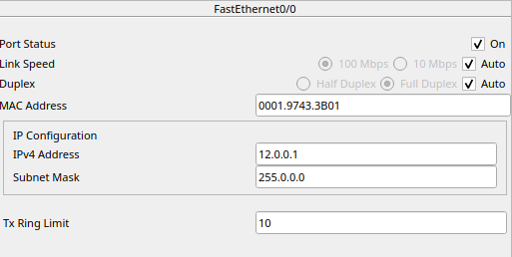

Fast-ethernet 0/1
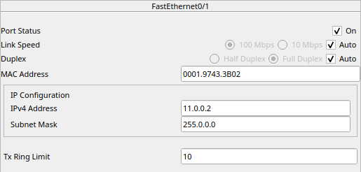
- Structure of the devices connection

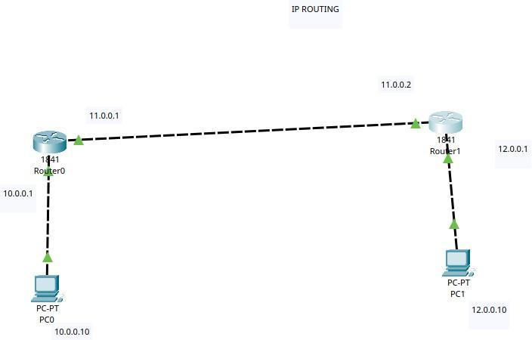

- Checking the connection by passing msg By using Ping command

From pc 0
