Name: - khan naseer Sem: - III
Roll no: - 25BIT34 Sub: - Computer Network
Class: - SY-BSCIT Batch:-2

Practical no: 07
Configuring Static Router:
Open Packet tracer and chose your devices and connections
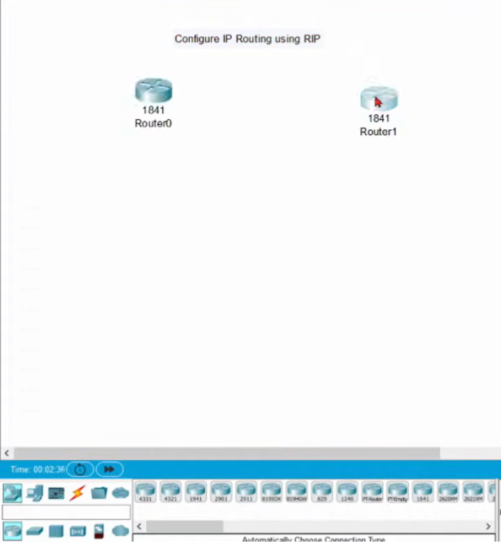

Select the ROUTER ICON from the side bar to insert two different router
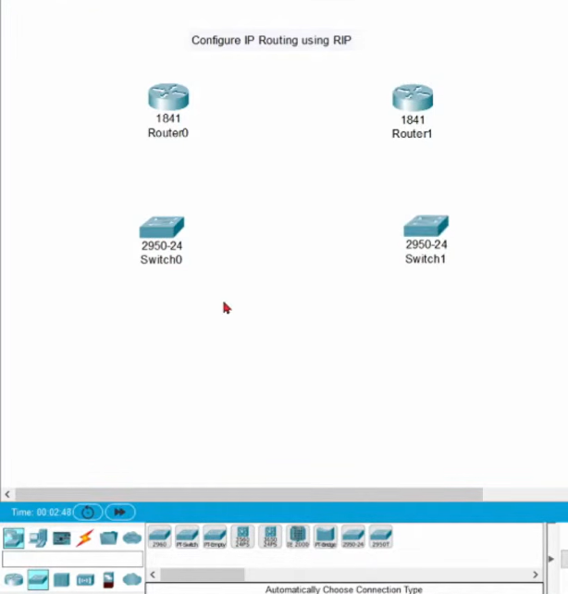

Do the same for the SWITCHES and insert both of them
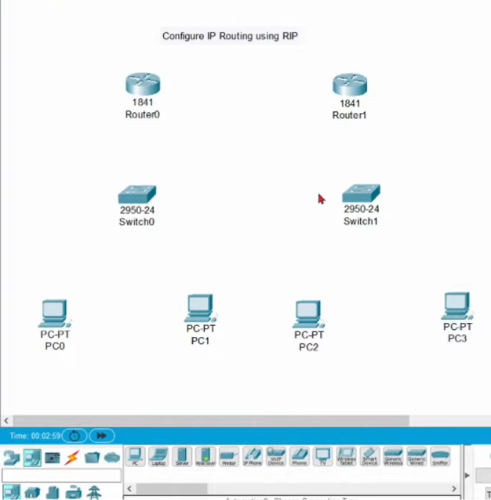

Do the same for the PC’s
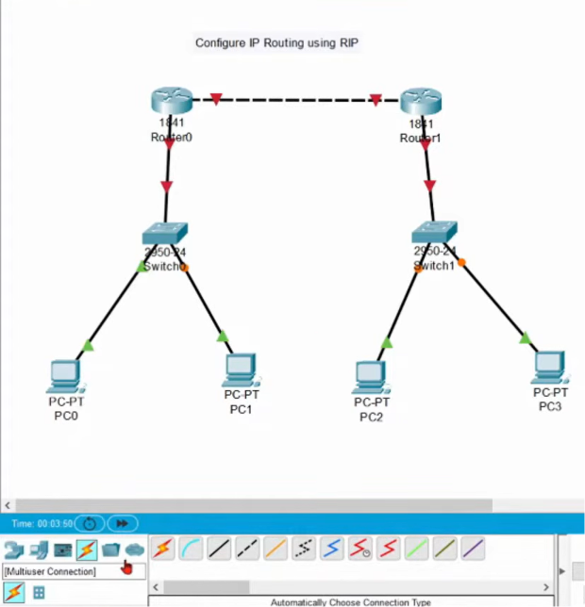

Select the WIRE (connection type) and connect the different devices together

Step 1:Create the Diagram in Packet Tracer and configure PC
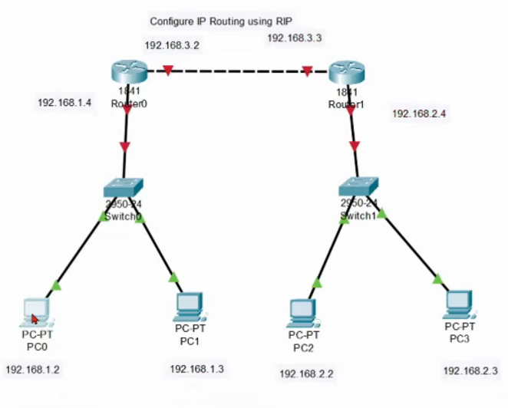
Steps to follow:-
PC0 CONFIG
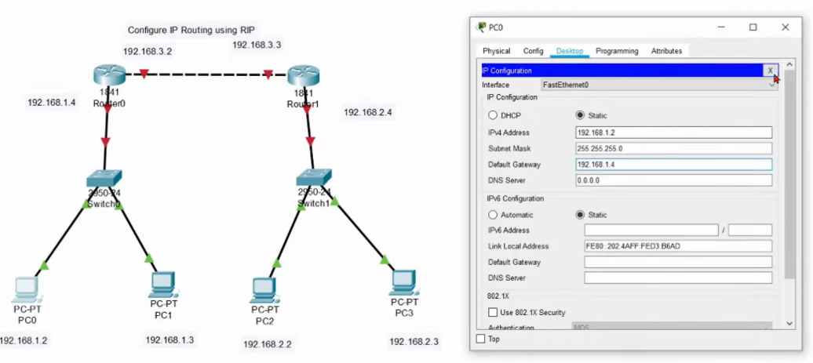
PC1 CONFIG
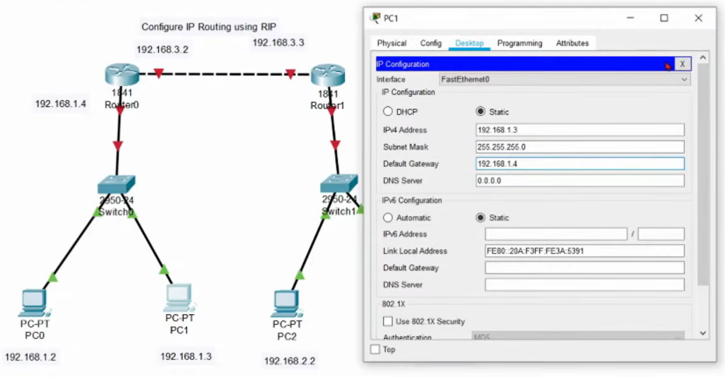

PC2 CONFIG
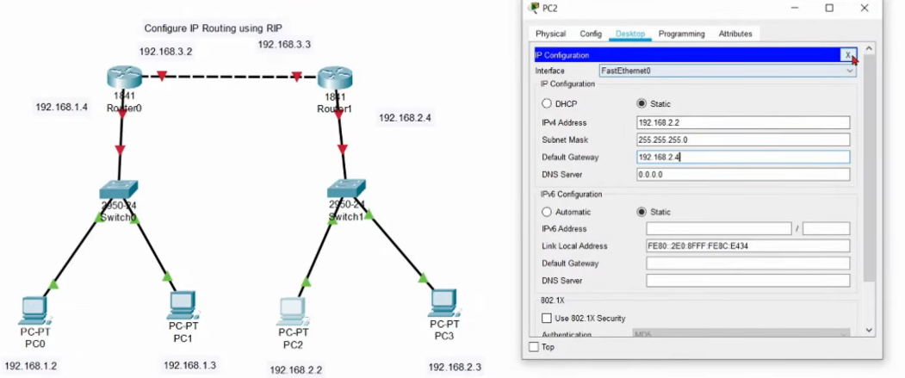
PC3 CONFIG
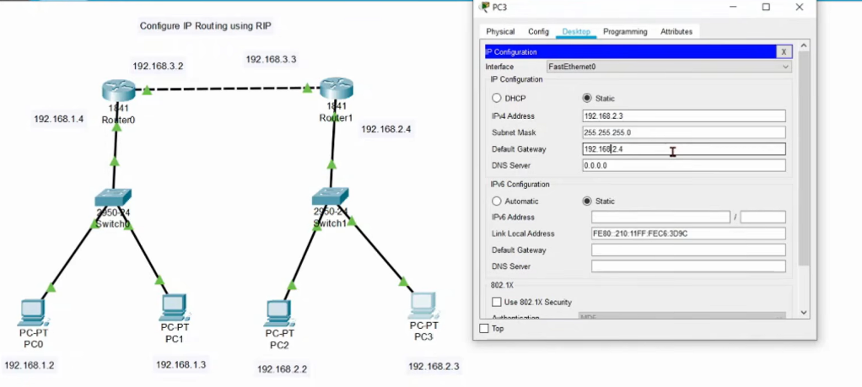

Step 2: Open the Config section of of any.
For example:-
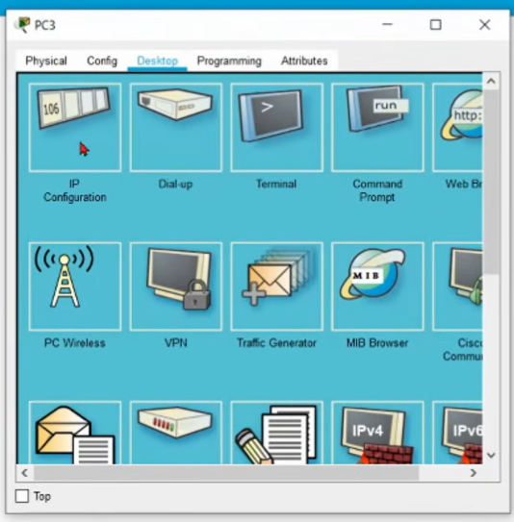
tap on any ICON() and go to DESTOP >> IP CONFIGIRATION enable STATIC
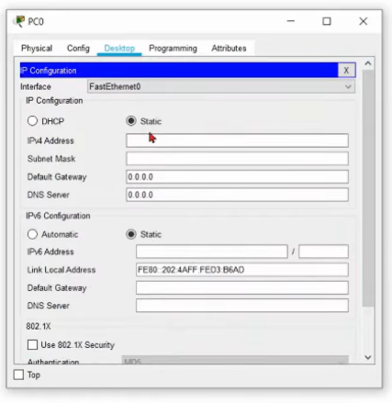

Step 3: Open the Config section of ROUTER0.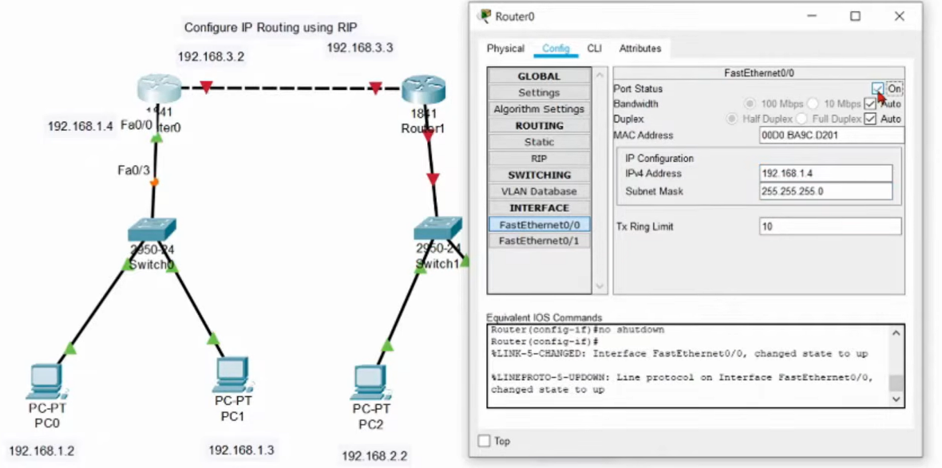
Go to FASTETHERNET0/0 put IPv4 & SUBNET MASK and ENABLE PORT STATUS
Step 4: Enter the Fa0/0 IP Address in IP4 Adress in FastEtherner0/0 and ON the router.
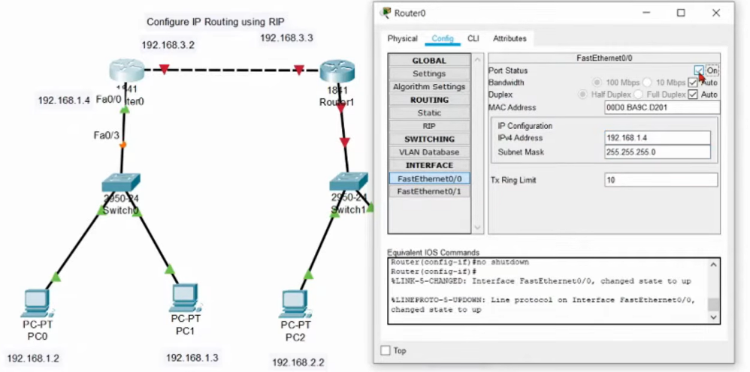
Go to FASTETHERNET0/0 put IPv4 & SUBNET MASK and ENABLE PORT STATUS

Step 5:Enter the Fa0/1 IP Address in IP4 Adress in FastEthernet0/1 and ON the router.

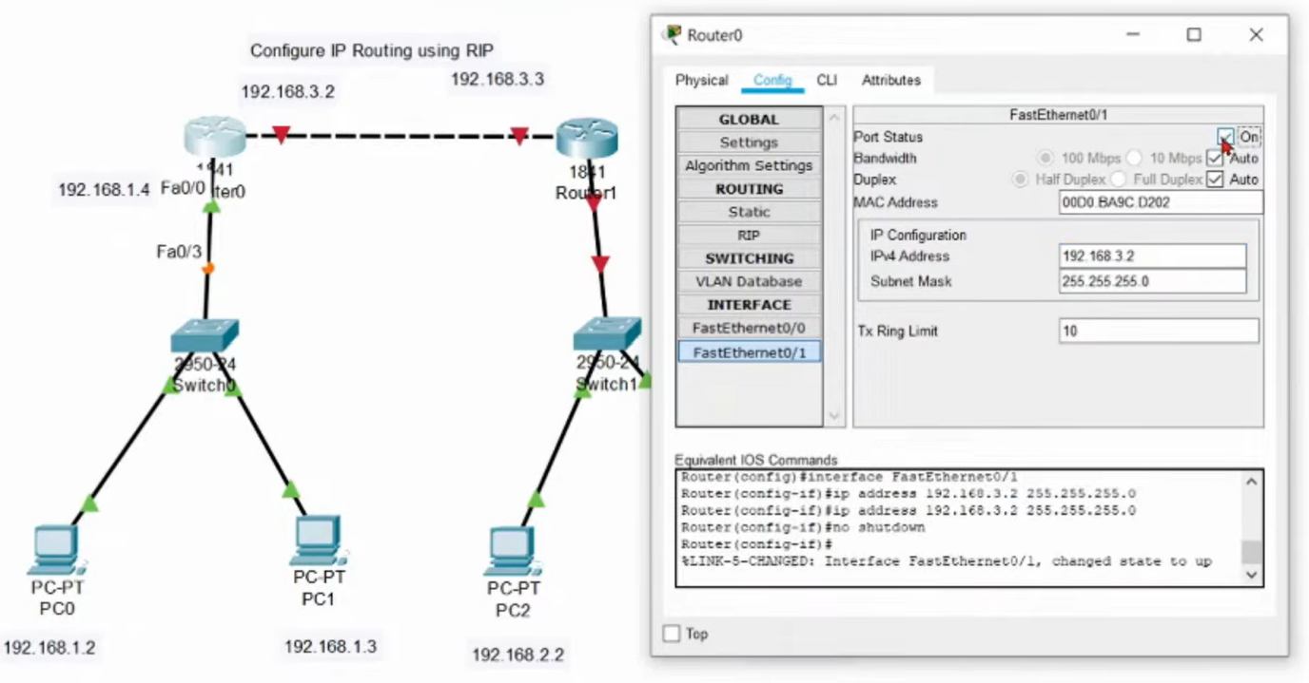
Go to FASTETHERNET0/1 put IPv4 & SUBNET MASK and ENABLE PORT STATUS

Step 6: Open the Config section of ROUTER1.
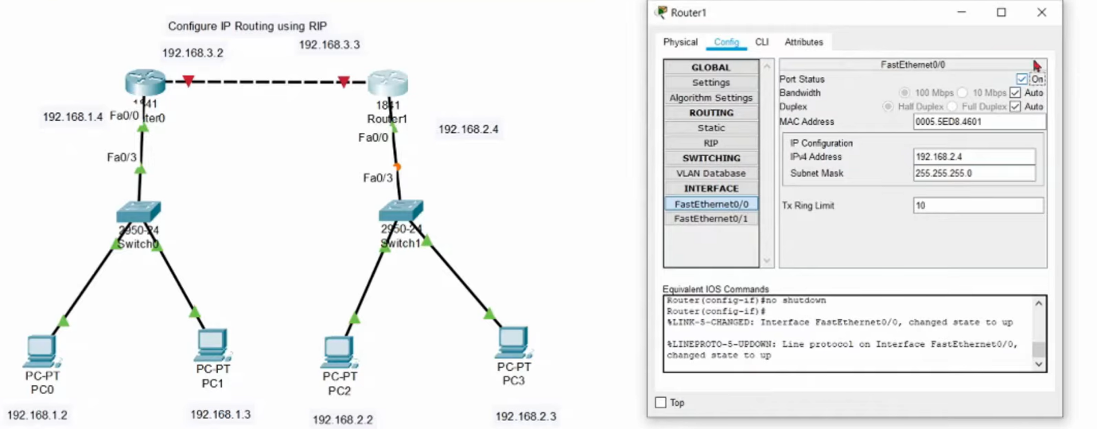

Step 7: Enter the Fa0/0 IP Address in IP4 Adress in FastEthernet0/0 and ON the router.
Go to FASTETHERNET0/0 put IPv4 & SUBNET MASK and ENABLE PORT STATUS

Step 8:Enter the Fa0/1 IP Address in IP4 Adress in FastEthernet0/1 and ON the router.
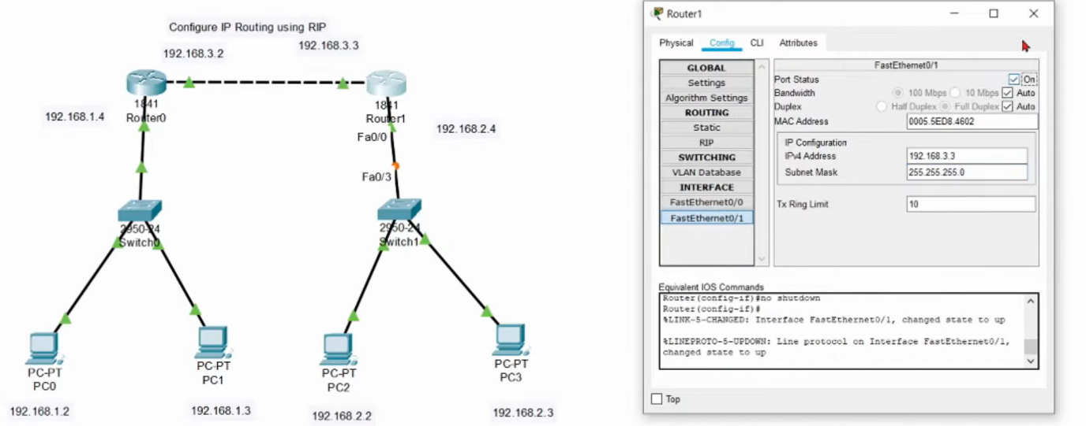
Go to FASTETHERNET0/1 put IPv4 & SUBNET MASK and ENABLE PORT STATUS
Step 9: All the Devices are Connected with Static Routing.
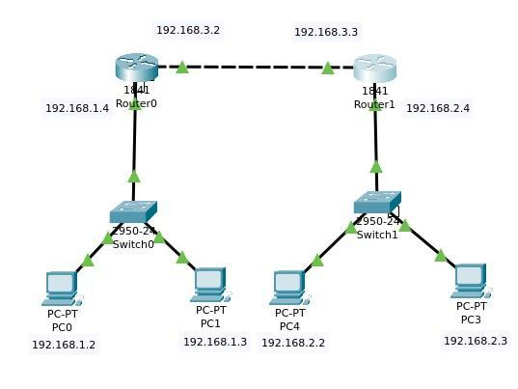
As shown ARROWS are now GREEN, that means all CABLES are connected

Step 12: CONFIG to RIP ROUTING by ROUTER0 & ROUTER1
Put The Addresses In Network And Click On Add
Enter IP ADDRESS as 192.168.1.0 for PC0,PC1 & ROUTER0
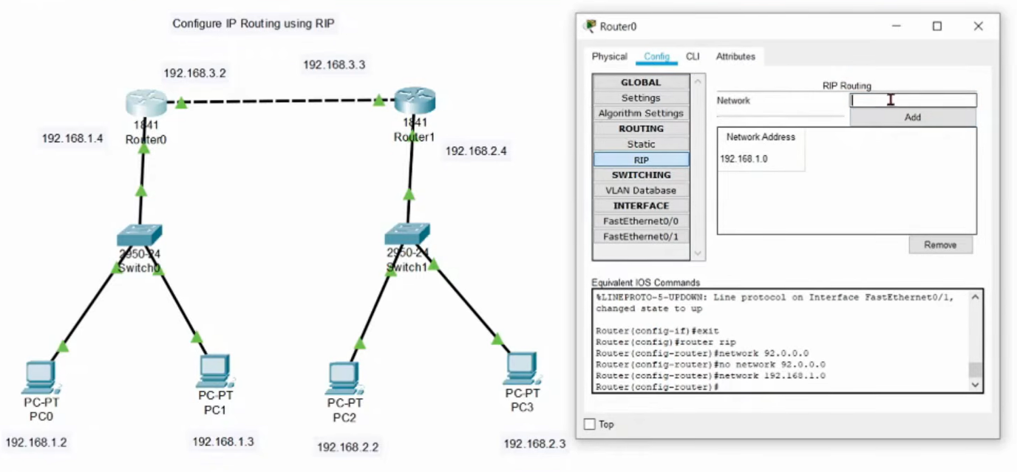
Enter IP ADDRESS as 192.168.3.0 forROUTER0 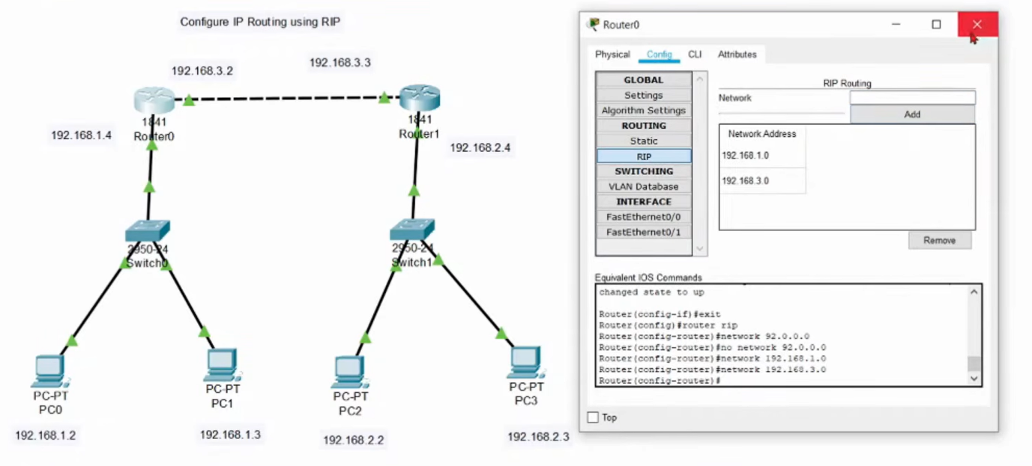
Enter IP ADDRESS as 192.168.2.0 for PC2,PC3 & ROUTER1
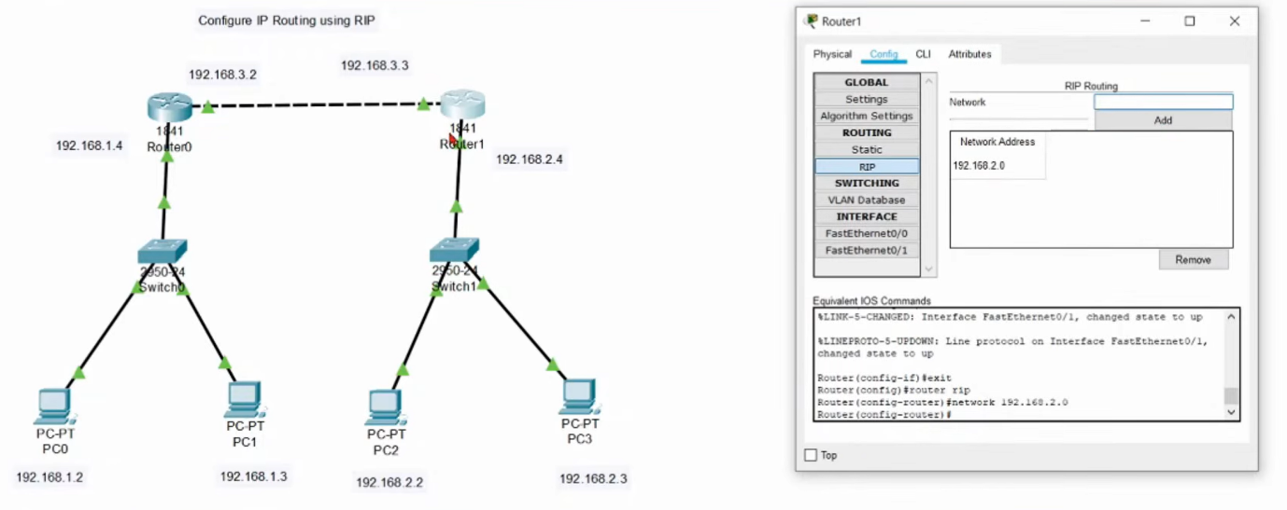
Enter IP ADDRESS as 192.168.3.0 for ROUTER1
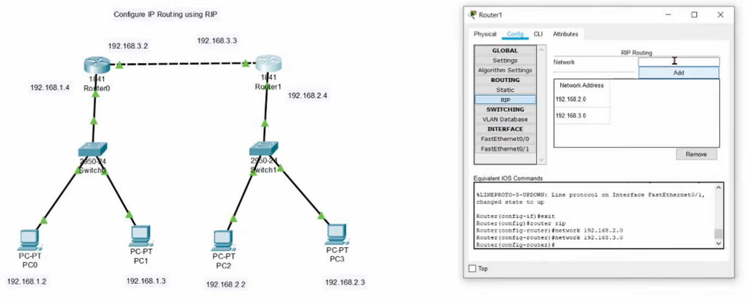

Step 11:ping of 192.168.1.2
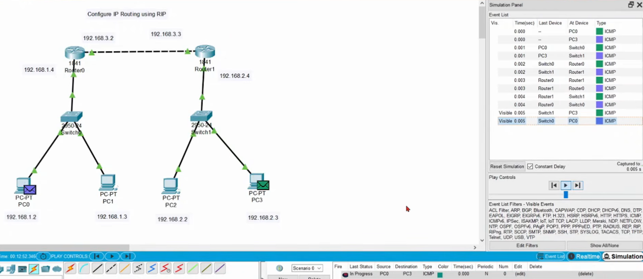 As you can see in SIMULATION the MESSAGE is going through PC0 to PC3

