1. Max Transaction Time to achieve Goals

Max Transaction time to achieve the following

* average waiting time<=30Min
* Min Number of served Customers =250
* Max Number of Customers left in line =25

Is 13 or less then 13. As with less maximum transaction time new coming customer’s waiting time will decrease that will result in more customers served and lesser customers in waiting line.

For Maximum Transaction Time = 13,

Arrival Probability =0.25, No. of service stations = 2, No. of service hours = 24, Line Capacity = 50

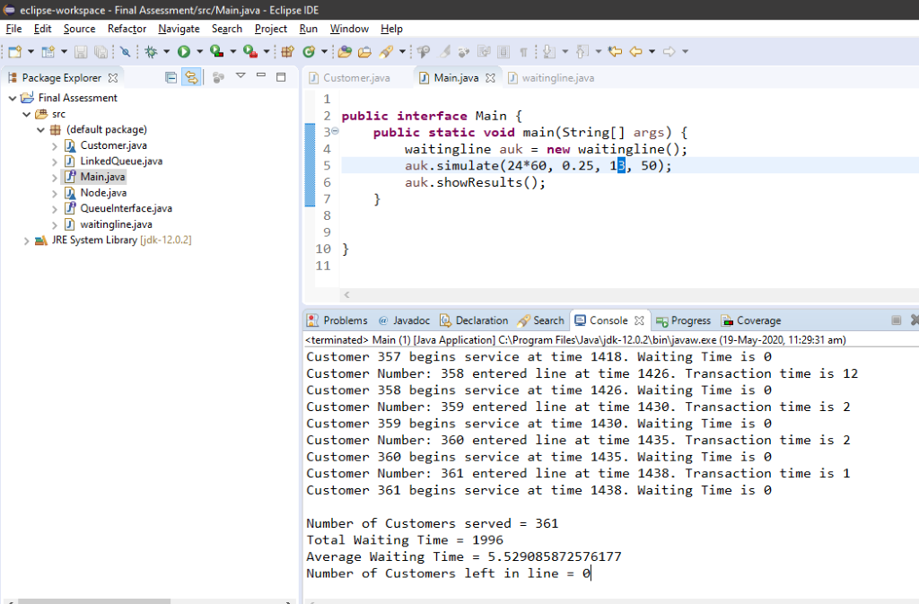

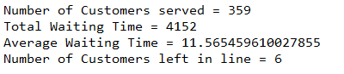

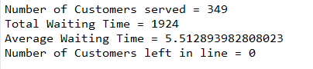

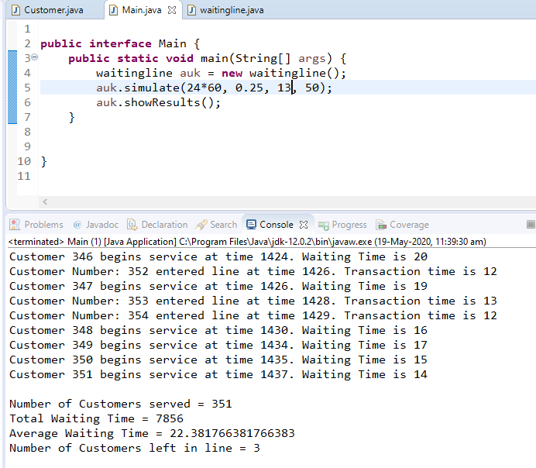

1. Arrival Probability Solution

Arrival Probability to achieve the following

* average waiting time<=30Min
* Min Number of served Customers =250
* Max Number of Customers left in line =25

Doesn’t exist as if we increase the arrival probability then the queue will be filled with average time higher than 30Min and if we decrease the arrival probability then the Minimum no. of served customers won’t reach 250. Hence, Goal can not be reached by any arrival probability.

For Arrival Probability =0.7,

Maximum Transaction Time = 60, No. of service stations = 2, No. of service hours = 24, Line Capacity = 50

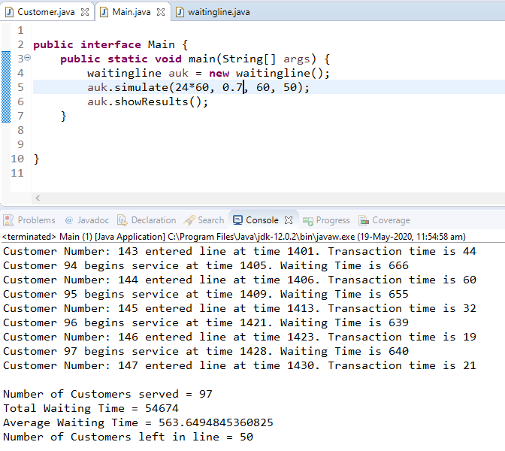

For Arrival Probability =0.1,

Maximum Transaction Time = 60, No. of service stations = 2, No. of service hours = 24, Line Capacity = 50

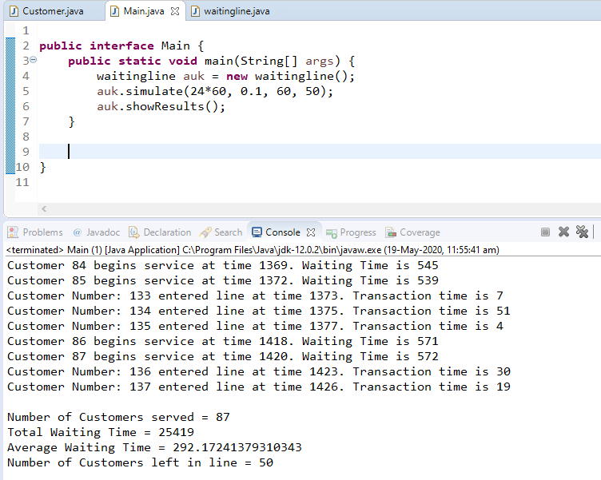

For Arrival Probability =0.05,

Maximum Transaction Time = 60, No. of service stations = 2, No. of service hours = 24, Line Capacity = 50

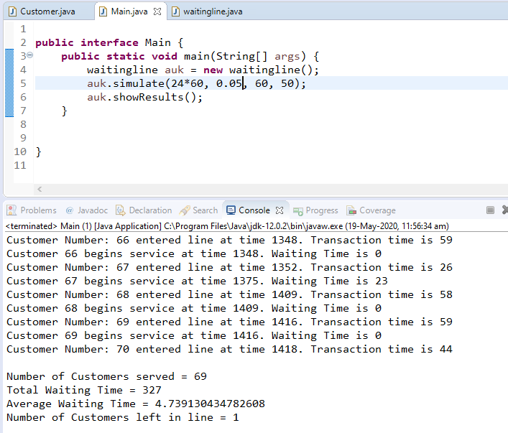

For Arrival Probability =0.95,

Maximum Transaction Time = 60, No. of service stations = 2, No. of service hours = 24, Line Capacity = 50

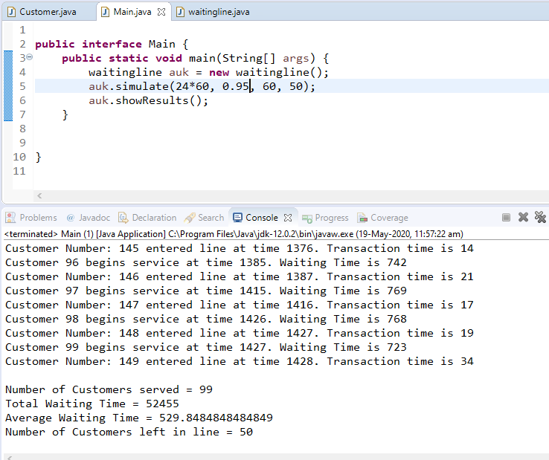

# 9. Screenshots

