***ASSIGNMENT***

**Q1. What is Git?**

Ans. Git is a Version Control System (VCS) for tracking changes in computer files and coordinating work on those files among multiple people. Git let us and others work together on projects from anywhere. In Git we can upload any type of programs of any language.

**Q2. What is the difference between Git and SVN?**

Ans. Git is decentralized. You have a local copy that is a repository in which you can commit. In SVN you always have to connect to central repository to check-in. also SVN can handle large binary files but git becomes slow when it deals with large binary files.

**Q3. Write a command to commit your work in Git?**

Ans. $ git commit -m "message"

**Q4. Create a repository with your name with unique roll number in GitHub?**

Ans. Before creating a repository you first have to sign in into GitHub. Then at the top right corner of the screen you will see a “+” sign. You click this sign and then you click new repository. Then you have to give a name of your repository and add some descriptions of it. After this you click on create repository and then it will look something like this:

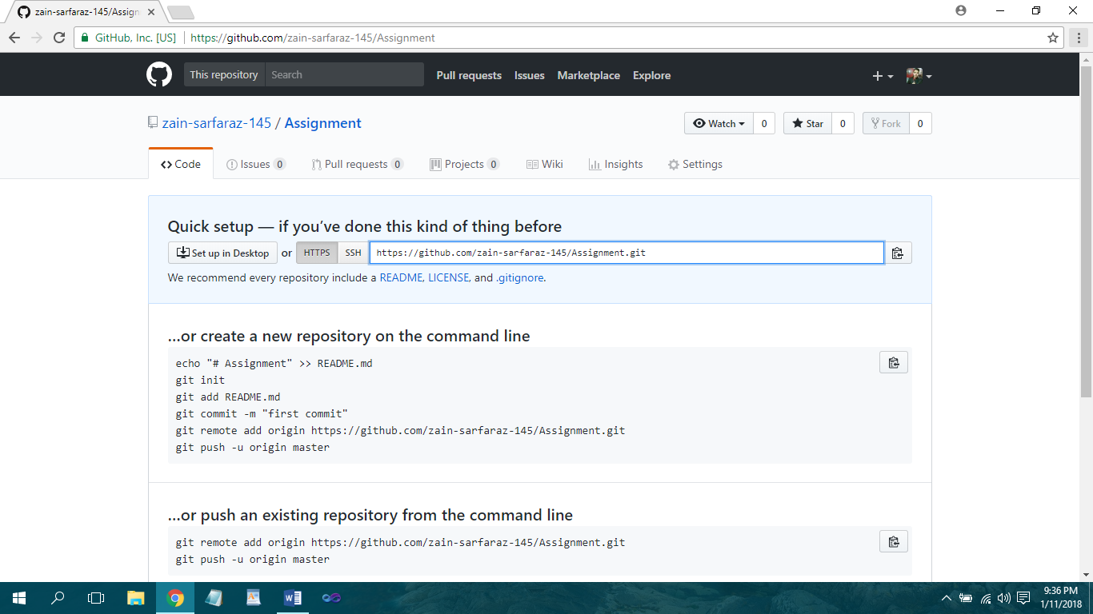

**Q5. What are the advantages of using Git?**

Ans. One of the biggest advantages of Git is its branching capabilities. Unlike centralized version control systems, Git branches are cheap and easy to merge. This facilitates the feature branch workflow popular with many Git users.

**Q6. What is Clone?**

Ans. Clone is a Git command line utility which is used to target an existing repository and create a clone, or copy of the target repository.

**Q7. What is the command to delete branch?**

Ans. $ git branch -d branch_name

**Q8. Explain the architecture of Git in your own words?**

Ans. Git has three main states that your files can reside in, **committed, modified, and staged**.

1) **Committed** means that the data is safely stored in your local database.

2) **Modified** means that you have changed the file but have not committed it to your database yet.

3) **Staged** means that you have marked a modified file in its current version to go into your next commit snapshot.

This leads us to the three main sections of a Git project, the **Git directory, the working tree, and the staging area.**

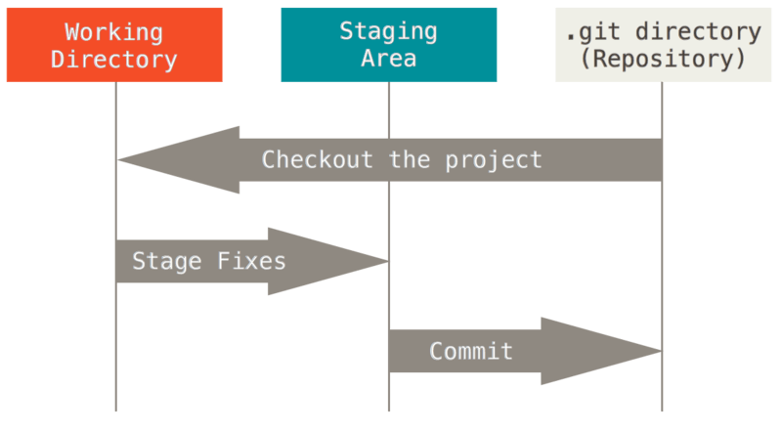

1) The **Git directory** is where Git stores the metadata and object database for your project.

2) The **Working tree** is a single checkout of one version of the project.

3) The **Staging area** is a file, generally contained in your Git directory that stores information about what will go into your next commit.

The basic Git workflow goes something like this:

1) You modify files in your working tree.

2) You selectively stage just those changes you want to be part of your next commit, which adds only those changes to the staging area.

3) You do a commit, which takes the files as they are in the staging area and stores that snapshot permanently to your Git directory.

**Q9. How to resolve conflicts in Git?**

Ans. To resolve a merge conflict caused by competing changes to a file, where a person deletes a file in one branch and another person edits the same file, you must choose whether to delete or keep the removed file in a new commit.

Steps:

1. Open Git Bash.
2. Navigate into the local Git repository that has the merge conflict
3. Generate a list of the files affected by the merge conflict. For example, the file *README.md* has a merge conflict.

1. Open your text editor and navigate to the file that has merge conflicts.
2. Decide if you want keep the removed file. You may want to view the latest changes made to the removed file in your text editor.
3. Commit your changes with a comment.

**Q10. Name the different vendors that are working on VCS**

Ans**.** CVS, SVN, GIT, MERCURIAL, BAZAAR, MONOTONE