Technological University of the Shannon: Midlands Midwest

Faculty of Engineering & Informatics



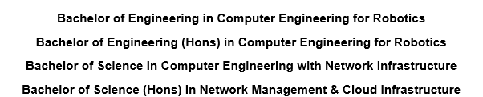

Software Development for Connected Devices 2.1
Assignment 3

Team Name: Scorpion
Team Members: -
- Caitlin Blom - A00327822
- Mohammad Zain - A00326693
Date Submitted: 01/12/2025
Contents
Introduction 3
Architecture and Design 4
1. Python Server 4
2. Java Client 4
3. User Stories 4
Verification 6
Team Effort Contribution 10
Summary 11

Introduction
Our task was to develop a basic client-server system that utilizes Sense HAT to provide sensor data. The objective was to establish a Python server that supplied one minute of data, alongside a Java client that interfaced with the server to request either temperature or humidity. Thereafter, doing calculations for average, maximum, and minimum. Once the data is obtained, the client calculates the maximum, minimum, and average, as well as printing all the data.
Additionally, we incorporated a small GUI that changes color according to the average value, just to make it easier to understand the situation at a mere glance. For instance, if the temperature is high, the background and the button change to red; if the temperature is low, the background as well as the button turn blue.
This report details what we did, the reasoning behind our design, the code we wrote on both sides of the interface, and our testing methods. I will also share my personal experience and the lessons I gained from this project.

Architecture and Design
The Python server and Java client are the two main elements of our system.

Python Server
The server operates on the Sense HAT. It captures temperature and humidity information. For this experiment, we chose to take ten readings across one minute (one every 5 seconds). It combines all the readings into a single string separated by spaces and transmits it to the client over a TCP connection.

Java Client
The Java client connects to our server via a defined IP address and port. It sends a menu choice to the server ("1" for temperature, "2" for humidity) and then waits for the results. When it gets the readings, it separates them and executes the four necessary operations: Max, Min, Average, and Print All. The GUI changes color dependent on the average reading.

User Stories
- As a user, I want to get the average temperature for 10 readings​
- As a user, I want to get the max temperature for 10 readings​
- As a user, I want to get the min temperature for 10 readings​
- As a user, I want to get the average humidity for 10 readings​
- As a user, I want to get the max humidity for 10 readings​
- As a user, I want to get the min humidity for 10 readings​
- As a user, I want to get the print all 10 humidity readings

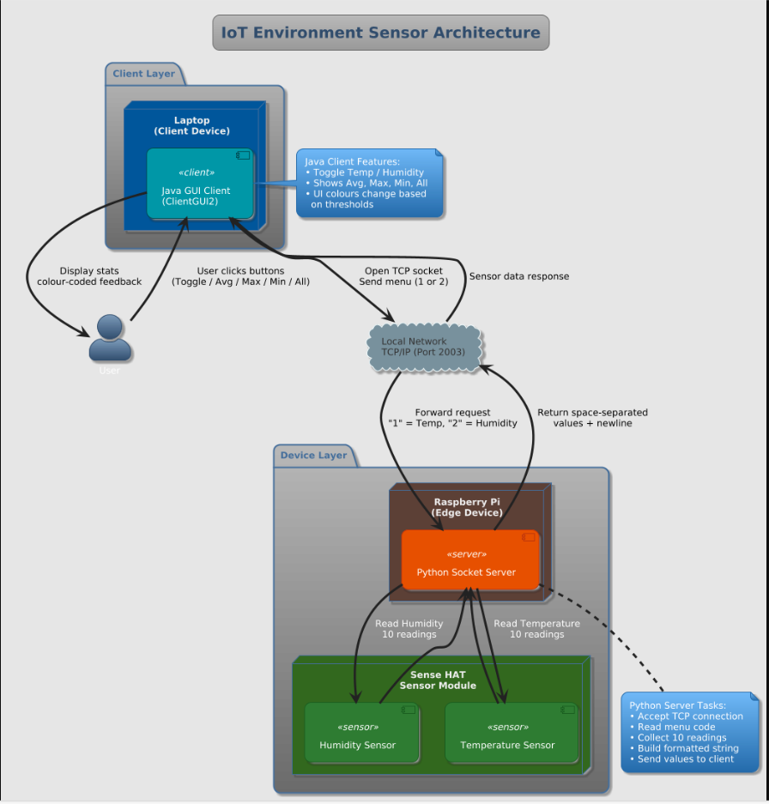

Verification
- As a user, I want to get the average temperature for 10 readings
Results - The average temperature was 18.49°C (between 15°C and 22°C), the GUI button and background turned green.
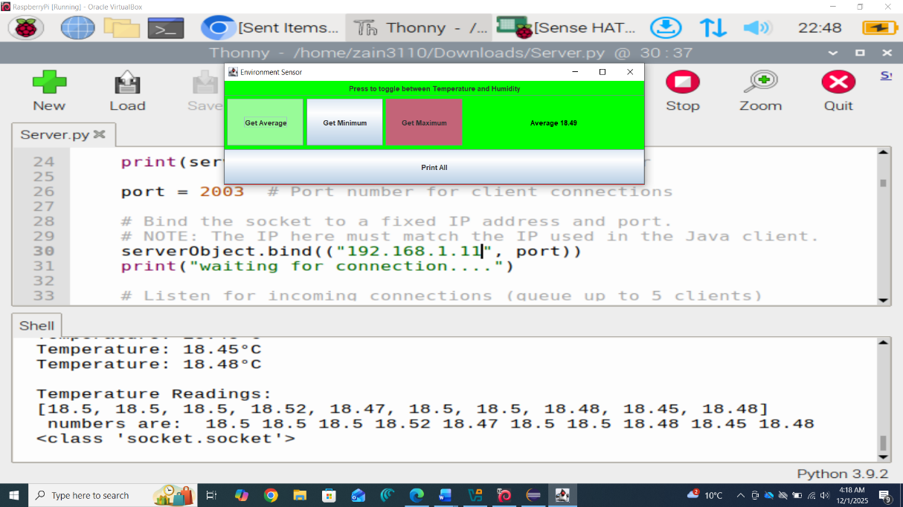
- As a user, I want to get the max temperature for 10 readings​
Results - The max temperature was 24.98°C (greater than 22°C), the GUI button and background turned red.
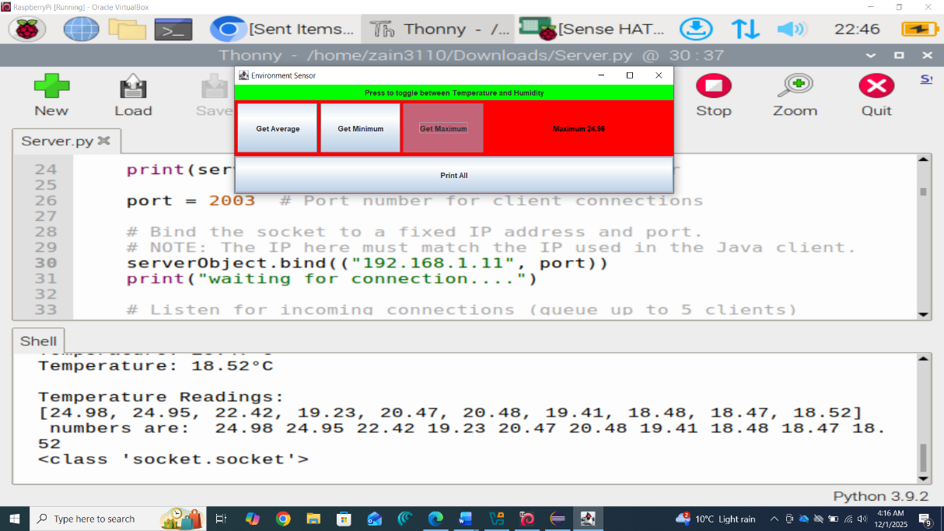
- As a user, I want to get the min temperature for 10 readings
Results - The min temperature was 8.44°C (less than 15°C), the GUI button and background turned blue.
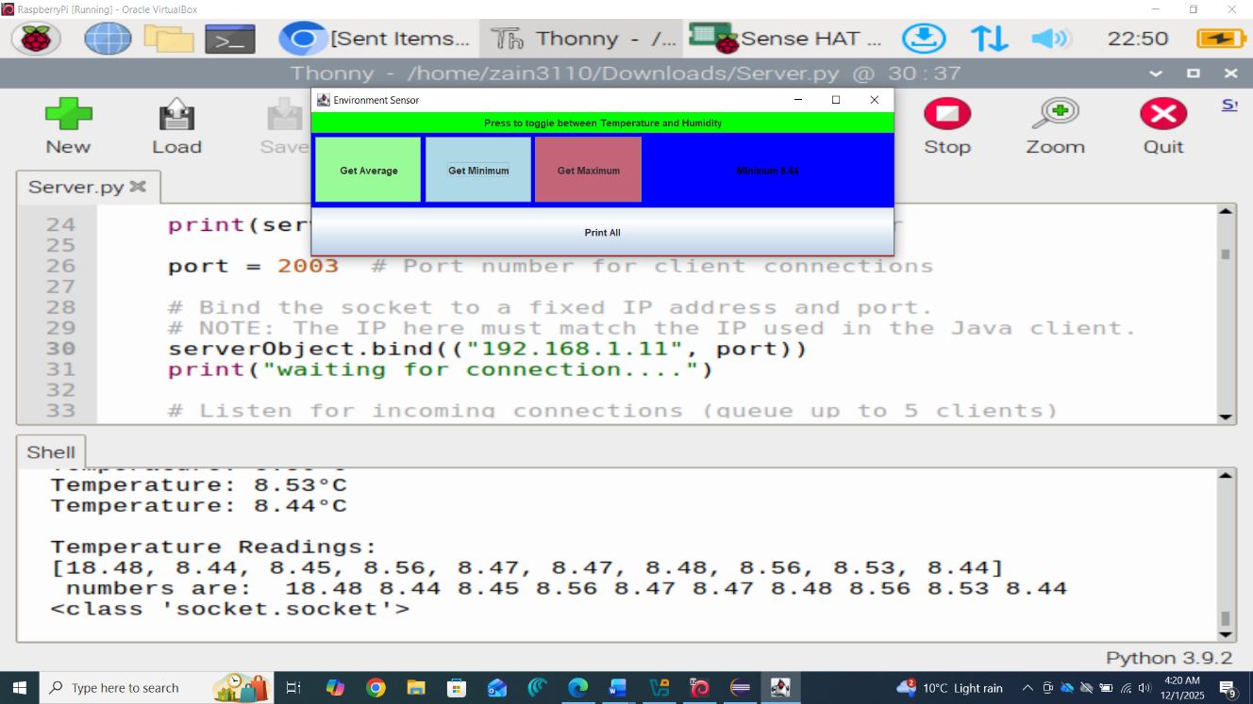
- As a user, I want to get the average humidity for 10 readings​
Results - The average humidity was 57.415% (between 55% and 65%), the GUI button and background turned yellow.
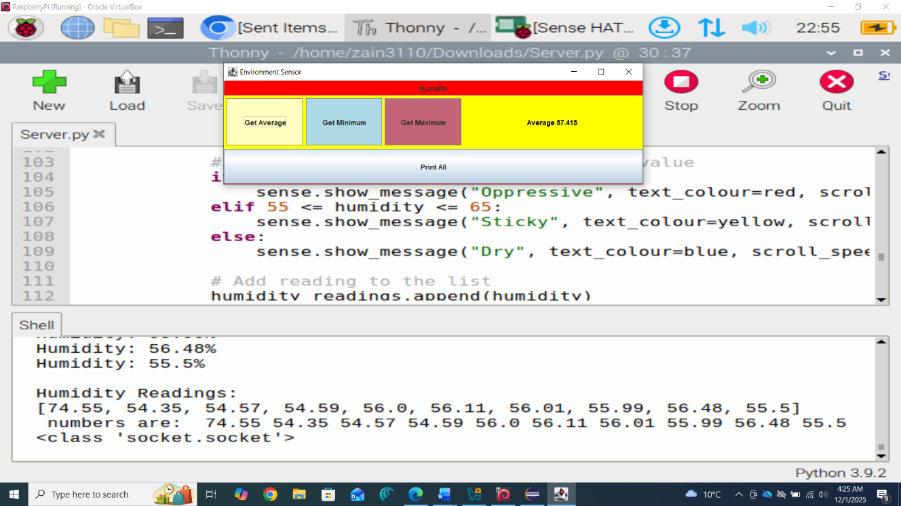
- As a user, I want to get the max humidity for 10 readings​
Results - The max temperature was 74.39% (greater than 65%), the GUI button and background turned red.
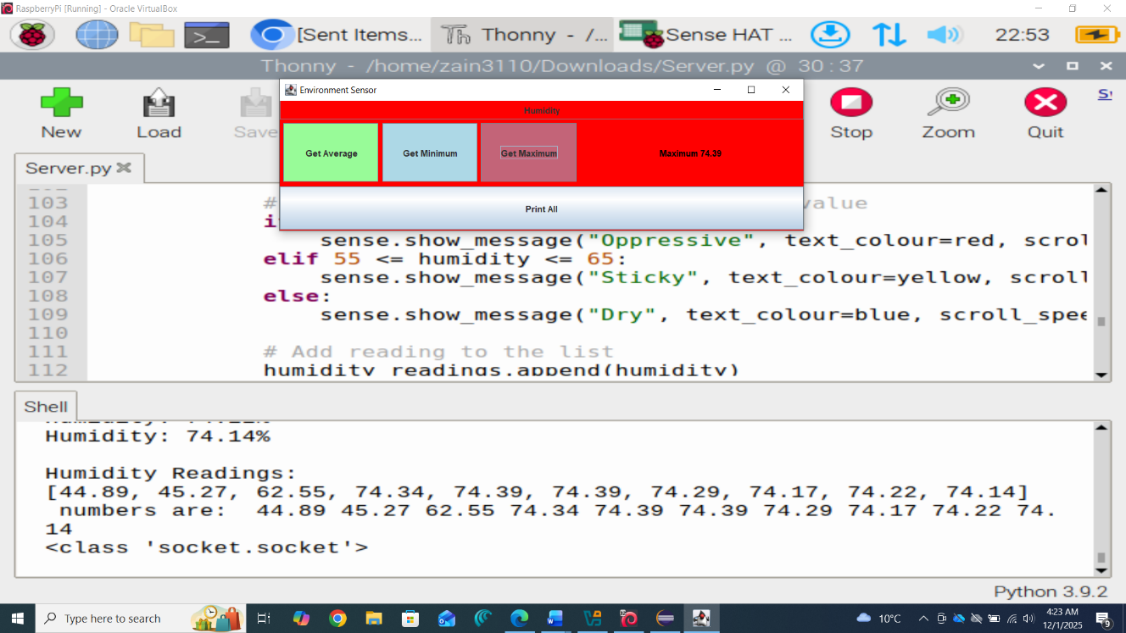
- As a user, I want to get the min humidity for 10 readings​
Results - The min temperature was 8.44% (less than 55%), the GUI button and background turned blue.
- As a user, I want to get the print all 10 humidity readings
Results – The entire list of humidity readings was printed on the GUI background.
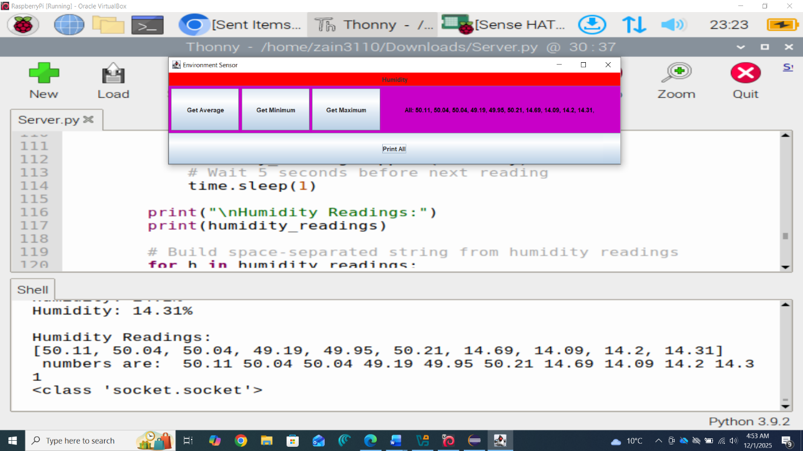

Team Effort Contribution
Name | Architecture & Design | Implementation | Verification | Contribution
Caitilin | 80% | 50% | 20% | Mainly worked on the Python server, handled sockets, and assisted in overall testing.
Zain | 20% | 50% | 80% | Helped design the flow, wrote part of Java GUI, and helped test all readings.
We discussed the percentages together and agreed on these numbers.

Summary
In this project, we created a client-server system based on the Sense HAT in both Python and Java languages. In this report, we discussed what our application was for, we explored the design of the system, and we ensured that it functions as it should.
Apart from contributing to the design phase, I also contributed to some areas of client implementation in Java, especially the GUI and logic for displaying average, max, and min values. Further, in verification, I helped in testing temperature and humidity values.
Working on this project has made me better informed about sockets and informed me on the ways in which different languages can talk to each other through a protocol. It has also helped me develop my teamwork abilities, as the communication between the server and client had to be synchronized between us.

