Technological University of the Shannon: Midlands Midwest

Faculty of Engineering & Informatics




Year 2
Software Development for Connected Devices 2.1

STUDENT NAME: MOHAMMAD ZAIN

STUDENT NUMBER: A00326693

ASSIGNMENT TITLE: PRINTING HUMIDITY & TEMPERATURE USING SENSE HAT IN PYTHON

DATE: 11/11/2025

Contents
Real Life Scenario 3
Temperature Output 4
Humidity Output 5
Video Sense HAT 6

Real Life Scenario
In a smart environment setup, we can use a Raspberry Pi as the main controller, while the Sense HAT could sense the temperature and humidity of a room. This system would calculate the comfort level and display colour coded messages on an LED display immediately. This model could be expanded to send the readings to a cloud database or a mobile app for home automation monitoring.
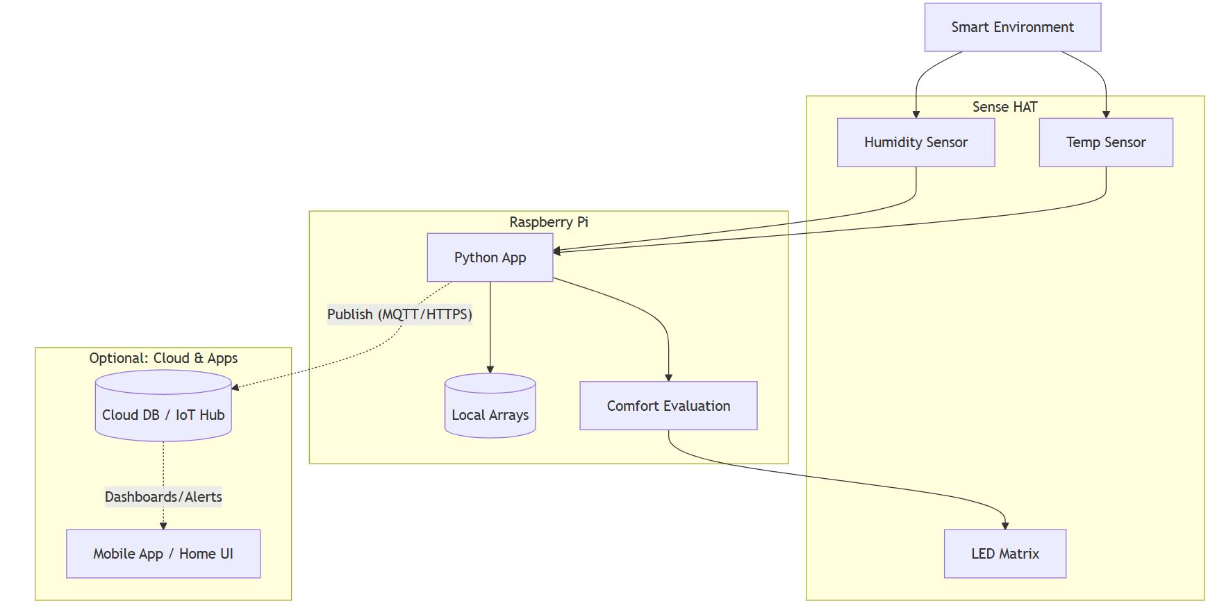

Temperature Output
Too Hot - temp > 22°C 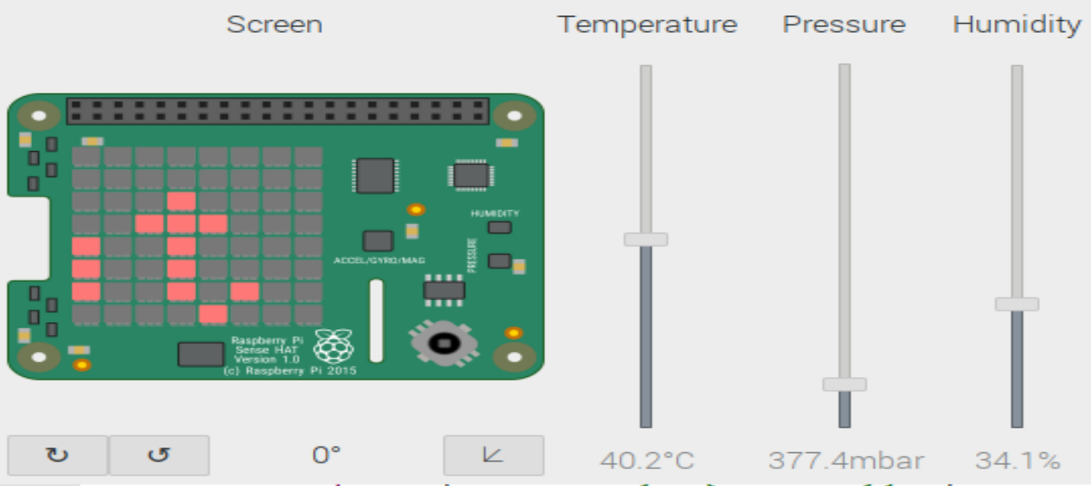
Comfortable - 15°C <= temp <= 22°C 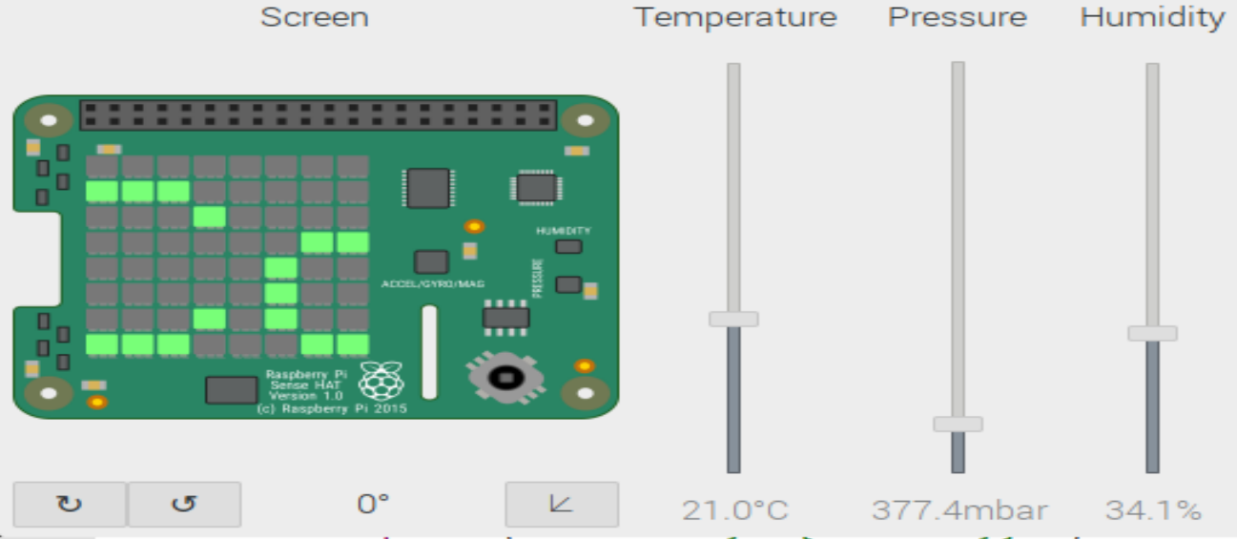
Cold - temp < 15°C 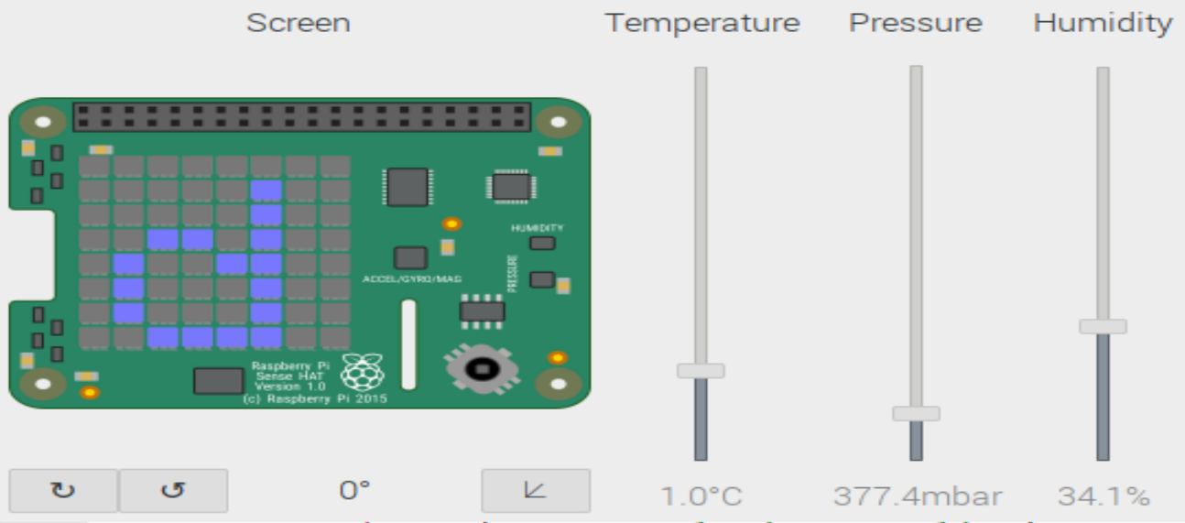

Humidity Output
Oppressive - humidity > 65% 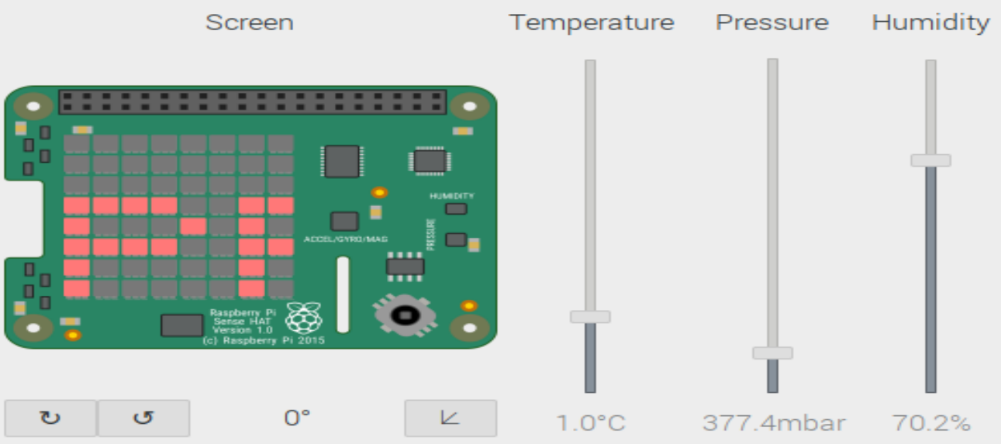
Sticky - 55% <= humidity <= 65% 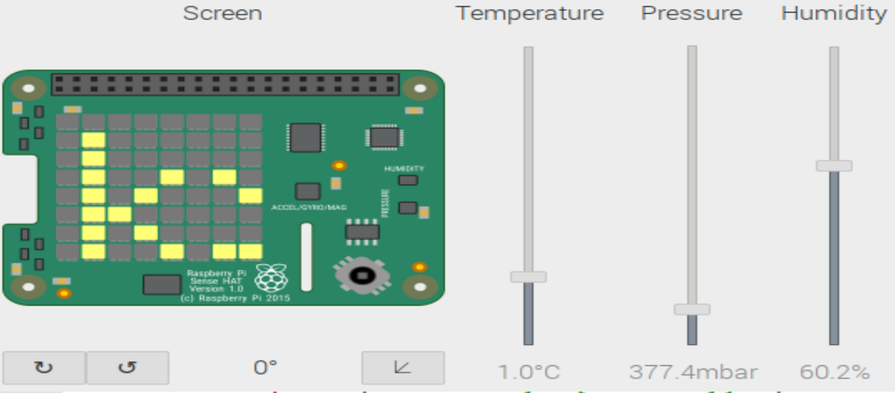
Dry - humidity > 55%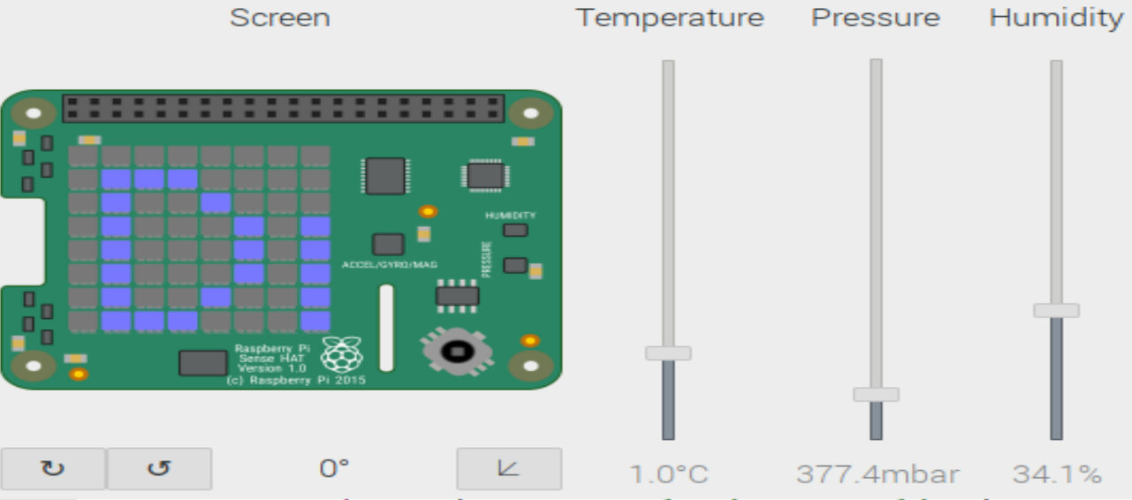

Video Sense HAT
Recording-20251112_031521.webm

