Technological University of the Shannon: Midlands Midwest

Faculty of Engineering & Informatics



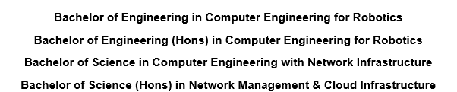

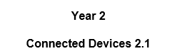
STUDENT NAME: Mohammad Zain

STUDENT NUMBER: A00326693

ASSIGNMENT TITLE: T-JUNCTION TRAFFIC LIGHT CONTROL SYSTEM

DATE: 10/11/2025

Contents
- Introduction ...................................................................... 3
- Rationale ........................................................................... 4
- Specification ..................................................................... 5
- Design ............................................................................... 7
4.1 Hardware Design ....................................................... 7
4.2 Software Design ......................................................... 8
- Build ................................................................................ 11
- Test .................................................................................. 22
- Conclusion ...................................................................... 25

Introduction
This report elaborates on the design, building, and testing of a system for controlling traffic lights using an Arduino uno microcontroller. The system controls three vehicular streams or clusters, two pedestrian streams and includes such intelligent aspects as pedestrian buttons, auditory alerts, and light sequence modeling with safety considerations. Advanced urban city traffic control demands advanced control systems to facilitate efficiency and safety, and this project illustrates elementary aspects of embedded systems design principles in practical traffic control applications.
The system aims to develop a reliable system that considers safety while ensuring efficient flow of traffic. Using pedestrian buttons on demand and timed light cycles. The system reiterates the working of a T-Junction traffic system while allowing for pedestrian access when required.

Rationale
Purpose of the System:
The main aim behind such a traffic light system is to present a secure and efficient way to regulate two streams of traffic at an intersection. In cities and towns, well-coordinated traffic lights are required for:
• Averting collisions among the traffic streams
• Safe pedestrian crossing management and offering manageable crossing times
• Minimizing traffic jams and maximizing the light timings for better
Why This Solution Matters:
Traditional fixed time traffic light systems are not responsive to current conditions. The inclusion of pedestrian initiated crossing stages (Buttons) increases the responsiveness to of the system. The addition of audible feedback (Buzzer) improves accessibility for the blind pedestrians and is in accordance with current accessibility requirements.
The system apprehends concepts of key ideas such as:
• Real time input processing through interrupts
• Multitask sequences and timing control
• Hardware and software integration
• Safety critical system design

Specification
System Requirements and Functional Specifications:
- Hardware Components:
- Arduino Uno microcontroller
- 9 LEDs for vehicle traffic lights (3 sets of red, yellow and green)
- 4 LEDs outputs for pedestrian signals (2 sets of red and green)
- 2 pedestrian buttons
- 1 piezo buzzer
- 13 resistors of 220 Ω
- 3 small breadboards
- 2 packs of jumper wires (1 pack – 15 wires)
- Functional Requirements:
- Vehicle Traffic Control:
  - Three independent vehicle traffic streams.
  - Standard red, yellow, and green light sequences.
  - Minimum green time of 7 seconds per phase.
  - Yellow warning period of 1.5 seconds between phases.
- Pedestrian Safety Features:
  - Two pedestrian crossing points
  - Request triggered crossing phases.
  - Visual countdown (blinking green) before the end of crossing time
  - The buzzer gives audible signals during crossing period.
  - All vehicles must stop during pedestrian crossings.
- System Behavior:
  - Pedestrian buttons can be pressed at any moment and if pressed once the latch will change its value, which cannot be changed until the entire cycle is over.
  - Interrupt driven button for managing immediate responses and safe transitions between all light states.
  - The traffic phase is continuous.

Design
Hardware Design
  - Hardware Design:
The T-junction traffic light system works with an Arduino Uno microcontroller, which acts as the controller for all the operations of the signals. Three breadboards are utilized for traffic and pedestrian lights. Red, yellow, and green LEDs are used for each set of traffic lights, which are paired with 220 Ω resistors and are connected to Arduino’s digital pins. The pedestrian crossings have push buttons for inputs and a buzzer for audio feedback. The Arduino processes inputs and outputs using programmed timings and conditions.
  - Schematics:
- Vehicle Light Clusters:
- Cluster 1: Pins 8 (Red), 9 (Yellow), 10 (Green)
- Cluster 2: Pins 11 (Red), 12 (Yellow), 13 (Green)
- Cluster 3: Pins 4 (Red), 5 (Yellow), 6 (Green)
- Pedestrian Systems:
- Crossing 1: Pin 7 (Red), Pin A3 (Green), Pin 2 (Button)
- Crossing 2: Pin A1 (Red), Pin A2 (Green), Pin 3 (Button)
- Feedback Device:
- Auditory: Pin A0 (Buzzer)
  - Why Arduino:
Arduino Uno is an open-source microcontroller board that runs on ATmega328P chip. It was developed in Italy by a group of engineers to make it simple and accessible for beginners and professionals to work on electronics and programming. It has digital and analog output/input pins, a USB to program it, and a power jack to pass on an external supply are all parts of the board. In this project, the Arduino Uno manages LED timing and sequencing with a real simulation of traffic signal operations with accuracy and dependability.
Software Design
Flowchart:
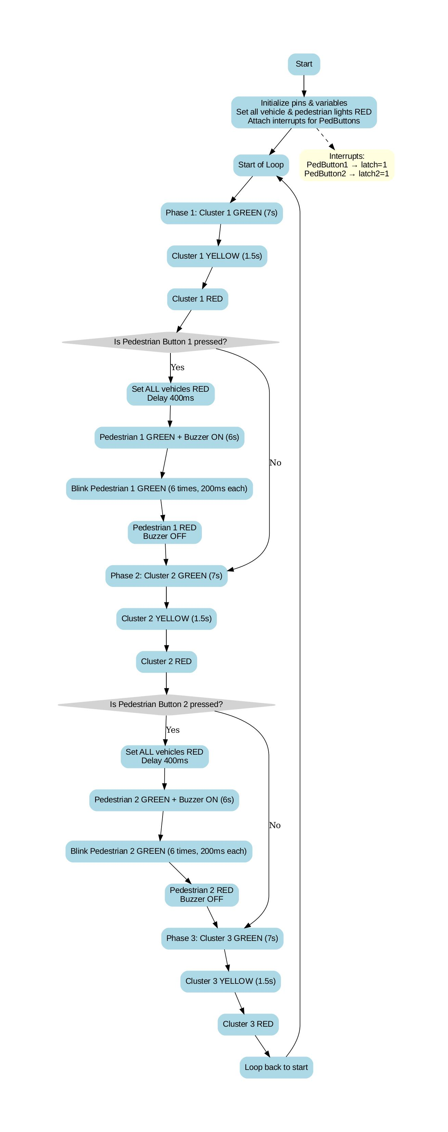
Functioning of the code:
1.) System Setup
Each pin is linked to three groups of vehicle lights (green, yellow, and red), two groups of pedestrian lights (green and red), two pedestrian buttons, and a buzzer, which have all been defined under outputs. In push buttons, the INPUT_PULLUP command is used such that the button becomes a pull-up with no resistor.
First, all pedestrian and vehicle lights will be red. A done function has been employed on the two pedestrian push buttons so that they begin the Interrupt Service Routine (ISR) upon being triggered. Whenever the push button is triggered (goes to low), it invokes the Interrupt Service Routine (ISR) function.
2.) Interrupt Handling for Pedestrian Buttons
Whenever a pedestrian button is activated the corresponding Interrupt Service Routine (ISR) is triggered. The ISR does not change the lights immediately. Rather, it sets a global variable (latch and latch2) to 1. The main program latches or stores the request for later use.
3.) Looping Phase
The program consists of three individual phases, each relating to a specific cluster.
Phase 1: Cluster 1
Cluster 1's vehicle light turns green for seven seconds; then, the light changes to yellow for 1.5 seconds and then turns red.
Pedestrian Button & Lights: All the vehicle lights turn red when the pedestrian button is pressed, after a 400ms delay. Pedestrian 1 light turns green, and the buzzer rings for six seconds and flashes six times (200ms on/off) at the end as a warning that crossing time is approaching its end. The pedestrian light goes red, and the ringing of the buzzer ceases. The pedestrian phase is skipped, and the program goes to the next phase.
Phase 2: Cluster 2
Cluster 2's vehicle light turns green for seven seconds; then, the light changes to yellow for 1.5 seconds and then turns red.
Pedestrian Button & Lights: All the vehicle lights turn red when the pedestrian button is pressed, after a 400ms delay. Pedestrian 2 light turns green, and the buzzer rings for six seconds and flashes six times (200ms on/off) at the end as a warning that crossing time is approaching its end. The pedestrian light goes red, and the ringing of the buzzer ceases. The pedestrian phase is skipped, and the program goes to the next phase.
Phase 3: Cluster 3
Cluster 3's vehicle light turns green for seven seconds; then, the light changes to yellow for 1.5 seconds and then turns red.
After completing phase 3, the loop runs again.

Build
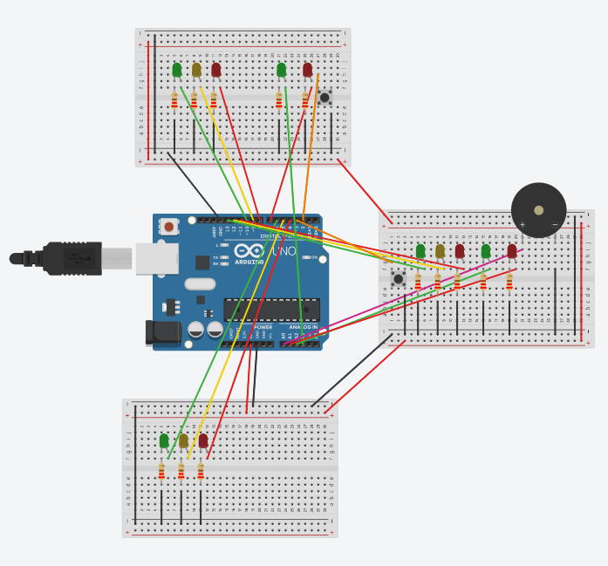

The Code (Arduino / C++)
Test
C1 – Green, C2 – Red, C3 – Red
Ped1 – Red, Ped2 – Red (Ped Button not pressed)
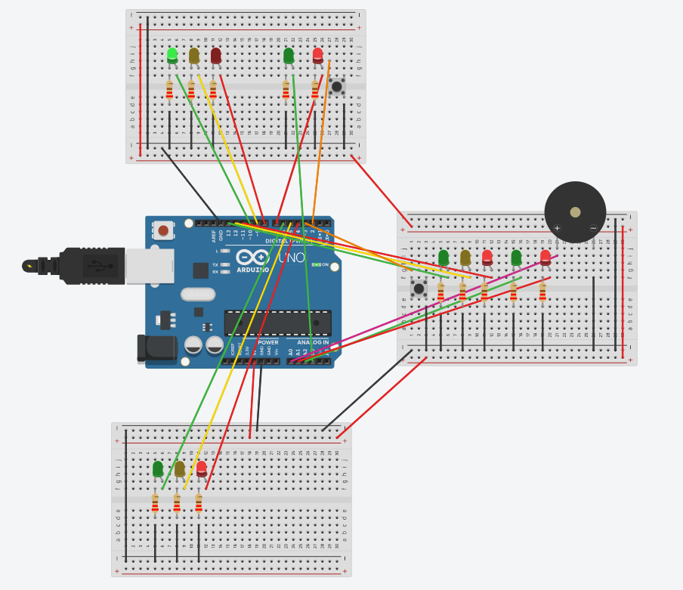

C1 – Red, C2 – Green, C3 – Red
Ped1 – Red, Ped2 – Red (Ped Button not pressed)
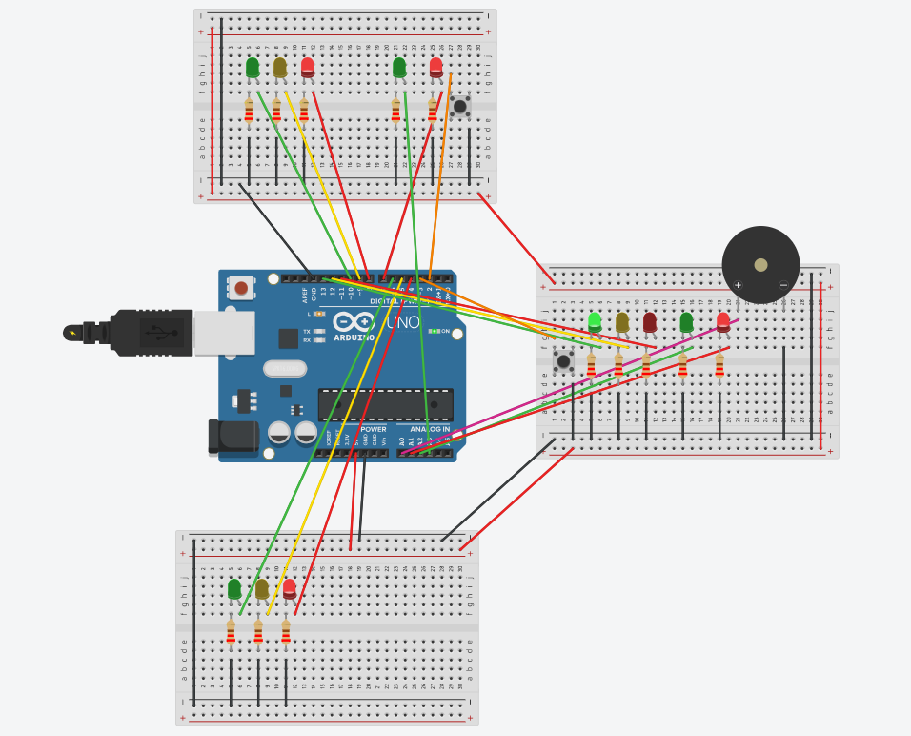
C1 – Green, C2 – Red, C3 – Red
Ped1 – Red, Ped2 – Red (Ped Button not pressed)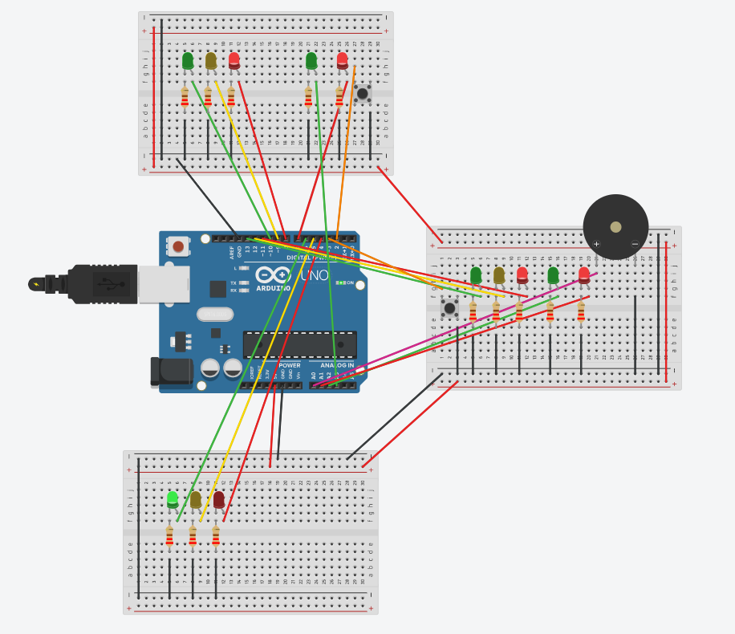
C1 – Red, C2 – Red, C3 – Red
Ped1 – Green, Ped2 – Red (Ped Button 1 pressed)
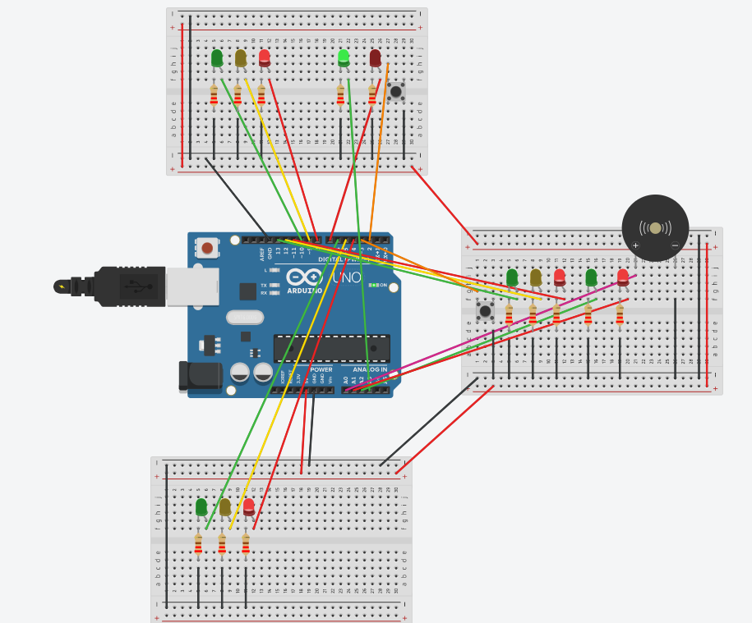
C1 – Red, C2 – Red, C3 – Red
Ped1 – Red, Ped2 – Green (Ped Button 2 pressed)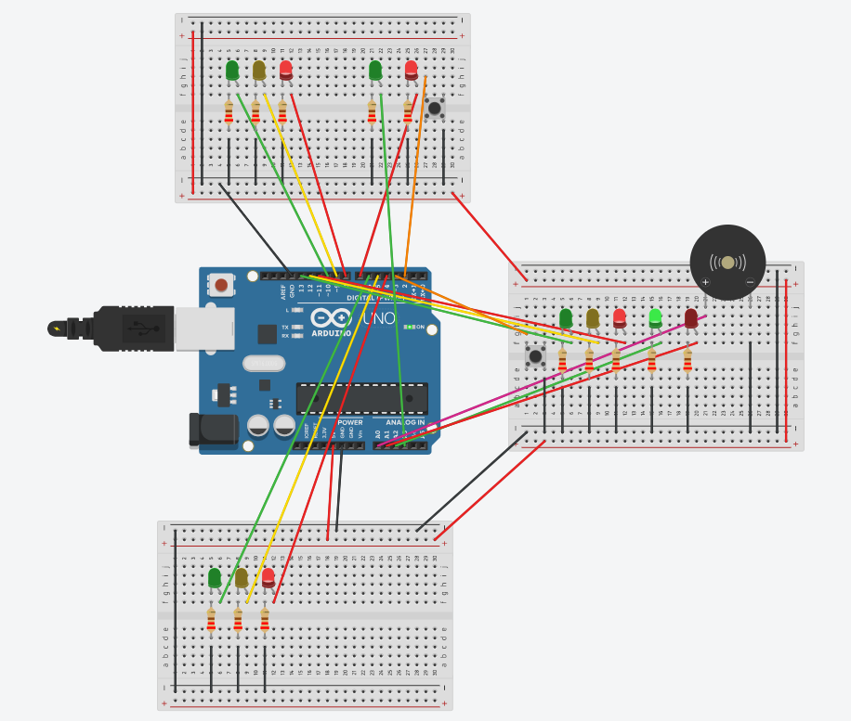
Conclusion
Building the T-Junction Traffic Light System with Arduino Uno was an indulging task that led me to apply theoretical knowledge to real life applications. I learned real world tasks like timed light control, user-input response, and getting auditory feedback. This helped me in increasing my knowledge of C++ and getting to know different functions which can be used in real world situations.
Adding interrupts to the pedestrian buttons was the most crucial part of this project. This caused the system to respond immediately to user inputs while keeping the main traffic cycle unaffected. Debugging and fine-tuning the timing refined my problem-solving skills.
Using LEDs, resistors, pedestrian buttons and the buzzer emphasized the versatility of the microcontroller, demonstrating how careful design could help the usage of the pedestrian crossing by all pedestrians. This project overall refined my programming, circuit construction, and thinking capabilities while reiterating the importance of versatility in devices.

