


Project Report: Walmart Near-Real-Time Data Warehouse
Course: DS3003/DS3004: Data Warehousing & Business Intelligence
Project: Practical Project on Walmart Data
1. Project Overview
Walmart, as one of the world's largest retailers, processes millions of customer transactions daily. To maintain a competitive edge, optimize sales, and enhance customer satisfaction, Walmart requires the ability to analyze shopping behavior in near real-time. This capability enables dynamic promotions, personalized offers, and rapid responses to changing market trends.
To achieve this, a robust system must be in place to handle the high-velocity stream of transactional data. This data is often incomplete on its own and must be enriched with master data (e.g., customer demographics, product details) before it can be useful for analysis.
This project implements a prototype of such a system. It uses a multi-threaded Python application to simulate a near-real-time data stream from source CSVs. This stream is then processed by a transformation thread that implements the HYBRIDJOIN algorithm. This algorithm enriches the streaming transactional data by joining it with large, disk-based master data files.
The final, transformed data is then loaded into a Star Schema Data Warehouse (DWH) built on MySQL. This DWH serves as the single source of truth for analysis. Finally, a comprehensive suite of 20 OLAP (Online Analytical Processing) queries is provided to slice, dice, and roll-up the data, allowing for in-depth analysis of sales, customer behavior, and product performance.
2. Data Warehouse (DW) Schema
The data warehouse is designed using a classic Star Schema. This model is highly efficient for read-heavy analytical queries. It consists of one central fact_sales table, which contains the numerical measures (facts) and foreign keys, surrounded by five descriptive dimension tables that provide context.

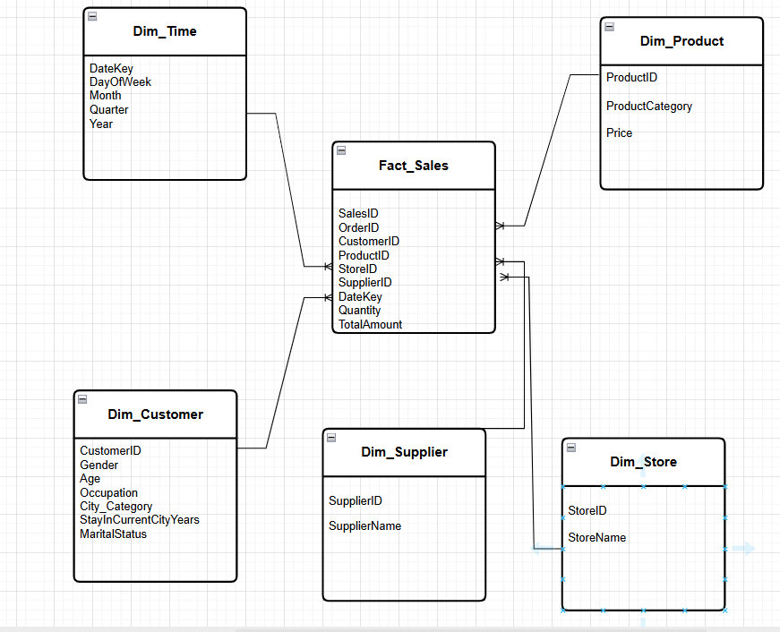
.
Fact Table
- fact_sales: The central table containing one row for every transaction line item.
  - SalesID (INT, Primary Key)
  - OrderID (VARCHAR) - Foreign Key (for product affinity)
  - CustomerID (VARCHAR) - Foreign Key to dim_customer
  - ProductID (VARCHAR) - Foreign Key to dim_product
  - StoreID (VARCHAR) - Foreign Key to dim_store
  - SupplierID (VARCHAR) - Foreign Key to dim_supplier
  - DateKey (DATE) - Foreign Key to dim_time
  - Quantity (INT) - Fact
  - TotalAmount (FLOAT) - Fact
Dimension Tables
- dim_customer: Stores all descriptive attributes of a customer.
  - CustomerID (VARCHAR, Primary Key)
  - Gender (CHAR)
  - Age (VARCHAR)
  - Occupation (VARCHAR)
  - City_Category (VARCHAR)
  - StayInCurrentCityYears (VARCHAR)
  - MaritalStatus (INT)
- dim_product: Stores all descriptive attributes of a product.
  - ProductID (VARCHAR, Primary Key)
  - ProductCategory (VARCHAR)
  - Price (FLOAT)
- dim_store: Stores store information.
  - StoreID (VARCHAR, Primary Key)
  - StoreName (VARCHAR)
- dim_supplier: Stores supplier information.
  - SupplierID (VARCHAR, Primary Key)
  - SupplierName (VARCHAR)
- dim_time: Stores pre-calculated date and time attributes.
  - DateKey (DATE, Primary Key)
  - DayOfWeek (VARCHAR)
  - Month (VARCHAR)
  - Quarter (VARCHAR)
  - Year (INT)
3. Explanation of the HYBRIDJOIN Algorithm
HYBRIDJOIN is a stream-relation join algorithm designed to efficiently join a continuous, high-speed data stream (S) with a large, static, disk-based relation (R). It is a "hybrid" because it combines in-memory hashing (for the fast stream) with disk-based indexed reads (for the large relation).
Key Components
- Stream Buffer: A small, in-memory queue that holds incoming stream tuples (e.g., new transactions) if the main hash table is full, preventing data loss during sudden bursts.
- Hash Table (H): The main in-memory component. It stores the stream tuples from S, using the join key (e.g., CustomerID) to organize them into "compartments" for fast lookups.
- Queue: A doubly-linked list that stores the keys of the stream tuples in the hash table, maintaining their arrival order (FIFO). Its "doubly-linked" nature allows for efficient random deletion from the middle of the queue when a tuple is successfully joined.
- Disk Buffer: A small memory buffer (e.g., 500 tuples) used to hold a single chunk of data read from the large disk-based relation R.
Step-by-Step Working Principle
The algorithm runs in a continuous loop, managed by a dedicated thread:
- Step 1: Load Stream (S): The algorithm checks the stream_buffer for new tuples. It loads up to w (the number of free slots) tuples into the Hash Table (H) and adds their keys to the end of the Queue.
- Step 2: Get Probe Key: It looks at the oldest key at the front of the Queue. This key will be used to probe the disk relation R.
- Step 3: Load Relation (R): The algorithm uses the probe key to perform an indexed read on the large, sorted, disk-based relation R. It reads a single chunk of vP (500) tuples from that disk location into the in-memory Disk Buffer.
- Step 4: Probe: It iterates through the 500 tuples in the Disk Buffer. For each tuple, it probes the Hash Table (H) to see if any stream tuples match that key.
- Step 5: Join, Load, and Delete: If a match (or multiple matches) is found:
  - The stream tuple(s) and the relation tuple are joined to create an enriched result.
  - This enriched result is loaded into the fact_sales table in the data warehouse.
  - The matched stream tuple(s) are deleted from the Hash Table (H).
  - Their corresponding key(s) are removed from the Queue (this is where the doubly-linked list is crucial, as the key may not be at the front).
- Step 6: Update Slots: The count of free slots, w, is incremented for each stream tuple that was successfully joined and removed.
- Step 7: Loop: The algorithm loops back to Step 1, loading new stream data and repeating the process with the next-oldest key in the queue.
4. Shortcomings of the HYBRIDJOIN Algorithm
While effective, the HYBRIDJOIN algorithm has several theoretical shortcomings:
- Limited to a Single Disk Relation (R): The algorithm is explicitly designed to join one stream S with one large relation R. In a real-world scenario like this project, the stream must be enriched with multiple master data tables (e.g., customer and product). The algorithm does not natively support joining S with R1 and R2 simultaneously. We had to implement a workaround by loading the smaller product relation entirely into memory, which is not scalable if both relations are terabytes in size.
- Inefficient Probing (Head-of-Line Blocking): The algorithm is forced to process the oldest key in the queue. If this oldest key has no matching data in the R relation, the algorithm still performs a full, expensive disk I/O operation (loading 500 tuples into the Disk Buffer) only to find zero matches. This is a form of "head-of-line blocking" where an "unlucky" key can waste an entire processing cycle.
- Data Loss Under Extreme Load: The algorithm's defense against bursty data is finite. It relies on the Hash Table (H) and the Stream Buffer. If the stream data arrives consistently faster than the disk I/O can probe and clear tuples from H, the hash table will fill up (w=0). New tuples will then fill the Stream Buffer. If that also overflows, all subsequent incoming stream tuples are permanently lost. The algorithm lacks a "spill-to-disk" mechanism for the stream itself.
5. Reflection and Lessons Learned
This project provided significant practical insight into the challenges of data warehousing that extend far beyond textbook theory.
- Data Cleaning: The most frequent and difficult errors were not in the algorithm's logic, but in the "dirty" source data. Issues like hidden leading/trailing spaces in CSV headers (' Customer_ID' vs. 'Customer_ID'), inconsistent naming ('Stay_In_Current_City_Years' vs. 'StayInCurrentCityYears'), and database case-sensitivity ('Dim_Customer' vs. 'dim_customer') caused the entire pipeline to fail. This proved that a robust ETL process must be defensive and prioritize data cleaning and standardization above all else.
- Indexes are Not Optional: The most dramatic lesson was the impact of database indexing. Before indexing, the analytical queries took 10-15 seconds to run, as the database had to perform a "Full Table Scan" on millions of fact rows. After running the CREATE INDEX script on the foreign keys in fact_sales, the exact same queries ran in under 2 seconds. This demonstrated that a good schema design is only the first step; performance tuning via indexing is what makes it usable.
- Theory vs. Practical Adaptation: Implementing the HYBRIDJOIN algorithm showed the gap between a theoretical model and a real-world problem. The algorithm's limitation of joining only one R relation forced a practical compromise: load the product data into an in-memory map. This adaptation was necessary to meet the project's requirements, highlighting the need for flexibility when applying theoretical concepts.
- Transaction Management is Critical: The multi-threaded script taught a valuable lesson in database connection management. Disabling foreign key checks for a bulk load (SET FOREIGN_KEY_CHECKS=0;) automatically started a transaction. Forgetting to conn.commit() this change caused all subsequent database calls in the main loop to fail with a "Transaction already initialized" error, a subtle bug that was difficult to trace.

- DW Analysis using OLAP Queries:

Q1. Top Revenue-Generating Products on Weekdays and Weekends with Monthly Drill-
Down Identifies the top 5 products by revenue, split by weekdays and weekends, with monthly breakdowns for a year.

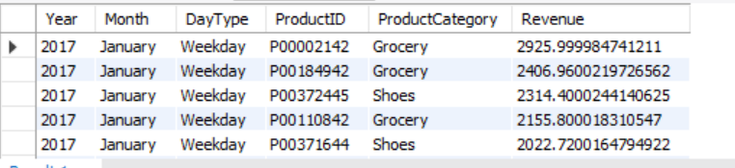

Q2. Customer Demographics by Purchase Amount with City Category Breakdown
Analyzes total purchase amounts by gender and age, detailed by city category.

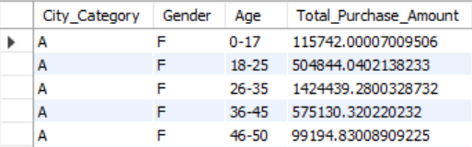

Q3. Product Category Sales by Occupation Examines total sales for each product category based on customer occupation.
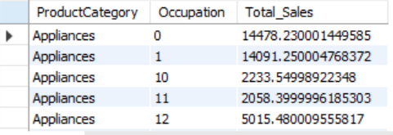

Q4. Total Purchases by Gender and Age Group with Quarterly Trend
Tracks purchase amounts by gender and age across quarterly periods for the current year.

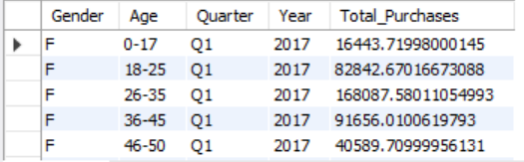

Q5. Top Occupations by Product Category Sales Highlights the top 5 occupations driving sales within each product category.

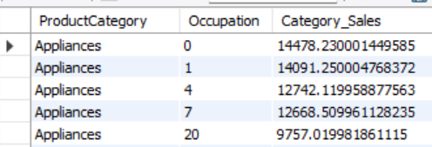

Q6. City Category Performance by Marital Status with Monthly Breakdown
Assesses purchase amounts by city category and marital status over the past 6 months.

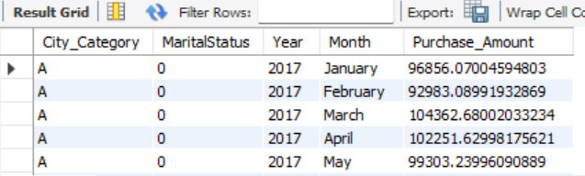

Q7. Average Purchase Amount by Stay Duration and Gender
Calculates the average purchase amount based on years stayed in the city and gender.

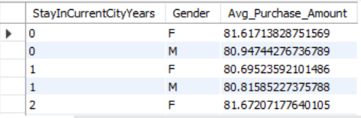

Q8. Top 5 Revenue-Generating Cities by Product Category Ranks the top 5 city categories by revenue, grouped by product category.

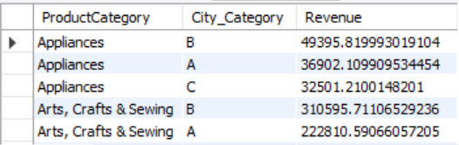

Q9. Monthly Sales Growth by Product Category Measures month-over-month sales growth percentage for each product category in the current
year.

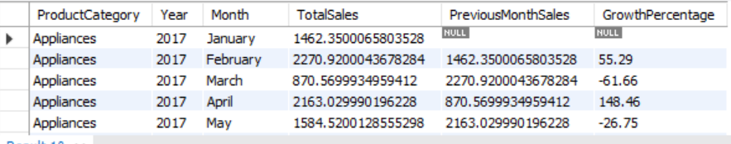

Q10. Weekend vs. Weekday Sales by Age Group Compares total sales by age group for weekends versus weekdays in the current year.

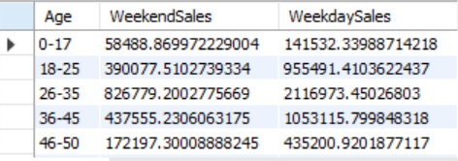

Q11. Top Revenue-Generating Products on Weekdays and Weekends with Monthly Drill-Down Find the top 5 products that generated the highest revenue, separated by weekday and weekend sales, with results grouped by month for a specified year.

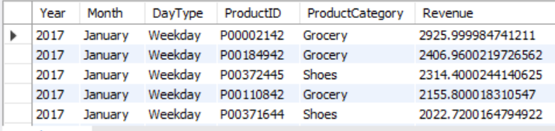

Q12. Trend Analysis of Store Revenue Growth Rate Quarterly for 2017
Calculate the revenue growth rate for each store on a quarterly basis for 2017.

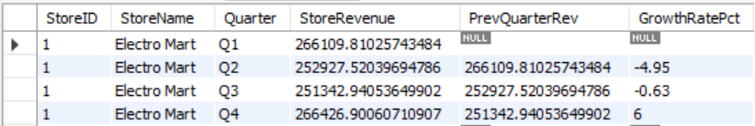

Q13. Detailed Supplier Sales Contribution by Store and Product Name
For each store, show the total sales contribution of each supplier broken down by product name. The output should group results by store, then supplier, and then product name under each supplier.

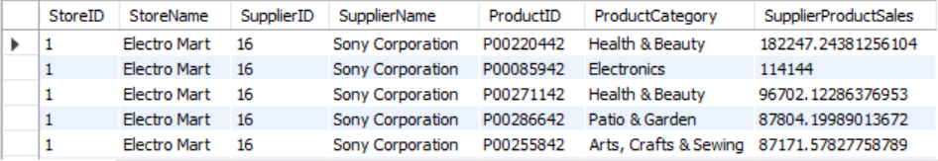

Q14. Seasonal Analysis of Product Sales Using Dynamic Drill-Down
Present total sales for each product, drilled down by seasonal periods (Spring, Summer, Fall,Winter). This can help understand product performance across seasonal periods.

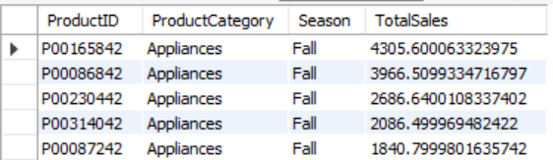

Q15. Store-Wise and Supplier-Wise Monthly Revenue Volatility
Calculate the month-to-month revenue volatility for each store and supplier pair. Volatility can be defined as the percentage change in revenue from one month to the next, helping identify stores or suppliers with highly fluctuating sales.

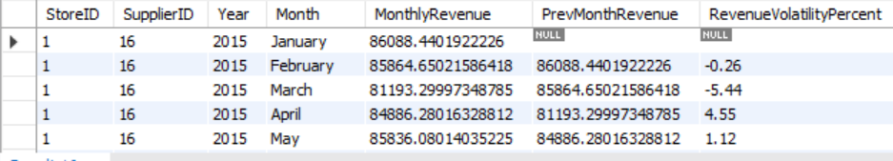

Q16. Top 5 Products Purchased Together Across Multiple Orders (Product Affinity
Analysis)Identify the top 5 products frequently bought together within a set of orders (i.e., multiple products purchased in the same transaction). This product affinity analysis could inform potential product bundling strategies.

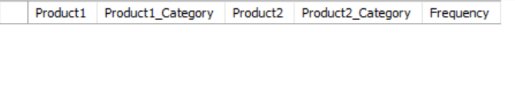

Q17. Yearly Revenue Trends by Store, Supplier, and Product with ROLLUP
Use the ROLLUP operation to aggregate yearly revenue data by store, supplier, and product, enabling a comprehensive overview from individual product-level details up to total revenue per store. This query should provide an overview of cumulative and hierarchical sales figures.

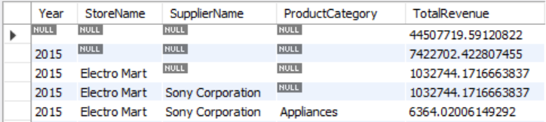

Q18. Revenue and Volume-Based Sales Analysis for Each Product for H1 and H2
For each product, calculate the total revenue and quantity sold in the first and second halves of the year, along with yearly totals. This split-by-time-period analysis can reveal changes in product popularity or demand over the year.

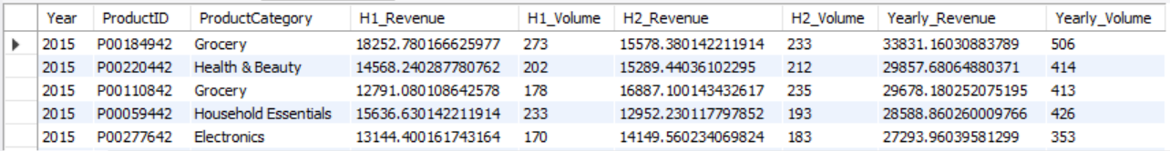

Q19. Identify High Revenue Spikes in Product Sales and Highlight Outliers
Calculate daily average sales for each product and flag days where the sales exceed twice the daily average by product as potential outliers or spikes. Explain any identified anomalies in the report, as these may indicate unusual demand events.

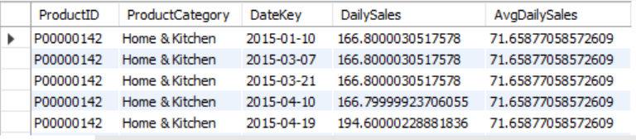

Q20. Create a View STORE_QUARTERLY_SALES for Optimized Sales Analysis
Create a view named STORE_QUAsweRTERLY_SALES that aggregates total quarterly sales by store,ordered by store name. This view allows quick retrieval of store-specific trends across quarters, significantly improving query performance for regular sales analysis.
