Manuscript prepared for submission to the International Journal of Heat and Mass Transfer
Original research article
Finite-gap corrections for homogenized TPMS lattices and the multi-objective design of a graded cooling jacket for an electric motor
Zain ul Abiden^{a*}, Ahmed Mukhtar Bukhariª
ª Department of Aerospace Engineering, School of Mechanical and Manufacturing Engineering (SMME), National University of Sciences and Technology (NUST), H-12, Islamabad 44000, Pakistan
* Corresponding author. E-mail address: zabiden.ug23smme@student.nust.edu.pk (Z. ul Abiden).
A R T I C L E I N F O |  | A B S T R A C T
Keywords:  triply periodic minimal surface  finite-size effect  homogenization  permeability  electric motor cooling  graded lattice  multi-objective Bayesian optimization  additive manufacturing |  | Additively manufactured triply periodic minimal surface (TPMS) lattices are attractive for the liquid cooling jackets of electric machines because one printed structure can transfer heat, guide the coolant and carry load. Design studies of graded lattices rely on homogenized closures computed on periodic unit cells, yet a jacket gap of a few millimetres holds only one to three cells. We quantify the resulting error and use corrected closures to design a graded jacket for a 15 kW permanent-magnet motor (770 W into the jacket, 6 mm gap). Periodic voxel solvers for conductivity, stiffness and Stokes permeability, verified against exact and published solutions, are applied to lattice strips with N = 1–8 cells between bonded walls. Bulk closures over-predict the in-plane permeability by 23–40% at N = 1 and by 7–10% at N = 3; the deficit scales as 1/N with a wall coefficient of 0.19–0.28 for gyroid and diamond, whereas the through-gap conductivity changes by at most 2.3% and the walls stiffen the core. A physically based 1/N correction reduces the cross-validated permeability error from 12.9 to 0.4 percentage points. The corrected closures, literature correlations for inertia and interstitial heat transfer, and a three-field non-equilibrium model form a verified device model that runs in under one second. With axial-slot manifolds, optimizing the density, morphology and cell-size fields lowers the thermal resistance at equal pump power by 14.6% relative to circumferential channels, 10.1% relative to the best uniform gyroid and 3.3% relative to density-only grading; changing the manifolds to end rings matters more than any lattice grading. Batch Bayesian optimization (qNEHVI) needs about seven times fewer model evaluations than NSGA-II for the same hypervolume. The manufacturable optimum is exported as a printable geometry that passes minimum-wall, pore-throat and connectivity checks. All code and data are open source.

HIGHLIGHTS
• Bulk TPMS closures over-predict in-plane permeability by up to 40% in one-cell gaps
• The permeability deficit follows 1/N with a wall coefficient of 0.19–0.28
• A verified sub-second jacket model couples Darcy–Forchheimer flow and LTNE heat
• Graded lattices cut thermal resistance by 10% vs uniform gyroid at equal pump power
• Batch Bayesian optimization needs about 7× fewer evaluations than NSGA-II
CONTENTS
NOMENCLATURE 2
1. INTRODUCTION 3
2. RELATED WORK AND RESEARCH GAP 4
2.1. Thermal–hydraulic closures for TPMS lattices 4
2.2. Homogenization-based design of graded lattices 4
2.3. Finite-size and wall effects 5
2.4. Motor cooling jackets and optimizers 5
2.5. Positioning of the present work 5
3. REFERENCE PROBLEM 6
4. METHODS 7
4.1. TPMS cell geometry 7
4.2. Periodic cell problems 8
4.3. Closure dataset and surrogates 10
4.4. Finite-gap strips 11
4.5. Literature closures for inertia and interstitial heat transfer 12
4.6. Homogenized jacket model 12
4.7. Baselines 14
4.8. Multi-objective optimization 14
4.9. Geometry export and manufacturability checks 15
5. RESULTS AND DISCUSSION 15
5.1. Bulk closures of gyroid, diamond and blends 15
5.2. RQ1: finite-gap error and its correction 16
5.3. Device-level behaviour of the reference jacket 19
5.4. RQ2: optimized graded lattices against the baselines 20
5.5. RQ3: sample efficiency of the optimizers 22
5.6. Manufacturable optimum and exported geometry 23
6. LIMITATIONS 24
7. CONCLUSIONS 25
DATA AND CODE AVAILABILITY 26
SUPPLEMENTARY MATERIAL 26
DECLARATION OF COMPETING INTEREST 26
REFERENCES 26

NOMENCLATURE
Latin symbols
$a$ | wall coefficient of the finite-gap correction, Eqs. (9)–(10)
$a_{sf}$ | specific solid–fluid surface area per total volume [m$​^{−1}$]
$a_{z}$ | axial stretch of the unit cell
$C_{eff}$ | effective stiffness tensor (Voigt, engineering shear) [Pa]
$C_{F}$ | Forchheimer (inertial) coefficient
$C_{nn}$, $G_{t}$, $G_{sz}$ | normal stiffness across the gap, transverse and in-plane shear moduli of the core [Pa]
$D_{h}$ | hydraulic diameter, $4ϕ/a_{sf}$ [m]
$f$ | Darcy friction factor
$f_{K}$ | finite-gap factor applied to the Darcy term, $1−a_{K}/N$
$h$ | lattice gap height (6 mm) [m]
$h_{sf}$ | interstitial heat-transfer coefficient [W m$​^{−2}$ K$​^{−1}$]
$h_{m}$ | sleeve-to-plenum heat-transfer coefficient under a manifold slot [W m$​^{−2}$ K$​^{−1}$]
$K$, $K_{t}$ | permeability tensor; in-plane permeability along the gap [m$​^{2}$]
$k_{eff}$, $k_{n}$ | effective conductivity tensor; through-gap conductivity [W m$​^{−1}$ K$​^{−1}$]
$L$ | in-plane cell size [m]
$L_{min}$ | smallest manufacturable cell size for given $\left(w,ρ^{*}\right)$ [m]
$N$ | number of cells across the gap, $h/L$
$n$ | voxels per cell edge
$P$ | pump power, $Δp \dot{V}/η_{pump}$ [W]
$Pr$, $Re_{D_{h}}$ | Prandtl number; Reynolds number based on $D_{h}$ and pore velocity
$Q$ | heat load into the jacket (770 W) [W]
$R$ | thermal resistance, $\left(T_{wall,max}−T_{in}\right)/Q$ [K W$​^{−1}$]
$R_{active}$ | thermal resistance of the cooled region, excluding the sleeve under the manifold slots
$s$, $z$ | arc length at the mean lattice radius; axial coordinate [m]
$U$ | superficial (Darcy) velocity [m s$​^{−1}$]
$U_{eff}$ | sleeve-to-coolant conductance per unit sleeve area [W m$​^{−2}$ K$​^{−1}$]
$\dot{V}$ | coolant volume flow rate (3 L/min nominal) [m$​^{3}$ s$​^{−1}$]
$w$ | gyroid–diamond blend weight (0 = gyroid, 1 = diamond)
Greek symbols
$δ_{q}$ | finite-gap discrepancy of quantity $q$, $q_{strip}/q_{hom}−1$
$η$ | fin efficiency of the lattice across the gap
$θ$ | morphology parameters $\left(w,ρ^{*},a_{z}\right)$; or circumferential angle
$ρ^{*}$ | relative density (solid volume fraction)
$ϕ$ | porosity, $1−ρ^{*}$; also TPMS level-set value $ϕ_{w}$
Abbreviations
B1, B1s, B2, B3 | baselines: helical channels, circumferential channels, best uniform gyroid, density-only grading
G, D | gyroid, Schwarz diamond
HV | hypervolume indicator
LTNE | local thermal non-equilibrium
MAC | marker-and-cell (staggered) finite volumes
qNEHVI | batch noisy expected hypervolume improvement
TPMS | triply periodic minimal surface

1. INTRODUCTION
Electric machines for aircraft, rotorcraft, drones and road vehicles are limited by heat. Copper and iron losses in the stator must leave through a thin housing, and the hottest point of the winding insulation, not the average temperature, sets the continuous rating [1, 2]. Liquid jackets around the stator are the usual answer. They are judged by three numbers: the thermal resistance between stator and coolant, the pumping power, and the mass. The third matters most in flight, where every kilogram of thermal hardware costs payload or range [1].
Laser powder-bed fusion makes it possible to fill the jacket gap with a lattice instead of a channel. Network (skeletal) triply periodic minimal surface (TPMS) lattices such as the gyroid and the Schwarz diamond are attractive for this purpose: their solid and fluid phases are both continuous, they are self-supporting, their surface area per volume is large, and the same struts that exchange heat can also carry the motor torque and thrust from the sleeve to the housing [3, 4]. TPMS heat exchangers and heat sinks are now studied widely [5–8], including a gyroid housing for an air-cooled motor [9]. Recent work grades the lattice in space, varying the density, the cell size or the morphology to steer the flow and to put heat-transfer area where it is needed [6, 7, 10].
Designing such a graded lattice for a whole device is expensive. A pore-resolved conjugate simulation of a motor jacket has tens of millions of cells, and an optimizer needs hundreds to thousands of designs. Design studies therefore replace the lattice by a homogenized porous medium whose properties (permeability, inertial coefficient, effective conductivity, interstitial heat-transfer coefficient, stiffness) come from periodic unit-cell simulations [10–14]. Periodic closures rest on scale separation: the cell must be small compared with the region it fills [15, 16]. A motor jacket breaks this assumption. Its gap is a few millimetres, the smallest printable cells are about 2 mm, and so only one to three cells fit between the sleeve and the outer wall. Wall effects of this kind are well known for packed beds, where the porosity rises near a wall and the flow channels along it [17], and size effects are known for the stiffness of cellular solids [18]. For TPMS lattices, pore-resolved simulations of wall-bounded channels give inertial coefficients that differ from the periodic values [19], but we did not find a study that measures the finite-gap error of the closures used in design, separates it from discretization error, and supplies a correction that a device model can use.
A second gap concerns the comparisons. Graded designs are usually compared with uniform lattices of the same family. Whether grading beats a well-tuned conventional jacket, such as a helical channel, at equal pumping power, and how much of any advantage comes from the manifolds rather than the lattice, is rarely tested. Third, multi-objective optimization of such device models is done with evolutionary algorithms or with Bayesian optimization, but their sample efficiency on the same problem, with the same constraints and seeds, is seldom reported.
This paper addresses these gaps for a concrete reference problem, the liquid jacket of a 15 kW inrunner permanent-magnet motor, and asks three research questions:
• RQ1. How large is the error of bulk homogenized properties when only N = 1–8 cells fit across a bounded gap, and can a simple correction remove it?
• RQ2. Under identical constraints and at equal pump power, does grading the density, morphology and cell size beat a tuned helical channel, the best uniform gyroid and density-only grading?
• RQ3. How sample-efficient is batch Bayesian multi-objective optimization (qNEHVI) compared with NSGA-II and random search on this problem?
The contributions are:
a) verified periodic voxel solvers for the effective conductivity, stiffness and Stokes permeability of gyroid, diamond and blended network lattices, with a two-grid estimator whose error is below 1% for permeability and conductivity and below 3% for stiffness (Section 4.2);
b) a systematic finite-gap study of TPMS closures, the first we are aware of: 336 wall-bounded strips with one to eight cells, several cut phases, density gradients and cell stretches, and a 1/N correction with fitted wall coefficients that removes the permeability error down to the cut-phase noise floor (Section 5.2);
c) a sub-second homogenized jacket model that couples Darcy–Forchheimer flow, a three-field non-equilibrium energy balance and a sandwich structural check, verified against analytic solutions to round-off (Section 4.6);
d) a like-for-like comparison of optimized graded lattices with tuned baselines on two manifold layouts, and a five-seed comparison of NSGA-II, qNEHVI and Sobol search (Sections 5.4 and 5.5);
e) a manufacturable optimum exported as a voxel-checked printable geometry, and an open-source, scripted pipeline that reproduces every figure and table on a laptop CPU.
The study is computational. It uses no pore-resolved conjugate CFD of the full jacket and no experiment; the two closures that we could not compute ourselves, the inertial coefficient and the interstitial heat-transfer coefficient, are taken from the literature. Section 6 states what this means for the conclusions. The rest of the paper is organized as follows. Section 2 reviews related work, Section 3 defines the reference problem, Section 4 describes the solvers and models with their verification, Section 5 presents the results for RQ1–RQ3, and Section 7 concludes.

2. RELATED WORK AND RESEARCH GAP

2.1. Thermal–hydraulic closures for TPMS lattices
Pore-scale simulations of single periodic cells have produced power-law fits of the permeability and the Forchheimer coefficient of skeletal gyroid, diamond and Split-P lattices for porosities of 0.3–0.6 and hydraulic Reynolds numbers up to 100 [11]. The same group derived a modified Reynolds analogy for the interstitial Nusselt number of the gyroid in laminar flow, calibrated at a Prandtl number of one [12]. Rathore et al. simulated four-cell channels of several TPMS types and reported permeabilities and inertial coefficients that include the channel walls [19]. Correlations for sheet TPMS heat exchangers in turbulent flow [5], for printed gyroid ducts at high Prandtl number [20] and a recent meta-analysis of 57 studies [21] complete the picture. Most closures are bulk properties of a single cell; the effect of a bounding wall is either absent or folded into a device-specific correlation.

2.2. Homogenization-based design of graded lattices
Homogenization lets a lattice be designed as a continuum whose local parameters vary in space, followed by a de-homogenization step that builds the actual geometry. Modrek et al. optimized conductive heat sinks with homogenized gyroid conductivities and mapped the result to gyroid sheets and solids [13]. Ohtani et al. optimized the wall thickness of a two-fluid gyroid heat exchanger with a Brinkman–Forchheimer porous model and validated the result with full CFD [14]. Kawabe et al. graded the cell size of gyroid lattices for stiffness and proposed a phase-field de-homogenization that keeps cells undistorted [10]. Andreassen and Andreasen give the standard numerical homogenization procedure [22]. All of these use bulk closures, which presume many cells across every feature.

2.3. Finite-size and wall effects
Near a flat wall, a random packing of spheres has a porosity close to one within half a diameter, which creates a fast channel along the wall [17]. Brinkman's equation [23, 24] is the usual continuum description of such boundary layers. The stiffness of a few-cell cellular solid differs from the bulk value because cut cells at the free surface carry less load [18]. A TPMS lattice bonded to two walls is a different case: the cut is periodic, not random, and the bond can stiffen rather than weaken the boundary cells. How the closures of such a lattice change with the number of cells across a gap has, to our knowledge, not been quantified.

2.4. Motor cooling jackets and optimizers
Conventional stator jackets use spiral, axial or U-shaped channels, often optimized with CFD-trained surrogates [2, 25]. Multi-objective problems of this kind are commonly solved with NSGA-II [26, 27]. Batch Bayesian optimization with expected-hypervolume acquisition (qEHVI, qNEHVI) promises far fewer evaluations [28–30], at a cost in wall-clock time for fitting and acquisition. On the same expensive engineering problem, the two are rarely compared with several seeds, a common budget unit and identical constraints.

2.5. Positioning of the present work
Table 1 contrasts representative studies with the present work. None combines periodic closures computed and verified in house with a measured finite-gap correction, a structural constraint in the design loop, grading of density, morphology and cell size, fair baselines, and an optimizer comparison.
Table 1. Comparison of representative studies with the present work. "Bulk" = periodic-cell closure without wall correction; "resolved" = walls present in a pore-resolved simulation; "none" = not addressed. Entries marked † were summarized from the abstract only and must be checked against the full text.
Study | Application | Closure source | Grading variables | Few-cell (finite-gap) effect | Structure in loop | Optimizer / comparison | Geometry export and checks
Gajetti et al. [11] | generic porous TPMS | periodic-cell CFD (K, C_{F}) | none | bulk | none | none | none
Savoldi et al. [12] | gyroid heat exchanger | periodic-cell CFD (f, Nu) | uniform cell | bulk | none | multi-objective, uniform cell | none
Rathore et al. [19] | TPMS-filled channels | pore-resolved DNS, 4-cell channel | none | resolved, not modelled | none | none | none
Modrek et al. [13] | conductive heat sink | homogenized k_{eff} | density (topology optimization) | bulk | none | gradient-based | mapping to gyroid
Ohtani et al. [14] | two-fluid gyroid heat exchanger | unit-cell FEM fits, Brinkman–Forchheimer | wall thickness | bulk | none | gradient-based (MMA) | full CFD check
Kawabe et al. [10] | stiff lattice parts | homogenized stiffness | cell size | bulk | stiffness objective | topology optimization | phase-field de-homogenization, tests
You et al. [6] † | electronics cooling channel | pore-resolved CFD | multi-directional density grading | resolved | none | parametric | none
Hassanirad et al. [7] † | liquid-cooled heat sink | pore-resolved CFD | multi-morphology | resolved | none | parametric | none
Hassan et al. [9] | air-cooled motor housing | pore-resolved CFD | uniform | resolved | none (future work) | parametric | none
Li et al. [25] † | motor water jacket (channels) | CFD + surrogate | channel dimensions | n/a | none | surrogate multi-objective | none
Present work | 15 kW motor stator jacket | in-house periodic voxel solvers (k_{eff}, C_{eff}, K) + literature C_{F}, Nu | density, morphology, cell size (B-spline fields) | measured, 1/N correction | margin ≥ 1 constraint | NSGA-II vs qNEHVI vs Sobol, 5 seeds; tuned baselines B1–B3 | PicoGK geometry; wall, throat, connectivity checks

3. REFERENCE PROBLEM
The demonstrator is the cooling jacket of a 15 kW continuous inrunner permanent-magnet synchronous motor with an efficiency of 0.94 (Table 2). Of the 957 W of total loss, 770 W are assumed to enter the jacket through the stator sleeve (80%); the rest leaves through the end windings, rotor and shaft. The aluminium sleeve (inner radius 70 mm, thickness 1.5 mm) is surrounded by a 6 mm lattice gap (r = 71.5–77.5 mm) and a 2 mm outer wall, over an axial length of 50 mm. The wall heat flux on the stator side has a mean of 35.0 kW m$​^{−2}$ and an end-peaked profile,
$$\begin{matrix} & q″\left(z\right)=\overset{‾}{q}\left[1+0.25\left(12{\left(ζ−1/2\right)}^{2}−1\right)\right], \\ & ζ=z/L_{ax}, \overset{‾}{q}=Q/\left(2πr_{s}L_{ax}\right)\end{matrix}$$ | (1)

so that the axial ends see twice the centre value. A 50/50 water–glycol coolant enters at 50 °C with a nominal flow of 3 L/min (swept from 1 to 5 L/min). In the reference layout the coolant enters through an axial manifold slot at θ = 0°, splits into two half-annulus paths and leaves through a second slot at θ = 180°; both slots are 15 mm wide and span the full length. An alternative end-ring layout, with ring manifolds at the two axial ends outside the heated length, is studied in Section 5.4.
The lattice and walls are AlSi10Mg. The lattice must carry the motor torque (36 N m) and thrust (780 N) from the sleeve to the housing and hold a coolant pressure of 2 bar gauge; the allowable stress of 80 MPa is a fatigue-limited assumption. Manufacturability requires a minimum wall of 0.35 mm, a minimum pore throat of 0.8 mm (powder removal) and a limited density change per cell. The three objectives are the thermal resistance $R=\left(T_{wall,max}−T_{in}\right)/Q$, with $T_{wall,max}$ the hottest point on the stator side of the sleeve; the pump power $P=Δp \dot{V}/η_{pump}$ with $η_{pump}=0.3$; and the jacket mass (lattice, sleeve and outer wall). All values are stored in one configuration file of the software (configs/reference.yaml).
Table 2. Reference problem (SI units in the software).
Item | Value
Motor | 15 kW continuous inrunner PMSM, η = 0.94
Heat into the jacket | Q = 770 W (80% of 957 W loss, assumption)
Sleeve | r_{i} = 70 mm, thickness 1.5 mm
Lattice gap | h = 6 mm (r = 71.5–77.5 mm)
Outer wall; axial length | 2 mm; L_{ax} = 50 mm
Wall heat flux | mean 35.0 kW m⁻², ends 2× centre, Eq. (1)
Coolant (water–glycol 50/50) | ρ = 1060 kg m⁻³, c_{p} = 3400 J kg⁻¹ K⁻¹, k = 0.40 W m⁻¹ K⁻¹, ν = 2.3 × 10⁻⁶ m² s⁻¹, Pr = 20.7
Inlet | 50 °C; 3 L/min nominal (1–5 L/min); pump efficiency 0.3
Manifolds (reference) | axial slots at θ = 0° and 180°, 15 mm wide, full length
Material (AlSi10Mg) | E = 70 GPa, ν = 0.33, ρ = 2670 kg m⁻³, k = 130 W m⁻¹ K⁻¹, σ_{allow} = 80 MPa
Loads | torque 36 N m, thrust 780 N, coolant 2 bar(g)
Design bounds | ρ* 0.20–0.50; w 0–1; L 2–6 mm; a_{z} 0.7–1.5
Manufacturability | min wall 0.35 mm; min pore throat 0.8 mm; |∇ρ*| L ≤ 0.05

Fig. 1 summarizes the pipeline. Steps 1–3 compute and learn the bulk closures, step 4 measures and models their finite-gap error, steps 5–6 assemble the device model, and steps 7–8 optimize and export the design.
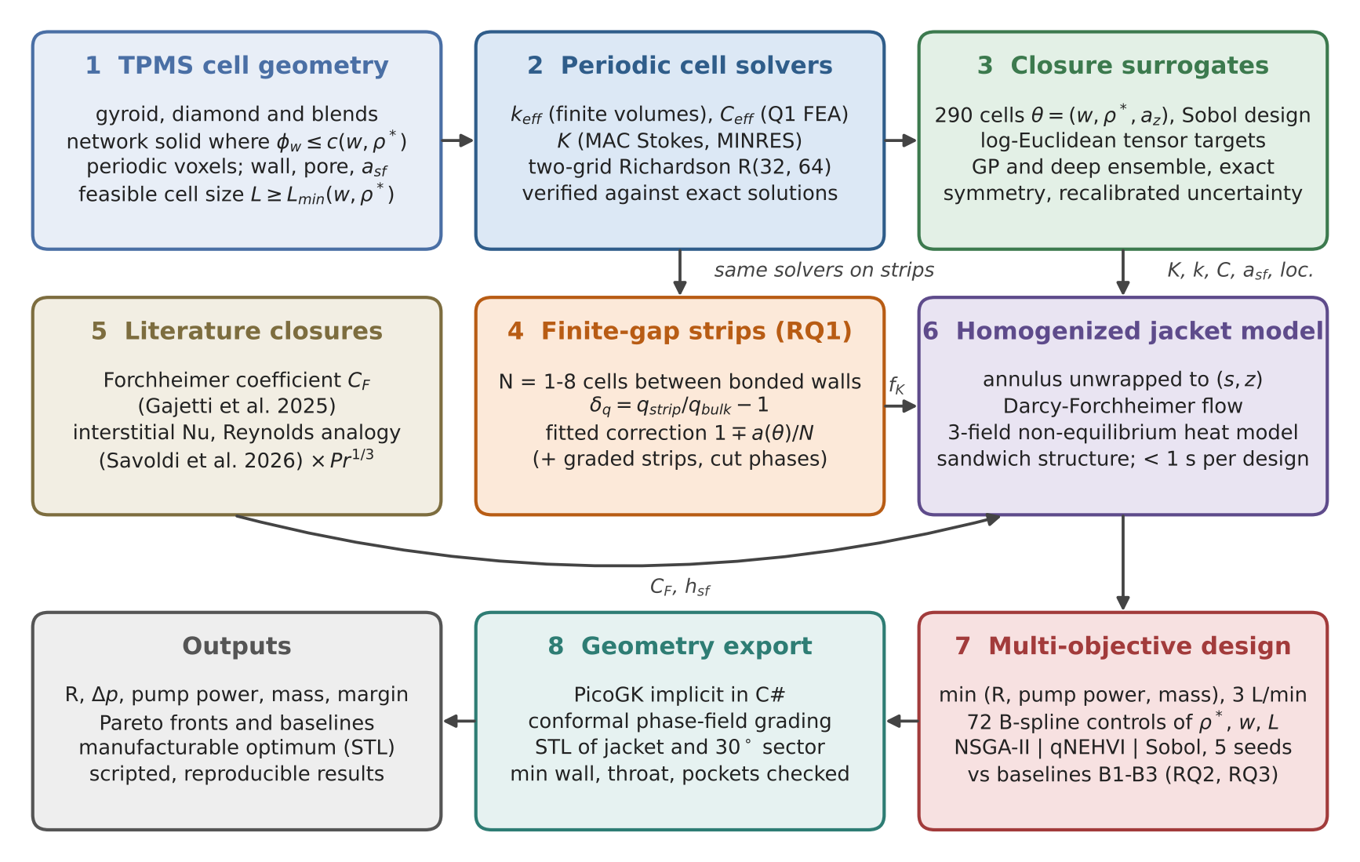
Fig. 1. Workflow of the study. Numbers give the order of the methods in Section 4; arrows show which quantities pass between steps (loc. = stress localization factors). Steps 2–4 run on unit cells and strips; steps 6–8 run on the whole jacket.

4. METHODS

4.1. TPMS cell geometry
The gyroid (G) and Schwarz diamond (D) are represented by their nodal level sets [31], normalized by their maxima so that both span [−1, 1]:
$$\begin{matrix}G & =2/3\left(sinXcosY+sinYcosZ+sinZcosX\right), \\ D & =1/{\sqrt{2}}(sinXsinYsinZ+sinXcosYcosZ \\ & +cosXsinYcosZ+cosXcosYsinZ)\end{matrix}$$ | (2)

with $X=2πξ_{x}$ and $ξ$ the normalized cell coordinate. A blend $ϕ_{w}=\left(1−w\right) G+w D$ interpolates between them. The solid is the network (skeletal) phase $ϕ_{w}≤c\left(w,ρ^{*}\right)$, where the threshold $c$ is found by bisection so that the voxel solid fraction equals the target relative density $ρ^{*}$ (the continuum value is tabulated on a 21 × 99 grid in $\left(w,ρ^{*}\right)$ for fast evaluation). The network phase was chosen over the sheet phase because it leaves one connected fluid domain from inlet to outlet; a sheet TPMS splits the fluid into two disjoint labyrinths, the wrong topology for a single-coolant jacket. Fields are sampled at voxel centres, $ξ=\left(k+\frac{1}{2}\right)/n$, so that tiling a cell reproduces the supercell exactly. A stretched cell $L×L×a_{z}L$ keeps cubic voxels and uses $round\left(na_{z}\right)$ voxels along $z$, so every downstream solver works with one voxel size. Fig. 2 shows the three morphologies.
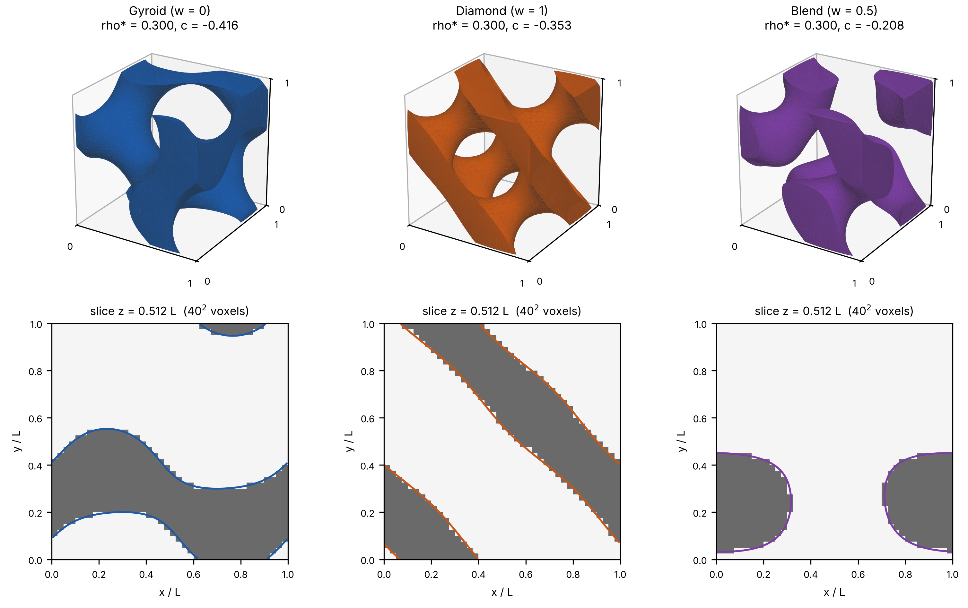
Fig. 2. Network TPMS unit cells at ρ* = 0.30: gyroid (w = 0), Schwarz diamond (w = 1) and the 50/50 blend (w = 0.5); renders and slices with the voxel solid (grey) and the exact level set (line).
The geometry metrics are the specific surface area $a_{sf}$ (marching cubes on the periodic level set), the wall thickness (local thickness [32] computed from sub-voxel distances to the surface) and the pore throat (the largest sphere that can travel through the fluid in all three directions). Applied to the zero level sets, the surface area per cell extrapolates to 3.0917 for G and 3.8381 for D, within 0.01% of the minimal-surface values 3.0915 and 3.8377 [33]; the area converges at second order and is within 0.16% at n = 48. Because both the wall and the throat scale with $L$, the manufacturing limits reduce to a cell-size floor, $L≥L_{min}\left(w,ρ^{*}\right)$. For the pure gyroid $L_{min}$ = 1.46–1.82 mm and for the diamond 1.77–2.16 mm, so almost the whole design box (L = 2–6 mm) is feasible. Blends behave differently: for 0 < w < 1 the minimum wall drops to 0.04–0.1 L at some densities because the blended level set develops pinch-point necks, and $L_{min}$ exceeds 6 mm on narrow "valleys" in the $\left(w,ρ^{*}\right)$ plane. Pointwise linear blending of two TPMS is therefore not a smooth morphological interpolation, a finding that shapes the optimization in Section 5.4.

4.2. Periodic cell problems
Three cell problems give the bulk closures. All are solved on the same binary voxel cell (true = solid) with periodic boundary conditions, and each solver computes its effective tensor in two independent ways (volume-averaged flux and energy) as a built-in consistency check.
Conduction. For each unit macroscopic gradient $e_{j}$, the periodic temperature fluctuation $ϑ_{j}$ solves
$$\begin{matrix} & ∇⋅\left[k\left(x\right)\left(∇ϑ_{j}+e_{j}\right)\right]=0, \\ & k_{eff} e_{j}=\left\langle k\left(x\right)\left(∇ϑ_{j}+e_{j}\right)\right\rangle \end{matrix}$$ | (3)

with $k=k_{s}$ = 130 W m$​^{−1}$ K$​^{−1}$ in the solid and $k=k_{f}$ = 0.40 W m$​^{−1}$ K$​^{−1}$ in the coolant. Cell-centred finite volumes with harmonic-mean face conductances and a preconditioned conjugate-gradient solver (relative tolerance 10$​^{−8}$) are used; the flux and energy forms agree to about 10$​^{−9}$.
Elasticity. For each of the six unit macroscopic strains $E_{j}$ (Voigt order, engineering shear), the periodic displacement fluctuation ${\tilde{u}}_{j}$ solves
$$\begin{matrix} & ∇⋅\left[C\left(x\right):\left(ε\left({\tilde{u}}_{j}\right)+E_{j}\right)\right]=0, \\ & C_{eff} E_{j}=\left\langle C\left(x\right):\left(ε\left({\tilde{u}}_{j}\right)+E_{j}\right)\right\rangle \end{matrix}$$ | (4)

discretized with eight-node trilinear hexahedra on the solid voxels. The void is removed rather than given a small modulus: a soft void with $E_{min}$ biases $C_{eff}$ by about $22 E_{min}/E_{s}$, whereas removal is exact and halves the cost. Stress localization is measured by the factor $K_{σ}=σ_{vm}/Σ_{vm}$ under unit macroscopic uniaxial and shear stresses. We use its 99th percentile, which is resolution-stable to ±3% from n = 24 upwards; the maximum is a voxel-corner singularity that keeps growing with resolution and is not used.
Stokes permeability. For a unit body force along $e_{j}$, the creeping flow in the fluid voxels solves
$$\begin{matrix} & μ∇^{2}u_{j}−∇p_{j}+e_{j}=0, ∇⋅u_{j}=0, \\ & u_{j}=0 \text{on solid faces}, K e_{j}=μ\left\langle u_{j}\right\rangle \end{matrix}$$ | (5)

with $⟨⋅⟩$ the average over the whole cell, so that $K$ is the superficial (Darcy) permeability. A staggered marker-and-cell discretization places the wall exactly on the voxel faces, as in the other two solvers, with mirror ghost velocities for tangential no-slip [34]. The symmetric saddle-point system is solved with MINRES and a block-diagonal preconditioner [35]. We report the symmetrized flux form of $K$, whose error is quadratic in the solver residual, and use the energy form as a check.
Production estimator. The voxel staircase drops edge and corner contacts between solid voxels, so all three quantities converge at about first order in $1/n$ and from below. The conductivity is the most affected (3–17% low on a single n = 32–64 grid, most at low density), the stiffness much less (−1.8 to −4.3% at n = 24 and −1.4 to −2.5% at n = 48), the permeability least (≤ 1.6% at n = 48). We therefore use the two-grid Richardson estimator [36]
$$\begin{matrix} & q_{∞}≈\frac{n_{2} q\left(n_{2}\right)−n_{1} q\left(n_{1}\right)}{n_{2}−n_{1}}, \\ & \left(n_{1},n_{2}\right)=\left(32,64\right)\end{matrix}$$ | (6)

whose error against an extrapolated reference built from four grid offsets at n = 16–64 (and checked against n = 96 solutions) is at most 0.7% for $k_{eff}$, 2.9% for every stiffness constant and 1.0% for $K$ over gyroid and diamond at ρ* = 0.2–0.5.
Verification. Table 3 lists the verification cases; all pass. Homogeneous cells and laminates reproduce the exact (harmonic/arithmetic, Backus [37]) tensors to round-off, the conductivities lie inside the Hashin–Shtrikman bounds [38], and the Stokes solver reproduces plane Poiseuille flow exactly (the MAC value $\left(H^{2}+2\right)/12$, i.e. a $2/H^{2}$ error against the continuum $H^{2}/12$), converges at second order for ducts and lies within 0.3–0.9% of the Zick–Homsy values for simple-cubic sphere arrays at six solid fractions [39] (Fig. 3). As an independent validation, our gyroid permeability at porosities of 0.5 and 0.6 differs from the body-fitted OpenFOAM values of Gajetti et al. [11] by +1.1% and −1.8%, and the diamond values by +0.7% and −0.4%, i.e. agreement within the two-digit precision of their table.
Table 3. Verification of the periodic cell solvers (all cases pass; details and data in the repository).
Solver | Case | Result
Conduction | homogeneous cells; laminates along x, y, z (contrast 0.1 and 10⁻³; k_{f} = 0) | exact to 10⁻¹³ / 10⁻⁹ (harmonic across, arithmetic along)
Conduction | G and D, ρ* = 0.2/0.35/0.5, three contrasts | inside Hashin–Shtrikman bounds; isotropic to 2 × 10⁻⁴
Conduction | simple-cubic spheres vs Rayleigh [40] | < 1% at n = 48 (conducting spheres)
Elasticity | element patch test, rigid modes; laminates vs Backus | exact (10⁻¹⁴; 10⁻⁹)
Elasticity | cubic symmetry of G, D; trigonal symmetry of the blend | deviation < 5 × 10⁻³; blend [111] axis confirmed
Elasticity | soft-void limit; floating islands and hinged voxels | linear in E_{min}; add exactly nothing
Stokes | plane Poiseuille, H = 1–64 voxels | K = (H² + 2)/12 exactly; order 2.000 vs H²/12
Stokes | square and 2:1 ducts vs series solution [41] | +1.5% / +0.38% at 16 / 32 voxels; order 2.0
Stokes | simple-cubic sphere arrays vs Zick & Homsy [39] | −0.3 to −0.9% at c = 0.027–0.45, n = 32–64
Stokes | G, D vs body-fitted CFD [11] (φ = 0.5, 0.6) | +1.1 / −1.8% (G); +0.7 / −0.4% (D)
All | two-grid estimator R(32, 64) vs n = 96 anchored reference | ≤ 0.7% (k_{eff}), ≤ 2.9% (C_{eff}), ≤ 1.0% (K)

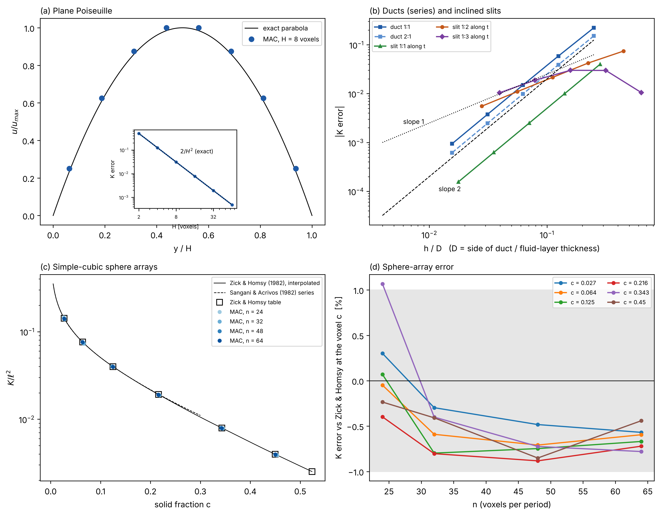
Fig. 3. Verification of the MAC Stokes solver: (a) plane Poiseuille profile and its 2/H² error, (b) square and rectangular ducts and inclined slits against the series solution, (c) simple-cubic sphere arrays against Zick & Homsy [39] and the Sangani–Acrivos series [42], (d) sphere-array error against resolution.

4.3. Closure dataset and surrogates
The device model needs the closures at every point of a graded field, so they are learned from a dataset. The morphology space $θ=\left(w,ρ^{*},a_{z}\right)∈\left[0,1\right]×\left[0.20,0.50\right]×\left[0.69,1.5\right]$ was sampled with 256 scrambled Sobol points [43], 8 corners, 12 edge midpoints and 14 points on the pure G and D lines (290 cells). Each cell was solved with the R(32, 64) estimators for $k_{eff}$, $C_{eff}$ and $K$, plus the geometry metrics and the localization factors at n = 64; the run took 7.4 h of wall-clock time on a laptop (27.8 CPU-h). Every cell had one connected, percolating solid and fluid.
To keep the predicted tensors symmetric positive-definite and their symmetry exact, the targets are the matrix logarithms of $K/L^{2}$, $k_{eff}/k_{s}$ and the Mandel-form $C_{eff}/E_{s}$ (the log-Euclidean metric [44]), plus the logs of $a_{sf}L$ and of the six 99th-percentile localization factors: 40 latent targets in all. The exponential of any symmetric prediction is SPD, and the material symmetry of each cell class (cubic for pure G and D, tetragonal for stretched pure cells, trigonal about [111] for blends, triclinic for stretched blends) is imposed by projection. Two surrogate families were trained on inputs $\left(w,logρ^{*},loga_{z}\right)$: an ARD Matérn-5/2 Gaussian process per target [45] and a five-member heteroscedastic deep ensemble [46]. Their predictive standard deviations were recalibrated on out-of-fold errors [47]. The cell size $L$ enters analytically ($K=\left(K/L^{2}\right)L^{2}$, $a_{sf}=\left(a_{sf}L\right)/L$).
In five-fold cross-validation the ensemble predicts the principal permeabilities with a mean absolute percentage error of 0.9%, the conductivity diagonal with 1.5%, the mean Young's modulus with 3.9%, the surface area with 0.2% and the localization factors with 2.9–3.5%; the recalibrated 95% intervals cover 86–98% of the held-out values. The errors concentrate in the pinch-neck region of the blends (0.3 < w < 0.7, ρ* < 0.4), where the mean Young's modulus error rises to 11.6% against 1.4% elsewhere. When all blends with 0.25 ≤ w ≤ 0.75 are withheld, the stiffness error reaches 43–49%: the neck mechanism is absent from the training data. A 3D convolutional network trained on 32³ voxel images did not extrapolate better across this gap (107% error), but it was the most accurate stiffness model when 25% of the blends were seen in training. The production device model uses the ensemble, with the GP as a cross-check.

4.4. Finite-gap strips
The jacket frame is $x=r$ (across the gap), $y=s$ (circumferential) and $z$ (axial). A strip is a lattice of $N$ cells across a gap $H=NL$ bounded by solid walls, periodic and one cell wide in $y$ and $z$. Because the cell solvers are periodic in $x$ too, the computational cell is the stack [lattice of thickness $H$ | solid wall of thickness $t_{w}=L/2$] repeated along $x$, so every lattice layer is bounded by a perfectly bonded no-slip wall of conductivity $k_{s}$ on both sides. The inner wall cuts the lattice at a phase $φ_{0}$ and the outer wall at $φ_{0}+N$. For the gyroid and the diamond, the screw axes along $x$ make the cuts $φ_{0}$, $φ_{0}+1/4$ and $−φ_{0}$ equivalent, so the symmetry-distinct cuts lie in [0, L/8]; we use {0, L/12, L/8}. Blends have no such symmetry and are cut at three phases over a full period. The strip lattice is a bit-exact tiling of the bulk reference cell (same grid, phase and threshold), so the staircase error of Section 4.2 is common to strip and bulk and cancels in their ratio; changing n from 24 to 48 changes the discrepancies by at most 0.4 percentage points (pp) for the permeability and 1.4 pp for the stiffness at N = 1.
The walls are then removed analytically under the homogenized picture "homogeneous lattice layer plus plain walls", which is exact for a laminate: the through-gap conductivity follows from the series sum, the in-plane permeability from the share of the flow carried by the lattice, and the stiffness from the laminate mixed form, in which the tractions $\left(σ_{xx},σ_{xz},σ_{xy}\right)$ and the in-plane strains are continuous across layers [37]:
$$\begin{matrix} & \frac{H+t_{w}}{k_{stack}}=\frac{H}{k_{n}}+\frac{t_{w}}{k_{s}}, \\ & K_{t}=\frac{H+t_{w}}{H} K_{stack}^{\left(yz\right)}\end{matrix}$$ | (7)

Five apparent core properties are reported: the through-gap conductivity $k_{n}$, the in-plane permeability $K_{t}$ (mean of $K_{ss}$ and $K_{zz}$), the normal stiffness $C_{nn}=C_{rrrr}$, the transverse shear $G_{t}=\left(G_{rs}+G_{rz}\right)/2$, which carries torque and thrust from the sleeve to the outer wall, and the in-plane shear $G_{sz}$. Their discrepancy from the homogenized prediction is
$$δ_{q}=\frac{q_{strip}}{q_{hom}}−1,$$ | (8)

where $q_{hom}$ is the bulk closure for uniform strips and, for graded strips, the local bulk closures combined across the gap like a laminate (series, mixed form or arithmetic mean), which is exactly what a local-closure device model does.
Each bonded wall adds a boundary layer whose effect does not depend on the distance to the other wall, so it should scale with the wall area per lattice volume, $2/H=2/\left(NL\right)$. This suggests one wall coefficient $a$ per quantity, in a series form for $k_{n}$, $C_{nn}$, $G_{t}$ and a parallel form for $K_{t}$, $G_{sz}$:
$$\frac{q_{bulk}}{q}=\left(1+\frac{a\left(θ\right)}{N}\right){\left(1+c_{g} g^{2}\right)}^{−1}$$ | (9)

$$\frac{q}{q_{bulk}}=\left(1−\frac{a\left(θ\right)}{N}\right)\left(1+c_{g} g^{2}\right)$$ | (10)

for the series quantities and the parallel ones, respectively, with $g=\left|∇ρ^{*}\right|L$ the density change per cell and $a\left(θ\right)=β⋅\left[1, r, w, b, rw, rb, lna_{z}\right]$, $r=\left(ρ^{*}−0.35\right)/0.1$, $b=4w\left(1−w\right)$, fitted by weighted least squares. In the parallel form, $aL/2$ is the thickness of a layer at each wall that carries no flow. A Gaussian process on the residuals tests whether anything systematic remains. Both models were judged by leave-one-$θ$-out and leave-one-$N$-out cross-validation against the "floor", the pooled scatter over cut phases that no model in $\left(N,θ,g\right)$ can remove. The study covers G, D and the w = 0.5 blend at ρ* = 0.25, 0.35, 0.45, N ∈ {1, 1.5, 2, 3, 4, 6, 8}, linear density gradients g ≤ 0.15 and stretches $a_{z}$ = 0.75 and 1.5: 336 strips and 157 bulk cells at n = 32 (92 min on two cores with a two-level aggregation preconditioner [48]).

4.5. Literature closures for inertia and interstitial heat transfer
Two closures were not computed: the inertial (Forchheimer) coefficient and the interstitial heat-transfer coefficient. With porosity $ϕ=1−ρ^{*}$, hydraulic diameter $D_{h}=4ϕ/a_{sf}$, superficial velocity $U$ and $Re_{D_{h}}=4U/\left(a_{sf}ν\right)$,
$$\begin{matrix}−∇p & =\frac{μ}{K}U+\frac{ρ C_{F}}{\sqrt{K}}\left|U\right|U, \\ f Re_{D_{h}} & =\frac{2ϕD_{h}^{2}}{K}+2ϕ^{2}C_{F}\frac{D_{h}}{\sqrt{K}}Re_{D_{h}}\end{matrix}$$ | (11)

with $f$ the Darcy friction factor based on the pore velocity [12]. After reviewing fourteen correlations (Supplementary Table S4) we use the power laws $C_{F}=b ϕ^{m}$ of Gajetti et al. [11] (G: b = 0.0908, m = −1.81; D: b = 0.0666, m = −1.69; blends log-linear in w), the only source that covers G and D with one method, and the modified Reynolds analogy of Savoldi et al. [12] (their Eq. 37) extended to our Prandtl number with the Chilton–Colburn factor:
$$Nu_{D_{h}}=\frac{h_{sf}D_{h}}{k_{f}}=0.0267 ϕ^{0.19}\left(f Re_{D_{h}}\right)Pr^{1/3}$$ | (12)

evaluated with our own $K$, $a_{sf}$ and the Gajetti $C_{F}$. This variant has a constant Nusselt number in the Darcy limit and grows monotonically with Re across the jacket operating box. With $Pr^{1/3}$ it stays within 0.63–1.37 times the packed-bed correlation of Gnielinski [49], which is valid up to Pr = 1000. Both closures are extrapolated: they were fitted for $Re_{D_{h}}≤100$, ϕ ≤ 0.6–0.7 and Pr = 1, while the jacket operates at $Re_{D_{h}}$ = 25–577, ϕ = 0.5–0.8 and Pr = 20.7, where inertia carries 16–84% of the pressure drop. Section 6 returns to this.

4.6. Homogenized jacket model
The annulus is unwrapped to the plane $\left(s,z\right)$, with $s=r_{m}θ$ the arc length at the mean lattice radius $r_{m}$ = 74.5 mm, and every field is averaged over the gap depth. Curvature is neglected ($h/r_{m}$ = 0.08); the planform area times $h$ equals the annulus volume exactly. The cell axes coincide with $\left(r,s,z\right)$, so the predicted tensors are used directly; the in-plane permeability of a blend is the Schur complement $K_{t}=K_{tt}−K_{tr}K_{rr}^{−1}K_{rt}$ of the full tensor (zero net radial flow), which keeps its off-diagonal $K_{sz}$.
Flow. The superficial velocity $U=\left(U_{s},U_{z}\right)$ obeys the depth-averaged Darcy–Forchheimer equation with the finite-gap factor on the viscous term only:
$$\begin{matrix}−∇p & =μ{\left(f_{K}K_{t}\right)}^{−1}U+\frac{ρ C_{F}}{\sqrt{K_{e}}}\left|U\right|U, ∇⋅U=0, \\ f_{K} & =1−a_{K}\left(θ\right)/N, N=h/L\end{matrix}$$ | (13)

with $K_{e}=1/\left(e⋅K_{t}^{−1}e\right)$ the bulk permeability along the local flow direction $e$. The manifold slots are plenums at uniform pressure ($p_{in}$, unknown, and 0); the total flow rate fixes $p_{in}$; the axial ends are no-flow. Cell-centred finite volumes with harmonic face mobilities and an implicit cross term for anisotropic cells are used, and the inertial term is linearized by Picard iteration (3 iterations for uniform designs, 10–15 for graded ones).
Heat. A two-equation (local thermal non-equilibrium) model [50] is reduced to three depth-averaged fields: the coolant temperature $T_{f}$, the sleeve temperature $T_{w}$ and the mean lattice-solid temperature ${\overset{‾}{T}}_{s}$:
$$ρc_{p}h U⋅∇T_{f}−∇⋅\left(hϕk_{f}∇T_{f}\right)=U_{eff}\left(T_{w}−T_{f}\right)$$ | (14)

$$\begin{matrix} & −∇⋅\left(k_{w}t_{sl}∇T_{w}\right)−∇⋅\left(h k_{t}∇{\overset{‾}{T}}_{s}\right) \\ & +U_{eff}\left(T_{w}−T_{f}\right)=q_{in}\left(z\right)\end{matrix}$$ | (15)

Across the gap, the lattice solid is a one-dimensional fin bonded to the sleeve with an adiabatic outer wall, which gives
$$\begin{matrix}U_{eff} & =\sqrt{k_{n}H_{v}} tanh\left(mh\right)+ϕ h_{sf}, m=\sqrt{H_{v}/k_{n}}, H_{v}=h_{sf}a_{sf}, \\ {\overset{‾}{T}}_{s} & =T_{f}+η\left(T_{w}−T_{f}\right), η=tanh\left(mh\right)/\left(mh\right)\end{matrix}$$ | (16)

where the second term of $U_{eff}$ is the direct convection from the exposed sleeve fraction ϕ (the planar porosity at a cut equals the bulk porosity, Section 5.2). The in-plane solid conductivity $k_{t}=\left(k_{ss},k_{zz}\right)$ comes from the surrogate; $k_{n}=k_{eff,rr}$ needs no finite-gap correction (Section 5.2). The heat input $q_{in}\left(z\right)=q″\left(z\right) r_{s}/r_{m}$ is integrated exactly over each cell, so its sum is 770 W. Under a manifold slot there is no lattice; the sleeve exchanges heat with the well-mixed plenum through $h_{m}$, taken from fully developed laminar flow between parallel plates with one wall heated, $Nu_{D_{h}}$ = 5.385 with $D_{h}=2h$ [41], about 180 W m$​^{−2}$ K$​^{−1}$ (a conservative value; see the sensitivity study in Section 5.3). Advection is first-order upwind and the axial ends are adiabatic. The reported wall temperature is that of the stator side of the sleeve, $T_{wall}=T_{w}+q″t_{sl}/k_{s}$.
Structure. The sleeve and the outer wall are treated as rigid faces of a cylindrical sandwich whose lattice core carries the torque $T$ and thrust $F$ in shear with uniform shear strain. The local shear stresses at the sleeve radius $r_{i}$ follow the local transverse moduli,
$$\begin{matrix}τ_{rs} & =\frac{T G_{rs}}{r_{m}∑G_{rs}A}{\left(\frac{r_{m}}{r_{i}}\right)}^{2}, \\ τ_{rz} & =\frac{F G_{rz}}{∑G_{rz}A} \frac{r_{m}}{r_{i}}\end{matrix}$$ | (17)

the coolant pressure loads the lattice in radial tension, shared with the hoop stiffness of the outer wall, and the local 99th-percentile von Mises stress is the linear superposition $σ_{vm}=K_{ux}σ′_{rr}+\sqrt{3} \left(K_{s,xy}τ_{rs}+K_{s,xz}τ_{rz}\right)$ with the localization factors of Section 4.2. The structural margin is $σ_{allow}/σ_{vm}$, minimized over the lattice and the outer wall (hoop stress, strip bending over a slot and plate bending over a pore).
Verification. The model reproduces uniform Darcy and Darcy–Forchheimer flow against the analytic two-path solution to $2×{10}^{−13}$, layered media to 10$​^{−10}$, the exact discrete upwind solution of the ε-NTU problem at fixed wall temperature to 10$​^{−12}$ (and the continuous ε-NTU solution at first order), and the analytic fin conductance to 10$​^{−7}$. Mass and energy balances close to better than ${10}^{−13}$ and $2×{10}^{−11}$ of the throughput on graded, blended and stretched designs at 1 and 5 L/min, far inside the 0.5% target. The thermal resistance converges at an observed order of 1.76; on the default grid (1.25 mm × 2.5 mm, 376 × 20 cells) it is 0.44% above the Richardson-extrapolated value (Fig. 4). One evaluation takes 0.2 s for uniform and 0.3–0.7 s for graded designs on one CPU core.
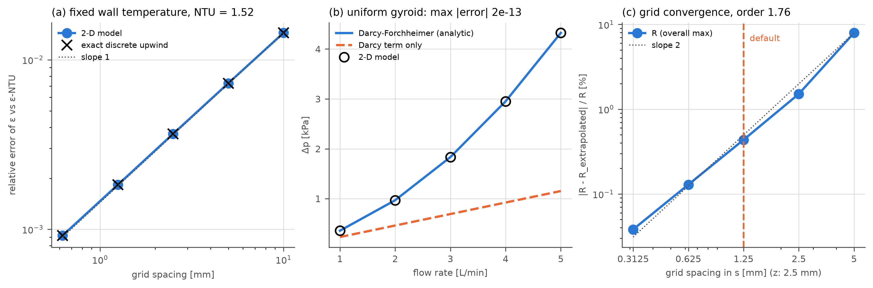
Fig. 4. Verification of the jacket model: (a) ε-NTU problem at fixed wall temperature against the exact discrete solution, (b) pressure drop of the uniform gyroid against the analytic Darcy–Forchheimer solution over 1–5 L/min, (c) grid convergence of the thermal resistance (observed order 1.76).

4.7. Baselines
Four baselines are evaluated with the same interface, heat input, sleeve conduction and wall-temperature definition, and each is tuned before comparison:
• B1, helical rectangular channels in the same 6 mm gap with end-ring manifolds outside the heated length. Channel width, rib thickness (≥ 0.35 mm) and number of starts were searched over 479 candidates. Friction follows the exact laminar series for rectangular ducts [41] with Schmidt's curvature factor [51], and the Nusselt number follows the VDI laminar coil correlation, floored by the straight-duct value, with Gnielinski's transition and turbulent forms [49, 52]. Ribs are fins with an adiabatic tip, the same outer-wall assumption as for the lattice.
• B1s, circumferential channels fed by the same axial slots as the lattice (75 candidates), the like-for-like channel baseline.
• B2, the best uniform gyroid (221 candidates in ρ* = 0.20–0.50, L = 2–6 mm).
• B3, density-only grading of a gyroid at fixed cell size, emulating prior art: four density knots along each half path plus an axial term shaped like $q″\left(z\right)$, tuned by 64 Sobol points and a Nelder–Mead search.
All families use the same selection rule: minimum R at 3 L/min subject to manufacturability, structural margin ≥ 1 and a pump power no higher than that of the reference uniform gyroid (ρ* = 0.35, L = 4 mm), 0.306 W.

4.8. Multi-objective optimization
Each design field $f∈\{ρ^{*},w,L\}$ is a tensor-product B-spline on the unwrapped jacket,
fs,z=flo+fhi−floi,j​xij Biss Bjzz,xij∈0,1 | (18)

with a periodic cubic basis in $s$ and a clamped basis in $z$. Because the bases are non-negative partitions of unity, the fields never leave their bounds. The default control grids are 8 × 4 for ρ* and w and 4 × 2 for L, with $a_{z}$ = 1: 72 variables. The problem is
$$\begin{matrix} & \min_{x} \left(R, P, m\right) \text{at 3 L/min, subject to} \\ & L≥1.01 L_{min}\left(w,ρ^{*}\right) \text{in every cell}, \\ & \left|∇ρ^{*}\right| L≤0.05, σ_{allow}/σ_{vm}≥1\end{matrix}$$ | (19)

The gradient limit of 0.05 is the value at which the graded strips of Section 5.2 keep the local-closure error below 1%. The cell-size rule uses a morphology table with a blend step of 0.025 and excludes the pinch-neck valleys (cells whose neighbourhood in the table has a minimum wall below 0.09 L). A first study with a coarser table let optimizers place blends on these valleys, which a direct n = 48 check later rejected; the corrected rule is used throughout this paper. Random B-spline fields are averages of several controls and therefore mostly mid-range blends: only 8 of 40 000 Sobol designs were feasible. A deterministic repair, applied identically by every method, polarizes violating w controls toward the design's majority pure type, raises the cell-size controls where needed and shrinks the density net toward its mean until the gradient limit holds; it maps every random design to a feasible one in 3 ms and leaves feasible designs unchanged. Because the extremes of the front lie where every field is at a bound, every method starts from the same nine uniform anchors (G and D at the four (ρ*, L) corners and the reference gyroid), counted in its budget.
Three methods were run with five seeds on each of the two manifold layouts: NSGA-II [26] in pymoo [27] (population 100, 100 generations, 10 000 evaluations); batch Bayesian optimization with the log-form qNEHVI acquisition [29, 53] in BoTorch [30] (200 evaluations in batches of four; the mass, a known linear function of the density controls, is not modelled by a GP); and scrambled Sobol search (1000 evaluations). An evaluation is one call of the device model for a design that passed the cheap checks. Fronts are compared by the hypervolume [28] in a fixed normalized objective space (R in mK W$​^{−1}$ on [5, 40], $\log_{10}P$ on [−3, 0.5], mass on [0.28, 0.42] kg) with the reference point (1, 1, 1). The 30 runs were executed in parallel on 4-core cloud runners (2 h 35 min wall clock in total).

4.9. Geometry export and manufacturability checks
A chosen design is turned into a solid with the PicoGK geometry kernel [54]. The graded fields are mapped into conformal cylindrical phase coordinates so that cells never tear: an integer number of cells around the circumference, $N_{θ}=round\left(\overline{P}\left(2π\right)\right)$ with $P\left(θ,z\right)=\int_{0}^{θ}{r_{m}}/L dθ′$, the axial phase $u_{z}=∫dz/\left(a_{z}L\right)$ and the radial phase $u_{r}=φ_{r0}+\left(r_{m}/L\right)ln\left(r/r_{i}\right)$, which keeps the cell shape constant through the gap. The blended level set of Eq. (2) is evaluated at these coordinates in a C# implicit function, intersected with the gap, and united with the sleeve, outer wall, end caps, plenums and port bosses. A pure-numpy mirror of the same signed-distance function serves as the specification and as an independent check. The checks run on voxel masks of a 30° sector at 0.05 mm and of the full jacket at 0.2 mm: minimum wall by a discrete opening, pore throat by the largest sphere that passes from inlet to outlet, fluid connectivity between the ports, trapped pockets and loose solid.

5. RESULTS AND DISCUSSION

5.1. Bulk closures of gyroid, diamond and blends
The bulk closures set the scale for everything that follows (Fig. 5). At ρ* = 0.35 the conductivity of the gyroid and the diamond is $k_{eff}/k_{s}$ = 0.208 and 0.205, 67–83% of the Hashin–Shtrikman upper bound over the design range, with power-law fits $0.81ρ^{*1.29}$ (G) and $0.85ρ^{*1.36}$ (D); the coolant adds only 1–4%. The Young's modulus scales as $E^{*}/E_{s}=0.90ρ^{*2.13}$ (G) and $0.67ρ^{*1.93}$ (D), the exponent of about two of bending-dominated lattices [4, 55]. With the exponent fixed at two, the prefactors (0.79 for G, 0.72 for D) are 11% and 9% above the values measured by Maskery et al. on polymer lattices [56], a plausible gap between an ideal geometry and printed parts with porosity and roughness. Neither lattice is elastically isotropic: the Zener ratio is 1.3–1.9 for G and 1.7–2.3 for D, so the device model uses full tensors. The permeability follows $K/L^{2}=0.0202 ϕ^{3.22}$ (G) and $0.0132 ϕ^{3.29}$ (D); the diamond is 35–37% less permeable at equal porosity because its pores and throats are smaller. The Kozeny constant $c_{K}=ϕ^{3}/\left(Ka_{sf}^{2}\right)$ collapses within about 4% for all three morphologies at ϕ ≥ 0.5, falling from about 8 to 6 between ϕ = 0.8 and 0.5.
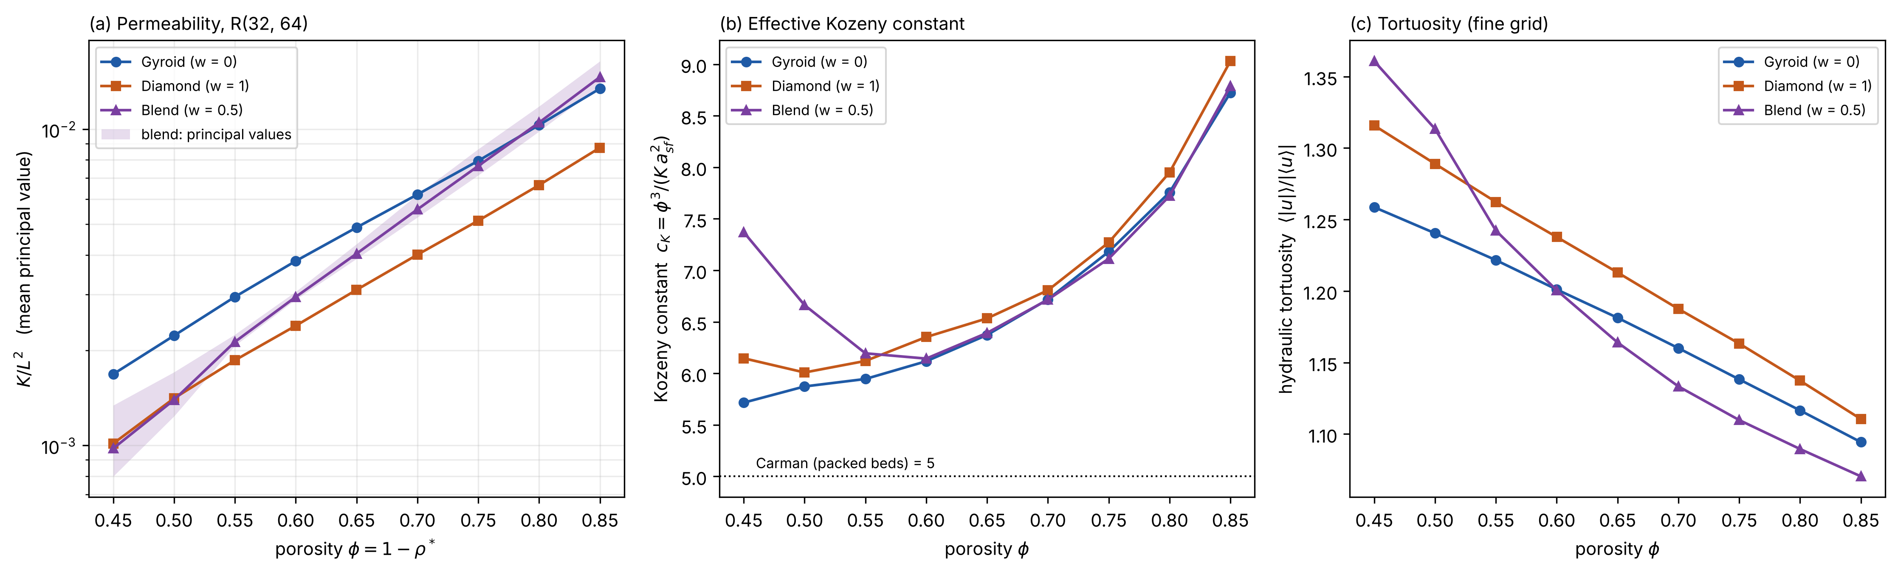
Fig. 5. Bulk permeability of the network lattices from the R(32, 64) estimator: (a) K/L² against porosity for gyroid, diamond and the 50/50 blend (band = range of its principal values), (b) effective Kozeny constant φ³/(K a_{sf}²), (c) hydraulic tortuosity.
The blends are different. At w = 0.5 and ρ* below about 0.375, the pinch-point necks of Section 4.1 make the lattice 3.4–4.5 times softer than G or D, strongly anisotropic, and give it 2.5–4 times higher stress localization (99th-percentile factor up to 95 at ρ* = 0.2). Between ρ* = 0.35 and 0.40 the Young's modulus jumps threefold and the conductivity rises from about 40% to 60% of the upper bound, the signature of a topology change. The blend permeability, in contrast, stays close to that of the gyroid. Blends therefore trade structure for flow, and their properties change abruptly with the parameters, which is why the surrogate errors concentrate there (Section 4.3).

5.2. RQ1: finite-gap error and its correction
Fig. 6 and Table 4 give the discrepancy of the five core properties as a function of the number of cells across the gap. The dominant effect is on the in-plane permeability. The bulk closure over-predicts $K_{t}$ by 23–40% at N = 1 ($δ$ = −19 to −28%), 10–17% at N = 2 and 7–10% at N = 3, which is the whole jacket design range (L = 2–6 mm in a 6 mm gap). The deficit is cleanly proportional to 1/N: a $1/N^{2}$ term does not improve the fit, the root-mean-square deviation from the 1/N line is 0.4 pp, and the wall coefficient hardly depends on density or on where the wall cuts the lattice (phase standard deviation of $a_{K}$ ≤ 0.011 for G and D). The wall coefficient is $a_{K}$ = 0.25–0.28 for the gyroid and 0.19–0.22 for the diamond at ρ* = 0.25–0.45 (Table 4), and grows with axial stretch (0.24/0.27/0.30 for G at $a_{z}$ = 0.75/1/1.5). In the parallel picture of Eq. (10), each wall carries a stagnant layer of thickness $a_{K}L/2$ ≈ 0.13 L (G), 0.10 L (D) and 0.12 L (blend).
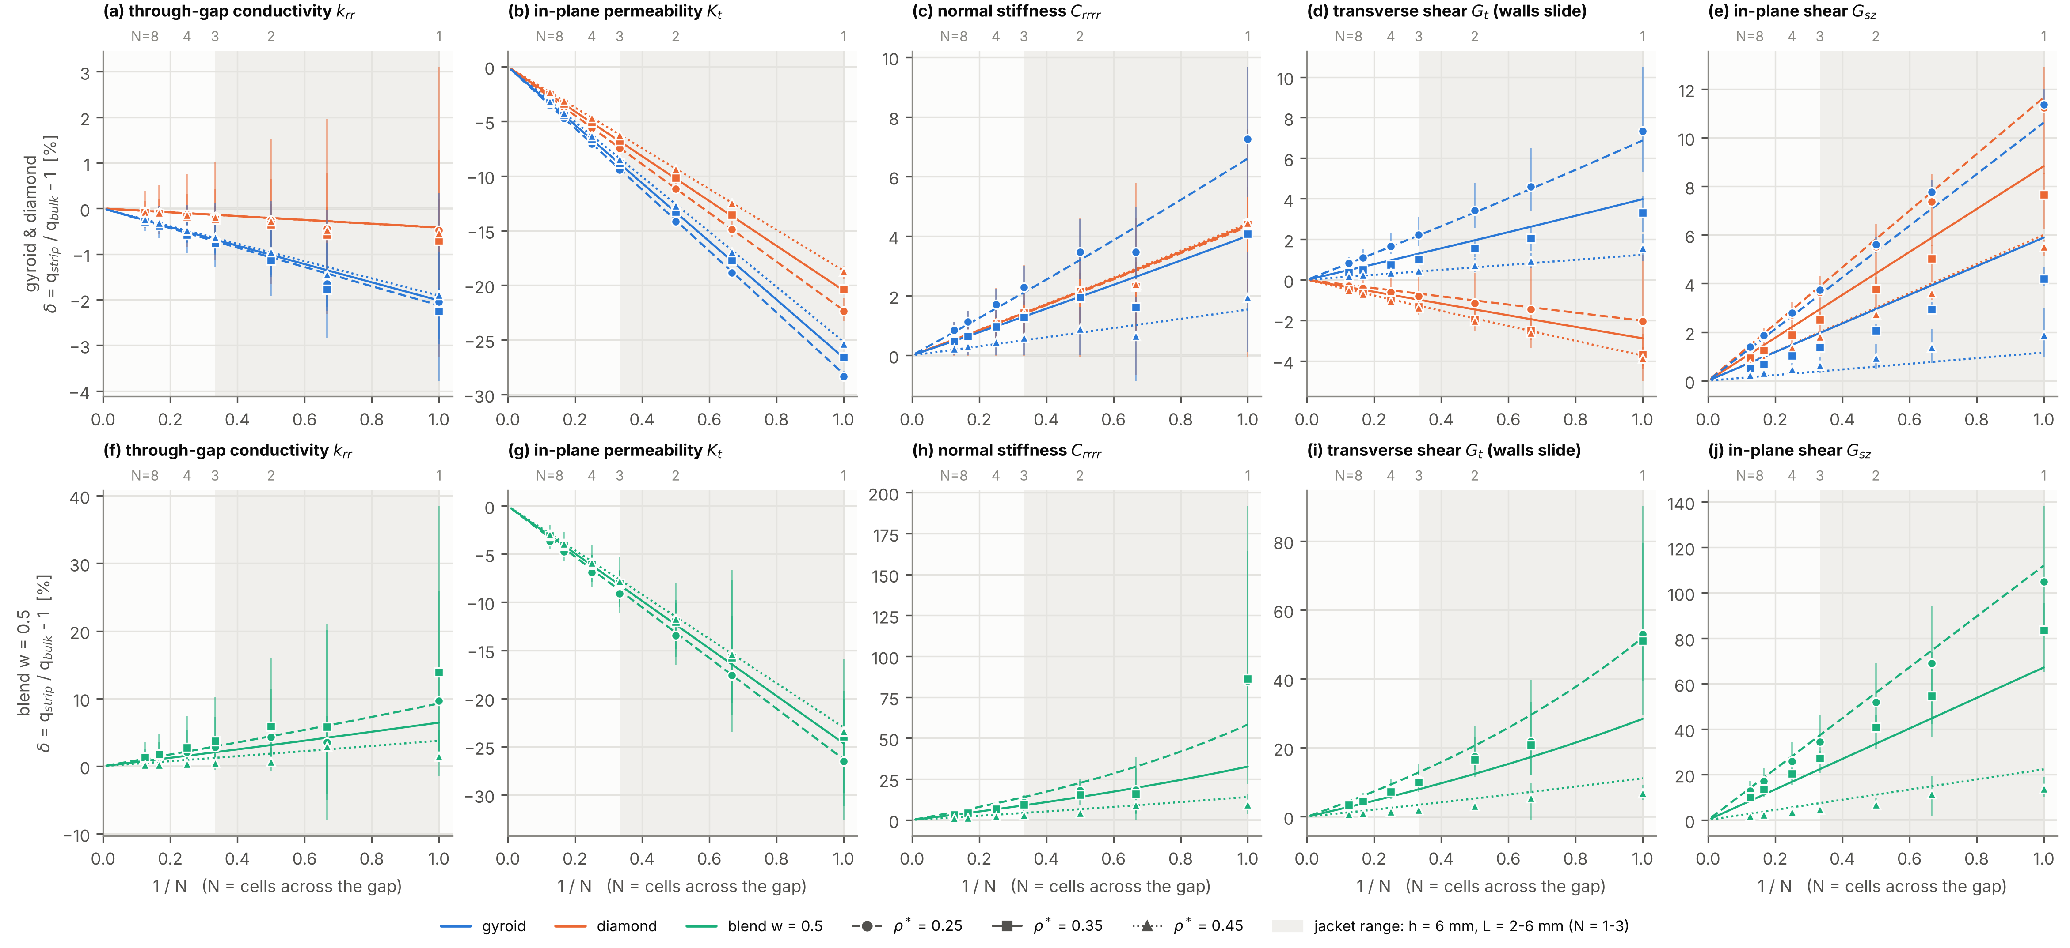
Fig. 6. RQ1: discrepancy δ = q_{strip}/q_{bulk} − 1 of the bulk closure against 1/N for lattice strips between bonded walls (n = 32 voxels per cell): (a, f) through-gap conductivity, (b, g) in-plane permeability, (c, h) normal stiffness, (d, i) transverse shear G_{t} that carries torque and thrust, (e, j) in-plane shear G_{sz}. Top row: gyroid (blue) and diamond (orange); bottom row: w = 0.5 blend. Markers = mean over symmetry-distinct cut phases, bars = their range, lines = fitted 1/N model, shaded band = jacket design range (N = 1–3).
The mechanism is not near-wall channelling (Fig. 7). For a randomly packed bed, porosity rises toward one at the wall and a fast layer forms [17]. For a TPMS lattice the planar porosity at a cut equals the bulk porosity, the wall closes the pores it cuts, and the flow deficit is confined to about a quarter of a cell next to each wall; the interior velocity profile equals the bulk one. A Brinkman description with the fluid viscosity as effective viscosity [23, 24] gives a boundary layer of thickness $\sqrt{K}$ (2√K/L = 0.11–0.14 at ρ* = 0.35) and under-predicts the loss by a factor of about 1.9. Moreover, the measured coefficient scales with L at fixed density rather than with √K, so a Brinkman layer is the wrong model here.
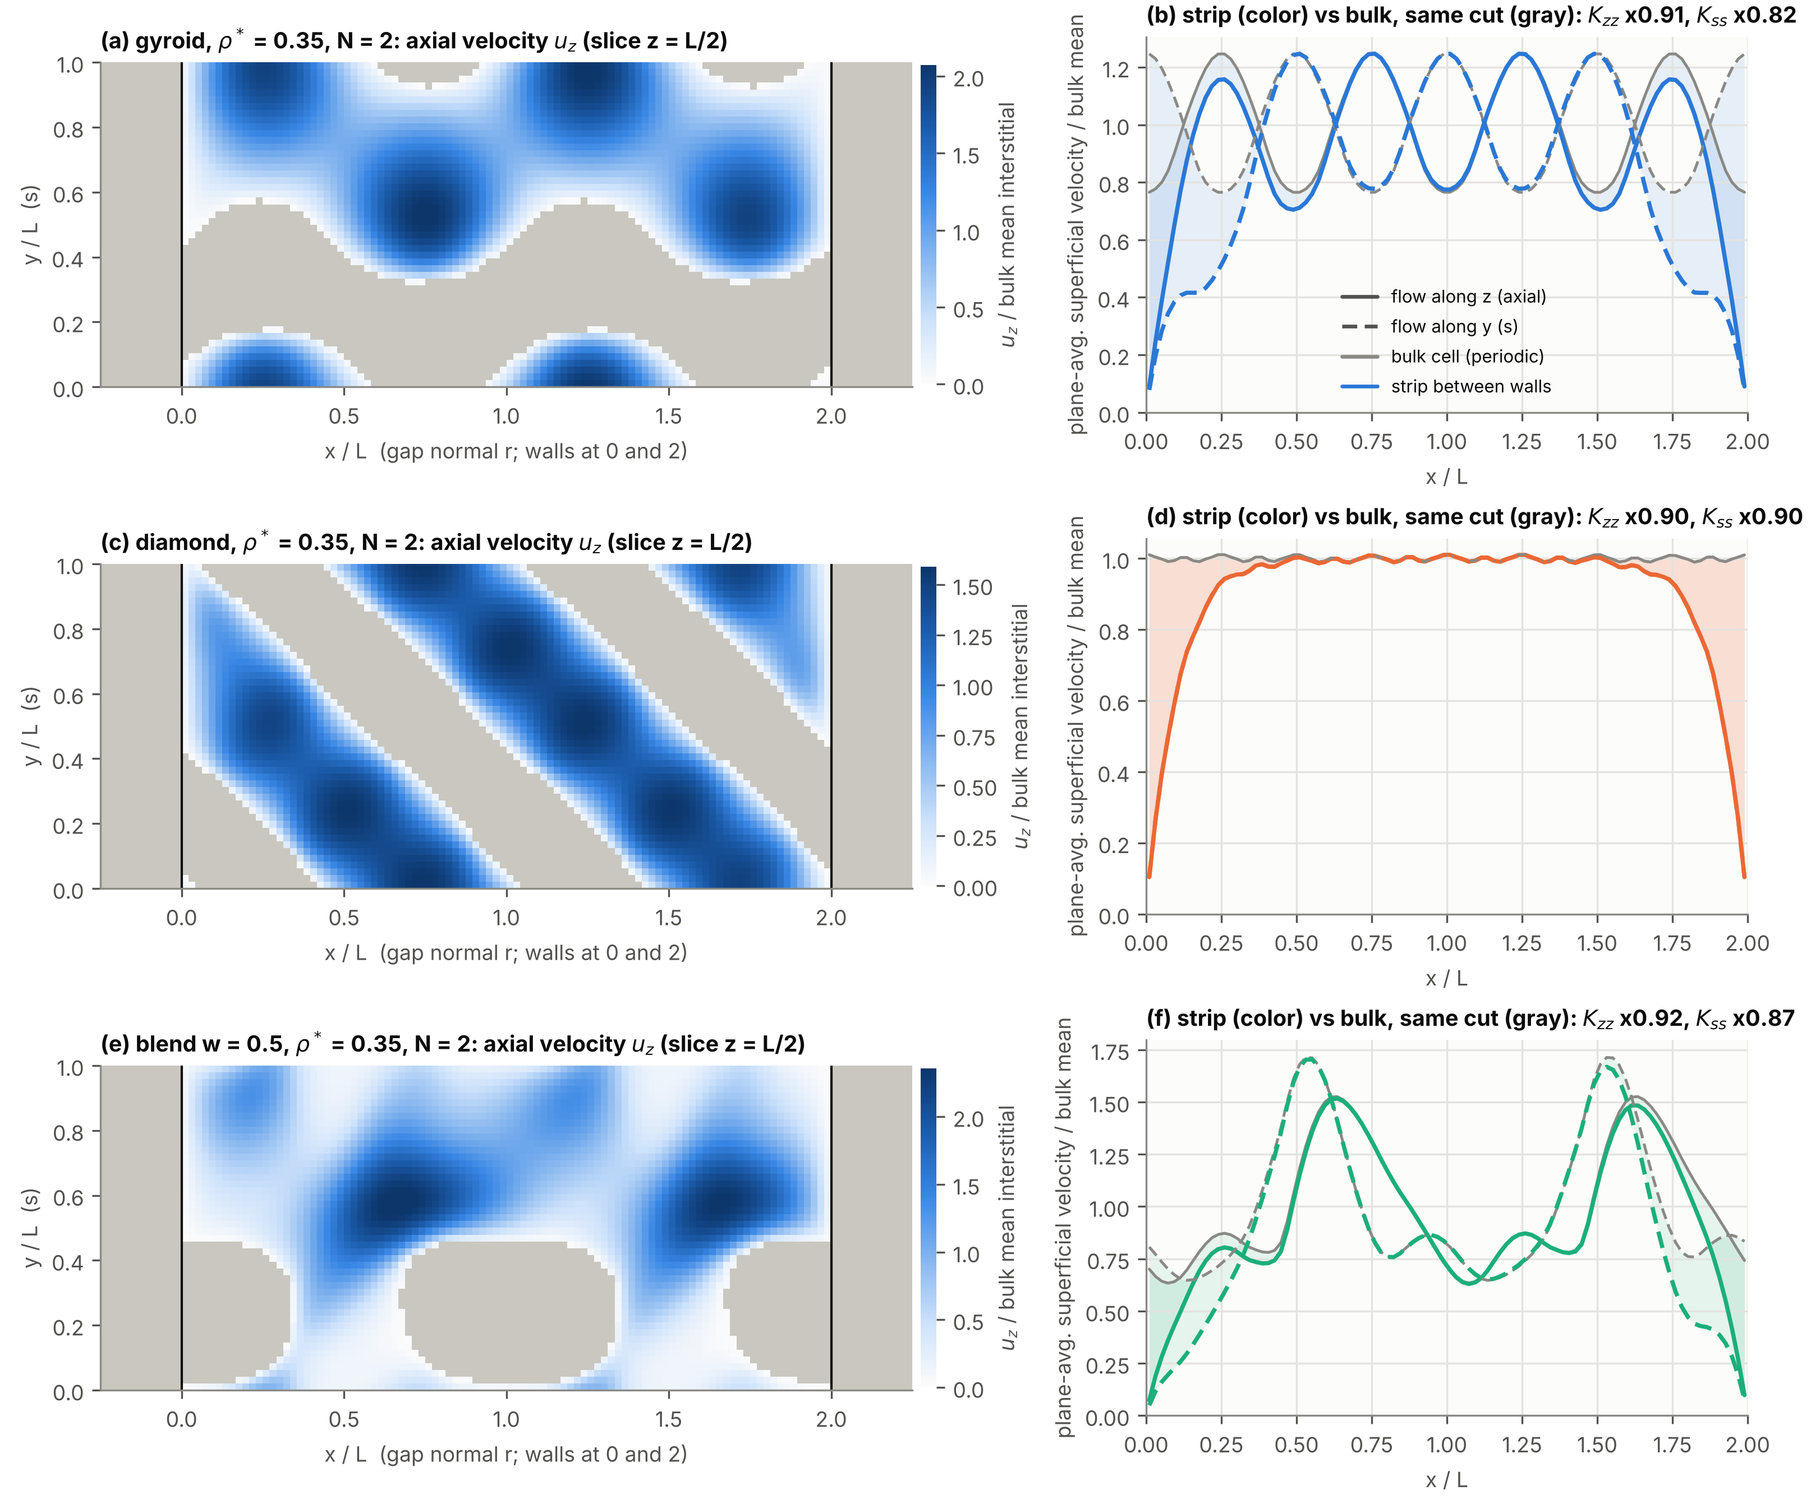
Fig. 7. Flow in a finite-gap strip (Stokes, unit body force, N = 2, n = 48; grey = solid): (a) axial velocity in a slice of a gyroid strip at ρ* = 0.35, (b) plane-averaged velocity profile of the strip (colour) against the bulk cell with the same cut (grey). The deficit is confined to about L/4 next to each wall; there is no fast near-wall channel.
The through-gap conductivity is almost unaffected for G and D (|δ| ≤ 2.3%, below the surrogate error), because the constriction of heat flow at the strut–wall contacts and the spreading in the wall nearly cancel. The walls stiffen the core: at N = 1, $C_{nn}$ rises by 2–7%, $G_{sz}$ by 2–11%, and $G_{t}$ by 2–7% for the gyroid, while it falls by 2–4% for the diamond. For the blends below ρ* ≈ 0.4, the stiffness gains reach +50 to +190% at N = 1 because a wall replaces the weakest pinch necks; these effects depend strongly on the cut phase and do not follow 1/N.
Table 4. Finite-gap discrepancy δ [%] at N = 1 / 2 / 3 cells across the gap (mean over cut phases, n = 32) and the in-plane permeability wall coefficient a_{K}. Negative = the bulk closure over-predicts.
Morphology | ρ* | k_{n} | K_{t} (a_{K}) | C_{nn} | G_{t} | G_{sz}
Gyroid | 0.25 | −2.1 / −1.0 / −0.7 | −28.4 / −14.2 / −9.4 (0.283) | +7.3 / +3.5 / +2.3 | +7.3 / +3.4 / +2.2 | +11.4 / +5.6 / +3.7
Gyroid | 0.35 | −2.3 / −1.1 / −0.8 | −26.6 / −13.3 / −8.9 (0.266) | +4.1 / +1.9 / +1.3 | +3.3 / +1.5 / +1.0 | +4.2 / +2.1 / +1.4
Gyroid | 0.45 | −1.9 / −1.0 / −0.6 | −25.4 / −12.7 / −8.5 (0.254) | +1.9 / +0.9 / +0.6 | +1.6 / +0.7 / +0.5 | +1.9 / +0.9 / +0.6
Diamond | 0.25 | −0.5 / −0.3 / −0.2 | −22.4 / −11.2 / −7.5 (0.224) | +4.4 / +2.1 / +1.4 | −2.0 / −1.1 / −0.8 | +11.2 / +5.5 / +3.6
Diamond | 0.35 | −0.7 / −0.4 / −0.2 | −20.3 / −10.2 / −6.8 (0.204) | +4.4 / +2.1 / +1.4 | −3.7 / −1.9 / −1.3 | +7.7 / +3.8 / +2.5
Diamond | 0.45 | −0.5 / −0.3 / −0.2 | −18.7 / −9.4 / −6.2 (0.187) | +4.4 / +2.2 / +1.4 | −3.9 / −2.0 / −1.4 | +5.5 / +2.7 / +1.8
Blend w = 0.5 | 0.25 | +9.7 / +4.3 / +2.8 | −26.5 / −13.4 / −9.1 (0.275) | +85 / +18 / +11 | +53 / +18 / +11 | +105 / +52 / +35
Blend w = 0.5 | 0.35 | +13.9 / +5.9 / +3.7 | −23.9 / −12.0 / −8.1 (0.242) | +86 / +15 / +9 | +51 / +17 / +10 | +84 / +41 / +27
Blend w = 0.5 | 0.45 | +1.4 / +0.7 / +0.4 | −23.4 / −11.7 / −7.8 (0.235) | +9.4 / +4.3 / +2.8 | +6.8 / +3.1 / +2.0 | +14 / +7 / +5

Table 5. Cross-validated rms error of δ [pp] (leave-one-(w, ρ*, a_{z})-out): uncorrected bulk closure, physical 1/N model (Eqs. (9)–(10)), physical model plus a GP on its residuals, and the floor set by cut-phase scatter.
Group / model | k_{n} | K_{t} | C_{nn} | G_{t} | G_{sz}
G and D: uncorrected | 1.15 | 12.9 | 2.79 | 2.23 | 4.26
G and D: physical 1/N | 0.85 | 0.40 | 1.17 | 0.98 | 1.77
G and D: physical + GP | 0.85 | 0.40 | 1.16 | 1.04 | 1.95
G and D: cut-phase floor | 0.96 | 0.28 | 1.31 | 0.82 | 0.67
Blend: uncorrected | 7.4 | 12.9 | 32 | 20 | 38
Blend: physical 1/N | 7.9 | 3.5 | 26 | 18 | 21
Blend: physical + GP | 7.9 | 3.5 | 27 | 18 | 21
Blend: cut-phase floor | 7.5 | 4.1 | 24 | 9.8 | 11

Can a simple correction remove the error? Table 5 answers this. For G and D the physical 1/N model reduces the cross-validated permeability error from 12.9 pp to 0.40 pp, close to the floor of 0.28 pp set by the cut phase, which a homogenized model cannot know; leave-one-N-out validation gives the same result (13.4 → 0.29 pp), so the form also extrapolates in N. A Gaussian process on the residuals never improves the error by more than 0.1 pp and sometimes worsens it. For the blends the 1/N model still removes most of the permeability error (12.9 → 3.5 pp), but their stiffness corrections are dominated by the cut phase and are not predictable from $\left(N,θ\right)$ at all. The answer to RQ1 is therefore: for G and D the finite-gap error is large only for the permeability, and the one-coefficient correction $K_{t}=K_{bulk}\left(1−a_{K}/N\right)$, with $a_{K}≈0.27$ (G) and 0.20 (D) at ρ* = 0.35, removes it to within the cut-phase noise.
Density gradients across the gap add a second, smaller error, because a local Darcy closure cannot see the momentum exchange between fast low-density and slow high-density layers. Relative to uniform strips with the same mean density, the worst-case change of any G/D property is 0.9% at g = |∇ρ*|L = 0.025, 1.0% at 0.05, 2.0% at 0.075 and 3.5% at 0.15 (Supplementary Fig. S23). This confirms the gradient limit of 0.05 used in the optimization. The study is radial; the design grades in-plane, where the same per-cell gradient is expected to bound the error. For blends the gradient effect is −8 to −20% even at small g, so no gradient limit makes graded blends safe.
At device level the correction matters mainly for the pump power. For the uniform reference gyroid (Section 5.3), omitting it lowers the predicted pressure drop by 6.7% but changes R by only 0.1%, because the hottest point of the slot layout lies outside the lattice. Without the correction, the viscous (Darcy) part of the pressure drop of a G or D lattice is underestimated by 7–37% over N = 1–3 (the range of $1/f_{K}−1$), which biases any comparison with channel jackets in favour of the lattice.

5.3. Device-level behaviour of the reference jacket
Fig. 8 shows the uniform reference gyroid (ρ* = 0.35, L = 4 mm) at 3 L/min. The coolant splits evenly into the two half-annulus paths and heats up by 4.27 K. The pressure drop is 1833 Pa (inertia carries 62% of it, Forchheimer number 1.65), the pump power 0.31 W, the jacket mass 0.344 kg (lattice 0.123 kg) and the minimum structural margin 12.7. The thermal resistance is R = 24.4 mK W$​^{−1}$ ($T_{wall,max}$ = 68.8 °C). The hottest point does not lie in the lattice but on the unfinned sleeve under the outlet slot, at the axial end where the heat flux peaks; the hottest lattice-covered point is 5.9 K cooler. The overall conductance of the lattice region is high ($U_{eff}$ = 12.5 kW m$​^{−2}$ K$​^{−1}$, fin efficiency 0.45), so the slot strip, which is cooled only by conduction along the sleeve and by the weak plenum coefficient, controls R.
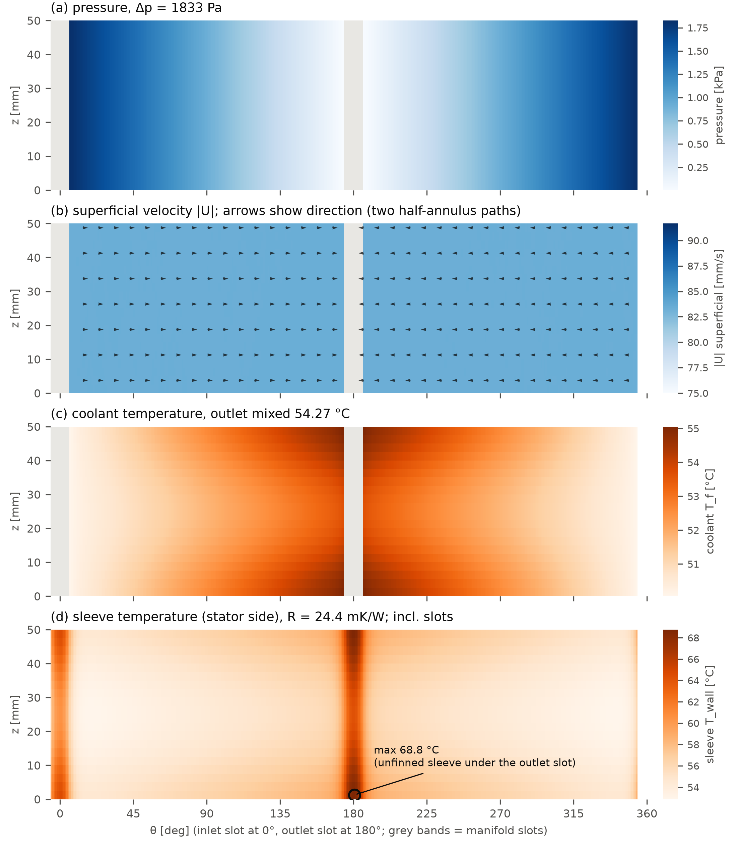
Fig. 8. Homogenized jacket model for the uniform gyroid reference (ρ* = 0.35, L = 4 mm, 3 L/min, Q = 770 W) on the unwrapped jacket: (a) pressure, (b) superficial velocity, (c) coolant temperature, (d) stator-side sleeve temperature. Grey bands = manifold slots; the hottest point (circle) lies on the unfinned sleeve under the outlet slot.
Table 6. Sensitivity of the reference gyroid to model assumptions (change of R and Δp at 3 L/min).
Case | ΔR | Δ(Δp)
no finite-gap correction | −0.1% | −6.7%
Nu variant 2 of [12] (low-h bound) | +5.1% | 0
Pr exponent 0.4 instead of 1/3 | −3.1% | 0
C_{F} plateau beyond φ = 0.6 | −0.1% | +0.6%
isothermal lattice (perfect fin) | −16% | 0
no direct convection from exposed sleeve | +8.0% | 0
h_{m} = 1000 W m⁻² K⁻¹ (default 180) | −12% | 0
h_{m} = 5000 W m⁻² K⁻¹ | −40% | 0
GP instead of ensemble surrogate | −0.06% | +0.03%
no in-plane lattice conduction | +1.4% | 0

Table 6 ranks the modelling assumptions. The closures inherited from the literature move R by 3–5%, the surrogate choice by less than 0.1%, but the plenum coefficient under the slots moves it by up to 40%. This is the first sign that the manifold layout, not the lattice, will dominate RQ2. The comparisons below therefore treat the manifold layout explicitly and report, besides R, the resistance of the cooled region $R_{active}$, which excludes the sleeve under the slots.

5.4. RQ2: optimized graded lattices against the baselines
Baselines. Table 7 lists the tuned baselines. The helical channel B1 has the lowest resistance of all baselines, 13.3 mK W$​^{−1}$ at 0.287 W: its end-ring manifolds lie outside the heated length, so the whole sleeve is finned, and the Dean flow in the curved channels raises its Nusselt number from 5.0 (straight duct) to 11.6. With the same axial slots as the lattice, the channel jacket B1s is 5% worse than the uniform gyroid B2 in R and 9% worse in $R_{active}$, at lower pump power, and its family saturates: many short parallel channels cannot convert more pressure drop into heat transfer. Density-only grading B3 is 7% (R) and 11% ($R_{active}$) better than B2 at equal pump power. It densifies the lattice toward the outlet slot, where the density reaches its upper bound of 0.50.
Table 7. Tuned baselines at 3 L/min (selection: minimum R with pump power ≤ 0.306 W, manufacturable, margin ≥ 1). R values at 1 / 5 L/min in brackets.
Baseline | Selected design | R [mK/W] | R_{active} [mK/W] | Δp [Pa] | P [W] | Mass [kg]
B1 helical channels (end rings) | w_{c} 1.75 mm, rib 0.75 mm, 20 starts | 13.3 (25.9 / 10.1) | 13.3 | 1720 | 0.287 | 0.333
B1s circumferential channels (slots) | w_{c} 0.90 mm, rib 0.35 mm, 40 channels per path | 25.7 (37.5 / 22.6) | 18.3 | 1088 | 0.181 | 0.319
B2 best uniform gyroid (slots) | ρ* 0.35, L 4 mm | 24.4 (38.1 / 20.7) | 16.8 | 1833 | 0.306 | 0.344
B3 density-only grading (slots) | ρ* 0.25 → 0.50 along each path, L 4 mm | 22.7 (35.9 / 19.3) | 15.0 | 1827 | 0.304 | 0.335

Optimized fronts. Fig. 9 overlays the feasible Pareto fronts of all optimizers with the baseline candidates, and Table 8 compares the best optimized design with the best baseline of each family at equal pump power. With axial slots, the manufacturable optimum at the reference pump power reaches R = 21.92 mK W$​^{−1}$ (P = 0.308 W, mass 0.310 kg). Against baselines that use at most this pump power, this is 14.6% better than the circumferential channels B1s, 10.1% better than the best uniform gyroid B2, 11.1% better than the best uniform diamond and 3.3% better than density-only grading B3, at a 10% lower mass than B2. The advantage over uniform lattices shrinks as more pump power is allowed (−5% at 1 W), where the optimum becomes nearly uniform with every field at a bound. All lattices with axial slots, however, remain about 65% worse than the helical channel B1, whose manifolds leave no unfinned strip.
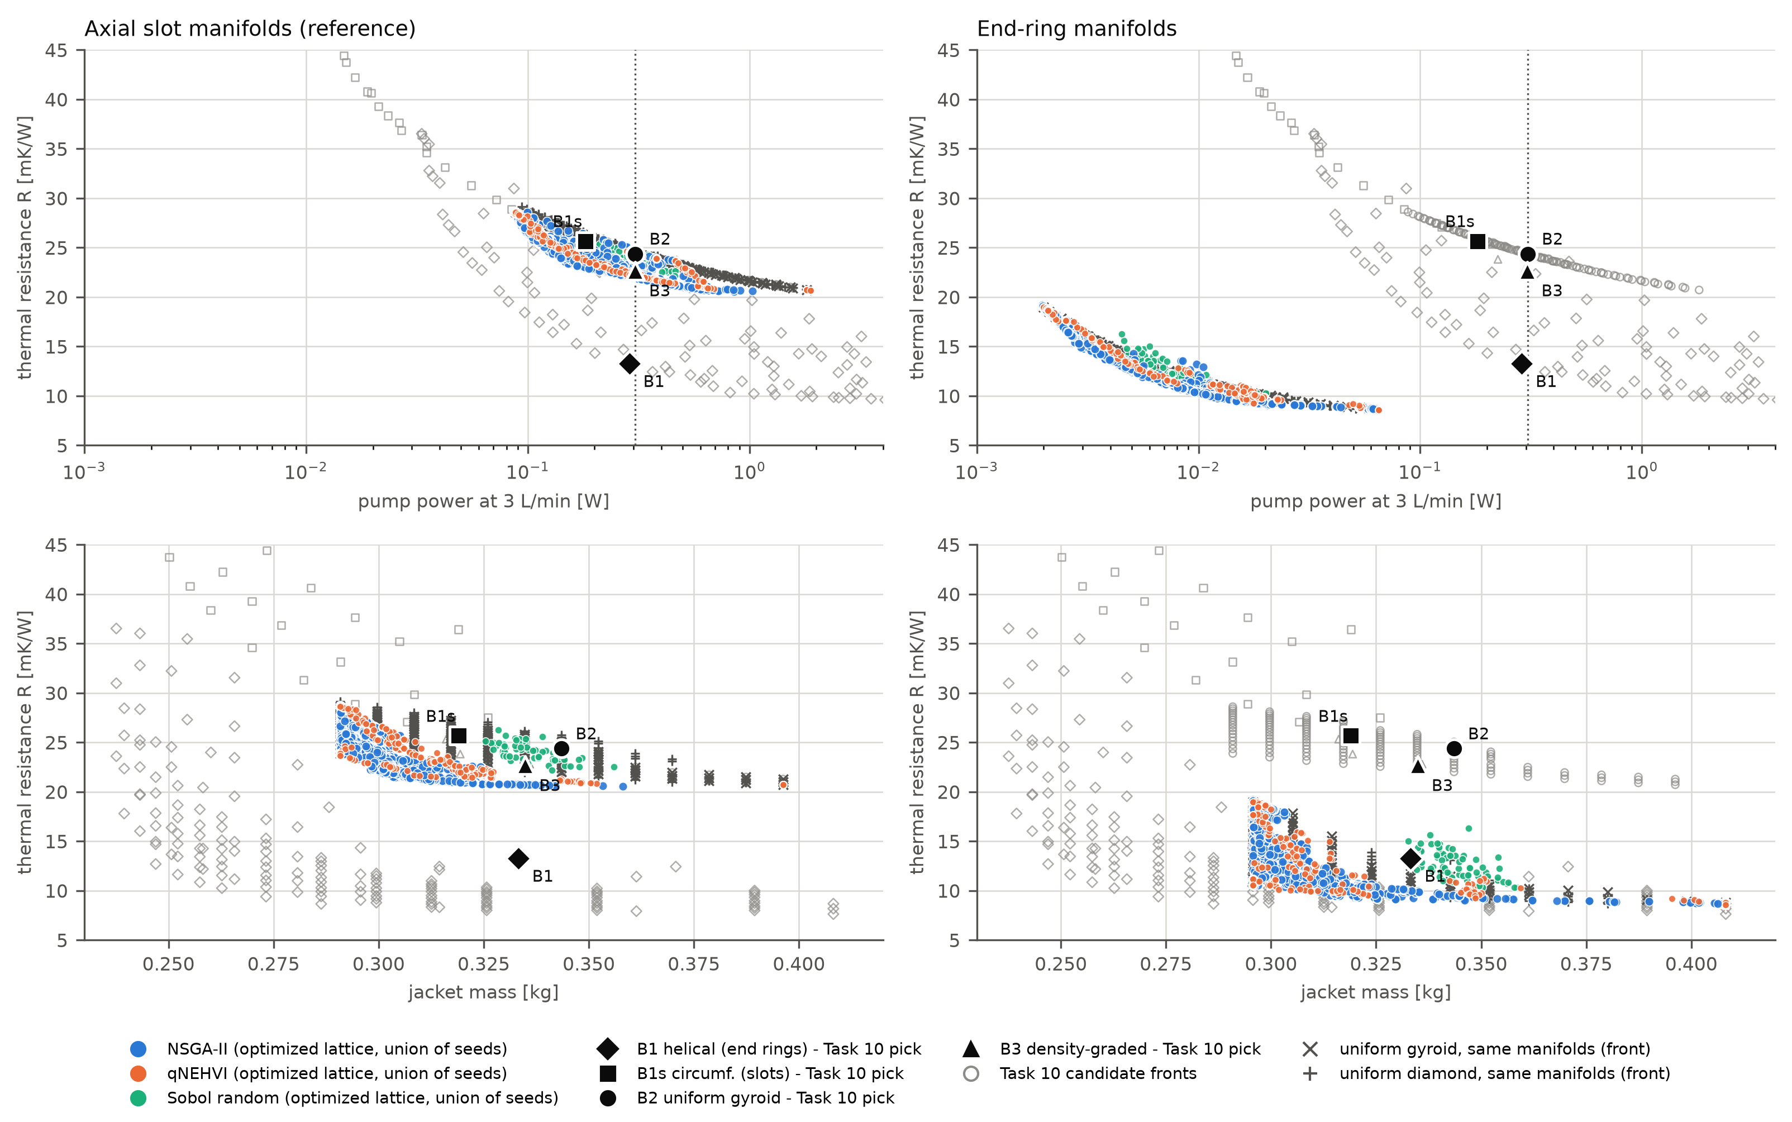
Fig. 9. RQ2: feasible Pareto fronts at 3 L/min of the optimized graded lattices (union of seeds per method) with the tuned baselines, their candidate fronts (open symbols) and uniform gyroid/diamond references on the same manifolds. Top: R against pump power; bottom: R against jacket mass. Left: axial-slot manifolds; right: end-ring manifolds. Dotted line: 0.306 W selection cap.
Table 8. RQ2 at equal pump power (3 L/min): R [mK/W] of the best optimized design and change relative to the best design of each baseline family whose pump power does not exceed that of the optimized design. Slot layout at the reference power uses the manufacturable optimum (pure gyroid, P = 0.308 W); other entries are front designs that satisfy the in-loop manufacturability rule. Negative = optimized design better.
Layout, power cap | Optimized R | vs B1 (helical) | vs B1s (channels, slots) | vs B2 (uniform G) | vs U-D (uniform D) | vs B3 (density-graded)
Slots, 0.10 W | 26.6 | +44.1% | −8.1% | −5.5% | −8.1% | n/a
Slots, 0.308 W | 21.92 | +65.3% | −14.6% | −10.1% | −11.1% | −3.3%
Slots, 1.0 W | 20.6 | +99.1% | −19.8% | −5.0% | −5.2% | −9.2%¹
End rings, 0.01 W | 10.4 | n/a² | n/a | −10.8%³ | −11.1% | n/a
End rings, 0.03 W | 9.04 | n/a² | n/a | −5.0%³ | −4.0% | n/a
End rings, 0.306 W | 8.57⁴ | −35.3% | n/a | −2.7%³ | −0.7% | n/a
End rings, 1.0 W | 8.57⁴ | −17.0% | n/a | −2.7%³ | −0.7% | n/a
¹ B3 was searched only near 0.30 W, so its 0.30 W design is used. ² B1 needs more than 0.08 W. ³ Uniform gyroid with end rings. ⁴ Uniform dense diamond (ρ* 0.50, L 2.2 mm) at 0.065 W, the end-ring optimum for every cap above 0.06 W.
What the grading does. Fig. 10 shows the representative designs with slots. The design at the reference pump power is a gyroid whose density rises from 0.20 near the inlet to 0.41 at the outlet slot, and whose cell size falls from 5.0 mm to 2.2 mm along each path. Coarse, open cells near the inlet spend little pressure; dense, fine cells near the outlet slot, where the coolant is warmest and the unfinned strip must be fed by sleeve conduction, add surface area and solid conductance. Cell-size grading is the lever that density-only grading B3 lacks; it explains most of the 3.3% gain over B3 and the larger gains in $R_{active}$ (14.4 vs 15.0 mK W$​^{−1}$). The structural margin is at least 8.7 for every representative design, so the structural constraint is never active at the reference loads; it would bind only for low-density blends or much higher loads.
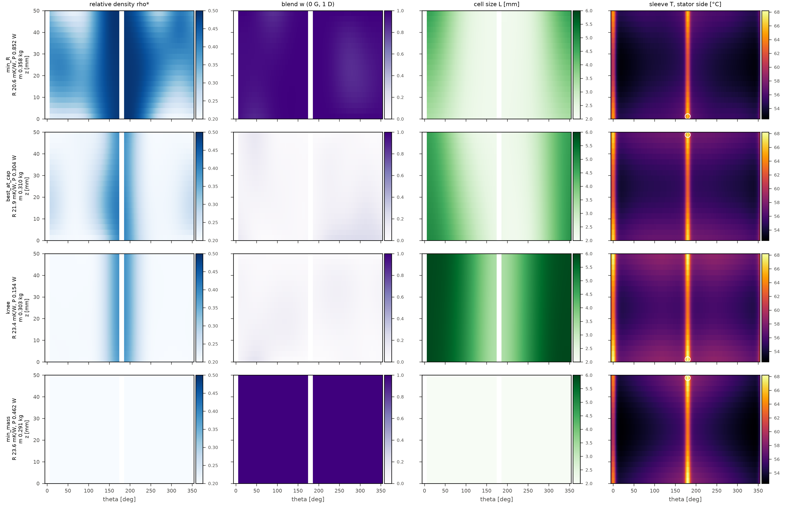
Fig. 10. Representative slot-manifold designs from the combined front: minimum R, best at the 0.306 W cap, knee and minimum mass (rows); relative density, blend weight w (0 = gyroid, 1 = diamond), cell size L and stator-side sleeve temperature (columns) on the unwrapped jacket; circle = hottest point. The best-at-cap design shown carries small blend weights (w ≤ 0.24); its manufacturable version used in this paper has w ≡ 0 with identical density and cell-size fields (Section 5.6).
The role of morphology blending. Under the strict minimum-wall criterion, gyroid–diamond transitions must cross the pinch-neck valleys of Section 4.1, where the minimum wall vanishes. Manufacturable designs are therefore near-pure gyroid or near-pure diamond with graded density and cell size; both families appear on the fronts (near-diamond at minimum R, near-gyroid in the trade-off region), but not as graded mixtures. Grading the morphology in the sense of a continuous blend is thus not useful for this jacket under strict-wall manufacturability. A relaxed criterion that checks only load-path necks would reopen the blends; we leave this to a sensitivity study, since the blends are also structurally weak (Section 5.1).
Manifolds dominate. With end-ring manifolds, the same optimization reaches R = 8.57 mK W$​^{−1}$ at only 0.065 W, 35.3% better than the tuned helical channel B1 at its 0.287 W (and 53.5% better at a 0.1 W cap). Here the optimum above about 0.06 W is a uniform dense diamond, and grading pays only at very low pump power (−4 to −11% relative to uniform lattices at ≤ 0.03 W, where the knee design is a light gyroid with coarse cells at the inlet ring and fine cells at the outlet ring). The answer to RQ2 is therefore two-sided. Under identical constraints and manifolds, grading density and cell size beats every baseline at equal pump power, by 3–15% depending on the baseline. The choice of manifolds changes R by a factor of 2.6, far more than any lattice grading.

5.5. RQ3: sample efficiency of the optimizers
Fig. 11 and Table 9 compare the hypervolume reached by the three methods. On both layouts qNEHVI pulls ahead after 30–40 evaluations and reaches a median hypervolume at 200 evaluations that NSGA-II needs a median of 1368 evaluations to match. Bayesian optimization is therefore about seven times more sample-efficient. Sobol search never reaches it within 1000 evaluations. With its full budget of 10 000 evaluations NSGA-II eventually exceeds qNEHVI's 200-evaluation result (0.209 vs 0.200 with slots, 0.688 vs 0.675 with end rings). The seed-to-seed variation is small (interquartile range ≤ 0.003).
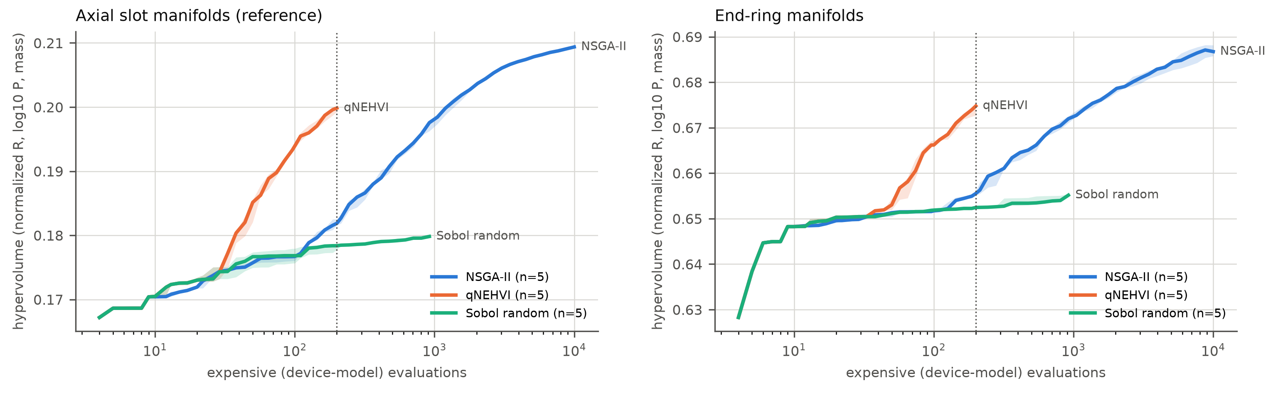
Fig. 11. RQ3: normalized hypervolume against the number of device-model evaluations (median and interquartile range over five seeds) for NSGA-II, qNEHVI and Sobol search with axial-slot (left) and end-ring (right) manifolds; the dotted line marks the 200-evaluation qNEHVI budget.
Table 9. Hypervolume (median over five seeds) after 50, 100 and 200 evaluations and at the final budget; last column: evaluations NSGA-II needs to match qNEHVI at 200.
Layout / method | HV at 50 | HV at 100 | HV at 200 | Final HV | Final budget | Evaluations to match qNEHVI@200
Slots / NSGA-II | 0.1757 | 0.1767 | 0.1819 | 0.2093 | 10 000 | 1368
Slots / qNEHVI | 0.1851 | 0.1939 | 0.1998 | 0.1998 | 200 | 200
Slots / Sobol | 0.1767 | 0.1768 | 0.1784 | 0.1798 | 1000 | not reached
End rings / NSGA-II | 0.6513 | 0.6517 | 0.6555 | 0.6875 | 10 000 | 1368
End rings / qNEHVI | 0.6530 | 0.6662 | 0.6748 | 0.6748 | 200 | 200
End rings / Sobol | 0.6511 | 0.6519 | 0.6525 | 0.6552 | 1000 | not reached

Wall-clock time tells the opposite story. A 200-evaluation qNEHVI run took 1660–3780 s on a four-core machine, 90–95% of it in GP fitting and acquisition over 72 dimensions, whereas NSGA-II reaches the same hypervolume in about 1368 × (0.65–0.85) s ≈ 15–20 min. With a model that costs under one second, the evolutionary algorithm is faster in practice; Bayesian optimization pays off once one evaluation costs more than roughly 10–20 s, as for a three-dimensional conjugate CFD or FE model of the jacket. The anchors matter for every method: without the nine uniform anchor designs, all fronts missed the dense-diamond corner, where a uniform diamond beat them by 5–8% (end rings), and the median slot hypervolume fell to 0.154 (NSGA-II after 2000 evaluations) and 0.196 (qNEHVI after 200). The repair and the anchors are therefore part of the method, not tuning details, and they are applied identically to every optimizer.

5.6. Manufacturable optimum and exported geometry
The direct voxel check of the exported geometry changed one result. The optimizer's best design at the reference pump power carried small blend weights (w ≤ 0.24). In a 30° sector at 0.06 mm it showed 0.28–0.31 mm necks, below the 0.35 mm limit, in the first cell next to the end cap. The cause was twofold: the n = 48 wall table over-reads the strict minimum wall of this blend by about 6% (6–12% for the diamond, from an n = 96 check), more than the 1% margin of the cell-size rule, and near the axial ends the conformal phase field compresses cells circumferentially by 3% and tilts them by up to 9°. Setting w ≡ 0 with unchanged density and cell-size fields gives R = 21.92 mK W$​^{−1}$ (−0.09%), P = 0.308 W (+1.2%), the same mass and a margin of 9.8. This pure-gyroid design passes every check and is the optimum reported in Table 8.
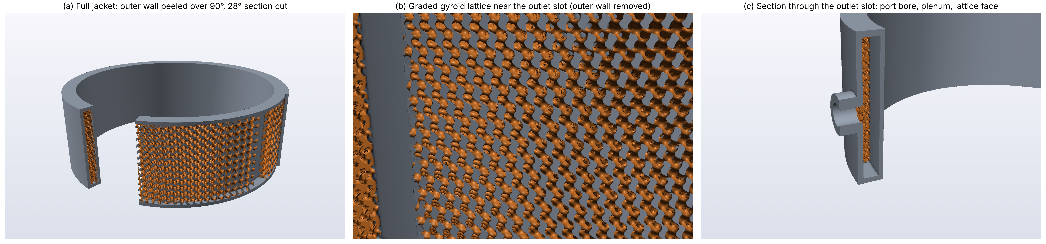
Fig. 12. The exported manufacturable optimum (graded gyroid, slot manifolds), ray-traced from the signed-distance field that the PicoGK geometry reproduces voxel by voxel: (a) full jacket with the outer wall removed over 90°, (b) graded lattice near the outlet slot, (c) section through the outlet slot with port bore and plenum.
Table 10. Manufacturability checks of the exported optimum (PicoGK geometry, laptop build; sector checks on its central 23° to fit in memory).
Check | 30° sector, 0.05 mm | Full jacket, 0.2 mm
Minimum wall (≥ 0.35 mm) | 0.482 mm | not resolved
Pore throat (≥ 0.8 mm) | 1.07 mm | 1.22 mm
Fluid connected port to port | yes | yes
Trapped pockets / loose solid | 0 / 0 | 0 / 0 (resolved)
Volume fraction vs design ρ* | −0.07% | n/a
IoU with numpy specification | 0.997 | n/a
Triangles; build time | 20.3 M; 859 s | 15.0 M; 144 s

Fig. 12 and Table 10 summarize the export. The PicoGK voxel mask of the sector agrees with the independent numpy specification at an intersection-over-union of 0.997 (volume +0.32%), its lattice volume fraction matches the design density to 0.07%, the minimum wall is 0.482 mm and the narrowest pore throat 1.07 mm. The full jacket at 0.2 mm is connected from inlet port to outlet port with a 1.22 mm throat and no resolved trapped pocket. Its solid volume of 136 cm³ (0.364 kg) equals the device-model mass of 0.310 kg plus the end caps and port bosses added at export. A conformal phase field has a single winding number around the circumference, so designs whose cells-around count varies along z must stretch their cells circumferentially (0.95–1.06 for the slot designs, 0.72–1.46 for the end-ring knee). Limiting the axial variation of $∮r_{m}/L dθ$ in the optimization would remove this distortion.

6. LIMITATIONS
The conclusions above are bounded by the following limitations, in decreasing order of importance.
• No experiment and no pore-resolved conjugate simulation of the jacket. Every solver is verified against exact or published solutions (Table 3, Fig. 4), and our permeabilities agree with independent body-fitted CFD to within 2% [11]. Verification is not validation [57], however: the device-level thermal resistances and pressure drops are predictions of a homogenized model whose closures and assumptions have not been tested together against a measurement. The relative rankings in RQ2 are more robust than the absolute values, because all lattices share the same closures. Even so, the comparison with the channel baselines B1 and B1s rests on duct correlations, while the lattices rest on porous-media closures; B1's advantage in particular depends on a coil correlation for circular tubes applied to a 1.75 mm × 6 mm rectangle (removing the Dean enhancement raises its R by 49%). The natural next step is a pore-resolved conjugate simulation of a 30° sector of the exported geometry, followed by a flow-loop test of a printed jacket.
• Creeping-flow permeability and the finite-gap correction. $K$ and the finite-gap factor are Stokes (Re → 0) results. In the jacket, inertia carries 16–84% of the pressure drop. We apply the finite-gap correction to the Darcy term only and use the bulk permeability inside the inertial term; whether the wall layer also changes the inertial coefficient is unknown. The correction was fitted at n = 32 (stiffness discrepancies carry about ±1.5 pp at N = 1), for perfectly bonded flat walls and for ρ* = 0.25–0.45 and $a_{z}$ = 0.75–1.5.
• Empirical Nusselt and Forchheimer closures. The inertial coefficient comes from pore-scale simulations of skeletal gyroid and diamond cells fitted for porosities of 0.3–0.6 and $Re_{D_{h}}≤100$ [11]. Our jacket operates at porosities of 0.5–0.8 and $Re_{D_{h}}$ ≈ 25–580, so pump-power predictions inherit this extrapolation; for the diamond above ϕ = 0.6, plausible values of $C_{F}$ differ by up to a factor of two. The interstitial heat-transfer coefficient follows the modified Reynolds analogy of Savoldi et al. [12], calibrated for the gyroid at Pr = 1, ϕ ≤ 0.7 and $Re_{D_{h}}$ = 20–100. We extend it to the water–glycol coolant (Pr ≈ 21) with the Chilton–Colburn factor $Pr^{1/3}$, and to the diamond and the blends through their own friction factors. An exponent of 0.4 would raise $h_{sf}$ by 22%, and the alternative variant of the analogy lowers it by up to 22% inside its fitted range. Both closures come from one research group and one CFD set-up. Removing these assumptions requires experiments or conjugate pore-resolved simulations at the operating Prandtl number.
• Manifolds. The slot plenums are well mixed with a laminar plate-channel coefficient $h_{m}$, to which R is very sensitive (−12% at 1000 and −40% at 5000 W m$​^{−2}$ K$​^{−1}$). The end-ring layout and B1 both assume ideal ring manifolds outside the heated length with no port losses; since the lattice pressure drop with end rings is only 40–400 Pa, real ring and port losses would be a larger fraction of its pump power than of B1's.
• Structure and printing. The structural check is a rigid-face sandwich with bulk 99th-percentile localization factors and linear superposition; it ignores fatigue notch effects at the as-built surface, residual stresses and the finite-gap change of localization. Surface roughness, porosity and the geometric deviations of laser powder-bed fusion are not modelled; they are known to raise the friction factor of printed gyroids [12]. The strict minimum-wall rule excludes graded gyroid–diamond blends, and the surrogates are least accurate in the pinch-neck region (about 10% stiffness error).
• Scope. One motor, one gap height, one coolant and one material were studied. The finite-gap coefficients are dimensionless and should transfer to other gaps with the same N, but the device-level gains are specific to this reference problem.

7. CONCLUSIONS
We built and verified an open-source, laptop-scale pipeline that computes TPMS lattice closures on periodic voxel cells, corrects them for the finite number of cells across a bounded gap, and uses them to optimize a graded liquid-cooling jacket for a 15 kW electric motor. The main conclusions are:
1. Finite-gap error (RQ1). With one to three cells across the gap, bulk closures over-predict the in-plane permeability of gyroid and diamond lattices by 7–40%. The deficit is proportional to 1/N, nearly independent of density and cut phase, and caused by a stagnant layer of about 0.10–0.13 L at each bonded wall, not by near-wall channelling. The correction $K_{t}=K_{bulk}\left(1−a_{K}/N\right)$ with $a_{K}≈0.27$ (gyroid) and 0.20 (diamond) reduces the cross-validated error from 12.9 to 0.4 pp, the cut-phase noise floor; a Gaussian process on the residuals adds nothing. The through-gap conductivity changes by at most 2.3%, and the bonded walls stiffen the core. A density change of 0.05 per cell keeps the local-closure error below 1%.
2. Graded designs versus baselines (RQ2). Under identical constraints and manifolds, grading density and cell size lowers the thermal resistance at equal pump power by 14.6% relative to circumferential channels, 10.1% relative to the best uniform gyroid, 11.1% relative to the best uniform diamond and 3.3% relative to density-only grading, at 10% less mass than the uniform gyroid. The optimizer densifies and refines the lattice toward the outlet slot. Continuous gyroid–diamond blending is not useful under strict-wall manufacturability because blends develop pinch-point necks.
3. Manifolds dominate. Replacing the axial slots by end rings lowers the thermal resistance by a factor of 2.6 and turns a 65% deficit relative to a tuned helical channel into a 35% advantage at less than a quarter of its pump power. For lattice jackets, the manifold layout should be designed first.
4. Optimizers (RQ3). Batch Bayesian optimization (qNEHVI) reaches in 200 evaluations the hypervolume that NSGA-II needs about 1370 evaluations for, a sevenfold gain in sample efficiency, while NSGA-II is faster in wall-clock time for a sub-second model. Bayesian optimization should be preferred once one evaluation costs more than roughly 10–20 s. A feasibility repair and a common set of uniform anchors are essential for every method.
5. Manufacturability. A direct voxel check of the exported geometry caught a minimum-wall violation that the tabulated cell-size rule had missed; the corrected, pure-gyroid optimum passes all wall, throat, connectivity and pocket checks and loses only 0.09% in R.
Future work should validate the device model with a pore-resolved conjugate simulation of a jacket sector and a flow-loop experiment on a printed part, extend the finite-gap study to the inertial and heat-transfer closures, and add the manifold geometry to the design variables.

DATA AND CODE AVAILABILITY
The VoxLat source code (Python package, C# exporter, tests and one script per figure and table), the closure dataset, the trained surrogate models, the finite-gap data, the optimization archives and the design files are openly available at https://github.com/zain4366/voxlat under the MIT licence. The script scripts/experiments/run_all.py regenerates every figure and table of this paper from the committed data in about ten minutes (replot mode) and runs every producer at reduced size (quick mode). An archived release with a DOI will be deposited on Zenodo upon acceptance [DOI to be added].

SUPPLEMENTARY MATERIAL
The supplementary figure gallery (Figs. S1–S40, Tables S1–S9) contains every figure and table produced by the pipeline with captions, including the geometry metrics and feasible region (S3–S5), conductivity and stiffness against density (S6–S11), the closure dataset and surrogate parity and calibration plots (S15–S19), the discrepancy-model cross-validation and graded strips (S21–S24), the literature closures (S25–S26, Table S4), the baseline fronts (S30–S32) and the export checks (S38–S40, Table S9).

DECLARATION OF COMPETING INTEREST
The authors declare that they have no known competing financial interests or personal relationships that could have appeared to influence the work reported in this paper.

REFERENCES
[1] van Heerden ASJ, Judt DM, Jafari S, Lawson CP, Nikolaidis T, Bosak D. Aircraft thermal management: practices, technology, system architectures, future challenges, and opportunities. Progress in Aerospace Sciences. 2022;128:100767. https://doi.org/10.1016/j.paerosci.2021.100767.
[2] Gai Y, Kimiabeigi M, Chong YC, Widmer JD, Deng X, Popescu M, Goss J, Staton DA, Steven A. Cooling of automotive traction motors: schemes, examples, and computation methods. IEEE Transactions on Industrial Electronics. 2019;66(3):1681-1692. https://doi.org/10.1109/TIE.2018.2835397.
[3] Al-Ketan O, Abu Al-Rub RK. Multifunctional mechanical metamaterials based on triply periodic minimal surface lattices. Advanced Engineering Materials. 2019;21(10):1900524. https://doi.org/10.1002/adem.201900524.
[4] Al-Ketan O, Rowshan R, Abu Al-Rub RK. Topology-mechanical property relationship of 3D printed strut, skeletal, and sheet based periodic metallic cellular materials. Additive Manufacturing. 2018;19:167-183. https://doi.org/10.1016/j.addma.2017.12.006.
[5] Brambati G, Guilizzoni M, Foletti S. Convective heat transfer correlations for triply periodic minimal surfaces based heat exchangers. Applied Thermal Engineering. 2024;242:122492. https://doi.org/10.1016/j.applthermaleng.2024.122492.
[6] You H, Lee S, Baek C, Han C, Kim Y. Enhancement of heat transfer in cooling channels for electronic devices using multi-directional graded triply periodic minimal surfaces (TPMS). International Communications in Heat and Mass Transfer. 2024;159:108278. https://doi.org/10.1016/j.icheatmasstransfer.2024.108278.
[7] Hassanirad A, Kwasi-Effah CC, Ibhadode O. Performance evaluation of architected multi-morphological TPMS structures for liquid-cooled heat sinks. International Journal of Heat and Mass Transfer. 2027;272:129515. https://doi.org/10.1016/j.ijheatmasstransfer.2026.129515.
[8] Ma Y, Zhao Q, Du D, Li W. Thermal-hydraulic characteristics of liquid-cooled heat sinks with TPMS structures in serpentine and parallel channels. International Journal of Heat and Mass Transfer. 2026;265:128807. https://doi.org/10.1016/j.ijheatmasstransfer.2026.128807.
[9] Hassan SU, Shah MH, Gruber P, Chomat M. Triply periodic minimal surfaces structure for efficient heat dissipation in motor housings: a convective potential analysis. In: 2024 International Conference on Electrical Machines (ICEM); 2024. https://doi.org/10.1109/ICEM60801.2024.10700091.
[10] Kawabe H, Ohtani K, Yang Y, Al Ali M, Yaji K. Distortion-minimized de-homogenization for optimization of cell-size distribution in TPMS structures. arXiv:2605.06011 [preprint]; 2026. https://doi.org/10.48550/arXiv.2605.06011.
[11] Gajetti E, Boccardo G, Savoldi L, Marocco L. Hydrodynamic characterization of Gyroid, Diamond and Split-P triply periodic minimal surfaces as porous medium. International Journal of Heat and Mass Transfer. 2025;252:127439. https://doi.org/10.1016/j.ijheatmasstransfer.2025.127439.
[12] Savoldi L, Cammi A, Gajetti E, Marocco L. A modified Reynolds analogy for the Gyroid TPMS in laminar flow: thermal-hydraulic correlations, numerical validation and multi-objective optimisation. International Journal of Heat and Fluid Flow. 2026;121:110631. https://doi.org/10.1016/j.ijheatfluidflow.2026.110631.
[13] Modrek M, Viswanath A, Khan KA, Ali MIH, Abu Al-Rub RK. An optimization case study to design additively manufacturable porous heat sinks based on triply periodic minimal surface (TPMS) lattices. Case Studies in Thermal Engineering. 2022;36:102161. https://doi.org/10.1016/j.csite.2022.102161.
[14] Ohtani K, Kawabe H, Yaji K, Fujita K, Aute V. Homogenization-based optimization of wall thickness distribution for TPMS two-fluid heat exchangers. arXiv:2510.10622 [preprint]; 2025. https://doi.org/10.48550/arXiv.2510.10622.
[15] Whitaker S. Flow in porous media I: a theoretical derivation of Darcy's law. Transport in Porous Media. 1986;1(1):3-25. https://doi.org/10.1007/BF01036523.
[16] Sanchez-Palencia E. Non-homogeneous media and vibration theory. Lecture Notes in Physics 127. Berlin: Springer; 1980.
[17] Benenati RF, Brosilow CB. Void fraction distribution in beds of spheres. AIChE Journal. 1962;8(3):359-361. https://doi.org/10.1002/aic.690080319.
[18] Onck PR, Andrews EW, Gibson LJ. Size effects in ductile cellular solids. Part I: modeling. International Journal of Mechanical Sciences. 2001;43(3):681-699.
[19] Rathore SS, Mehta B, Kumar P, Asfer M. Flow characterization in triply periodic minimal surface (TPMS)-based porous geometries: Part 1 - hydrodynamics. Transport in Porous Media. 2023;146:669-701. https://doi.org/10.1007/s11242-022-01880-7.
[20] Piandoro S, Azzini F, Francioso M, Zha D, Liverani E, Pulvirenti B, Fortunato A. Laser 3D-printed periodic porous structures for heat exchangers: a novel characterization approach under fully developed conditions. Lasers in Manufacturing and Materials Processing. 2026;13:555-581. https://doi.org/10.1007/s40516-026-00347-7.
[21] Al-Safadi M, Ejaz F, Shuja SZ, Zubair SM. Quantitative synthesis and correlations of heat transfer and friction factor in TPMS structures. Results in Engineering. 2026;29:109402. https://doi.org/10.1016/j.rineng.2026.109402.
[22] Andreassen E, Andreasen CS. How to determine composite material properties using numerical homogenization. Computational Materials Science. 2014;83:488-495. https://doi.org/10.1016/j.commatsci.2013.09.006.
[23] Brinkman HC. A calculation of the viscous force exerted by a flowing fluid on a dense swarm of particles. Applied Scientific Research. 1949;A1:27-34. https://doi.org/10.1007/BF02120313.
[24] Neale G, Nader W. Practical significance of Brinkman's extension of Darcy's law: coupled parallel flows within a channel and a bounding porous medium. Canadian Journal of Chemical Engineering. 1974;52(4):475-478. https://doi.org/10.1002/cjce.5450520407.
[25] Li R, Yang S, Qi C, Guo DM. Multi-objective optimization procedure for electric motor water jacket based on surrogate model. Journal of Thermal Analysis and Calorimetry. 2026;151:1373-1392. https://doi.org/10.1007/s10973-025-14776-7.
[26] Deb K, Pratap A, Agarwal S, Meyarivan T. A fast and elitist multiobjective genetic algorithm: NSGA-II. IEEE Transactions on Evolutionary Computation. 2002;6(2):182-197. https://doi.org/10.1109/4235.996017.
[27] Blank J, Deb K. pymoo: multi-objective optimization in Python. IEEE Access. 2020;8:89497-89509. https://doi.org/10.1109/ACCESS.2020.2990567.
[28] Emmerich MTM, Giannakoglou KC, Naujoks B. Single- and multiobjective evolutionary optimization assisted by Gaussian random field metamodels. IEEE Transactions on Evolutionary Computation. 2006;10(4):421-439. https://doi.org/10.1109/TEVC.2005.859463.
[29] Daulton S, Balandat M, Bakshy E. Parallel Bayesian optimization of multiple noisy objectives with expected hypervolume improvement. In: Advances in Neural Information Processing Systems 34 (NeurIPS 2021); 2021. p. 2187-2200.
[30] Balandat M, Karrer B, Jiang DR, Daulton S, Letham B, Wilson AG, Bakshy E. BoTorch: a framework for efficient Monte-Carlo Bayesian optimization. In: Advances in Neural Information Processing Systems 33 (NeurIPS 2020); 2020. p. 21524-21538.
[31] von Schnering HG, Nesper R. Nodal surfaces of Fourier series: fundamental invariants of structured matter. Zeitschrift für Physik B Condensed Matter. 1991;83:407-412.
[32] Hildebrand T, Rüegsegger P. A new method for the model-independent assessment of thickness in three-dimensional images. Journal of Microscopy. 1997;185(1):67-75. https://doi.org/10.1046/j.1365-2818.1997.1340694.x.
[33] Schröder-Turk GE, Fogden A, Hyde ST. Bicontinuous geometries and molecular self-assembly: comparison of local curvature and global packing variations in genus-three cubic, tetragonal and rhombohedral surfaces. European Physical Journal B. 2006;54:509-524.
[34] Manwart C, Aaltosalmi U, Koponen A, Hilfer R, Timonen J. Lattice-Boltzmann and finite-difference simulations for the permeability for three-dimensional porous media. Physical Review E. 2002;66:016702. https://doi.org/10.1103/PhysRevE.66.016702.
[35] Silvester D, Wathen A. Fast iterative solution of stabilised Stokes systems. Part II: using general block preconditioners. SIAM Journal on Numerical Analysis. 1994;31(5):1352-1367.
[36] Roache PJ. Quantification of uncertainty in computational fluid dynamics. Annual Review of Fluid Mechanics. 1997;29:123-160. https://doi.org/10.1146/annurev.fluid.29.1.123.
[37] Backus GE. Long-wave elastic anisotropy produced by horizontal layering. Journal of Geophysical Research. 1962;67(11):4427-4440. https://doi.org/10.1029/JZ067i011p04427.
[38] Hashin Z, Shtrikman S. A variational approach to the theory of the effective magnetic permeability of multiphase materials. Journal of Applied Physics. 1962;33(10):3125-3131. https://doi.org/10.1063/1.1728579.
[39] Zick AA, Homsy GM. Stokes flow through periodic arrays of spheres. Journal of Fluid Mechanics. 1982;115:13-26. https://doi.org/10.1017/S0022112082000627.
[40] Rayleigh Lord. On the influence of obstacles arranged in rectangular order upon the properties of a medium. Philosophical Magazine. 1892;34(211):481-502. https://doi.org/10.1080/14786449208620364.
[41] Shah RK, London AL. Laminar flow forced convection in ducts. Advances in Heat Transfer, Supplement 1. New York: Academic Press; 1978.
[42] Sangani AS, Acrivos A. Slow flow through a periodic array of spheres. International Journal of Multiphase Flow. 1982;8(4):343-360. https://doi.org/10.1016/0301-9322(82)90047-7.
[43] Owen AB. Scrambling Sobol' and Niederreiter-Xing points. Journal of Complexity. 1998;14(4):466-489. https://doi.org/10.1006/jcom.1998.0487.
[44] Arsigny V, Fillard P, Pennec X, Ayache N. Log-Euclidean metrics for fast and simple calculus on diffusion tensors. Magnetic Resonance in Medicine. 2006;56(2):411-421. https://doi.org/10.1002/mrm.20965.
[45] Rasmussen CE, Williams CKI. Gaussian processes for machine learning. Cambridge, MA: MIT Press; 2006.
[46] Lakshminarayanan B, Pritzel A, Blundell C. Simple and scalable predictive uncertainty estimation using deep ensembles. In: Advances in Neural Information Processing Systems 30 (NIPS 2017); 2017. p. 6402-6413.
[47] Kuleshov V, Fenner N, Ermon S. Accurate uncertainties for deep learning using calibrated regression. In: Proceedings of the 35th International Conference on Machine Learning (ICML), PMLR 80; 2018. p. 2796-2804.
[48] Vaněk P, Mandel J, Brezina M. Algebraic multigrid by smoothed aggregation for second and fourth order elliptic problems. Computing. 1996;56:179-196. https://doi.org/10.1007/BF02238511.
[49] VDI e.V., editor. VDI Heat Atlas. 2nd ed. Berlin: Springer; 2010. https://doi.org/10.1007/978-3-540-77877-6.
[50] Nield DA, Bejan A. Convection in porous media. 5th ed. Cham: Springer; 2017. https://doi.org/10.1007/978-3-319-49562-0.
[51] Schmidt EF. Wärmeübergang und Druckverlust in Rohrschlangen. Chemie Ingenieur Technik. 1967;39(13):781-789.
[52] Gnielinski V. Heat transfer and pressure drop in helically coiled tubes. In: Proceedings of the 8th International Heat Transfer Conference, Vol. 6. Washington, DC: Hemisphere; 1986. p. 2847-2854.
[53] Ament S, Daulton S, Eriksson D, Balandat M, Bakshy E. Unexpected improvements to expected improvement for Bayesian optimization. In: Advances in Neural Information Processing Systems 36 (NeurIPS 2023); 2023.
[54] LEAP 71. PicoGK: a compact and robust geometry kernel for computational engineering [Internet]. GitHub repository, Apache-2.0 licence; 2023-2026 [cited 2026 Oct 16]. Available from: https://github.com/leap71/PicoGK.
[55] Khaderi SN, Deshpande VS, Fleck NA. The stiffness and strength of the gyroid lattice. International Journal of Solids and Structures. 2014;51(23-24):3866-3877.
[56] Maskery I, Sturm L, Aremu AO, Panesar A, Williams CB, Tuck CJ, Wildman RD, Ashcroft IA, Hague RJM. Insights into the mechanical properties of several triply periodic minimal surface lattice structures made by polymer additive manufacturing. Polymer. 2018;152:62-71. https://doi.org/10.1016/j.polymer.2017.11.049.
[57] Oberkampf WL, Roy CJ. Verification and validation in scientific computing. Cambridge: Cambridge University Press; 2010. https://doi.org/10.1017/CBO9780511760396.

