**Revision History**

|  |  |  |  |
| --- | --- | --- | --- |
| **Date** | **Version** | **Description** | **Author** |
| 25/10/2017 | 1.0 | SRS document includes the Scope of the project,Functional requirements, Non Functional requirements, Use Case Diagrams, Usage Scenarios, Adopted Methodology,Work Plan |  |

**Table Of Contents**

1. Scope (Of the Project)

2. Functional Requirements and Non Functional Requirements

3. Use Case Diagram

4. Usage Scenarios

5. Adopted Methodology

6. Work Plan

1. **Scope**

Events Information Management System (EIMS) is a web application that will allow its users to view, add, and search for the details of events/tours/trips scheduled to be held in future and already held in past as well. User will also be able to subscribe on the website for any latest updates regarding the events.

The application will provide its users with the facilities of searching for an event with different parameters such as

• Dates

• Location (by province or city)

• Charges range

• Number of days

• Type of Event

The user will be provided with the relevant event(s) information according to the search parameters in a properly structured form. User will also be provided with a subscription facility, in which user will provide his/her email address along with other necessary information so that the user may be informed via email whenever a new event is generated or an existing one is updated. The user will also be able to add an event which will be subjected to be approved by the admin. Only after the approval by the admin, the event added by the user will become part of the system.

1. **Functional Requirements**

The EIMS website will have the following menu items (with submenus)

* Home
* Submit Event
  + Tour Event
  + Conference
  + Workshop
* Search Event
  + By Date
  + By Location
  + By Charges
  + By Number Of Days
* Subscribe
* Contact Us
* About Us

The website will have two main modules

* Admin
* User

**Admin:**

The Admin will be able to add event details in a structured form.The event details will include

* Start Date and Time (Including day of the week)
* End Date and Time (Including day of the week)
* Venue
* Participation Charges (Per Person)
* Relevant Images
* Daywise Details (Pick up time, First destination, Stay and then leaving for 2nd destination etc).
* Services included (Breakfast, Lunch or Dinner etc)

The Admin will also be able to modify or remove any event information from the application’s database.The admin will also have the privilege to grant or revoke subscription of any user.The admin will also be able to approve or reject an event added by the user.

**User:**

The User will able to perform following tasks:

* User will be able to view all the information available on the website
* User will be able to search the information for events with different parameters
* User will be able to add an event
* User will be able to subscribe for the events and updates

1. **Non Functional Requirements**

The website should have the following non functional requirements

**Website Theme:**

The website should not have very bright background colors and images.Color scheme should be compatible and text should be clearly visible.

**Performance:**

The time taken by application to search for an event should be very fast and results should be visible in few seconds.The loading time of website should also be very fast.

**Availability:**

The website will be free for its subscribers.

**Portability:**

The website should be able to work fluidly on any operating system (windows/pac) with any internet browser.

**User Friendly:**

The website should be able to work on any device such as mobiles, tablets and desktops.The layout of website should align properly according to the device on which it is running.

1. **Use Case Diagrams**

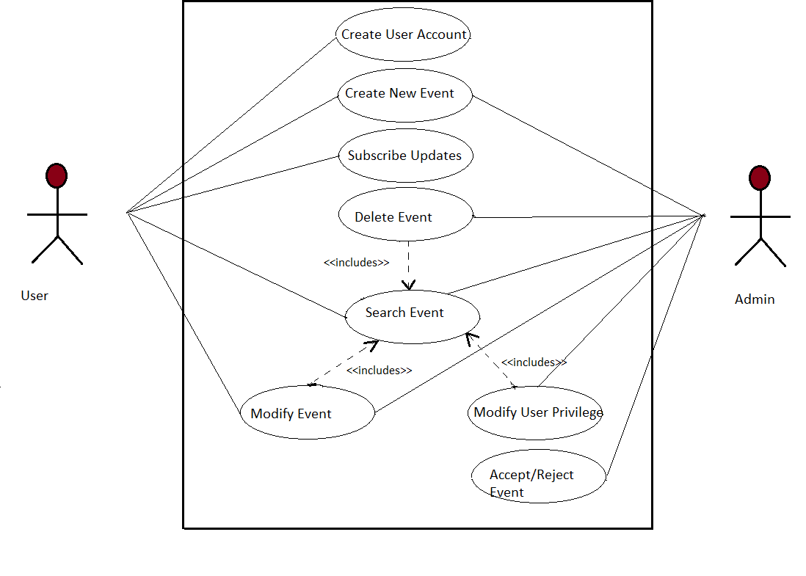

1. **Usage Scenarios**

|  |  |  |
| --- | --- | --- |
| **Use Case Title** | **Search Event** | |
| **Use Case Id** | 1 | |
| **Requirement ID** | 1 | |
| **Description:** This use case is about searching for an event using the Search Form | | |
| **Pre-Conditions**:   1. The website and its database should be online and working properly. 2. The user must provide all the related parameters for searching the event | | |
| **Task Sequence:** | | **Exceptions** |
| 1. The user will login the application 2. The user will goto the Search Event Form and fill the parameters. 3. The system will check the search parameters.If some search parameter is missing or wrong ,then application will inform user about it. 4. The search results will be returned to the user in a table form. | |  |
| **Post Conditions:**  If results are found according to the search criteria ,then results are shown.If there is no event found for the search criteria, then no events will be visible. | | |
| **Unresolved Issues:** | | |
| **Authority:** | | |
| **Modification History: 1.0**  **Author: mc150200943** | | |

|  |  |  |
| --- | --- | --- |
| **Use Case Title** | **Create User Account** | |
| **Use Case Id** | 1 | |
| **Requirement ID** | 1 | |
| **Description:** This use case is about creating a new user account | | |
| **Pre-Conditions**:   1. The website and its database should be online and working properly. 2. The user must provide all the related information for creating the account | | |
| **Task Sequence:** | | **Exceptions** |
| 1. The user will request for creation of new account 2. The application will display a form with all the required parameters like name,age,city,email ,password etc 3. The user will fill all the mandatory parameters. 4. The system will validate the mandatory parameters and display error if some parmater is entered wrong or missing 5. The system will create an account | |  |
| **Post Conditions:**  The user profile will be created. | | |
| **Unresolved Issues:** | | |
| **Authority:** | | |
| **Modification History: 1.0**  **Author: mc150200943** | | |

|  |  |  |
| --- | --- | --- |
| **Use Case Title** | **Create New Event** | |
| **Use Case Id** | 1 | |
| **Requirement ID** | 1 | |
| **Description:** This use case is about creating a new event by the user | | |
| **Pre-Conditions**:   1. The website and its database should be online and working properly. 2. The user must provide all the related information for creating the event. | | |
| **Task Sequence:** | | **Exceptions** |
| 1. The user will login the application 2. The user will request for creation of new event 3. The application will display a form with all the required parameters like date,venue,charges etc 4. The user will fill all the mandatory parameters. 5. The system will validate the mandatory parameters and display error if some paramater is entered wrong or missing 6. The system will create an event | |  |
| **Post Conditions:**  The event will be created. | | |
| **Unresolved Issues:** | | |
| **Authority:** | | |
| **Modification History: 1.0**  **Author: mc150200943** | | |

|  |  |  |
| --- | --- | --- |
| **Use Case Title** | **Subscribe for Updates** | |
| **Use Case Id** | 1 | |
| **Requirement ID** | 1 | |
| **Description:** This use case is about subscribing for latest updates from EIMS application | | |
| **Pre-Conditions**:   1. The website and its database should be online and working properly. | | |
| **Task Sequence:** | | **Exceptions** |
| 1. The user will login the application. 2. The user will request for subscribing the latest updates by entering the email. 3. The system will send an acknowledgment email to user | |  |
| **Post Conditions:**  The user profile will be updated to show that user has subscribed for latest updates. | | |
| **Unresolved Issues:** | | |
| **Authority:** | | |
| **Modification History: 1.0**  **Author: mc150200943** | | |

|  |  |  |
| --- | --- | --- |
| **Use Case Title** | **Modify Event** | |
| **Use Case Id** | 1 | |
| **Requirement ID** | 1 | |
| **Description:** This use case is about modifying the existing event by the user | | |
| **Pre-Conditions**:   1. The website and its database should be online and working properly. 2. The user must provide all the related information for modifying the event. | | |
| **Task Sequence:** | | **Exceptions** |
| 1. The user will login the application. 2. The user will select his event and request for modification 3. The system will display a form with event details . 4. The user will modify the event and submit 5. The system will validate the mandatory parameters and accept the event | |  |
| **Post Conditions:**  The event will be updated and visible in the application | | |
| **Unresolved Issues:** | | |
| **Authority:** | | |
| **Modification History: 1.0**  **Author: mc150200943** | | |

|  |  |  |
| --- | --- | --- |
| **Use Case Title** | **Delete Event** | |
| **Use Case Id** | 1 | |
| **Requirement ID** | 1 | |
| **Description:** This use case is about deleting the existing event by the user | | |
| **Pre-Conditions**:   1. The website and its database should be online and working properly. 2. The admin must provide all the related information for deleting the event. | | |
| **Task Sequence:** | | **Exceptions** |
| 1. The admin will login the application.   1. The admin will select event and request for deletion 2. The system will display a confirmation box. 3. The admin will confirm the event and submit 4. The system will delete the event from its database | |  |
| **Post Conditions:**  The event will be not be visible in the application. | | |
| **Unresolved Issues:** | | |
| **Authority:** | | |
| **Modification History: 1.0**  **Author: mc150200943** | | |

1. **Adopted Methodology**

**VU Model:**

The waterfall model is a sequential design process, used in software development processes, in which progress is seen as flowing steadily downwards (like a waterfall) through the phases of Conception, Initiation, Analysis, Design, Construction, Testing, Production/Implementation and maintenance.

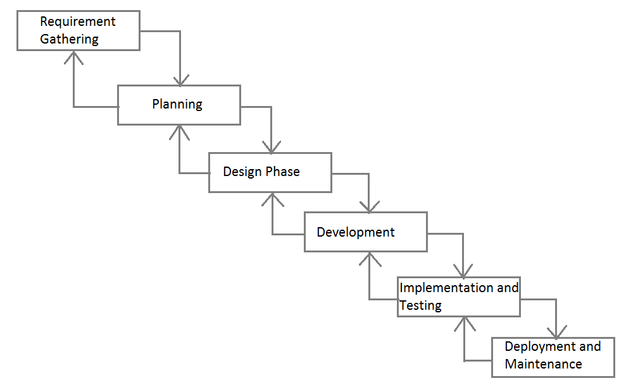

1. **Work Plan**