**ADVANCED PROGRAMMING**

**ASSIGNMENT 1**

**DOCUMENTATION**

A quiz app has been created which can be used by students and teachers.

Teachers can login and create quiz for students.

Students can login and solve the quiz.

**HOW TO RUN THE APP**

Open the file named ‘main’

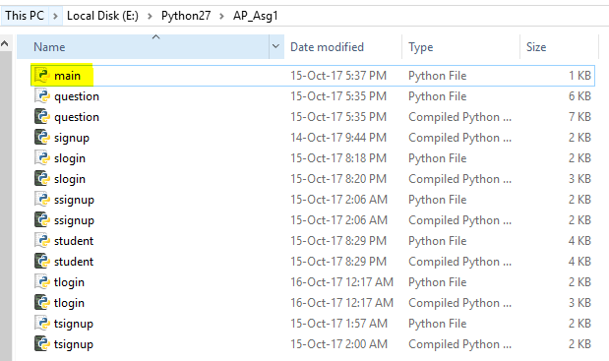

**DOCUMENTATION FOR TEACHER**

Main screen

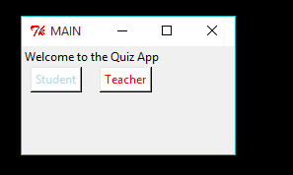

Select ***teacher***if you are a teacher.

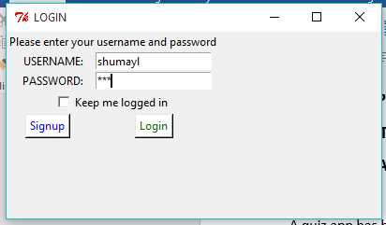

Press ***login*** if you have an account or press ***signup*** if you don’t.

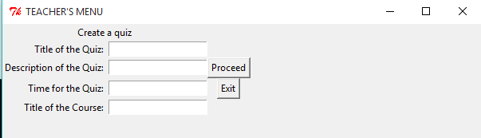

Then you are asked to enter the above details. Press ***proceed.***

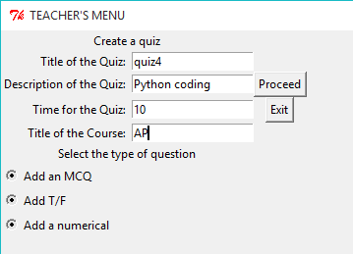

The select any one ***type*** of question.

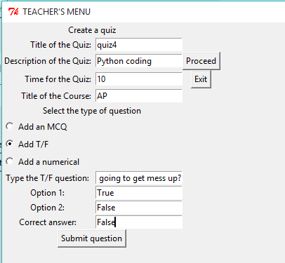

After entering details, press ***Submit*** *button.*

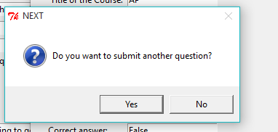

You will be asked if you want to ***submit the next question***. If ***yes***, then you will be redirected to the ***teacher’s menu*** window. Otherwise, you will be asked if you want to ***create a separate quiz***.

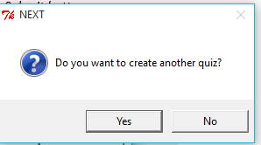

If ***yes***, then you will be redirected to the ***teacher’s menu***. Otherwise, you will be able to ***quit the app***.

**DOCUMENTATION FOR STUDENT**

Main screen

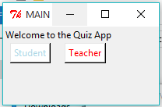

Press ***student*** if you are a student.

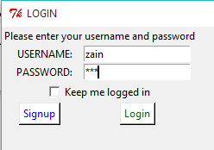

Press ***login*** if you have account or press ***signup*** if you don’t.

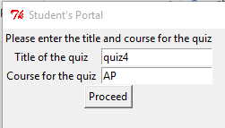

Type in the ***details*** given to you by your teacher. On giving the correct ***details***, you will be given ***access to the quiz***.

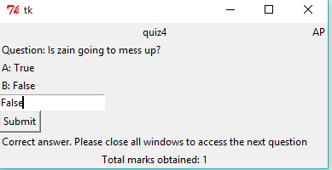

Give the answer and press ***submit***. If the answer is correct, it will tell you. Your ***marks*** will also be showed.