RESTAURANT & ROOM BOOKING SYSTEM
Software Requirements Specification (SRS)
August 2026
Document Control
Prepared For | Client
Prepared By | Development Team
Document Type | Software Requirements Specification
Project | Restaurant & Room Booking System
Approval Status | Pending Client Sign-off

1. Introduction

1.1 Purpose
This Software Requirements Specification (SRS) describes, in full detail, the functional and non-functional requirements of the Restaurant & Room Booking System. The purpose of this document is to give the client a clear and complete picture of what will be built, how the different parts of the system work together, and how the underlying database is structured — so that the scope can be reviewed and formally approved before development begins.
The system combines two closely related operations under one platform: short/long-duration room bookings (hourly and daily stays) and a full restaurant operation covering dine-in, takeaway and home delivery, including in-room food service for booked guests.

1.2 Scope
The system will be delivered as a single integrated platform with:
- A customer-facing booking flow for rooms, and a food ordering flow for dine-in, takeaway, delivery and in-room service.
- A staff/admin back office for managing rooms, room types, bookings, menu, orders, tables, staff accounts, coupons, taxes and reports.
- A shared customer and payment model so a guest's room stay and food orders reconcile into one bill when needed.
- Role-based access so receptionists, waiters, kitchen staff, accountants and managers each see only what is relevant to their job.
Out of scope for this phase: certification with a specific payment gateway provider, native mobile apps (the system will be a responsive web application usable on mobile browsers), and integration with external channel managers (e.g. third-party travel booking portals). These are listed under Future Enhancements (Section 11) and can be scoped as a follow-on phase.

1.3 Intended Audience
- Client / business owner — to review and approve scope, workflows and reporting.
- Project manager — to plan delivery milestones against the modules described here.
- Designers and developers — to use the database schema and workflows as the build reference.
- QA / testers — to derive test cases from the functional requirements and business rules.

1.4 Definitions & Abbreviations

Term | Meaning
SRS | Software Requirements Specification
Admin / Back Office | The staff-facing management dashboard
Room Service | Food ordered by a guest while checked into a room, billed to that booking
Dine-in | Food ordered and consumed at a restaurant table
Takeaway | Food ordered and picked up by the customer at the counter
Delivery | Food ordered for delivery to a customer address
PK / FK | Primary Key / Foreign Key
CRUD | Create, Read, Update, Delete

2. System Overview
The Restaurant & Room Booking System is a web-based platform with two customer-facing entry points (Room Booking and Food Ordering) and one unified back office. Both entry points share the same customer, payment, coupon and notification infrastructure, which keeps pricing, discounts and reporting consistent across the whole business rather than running as two disconnected systems.

2.1 Core Modules
- Customer Management — registration, profile, booking & order history, loyalty.
- Room & Room Type Management — inventory of rooms, pricing per duration, amenities, availability.
- Room Booking — search, duration selection, availability check, checkout, check-in/checkout.
- Restaurant Management — dining tables, categories, menu (foods).
- Food Ordering — dine-in, takeaway, delivery, and in-room service, with kitchen order status.
- Payments — cash, card and online payments against bookings and/or orders, partial/advance payments.
- Coupons & Discounts — promo codes and rule-based discounts applicable to rooms, food, or both.
- Taxes — configurable tax rates applied to bookings and orders.
- Notifications — SMS/email/push confirmations, reminders and status updates.
- Reviews & Ratings — post-stay and post-order feedback.
- Admin Dashboard — day-at-a-glance operational view (occupancy, live orders, revenue).
- Reports — booking, revenue, occupancy, food sales and staff-performance reports.
- Roles & Permissions — controls what each staff account can see and do.

2.2 High-Level Architecture
The application follows a standard 3-tier architecture: a web/mobile-responsive front end for customers and staff, an application/API layer that enforces business rules (availability checks, pricing, tax and discount calculation, role permissions), and a relational database that stores all master data and transactions described in Section 7. This separation allows the restaurant and room-booking sides to be developed, tested and scaled independently while sharing one source of truth for customers, payments and reporting.

3. User Roles & Permissions
Access to the back office is role-based. Each staff account is assigned exactly one role; a role's permissions determine which modules and actions are available. Roles and permissions are stored in the database (Roles table) so the client can rename roles or adjust permissions later without a code change.

Role | Primary Responsibilities | Key Permissions
Super Admin | Overall system owner | Full access to all modules, including staff accounts, roles, taxes, and system settings
Manager | Day-to-day operations oversight | Manage rooms, menu, coupons, view all reports; cannot manage system-level settings
Receptionist / Front Desk | Handles room bookings and check-in/out | Create/modify bookings, take payments, register customers, view room availability
Waiter / Restaurant Staff | Takes and manages dine-in orders | Create orders, assign tables, update order status, take restaurant payments
Kitchen Staff | Prepares food orders | View incoming orders by status, update preparation status (Preparing / Ready)
Accountant | Financial oversight | View/export payments and revenue reports; no booking/order editing rights
Customer | End user of the platform | Book rooms, place food orders, view own history, leave reviews

Business rule: a user with no assigned role cannot log in to the back office; the Customer role is implicit for anyone who registers through the public site and does not grant back-office access.

4. Functional Requirements

4.1 Customer Management
Customers can be created in two ways: self-registration on the public site, or quick registration by front-desk/waiter staff for walk-in guests who do not want to create an account.
- Capture name, phone, email, address and (optionally) CNIC/passport number for room guests.
- Maintain a single customer record shared by both the room-booking and food-ordering sides, so a guest's order history and stay history appear together.
- Track loyalty points (configurable earn rate) that can optionally be redeemed against future bookings or orders.
- Support guest checkout for food orders (delivery/takeaway) without forcing account creation, while still logging the order under a lightweight customer record for reporting.

4.2 Room & Room Type Management
Admin/Manager can define room types (e.g. Standard, Deluxe, Suite, Family) and the individual rooms that belong to each type.
- Each room type stores capacity, amenities and a base rate per duration option (2 hr, 4 hr, 6 hr, 8 hr, Full Day, Full Night, Day & Night).
- Each physical room belongs to one room type and has its own status: Available, Occupied, Reserved, Under Maintenance.
- Rooms under maintenance are automatically excluded from availability search results.
- Room status updates automatically at check-in and checkout; it can also be changed manually by staff (e.g. for maintenance).

4.3 Room Booking Module
This is the core guest-facing flow, detailed as a workflow diagram in Section 6.1. Functional capabilities:
- Search available rooms by date, duration option and room type.
- Real-time availability check that blocks double-booking of the same room for an overlapping time window.
- Duration-based pricing: the system automatically applies the correct rate for the selected duration (2/4/6/8 hours, Full Day, Full Night, or Day & Night) from the room type's rate table.
- Capture guest details (new or existing customer, number of guests, ID proof reference, special requests) as Booking Details.
- Apply applicable coupon and tax rules and calculate the final payable amount before payment.
- Accept full or advance/partial payment at time of booking; balance is settled at checkout.
- Generate a booking confirmation with a unique booking reference and send a confirmation notification.
- Check-in workflow that marks the room Occupied and activates in-room food ordering for that booking.
- Checkout workflow that consolidates room charges and any linked food orders into one final bill, marks the room Available, and triggers a review request.
- Booking status lifecycle: Pending → Confirmed → Checked-in → Checked-out, with a separate Cancelled state reachable from Pending or Confirmed.
- Cancellation and no-show handling per the business rules in Section 5.

4.4 Restaurant Management
Covers the setup staff need before the restaurant can take orders:
- Manage dining tables: table number, seating capacity, indoor/outdoor location, and live status (Free / Occupied / Reserved).
- Manage food categories (e.g. Starters, Main Course, Beverages, Desserts) used to organise the menu.
- Manage the food menu: name, description, price, category, image, and availability toggle (so an item can be temporarily marked unavailable without deleting it).

4.5 Food Ordering Module
Detailed as a workflow diagram in Section 6.2. The same ordering and kitchen flow supports four order types:
- Dine-in — order is linked to a Dining Table; waiter creates/updates the order and marks it served.
- Takeaway — customer selects a pickup time slot; order is marked Ready for pickup at the counter.
- Delivery — customer provides a delivery address; order is marked Dispatched and then Delivered.
- Room Service — available only for guests with an active (checked-in) booking; the order is billed to that booking rather than paid separately.
- Every order moves through a status pipeline: Placed → Preparing → Ready → (Served / Picked Up / Dispatched → Delivered / Billed to Room).
- Kitchen staff see a live queue of incoming orders filtered by status, independent of order type.
- Order total is calculated from order items, with applicable tax and coupon discount applied the same way as room bookings.

4.6 Payments Module
- Supports cash, card and online payment methods, recorded per booking and/or per order.
- Supports partial/advance payment for bookings, with the remaining balance tracked until checkout.
- A single payment can be reconciled against a booking, a standalone order, or a booking plus its linked room-service orders.
- Refund handling is recorded against the original payment reference for cancellations, subject to the refund policy in Section 5.

4.7 Coupons & Discounts
- Admin can create coupon codes with a discount type (percentage or fixed amount), validity window, minimum order/booking amount, usage limit, and applicability (Rooms only, Food only, or Both).
- The system validates a coupon at checkout against its rules before applying the discount.
- Only one coupon may be applied per booking or order; coupon and loyalty-point redemption cannot be combined unless explicitly enabled by the client.

4.8 Notifications
- Automated notifications for: booking confirmation, payment received, check-in reminder, order status updates (Preparing/Ready/Dispatched), and checkout receipt.
- Delivered via SMS and/or email; channel is configurable per notification type.
- Admin can view a notification log per customer for support purposes.

4.9 Reviews & Ratings
- Customers can leave a rating (1–5) and comment after a completed booking or a completed order.
- Reviews are linked to the specific booking or order so staff can trace feedback to a specific stay/meal.
- Admin can view aggregate ratings per room type and per menu item to spot recurring issues.

4.10 Admin Dashboard
A single operational screen for managers/front desk giving an at-a-glance view of the day:
- Current room occupancy (Available / Occupied / Reserved / Maintenance counts).
- Today's check-ins and check-outs due.
- Live restaurant orders by status (Preparing / Ready / Out for delivery).
- Today's revenue split between room bookings and food sales.
- Low-stock or unavailable menu items flagged for attention.

4.11 Reports Module
All reports support date-range filtering and export (CSV/PDF):
- Booking Report — bookings by status, room type, and duration option.
- Occupancy Report — room utilisation rate over a selected period.
- Revenue Report — combined and split (rooms vs. food) revenue, taxes and discounts given.
- Food Sales Report — best-selling items, sales by category, sales by order type.
- Payment Report — payments by method, outstanding balances.
- Staff Performance Report — bookings/orders handled per staff account (for Manager/Admin only).

5. Business Rules

5.1 Booking Rules
- A room cannot be double-booked: the system blocks any new booking whose time window overlaps an existing Confirmed or Checked-in booking for the same room.
- Duration options (2/4/6/8 hr, Full Day, Full Night, Day & Night) each map to a fixed rate defined per room type; staff cannot enter an arbitrary custom duration through the standard flow.
- A booking must be paid (in full or in part) before it moves from Pending to Confirmed.
- Check-in is only allowed on/after the booking's scheduled start time and while the booking is Confirmed.
- Checkout requires all linked room-service food orders to be marked Billed to Room before the final bill is generated.
- Cancellations follow a configurable refund window (e.g. full refund if cancelled 24+ hours in advance, partial or no refund inside that window) — exact thresholds to be confirmed with the client and stored as system settings.
- A no-show (customer does not check in within a grace period after the scheduled start) automatically releases the room and is logged separately from a cancellation for reporting.

5.2 Food Ordering Rules
- Room Service orders are only permitted while the associated booking is in Checked-in status.
- A dine-in order must be linked to a table that is currently Free or Reserved for that customer; the table status changes to Occupied once the order is placed.
- A menu item marked unavailable cannot be added to a new order, even if it still appears in historical orders.
- Delivery orders require a delivery address and a minimum order amount, if configured by the client.

5.3 Pricing, Tax & Discount Rules
- Every booking and order is priced as: Subtotal → minus Coupon/Discount → plus Tax → Total Payable.
- Tax rates are configurable per module (rooms and food may have different rates) and are always applied after discounts.
- A coupon must satisfy its validity window, minimum amount, applicability (Rooms/Food/Both) and remaining usage limit at the time of checkout, or it is rejected with a clear error.
- Prices are locked at the time of booking/order confirmation; later changes to base rates do not retroactively affect already-confirmed bookings or orders.

5.4 Access & Data Rules
- Only Super Admin can create or deactivate staff accounts and change role permissions.
- Financial reports are visible to Manager, Accountant and Super Admin roles only.
- A customer can only view and manage their own bookings, orders and reviews.

6. Workflows

6.1 Room Booking Workflow
The diagram below shows the full lifecycle of a room booking, from search through to checkout and post-stay review, matching the flow named in the project brief: Search Room → Select Duration → Availability Check → Customer Details → Payment → Confirmation → Check-in → Food Ordering → Checkout.

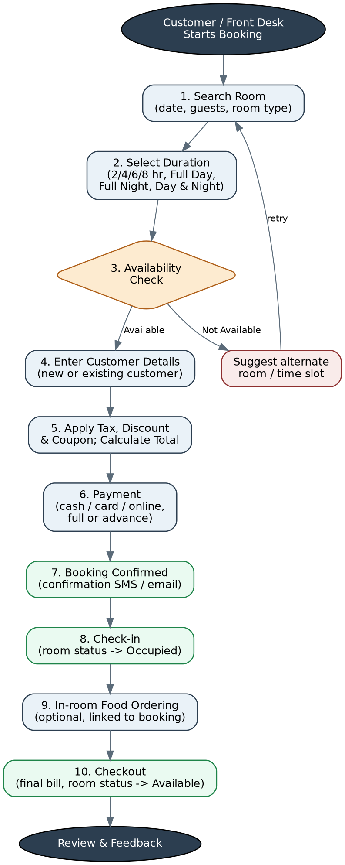
Figure 1 — Room Booking Workflow

6.2 Food Ordering Workflow
Food can be ordered in four ways — dine-in, takeaway, delivery, or in-room service for checked-in guests. All four converge on the same menu browsing and kitchen preparation steps, and diverge again at fulfilment and billing.

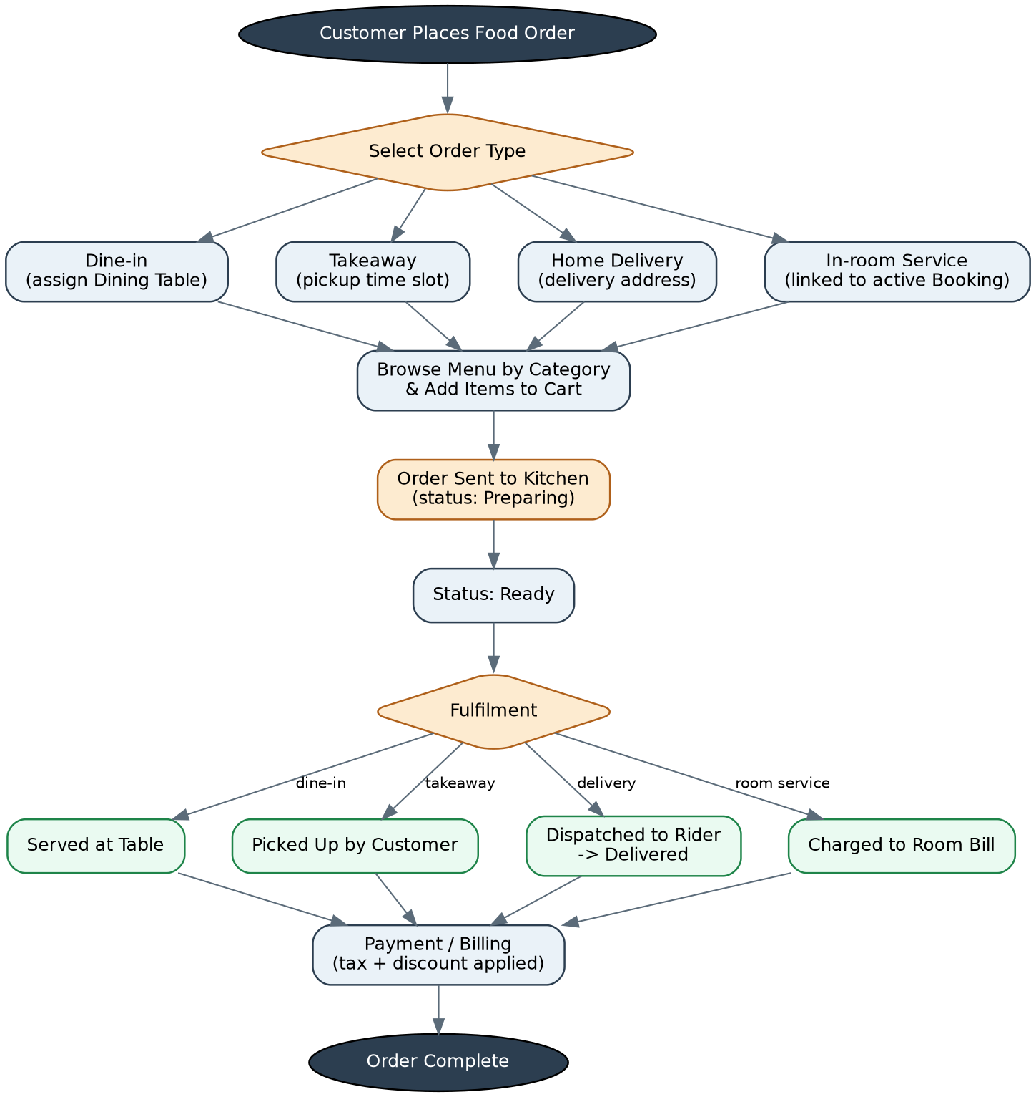

Figure 2 — Food Ordering Workflow (Dine-in / Takeaway / Delivery / Room Service)

7. Database Design
The database is designed around two linked transaction backbones — Bookings (rooms) and Orders (food) — that share the same Customers, Payments, Coupons and Reviews tables. This keeps a guest's full history, and the business's full revenue picture, in one consistent data model instead of two separate systems bolted together.

7.1 Entity-Relationship Diagram
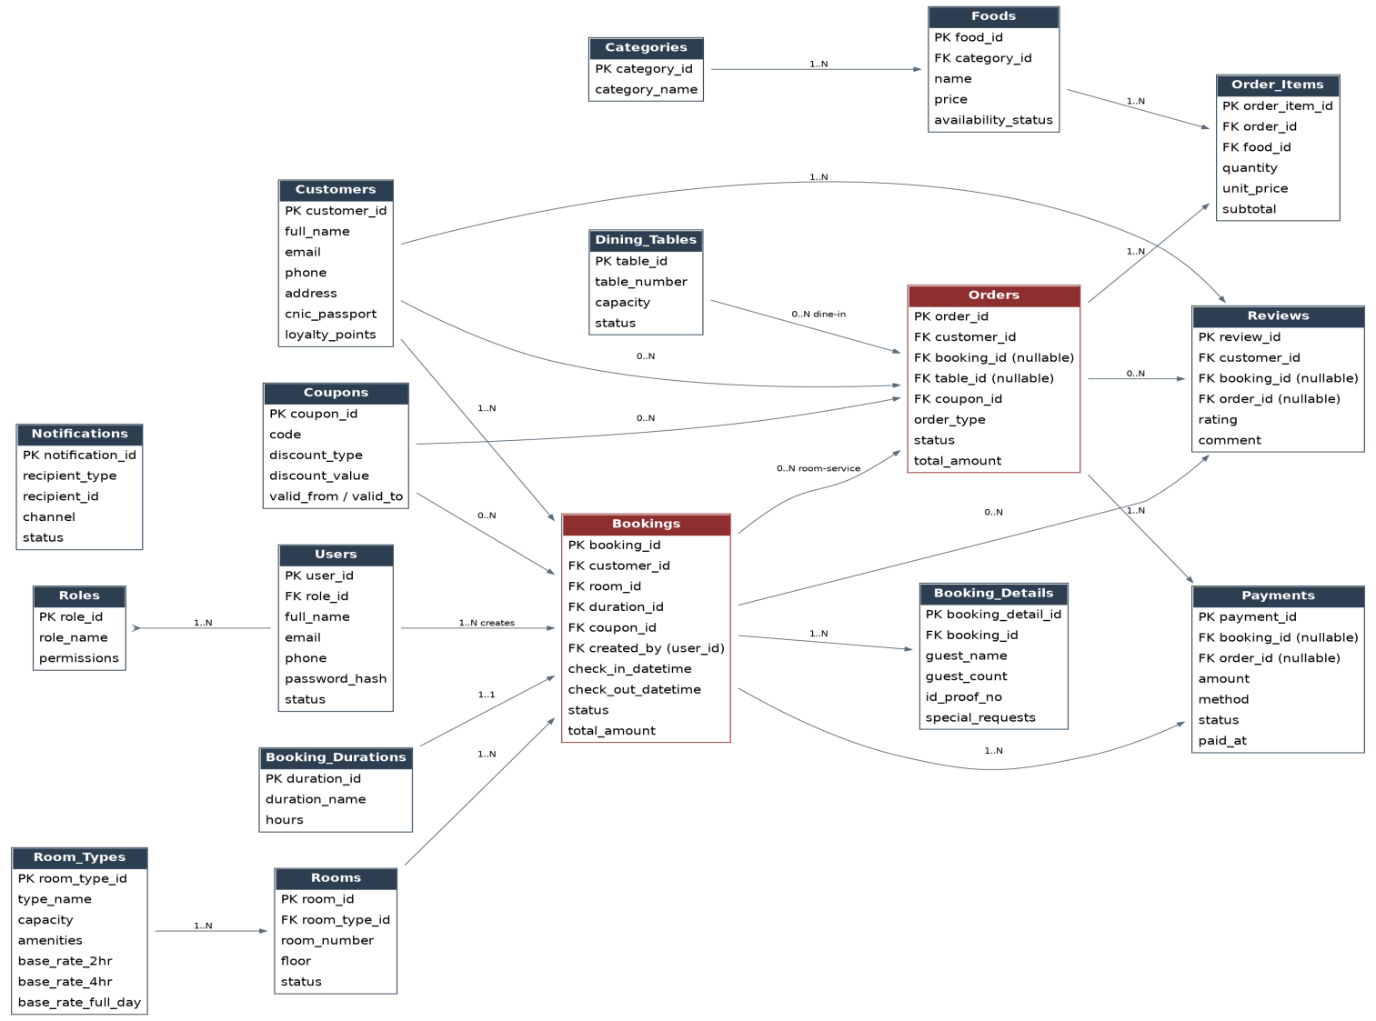

Figure 3 — Entity-Relationship Diagram (core entities, keys and relationships)

7.2 Database Schema — Table Definitions
Every table below uses an auto-incrementing integer primary key unless noted otherwise. Timestamps (created_at / updated_at) are included on all transactional tables for auditing but are omitted from the field lists for brevity where not functionally significant.

Table: roles
Defines the staff roles available in the system and what each is allowed to do
Field | Data Type | Constraints | Description
role_id | INT | PK, Auto-increment | Unique role identifier
role_name | VARCHAR(50) | NOT NULL, UNIQUE | e.g. Super Admin, Manager, Receptionist
permissions | JSON / TEXT | NOT NULL | Serialized list of permitted modules/actions

Table: users
Staff accounts that can log in to the back office.
Field | Data Type | Constraints | Description
user_id | INT | PK, Auto-increment | Unique staff user identifier
role_id | INT | FK -> roles.role_id | Assigned role
full_name | VARCHAR(100) | NOT NULL | Staff member's name
email | VARCHAR(100) | UNIQUE, NOT NULL | Login email
phone | VARCHAR(20) |  | Contact number
password_hash | VARCHAR(255) | NOT NULL | Hashed login credential
status | ENUM | Active / Inactive | Whether the account can log in

Table: customers
Guests and diners — shared between the room-booking and food-ordering sides.
Field | Data Type | Constraints | Description
customer_id | INT | PK, Auto-increment | Unique customer identifier
full_name | VARCHAR(100) | NOT NULL | Customer's name
email | VARCHAR(100) | UNIQUE | Optional for guest-checkout orders
phone | VARCHAR(20) | NOT NULL | Primary contact for confirmations
address | VARCHAR(255) |  | Used as default delivery address
cnic_passport | VARCHAR(30) |  | ID reference, required for room bookings
loyalty_points | INT | DEFAULT 0 | Accumulated loyalty balance
password_hash | VARCHAR(255) | NULLABLE | Set only for registered (non-guest) accounts

Table: room_types
Categories of room with shared capacity, amenities and duration-based pricing.
Field | Data Type | Constraints | Description
room_type_id | INT | PK, Auto-increment | Unique room type identifier
type_name | VARCHAR(50) | NOT NULL | e.g. Standard, Deluxe, Suite, Family
capacity | INT | NOT NULL | Maximum guests
amenities | TEXT |  | Comma-separated or JSON list
rate_2hr / rate_4hr / rate_6hr / rate_8hr | DECIMAL(10,2) |  | Hourly-duration rates
rate_full_day / rate_full_night / rate_day_night | DECIMAL(10,2) |  | Extended-duration rates

Table: rooms
Individual physical rooms, each belonging to one room type.
Field | Data Type | Constraints | Description
room_id | INT | PK, Auto-increment | Unique room identifier
room_type_id | INT | FK -> room_types.room_type_id | Room's category
room_number | VARCHAR(10) | NOT NULL, UNIQUE | Physical room label
floor | VARCHAR(10) |  | Floor / block reference
status | ENUM | Available / Occupied / Reserved / Maintenance | Current room state

Table: booking_durations
Lookup table of the fixed duration options and their hour count.
Field | Data Type | Constraints | Description
duration_id | INT | PK, Auto-increment | Unique duration identifier
duration_name | VARCHAR(30) | NOT NULL | 2 Hours / 4 Hours / 6 Hours / 8 Hours / Full Day / Full Night / Day & Night
hours | DECIMAL(4,1) | NULLABLE | Numeric hour count where applicable

Table: bookings
The core room-booking transaction record.
Field |  | Data Type | Constraints |  |  | Description
booking_id |  | INT | PK, Auto-increment |  |  | Unique booking identifier
customer_id |  | INT | FK -> customers.customer_id |  |  | Guest making the booking
room_id |  | INT | FK -> rooms.room_id |  |  | Room reserved
duration_id |  | INT | FK -> booking_durations.duration_id |  |  | Selected duration option
coupon_id |  | INT | FK -> coupons.coupon_id, NULLABLE |  |  | Applied coupon, if any
created_by |  | INT | FK -> users.user_id |  |  | Staff member who created the booking
check_in_datetime / check_out_datetime |  | DATETIME | NOT NULL |  |  | Scheduled stay window
actual_check_in / actual_check_out |  | DATETIME | NULLABLE |  |  | Actual timestamps recorded by staff
status |  | ENUM | Pending / Confirmed / Checked-in / Checked-out / Cancelled / No-show |  |  | Booking lifecycle state
DECIMAL(10,2) | NOT NULL |  |  | Pricing breakdown

Table: booking_details
Additional guest information captured against a booking.
Field | Data Type | Constraints | Description
booking_detail_id | INT | PK, Auto-increment | Unique record identifier
booking_id | INT | FK -> bookings.booking_id | Parent booking
guest_name | VARCHAR(100) |  | Name of the staying guest, if different from the customer
guest_count | INT | NOT NULL | Number of occupants
id_proof_no | VARCHAR(30) |  | ID reference recorded at check-in
special_requests | TEXT | NULLABLE | Free-text notes (e.g. extra bed, late checkout)

Table: dining_tables
Physical restaurant tables used for dine-in orders.
Field | Data Type | Constraints | Description
table_id | INT | PK, Auto-increment | Unique table identifier
table_number | VARCHAR(10) | NOT NULL, UNIQUE | Table label
capacity | INT | NOT NULL | Number of seats
location | ENUM | Indoor / Outdoor | Seating area
status | ENUM | Free / Occupied / Reserved | Current table state

Table: categories
Menu categories used to organise food items.
Field | Data Type | Constraints | Description
category_id | INT | PK, Auto-increment | Unique category identifier
category_name | VARCHAR(50) | NOT NULL | e.g. Starters, Main Course, Beverages, Desserts

Table: foods
The restaurant menu.
Field | Data Type | Constraints | Description
food_id | INT | PK, Auto-increment | Unique menu item identifier
category_id | INT | FK -> categories.category_id | Item's category
name | VARCHAR(100) | NOT NULL | Menu item name
description | TEXT | NULLABLE | Short description
price | DECIMAL(10,2) | NOT NULL | Selling price
image_url | VARCHAR(255) | NULLABLE | Menu photo
availability_status | ENUM | Available / Unavailable | Whether it can currently be ordered

Table: orders
The core food-order transaction record, covering all four order types.
Field | Data Type | Constraints | Description
order_id | INT | PK, Auto-increment | Unique order identifier
customer_id | INT | FK -> customers.customer_id, NULLABLE for anonymous walk-in | Customer placing the order
booking_id | INT | FK -> bookings.booking_id, NULLABLE | Set only for Room Service orders
table_id | INT | FK -> dining_tables.table_id, NULLABLE | Set only for Dine-in orders
coupon_id | INT | FK -> coupons.coupon_id, NULLABLE | Applied coupon, if any
order_type | ENUM | Dine-in / Takeaway / Delivery / Room Service | How the order will be fulfilled
delivery_address | VARCHAR(255) | NULLABLE | Required for Delivery orders
status | ENUM | Placed / Preparing / Ready / Served / Picked Up / Dispatched / Delivered / Billed to Room / Cancelled | Order lifecycle state
subtotal / discount_amount / tax_amount / total_amount | DECIMAL(10,2) | NOT NULL | Pricing breakdown

Table: order_items
Line items belonging to an order.
Field | Data Type | Constraints | Description
order_item_id | INT | PK, Auto-increment | Unique line item identifier
order_id | INT | FK -> orders.order_id | Parent order
food_id | INT | FK -> foods.food_id | Ordered menu item
quantity | INT | NOT NULL | Units ordered
unit_price | DECIMAL(10,2) | NOT NULL | Price at time of order
subtotal | DECIMAL(10,2) | NOT NULL | quantity x unit_price
special_instructions | VARCHAR(255) | NULLABLE | e.g. "no onions"

Table: payments
Payment records, each tied to a booking, an order, or both.
Field | Data Type | Constraints | Description
payment_id | INT | PK, Auto-increment | Unique payment identifier
booking_id | INT | FK -> bookings.booking_id, NULLABLE | Set when paying for a room booking
order_id | INT | FK -> orders.order_id, NULLABLE | Set when paying for a standalone food order
amount | DECIMAL(10,2) | NOT NULL | Amount paid in this transaction
method | ENUM | Cash / Card / Online | Payment channel used
payment_type | ENUM | Full / Advance / Balance / Refund | Nature of this transaction
status | ENUM | Pending / Completed / Failed / Refunded | Payment state
transaction_ref | VARCHAR(100) | NULLABLE | Gateway/reference number for card or online payments
paid_at | DATETIME | NOT NULL | Timestamp of payment

Table: coupons
Promotional codes and their rules.
Field | Data Type | Constraints | Description
coupon_id | INT | PK, Auto-increment | Unique coupon identifier
code | VARCHAR(30) | NOT NULL, UNIQUE | Code entered by the customer
discount_type | ENUM | Percentage / Fixed Amount | How the discount is calculated
discount_value | DECIMAL(10,2) | NOT NULL | Percentage or fixed value
applicable_to | ENUM | Rooms / Food / Both | Where the coupon can be used
min_amount | DECIMAL(10,2) | NULLABLE | Minimum subtotal required to apply
usage_limit | INT | NULLABLE | Maximum number of redemptions
valid_from / valid_to | DATE | NOT NULL | Validity window

Table: reviews
Customer feedback linked to a completed booking or order.
Field | Data Type | Constraints | Description
review_id | INT | PK, Auto-increment | Unique review identifier
customer_id | INT | FK -> customers.customer_id | Reviewer
booking_id | INT | FK -> bookings.booking_id, NULLABLE | Set for a stay review
order_id | INT | FK -> orders.order_id, NULLABLE | Set for a food-order review
rating | TINYINT | 1–5, NOT NULL | Star rating
comment | TEXT | NULLABLE | Free-text feedback

Table: notifications
Log of automated messages sent to customers or staff.
Field | Data Type | Constraints | Description
notification_id | INT | PK, Auto-increment | Unique notification identifier
recipient_type | ENUM | Customer / Staff | Who the message was sent to
recipient_id | INT | References customers.customer_id or users.user_id | Recipient identifier
title | VARCHAR(100) | NOT NULL | Notification headline
message | TEXT | NOT NULL | Notification body
channel | ENUM | SMS / Email / Push | Delivery channel
status | ENUM | Sent / Failed / Pending | Delivery outcome

7.3 Relationship Summary
- One Customer can have many Bookings and many Orders (1-to-many).
- One Room Type has many Rooms; one Room has many Bookings over time (1-to-many).
- One Booking has one Booking Details record, may have many Payments, may have many Room-Service Orders, and may have one Review (1-to-many / 1-to-one).
- One Order has many Order Items, may have many Payments, and may have one Review (1-to-many).
- One Category has many Foods; one Food can appear in many Order Items (1-to-many).
- One Coupon can be applied to many Bookings and many Orders, but only once per booking/order (1-to-many).
- One Role has many Users; one User can create many Bookings (1-to-many).

Non-Functional Requirements

Category | Requirement
Performance | Room availability search and menu browsing should return results within 2 seconds under normal load.
Scalability | Database schema and application layer should support growth to multiple branches/locations without redesign.
Security | Passwords stored hashed (never plain text); role-based access enforced on every back-office endpoint; payment data handled per the client's chosen payment gateway's compliance requirements.
Availability | Target 99.5% uptime for the booking and ordering front end during business hours.
Usability | Responsive design usable on desktop, tablet and mobile browsers for both customers and staff.
Auditability | All bookings, orders and payments retain created/updated timestamps and the staff user who performed the action.
Data Backup | Automated daily database backups with a defined retention period (to be agreed with the client).
Localization | Currency and date/time formatting configurable to the client's locale.

9. Taxes & Discounts Policy
Tax and discount handling is designed to be configurable rather than hard-coded, so the client can adjust rates without requesting a code change:
- A Tax Settings screen lets Super Admin define one or more tax rates and apply them independently to Rooms and to Food.
- Every booking and order stores the tax amount actually charged at the time of transaction, so historical bills remain accurate even if rates change later.
- Discounts arrive from exactly one of two sources at checkout: a Coupon Code (Section 4.7) or a Loyalty Point redemption — never stacked, unless the client later requests combinable promotions as an enhancement.
- The calculation order is always: Subtotal → Discount → Tax → Total, ensuring tax is charged on the discounted amount, consistent with standard retail/hospitality practice.

10. Assumptions & Constraints
- The client will provide the exact tax rate(s), refund/cancellation windows, and loyalty point earn-rate before the pricing engine is finalised.
- A single property/branch is assumed for this phase; multi-branch support is listed as a future enhancement.
- Payment gateway selection (e.g. for online payments) will be confirmed by the client; integration effort may vary by provider.
- SMS/email delivery depends on a third-party provider account being set up by the client (e.g. Twilio, an SMTP provider).
- Menu items, room types and initial rates will be supplied by the client for data entry/import before go-live.

11. Future Enhancements
- Native iOS/Android apps for customers.
- Multi-branch/multi-property support with centralized reporting.
- Integration with third-party travel/booking portals (channel manager).
- Kitchen Display System (KDS) screen for real-time order tickets.
- Dynamic/seasonal pricing for room rates.
- Combinable coupon and loyalty-point discounts.
- Customer-facing live order tracking map for deliveries.

