**ZAINAAZ HANSA – VIRTUAL CV WEBSITE DOCUMENTATION**

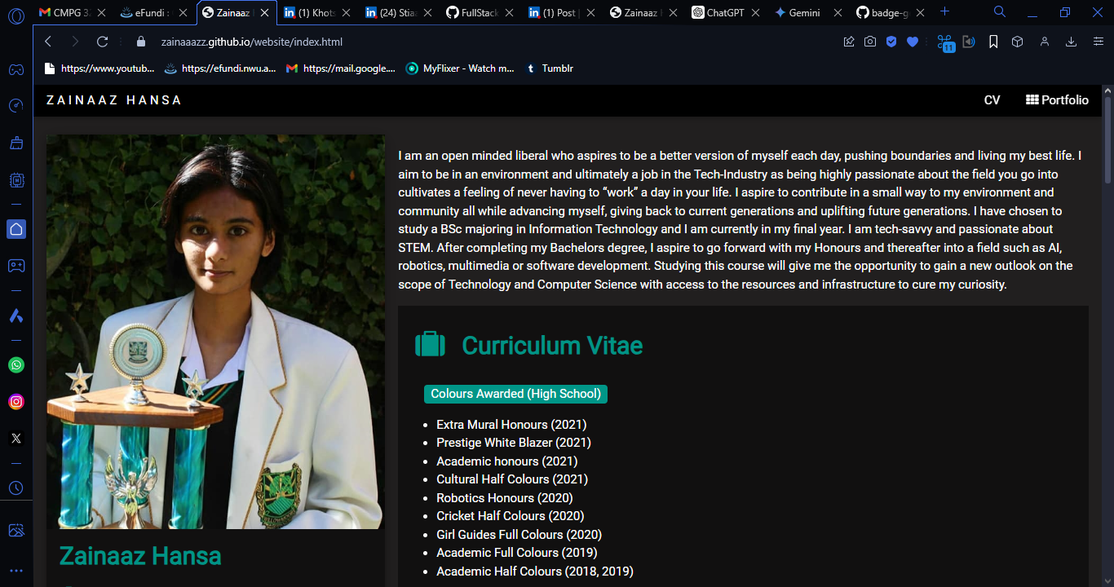

Welcome to my Virtual CV portfolio website! This dynamic portfolio serves as a virtual CV, showcasing my skills, projects, and experiences. The website is designed to be user-friendly, visually appealing, and technically proficient.

You can view the live site [here](https://zainaaazz.github.io/website/index.html).

Table of Contents

About 2

Features 2

Technologies Used 2

Sections 2

Installation 3

Usage 3

Contact 3

# About

This portfolio website is a requirement for CMPG 323. It serves as a dynamic CV that highlights my professional and academic journey. The website is hosted on GitHub Pages and follows all the criteria outlined in the module's guidelines. But more importantly, it is to prepare me for when I enter the IT industry and to stand out to employers.

# Features

Aesthetically Pleasing: Effective use of visuals to enhance engagement and understanding.

User-Friendly Navigation: Clear, intuitive, and accessible navigation throughout the site.

Innovative Elements: Incorporation of innovative features that enhance the presentation and functionality of the CV.

Modern Web Technologies: Utilization of modern web technologies including CSS animations and JavaScript.

Responsive Design: Compatible with major web browsers and displays correctly on different devices.

Error-Free Content: Well-written content with correct grammar and spelling.

# Technologies Used

* HTML
* CSS
* JavaScript
* GitHub Pages for hosting

# Sections

Index.html:

* Contact Information: How to get in touch.
* Education: Academic qualifications and institutions.
* Work Experience: Professional history and roles.
* Matric Distinctions: Academic honours achieved in high school.
* Technical Skills: Proficiencies in programming and software.
* Hobbies: Personal interests and activities.
* Colours Awarded: Awards represented by colours.
* Trophies Awarded: Physical awards and recognitions.
* Leadership Roles: Positions of leadership held.
* National Recognition: Awards and honours on a national level.
* Vodacom Recognition: Specific recognition from Vodacom.
* Robotics Recognition: Awards and achievements in robotics.

Portfolio.html:

* Projects
* App Gui Designs
* Logo Designs
* Infographic Designs

# Installation

To run this project locally, follow these steps:

Clone the repository:

git clone https://github.com/zainaaazz/website.git

Navigate to the project directory:

cd website

Open index.html in your preferred web browser.

# Usage

You can view the live version of the site [here](https://zainaaazz.github.io/website/index.html).

# Contact

For any inquiries, you can reach me at:

Email: <mailto:zainaazhansa@gmail.com>

LinkedIn: <https://www.linkedin.com/in/zainaaz-hansa-a8795a203/>

GitHub: <https://github.com/zainaaazz>

Thank you for visiting my Virtual CV portfolio website! Don’t forget to upvote!