
CLOUD COMPUTING
Assignment # 01

Name | Zainab
Roll No. | FA24B1-SE-016016
Section | A
Date | 10-10-2026

Task 01:
Screenshot 1:
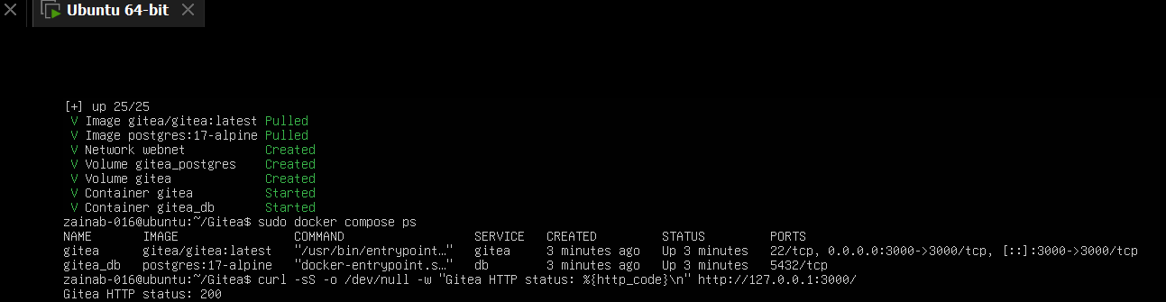
task1_gitea_running.png
Screenshot 2:
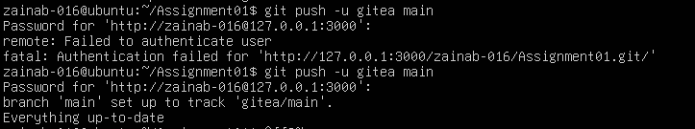
task1_gitea_push.png
Screenshot 3:
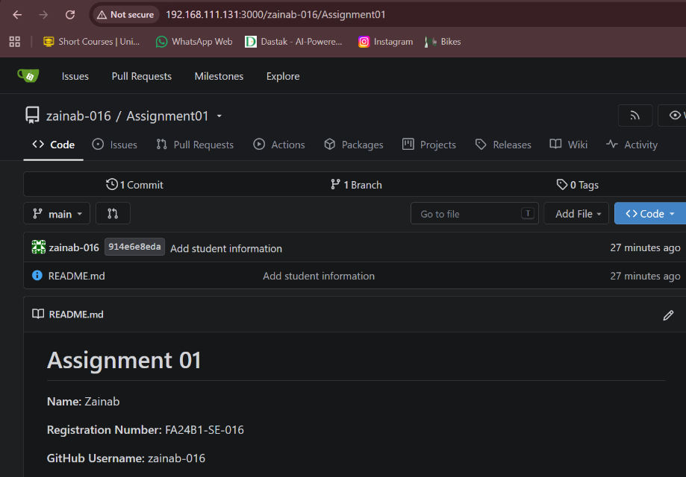
task1_gitea_repository.png

Task 02:
Screenshot 4:
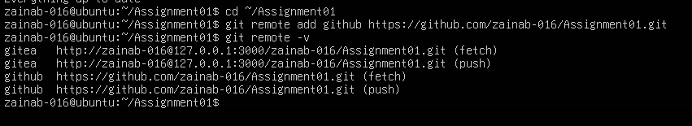
task2_remotes.png
Screenshot 5 :
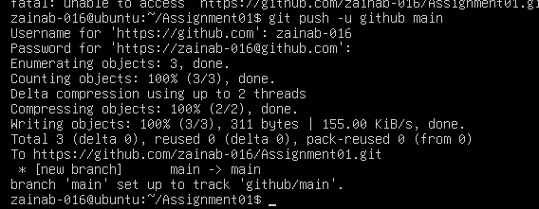
task2_github_push.png
Screenshot 6 :
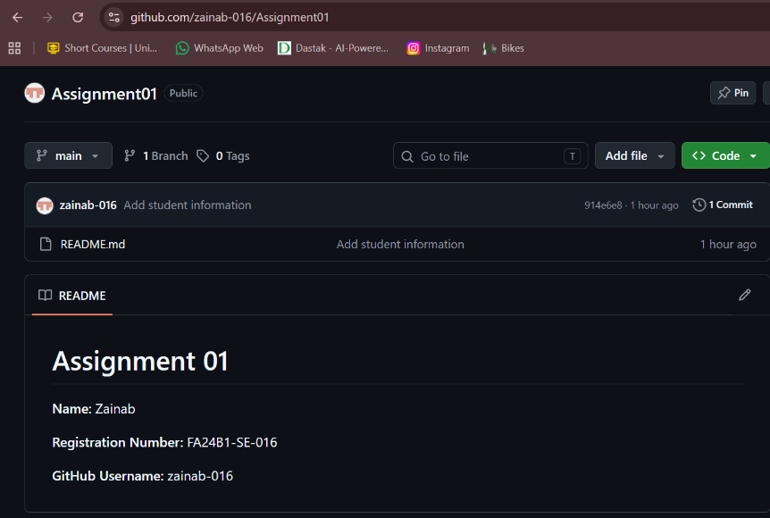
task2_github_repository.png

Task 03:
Screenshot 7 :
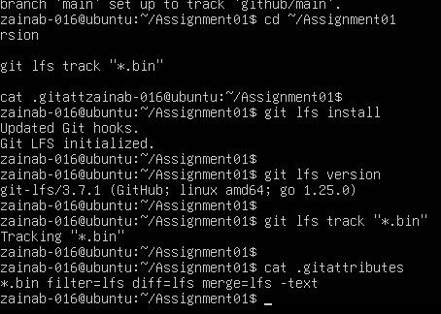
task3_lfs_setup.png
Screenshot 8 :
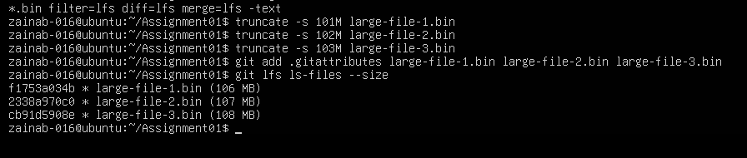
task3_lfs_files.png
Screenshot 9 :
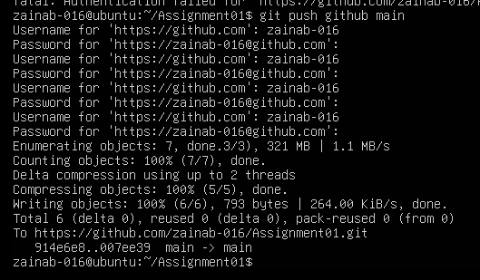
task3_lfs_push.png

Task : 04
Screenshot 10:
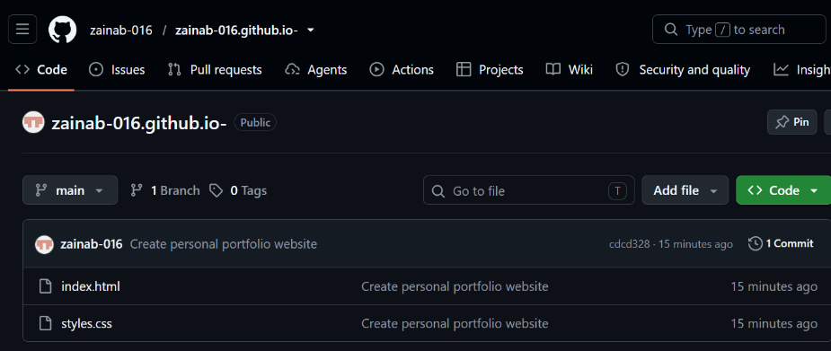
task4_pages_repository.png
Screenshot 11 :
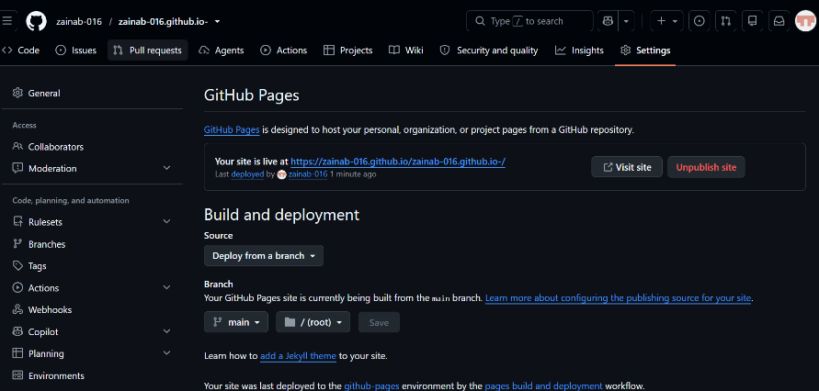
task4_pages_deployment.png
Screenshot 12 :
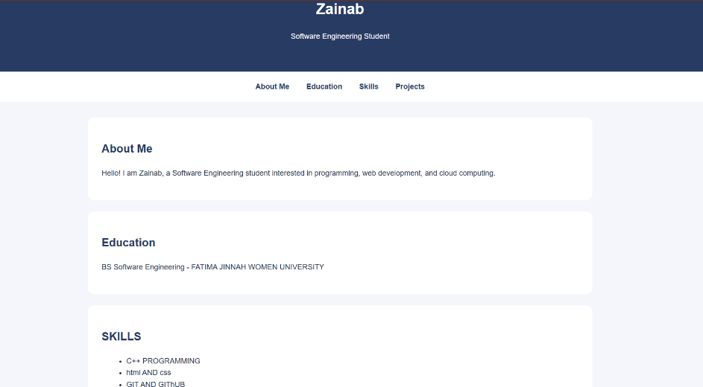
task4_portfolio_live.png

