
CLOUD COMPUTING

Name: Zainab
Roll no. : FA24-B1-SE-016
Course Code: SE-665
Section: A
GitHub Username: zainab-016
Lab#01

Task 1: Create and Configure Your GitHub Account
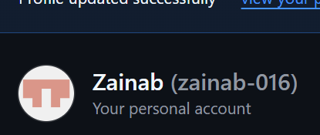
github_profile.png
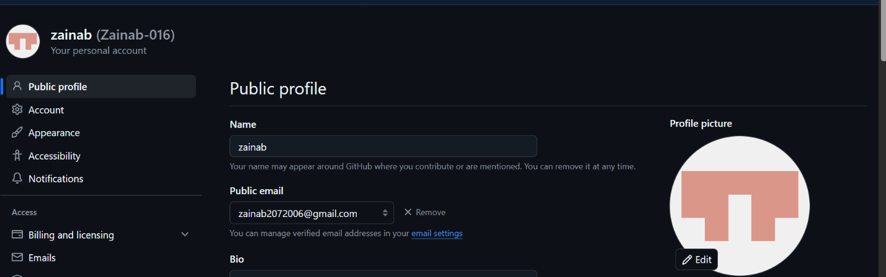
github_actual_name.png
Task 2: Register in the Student Marks Portal
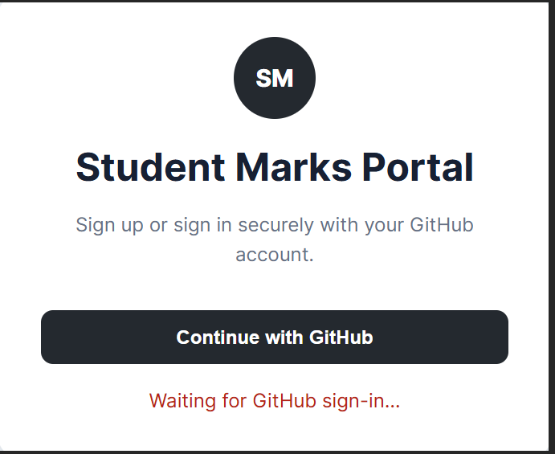portal_login_page.png
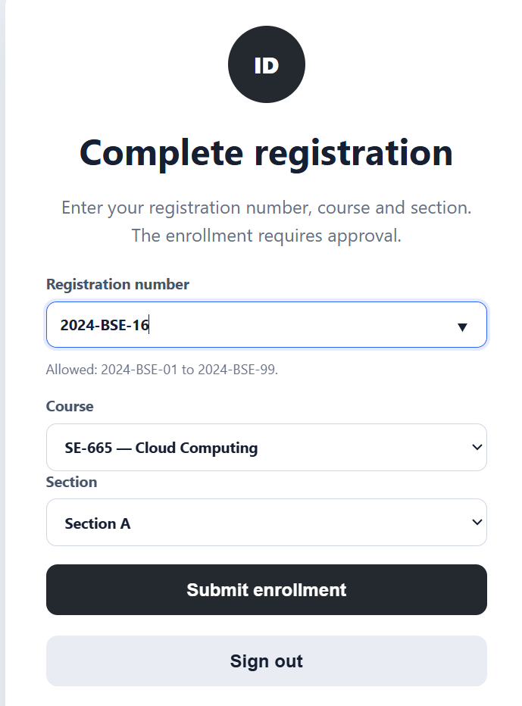
portal_github_profile.png
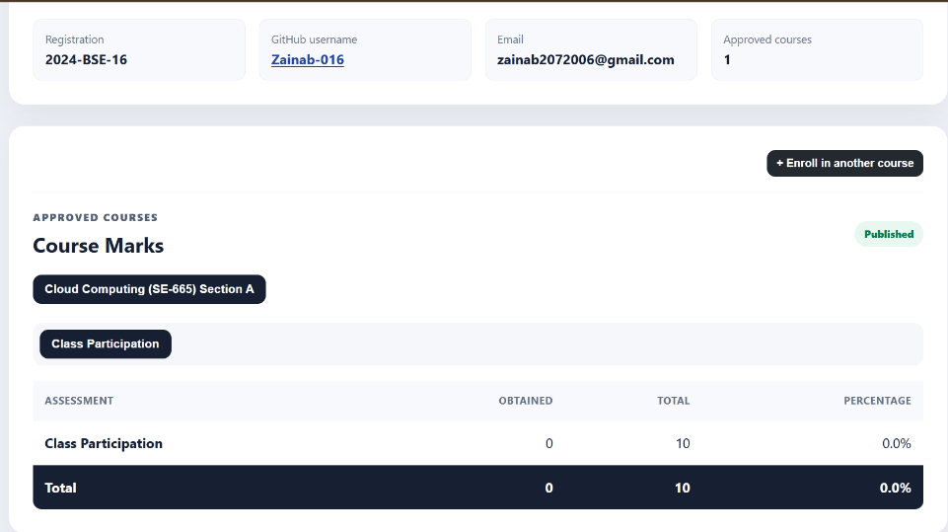
portal_enrollment_submitted.png
Task 3: Download VMware Workstation Pro and Ubuntu Server
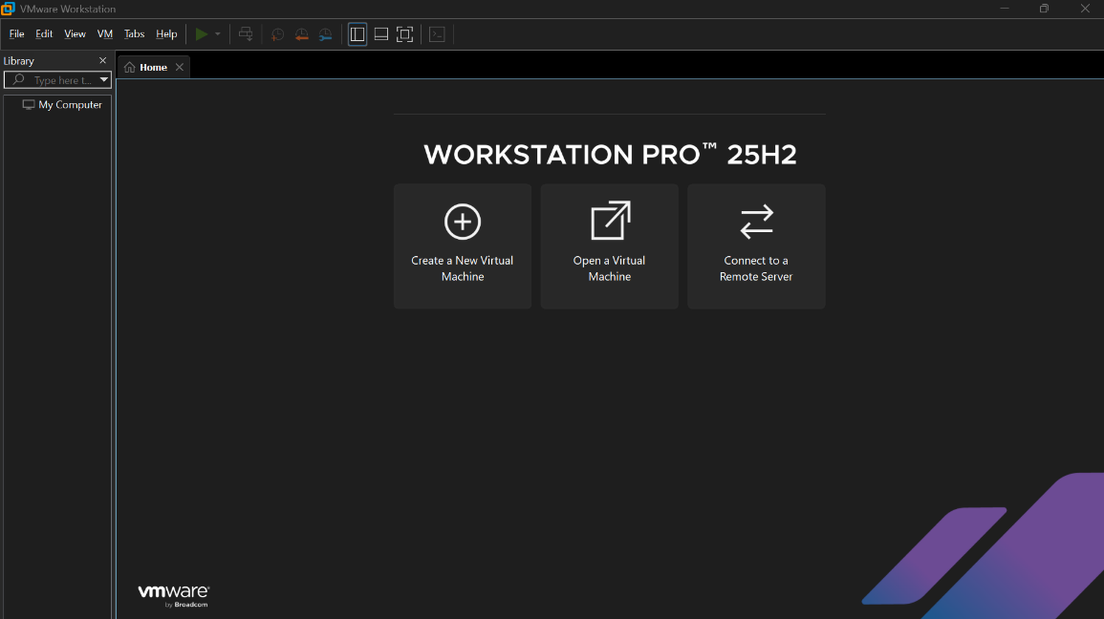
vmware_workstation.png
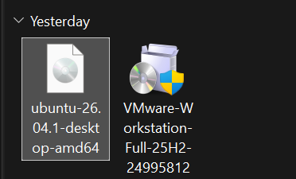
ubuntu_server_iso.png
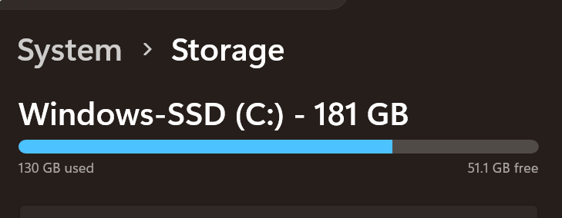
available_storage.png
Task 4: Create the Ubuntu Server Virtual Machine
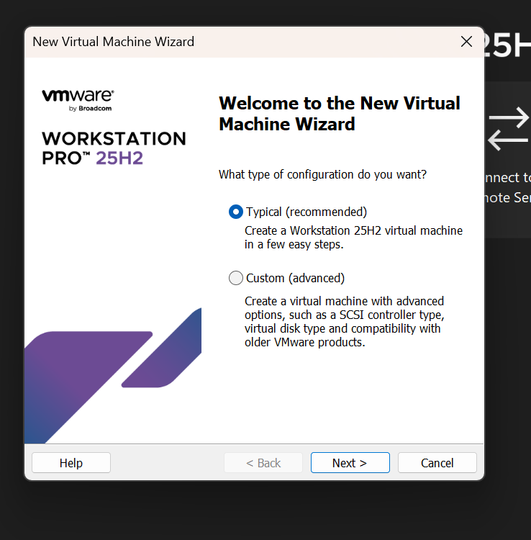
vm_creation_wizard.png
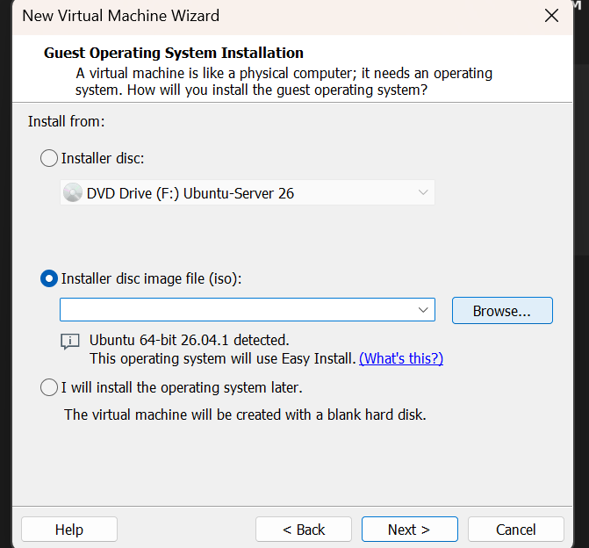
vm_typical_configuration.png
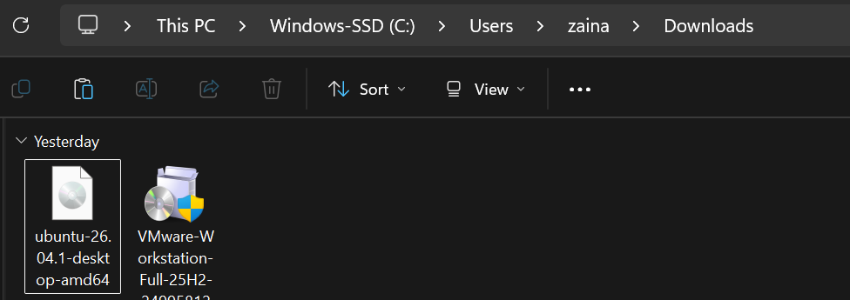
vm_ubuntu_iso_selected.png.
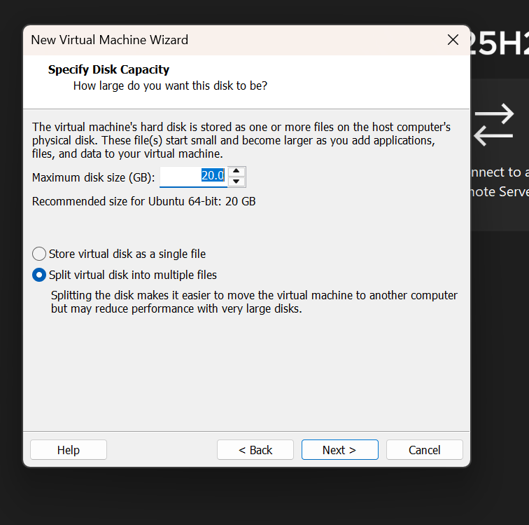
vm_configuration_summary.png

ubuntu_installer_boot.png
Task 5: Choose the Installation Language
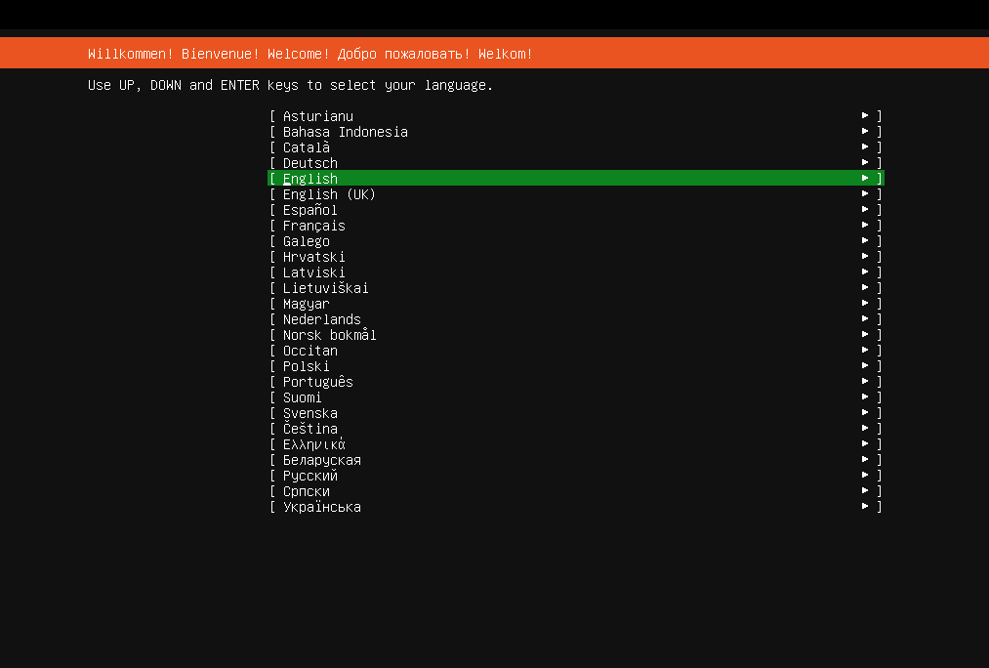
ubuntu_language.png
Task 6: Configure the Keyboard Layout
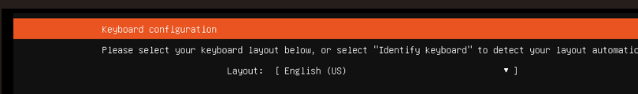
ubuntu_keyboard_layout.png
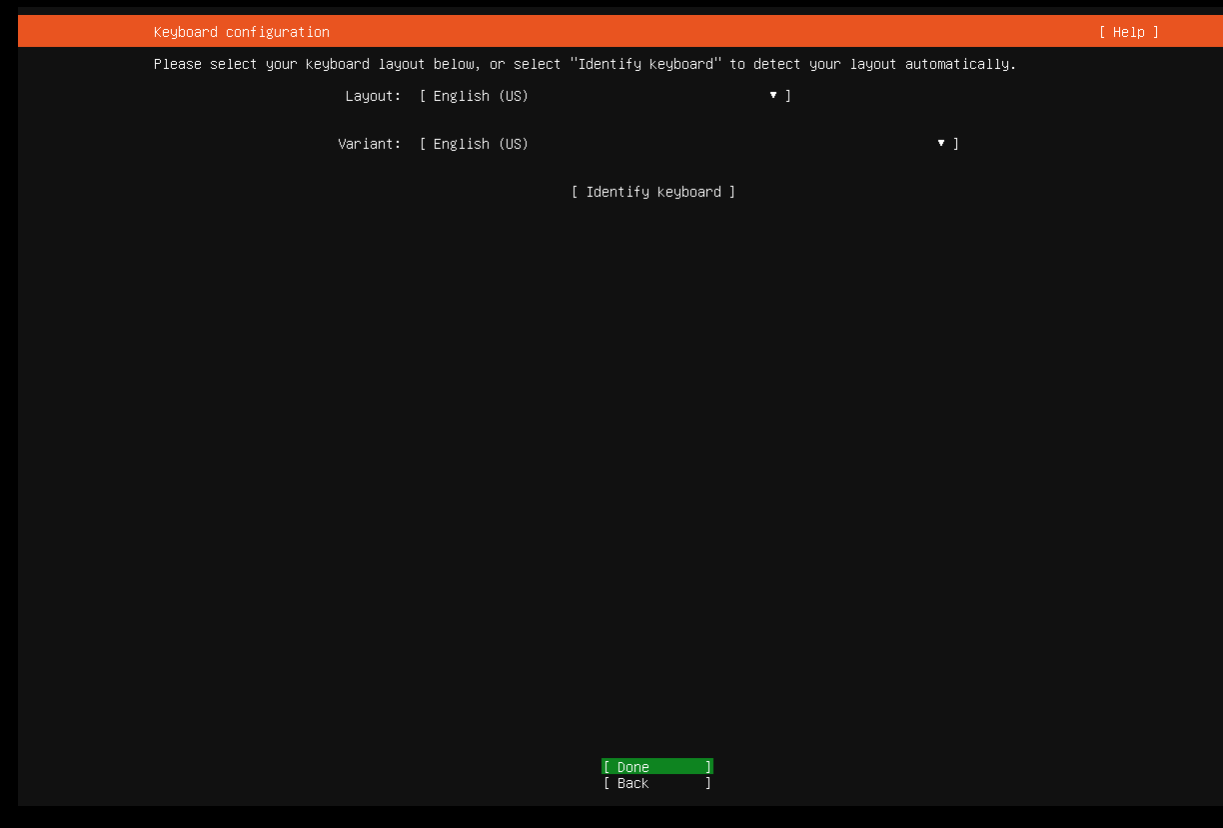
ubuntu_keyboard_variant.png
Task 7: Choose the Ubuntu Server Installation Type
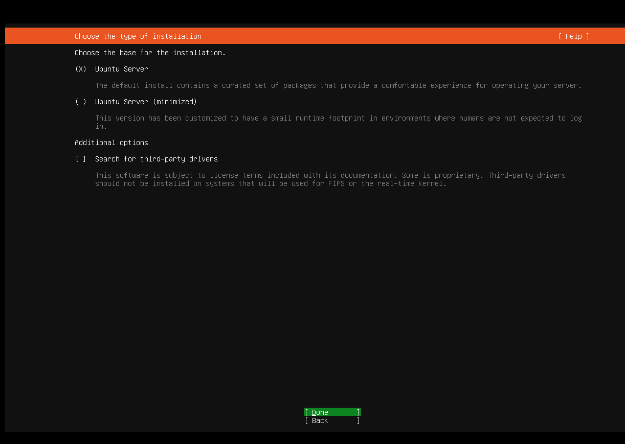
ubuntu_installation_type.png
Task 8: Configure the Network
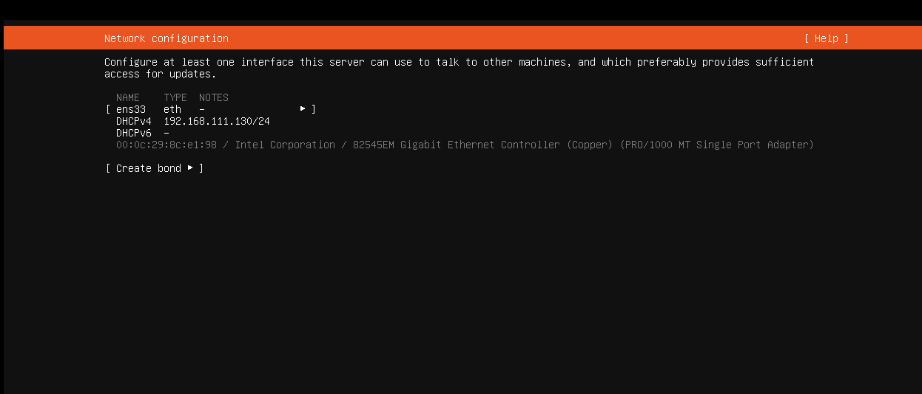
ubuntu_network_interface.png
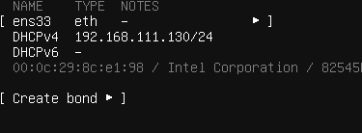
ubuntu_installer_network.png
Task 9: Configure Storage
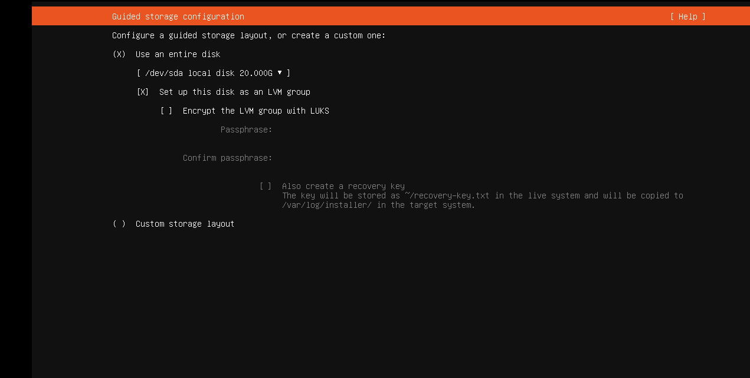
ubuntu_guided_storage.png

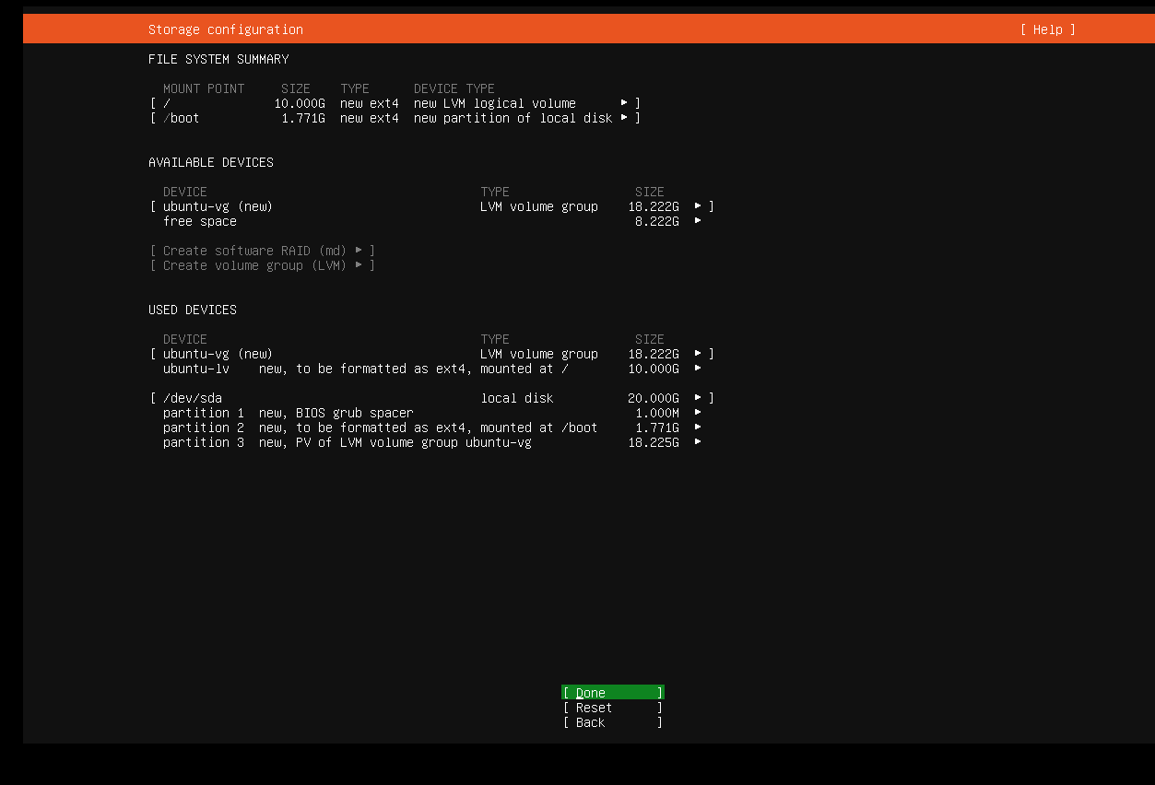
ubuntu_storage_configuration.png
Task 10: Select the Installation Disk
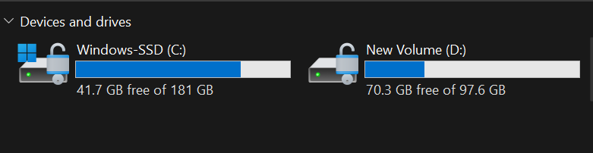
ubuntu_selected_disk.png
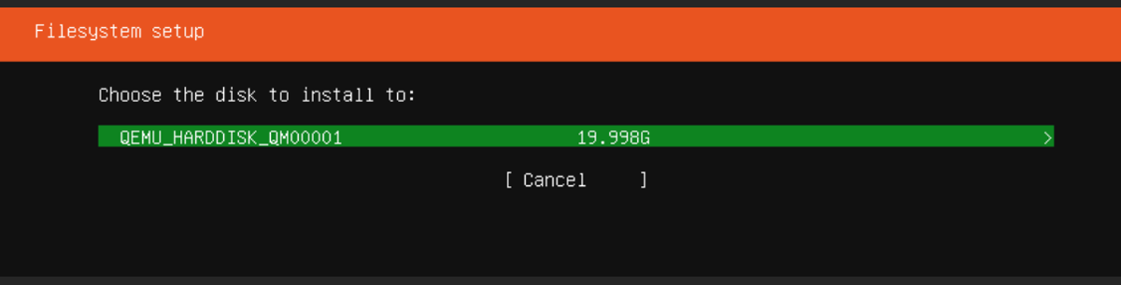
ubuntu_disk_details.png
Task 11: Review the Partitions
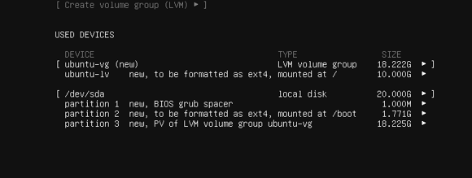
ubuntu_partition_layout.png
Task 12: Confirm the Storage Changes
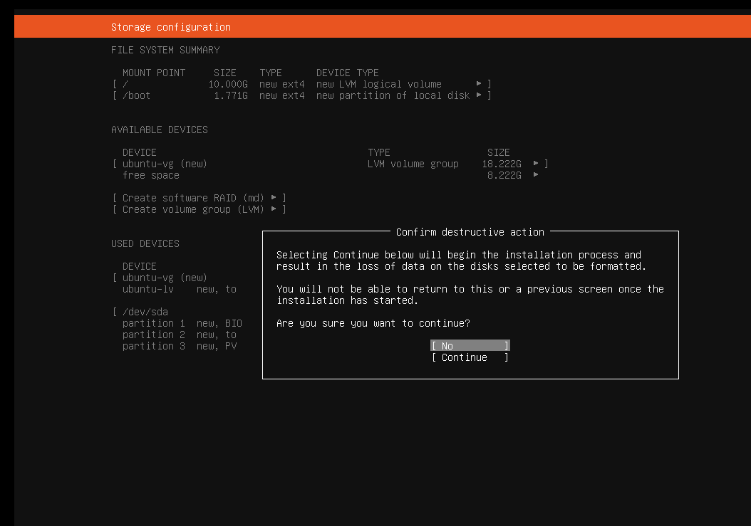

ubuntu_storage_warning.png
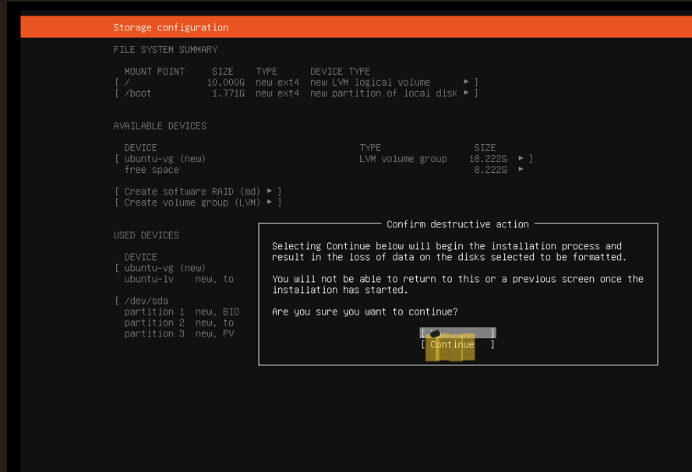
ubuntu_storage_confirmed.png
Task 13: Configure the Ubuntu Profile
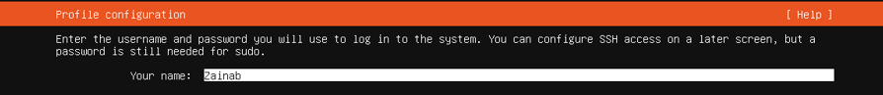
ubuntu_actual_name.png
ubuntu_server_name.png
ubuntu_username.png
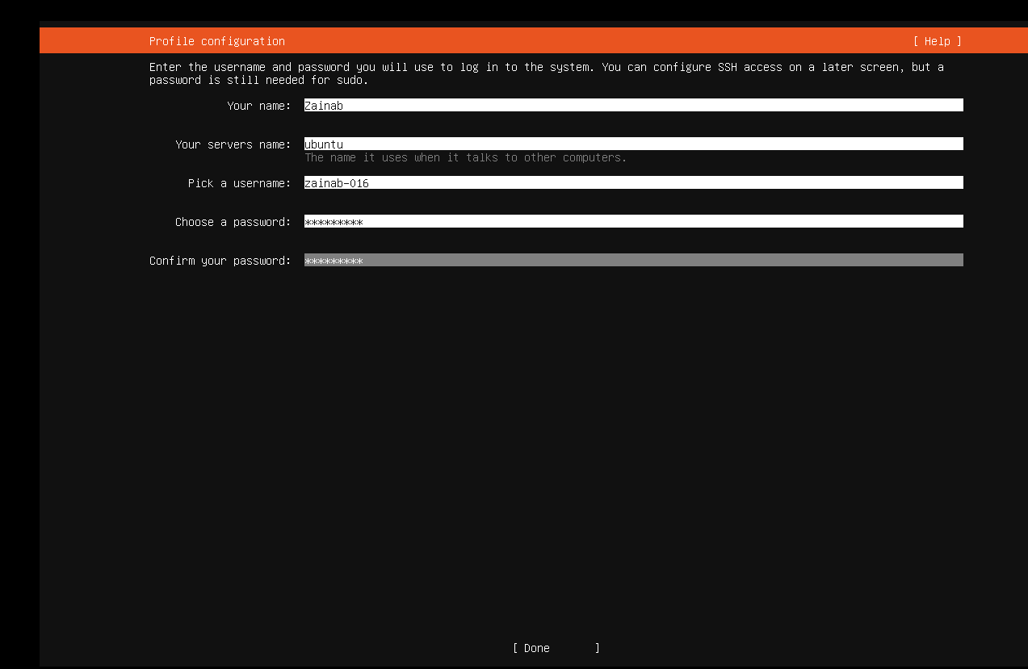
ubuntu_profile_setup.png
Task 14: Complete the Software Installation
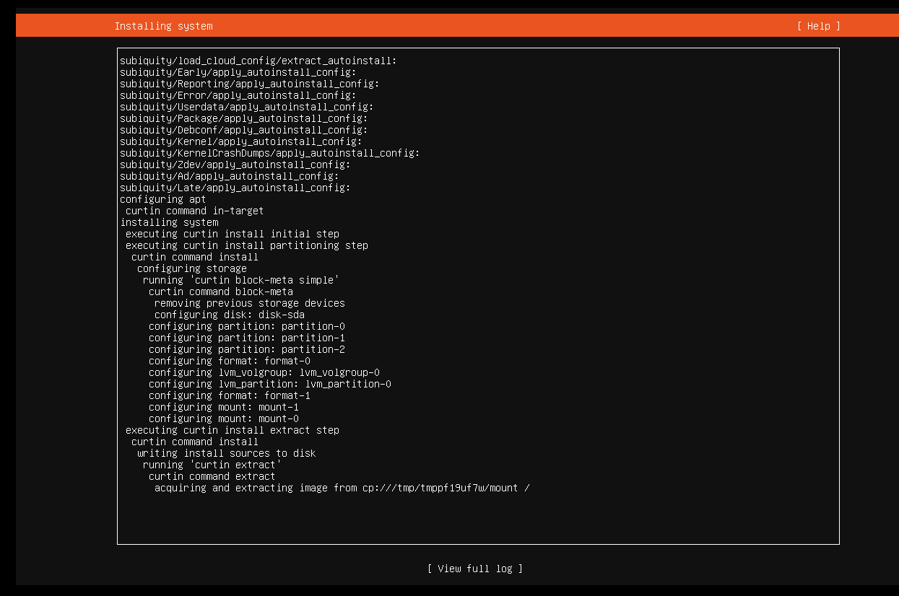
ubuntu_installation_progress.png
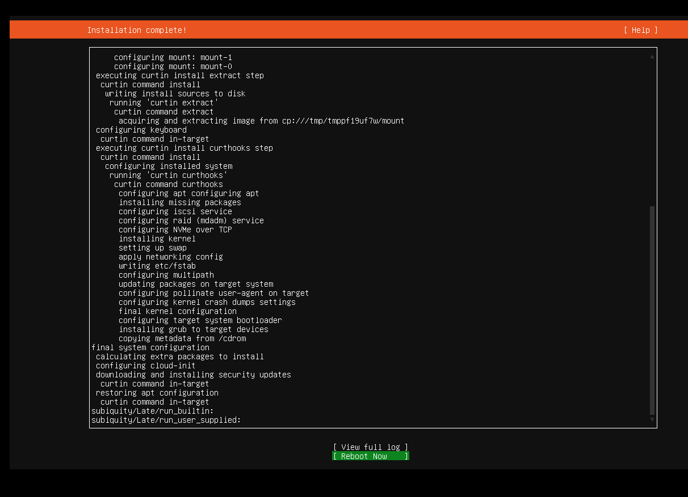
ubuntu_installation_complete.png
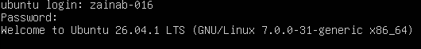ubuntu_login_screen.png
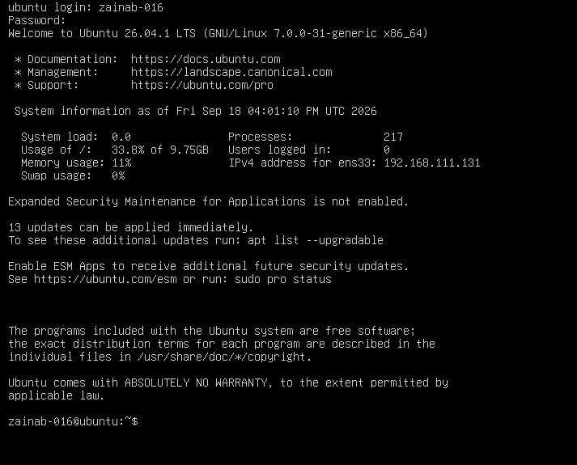
ubuntu_terminal_login.png
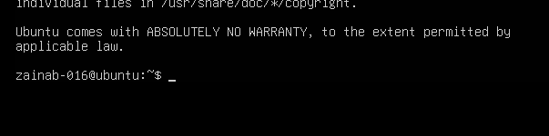
ubuntu_identity_verified.png
Task 16: Find the Ubuntu Server IP Address
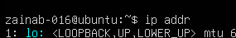
ubuntu_ip_addr_command.png
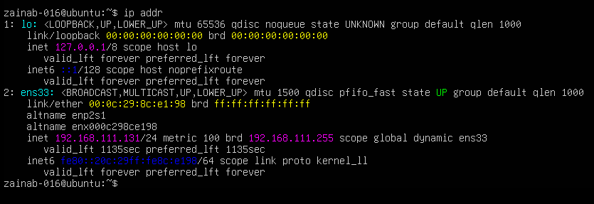
ubuntu_ip_address.png
Task 17: Connect to Ubuntu Server from Windows
windows_ssh_command.png
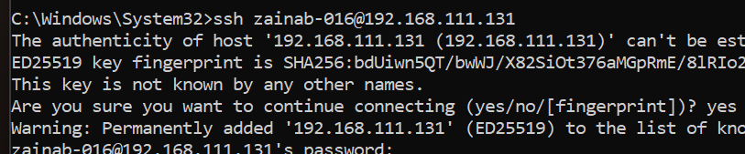
windows_ssh_fingerprint.png
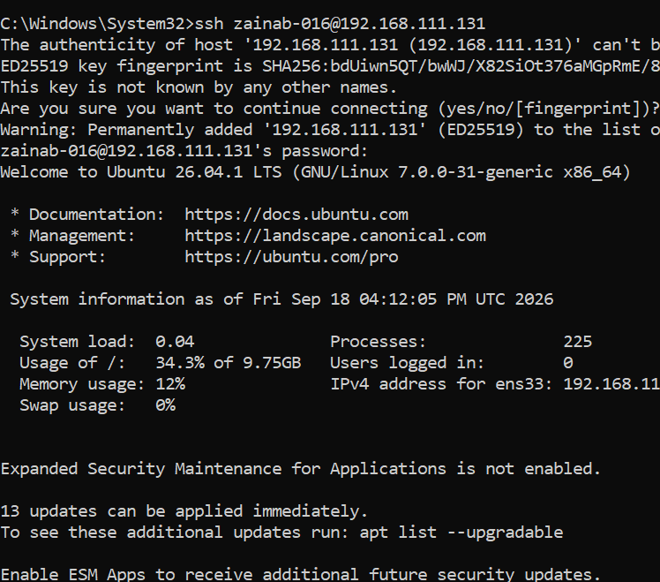
windows_ssh_login.png
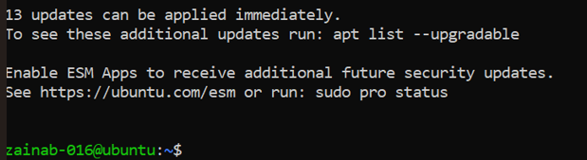
windows_ssh_identity.png

