Column ki default cross axis alignment is center.

Drawer

**TabBar** inside appbar’s bottom property and then Tab bar view widget inside Scaffolds body.

A TabController is needed to manage the state of the TabBar and TabBarView.

You can have the default tab controller or your own controller:

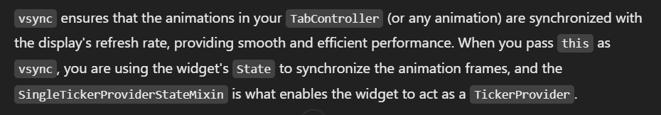

Snackbar

Image.asset you use when you have a png file inside your project.

Image.network you use when you have a url for the image

Image.file and Image.memory

Stack ka widget parhlo sahi say

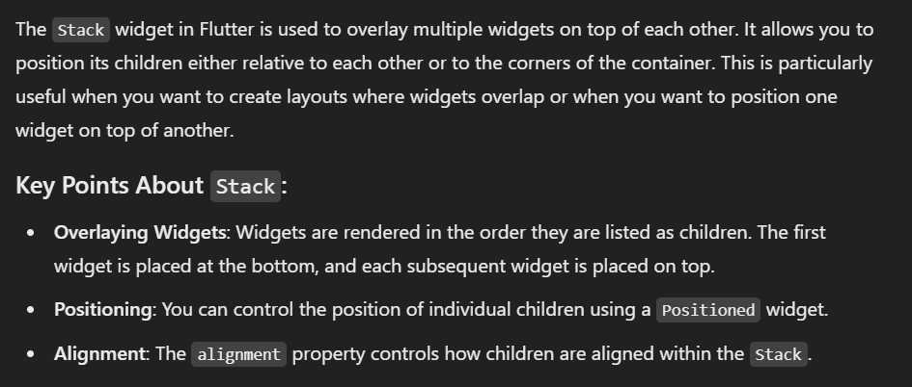

API say data lakar integrate in your app and widgets. Ui bunani ani chahiyay.

API and Web Services

Web services mein you have json

