* Widget lifecycle
* Setstate par widget rebuild hota
* Fetchallposts gulut jagha parha hai because v tightly bound with UI
* API / Network code shouldn’t be tightly bound with UI. Cause API change hoa tou UI phut gaya
* Setstate bhi gulut poora widget rebuild hoga

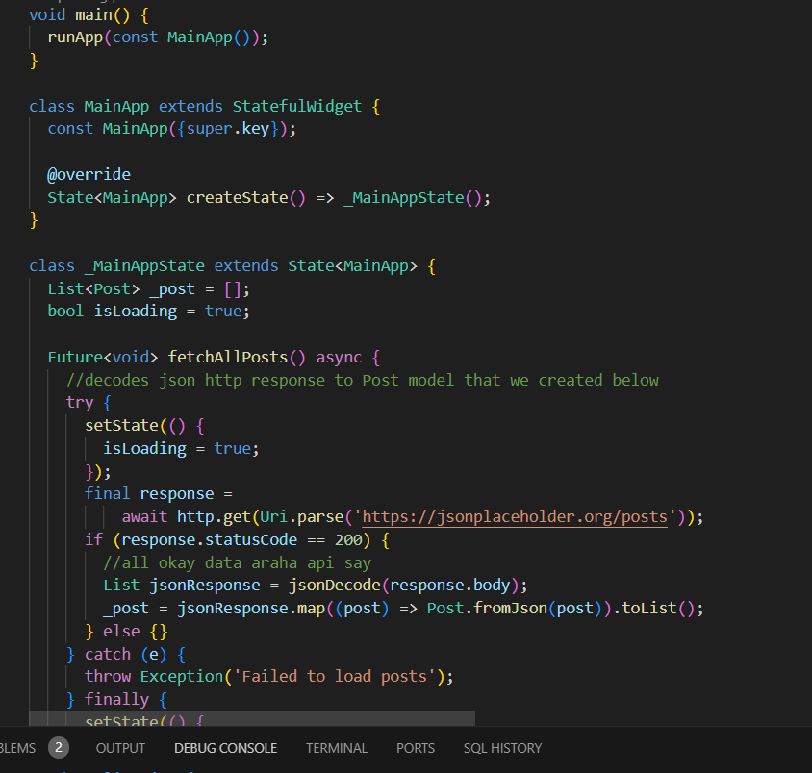

* Would separate network layer also.
* UI model: data hee wahan aesay rukho jesay UI ko chahiyay. Agr data model mein koi change aya tou UI phuttay gee nahi.
* Network layer (get, post, put, patch, jo url do who lakar day ga) -> data provider / data layer (state management will talk to data layer, json to dart model) -> state management -> UI