Kubhi bhi life mein bug say frustrate na hona, warna achay se nahi bun pao gay -8.52 am 1st oct

* API call: frontend to communicate with backend. Jahan bhi data hai wahan say lay ao.
* Firebase, WS cloud
* Firebase khud api kuch cheezayn kay liyay use karta not all
* API ko pehlay client(postman) par chulao then connect to frontend
  + Api response type is json and soap
    - Json v easy to use and lightweight
    - [] – list has containing anything
    - {} – object hai
  + API parsing
* jsonplaceholder.org : GET, PATCH, UPDATE, POST
* APIs k under bhi authentication lagayi jaati hai takay user ko user ka data hee dikhaya jata hai.
* Status code families
* Packages for networking http, dio
* Await : event loop
* Sync vs async (await)
* Humaysha api call k response ko different thread mein parse karo
* Hur event loop ka apna thread hota hai, react native mein bridging hoti hai
* Breakpoints used to judge code kahan phut raha
* Json decode , json encoding
* Iss class ka code ugly code hai
* Factory keyword indicates this constructor can return new or existing instances.

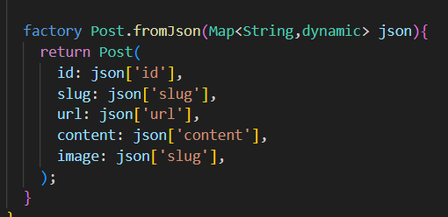 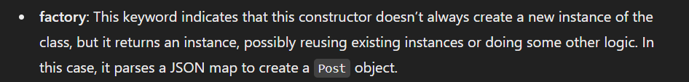

* 3 types k design patterns hotay hain
* Factory is a creational design pattern. Factory ka faida hai k if checks buch jatay, and implementation process hide karta from user.
* ListView Builder future mein kaam nahi karta. Needs data now.
* Snap works asynchronously and renders according to future changes
  + Snap.hasData
  + Snap.hasError
* Lazy Loading