Case B – Consulting Report – Next Auckland Scooter Project
Prepared for: Ben Keith, Next Auckland Company (NAC)
Prepared by: Zainab Kazmi
Date: 29 August 2025

Executive Summary
The AET Data Centre Migration project aims to relocate critical IT infrastructure to a new site while maintaining service continuity for petroleum industry clients. Reliability is paramount, as downtime would undermine AET’s competitive advantage. The project’s priority matrix constrains scope/quality (no downtime allowed), enhances time, and accepts cost flexibility.
The initial schedule (71 days) indicates completion from 1 March 2024 to 10 May 2024, meeting the required timeline. Critical path analysis shows the longest dependency chain runs through network design, city inspection, ventilation, rack installation, approvals, and final cutover activities. These tasks have zero slack and must be managed closely.
Resource allocation highlights pressure on technical staff during installation phases, and the cash flow profile shows expenditure peaking mid-April. With careful monitoring of critical path activities, proactive contractor coordination, and phased approvals, the migration can be achieved within schedule and quality constraints.

Contents
1. Introduction 4
2. Problem and Objectives 4
3. Analysis 6
3.1 Work Breakdown Structure (WBS) 6
3.2 Project Priority Matrix 7
3.3 Initial Schedule Feasibility 8
3.4 Project Duration & Feasibility 8
3.5 Critical Path Activities 9
3.6 Resource and Dependency Risks 9
4. Recommendations to Sophie Smith (Revised) 10

1. Introduction
This report evaluates the feasibility and risks of the AET Data Centre Migration project, scheduled between 1 March and 10 May 2024 (71 working days). Sophie Smith, Network Administrator, must coordinate the relocation of AET’s large data centre with minimal downtime to maintain client access to hosted applications. The project involves dependencies across design, procurement, installation, inspections, and approvals. The priority matrix specifies scope/quality (no downtime) as the key constraint, time as the secondary enhancement goal, and cost as the trade-off variable. This report analyses feasibility, highlights critical risks, and recommends scheduling and resource management strategies.

2. Problem and Objectives
Problem Statement
The migration must be completed within 71 days to minimise costs and ensure operational continuity. The project faces interdependencies across design, procurement, renovation, and installation tasks, making sequencing critical. Any delays along the critical path risk pushing back the cutover date. Scope cannot be compromised, as even a short downtime would jeopardise AET’s reliability reputation.
Objectives
- Confirm whether the project duration (71 days) allows completion by 10 May 2024.
- Identify activities with zero slack that Sophie must monitor most closely.
- Assess the realism of procurement and installation sequencing.
- Analyse resource and approval bottlenecks.
- Provide recommendations to mitigate downtime and ensure quality delivery

3. Analysis

3.1 Work Breakdown Structure (WBS)
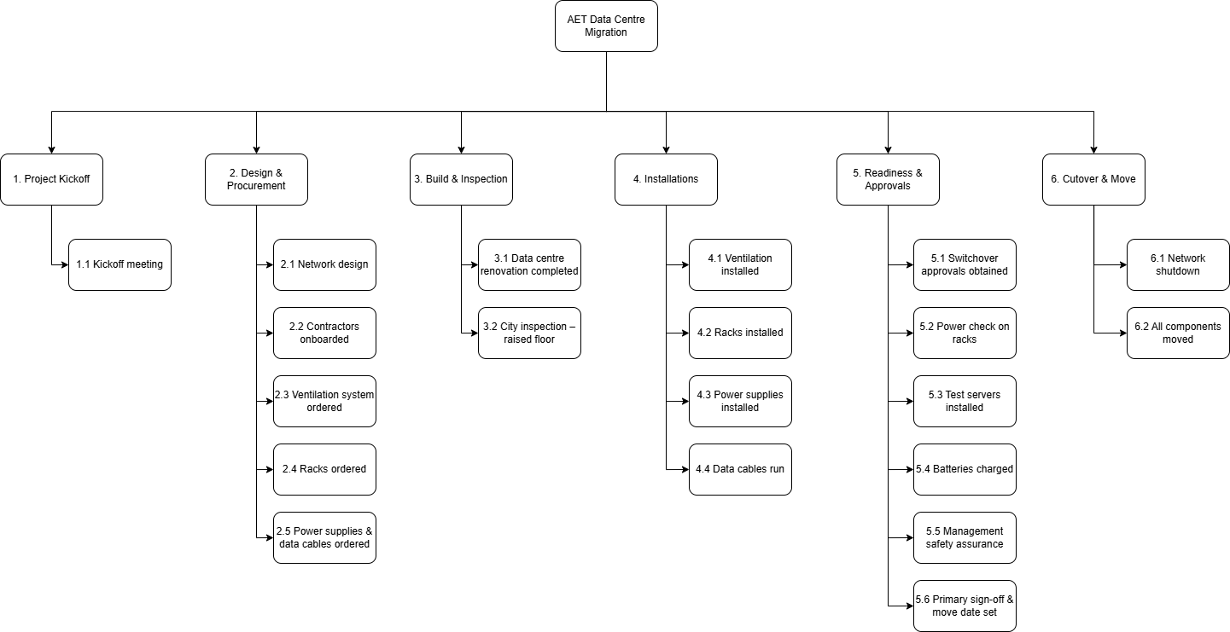
Figure 1: Work Breakdown Structure for AET Migration
The Work Breakdown Structure (WBS) decomposes the AET Data Centre Migration project into six structured phases, each capturing a major deliverable:
- Project Kickoff – Establishes the foundation for the project with the kickoff meeting. This ensures stakeholders are aligned on objectives, timelines, and risk expectations from the very start.
- Design & Procurement – Covers technical design (network layout), contractor onboarding, and ordering of all major equipment (ventilation systems, racks, power supplies, and cables). Breaking this into separate elements reduces the chance of procurement delays cascading into the installation stage.
- Build & Inspection – Encompasses data centre renovations and mandatory city inspections for raised flooring and compliance. Including inspection as a discrete task highlights a known risk point, since delays here could block installation.
- Installations – Represents the physical build-out of the new centre: installing ventilation, racks, power supplies, and running data cables. This is the most resource-intensive stage and directly drives the critical path, so treating each installation as its own activity allows closer monitoring of workload and sequencing.
- Readiness & Approvals – Focuses on validating infrastructure before cutover: switchover approvals, rack power checks, test server installation, battery charging, management safety checks, and final executive sign-off. This staged approach ensures quality is not compromised and all systems are verified as operational before the live migration.
- Cutover & Move – The final phase includes the network shutdown at the old site and migration of all components to the new facility. This is the most sensitive stage as it involves switching client traffic and carries the highest risk if any upstream task is incomplete.
This matters because the WBS doesn’t just list tasks; it clarifies dependencies and responsibilities. It ensures Sophie Smith can allocate resources logically, anticipate risks (e.g., inspection delays, overloaded installation staff), and monitor progress through well-defined milestones. Structuring the work into these six phases provides traceability from initiation to cutover, aligning perfectly with AET’s constraint of “no downtime.”

3.2 Project Priority Matrix
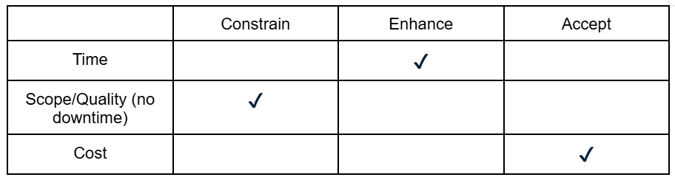
Table 1: Project Priority Matrix
The priority matrix defines how trade-offs between scope, time, and cost should be managed for the AET Data Centre Migration project.
- Scope/Quality – Constrain
Service continuity is the highest priority. The data centre migration must not cause downtime for AET’s clients, since uninterrupted access to hosted applications is a cornerstone of AET’s competitive advantage. This constraint means no corners can be cut on system testing, safety approvals, or compliance checks. For example, tasks like rack power testing, management safety assurance, and switchover approvals cannot be shortened or skipped, even if they add pressure to the schedule.
- Time – Enhance
While not an absolute constraint, time is a secondary priority. Faster completion provides AET with earlier operational stability in the new data centre, reducing the cost of running two facilities in parallel. Where possible, tasks should be accelerated e.g., overlapping procurement with design, pre-booking inspections, or adding contractor capacity for installations. However, acceleration must never undermine scope/quality.
- Cost – Accept
Cost is the most flexible dimension. Management has signalled willingness to absorb higher costs (e.g., overtime labour, expedited shipping of equipment, or hiring additional contractors) if necessary to protect scope and meet schedule commitments. Budget trade-offs are therefore permissible when they reduce schedule risk or guarantee reliability.
This matters because this matrix is crucial for Sophie Smith’s decision-making. It means that in every conflict for example, if inspections run late, or if installation resources are overloaded the project manager must prioritise quality first, schedule second, cost last. This ensures that the migration meets the zero-downtime requirement while still delivering on time, even if it requires extra financial investment.
3.3 Initial Schedule Feasibility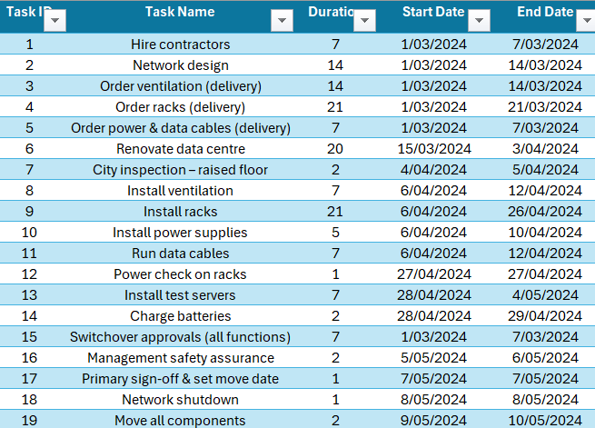 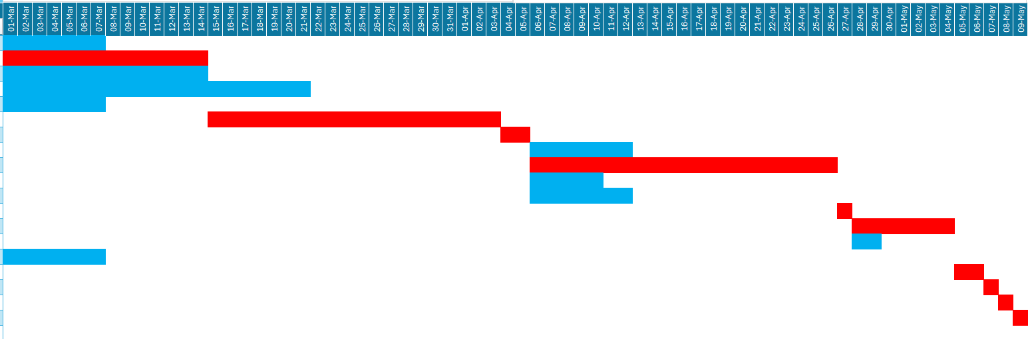
Figure 2: Baseline Gantt Schedule
The Gantt shows a project duration of 71 days (1 Mar – 10 May 2024), which is achievable within constraints. However, several tasks overlap heavily, increasing resource strain and requiring careful sequencing.
The Gantt reveals several important features:
- Feasibility of timeline – The project can be completed by 10 May, ensuring migration occurs within the required timeframe. However, the Gantt also shows minimal slack for approval and cutover tasks, meaning the deadline is highly sensitive to upstream delays.
- Task overlaps – Multiple activities, such as procurement (ordering equipment) and preliminary installations, overlap heavily. While this overlap accelerates the schedule, it also creates pressure on shared resources (contractors, IT staff). If not managed carefully, this concurrency could lead to resource conflicts or idle periods where one task is waiting on another to finish.
- Critical transitions – The Gantt highlights key handoffs: renovation to inspection, ventilation to racks, racks to server installation, and approvals leading to the final shutdown. These transitions are points of risk; if the preceding task is delayed, the downstream activity cannot begin.
- Cutover sensitivity – The final activities (shutdown and move) occur right at the project end date. With no slack, Sophie must ensure all preceding tasks (approvals, installations, testing) are complete before committing to a cutover date.
This matters because the baseline Gantt demonstrates that the project is possible within the set timeframe but also exposes its vulnerability: heavy overlaps and zero slack at the end. Sophie Smith must therefore use the Gantt not just as a schedule, but as a risk map, ensuring careful sequencing, proactive resource management, and contingency planning around inspections and approvals.

3.4 Project Duration & Feasibility
The baseline plan shows completion within 71 days, meeting the required date of 10 May 2024. However, no float exists in the final approval and migration tasks, meaning any upstream delay will directly push the end date.

3.5 Critical Path Activities
The critical path runs through the following sequence:
Network design → City inspection → Install ventilation → Install racks → Power check on racks → Install test servers → Switchover approvals → Primary sign-off & move date → Network shutdown → Move all components.
This path contains all tasks with zero slack, meaning any delay here will directly extend the project’s completion beyond the May 10 deadline.
- Network design (Task 2) is the first critical activity, forming the foundation for subsequent installations.
- City inspection (Task 6) is highly sensitive — it is only one day long and has no buffer, so failure to pass inspection on time would stall all downstream tasks.
- Install ventilation (Task 7) and Install racks (Task 9) are long installation activities that dominate the middle of the schedule. Rack installation, in particular (21 days), is a high-risk driver due to its duration and critical status.
- Power check on racks (Task 12) and Install test servers (Task 13) are short but critical technical tasks, ensuring the infrastructure is ready before approvals.
- Switchover approvals (Task 16) and Primary sign-off & move date (Task 17) are organisational bottlenecks. As approval-based activities, they pose a significant risk if management availability is delayed.
- Finally, Network shutdown (Task 18) and Move all components (Task 19) complete the migration. These tasks are mission-critical to the cutover, with no slack available.
Together, these activities represent the project’s longest chain and therefore must be tightly managed by Sophie Smith to ensure on-time delivery.

3.6 Resource and Dependency Risks
- Procurement tasks (ordering ventilation, racks, and power/data cables) are non-critical individually, but late delivery would create a bottleneck for installation.
- Inspection dependency: The city inspection (1 day) has no buffer; scheduling must be secured early to avoid hold-ups.
- Approvals: Switchover approvals and management safety assurance are critical dependencies, with no slack available.

4. Recommendations to Sophie Smith (Revised)
- Focus on the critical path sequence: The tasks from Network design through to Move all components must be tracked daily. Even minor delays in ventilation or rack installation would cascade forward and jeopardise the deadline.
- Pre-secure inspection and approvals: Since the city inspection (Task 6) and approvals (Tasks 16 & 17) are on the critical path, Sophie should schedule these well in advance and maintain strong communication with city officials and management.
- Allocate contingency for rack installation: Rack installation (Task 9) is the longest activity on the path and carries the highest execution risk. Extra labour or overtime should be budgeted to absorb any slippage.
- Parallel preparation for technical checks: The power check on racks (Task 12) and test server installation (Task 13) should be prepared with checklists and contingency test equipment, ensuring that any faults can be resolved quickly without extending the path.
- Ensure migration readiness before shutdown: Tasks 17–19 (sign-off, shutdown, move) have no buffer. Sophie must confirm in advance that all dependencies (installation, approvals, testing) are cleared before setting the cutover date, as rescheduling would be highly disruptive.

