Case A – Consulting Report – Next Auckland Scooter Project
Prepared for: Ben Keith, Next Auckland Company (NAC)
Prepared by: Zainab Kazmi
Date: 29 August 2025

Executive Summary
This report evaluates the feasibility and execution of the Next Auckland Scooter Project, which must deliver a children’s scooter product to the market by 6 October 2025 to capture the 2025 Christmas sales window.
The baseline plan indicates completion in 141 working days from the 3rd of March to the 22nd of September 2025 with a total estimated cost of $539,920. The project therefore meets the deadline with a two-week buffer.
Critical analysis identified a zero-slack critical path running through Product Design, Manufacturing Study, Product Design Selection, Manufacturing Process, Detailed Product Design, Prototype Testing, Finalised Product Design, and Procurement (with additional shipping lags). These tasks must be carefully monitored, as any delay would directly threaten the project deadline.
Resource analysis highlighted overallocation of Design Engineers, Industrial Engineers, Marketing Specialists, and the sole Purchasing Agent. To resolve this, additional resources were applied only to three critical tasks. Detailed Product Design, Manufacturing Process and Install Production Equipment which reduced durations and balanced the workload. Procurement lags of 10 and 15 days were modelled using Finish-to-Start (FS+10 and FS+15) dependencies to reflect realistic shipping times for production equipment and components.
Cost analysis confirmed that Detailed Product Design ($92,400) is the most expensive activity, followed by the Manufacturing Process and Product Design. Resource cost drivers are primarily Industrial and Development Engineers. Cash flow peaks between May–July 2025, reflecting intensive design, production, and procurement phases.
The report recommends focused monitoring of critical activities, proactive supplier management, phased milestone financing, and structured approval gates. With these measures, NAC can deliver on time, within budget, and with reduced execution risk.

Contents
1. Introduction 4
2. Problem and Objectives 4
3. Analysis of the Business Scenario 5
3.1 Baseline Schedule and Deadline Feasibility 5
3.2 Critical Activities to Manage Closely 7
3.3 Resource Overallocation and Levelling 10
3.4 Revised Feasible Plan with Extra Resources 11
3.5 Predecessor and Lag Adjustments 11
3.6 Project Cost Estimate 12
3.7 Activity Cost Drivers and Cash Flow 13
4.Recommendations to the Client (Ben Keith) 13

Introduction
Next Auckland Company (NAC) is pursuing a new product introduction: a children’s scooter based on a popular cartoon character. The commercial viability of the scooter is tied to the seasonal Christmas market, meaning the scooter must be available in retail channels by 6 October 2025. Any delay would risk losing demand, as consumer tastes in this category are volatile.
Ben Keith, Product Manager, has prepared a preliminary activity list, consulted with the engineering and development teams, and identified constraints such as limited resources and shipping lead times. He has engaged this report to evaluate the feasibility of the project, determine risks, and recommend a viable plan for execution.
This report provides a detailed feasibility assessment, cost analysis, and recommended scheduling adjustments. It answers Ben Keith’s key concerns: whether the deadline is achievable, which activities require the closest management, whether resources are overloaded, how additional resources should be allocated, and what the financial implications are.

Problem and Objectives
Problem Statement
Next Auckland Company must launch a children’s scooter by 6 October 2025 to capture the Christmas sales window. The project begins 3 March 2025 under a Time-constrained priority (Scope: Enhance; Cost: Accept) with a lean workforce allocation: Marketing 4, Design 4, Development 4, Industrial 4, Purchasing 1.
Execution risk is high due to multiple factors:
- Product Design and Manufacturing Study must finish together to allow simultaneous outcome review before Product Design Selection.
- Procurement tasks (Order Components and Order Production Equipment) include unavoidable shipping lags of 10 and 15 days, delaying installation readiness.
- Resource analysis revealed overallocation of Marketing, Design, and Industrial Engineers, as well as the sole Purchasing Agent, creating infeasible bottlenecks.
- Without adjustment, critical-path tasks could suffer slippage, endangering the October 2025 deadline
Objectives
- Confirm whether the project can be completed by the 6 October 2025 deadline under the given calendar and constraints.
- Identify the activities on the critical path that require the closest monitoring and control to prevent slippage.
- Evaluate the feasibility of the initial baseline plan, considering schedule logic, resource limits, and procurement dependencies.
- Diagnose and resolve resource overallocations, ensuring that workloads are realistic and aligned with the project’s limited workforce.
- Develop a revised feasible plan that uses additional resources selectively, in line with the project’s priority matrix (Time = Constrain; Scope = Enhance; Cost = Accept).
- Estimate total project costs and highlight the activity that incurs the highest expense, with an explanation of why.
- Forecast the project’s monthly cash flow to anticipate peak expenditure periods and inform financial planning.

3. Analysis of the Business Scenario

3.1 Baseline Schedule and Deadline Feasibility
The baseline schedule begins on 3 March 2025 and runs for 141 working days, finishing on 22 September 2025. This comfortably precedes the required 6 October 2025 deadline, providing a small contingency buffer. The baseline is therefore time-feasible, assuming critical activities proceed without interruption.
Initial Gantt chart: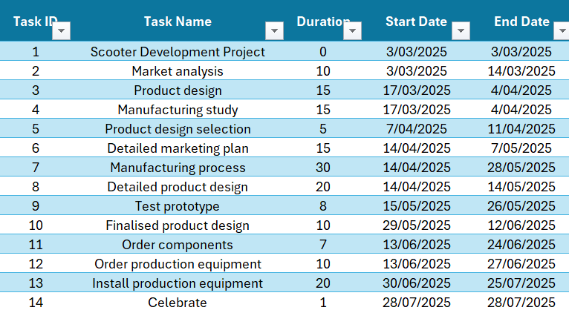 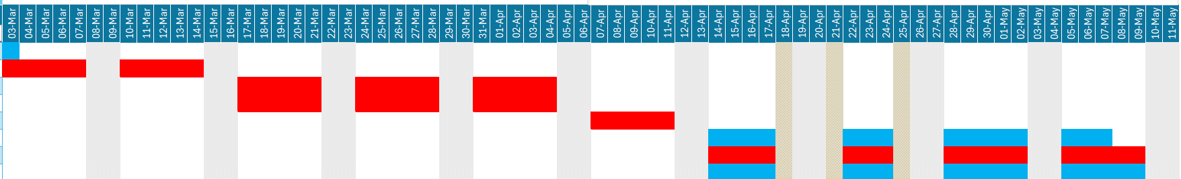

Improved Gantt chart: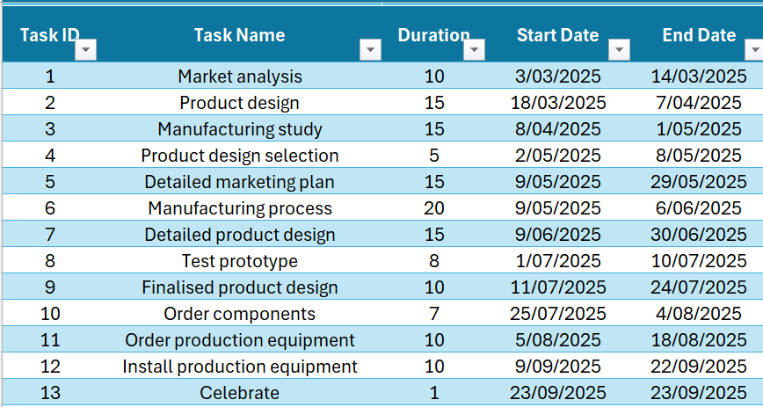 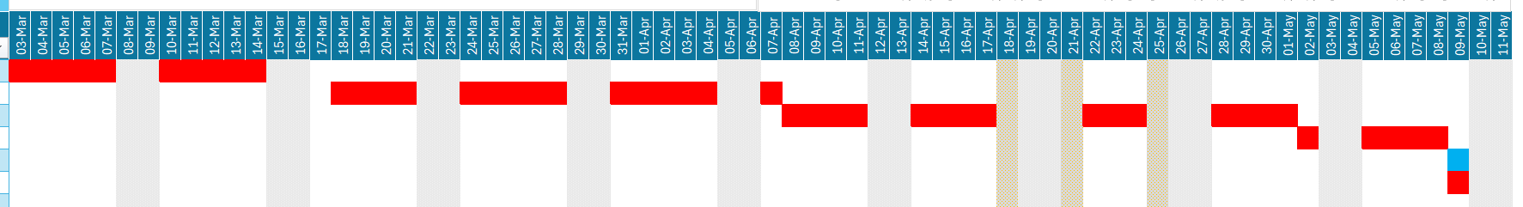

3.2 Critical Activities to Manage Closely
The critical path runs through:
Market Analysis → Product Design → Manufacturing Study → Product Design Selection → Manufacturing Process → Detailed Product Design → Test Prototype → Finalised Product Design → Procurement (with lags) → Installation.
This path has zero slack, meaning these tasks must be tightly monitored. Any slippage in these areas would directly impact delivery. The procurement tasks are especially risky due to the added FS+10 and FS+15 shipping delays.
Initial network diagram:
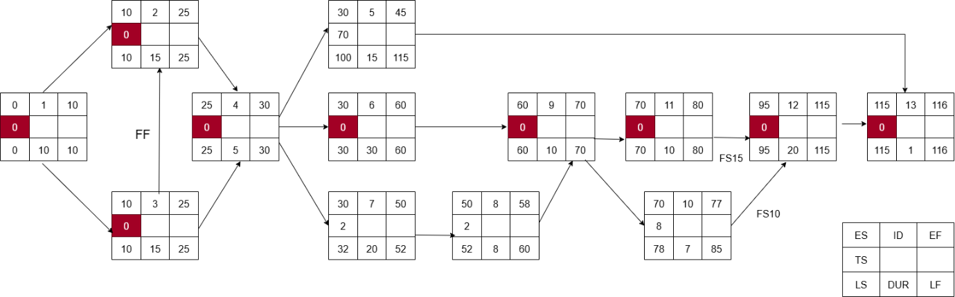
Improved Network Diagram:
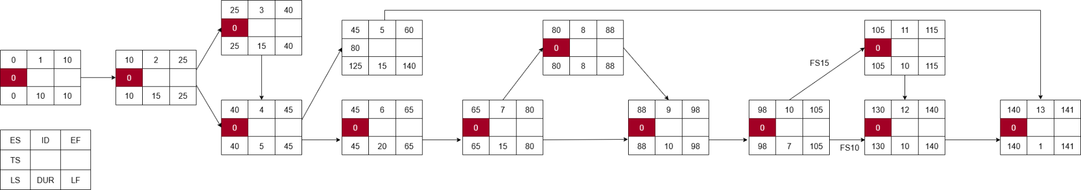

3.3 Resource Overallocation and Levelling
The baseline resource analysis revealed multiple points of overallocation, which meant the initial plan was infeasible without intervention.
Design Engineers were heavily overallocated during the overlapping phases of Product Design, Detailed Product Design, and Prototype Testing. Since only 4 were available but tasks demanded up to 5 simultaneously, this created a bottleneck that would have forced either delays or reduced quality of work.
Industrial Engineers also faced conflicts, particularly between the Manufacturing Process and later Installation tasks. The Manufacturing Process alone required all four Industrial Engineers continuously for several weeks, leaving none available for installation preparations, a clear scheduling risk.
Marketing Specialists were overloaded during the Detailed Marketing Plan, especially when combined with their contributions to Product Design Selection. Demand temporarily exceeded the capacity of four staff.
Finally, the Purchasing Agent was a single point of failure: one person was responsible for both component and equipment orders, which were on the critical path. If the agent was delayed, both procurement streams would slip.
In summary, the baseline plan forced more resources than available at key points, creating risks of delay and burnout. Without resolving these overallocations, the schedule could not have been executed as planned.
Initial Resources graph
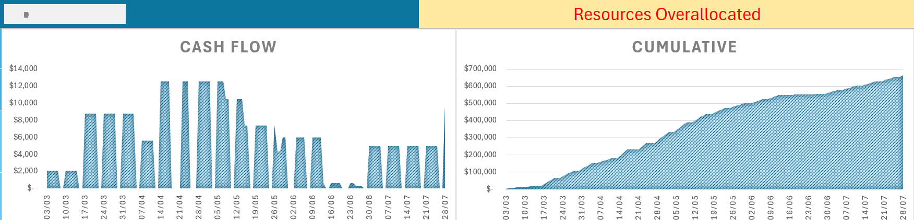

Improved Resources graph
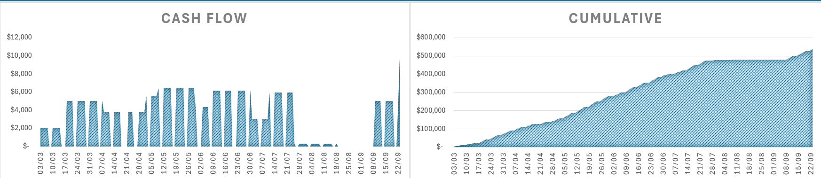

3.4 Revised Feasible Plan with Extra Resources
To make the plan feasible, additional resources were allocated selectively to three activities that lay directly on the critical path:
Detailed Product Design – This task was originally scheduled for 20 days but was reduced to 15 days by assigning 1 additional Design Engineer and 1 Development Engineer. This decision was made because Detailed Product Design is not only resource-intensive but also the single costliest activity ($92,400) in the project. Reducing its duration and balancing workload ensured the team could finish this design stage on time without overburdening staff, and it created buffer time for downstream prototype and final design tasks.
Manufacturing Process – Originally planned for 30 days, this task demanded all 4 Industrial Engineers continuously, creating both an infeasibility and no slack for unexpected delays. By assigning 2 additional Industrial Engineers, the task duration was cut to 20 days. This adjustment was critical because the Manufacturing Process is on the critical path and represents one of the highest cost drivers. Reducing its duration eased the resource load and freed staff for later installation stages, eliminating overlaps and conflicts.
Install Production Equipment – This activity was shortened from 20 to 10 days by assigning 1 additional Industrial Engineer and 1 Development Engineer. Installation is tightly linked to the procurement chain (with FS+10 and FS+15 lags), meaning delays here would push the entire project past the deadline. Accelerating installation not only reduced risk but also created additional buffer before the launch.
Notably, we did not use the extra Marketing resources offered for the Detailed Marketing Plan. This task lies off the critical path and has positive slack, meaning even if it took the full 15 days, it would not affect the final completion date. Therefore, assigning additional Marketing Specialists here would not improve the schedule outcome and would only add unnecessary cost.
This targeted use of additional resources solved all overallocation issues, balanced workloads across roles, and kept the project cost-effective while safeguarding the deadline.

3.5 Predecessor and Lag Adjustments
Several structural changes were made to the dependency network to improve realism and reflect operational constraints in NAC’s environment:
Finish-to-Start (FS+1) between Product Design and Manufacturing Study
In the baseline, Product Design (Task 2) and Manufacturing Study (Task 3) were set up as purely sequential. To align with team feedback that both streams should progress almost in parallel but still allow for outcome review, we introduced a short FS+1 lag. This means Manufacturing Study begins one day after Product Design starts, keeping the two tasks closely staggered but not entirely independent. This reflects real-world practice where design insights slightly precede manufacturing evaluation, without forcing full completion before progress can begin. The adjustment avoids idle time, preserves workflow continuity, and ensures Product Design Selection (Task 4) still receives both outputs in sequence.
Shipping Lags for Procurement
Procurement tasks were updated to explicitly model shipping delays:
- Order Components → Install Production Equipment: FS+10 (10-day shipping lag).
- Order Production Equipment → Install Production Equipment: FS+15 (15-day shipping lag).
These changes were critical because logistics delays are often underestimated in baseline schedules. By embedding these lags, the plan now gives Ben a more realistic picture of when installation can actually commence. This ensures supplier lead times are visible in the critical path and highlights the need for proactive procurement management.

3.6 Project Cost Estimate
The revised project has a total estimated cost of $539,920, which includes all direct labour across Marketing, Design, Development, Industrial Engineering, and Procurement. Importantly, the cost estimate did not increase despite adding extra resources, because these were specifically allocated to reduce durations on critical tasks without extending overall labour load across the project.
Breakdown of resource costs:
Industrial Engineers: $155,400
Development Engineers: $149,600
Design Engineers: $124,880
Marketing Specialists: $93,080
Purchasing Agent: $16,960
This distribution highlights that the Industrial and Development Engineers are the key cost drivers, representing nearly 57% of the total cost.

3.7 Activity Cost Drivers and Cash Flow
- Most expensive activity: Detailed Product Design ($92,400), because it requires sustained high input from Design and Development Engineers, the two most expensive roles on the team.
- Other high-cost activities: Manufacturing Process ($86,400) and Product Design ($75,600). Together, these three tasks consume over 47% of the project budget.
- Cash flow profile:
- March–April: Spending is moderate, reflecting Market Analysis, Product Design, and Manufacturing Study.
- May–July: Expenditure peaks above $100,000 per month as Manufacturing Process, Detailed Product Design, and procurement activities overlap. This is the riskiest period financially, as cost overruns here would magnify cash strain.
- August–September: Costs decline as installation and final approvals dominate.
- This profile suggests Ben should secure financing to cover the mid-year spike in resource demand and ensure contingency funds are available if supplier delays increase costs during procurement.

4.Recommendations to the Client (Ben Keith)
- Monitor the critical path rigorously – Focus on Product Design, Manufacturing Process, Detailed Product Design, Prototype Testing, Finalised Product Design, and Procurement with FS lags. These tasks have zero slack and must not slip.
- Leverage milestone approvals – Formal review gates should be built after Product Design Selection, Prototype Testing, and Installation. This prevents errors from propagating downstream.
- Manage cash flow actively – Ensure funding reserves are available in May–July 2025, when project expenditure peaks. Negotiating phased payments with suppliers could reduce strain.
- Preserve slack in non-critical tasks – Use tasks like the Detailed Marketing Plan as contingency levers. Delays here will not affect project completion and can absorb minor shocks.
- Supplier engagement and logistics – Communicate procurement deadlines early, track shipping closely, and negotiate penalties for late deliveries to mitigate FS+10 and FS+15 risks.
- Resource wellbeing – Avoid over allocating key engineers by sticking with the revised resourcing plan. This reduces burnout risk and preserves productivity.

