🌸 StayPink
Airbnb-Inspired Full Stack Web Application
Full Stack Web Development Project Report

Submitted by: Zainab Nayeem

Date: 17th May, 2026

[Department Of Artificial Intelligence & Data Science]
SIKKIM MANIPAL INSTITUTE OF TECHNOLOGY
(A constituent college of Sikkim Manipal University)
MAJITAR, RANGPO, E AST SIKKIM – 737136

1. Project Overview
StayPink is a fully functional Airbnb-inspired property rental web application built using the MERN stack (MongoDB, Express.js, React.js, and Node.js). The application allows users to browse property listings, register and log in securely, add their own property listings with image uploads, and manage their bookings through a personalized dashboard.

The project was developed as part of a Full Stack Web Development internship to demonstrate proficiency in end-to-end web application development, including frontend design, backend API development, database management, cloud integrations, and deployment.

2. Project Details

Project Name | StayPink - Airbnb Clone
Live URL | https://ornate-gumption-5de0ff.netlify.app
GitHub Repo | https://github.com/zainab-nayeem/airbnb-clone
Backend API | https://staypink-server.onrender.com
Type | Full Stack MERN Web Application
Developer | Zainab Nayeem
Completion Date | May 2026

3. Technology Stack

Category | Technology | Purpose
Frontend | React.js | UI components and routing
Styling | Tailwind CSS + Inline Styles | Baby pink responsive design
Backend | Node.js + Express.js | REST API server
Database | MongoDB Atlas | Cloud-hosted NoSQL database
Authentication | JWT + bcryptjs | Secure user auth
Image Storage | Cloudinary | Cloud image upload & hosting
Frontend Deploy | Netlify | CI/CD frontend hosting
Backend Deploy | Render | Node.js backend hosting
Version Control | GitHub | Source code management

4. Features Implemented

4.1 User Authentication
- User registration with name, email, and password
- Secure login with JWT token-based authentication
- Password hashing using bcryptjs
- Protected routes for authenticated users
- Persistent login state using localStorage

4.2 Property Listings
- Browse all available listings on the home page
- Filter listings by category (Beach, Mountain, City, Cabin, Luxury, etc.)
- Search listings by location
- View detailed listing pages with image gallery, amenities, and booking form
- Add new listings with title, description, location, price, guests, and photos
- Image upload to Cloudinary with real-time preview

4.3 Booking System
- Book a property with check-in and check-out dates
- Guest count selection with maximum limit enforcement
- Automatic total price calculation based on number of nights
- Booking confirmation message on successful reservation

4.4 User Dashboard
- View all personal listings with options to view or delete
- View all bookings made by the user
- Quick access to add new listings
- Logout functionality

5. Application Architecture
The application follows a client-server architecture with a clear separation between the frontend and backend:

- Frontend (React.js) communicates with the backend via RESTful API calls using Axios
- Backend (Express.js) handles all business logic and database operations
- MongoDB Atlas stores all user, listing, and booking data in the cloud
- Cloudinary handles all image uploads and serves optimized image URLs
- JWT tokens secure all protected API endpoints

6. API Endpoints

Authentication Routes (/api/auth)
- POST /register - Create new user account
- POST /login - Authenticate user and return JWT token

Listings Routes (/api/listings)
- GET / - Fetch all listings (with optional filters)
- GET /my - Fetch listings by logged-in user
- GET /:id - Fetch single listing by ID
- POST / - Create new listing (authenticated)
- DELETE /:id - Delete a listing (authenticated)

Bookings Routes (/api/bookings)
- POST / - Create a new booking (authenticated)
- GET /my - Fetch bookings by logged-in user

7. Deployment
The application is deployed as two separate services:

Frontend | Netlify - Auto-deploys from GitHub main branch
Backend | Render - Node.js web service with environment variables
Database | MongoDB Atlas - M0 free tier cluster
Images | Cloudinary - Free tier with 25GB storage

Environment variables are securely configured on both Netlify and Render, keeping all API keys and secrets out of the source code.

8. Challenges & Solutions

Image Upload | Configured Cloudinary with multer memory storage and base64 encoding for seamless image uploads
CORS Issues | Enabled CORS middleware on Express server to allow cross-origin requests from Netlify frontend
ESLint Build Errors | Set CI=false environment variable on Netlify to prevent warnings from blocking production builds
Publish Directory | Corrected Netlify publish path from client/client/build to build by setting base directory to client
Auth Persistence | Used localStorage to persist JWT token and user data across browser sessions

9. Conclusion
StayPink successfully demonstrates the development of a complete, production-ready full stack web application from scratch. The project covers all aspects of modern web development including responsive UI design, RESTful API development, database design, cloud integrations, user authentication, and cloud deployment.
The application is fully live and accessible at:
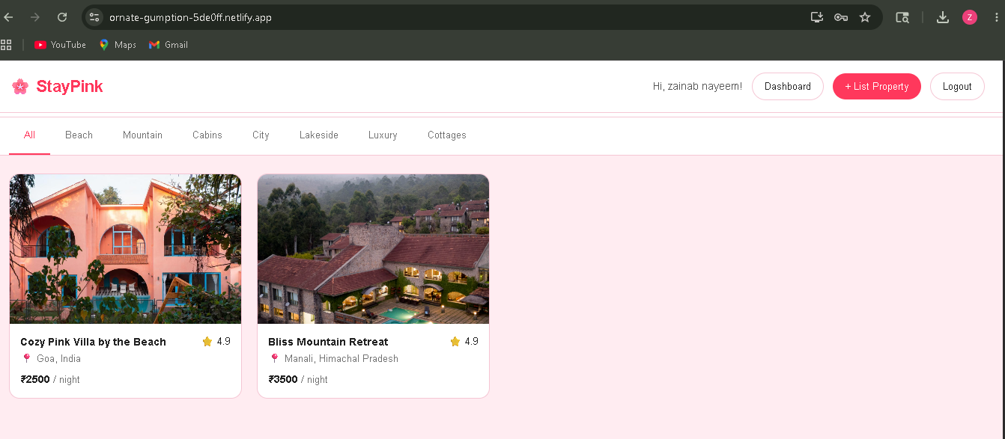
https://ornate-gumption-5de0ff.netlify.app

This project reflects strong competency in the MERN stack and the ability to independently build and deploy a complex web application end-to-end.

