Group Contract

Group Responsibilities
The success of a group depends on the contributions and professionalism of each and all of its members. When you join a group, you are throwing your lot in with the group. The group will let each member share in the fruits of its labour and each member should pay the group back by contributing to the group effort.
The group contract lays out the responsibilities and expectations of the group members. It also lays out how responsibilities will be determined, how group members can contact one another, consequences when group members do not meet their responsibilities, giving credit for work done and not giving credit for work which was not done.
This is a template for a contract. You can alter the parts you feel need to be altered. The final contract does need to be approved by the instructor and then signed by all members of the group.

Contact Information
Name | Email | Phone (optional) | Social Media
Anshaal Kumar | akumar239@yseneca.ca | N/A | N/A
Bibek Adhikari | Badhikari9@myseneca.ca | N/A | N/A
Zainab Mustak Vadia | zmvadia@myseneca.ca | N/A | N/A
Chieh Sung | csung7@myseneca.ca | N/A | N/A
Hanane Benidder | hbenidder@myseneca.ca | N/A | N/A
Thien Phuc Ngo | tpngo@myseneca.ca | N/A | N/A
 |  | N/A | N/A

Professionalism
As a member of this group, I will conduct myself in a professional manner, just as I would in the workplace. I will abide by the decisions of the group and participate in the group activities to the best of my ability. I will strive to be pleasant and treat my fellow group members with respect. Should conflict arise, I will do my best to overcome it and put it behind us.
INITIALS: BA, ZV,CS, AK, HB, TPN

Group Meetings
All group members agree to meet in the assigned class time.
In addition, they agree to participate in _1-2__ meeting(s) per week outside of class time.
Individual contributions will be completed by __3 days after assigned__ and the group submission will be completed by the _submission date_.
For the preparation of group submissions, the group will meet __online/in-person__ via _zoom____.
INITIALS: BA, ZV, CS, AK, HB, TPN

Work Distribution
Work will be distributed during a weekly group meeting where members pick the work that they are best equipped to do. Members will make every effort to distribute the work evenly amongst the group members.
INITIALS: AK, BA, ZV, CS, HB, TPN

Plagiarism
The group will submit only work done by the members of the group. The group will not post their workshops, assignments or other work on the internet or distribute it to others in any other manner.
INITIALS: AK, BA, ZV,CS,HB, TPN

Consequences
A group member who is often late for meetings or absent shall __- 10 percent___.
A group member who fails to complete their chosen work on time shall ____- 20 percent___.
A group member who submits substandard work shall ___- 10 percent__.
If a group member does not pick a fair share of the work the group shall ___- 10 percent___.
If a group member does not treat their fellow group members with courtesy and respect the group shall __- 20 percent_____.
INITIALS: AK, BA, ZV,CS,HB, TPN

Conflict Resolution
In the event there are inter-personal issues within the group or if a member does not meet their commitments, the group shall _______talk it out, vote________.
INITIALS: AK, BA, ZV,CS,HB, TPN

Other Rules
(add as appropriate)
INITIALS: AK, BA, ZV,CS,HB, TPN

Signatures
By signing below, I agree to abide by the group contract.
DATE: ____2/20/2024______
Print Name: Anshaal Kumar Signature:

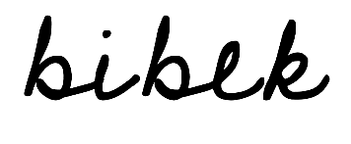
Print Name: Bibek Adhikari Signature:
Print Name: Zainab Mustak Vadia Signature:

Print Name: Chieh Sung Signature:

Print Name: Hanane Benidder Signature:
Print Name: Signature: 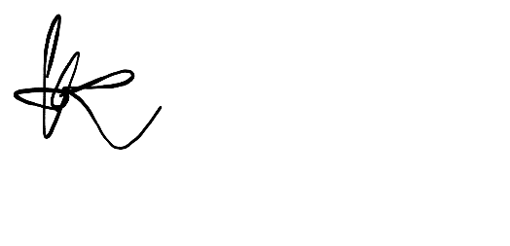

Print Name: Ngo Thien Phuc Signature:

