Technical Analysis Using R

Student Name: Zainab Lutfi
Course: BDA400 – Data Science Tools and Techniques
Assignment: A02
https://github.com/zainab2310/TechnicalAnalysis

Step 1: Creating the GitHub Repository
I created a GitHub repository named TechnicalAnalysis to organize and store the assignment files, including the R script, portfolio file, and report.
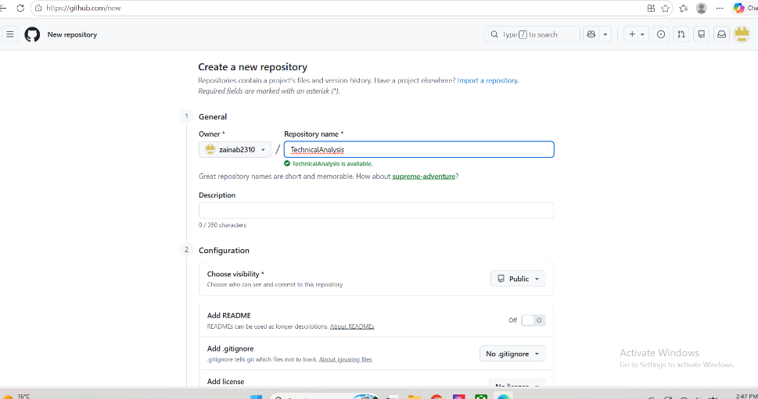
Step 2: R and RStudio Installation and Setup
I installed R and RStudio on my computer. After installation, I opened both programs to verify that they were working correctly. The screenshots below show the R Console and RStudio successfully running.
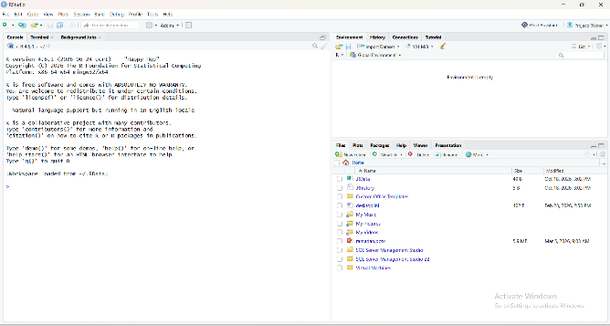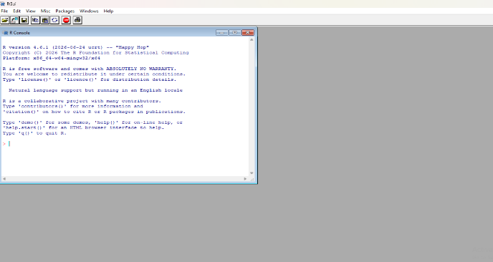

Step 3: R Packages Installation
I installed the required R package, quantmod, in RStudio to retrieve and analyze historical stock market data from Yahoo Finance. This package was used to load stock prices and create visualizations.
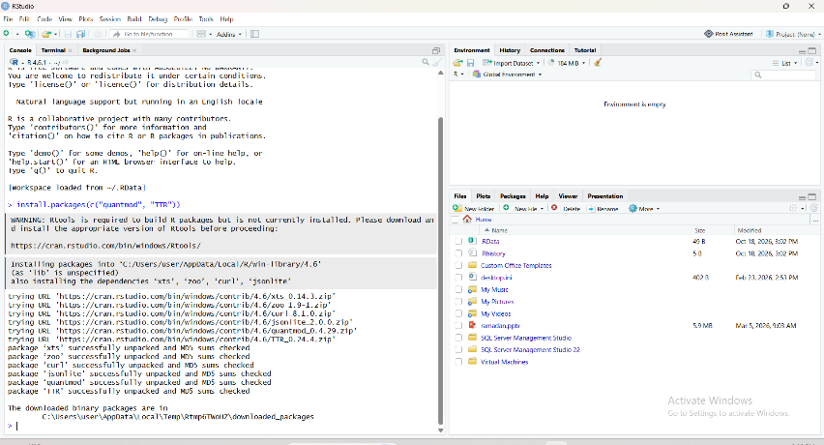

Step 4: Creating the Portfolio File

I created a text file named portfolio.txt containing five stock symbols: AAPL, MSFT, GOOGL, AMZN, and TSLA. This file is used by the R script to retrieve historical stock market data from Yahoo Finance.
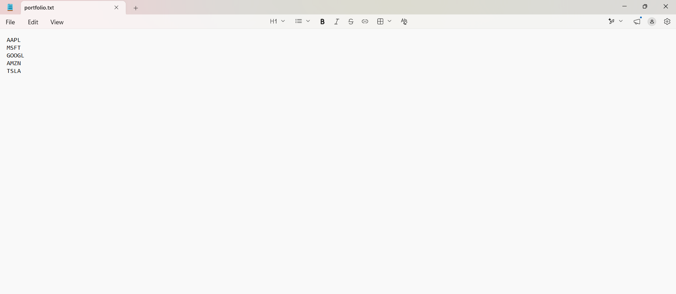

Step 5: Loading Stock Data into R
I used RStudio and the quantmod package to load historical stock market data from Yahoo Finance. I created a function called load_stock_data() to read the stock symbols from portfolio.txt and store the data for each stock in a separate data frame.
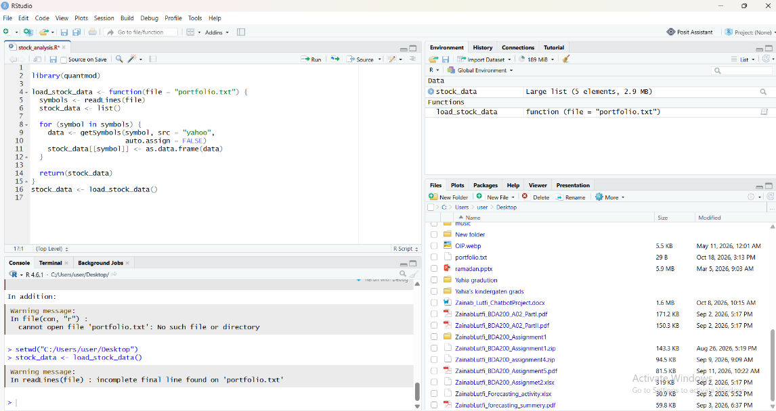
Step 6: Calculating Stock Statistics
I created a function called calculate_statistics() in RStudio to calculate the moving average, mean, mode, median, and standard deviation for each stock. I used lapply() to apply the function to all five stocks: AAPL, MSFT, GOOGL, AMZN, and TSLA. The calculated statistics were successfully displayed in the RStudio Console.
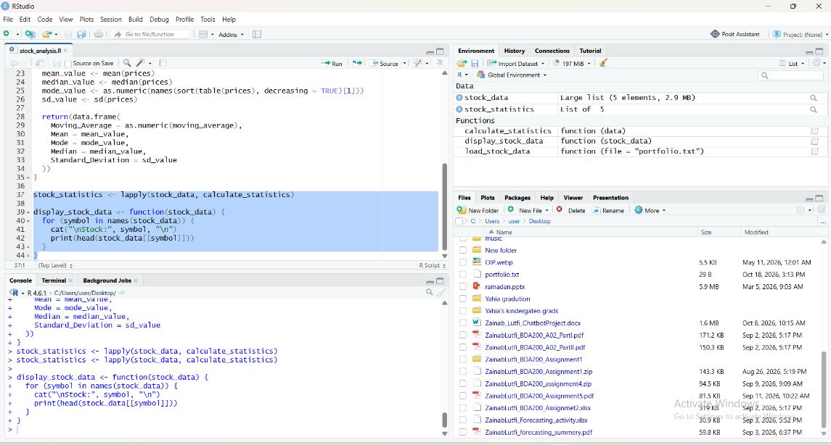

Step 7: Stock Price Visualizations
I created stock price charts in RStudio for AAPL, MSFT, GOOGL, AMZN, and TSLA to visualize their historical stock price movements.
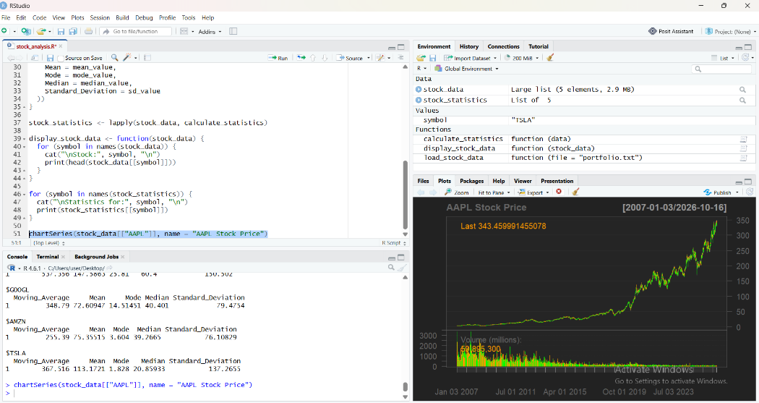
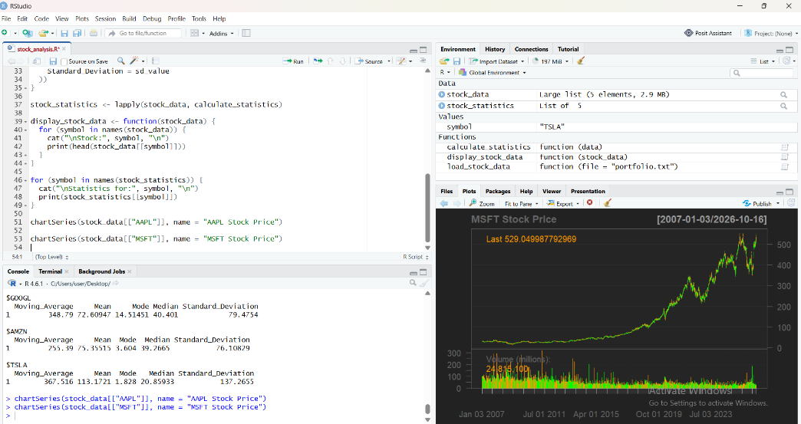

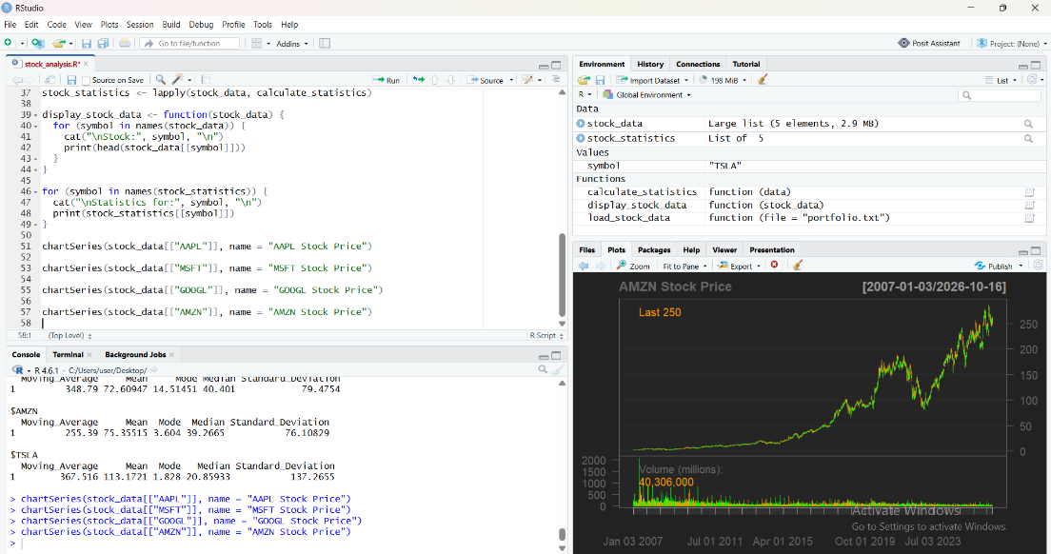
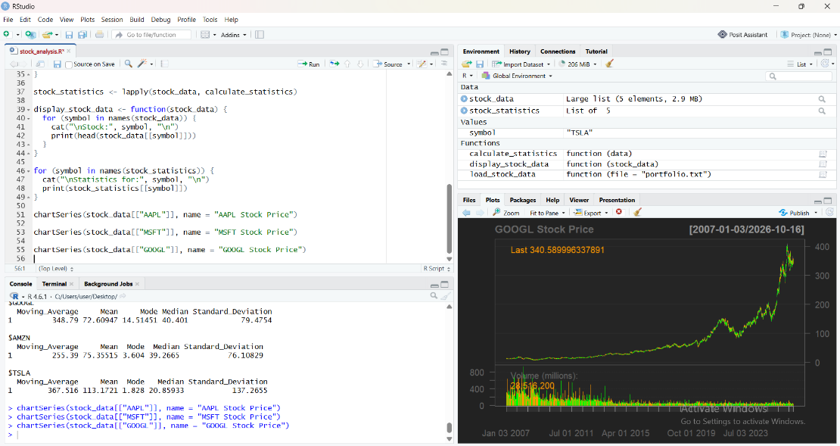
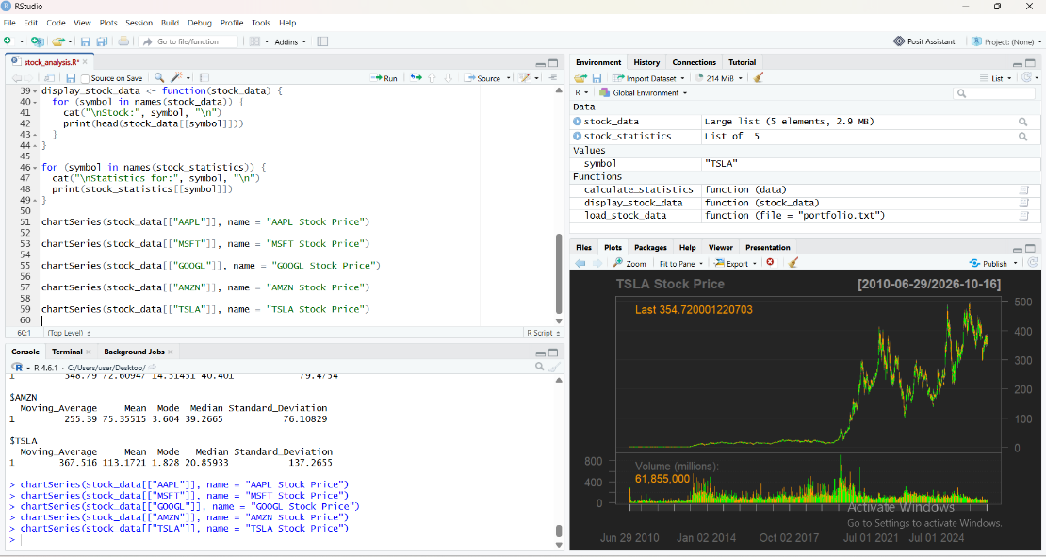

Step 8: GitHub Repository Submission
I uploaded the portfolio.txt file and R script (stock_analysis.R) to my GitHub repository named TechnicalAnalysis. The repository contains the project files for the stock market technical analysis assignment.

