MIT 8103 Advanced Database Systems - Portfolio Documentation
Student: Zainab Abubakar Bakabe Matric No.: 2026/A/MIT/0791 Student ID: 301929341 GitHub: https://github.com/zainababubakarbakabe-alt/advanced-database-portfolio (private; assessor added as collaborator)

1. Selected organisation
NaijaCart is a simulated Nigerian multi-seller e-commerce marketplace. Users of the database: customers, sellers, dispatch staff, finance staff and analysts. Major data: customers and addresses, sellers, a category tree, products and stock, orders and order items, payments (card, transfer, USSD, wallet), deliveries and reviews. Key operations: browse the catalogue, place an order and reduce stock, take payment, track delivery, review products, report sales. Test data: 50,000 customers, 20,000 products, 200,000 orders and 600,000 order items, generated with a fixed seed so every run is identical. The same case study runs through all five portfolios on PostgreSQL 16 and Redis 7; run_all.sh rebuilds everything in about two minutes.

2. Portfolio 1 - Database design and modelling
The 11-table schema is in BCNF: every functional dependency’s determinant is a candidate key (listed in the README). Normalising a spreadsheet-style order sheet turned repeating product columns into order_item rows (1NF), moved product facts out of the composite-key table (2NF) and moved customer, seller and category facts into their own tables (3NF). Business rules are enforced by the database, not just the application: CHECK (stock_qty >= 0), positive prices and quantities, status lists, one payment and one delivery per order, and one review per customer per product. order_item.unit_price is a deliberate denormalisation that preserves the price paid. Four roles implement least privilege; an analyst login could read 600,000 rows through an anonymised view but was refused access to customer emails and could not delete orders (NDPA 2023 data minimisation).
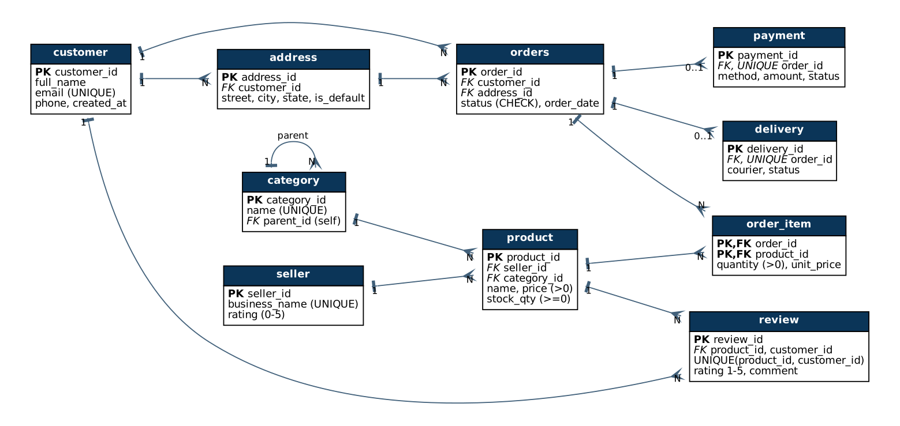
NaijaCart ER diagram (crow’s foot notation)

3. Portfolio 2 - Query processing and optimisation
Seven queries (joins, CTEs, a window function, aggregations) were measured with EXPLAIN (ANALYZE, BUFFERS) and timed as the median of five runs, before and after optimisation. Indexes chosen from the plans gave large gains only on selective queries: customer order history 12.0 to 0.31 ms (38.6x), replacing a sequential scan of 200,000 rows with an index scan; low-stock alert 1.35 to 0.26 ms (5.1x) with a covering index. Full-scan analytics did not improve with indexes, so other techniques were tested: a materialized view reduced the revenue report from 952 ms to 0.09 ms (at a refresh cost of 567 ms), and parallel query made Q3 and Q4 1.8x faster. The repeat-customer query’s plan showed an 11 MB disk sort; raising work_mem moved the sort into memory but did not reduce the time, proving the join, not the sort, was the bottleneck. Costs were measured too: the new indexes use 16.7 MB and made 20,000 order inserts 2.8x slower (15.3 to 42.3 ms).
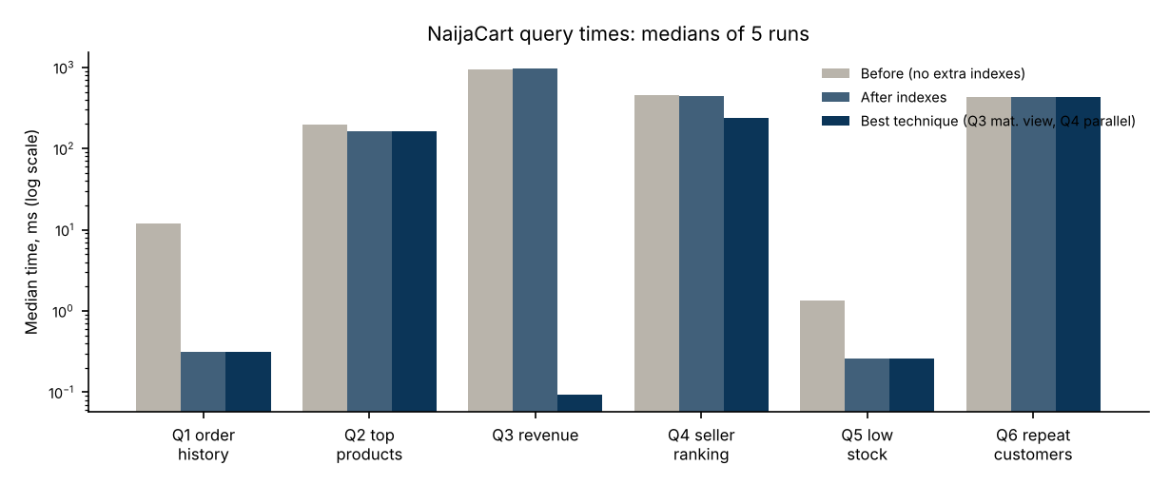
Median query times before and after optimisation (log scale)

4. Portfolio 3 - Transactions and concurrency
place_order() performs the order, stock decrement, items, payment and stock log as one atomic transaction. An order for 10 units when 3 remained violated the CHECK constraint and rolled back completely (order count unchanged); a SAVEPOINT undid one of two updates. Two concurrent sessions reproduced a lost update: both bought the last unit (stock oversold). Pessimistic locking (FOR UPDATE) and an atomic conditional UPDATE each fixed it, selling exactly one unit. READ COMMITTED showed a non-repeatable read (10,000 then 12,000) that REPEATABLE READ prevented; SERIALIZABLE aborted a write-skew transaction, and a retry loop then re-ran it correctly. Opposite lock order caused deadlock detected; a consistent lock order removed it. Optimistic locking (a version column) rejected a stale admin edit, and an MVCC test showed a reader seeing the old committed price without waiting while a writer held an uncommitted change. Each technique is matched to the NaijaCart situation it suits.

5. Portfolio 4 - NoSQL and advanced data models
Orders, payments and stock stay relational because they need ACID guarantees; other workloads use the model that fits them (polyglot persistence). Document: the catalogue as 20,000 JSONB documents with category-specific attributes and embedded latest reviews; a GIN index cut an attribute search from 6.2 to 0.63 ms, and loading 2,000 product pages took 24 ms as documents versus 106 ms relationally (4.4x). Key-value (Redis): carts as hashes with a 7-day TTL, sessions with a 30-minute expiry, an atomic DECR flash-sale counter (the fourth buyer for three units got -1 and was rejected) and a sorted-set best-seller board. Graph: a Cypher design for “customers who bought this also bought”. Embedding-versus-referencing and the consistency of each store are justified in the README. The MongoDB script is provided with run instructions.

6. Portfolio 5 - Distributed and cloud database
A primary and a streaming hot standby were built with pg_basebackup. Asynchronous replication applied writes in about 0.1 s and the replica rejected writes. Switching to synchronous replication and stopping the standby blocked the next commit (wait_event = SyncRep), demonstrating CAP’s choice of consistency over availability; the primary was then crashed and the replica promoted, and service continued. Orders were hash-sharded on customer_id across two nodes with postgres_fdw (10,098 and 9,902 rows); a per-customer query was pruned to one shard, while a global report had to scan both. The cloud design uses synchronous commit to any one of two standbys for payments, asynchronous replicas for browsing and reports, managed Redis, point-in-time recovery, and data kept in Nigeria where possible to simplify NDPA cross-border rules.

7. Individual technical reflection
The biggest lesson was that measurement beats assumption. I expected indexes to speed up every slow query, but the plans showed they only help selective lookups: order history became 38.6x faster while the revenue report did not change, because it needs almost every row. The same lesson came from the repeat-customer query, whose plan showed an 11 MB disk sort; when I gave it enough memory the sort moved into RAM but the query was no faster, so the real bottleneck was the join. A diagnosis is only a hypothesis until it is tested.
Concurrency bugs were the hardest to see. With one session, the read-then-write stock update looked correct; it only oversold when two sessions ran at the same moment, which I had to force with deliberate delays. I also learnt that SERIALIZABLE is only safe with a retry loop, and that a synchronous commit cannot be stopped by statement_timeout - my first test hung until I cancelled the waiting session explicitly.
I also found errors in my own work. My first phone data never contained a 128 GB model because of a modulo pattern, so a correct query returned zero rows. A benchmark loop called random() inside WHERE, which forced full table scans and made the document model look slower than it was. A shell-quoting mistake silently enabled parallel query and distorted a whole set of timings. Fixing these is why every result is now re-run from one script with a fixed seed. Design choices I would defend: the CHECK (stock_qty >= 0) constraint as the last line of defence against overselling, customer_id as the shard key because most queries are per customer, and keeping money in ACID PostgreSQL while Redis holds only temporary data. Next, I would run the MongoDB and Neo4j designs on real servers and test on a machine with more CPUs.

8. References and AI-use declaration
- Abadi, D. (2012) ‘Consistency tradeoffs in modern distributed database system design’, Computer, 45(2), pp. 37-42.
- Brewer, E. (2012) ‘CAP twelve years later: how the “rules” have changed’, Computer, 45(2), pp. 23-29.
- Federal Republic of Nigeria (2023) Nigeria Data Protection Act 2023.
- Kleppmann, M. (2017) Designing Data-Intensive Applications. Sebastopol, CA: O’Reilly.
- MongoDB Inc. (n.d.) MongoDB Manual. Available at: https://www.mongodb.com/docs/manual/.
- Ports, D.R.K. and Grittner, K. (2012) ‘Serializable snapshot isolation in PostgreSQL’, Proceedings of the VLDB Endowment, 5(12), pp. 1850-1861.
- PostgreSQL Global Development Group (n.d.) PostgreSQL 16 Documentation. Available at: https://www.postgresql.org/docs/16/.
- Redis Ltd (n.d.) Redis Documentation. Available at: https://redis.io/docs/.
- Silberschatz, A., Korth, H.F. and Sudarshan, S. (2019) Database System Concepts. 7th edn. New York: McGraw-Hill.
AI-use declaration. (i) Tool: Claude (Anthropic), used through claude.ai. (ii) Used for: choosing and scoping the case study; designing the schema; writing the SQL, shell and Python scripts; running them on PostgreSQL 16 and Redis 7 to produce the outputs in results/; reviewing the work against the marking rubric; and drafting the READMEs and this document, including a first draft of this reflection. (iii) Review and verification: every script was executed and its raw output saved in results/; every figure quoted in this document is taken from those files; timings are medians of five runs on data generated with a fixed seed, and two full rebuilds produced identical data; errors found during testing (listed in section 7) were corrected and the affected scripts re-run. The MongoDB script and the Neo4j design were not executed.

Appendix - Evidence (excerpts from the results/ files in the repository)
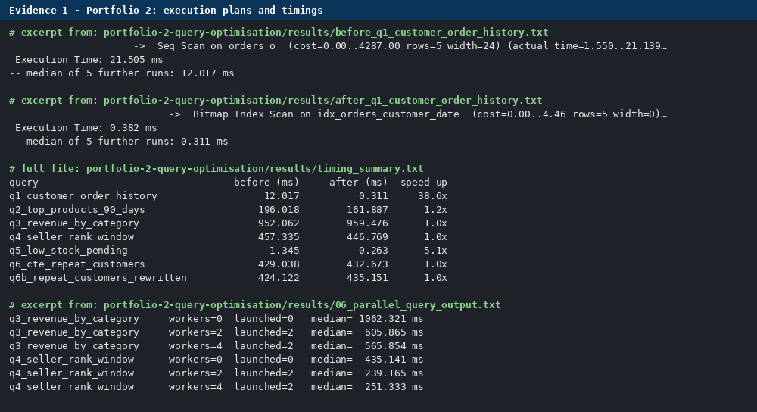
Evidence 1: Portfolio 2 plans and timings
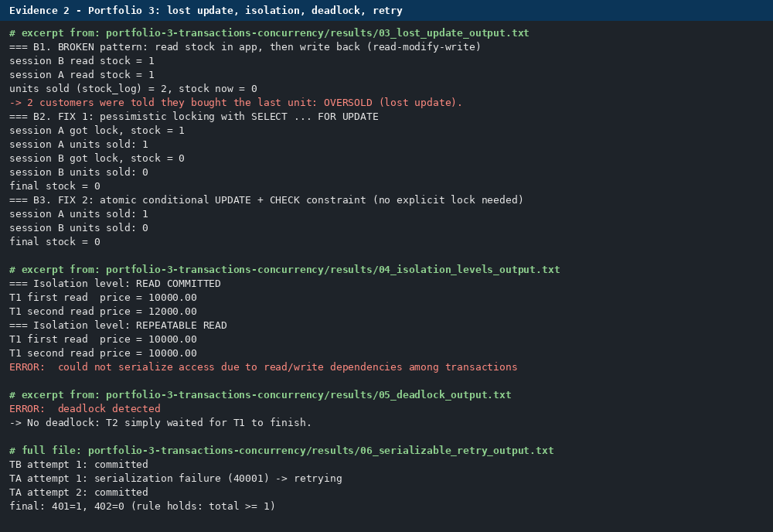
Evidence 2: Portfolio 3 concurrency demonstrations
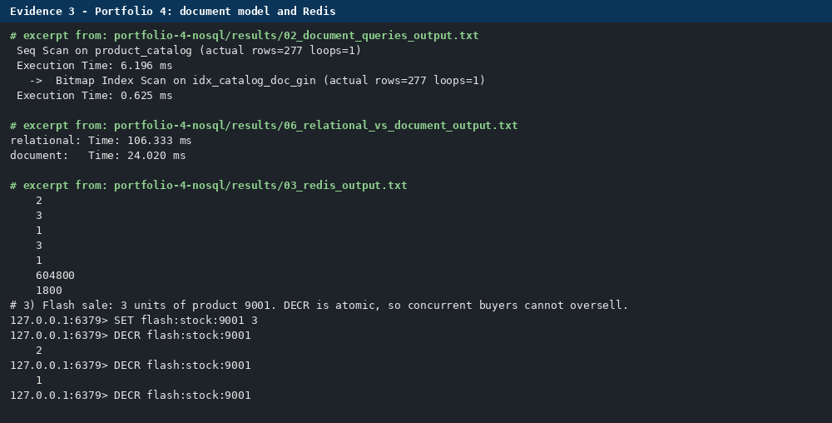
Evidence 3: Portfolio 4 document model and Redis
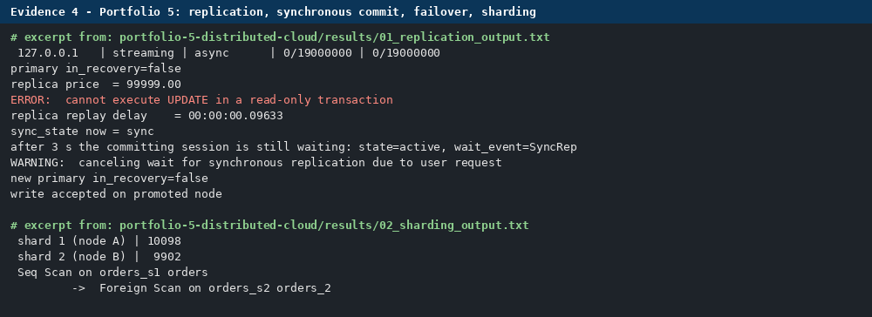
Evidence 4: Portfolio 5 replication, failover and sharding

