Sources Uploaded:

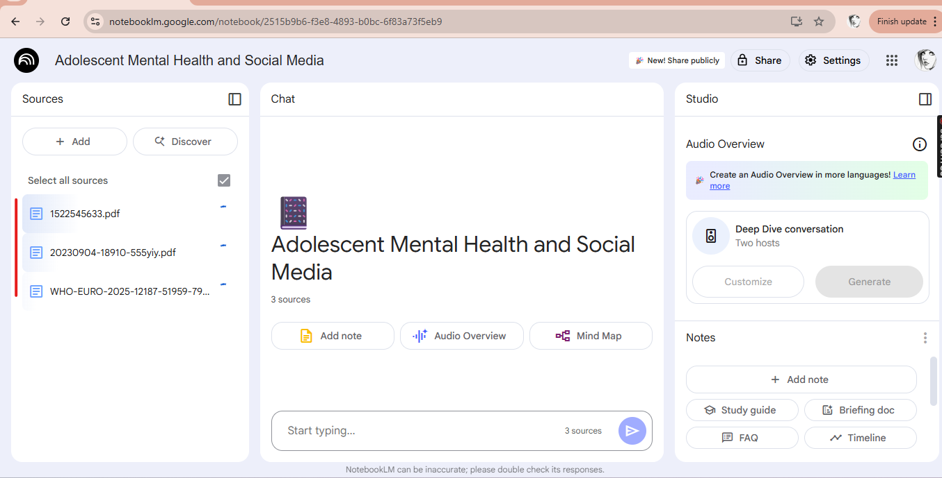

Questions asked from NotebookLLM:

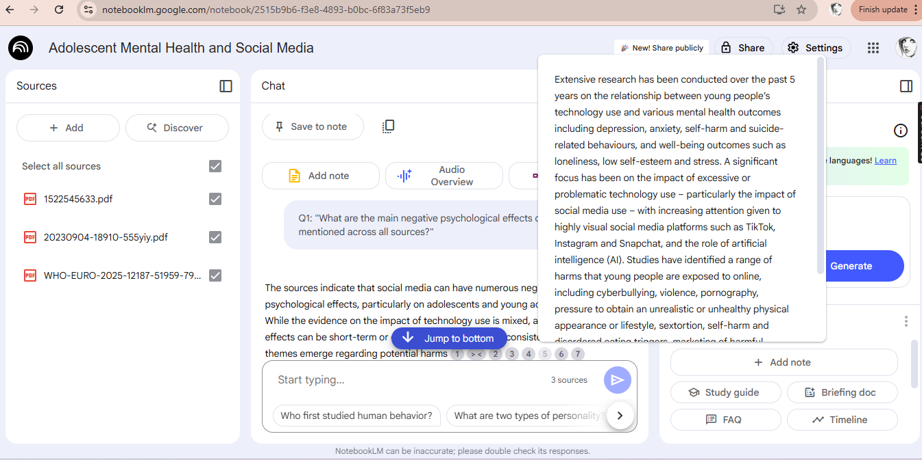

Summary Asked with Referencing of the documents:

Quiz Questions:

