Name: Zainab Amjad

Sap id: 47596

Mid Term Exam Solution OOP

Q1. Output

Code 1:

#include<iostream>

using namespace std;

class Base{

public:

int a;

protected:

int b;

public:

void fun(){

cout<<"this works";

}

};

class Child:public Base{

public:

void fun1(){

base::fun();

base::b=0;

}

};

int main(){

Child c1;

c1.fun();

}

Output:

Code 2:

#include<iostream>

using namespace std;

class TableofContents{

private:

list<string>items;

public:

TableofContents()

{

cout<<"Table of Content is shown\n";

}

void addItem(string item){

iltems.push_back(item);

}

};

class Book{

public:

TableofContents toc;

list<string>sections;

list<string>chapters;

Book(){

toc=TableofContents();

}

};

int main(){

Book book1=Book();

getchar();

return 0;

}

Output:

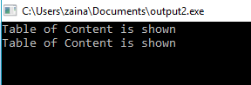

Code 3:

class A{

int a;

public:

A(int i){

a=i;

}

void assign(int i){

a=i;

}

int return_value(){

return a;

}

class A(){

int a=0;}

};

int main(int argc,char const*argv[])

{

A obj;

obj.assign(5);

cout<<obj.return_value();

}

Output:

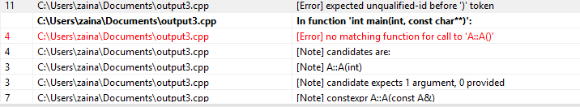

Q2. Q\A

1.What is the purpose of access modifiers in OOP languages?

A. Access modifiers are used to hide the implementation of the program .

2.If we want .................................................need to change?

A. We have to change the access modifiers.

3. Determine the accessibility........................?

A private data member is declared in class ............main function.

Not Accessible

A protected function..........child class.

Accessible

A public data..........child class.

Accessible

Q3. Program

#include<iostream>

using namespace std;

class Characters{

public:

int id;

string name;

int power;

int strength;

Characters(){

id=0;

name="";

power=1;

strength=0;

}

Characters(int id,string name,int power,int strength){

this->id=id;

this->name=name;

this->power=power;

this->strength=strength;

}

};

class Doremon{

public:

string namesofgadgets;

string nameofpartner;

void show gadgets();

void launch attack();

void fly();

void walk();

void jump();

void eat();

Doremon(){

namesofgadgets="";

namesofpartner="";

}

Doremon(string namesofgadgets,string namesofpartner){

this->namesofgadgets=namesofgadgets;

this->namesofpartner=namesofpartner;

}

};

class Benten{

public:

string watchname;

string namesofpower;

int chargingofwatch;

void walk();

void jump();

void eat();

void rotatewatch();

void fight();

void drive();

Benten(){

watchname="";

namesofpower="";

chargingofwatch=0;

}

Benten(string watchname,string namesofpower,int chargingofwatch){

this->watchname=watchname;

this->namesofpower=namesofpower;

this->chargingofwatch=chargingofwatch;

}

};

class Characters:public Doremon:public Benten{

cout<<"Doremon actions";

cout<<"Benten actions";

};

int main(){

Doremon.walk();

Doremon.jump();

Doremon.eat();

Doremon.showgadgets();

Doremon.launchattack();

Doremon.fly();

Benten.walk();

Benten.jump();

Benten.eat();

Benten.drive();

Benten.fight();

Benten.rotatewatch();

}

Q4. Error Finding

#include<iostream>

using namespace std;

class B1{

public:

int i;

int j;

void g(int){}

};

class B2{

public:

int j;

void g(int){}

};

class D:public B1:class public B2{

public:

int i;

};

int main(){

D.dobj;

D*dptr=&dobj;

dptr>i=5;

dptr>j=10;

dobg.g();

}