
COMSATS UNIVERSITY ISLAMABAD , ATTOCK CAMPUS
Computer Science Department
BSSE -6
Course Title | Software Construction & Development
Assignment Number | 03
Submitted To | Ma’am Sadaf Yasmeen
Submitted By | Zainab Khan  Manahil Tariq  Anum Hameed
Registration Number | FA22-BSE -032  FA22-BSE -050  FA22-BSE -048
Date Of Submission | 20TH May,2025

State Design Pattern
PATTERN OVERVIEW:
Category:
The category of the pattern is Behavioral Pattern.
Definition:
The State Pattern allows an object to alter its behavior when its internal state changes. The object will appear to change its class by switching to different state objects.
In simple terms:
"Encapsulate varying behavior for the same object based on its internal state”.
Intent
- To allow an object to change its behavior dynamically depending on its internal state.
- To eliminate large conditional statements (like if-else or switch) by using polymorphism.
- To organize code better when the object's behavior depends on its state.
AI TOOL USED:
AI tool used for the analysis is ChatGPT.
GENERATED CODE SAMPLE:
Real life example taken for state design pattern is working of traffic lights,

CODE:

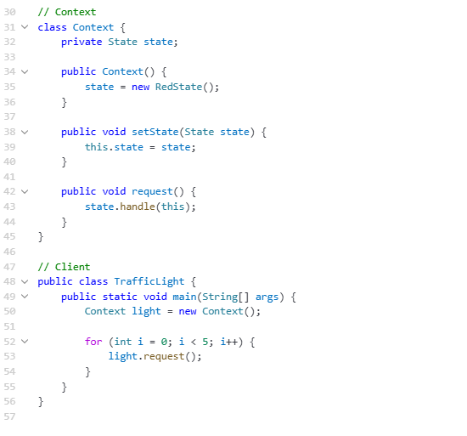
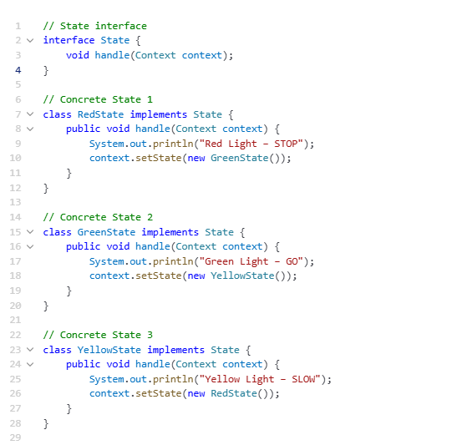
Prompts & prompt refinement:
Initial prompt:
“Implement the State design pattern to simulate a traffic light that cycles through Red, Green, and Yellow lights, printing a message for each state and transitioning to the next automatically.”
Refine prompts:
“Implement the State Design Pattern to simulate a traffic light system where each light is a state, and transitions follow a fixed sequence."
Refinement enable the following :
- Identify the pattern to use:
→ State Design Pattern.
- Define roles clearly:
Context: Maintains the current state and delegates behavior.
States: Encapsulate behaviors and transitions.
Client: Triggers state transitions.
- Organize the solution cleanly:
- Interface for State
- Concrete state classes for Red, Green, Yellow
- State transition logic inside each state's handle()
- Main loop for repeated simulation
COMPARISON WITH MANUAL IMPLEMENTATION:

Overall, the code structure and guidelines provided by Chat GPT were complete but not correct ,it provide an unstructured code without use of object oriented programming, also the description of the topic was misleading it provide quite complex solutions that were not easily understandable ,this may leads to difficulty in code implementation particularly. Moreover, AI tool assist a lot in analyzing the topic and understanding of whole topic thoroughly. It also detect mistakes in manual implementation of the code and description.
REAL-WORLD APPLICATION /FRAMEWORK USAGE:
1. Traffic Light System:
Used in embedded systems, simulators, or IoT devices to manage finite states.
Real-time state transitions are cleanly encapsulated.
2. ATM Machines:
ATM has different modes:
Idle, Card Inserted, Pin Verified, Transaction, Eject Card.
Each state has different allowed inputs and transitions.
3. UI/UX Components (Button States)
Buttons in software can be in states like: Enabled, Disabled, Hovered, Pressed.
Each state changes behavior and appearance.
4. Media Players
States: Playing, Paused, Stopped.
Each state dictates what user actions are allowed.
5. Game Development
Characters or environments have different states:
Idle, Walking, Running, Jumping, Dead.
Game engines like Unity and Unreal Engine use state machines for animation, character behavior, and level logic.
6.Authentication Flows
Auth state machine:
Logged Out → Logging In → Authenticated → Session Expired.
Common in mobile/web apps using OAuth or Firebase Auth.
UML CLASS DIAGRAM:
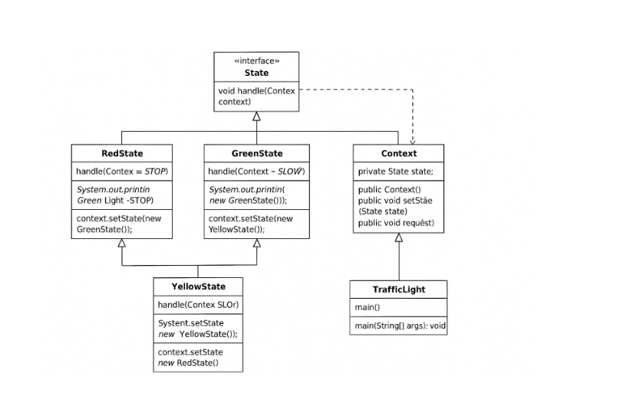
REFLECTIONS:
- Pros of Using AI to Build/Design the State Design Pattern
Using AI to implement the State Design Pattern offers significant advantages in terms of speed, accessibility, and consistency. AI can generate the full boilerplate code—including interfaces, context classes, and concrete states—within seconds, which dramatically reduces development time. This speed is especially helpful for prototyping or exploring pattern usage in smaller projects. Additionally, AI ensures adherence to the standard structure of the pattern, minimizing mistakes often made by beginners, such as misplacing logic or violating object-oriented principles. The ability to generate the pattern across multiple programming languages (Java, Python,C++) also enables cross-platform consistency. Moreover, developers can customize the generated pattern by prompting AI to include specific features like logging, transition rules, or advanced behaviors. Finally, for learners and junior developers, AI serves as an interactive tutor, not only writing code but also explaining it, which enhances understanding of object-oriented design and pattern usage.
- Cons of Using AI to Build/Design the State Design Pattern
Despite its benefits, relying on AI to design or build the State Pattern comes with notable drawbacks. AI-generated code can be overly simplistic and may skip important implementation details like exception handling, input validation, or memory optimization. In many cases, AI hardcodes state transitions inside each class, making the design less flexible and unsuitable for dynamic workflows where transitions are data-driven or user-controlled. There's also the risk of overengineering; AI might suggest using the State Pattern even when a basic if-else or switch-case would be more efficient, leading to unnecessary complexity. Since AI doesn’t fully understand domain-specific rules unless explicitly instructed, the generated code may not align well with the business logic. Furthermore, AI often misses critical performance improvements such as reusing state objects (e.g., via the Singleton pattern) or decoupling transitions from logic. Finally, AI-generated code can give a false impression of completeness, causing developers to overlook missing unit tests, comments, or deeper architectural issues that are crucial for production-ready systems.
DOES AI CHANGE HOW OR WHEN THE PATTERN IS USED?
1. Lower Barrier to Entry
- Before AI: Developers had to learn and implement the pattern manually from scratch.
- With AI: Even beginners can generate a working State Pattern in seconds.
- Impact: Teams are more likely to use the pattern earlier or in smaller projects.
2. Faster Prototyping and Iteration
- AI allows you to quickly test different states, transitions, and behaviors.
- Impact: Developers can try the pattern in more experimental features or early-stage designs.
3. Pattern Discovery & Recommendation
- AI can suggest the State Pattern when analyzing your description:
- "You mentioned this object behaves differently depending on its current mode — would you like to apply the State pattern?"
Impact: Developers may use the pattern in places they wouldn't have identified without AI.
4. Use in Non-Traditional Contexts
- With AI assistance, the State Pattern is now used in creative or non-obvious areas like:
  - Form validation stages
  - Chatbot conversation flows
  - Network connection states in IoT
- Impact: The pattern is applied more broadly, not just in classic cases like traffic lights or media players.

