Master Data: Adding Global + Tenant Scope
Solution Design & Implementation Guide
Status: Draft for review | Date: 2026-07-14 | Scope: minimal-impact change

Note: The described Master Data system is not in the current repository, so this guide is written from your description + multi-tenant best practice. Confirm the assumptions before implementing.

1. Goal (in one line)
Let master data be either GLOBAL (one copy shared by every tenant) or TENANT (owned by a single tenant), with the smallest possible change and full backward compatibility.
- Global data = maintained once, centrally (e.g. countries, currencies, standard categories).
- Tenant data = today's behaviour, unchanged.
- Each tenant sees: Global data + its own Tenant data, merged.

2. Concept: before vs. after
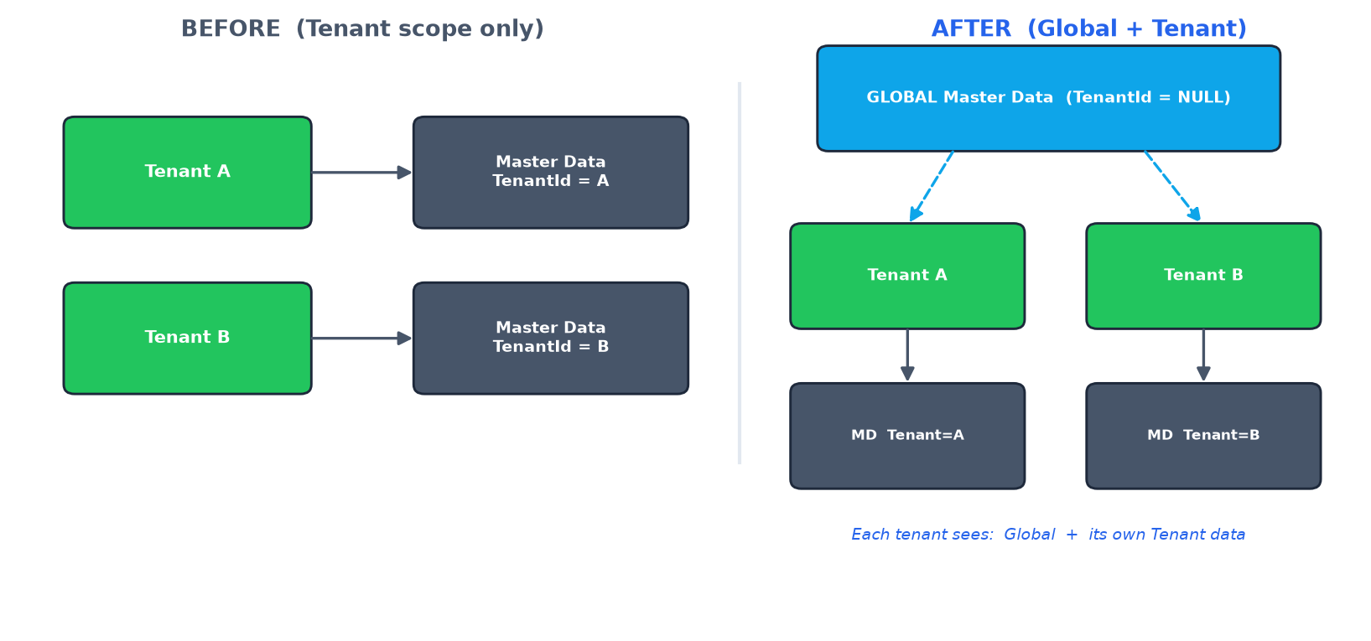
Figure 1 — Today only Tenant scope exists; after the change, Global data is shared and merged with each tenant's own data.

3. Where it lives (architecture)
Metadata (definitions & fields) stays in the ag schema and does NOT change. Only the MasterDataRecord table in the products schema gains scope. Same database, same two-schema layout.
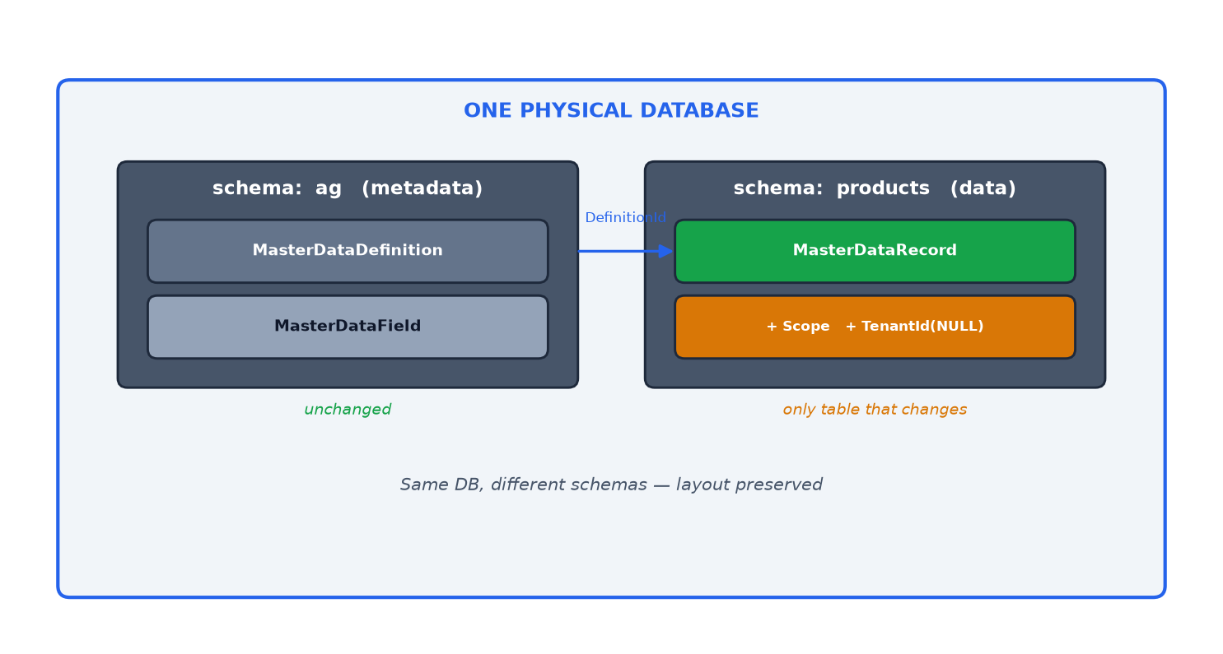
Figure 2 — One physical database, two schemas. Only products.MasterDataRecord changes.

4. Core idea (why it is minimal)
Add one Scope column and make TenantId nullable. Everything else derives from these two columns:
Scope = Global -> TenantId IS NULL (shared by all tenants)
Scope = Tenant -> TenantId = <tenant> (today's behaviour)
The new column defaults to Tenant, so every existing row auto-migrates to Tenant scope — no data backfill, no behaviour change.

5. How a tenant reads data
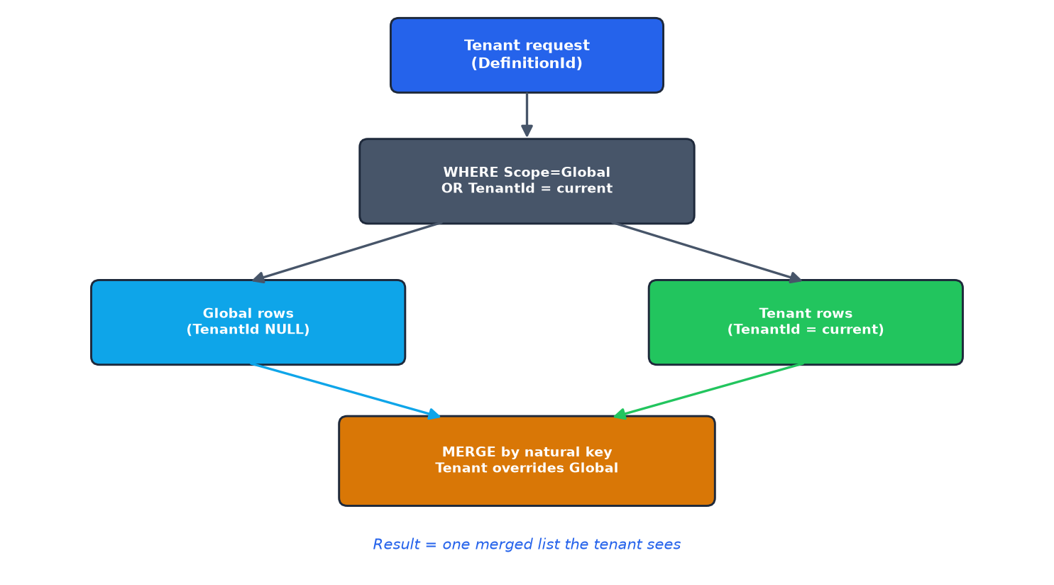
Figure 3 — One query returns Global + Tenant rows; a merge step lets a tenant row override a global row with the same key.

6. Implementation guide (step by step)
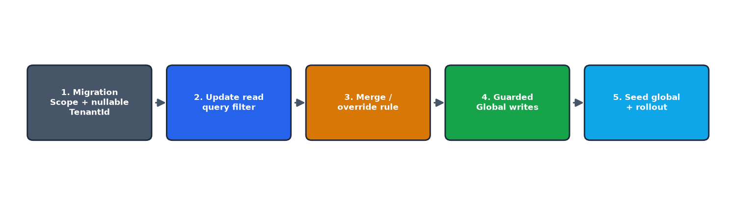
Figure 4 — Five implementation steps, backward compatible at every stage.

Step 1 — Database migration (products.MasterDataRecord)
ALTER TABLE products.MasterDataRecord
ADD Scope TINYINT NOT NULL
CONSTRAINT DF_MDR_Scope DEFAULT (2); -- 2 = Tenant (existing rows)
ALTER TABLE products.MasterDataRecord
ALTER COLUMN TenantId UNIQUEIDENTIFIER NULL;
ALTER TABLE products.MasterDataRecord
ADD CONSTRAINT CK_MDR_Scope_Tenant CHECK (
(Scope = 1 AND TenantId IS NULL) OR
(Scope = 2 AND TenantId IS NOT NULL));
Uniqueness — natural key unique per scope bucket (filtered indexes):
CREATE UNIQUE INDEX UX_MDR_Tenant_Key
ON products.MasterDataRecord (DefinitionId, TenantId, Code) WHERE Scope = 2;
CREATE UNIQUE INDEX UX_MDR_Global_Key
ON products.MasterDataRecord (DefinitionId, Code) WHERE Scope = 1;

Step 2 — Model + read filter (EF Core example)
public enum MasterDataScope : byte { Global = 1, Tenant = 2 }
public class MasterDataRecord {
public Guid Id { get; set; }
public int DefinitionId { get; set; }
public MasterDataScope Scope { get; set; } = MasterDataScope.Tenant;
public Guid? TenantId { get; set; } // NULL when Global
}
Change the read in ONE place — the tenant query filter:
modelBuilder.Entity<MasterDataRecord>().HasQueryFilter(r =>
r.Scope == MasterDataScope.Global ||
r.TenantId == _tenantProvider.CurrentTenantId);

Step 3 — Merge / override rule
If Global and Tenant both have the same natural key, the tenant row wins for that tenant:
var merged = rows
.GroupBy(r => r.Code)
.Select(g => g.OrderBy(r => r.Scope).Last()) // Tenant(2) after Global(1)
.ToList();

Step 4 — Guarded Global writes
- Create Tenant record: unchanged (Scope defaults to Tenant, TenantId = current).
- Create Global record: Scope = Global, TenantId = NULL — allowed only for a platform/admin permission (e.g. MasterData.ManageGlobal). Enforce server-side.
- Read is unchanged for tenant users — they see the merged view with no new permission.

Step 5 — Seed & rollout
- Deploy the migration (default Scope = Tenant keeps current behaviour).
- Deploy code with the updated read filter + merge (optionally behind a feature flag).
- Enable Global authoring for admins and seed initial global data.
Rollback is safe: old read path simply stops returning Global rows; tenant data is untouched.

7. Impact summary (how little changes)
Area | Change | Size
products.MasterDataRecord | +Scope col, nullable TenantId, 1 check + 2 indexes | Small
ag.* metadata schema | None | None
Read path | 1 predicate in the central query filter | Small
Merge / override | 1 grouping step | Small
Write path | Tenant unchanged; add guarded global create | Small
Security | 1 new permission + server guard | Small
Data migration | Column default auto-backfills to Tenant | Trivial

8. Decisions to confirm
- "AG one" = the ag metadata schema? (assumed yes)
- Collision policy: tenant-overrides-global (assumed) OR global is authoritative (reject tenant duplicates)?
- Scope only DATA (recommended, smallest) OR also DEFINITIONS (tenants define their own types)?
- Which role/permission may author Global data?
- Is there a single central tenant query filter to amend, or per-query filters?

End of document

