AG ONE
Subscription & Feature Entitlement
End-to-End Implementation Guide
Adding a Permission → Feature (plan tier) layer on top of existing RBAC
Products: Hire · Learn · Work | Gateway: AG ONE | Platform: .NET 8 / Azure App Services / SQL Server
Version 1.0

Contents
- 1. Executive Summary
- 2. Goals & Non-Goals
- 3. Current State
- 4. Core Concept — RBAC ∩ Entitlement
- 5. Architecture Overview
- 6. Data Model & Database Injection
- 7. Runtime Flows (login, permission fetch, DFD, process)
- 8. Database Implementation (SQL)
- 9. Application Implementation (.NET C#)
- 10. Enforcement Model — Baseline vs Strict
- 11. Plan × Feature Matrix
- 12. Rollout & Migration Plan
- 13. Security Considerations
- 14. Testing & Verification
- 15. Effort & Ownership
- 16. Appendix

1. Executive Summary
AG ONE already authenticates every user (SSO / non-SSO), checks which products a tenant has subscribed to, issues a JWT, and exposes a permissions service that Hire, Learn and Work call to obtain a user's permissions (cached ~10 minutes per app). What is missing is a link between the subscription plan tier (Freemium / Lite / Standard / Enterprise) and the permissions a user is actually allowed to exercise.
This guide adds that link with minimal change. The rule is a single intersection:
Effective access = RBAC permission (role grants it) AND plan-tier entitlement (feature is in the tier)

We compute the intersection inside AG ONE's existing permissions service, so the three apps keep their JWT handling, 10-minute cache and enforcement unchanged. On the database, the only new object is one bridge table, core.ProductFeaturePermissions, that maps a ProductFeature to the existing Permission(s) it unlocks.

2. Goals & Non-Goals

Goals
- Gate access by subscription tier reusing the permissions already defined in core.Permissions.
- Zero (or near-zero) change to the Hire / Learn / Work applications.
- One additive DB change; nothing in existing tables is modified.
- Clear upgrade/upsell signal (402) distinct from role denial (403).
- Safe, phased rollout that cannot break current behavior.

Non-Goals
- Replacing or redesigning the existing RBAC model.
- Changing pricing, billing provider, or the checkout flow.
- Per-record data-level security (out of scope; handled by existing app logic).

3. Current State
The platform runs as four .NET Core apps on Azure App Services against one SQL database ([agone-dev]) with per-product schemas (hire.*, learn.*, work.*) and a shared core.* schema.
- AG ONE Gateway — login, SSO, JWT issue, and a permissions service keyed by user id.
- Hire / Learn / Work — each reads user id from the JWT cookie, calls AG ONE for permissions, caches them ~10 minutes, and enforces them locally.
- core.* — RBAC (Users, Roles, Permissions, RolePermissions, UserRoles) plus the product catalog (Products, ProductFeatureModules, ProductFeatures with per-tier availability bits, ProductPlanTiers, prices, terms) and Subscriptions.
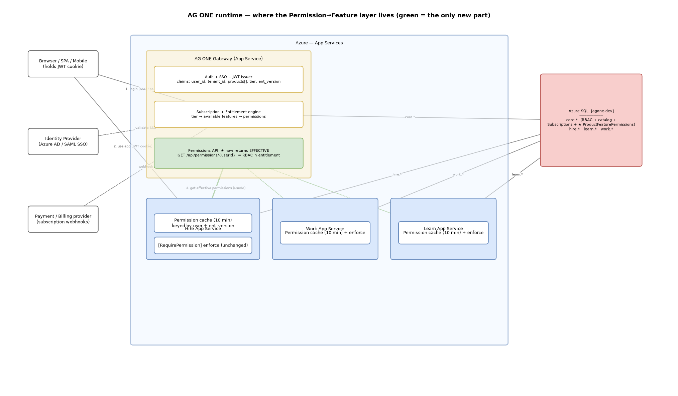
Figure 1 — Component / deployment. Green marks the only new part (AG ONE returns effective permissions).

4. Core Concept — RBAC ∩ Entitlement
Two orthogonal questions must both be true for access:
Layer | Question | Source
RBAC (existing) | Does the user's role grant this permission? | core.UserRoles → RolePermissions → Permissions
Entitlement (new) | Is this permission included in the tenant's plan tier? | Subscription tier → ProductFeatures (tier bits) → ProductFeaturePermissions → Permissions

Because both sides are expressed as the same permission codes, wiring them together needs only the feature→permission bridge; the existing permission checks are reused verbatim.

5. Architecture Overview
The entitlement computation is centralized in AG ONE. The three apps consume the result. The engine is a shared .NET library with three adapters bound to core.* tables.
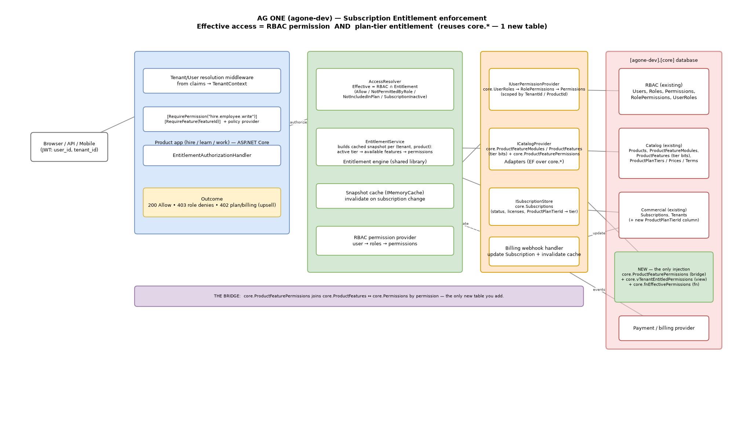
Figure 2 — Solution architecture (engine, adapters, data).

6. Data Model & Database Injection
Mapping the design onto your existing tables:
Concept | Existing table | Notes
Product | core.Products | Code = hire / learn / work
Feature module | core.ProductFeatureModules | grouping under a product
Feature | core.ProductFeatures | availability = per-tier bits (Freemium/Lite/Standard/Enterprise) + IsComingSoon
Plan tier | core.ProductPlanTiers | PlanTier name
Subscription | core.Subscriptions | tenant × product, status, licenses, dates
RBAC | core.Users/Roles/Permissions/RolePermissions/UserRoles | unchanged

The only injection
- NEW table core.ProductFeaturePermissions (ProductFeatureId → PermissionId) — the bridge.
- Recommended column core.Subscriptions.ProductPlanTierId (FK → core.ProductPlanTiers) so a subscription resolves to a tier.
- Read-only views/function: core.vSubscriptionTier, core.vTenantEntitledPermissions, core.fnEffectivePermissions.
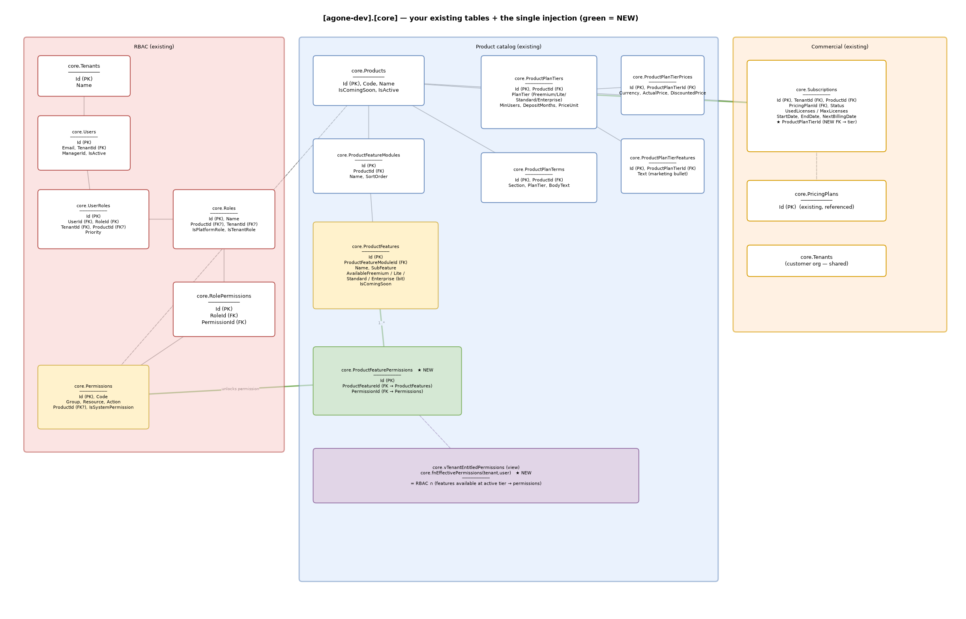
Figure 3 — ERD of existing core.* tables; green = the only new objects.

7. Runtime Flows

7.1 Login & JWT
Subscription and tier are checked once at login and baked into the JWT as claims (products[], per-product tier, ent_version).
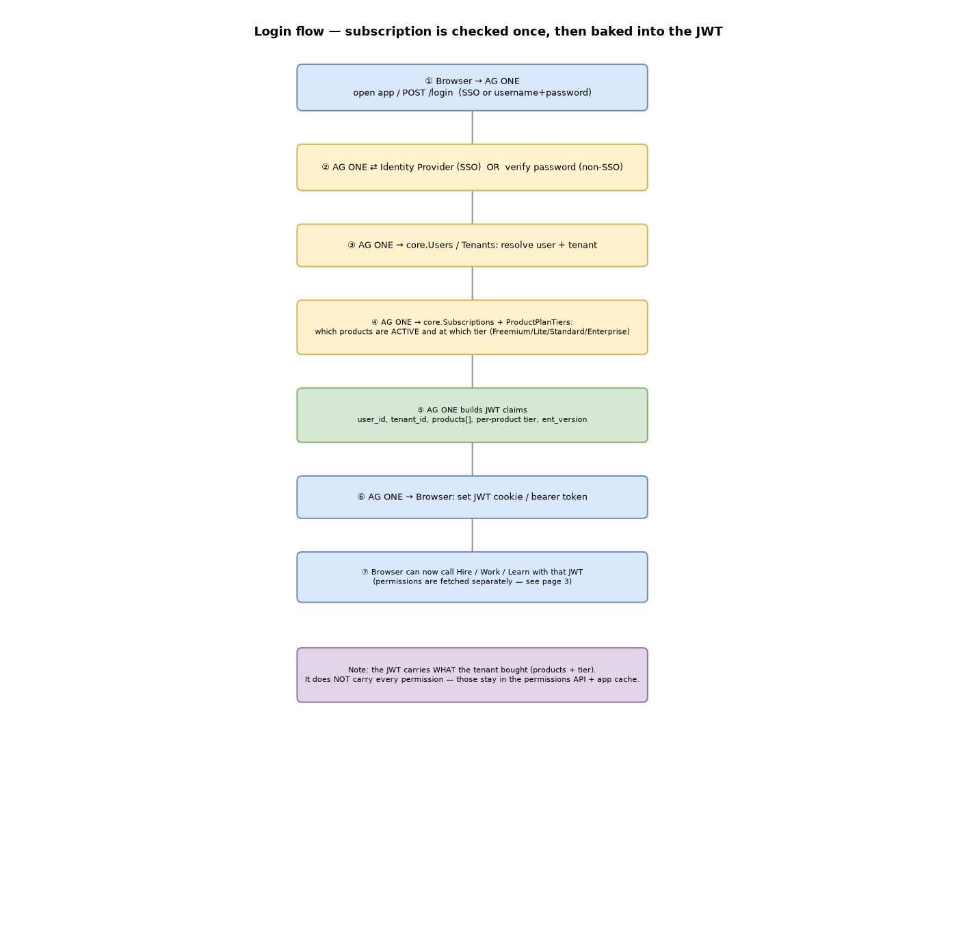
Figure 4 — Login and JWT issue.

7.2 Permission fetch + Feature intersection
On a cache miss, the app calls AG ONE, which now returns effective permissions (RBAC ∩ entitlement). The app caches and enforces exactly as today.
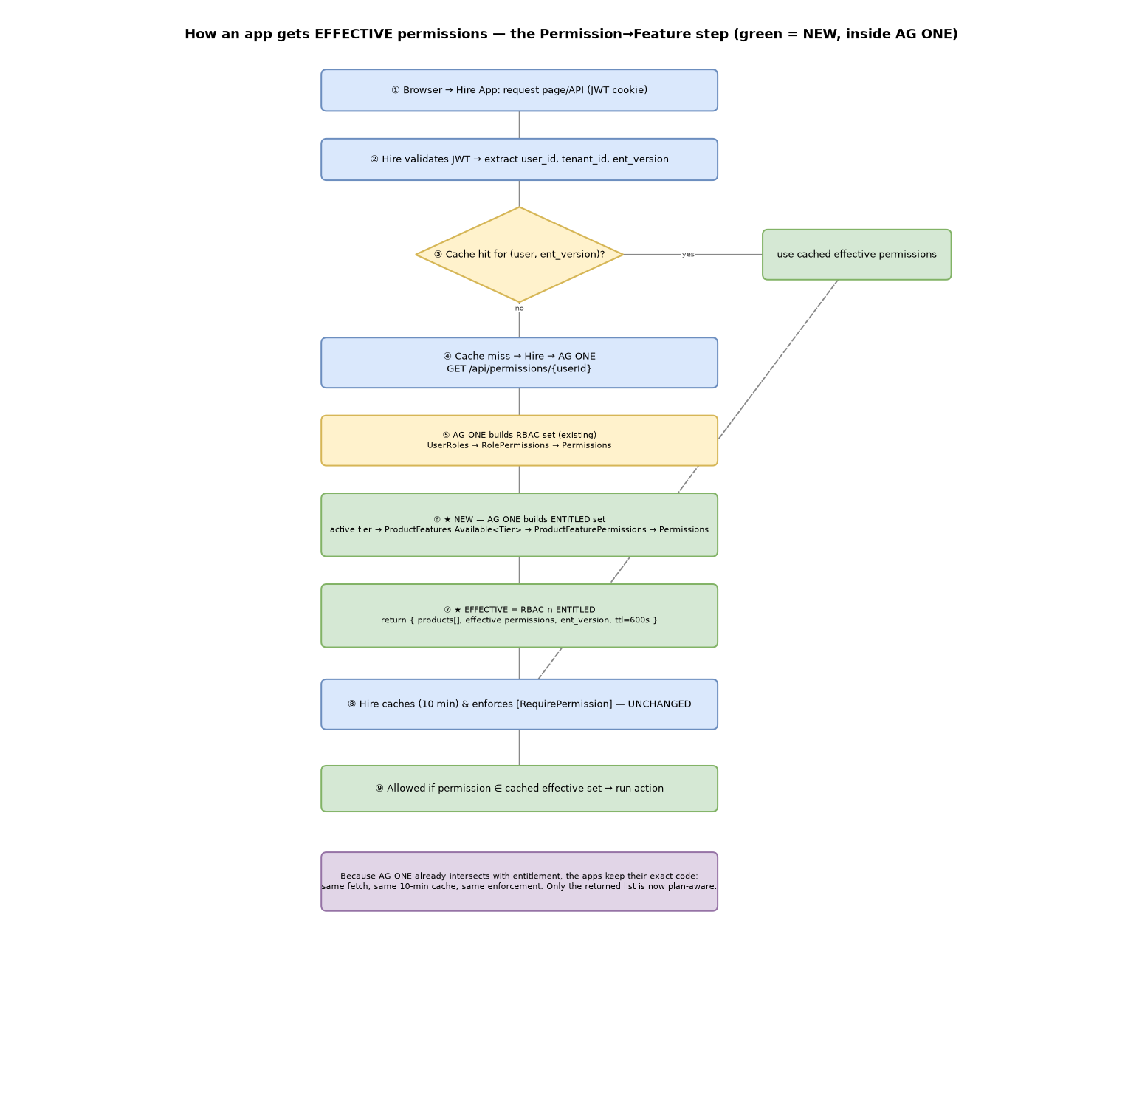
Figure 5 — Permission fetch; green steps ⑥–⑦ are the new intersection inside AG ONE.

7.3 Data Flow Diagram
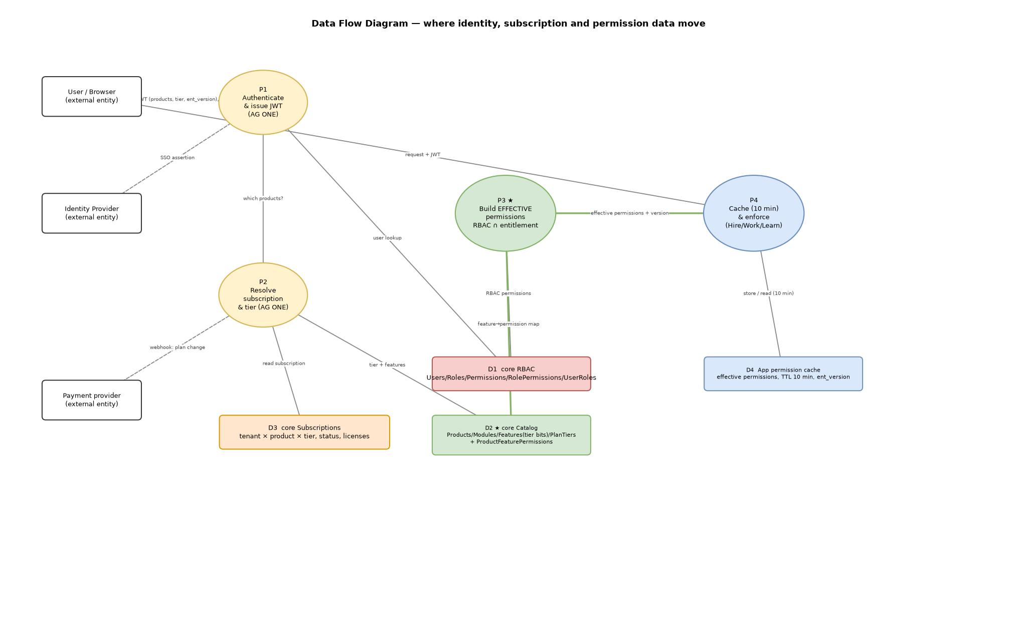
Figure 6 — Data flow across identity, subscription and permission stores.

7.4 Process flow — Permission → Feature decision
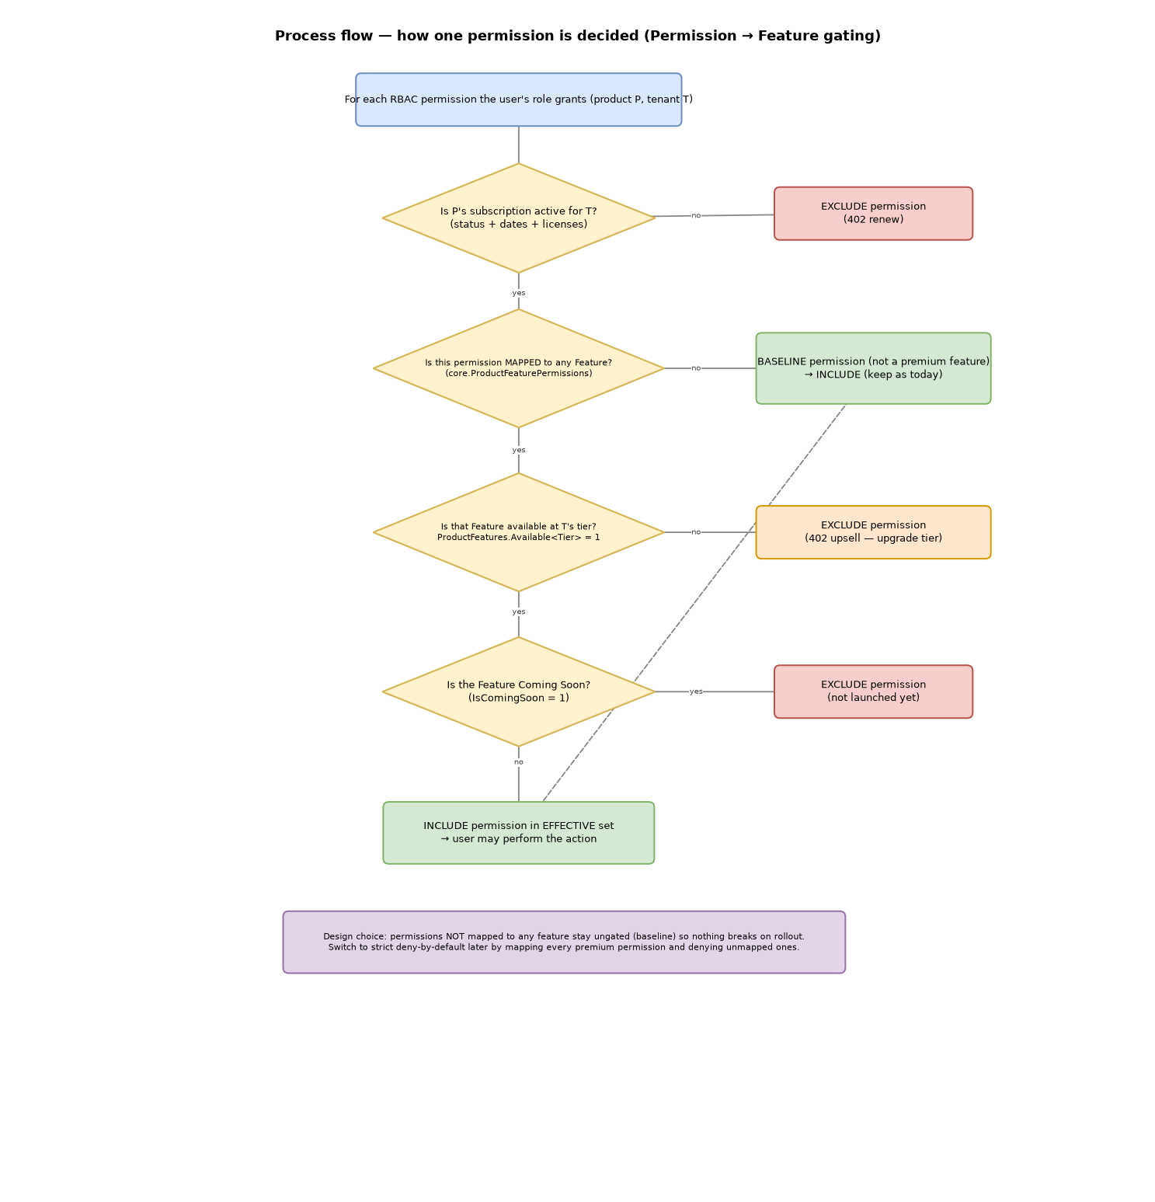
Figure 7 — How a single permission is decided (with baseline vs strict).

8. Database Implementation (SQL)
Additive and safe to run on a live database. Full script: src/Subscriptions/sql/003_inject_existing_core.sql.

8.1 The bridge table
CREATE TABLE core.ProductFeaturePermissions
(
Id UNIQUEIDENTIFIER NOT NULL DEFAULT NEWID(),
ProductFeatureId UNIQUEIDENTIFIER NOT NULL,
PermissionId UNIQUEIDENTIFIER NOT NULL,
CreatedAt DATETIME2(7) NOT NULL DEFAULT SYSUTCDATETIME(),
UpdatedAt DATETIME2(7) NULL,
IsDeleted BIT NOT NULL DEFAULT (0),
CONSTRAINT PK_ProductFeaturePermissions PRIMARY KEY (Id),
CONSTRAINT FK_PFP_ProductFeatures FOREIGN KEY (ProductFeatureId)
REFERENCES core.ProductFeatures (Id) ON DELETE CASCADE,
CONSTRAINT FK_PFP_Permissions FOREIGN KEY (PermissionId)
REFERENCES core.Permissions (Id) ON DELETE CASCADE,
CONSTRAINT UQ_PFP UNIQUE (ProductFeatureId, PermissionId)
);

8.2 Entitled permissions per (tenant, product)
CREATE OR ALTER VIEW core.vTenantEntitledPermissions AS
SELECT DISTINCT st.TenantId, st.ProductId, fpp.PermissionId, p.Code AS PermissionCode
FROM core.vSubscriptionTier st
JOIN core.ProductFeatureModules m ON m.ProductId = st.ProductId AND m.IsDeleted = 0
JOIN core.ProductFeatures pf ON pf.ProductFeatureModuleId = m.Id
AND pf.IsDeleted = 0 AND pf.IsComingSoon = 0
AND CASE st.PlanTier
WHEN N'Freemium' THEN pf.AvailableFreemium
WHEN N'Lite' THEN pf.AvailableLite
WHEN N'Standard' THEN pf.AvailableStandard
WHEN N'Enterprise' THEN pf.AvailableEnterprise
ELSE CONVERT(bit,0) END = 1
JOIN core.ProductFeaturePermissions fpp ON fpp.ProductFeatureId = pf.Id AND fpp.IsDeleted = 0
JOIN core.Permissions p ON p.Id = fpp.PermissionId AND p.IsDeleted = 0;

8.3 Effective permissions (RBAC ∩ entitlement)
CREATE OR ALTER FUNCTION core.fnEffectivePermissions(@TenantId uniqueidentifier, @UserId uniqueidentifier)
RETURNS TABLE AS RETURN
(
SELECT DISTINCT p.Id AS PermissionId, p.Code AS PermissionCode
FROM core.UserRoles ur
JOIN core.RolePermissions rp ON rp.RoleId = ur.RoleId AND rp.IsDeleted = 0
JOIN core.Permissions p ON p.Id = rp.PermissionId AND p.IsDeleted = 0
JOIN core.vTenantEntitledPermissions ep ON ep.PermissionId = p.Id AND ep.TenantId = @TenantId
WHERE ur.UserId = @UserId AND ur.TenantId = @TenantId AND ur.IsDeleted = 0
);

8.4 Seeding the bridge (ongoing authoring)
INSERT INTO core.ProductFeaturePermissions (ProductFeatureId, PermissionId)
SELECT pf.Id, p.Id
FROM core.ProductFeatures pf
JOIN core.Permissions p ON p.Code IN (N'hire.employee.read', N'hire.employee.write')
WHERE pf.Name = N'Employee Master Data'
AND NOT EXISTS (SELECT 1 FROM core.ProductFeaturePermissions x
WHERE x.ProductFeatureId = pf.Id AND x.PermissionId = p.Id);

9. Application Implementation (.NET C#)
A shared library (AgOne.Entitlements) holds the engine; AG ONE binds three adapters over core.* and exposes the effective-permissions endpoint. Reference code: src/Subscriptions.

9.1 Gateway effective-permission service
public interface IGatewayEntitlementService
{
Task<EffectivePermissionResponse> BuildAsync(
Guid tenantId, Guid userId, IEnumerable<ProductKey> subscribedProducts,
int cacheTtlSeconds = 600, CancellationToken ct = default);
}
// Per product: effective = RBAC ∩ entitlement; then union across products,
// plus a stable Version for client cache-busting. (See GatewayEntitlementService.cs)

9.2 Permissions endpoint (drop-in replacement)
[ApiController]
[Route("api/permissions")]
public sealed class PermissionsController : ControllerBase
{
private readonly IGatewayEntitlementService _gateway;
public PermissionsController(IGatewayEntitlementService gateway) => _gateway = gateway;
[HttpGet("{userId:guid}")]
public async Task<ActionResult<EffectivePermissionResponse>> Get(Guid userId, CancellationToken ct)
{
var tenantId = Guid.Parse(User.FindFirstValue("tenant_id")!);
var products = User.FindAll("product").Select(c => Enum.Parse<ProductKey>(c.Value, true));
return Ok(await _gateway.BuildAsync(tenantId, userId, products, 600, ct));
}
}

9.3 JWT enrichment at login
var products = await _subscriptions.GetActiveProductsAsync(tenantId);
var claims = new List<Claim> {
new("user_id", user.Id.ToString()),
new("tenant_id", tenantId.ToString()),
new("ent_version", entitlementVersion) // changes when a plan changes -> busts app caches
};
foreach (var p in products) {
claims.Add(new Claim("product", p.ProductCode));
claims.Add(new Claim($"tier:{p.ProductCode}", p.PlanTier));
}

9.4 App-side cached client (Hire / Learn / Work — minimal change)
public async Task<ISet<string>> GetPermissionsAsync(Guid userId, string entVersion, CancellationToken ct)
{
var key = $"perms:{userId:N}:{entVersion}"; // version in key = automatic invalidation
if (_cache.TryGetValue(key, out ISet<string>? cached)) return cached!;
var res = await _http.GetFromJsonAsync<EffectivePermissionResponse>($"api/permissions/{userId}", ct);
var set = res!.AllPermissionCodes.ToHashSet(StringComparer.OrdinalIgnoreCase);
_cache.Set(key, set, TimeSpan.FromSeconds(res.CacheTtlSeconds)); // existing ~10 min
return set;
}

Enforcement stays as-is: the existing [RequirePermission]/handler checks the cached set. Since the set is already plan-filtered, lower-tier users simply lack the gated permission.

10. Enforcement Model — Baseline vs Strict
Policy | Unmapped permission | Use when
Baseline (rollout) | Stays allowed (ungated). Only permissions mapped to a premium feature are gated. | Initial rollout — cannot break existing behavior.
Strict (target) | Denied unless entitled by the tier (deny-by-default). | After every premium permission is mapped.

Start baseline, map features incrementally, then switch to strict (core.fnEffectivePermissions).

11. Plan × Feature Matrix
Availability is stored per feature as tier bits on core.ProductFeatures. Representative HR matrix:
Feature (Hire) | Freemium | Lite | Standard | Enterprise
Employee Master Data | ✓ | ✓ | ✓ | ✓
Personal Profile / Personalized Home | ✓ | ✓ | ✓ | ✓
Employment History / Document Mgmt |  | ✓ | ✓ | ✓
Punch Clock / Leave Request |  | ✓ | ✓ | ✓
Org Chart / Geofencing / Leave Balance |  |  | ✓ | ✓
Onboarding / REST API / M365 |  |  | ✓ | ✓
Preboarding / Webhooks / SSO / SCIM |  |  |  | ✓
ISO 27001 / SOC 2 |  |  |  | ✓
Agentic AI (Coming Soon) | — | — | — | —

12. Rollout & Migration Plan
- Deploy DB injection (003 script). No behavior change.
- Backfill Subscriptions.ProductPlanTierId (or map via PricingPlans).
- Seed core.ProductFeaturePermissions for the first premium features.
- Deploy AG ONE change to return effective permissions in BASELINE mode (log gated denials, don't enforce).
- Verify logs vs expectations per tenant cohort.
- Enforce baseline; enable upsell (402) UX.
- Map remaining premium permissions; switch to STRICT deny-by-default.

13. Security Considerations
- Deny-by-default in the target state; baseline only during rollout.
- Entitlement can only remove permissions the role already grants — never escalate.
- Tenant scoping from the authenticated principal (tenant_id claim), never from request input.
- Coming-Soon features are dropped during computation and cannot leak.
- Audit every denial with reason (role vs plan vs billing) for support and telemetry.

14. Testing & Verification
The reference engine ships with 19 automated tests (xUnit), all passing:
- Effective access = RBAC ∩ entitlement (allow / upsell / forbidden).
- Cumulative tiers; Coming-Soon never entitles even on Enterprise.
- Lifecycle: trial expiry, past-due grace window.
- Product isolation: a learn subscription never unlocks hire permissions.
- Gateway: per-product intersection + union, version stability/change, inactive subscription yields no permissions.
cd src/Subscriptions
dotnet build # 0 warnings, 0 errors
dotnet test # Passed! Failed: 0, Passed: 19

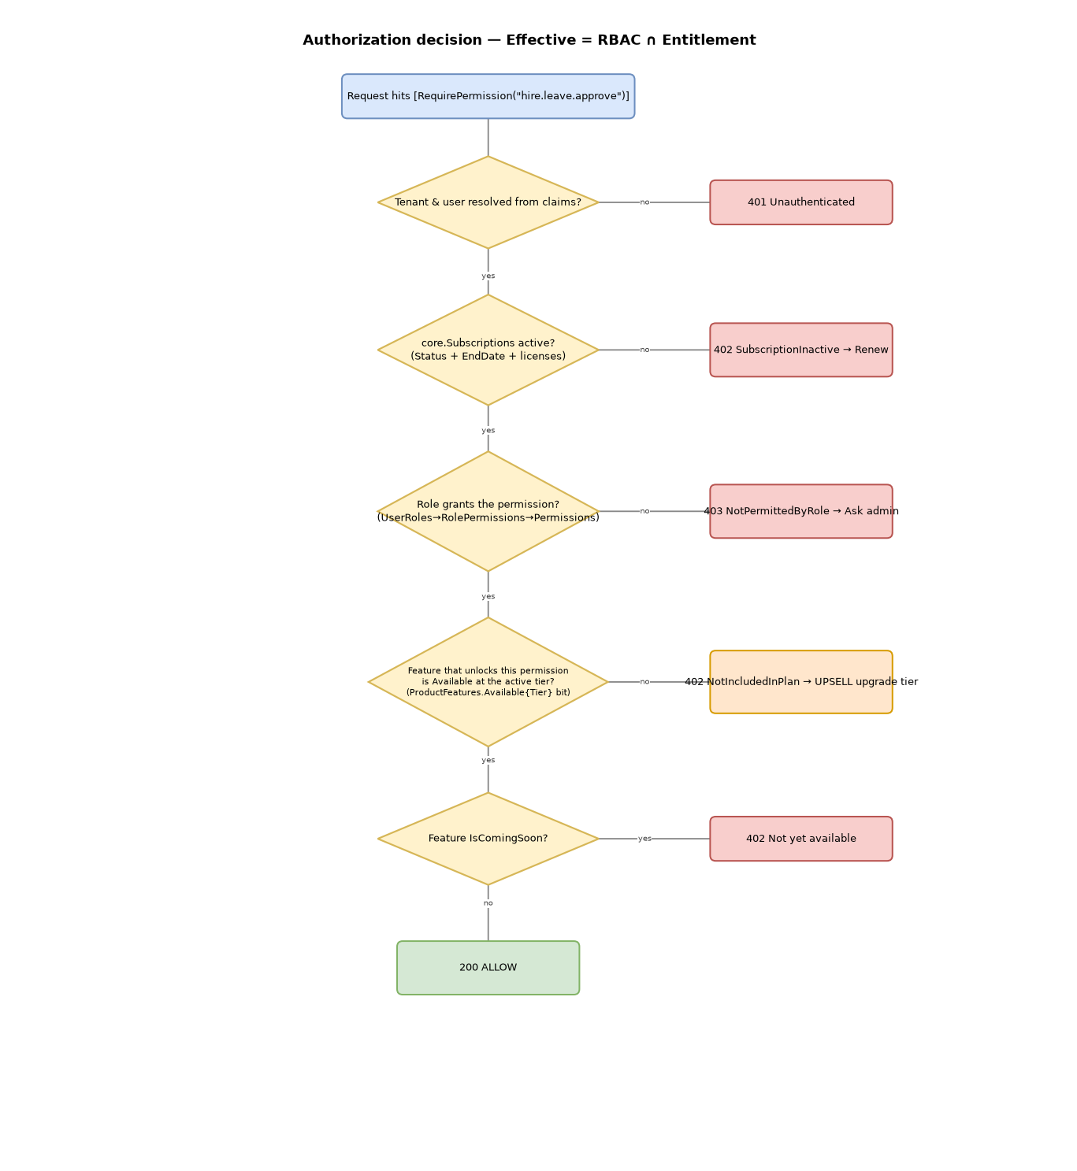
Figure 8 — Authorization decision outcomes (200 / 402 / 403).

15. Effort & Ownership
Workstream | Owner | Scope
DB migration + seed | Data / DBA | 003 script, tier backfill, feature→permission mapping
AG ONE gateway | Platform team | effective-permissions service, endpoint, JWT claims, cache invalidation
Hire / Learn / Work | Product teams | cache key by ent_version (1 line); upsell 402 handling
Billing webhook | Platform team | update subscription + bump entitlement version
QA | QA | tier matrix validation, regression of existing permissions

Difficulty note: the change is additive and isolated — one DB table, one gateway service, and an optional one-line app cache tweak. No existing table or RBAC assignment is modified.

16. Appendix

16.1 Repository artifacts
Path | What
docs/Subscription-Entitlement-Architecture.drawio | Solution, ERD (real schema), decision — editable
docs/AGONE-Entitlement-Runtime-Flow.drawio | Component, login, permission-fetch, DFD, process — editable
docs/Subscription-Entitlement-Architecture.md | Design doc (incl. schema mapping)
docs/AGONE-Entitlement-Runtime.md | Runtime step-by-step + C#
src/Subscriptions/sql/003_inject_existing_core.sql | DB injection (bridge + views/function)
src/Subscriptions/src/AgOne.Entitlements | Engine + gateway service
src/Subscriptions/tests | xUnit tests (19)

16.2 Glossary
Term | Meaning
RBAC | Role-based access control (existing permissions)
Entitlement | What a subscription tier includes
Effective permission | RBAC ∩ entitlement — what the user can actually do
ent_version | Version stamp that busts app caches when a plan changes
Baseline / Strict | Rollout policy for unmapped permissions

