Project Proposal

Title: SaaS Platform Support Ticket Management System

Table of Contents
1. Introduction 5
2. Problem Statement 5
3.Issue Being Resolved 6
4. Objectives 6
5. Scope of the System 6
Customer Side 6
Support Agent Side 7
Administrator Side 7
6. Database Design 7
7. Entity Relationship Diagram (ERD) 7
Main Entities 7
ERD Description 8
8. Entities and Attributes 8
1. ROLES 8
2. USERS 8
3. TICKETS 9
4. TICKET_STATUS 9
5. TICKET_PRIORITY 9
6. CATEGORIES 9
7. TICKET_ASSIGNMENTS 10
8. RESPONSES 10
9. TICKET_HISTORY 10
10. SLA 11
9. Relationships and Constraints 11
Participation Constraints 11
10. Entity Relation Diagram 12
11. Relational Schema 13
12. Functional Dependencies 13
ROLES 13
USERS 13
TICKETS 13
RESPONSES 14
TICKET_ASSIGNMENTS 14
TICKET_HISTORY 14
TICKET_STATUS 14
TICKET_PRIORITY 14
CATEGORIES 14
SLA 14
13.Normalization 14
Before Normalization 14
After Normalization 15
First Normal Form (1NF) 15
Second Normal Form (2NF) 15
Third Normal Form (3NF) 15
14. SQL Implementation 16
Create Database 16
Create USERS Table 16
Create TICKET_STATUS Table 16
Create TICKET_PRIORITY Table 17
Create CATEGORIES Table 17
Create SLA Table 17
Create TICKETS Table 17
Create RESPONSES Table 18
Create TICKET_ASSIGNMENTS Table 18
Create TICKET_HISTORY Table 18
15. Sample Data 19
16. SQL Queries 20
Basic Queries 20
1. Display All Users 20
2. Display All Tickets 20
3. Display Open Tickets 20
JOIN Queries 20
4. Show Ticket with Customer Name 20
5. Show Ticket Status 20
6. Show Ticket Category and Priority 20
7. Show Assigned Agent for Each Ticket 21
Aggregate Function Queries 21
8. Count Total Tickets 21
9. Count Tickets by Status 21
10. Count Tickets by Priority 21
Response Queries 22
11. Show Ticket Responses 22
12. Show Internal Responses Only 22
Sorting Queries 22
13. Display Latest Tickets 22
14. Display Tickets Alphabetically 22
UPDATE Query 22
15. Update Ticket Status 22
DELETE Query 23
16. Delete a Response 23
Subquery Examples 23
17. Show Users Who Created Tickets 23
18. Find Highest Priority Tickets 23
Advanced Queries 23
19. Show Average Resolution Time Limit 23
20. Show Number of Tickets Assigned to Each Agent 23
17. Advantages of the System 24
Conclusion 24

1. Introduction
A SaaS Platform Support Ticket Management System is designed to help organizations manage customer complaints, technical issues, and service requests in a structured and efficient way. In modern software companies, customer support is one of the most important departments because customer satisfaction directly affects business growth and reputation.
The purpose of this project is to design and implement a relational database system that can manage support tickets, user information, ticket assignments, ticket responses, and service-level agreements (SLA). The system ensures that tickets are tracked properly from creation to resolution.
This project applies core Database Management System (DBMS) concepts including:
- Entity Relationship Modeling
- Relational Schema Design
- Functional Dependencies
- Normalization
- SQL Queries
- Data Integrity Constraints
- Primary and Foreign Keys
The database is normalized up to Third Normal Form (3NF) to reduce redundancy and improve consistency.

2. Problem Statement
Many organizations face difficulties while managing customer complaints manually or through unstructured systems. Common problems include:
- Poor tracking of customer complaints
- Delayed ticket assignments
- Difficulty monitoring ticket status
- Lack of response history
- Duplicate or inconsistent data
- Inefficient reporting system
The proposed SaaS Ticket Management System solves these issues by providing a centralized relational database system where tickets can be created, assigned, monitored, updated, and resolved efficiently.

3.Issue Being Resolved
In SaaS platforms and freelancing systems such as Upwork, managing customer complaints and support requests manually can create several operational problems. Organizations often face difficulties in tracking tickets, assigning support agents, monitoring response times, and maintaining customer communication history.
Common issues include:
- Delayed responses to customer complaints
- Improper ticket assignment
- Difficulty tracking ticket status
- Data redundancy and inconsistency
- Missing communication records
- Poor monitoring of SLA compliance
- Reduced customer satisfaction
This project resolves these issues by providing a centralized relational database system that efficiently manages support tickets, tracks ticket progress, stores response history, assigns agents properly, and improves overall customer support operations.

4. Objectives
The main objectives of this project are:
- To design a normalized relational database
- To manage customer support tickets efficiently
- To establish relationships between users, tickets, and responses
- To track ticket assignments and status updates
- To maintain ticket history records
- To implement Service Level Agreements (SLA)
- To generate reports using SQL queries
- To reduce redundancy and improve data consistency

5. Scope of the System
The system covers the following functionalities:

Customer Side
- Create support tickets
- View ticket status
- Receive responses from support agents

Support Agent Side
- View assigned tickets
- Respond to customer queries
- Update ticket status
- Resolve tickets

Administrator Side
- Manage users and roles
- Assign tickets to agents
- Monitor ticket history
- Generate reports
- Configure SLA policies

6. Database Design
The database design is based on relational database principles. The design contains multiple related tables that maintain data integrity and support efficient data retrieval.
Main modules of the database include:
- User Management
- Ticket Management
- Ticket Assignment
- Responses and Communication
- Ticket History
- SLA Management

7. Entity Relationship Diagram (ERD)

Main Entities
- Roles
- Users
- Tickets
- Ticket_Status
- Ticket_Priority
- Categories
- Ticket_Assignments
- Responses
- Ticket_History
- SLA

ERD Description
- One user can create many tickets.
- One ticket can have many responses.
- One support agent can handle multiple tickets.
- Each ticket belongs to one category.
- Each ticket has one priority level.
- Each ticket follows one SLA policy.
- Ticket history records all status changes.

8. Entities and Attributes

1. ROLES
Attribute | Data Type | Description
role_id | INT | Primary Key
role_name | VARCHAR(50) | Name of role

2. USERS
Attribute | Data Type | Description
user_id | INT | Primary Key
Name | VARCHAR(100) | User name
Email | VARCHAR(100) | User email
role_id | INT | Foreign Key
is_active | BOOLEAN | Active status

3. TICKETS
Attribute | Data Type | Description
ticket_id | INT | Primary Key
Subject | VARCHAR(255) | Ticket subject
Description | TEXT | Ticket details
user_id | INT | Foreign Key
category_id | INT | Foreign Key
priority_id | INT | Foreign Key
status_id | INT | Foreign Key
created_at | DATETIME | Ticket creation date
sla_id | INT | Foreign Key

4. TICKET_STATUS
Attribute | Data Type | Description
status_id | INT | Primary Key
status_name | VARCHAR(50) | Status name

5. TICKET_PRIORITY
Attribute | Data Type | Description
priority_id | INT | Primary Key
Level | VARCHAR(20) | Priority level

6. CATEGORIES
Attribute | Data Type | Description
category_id | INT | Primary Key
category_name | VARCHAR(100) | Category name

7. TICKET_ASSIGNMENTS
Attribute | Data Type | Description
assignment_id | INT | Primary Key
ticket_id | INT | Foreign Key
agent_id | INT | Foreign Key
assigned_at | DATETIME | Assignment date
unassigned_at | DATETIME | Unassignment date
is_active | BOOLEAN | Current assignment status

8. RESPONSES
Attribute | Data Type | Description
response_id | INT | Primary Key
ticket_id | INT | Foreign Key
user_id | INT | Foreign Key
Message | TEXT | Response message
created_at | DATETIME | Response date
is_internal | BOOLEAN | Internal note indicator

9. TICKET_HISTORY
Attribute | Data Type | Description
history_id | INT | Primary Key
ticket_id | INT | Foreign Key
status_id | INT | Foreign Key
changed_by | INT | Foreign Key
changed_at | DATETIME | Status update date

10. SLA
Attribute | Data Type | Description
sla_id | INT | Primary Key
priority_id | INT | Foreign Key
response_time_limit | INT | Response limit in hours
resolution_time_limit | INT | Resolution limit in hours

9. Relationships and Constraints
- Users create Tickets (1:M)
- Tickets have Responses (1:M)
- Users write Responses (1:M)
- Roles assigned to Users (1:M)
- Tickets have Status (1:M)
- Tickets have Priority (1:M)
- Tickets belong to Categories (1:M)
- Tickets are assigned via Assignments (1:M)
- Tickets have history (1:M)
- Tickets follow SLA (M:1)
- Priority defines SLA (1:1)

Participation Constraints
- Every ticket must belong to one category.
- Every ticket must have one priority.
- Every ticket must have one status.
- Every response must belong to one ticket.
- Every assignment must reference one agent.

10. Entity Relation Diagram
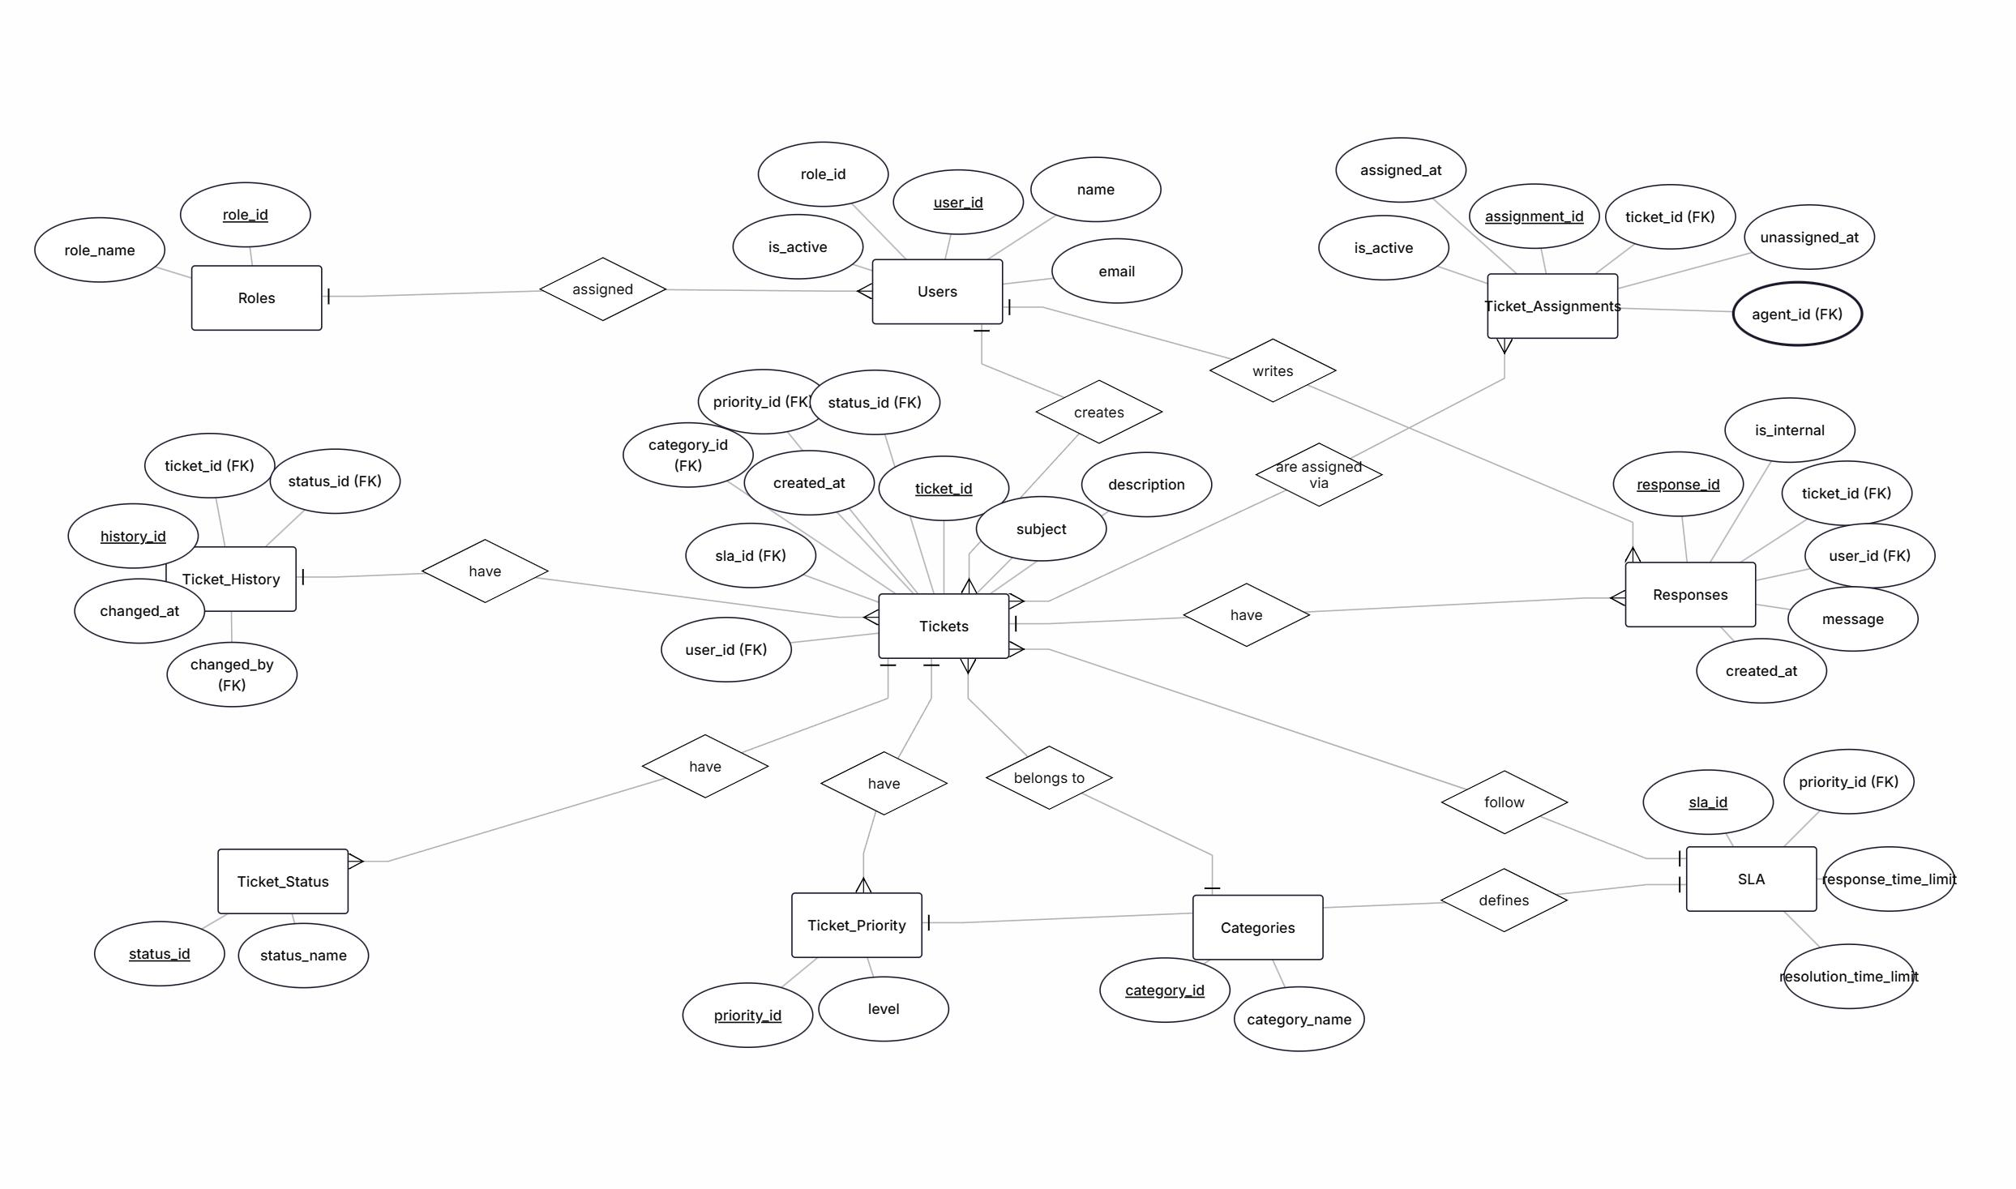

11. Relational Schema

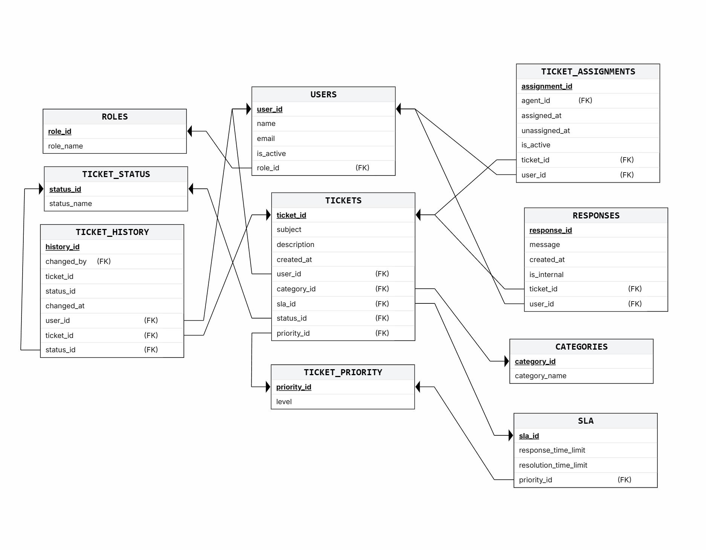

12. Functional Dependencies

ROLES
role_id → role_name

USERS
user_id → name, email, is_active, role_id
email → user_id, name, role_id

TICKETS
ticket_id → subject, description, created_at, user_id, category_id, priority_id, status_id, sla_id

RESPONSES
response_id → message, created_at, is_internal, ticket_id, user_id

TICKET_ASSIGNMENTS
assignment_id → ticket_id, agent_id, assigned_at, unassigned_at, is_active

TICKET_HISTORY
history_id → ticket_id, status_id, changed_by, changed_at

TICKET_STATUS
status_id → status_name

TICKET_PRIORITY
priority_id → level

CATEGORIES
category_id → category_name

SLA
sla_id → response_time_limit, resolution_time_limit, priority_id

13.Normalization
The database for the SaaS Platform Support Ticket Management System will be normalized up to Third Normal Form (3NF) to reduce redundancy and improve data integrity.

Before Normalization
Before normalization, all ticket-related information may exist in a single table containing:
- User details
- Ticket details
- Responses
- Agent assignments
- Status information
This structure can create:
- Data redundancy
- Update anomalies
- Insertion anomalies
- Deletion anomalies
- Duplicate records
Example:
A user’s information may be repeated for every ticket they create.

After Normalization
After normalization, the database is divided into multiple related tables such as:
- USERS
- TICKETS
- RESPONSES
- TICKET_ASSIGNMENTS
- TICKET_STATUS
- CATEGORIES
- SLA
This structure:
- Eliminates redundant data
- Improves consistency
- Maintains data integrity
- Simplifies maintenance
- Enhances query performance

First Normal Form (1NF)
- All attributes contain atomic values.
- Each table has a primary key.
- No repeating groups exist.

Second Normal Form (2NF)
- All non-key attributes fully depend on the primary key.
- Partial dependency is removed.

Third Normal Form (3NF)
- Transitive dependency is removed.
- Separate tables are created for status, priority, roles, categories, and SLA information.
The final database design will be normalized up to 3NF to ensure an efficient and reliable ticket management system.
Advantages of Normalization
- Reduces redundancy
- Prevents update anomalies
- Prevents insertion anomalies
- Prevents deletion anomalies
- Improves consistency
- Simplifies maintenance

14. SQL Implementation

Create Database
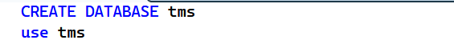
Create ROLES Table
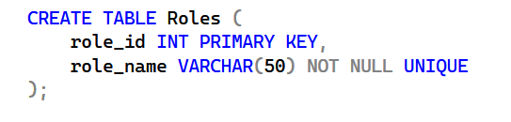

Create USERS Table
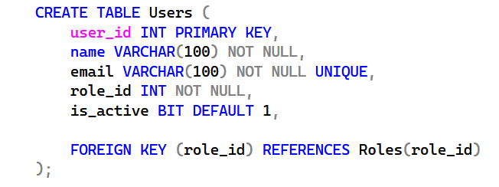

Create TICKET_STATUS Table
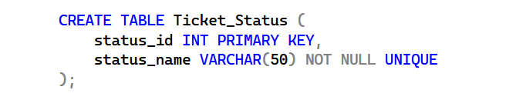

Create TICKET_PRIORITY Table
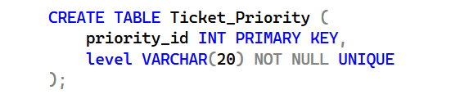

Create CATEGORIES Table
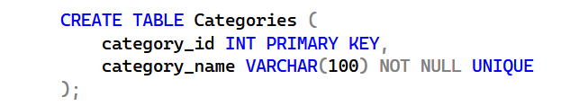

Create SLA Table
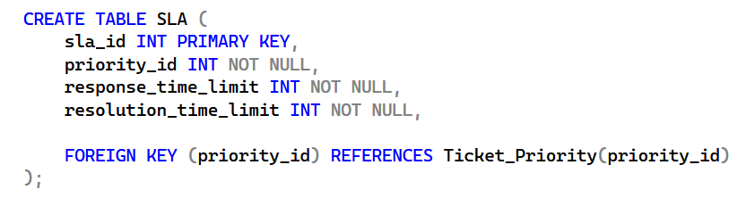

Create TICKETS Table
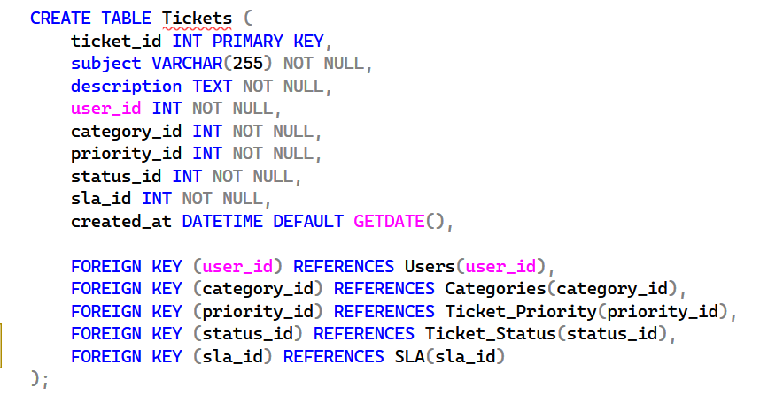

Create RESPONSES Table
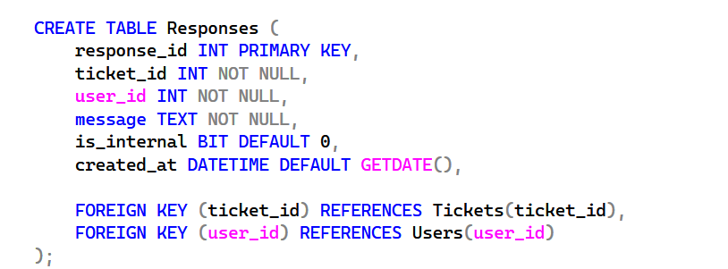

Create TICKET_ASSIGNMENTS Table
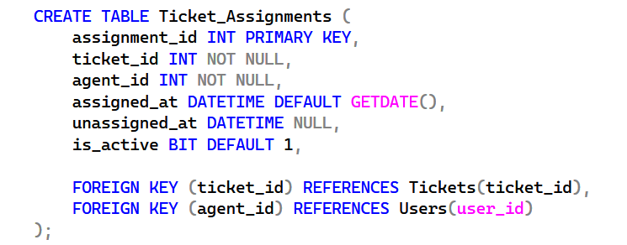

Create TICKET_HISTORY Table
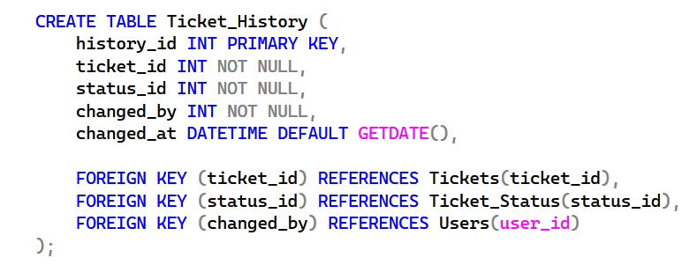

15. Sample Data
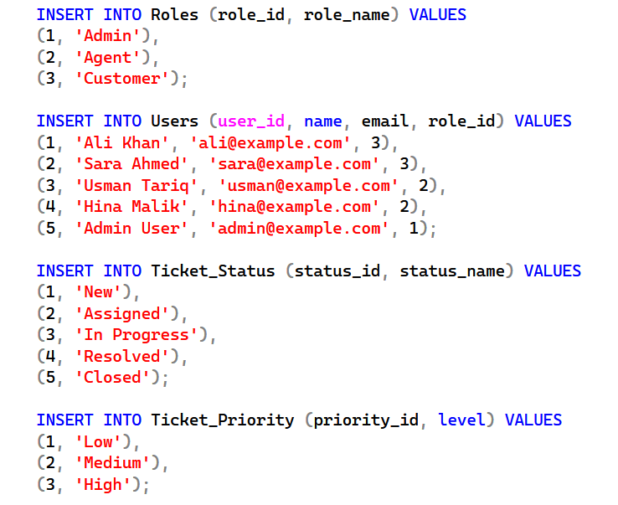
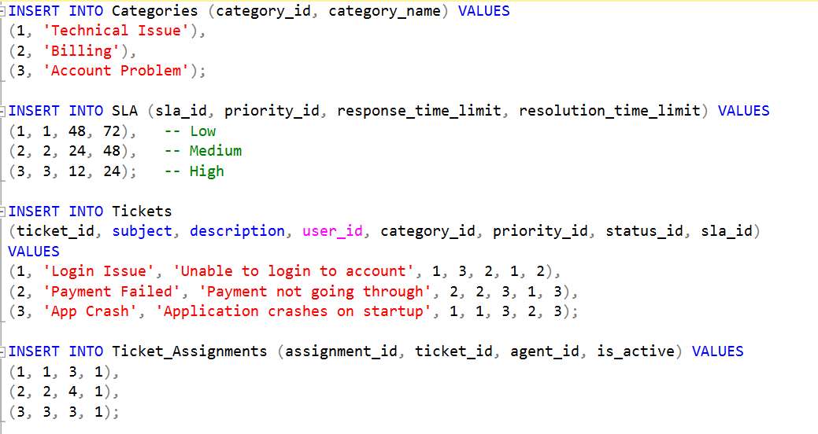
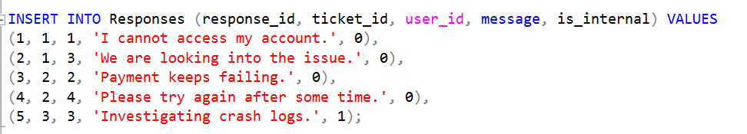
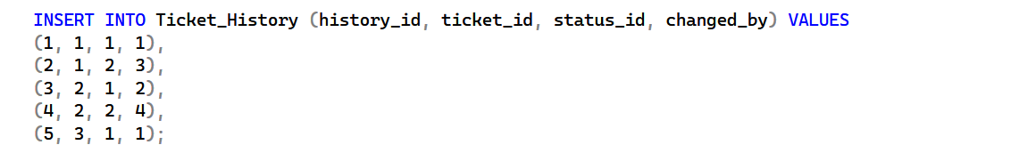

16. SQL Queries

Basic Queries

Display All Users

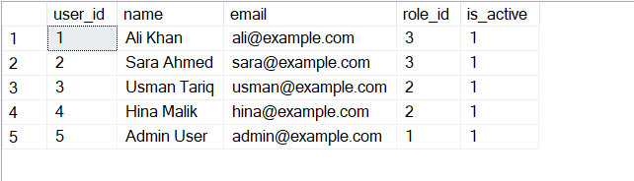

2. Display All Tickets
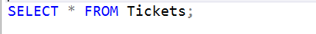
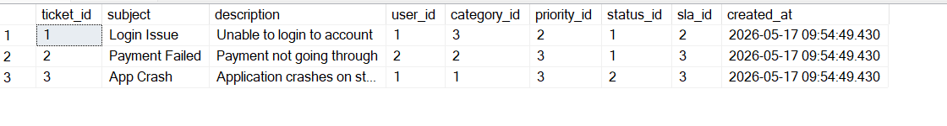

3. Display Open Tickets
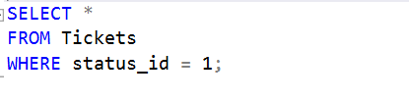
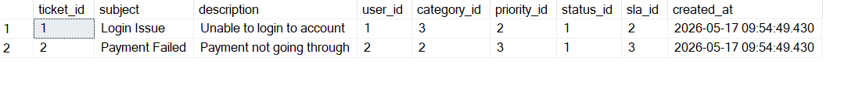

JOIN Queries

4. Show Ticket with Customer Name
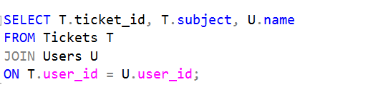
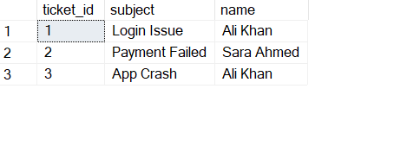

5. Show Ticket Status
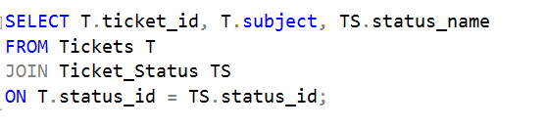
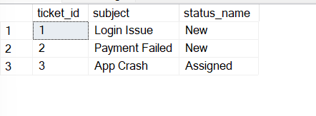

6. Show Ticket Category and Priority
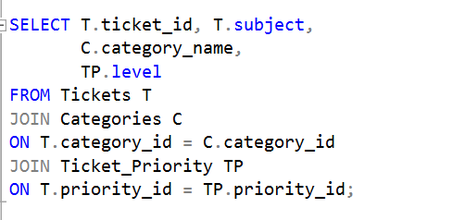
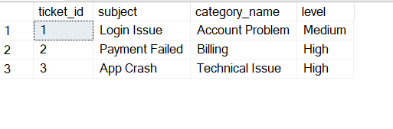

7. Show Assigned Agent for Each Ticket
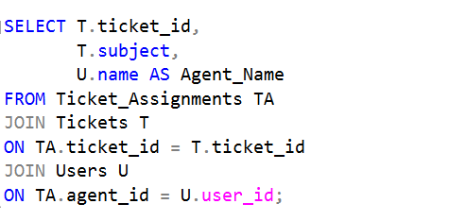
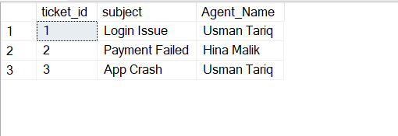

8.Displays all users and their ticket subjects, including users without tickets.
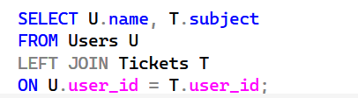
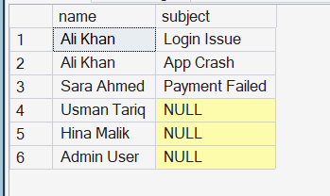

Aggregate Function Queries

9. Count Total Tickets

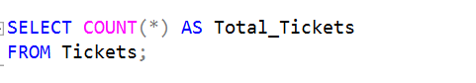
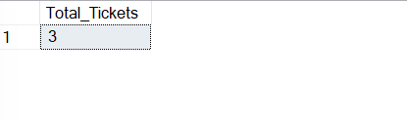

10. Count Tickets by Status
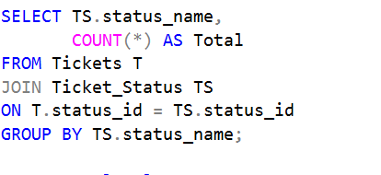
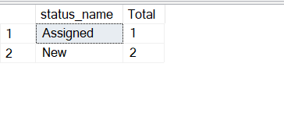

Count Tickets by Priority
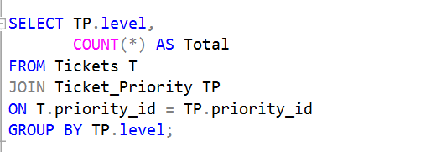
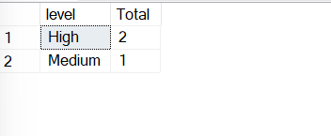

Response Queries

Show Ticket Responses
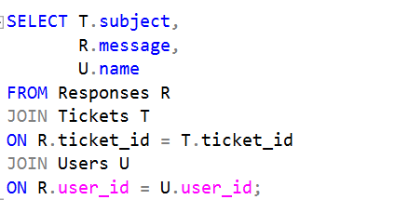
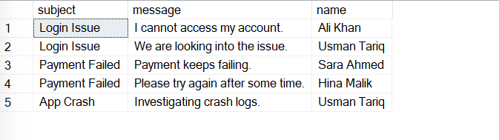

Show Internal Responses Only
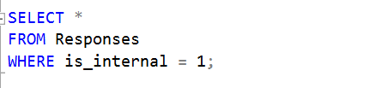
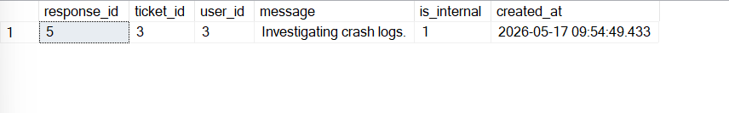

Sorting Queries

Display Latest Tickets
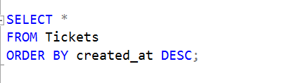
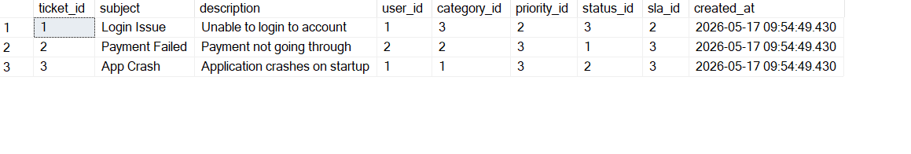

15. Display Tickets Alphabetically
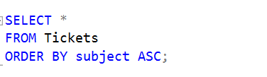
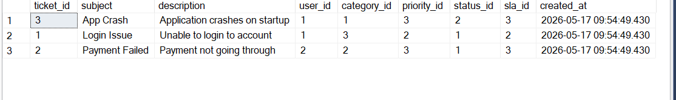

UPDATE Query

16. Update Ticket Status
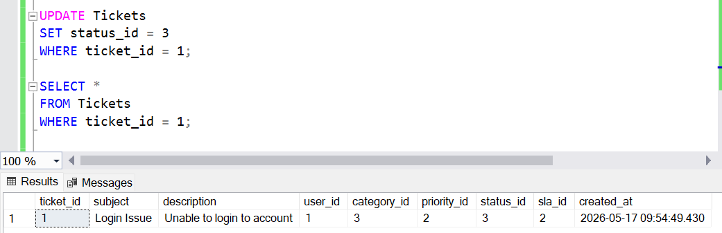

DELETE Query

17. Delete a Response
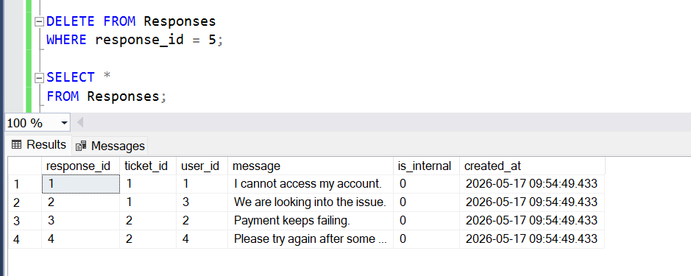

Subquery Examples

18. Show Users Who Created Tickets
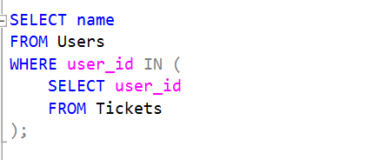

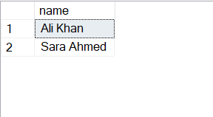

19. Find Highest Priority Tickets
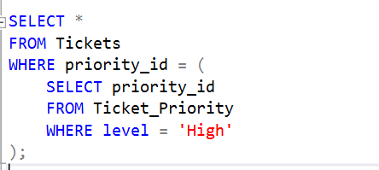
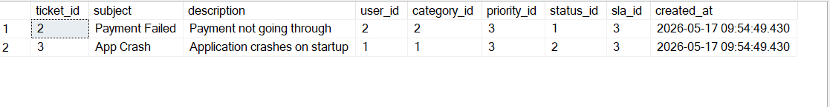

Advanced Queries

20. Show Average Resolution Time Limit
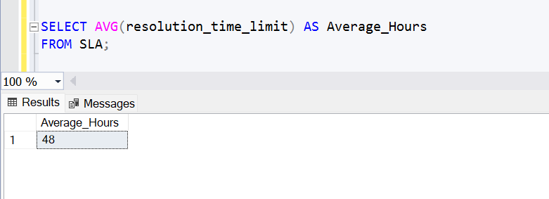

21. Show Number of Tickets Assigned to Each Agent
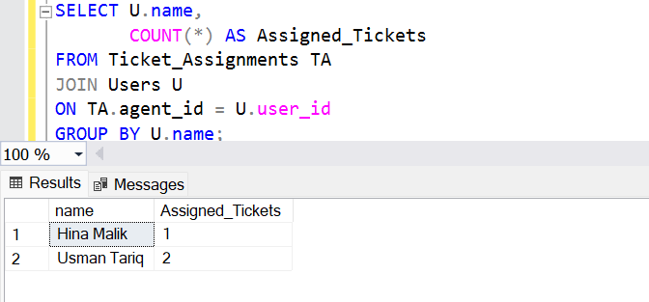

22.Displays agents having more than one assigned ticket.
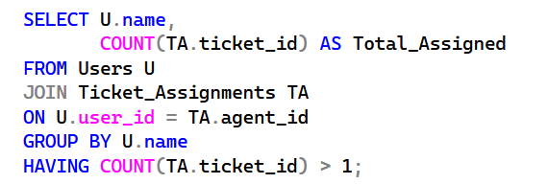
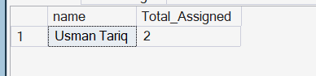

23.displays all users who are involved in the ticket management process either as ticket creators or assigned agents.
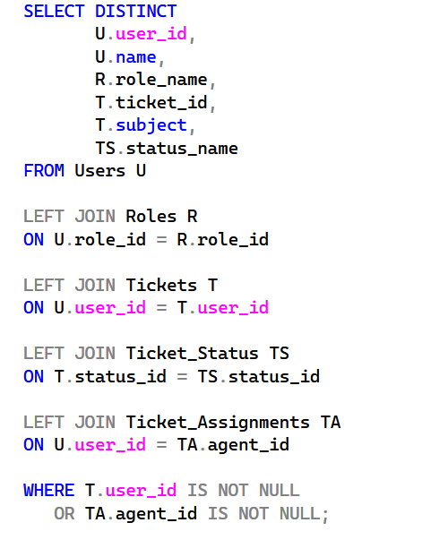
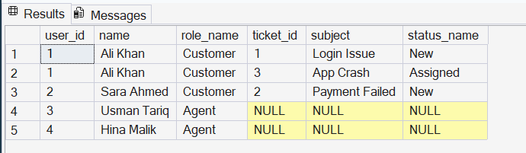

17. Advantages of the System
- Centralized ticket management
- Better customer support tracking
- Reduced data redundancy
- Improved data integrity
- Efficient assignment management
- Faster query processing
- Easy report generation
- Better monitoring of SLA compliance
- Scalable database structure

Conclusion
The SaaS Platform Support Ticket Management System successfully demonstrates the application of DBMS concepts in solving real-world business problems. The database structure supports efficient ticket management, user handling, response tracking, and SLA monitoring.
The project applies relational database principles and normalization techniques to ensure data consistency, integrity, and reduced redundancy. The system can easily be expanded into a complete web-based customer support solution.

