UAV Disaster-Surveillance Strategy Engine Using a Genetic Algorithm
Artificial Intelligence | BSCS 5 | Assignment 2
Name: _Zainab Fatima_______ Roll No: _03-134242-095__________

1. Problem and Proposed Approach
This project implements an educational Genetic Algorithm (GA) for multi-UAV route planning on a 50×50 grid. The map contains open cells, rectangular no-fly regions, a synthetic environmental-hazard field, and priority-weighted disaster zones. Three UAVs start from fixed locations. The GA evolves waypoint coordinates, speed settings, and sensor power while balancing priority-zone coverage, a target-detection proxy, energy, flight time, and environmental risk. Because objectives conflict, the result is a weighted compromise rather than a universal optimum.

2. Chromosome Representation
Each chromosome is a real-valued tensor of shape (3, 6, 4). The dimensions identify UAV, ordered waypoint, and genes (x, y, speed, sensor_power). Coordinates are bounded to 0–49, speed to 0.5–1.5, and sensor power to 0–1. Each route begins at a fixed launch point and follows six encoded waypoints. Repair clips values and relocates waypoints inside blocked cells to nearby open cells. Route segments are sampled for blocked-cell intersections; repairing endpoints alone cannot guarantee every segment is obstacle-free.

3. Multi-Objective Fitness Function
Let C be priority-weighted coverage, D normalized detection proxy, E normalized energy, T normalized flight time, R mean route hazard, and V constraint violation. The GA maximizes:
F = 0.48C + 0.22D − 0.13E − 0.07T − 0.10R − 0.02V
Coverage is the fraction of total priority weight reached by combined sensor footprints. Detection uses priority intensity sampled along routes and sensor power. Energy increases with distance, speed squared, and sensor-power squared. Time is approximated using segment distance and speed. Risk is mean hazard intensity along sampled routes. V penalizes no-fly incursions and excess distance beyond the model's range budget. Coverage receives the largest positive weight because priority-zone surveying is the main mission purpose; energy and risk receive negative weights, and time a smaller penalty. Weights are tunable design choices. A weighted sum is interpretable but can hide non-dominated solutions; NSGA-II is a possible extension.

4. Genetic Operators and Constraint Handling
Initialization samples bounded real-valued chromosomes. Tournament selection chooses a fitter candidate from a random subset. Elitism preserves the top two individuals. Segment-swapping crossover copies a waypoint suffix from one parent and may exchange later UAV segments. Gaussian mutation perturbs coordinates, speed, and sensor power. Repair enforces bounds and relocates blocked waypoints. Fitness evaluation samples interpolated segments and penalizes no-fly incursions and excessive route distance. The algorithm stops after a fixed generation count and retains the best candidate.

5. Experimental Results
The demonstration run used population size 30, 35 generations, mutation rate 0.12, tournament size 3, two elite chromosomes, and seed 42. Best fitness was 0.3263; priority-weighted coverage 0.483, detection proxy 1.000, normalized energy 0.334, and mean route hazard 0.491. Results are saved in results/metrics.json.
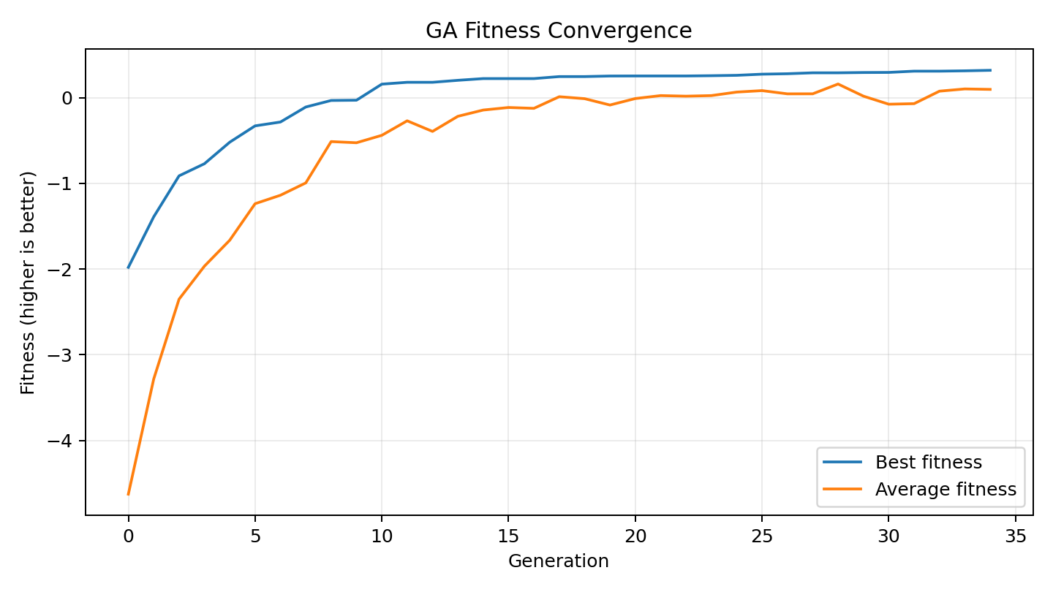
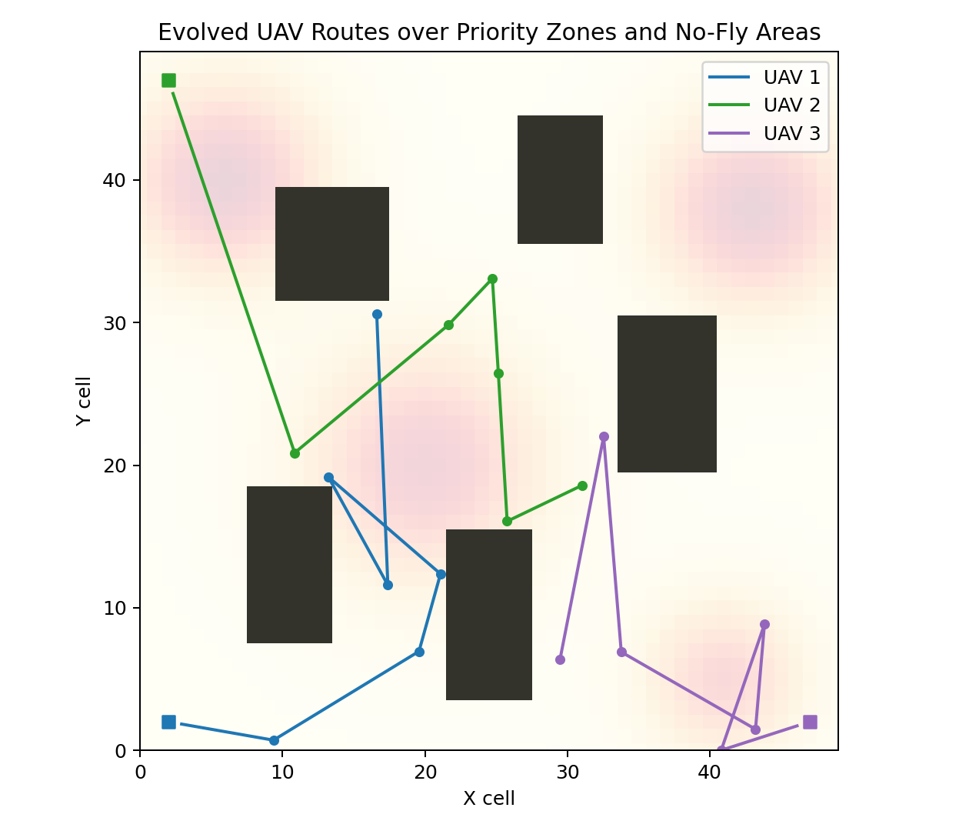

6. Hyperparameter Sensitivity
Six illustrative runs used 12 generations while varying population size (15, 30, 45), mutation rate (0.06, 0.12, 0.22), or tournament size (3 versus 5). One run per setting is not statistically conclusive. Larger populations explore more but cost more evaluations; low mutation may converge early, while high mutation can disrupt useful solutions. Larger tournaments increase selection pressure and may reduce diversity. A stronger experiment should repeat each setting over at least 10 seeds and report mean and standard deviation.
Population | Mutation | Tournament | Best fitness | Coverage
15 | 0.12 | 3 | -0.4207 | 0.650
30 | 0.06 | 3 | 0.2799 | 0.575
30 | 0.12 | 3 | 0.1784 | 0.477
30 | 0.22 | 3 | -0.0262 | 0.658
45 | 0.12 | 3 | 0.0593 | 0.834
30 | 0.12 | 5 | -0.1040 | 0.584

7. Comparison with Random Search
An illustrative random-search baseline sampled 40 independent chromosomes and achieved best fitness -2.7344, compared with GA fitness 0.3263. This baseline used fewer evaluations than the GA's 1,050 candidate evaluations, so it is not a fair equal-budget comparison and should not be interpreted as proof of GA superiority. For a robust comparison, increase random-search samples to at least 1,050 and repeat both algorithms over multiple seeds. Random search does not preserve promising partial solutions; GA selection, crossover, mutation, and elitism exploit useful genetic material while continuing exploration.

8. Conclusion and Limitations
The project covers chromosome encoding, multi-objective fitness, custom genetic operators, and constraint handling, with convergence, route, and coverage plots and a random-search baseline. This is a simplified simulation: energy, time, sensing, and hazards are proxies; route segments are sampled straight lines; and wind dynamics, battery discharge curves, collision avoidance, communication loss, and real sensor physics are omitted. It must not be used for real-world flight planning without validated data, physical models, robust path planning, and safety verification.

Appendix: Running the Project
Install dependencies with `python -m pip install -r requirements.txt`, then run `python src/uav_ga.py` from the project root. See README.md for assumptions and project structure.

