**Software Process Selection, Project Plan and Risk Management**

**<P14>:<Shop Savvy>**

**<team member names & ids>**

| **Student ID** | **Name** |
| --- | --- |
| **25100002** | **Ahmad Kashif Jabbar** |
| **25100105** | **Husnain Ali** |
| **25100179** | **Musa Aftab Ahmad** |
| **25100229** | **Syed Messam Ali** |
| **25100208** | **Zainab Fatima** |

**Table of Contents**

1. Introduction 3

2. Software Process Selection 4

3. Gantt Chart 5

4. Development Environment Preparation 6

5. Deployment Platform 6

6. Risk Management 7

6.1 Potential Risks and Mitigation Strategies 7

7. Who Did What? 8

8. Review checklist 8

# Introduction

**Shop Savvy** is an innovative AI-driven Personalized Clothing Recommendation Platform designed to revolutionize the online shopping experience for **Pakistani consumers**. By aggregating a curated selection of at least **10 prominent local clothing brands**, Shop Savvy simplifies the shopping process, enabling users to explore a diverse range of fashion options conveniently in one centralized location.

**Objectives:**

1. **Enhance User Experience:**
   * The primary goal of Shop Savvy is to provide a seamless and enjoyable shopping experience tailored to the unique preferences of Pakistani consumers. Leveraging advanced AI technologies, the platform will offer personalized product recommendations that align with individual styles, ensuring users find what they love quickly and easily.
2. **Showcase Local Fashion:**
   * Shop Savvy will highlight local clothing brands, fostering a sense of community and promoting the rich diversity of Pakistani fashion. By presenting various styles and options from multiple brands, users will gain access to a broader array of choices that reflect their cultural and personal identities.
3. **Streamline the Shopping Process:**
   * By bringing together various brands under one platform, Shop Savvy aims to eliminate the hassle of navigating multiple websites. Users can shop efficiently and enjoyably without needing to search through numerous sites to find their desired items.
4. **Implement AI-Powered Personalization:**
   * The recommendation engine will utilize user data, including browsing history, past purchases, and personal preferences, to suggest relevant products. This data-driven approach will enhance engagement, allowing users to discover items they might not have otherwise considered.
5. **Facilitate Brand Visibility and Revenue Generation:**
   * Shop Savvy has the potential to generate revenue through affiliate marketing by partnering with local brands. This partnership will not only drive visibility for the brands but also provide a financially sustainable model for the platform. The project aims to create a mutually beneficial relationship, allowing brands to reach a broader audience while offering tailored shopping experiences for consumers.

**Potential Users and Customers:**

The primary users of ShopSavvy will be **Pakistani consumers** seeking a convenient and personalized shopping experience. These users include:

* **Fashion Enthusiasts:** Individuals who actively seek out the latest trends and styles from various local brands.
* **Busy Professionals:** Shoppers who value efficiency and prefer a streamlined shopping process that saves them time.
* **Budget-Conscious Consumers:** Users looking for curated selections that offer quality products at competitive prices.
* **Brand Loyalists:** Customers who have specific preferences for local brands but want the convenience of browsing multiple options at once.

Ultimately, **Shop Savvy** aims to provide a **tailored, convenient, and engaging online shopping experience**. By simplifying the process of discovering and purchasing clothing from a variety of local brands, the platform empowers Pakistani consumers to make informed shopping decisions while celebrating the richness of local fashion.

# Software Process Selection

### **Pros and Cons of Waterfall and Agile (Scrum)**

#### **Waterfall:**

Waterfall is a linear, step-by-step approach where each phase of development is completed before moving on to the next.

* **Pros**:
  1. **Clear structure**: Waterfall follows a straightforward process, making it easier to manage and plan.
  2. **Well-documented**: Every stage is documented, which helps track progress and make onboarding smoother.
  3. **Predictable outcomes**: Once the requirements are set, the final product typically aligns with the initial scope.
* **Cons**:
  1. **Inflexible**: Difficult to adapt to new changes once a phase is completed.
  2. **Limited adaptability**: Poor fit for projects where requirements evolve over time.
  3. **Not ideal for evolving projects**: Complex projects with changing dynamics, like AI or API integrations, struggle under Waterfall’s rigid structure.

#### **Agile (Scrum):**

Agile breaks the project into smaller, iterative cycles (sprints), allowing for more flexibility and faster feedback.

* **Pros**:
  1. **Adaptable**: Agile allows for adjustments based on feedback or changes in requirements.
  2. **Encourages collaboration**: Teams work closely with frequent check-ins, leading to quicker problem-solving.
  3. **Incremental results**: Delivers working product versions at the end of each sprint, helping detect and fix issues early.
* **Cons**:
  1. **Requires experienced teams**: Agile depends on team autonomy, which can be hard for inexperienced teams.
  2. **Less predictability**: Project timelines and final scope are more flexible, making it harder to predict.
  3. **Scope creep**: Continuous changes can lead to adding more features than originally planned, risking delays.

**Selected Process**: Agile (Scrum)

#### **Justification:**

Agile Scrum was chosen for Shop Savvy because the project involves dynamic elements such as evolving API integrations with fashion platforms and real-time trend analysis using AI. These aspects require a flexible and adaptive approach that can accommodate frequent changes and new information.

1. **Real-time adaptability**: In Shop Savvy, the AI recommendation system relies on trends that change frequently, and the platform integrates with various APIs. Agile allows the team to adapt and make quick adjustments during sprints without the rigid structure of Waterfall. This is crucial for maintaining up-to-date, relevant recommendations for users.
2. **Incremental feature development**: Since Shop Savvy consists of multiple components—backend integration, AI models, frontend interfaces—it benefits from Agile’s incremental approach. The team can develop core features (like personalized recommendations) first, gather feedback, and continuously improve them in future sprints. This minimizes risks by delivering working components early and refining them based on real-world usage.
3. **Frequent feedback and user involvement**: The Agile process allows for regular feedback from potential users and stakeholders, helping the team shape the platform based on real user needs. For a consumer-facing platform like Shop Savvy, gathering insights about user preferences during the development cycle ensures the final product is aligned with the market.
4. **Handling evolving requirements**: As Shop Savvy interacts with multiple external platforms and involves AI-driven recommendations, new requirements or changes in APIs might arise frequently. Agile’s iterative process helps in incorporating these changes seamlessly, ensuring that the system remains current and functional.

In conclusion, Agile Scrum’s adaptability and focus on continuous feedback make it the best fit for Shop Savvy, allowing the team to navigate the complexities of API integration, real-time data processing, and the evolving nature of user preferences efficiently.

# Gantt Chart

<Draw a Gantt chart that illustrates your project’s schedule. The Gantt chart should show at least the following

* Tasks (tasks should not be too small or too large)
* Duration (in weeks)
* Milestones
* Team member names who are going to work on each task.

>

The Gannt chart should include both the activities that you have already completed and those that you would be doing in the future.

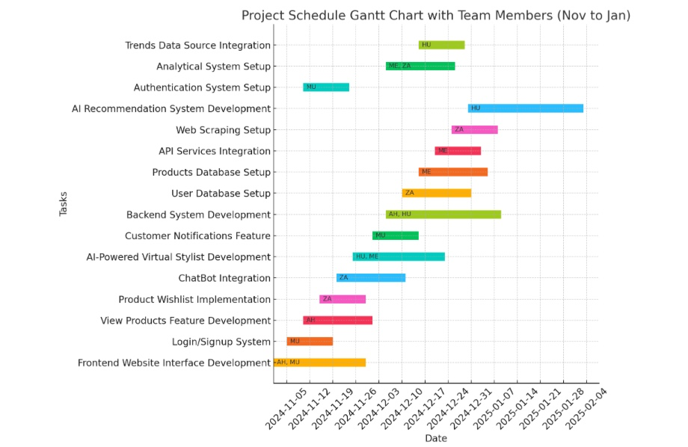

# Development Environment Preparation

< (1) List down tools and technologies that you will use for prototype development.

(2) Setup the development environment on your machines and mention here that you have actually setup the environment. Include three snapshots of the tool(s) that you are going to use for development. These snapshots must be taken from the tool(s) while they are actually running on your system.>

1. **Tools and Technologies**:
   * **MongoDB** for user and product data management.
   * **React** for the front-end interface.
   * **Node.js** for the backend server.
   * **Pinecone** for similarity search in recommendations.
   * **Vercel** for front-end deployment
2. **Environment Setup**: The development environment is set up using Node.js, MongoDB, and React on team members' machines. Below are snapshots of the environment:

MongoDB cluster

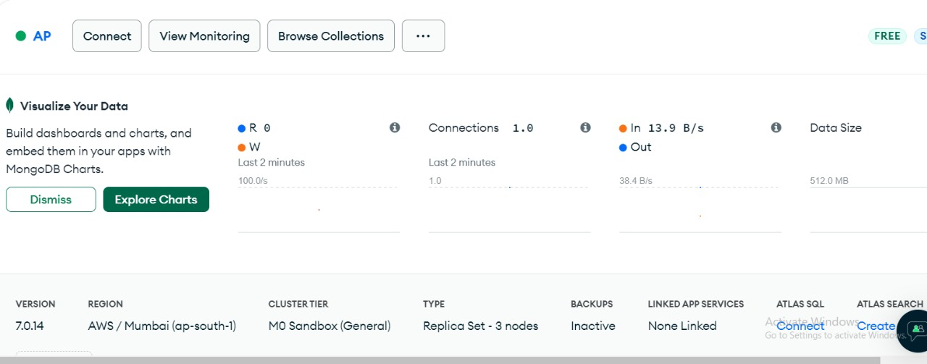

Vite Project for front end



Successful configuration

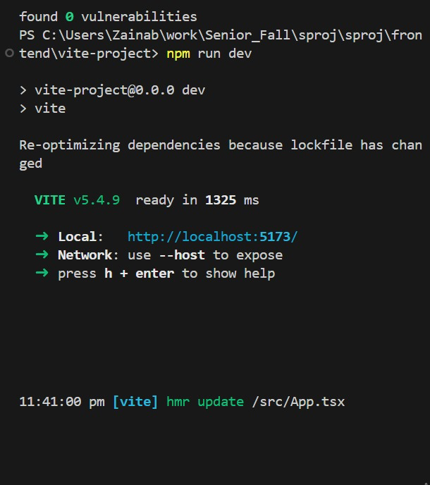

Backend Configuration

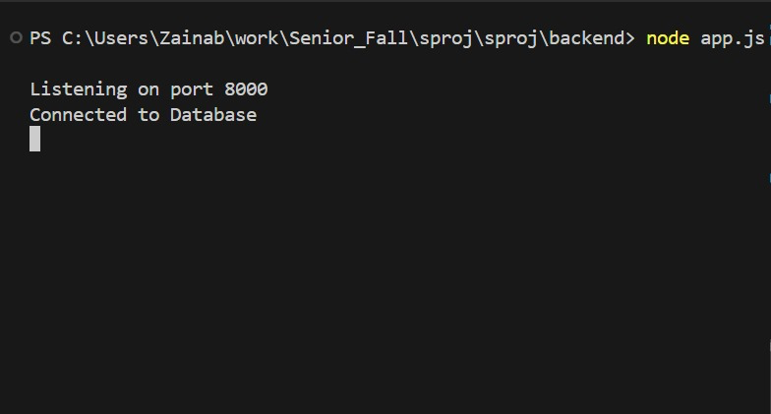

# Deployment Platform

We will use Vercel as our deployment platform for the AI-driven Personalized Clothing Recommendation Platform, Shop Savvy. Vercel is a free hosting service that excels in deploying modern web applications and static websites. With features like fast build times and hot module replacement, it ensures optimal performance and an efficient development process. Additionally, Vercel's seamless integration with GitHub allows for continuous deployment, making it easy for our development team to collaborate and update the platform efficiently. By leveraging Vercel, we can provide our users with a smooth and engaging shopping experience.

# Risk Management

## Potential Risks and Mitigation Strategies

<List down top 10 potential risks and their mitigation strategies>

| **Sr.** | **Risk Description** | **Mitigation Strategy** |
| --- | --- | --- |
|  | User data, including browsing history and personal preferences, may be exposed or misused. | Implement robust data encryption and secure storage practices. Ensure compliance with data protection laws (e.g., GDPR, local privacy laws). Regularly audit security protocols. |
|  | The AI model may fail to accurately suggest products based on user preferences, leading to a poor user experience. | Continuously improve the recommendation algorithm by integrating user feedback. Regularly update the AI model to improve its understanding of user behavior and local fashion trends. |
|  | The platform could face unexpected downtimes, affecting user experience and business operations. | Utilize a cloud infrastructure with load balancing and redundancy for high availability. Establish real-time monitoring to detect and resolve system issues before they impact users. |
| 4. | As the number of users or brands increases, the platform may struggle to handle the demand efficiently. | Implement scalable architecture (like microservices) that can grow as the platform expands. Regularly stress test the system to prepare for scaling needs. |
| 5. | Data from local brands or external fashion sources may be inconsistent or unreliable. | Build robust data validation mechanisms to detect and correct data inconsistencies. Work closely with brands to ensure data accuracy, and diversify sources to minimize reliance on any single source. |
| 6. | The platform could be susceptible to cyberattacks, such as phishing or DDoS attacks. | Implement multi-factor authentication (MFA), secure APIs, and firewall protections. Regularly conduct security audits and penetration testing to identify and patch vulnerabilities. |
| 7. | Users may not adopt the platform at the expected rate, leading to reduced revenue and visibility. | Invest in a marketing strategy that highlights the platform’s convenience and personalized experience. Engage users through referral programs, discounts, and social media campaigns to increase adoption. |
| 8. | The AI model might display biases based on the data it’s trained on, leading to unfair or inaccurate recommendations. | Regularly audit the AI model for biases and retrain it using diverse datasets. Ensure the inclusion of various fashion trends and preferences to make recommendations more inclusive. |
| 9. | The AI model's performance may degrade over time as user preferences or fashion trends evolve, leading to less accurate recommendations. | Implement continuous learning and periodic model retraining to adapt to changing user behaviors and trends. Regularly evaluate model performance against new data to detect drift early. |
| 10. | The AI model may overfit to a specific set of user data, providing recommendations that are too narrow and not adaptable to new users or broader trends. | Use cross-validation techniques and diversify training data to prevent overfitting. Introduce mechanisms to balance personalization with diversity in recommendations, ensuring new and varied products are suggested to users. |

# Who Did What?

| **Name of the Team Member** | **Tasks done** |
| --- | --- |
| Ahmad Kashif Jabbar | Introduction, Risk Management, Deployment Platform |
| Husnain Ali | Software Process Selection, Development Environment Preparation |
| Messam Ali | Gantt Chart |
| Musa Aftab | Software Process Selection |
| Zainab Fatima | Deployment Platform, Development Environment Preparation |

# Review checklist

Before submission of this deliverable, the team must perform an internal review. Each team member will review one or more sections of the deliverable.

| **Section** **Title** | **Reviewer Name(s)** |
| --- | --- |
| Gantt Chart | Ahmad Kashif Jabbar |
|  | Husnain Ali |
| Introduction, Risk Management, Deployment Platform | Messam Ali |
|  | Musa Aftab |
| Software Process Selection, Development Environment Preparation | Zainab Fatima |